**SDL Integration Guidelines**

# Table of Contents

Table of Contents 2

Introduction 50

Abbreviations and Definitions 51

I. SDL Programmer`s Guide 52

1 Overview 52

2 Architecture 52

3 Transport Manager 53

3.1 General description 53

3.1.1 Transport layer features 53

3.1.2 Transport Level Structure 54

3.1.2.1 Transport Manager Structure 55

3.1.2.2 Transport Adapter Structure 56

3.1.3 Operation Examples (Message Sequence Chart) 57

3.1.3.1 New device search 57

3.1.3.2 Device-originating connection 59

3.1.3.3 Connection close command 60

3.2 Transport Manager (TM) Usage 60

3.2.1 General Processing Description 60

3.2.1.1 TM initialization 60

3.2.1.2 TM structure 61

3.2.1.3 TA initialization 61

3.2.1.4 Getting started 61

3.2.1.5 Errors in TM 62

3.2.1.6 Messages in TM 62

3.2.1.7 Connection identifiers 62

3.2.1.8 Connection closing 63

3.2.1.9 SDL shutting down 63

3.2.2 Create Default TM Instance 63

3.2.3 Add Custom Listener to TM 63

3.2.4 Add Custom Transport Adapter to Default TM 64

3.2.4.1 About TA in general 64

3.2.4.2 Several instances of TA 64

3.2.4.3 Add Custom TA 64

3.2.4.4 Initialization 65

3.2.5 Custom TA implementation from scratch 65

3.2.6 Add a New Listener to TA 66

3.2.7 Create TM with Custom TAs Only (with No Default Adapter) 67

3.2.8 Transport Manager Customizing 68

3.2.8.1 Basic information 68

3.2.8.2 Queues as a fundamental of TM 68

3.2.8.3 Rules for developer 69

3.2.9 Transport Adapter Customizing 69

3.2.9.1 Basic information 69

3.2.9.2 Workers of TA 69

3.2.9.3 Connection 70

3.2.9.4 Descriptor 70

3.2.9.5 Create custom Transport Adapter 70

4 Build and Run SDL and Set Up the Environment 73

4.1 General 73

4.2 Known issues 73

4.3 Preparation steps 73

4.3.1 To prepare the Linux Host 73

4.3.2 To set up QNX cross platform build for Linux 74

4.3.3 To run specially prepared QNX in virtual machine 74

4.3.4 To make QNX virtual machine from scratch 74

4.3.5 To set up Android Simulator for using instead of real device 75

4.4 Configuration steps 75

4.4.1 HTML5 HMI and SDL to be running on separate computers 75

4.4.2 QML HMI and SDL to be running on separate computers 75

4.5 Build SDL from source on Linux Host 76

4.5.1 QNX with HTML5 HMI 76

4.5.2 QNX with QML HMI 76

4.5.3 Linux with HTML5 HMI 76

4.5.4 Linux with QML HMI 76

4.5.5 Build SDL 76

4.6 Run SDL 76

4.6.1 Linux host for both SDL and HMI (Qt / HTML5) 76

4.6.2 QNX host for both SDL and Qt HMI 77

4.6.3 QNX host for both SDL and HTML5 HMI 77

4.6.4 Run SDL on QNX Server and QML HMI on Linux host 77

5 Audio/Video Streaming over SDL 78

5.1 PulseAudio and GStreamer libraries: how to include or exclude from project 78

5.1.1 Short overview 78

5.1.2 Include 78

5.1.3 Exclude 78

5.2 Use SyncProxyTester to check audio/video streaming over SDL 78

5.3 Configuring audio/video streaming parameters in smartDeviceLink.ini file 78

II SDL-HMI Integration Guide 80

1 Overview 80

1.1 Operation System 80

1.2 Transports Supported 80

1.3 Communication 80

2 WebSocket Transport 81

2.1 Connection Opening 81

2.1.1 Requirements to HMI adapter 81

2.1.2 Handshake 81

2.1.3 Components registering 81

2.1.4 Examples 82

2.2 JSON Message Format 84

2.2.1 Request 84

2.2.1.1 Examples 85

2.2.2 Notification 85

2.2.2.1 Examples 86

2.2.3 Response 86

2.2.3.1 Examples 87

2.2.4 Error 88

2.2.4.1 Examples 89

4 D-Bus Transport 90

4.1 Overview 90

4.2 HMI Integration Aspects 90

4.3 Low Level D-Bus processing 91

5 Getting Started 93

5.1 Readiness confirming 93

5.1.1 Sequence diagram 93

6 BasicCommunication Component Description 95

6.1 UpdateDeviceList 95

6.1.1 Description 95

6.1.2 Request 95

6.1.2.1 Behavior 95

6.1.2.2 Parameters 95

6.1.2.3 DeviceInfo Structure 96

6.1.2.4 TransportType Enumeration 96

6.1.3 Response 96

6.1.4 Sequence Diagrams 97

6.1.4.1 UpdateDeviceList after SDL finds a new device over BT and USB 97

6.1.5 JSON Messages Examples 97

6.1.5.1 Request 97

6.1.5.2 Response 98

6.1.5.3 Error message 98

6.1.6 D-Bus Messages Examples 98

6.1.6.1 Request 98

6.1.6.2 Response 98

6.1.6.3 Failure 99

6.2 ActivateApp 99

6.2.1 Description 99

6.2.2 Request 99

6.2.2.1 Behavior 99

6.2.2.2 Parameters 100

6.2.2.3 AppPriority 100

6.2.2.4 HMILevel 100

6.2.3 Response 100

6.2.4 Sequence Diagrams 102

6.2.4.1 BasicCommunication.ActivateApp after successsful resumption. 102

6.2.4.2 BasicCommunication.ActivateApp after UNsuccesssful resumption. 103

6.2.4.3 BasicCommunication.ActivateApp after unexpected disconnect 104

6.2.4.4 BasicCommunication.ActivateApp after the User accepted the data consent prompt 105

6.2.4.5 BasicCommunication.ActivateApp after the User declined the data consent prompt 106

6.2.5 JSON Messages Examples 106

6.2.5.1 Request 106

6.2.5.2 Response 107

6.2.5.3 Error message 107

6.2.6 D-Bus Messages Examples 107

6.2.6.1 Request 107

6.2.6.2 Response 107

6.2.6.3 Failure 107

6.3 MixingAudioSupported 107

6.3.1 Description 107

6.3.2 Request 108

6.3.2.1 Behavior 108

6.3.3 Response 108

6.3.3.1 Behavior 108

6.3.3.2 Parameters 108

6.3.4 Sequence Diagrams 108

6.3.4.1 MixingAudioSupported Messaging 108

6.3.5 JSON Messages Examples 109

6.3.5.1 Request 109

6.3.5.2 Response 109

6.3.5.3 Error message 109

6.3.6 D-Bus Messages Examples 109

6.3.6.1 Request 109

6.3.6.2 Response 109

6.3.6.3 Failure 109

6.4 AllowDeviceToConnect 109

6.4.1 Description 109

6.4.2 Request 110

6.4.2.1 Behavior 110

6.4.2.2 Parameters 110

6.4.2.3 DeviceInfo Structure 110

6.4.2.4 TransportType Enumeration 110

6.4.3 Response 111

6.4.3.1 Behavior 111

6.4.3.2 Parameters 111

6.4.4 Sequence Diagrams 111

6.4.4.1 AllowDeviceToConnect Messaging 111

6.4.5 JSON Messages Examples 112

6.4.5.1 Request 112

6.4.5.2 Response 112

6.4.5.3 Error message 112

6.4.6 D-Bus Messages Examples 113

6.4.6.1 Request 113

6.4.6.2 Response 113

6.4.6.3 Failure 113

6.5 SystemRequest 113

6.5.1 Description 113

6.5.2 Request 113

6.5.2.1 Behavior 113

6.5.2.2 Parameters 113

6.5.2.3 RequestType 114

6.5.3 Response 114

6.5.4 Sequence Diagrams 115

6.5.4.1 SystemRequest flow 115

6.5.5 JSON Messages Examples 116

6.5.5.1 Request 116

6.5.5.2 Response 116

6.5.5.3 Error message 116

6.5.6 D-Bus Messages Examples 116

6.5.6.1 Request 116

6.5.6.2 Response 116

6.5.6.3 Failure 116

6.6 PolicyUpdate 116

6.6.1 Description 116

6.6.2 Request 117

6.6.2.1 Behavior 117

6.6.2.2 Parameters 117

6.6.3 Response 117

6.6.3.1 Behavior 117

6.6.4 Sequence Diagrams 118

6.6.4.1 PolicyUpdate 118

6.6.5 JSON Messages Examples 119

6.6.5.1 Request 119

6.6.5.2 Response 119

6.6.5.3 Error message 119

6.6.6 D-Bus Messages Examples 119

6.6.6.1 Request 119

6.6.6.2 Response 119

6.6.6.3 Failure 119

6.7 GetSystemInfo 120

6.7.1 Description 120

6.7.2 Request 120

6.7.2.1 Behavior 120

6.7.3 Response 120

6.7.3.1 Parameters 120

6.7.3.2 Language Enumeration 120

6.7.4 Sequence Diagrams 121

6.7.4.1 GetSystemInfo 121

6.7.5 JSON Messages Examples 122

6.7.5.1 Request 122

6.7.5.2 Response 122

6.7.5.3 Error message 122

6.7.6 D-Bus Messages Examples 122

6.7.6.1 Request 122

6.7.6.2 Response 122

6.7.6.3 Failure 122

6.8 OnReady 123

6.8.1 Description 123

6.8.2 Sequence Diagrams 123

6.8.2.1 OnReady after WebSocket connection establishment 123

6.8.2.2 OnReady after D-Bus service publishing 123

6.8.3 JSON Messages Examples 124

6.8.4 D-Bus Messages Examples 124

6.8.6.1 Request 124

6.8.6.2 Response 124

6.8.6.3 Failure 124

6.9 OnStartDeviceDiscovery 124

6.9.1 Description 124

6.9.2 Sequence Diagrams 125

6.9.2.1 OnStartDeviceDiscovery upon User`s request and resulting UpdateDeviceList 125

6.9.3 JSON Messages Examples 125

6.9.4 D-Bus Messages Examples 125

6.10 OnDeviceChosen 125

6.10.1 Description 125

6.10.1.1 Parameters 126

6.10.1.2 DeviceInfo Structure 126

6.10.1.3 TransportType Enumeration 126

6.10.2 Sequence Diagrams 127

6.10.2.1 OnDevcieChosen with preceding UpdateDeviceList 127

6.10.3 JSON Messages Examples 127

6.10.4 D-Bus Messages Examples 127

6.9.9.1 Request 127

6.9.6.2 Response 128

6.9.6.3 Failure 128

6.11 OnFindApplications 128

6.11.1 Description 128

6.11.1.1 Parameters 128

6.11.1.2 DeviceInfo Structure 128

6.11.1.3 TransportType Enumeration 129

6.11.2 Sequence Diagrams 129

6.11.2.1 OnFindApplications upon User`s choice and resulting OnAppRegistered 129

6.11.2.2 OnFindApplications upon User`s choosing the device in the list of found devices and resulting OnAppRegistered 129

6.11.3 JSON Messages Examples 130

6.11.4 D-Bus Messages Examples 131

6.11.9.1 Request 131

6.11.6.2 Response 131

6.11.6.3 Failure 131

6.12 OnAppActivated 131

6.12.1 Description 131

6.12.1.1 Parameters 131

6.12.2 Sequence Diagrams 131

6.12.2.1 OnAppActivated upon User`s choice and resulting ActivateApp 131

6.12.3 JSON Messages Examples 132

6.12.4 D-Bus Messages Examples 132

6.12.9.1 Request 132

6.12.6.2 Response 133

6.12.6.3 Failure 133

6.13 OnAppDeactivated 133

6.13.1 Description 133

6.13.1.1 Parameters 133

6.13.1.2 DeactivateReason Enumeration 133

6.13.2 Sequence Diagrams 134

6.13.2.1 OnAppDeactivated Simple Messaging Example 134

6.13.2.1 OnAppDeactivated with preceding registering, activation, adding UI/VR commands and resulting deleting UI/VR commands 134

6.13.3 JSON Messages Examples 135

6.13.4 D-Bus Messages Examples 136

6.14 OnAppRegistered 136

6.14.1 Description 136

6.14.1.1 Parameters 137

6.14.1.2 HMIApplication Structure 138

6.14.1.3 AppHMIType Enumeration 139

6.14.1.4 AppPriority Enumeration 140

6.14.1.5 RequestType 140

6.14.1.6 DeviceInfo Structure 140

6.14.1.7 TransportType Enumeration 141

6.14.2 Sequence Diagrams 141

6.14.2.1 OnAppRegistered with resume=true after unexpected disconnect 142

6.14.2.2 OnAppRegistered with ‘resume’=false parameter after unexpected disconnect 143

6.14.3 JSON Messages Examples 144

6.14.4 D-Bus Messages Examples 144

6.15 OnAppUnregistered 144

6.15.1 Description 144

6.15.1.1 Parameters 145

6.15.2 Sequence Diagrams 145

6.15.2.1 OnAppUnregistered of active application 145

6.15.3 JSON Messages Examples 146

6.15.4 D-Bus Messages Examples 146

6.16 OnExitApplication 146

6.16.1 Description 146

6.16.1.1 Parameters 146

6.16.1.2 ApplicationExitReason 147

6.16.2 Sequence Diagrams 147

6.16.2.1 OnExitApplication USER_EXIT 147

6.16.2.2 OnExitApplication UNAUTHORIZED_TRANSPORT_REGISTRATION 148

6.16.3 JSON Messages Examples 148

6.16.4 D-Bus Messages Examples 148

6.17 OnExitAllApplications 148

6.17.1 Description 148

6.17.1.1 Parameters 149

6.17.1.2 ApplicationsCloseReason Enumeration 149

6.17.2 Sequence Diagrams 149

6.17.2.1 OnExitAllApplications 149

6.17.3 JSON Messages Examples 149

6.17.4 D-Bus Messages Examples 150

6.18 PlayTone 150

6.18.1 Description 150

6.18.2 Request 150

6.18.2.1 Parameters 150

6.18.2.2 MethodName 150

6.18.3 Response 150

6.18.4 Sequence Diagrams 151

6.18.4.1 PlayTone with Alert request 151

6.18.5 JSON Messages Examples 151

6.18.5.1 Request 151

6.18.5.2 Response 151

6.18.5.3 Error message 152

6.18.5 D-Bus Messages Examples 152

6.19 OnSystemRequest 152

6.19.1 Description 152

6.19.1.1 Parameters 153

6.19.1.2 RequestType Enumeration 153

6.19.1.3 FileType Enumeration 154

6.19.2 Sequence Diagrams 154

6.19.2.1 OnSystemRequest requests the file to download from Cloud 154

6.19.3 JSON Messages Examples 154

6.19.4 D-Bus Messages Examples 155

6.20 OnPutFile 155

6.20.1 Description 155

6.20.1.1 Parameters 155

6.20.2 Sequence Diagrams 155

6.20.2.1 OnPutFile 155

6.20.3 JSON Messages Examples 156

6.20.4 D-Bus Messages Examples 156

6.21 OnFileRemoved 156

6.21.1 Description 156

6.21.1.1 Parameters 156

6.21.2 Sequence Diagrams 156

6.21.2.1 OnFileRemoved 156

6.21.3 JSON Messages Examples 157

6.21.4 D-Bus Messages Examples 157

6.22 OnSystemInfoChanged 157

6.22.1 Description 157

6.22.1.1 Parameters 158

6.22.1.2 Language Enumeration 158

6.22.2 Sequence Diagrams 158

6.22.2.1 OnSystemInfoChanged 158

6.22.3 JSON Messages Examples 159

6.22.4 D-Bus Messages Examples 159

6.23 OnIgnitionCycleOver 159

6.23.1 Description 159

6.23.2 Sequence Diagrams 160

6.23.2.1 OnIgnitionCycleOver 160

6.23.3 JSON Messages Examples 160

6.23.4 D-Bus Messages Examples 161

6.24 OnSDLClose 161

6.24.1 Description 161

6.24.2 Sequence Diagrams 162

6.24.2.1 OnSDLClose IGNITION_OFF 162

6.24.2.1 OnSDLClose MASTER_RESET 162

6.24.3 JSON Messages Examples 163

6.24.4 D-Bus Messages Examples 163

6.25 OnUpdateDeviceList 163

6.25.1 Description 163

6.25.2 Sequence Diagrams 164

6.25.2.1 OnUpdateDeviceList upon User`s request and resulting UpdateDeviceList 164

6.25.3 JSON Messages Examples 164

6.25.4 D-Bus Messages Examples 164

6.26 OnResumeAudioSource 164

6.26.1 Description 164

6.26.1.1 Parameters 165

6.26.2 Sequence Diagrams 166

6.26.2.1 AudioSource resumption for the app with FULL HMILevel 166

6.26.2.2 OnResumeAudioSource for the app with LIMITED HMILevel 167

6.26.2.3 OnResumeAudioSource for the app with LIMITED HMILevel (Phone call is active) 168

6.26.2.4 AudioSource resume for the app_1 with FULL HMILevel and app_2 just registered while Phone call is active 169

6.26.3 JSON Messages Examples 169

6.26.4 D-Bus Messages Examples 170

6.27 UpdateAppList 170

6.27.1 Description 170

6.27.2 Request 170

6.27.2.1 Behavior 170

6.27.2.2 Parameters 170

6.27.2.3 HMIApplication Structure 170

6.27.2.4 AppHMIType Enumeration 171

6.27.3 Response 172

6.27.4 Sequence Diagrams 172

6.27.4.1 UpdateAppList after application has just registered with SDL 172

6.27.4.2 UpdateAppList on User`s Request 172

6.27.5 JSON Messages Examples 173

6.27.5.1 Request 173

6.27.5.2 Response 174

6.27.5.3 Error message 174

6.27.6 D-Bus Messages Examples 174

6.27.6.1 Request 174

6.27.6.2 Response 174

6.27.6.3 Failure 174

6.28 OnSDLPersistenceComplete 174

6.28.1 Description 174

6.28.2 Sequence Diagrams 175

6.28.2.1 OnSDLPersistenceComplete 175

6.28.3 JSON Messages Examples 175

6.28.4 D-Bus Messages Examples 175

6.29 OnPhoneCall 176

6.29.1 Description 176

Resume the applications to the previous-to-phonecall state on HMI (as SDL does not send BC.ActivateApp or BC.OnResumeAudioSource to HMI after the phone call is ended6.29.1.1 Parameters 176

6.29.2 Sequence Diagrams 177

6.29.2.1 OnPhoneCall 177

6.29.3 JSON Messages Examples 177

6.29.4 D-Bus Messages Examples 178

6.30 OnEmergencyEvent 178

6.30.1 Description 178

6.30.1.1 Parameters 178

6.30.2 Sequence Diagrams 179

6.30.2.1 OnEmergencyEvent 179

6.30.3 JSON Messages Examples 179

6.30.4 D-Bus Messages Examples 179

6.31 OnAwakeSDL 180

6.31.1 Description 180

6.31.2 Sequence Diagrams 180

6.30.2.1 OnAwakeSDL 180

6.31.3 JSON Messages Examples 180

6.31.4 D-Bus Messages Examples 181

6.32 DialNumber 181

6.32.1 Description 181

6.32.2 Request 181

6.32.2.1 Parameters 181

6.32.3 Response 181

6.32.3.1 Behavior 183

6.32.4 Sequence Diagrams 183

6.32.5.1 DialNumber Success 183

6.32.5.1 DialNumber Failed 184

6.32.5 JSON Messages Examples 184

6.32.5.1 Request 184

6.32.5.2 Response 184

6.32.5.3 Error message 184

6.32.6 D-Bus Messages Examples 185

6.32.6.1 Request 185

6.32.6.2 Response 185

6.32.6.3 Failure 185

7 UI Component Description 185

7.1 IsReady 185

7.1.1 Description 185

7.1.2 Request 185

7.1.2.1 Behavior 185

7.1.3 Response 185

7.1.3.1 Parameters 185

7.1.4 Sequence Diagrams 186

7.1.4.1 UI.IsReady and preceding OnReady 186

7.1.5 JSON Messages Examples 186

7.1.5.1 Request 186

7.1.5.2 Response 186

7.1.5.3 Error message 186

7.1.6 D-Bus Messages Examples 187

7.1.6.1 Request 187

7.1.6.2 Response 187

7.1.6.3 Failure 187

7.2 GetCapabilities 187

7.2.1 Description 187

7.2.2 Request 187

7.2.2.1 Behavior 187

7.2.3 Response 187

7.2.3.1 Parameters 188

7.2.3.2 DisplayCapabilities Structure 188

7.2.3.3 DisplayType Enumeration 189

7.2.3.4 TextFieldName Enumeration 189

7.2.3.5 ImageField Structure 191

7.2.3.6 ImageFieldName Enumeration 191

7.2.3.7 FileType Enumeration 192

7.2.3.8 ImageResolution Structure 192

7.2.3.9 MediaClockFormat Enumeration 192

7.2.3.10 ImageType Enumeration 193

7.2.3.11 ScreenParams Structure 193

7.2.3.12 TouchEventCapabilities Structure 193

7.2.3.13 SoftButtonCapabilities Structure 193

7.2.3.14 HmiZoneCapabilities Enumeration 194

7.2.3.15 AudioPassThruCapabilities Structure 194

7.2.3.16 SamplingRate Enumeration 194

7.2.3.17 BitsPerSample Enumeration 194

7.2.3.18 AudioType Enumeration 194

7.2.3.19 HMICapabilities structure 195

7.2.4 Sequence Diagrams 195

7.2.4.1 UI.GetCapabilities and preceding IsReady 195

7.2.5 JSON Messages Examples 195

7.2.5.1 Request 195

7.2.5.2 Response 195

7.2.5.3 Error message 196

7.2.6 D-Bus Messages Examples 196

7.2.6.1 Request 196

7.2.6.2 Response 196

7.2.6.3 Failure 197

7.3 GetSupportedLanguages 197

7.3.1 Description 197

7.3.2 Request 197

7.3.2.1 Behavior 197

7.3.3 Response 197

7.3.3.1 Parameters 197

7.3.3.2 Language Enumeration 198

7.3.4 Sequence Diagrams 198

7.1.4.1 GetSupportedLanguages with preceding IsReady 198

7.3.5 JSON Messages Examples 199

7.3.5.1 Request 199

7.3.5.2 Response 199

7.3.5.3 Error message 199

7.3.6 D-Bus Messages Examples 199

7.1.6.1 Request 199

7.1.6.2 Response 199

7.1.6.3 Failure 199

7.4 Alert 199

7.4.1 Description 199

7.4.2 Request 200

7.4.2.1 Behavior 200

7.4.2.2 Parameters 201

7.4.2.3 TextFieldStruct Structure 202

7.4.2.4 TextFieldName Enumeration 202

7.4.2.4 AlertType Enumeration 202

7.4.3 Response 202

7.4.3.1 Parameters 204

7.4.4 Sequence Diagrams 205

7.4.4.1 Alert together with PlayTone and Speak RPCs and closed by the timeout 205

7.4.4.2 Alert displayed and closed by DEFAULT_ACTION soft button press 206

7.4.4.3 Alert for non-activa application displayed and closed by STEAL_FOCUS soft button press 207

7.4.4.4 Alert is displayed and then aborted by VR session started 208

7.4.4.5 Alert is rejected because of RPC of a higher priority currently presented on UI 208

7.4.4.6 Alert BOTH when UI is closed earlier than TTS has finished speaking 209

7.4.5 Possible Layout 209

7.4.5.1 Alert dialog with text fields and NO soft buttons 209

7.4.5.2 Alert dialog with text fields, one soft button and progress indicator 210

7.4.5.3 Alert dialog with text fields and four soft buttons 210

7.4.6 JSON Messages Examples 210

7.4.6.1 Request 210

7.4.6.2 Response 211

7.4.6.3 Error message 211

7.4.7 D-Bus Messages Examples 211

7.4.7.1 Request 211

7.4.7.2 Response 211

7.4.7.3 Failure 211

7.5 Show 211

7.5.1 Description 211

7.5.2 Request 212

7.5.2.1 Behavior 212

7.5.2.2 Parameters 212

7.5.2.3 TextFieldStruct Structure 213

7.5.2.4 TextFieldName Enumeration 213

7.5.2.5 TextAlignment Enumeration 214

7.5.3 Response 214

7.5.4 Sequence Diagrams 215

7.5.4.1 Show for the active application that is then deactivated and activated again 215

7.5.4.2 Show for the application currently not active on HMI 216

7.5.4.3 Requested with Show soft button press 218

7.5.4.4 Show text fields expected behavior 219

7.5.5 Possible Layout 220

7.5.5.1 Persistent display areas updated with Show for media applications 220

7.5.5.2 Persistent display areas updated with Show for non-media applications 220

7.5.6 JSON Messages Examples 220

7.5.6.1 Request 220

7.5.6.2 Response 221

7.5.6.3 Error message 221

7.5.7 D-Bus Messages Examples 222

7.5.7.1 Request 222

7.5.7.2 Response 222

7.5.7.3 Failure 222

7.6 AddCommand 222

7.6.1 Description 222

7.6.2 Request 222

7.6.2.1 Behavior 222

7.6.2.2 Parameters 223

7.6.2.3 MenuParams 223

7.6.3 Response 224

7.6.4 Sequence Diagrams 225

7.6.4.1 AddCommand for the active application on HMI, the command is chosen by the User. 226

7.6.4.2 AddCommand for the application not active on HMI 227

7.6.4.3 AddCommand: adding command to sub menu 228

7.6.4.4 AddCommand: expected behavior of adding commands depending on position parameter 229

7.6.4.5 AddCommand rejected because of the limit of menu items exhausted 230

7.6.4.6 UI.AddCommand returnes SUCCESS, VR portion failed 230

7.6.4.7 UI.AddCommand returnes SUCCESS, VR portion no response 231

7.6.4.8 UI.AddCommand fails, VR portion SUCCESS 231

7.6.4.9 UI.AddCommand no response, VR portion SUCCESS 232

7.6.5 Possible Layout 232

7.6.5.1 Application main menu with sub menus and commands 232

7.6.5.2 Application sub menu with commands 233

7.6.6 JSON Messages Examples 233

7.8.6.1 Request 233

7.6.6.2 Response 233

7.6.6.3 Error message 233

7.8.7 D-Bus Messages Examples 234

7.8.7.1 Request 234

7.8.7.2 Response 234

7.8.7.3 Failure 234

7.9 DeleteCommand 234

7.9.1 Description 234

7.9.2 Request 234

7.9.2.1 Behavior 234

7.9.2.2 Parameters 235

7.9.3 Response 235

7.9.4 Sequence Diagrams 235

7.9.4.1 DeleteCommand, for the application active on HMI, for the command from the menu currently open on UI and preceding AddCommand 235

7.9.4.2 DeleteCommand for the application not active on HMI 236

7.9.5 JSON Messages Examples 238

7.9.5.1 Request 238

7.9.5.2 Response 238

7.9.5.3 Error message 238

7.9.6 D-Bus Messages Examples 238

7.9.6.1 Request 238

7.9.6.2 Response 238

7.9.6.3 Failure 238

7.10 AddSubMenu 238

7.10.1 Description 238

7.10.2 Request 239

7.10.2.1 Behavior 239

7.10.2.2 Parameters 239

7.10.2.3 MenuParams 239

7.10.3 Response 240

7.10.4 Sequence Diagrams 241

7.10.4.1 AddSubMenu for the application active on HMI 241

7.10.4.2 AddSubMenu for the application not active on HMI 241

7.10.4.3 AddSubMenu: expected behavior of adding sub menus depending on position parameter 242

7.10.4.4 AddSubMenu rejected because of the limit of menu items exhausted 243

7.10.5 Possible Layout 244

7.10.5.1 Application main menu with sub menus and commands 244

7.10.6 JSON Messages Examples 244

7.10.6.1 Request 244

7.10.6.2 Response 245

7.10.6.3 Error message 245

7.10.7 D-Bus Messages Examples 245

7.10.7.1 Request 245

7.10.7.2 Response 245

7.10.7.3 Failure 245

7.11 DeleteSubMenu 245

7.11.1 Description 245

7.11.2 Request 245

7.11.2.1 Behavior 245

7.11.2.2 Parameters 246

7.11.3 Response 246

7.11.4 Sequence Diagrams 247

7.11.4.1 DeleteSubMenu: the application is active on HMI, the main menu is currently open on UI, AddSubMenu precedes 247

7.11.4.2 DeleteSubmenu which contains the commands @TODO create the diagram 247

7.11.5 JSON Messages Examples 248

7.11.5.1 Request 248

7.11.5.2 Response 248

7.11.5.3 Error message 248

7.11.6 D-Bus Messages Examples 248

7.11.6.1 Request 248

7.11.6.2 Response 248

7.11.6.3 Failure 248

7.12 UI.PerformInteraction 248

7.12.1 Description 248

7.12.2 Request 249

7.12.2.1 Behavior 249

7.12.2.2 Parameters 252

7.4.2.3 TextFieldStruct Structure 252

7.12.2.4 TextFieldName 253

7.12.2.5 Choice 253

7.12.2.6 VrHelpItem 253

7.12.2.7 LayoutMode 254

7.12.3 Response 254

7.12.4 Parameters 255

7.12.4 Sequence Diagrams 255

7.12.4.1 UI.PerfromInteraction in ‘VR only’ mode successfully completed 255

7.12.4.2 UI.PerfromInteraction in ‘Manual only’ mode successfully completed 256

7.12.4.3 UI.PerfromInteraction in ‘Both’ mode timed out 256

7.12.5 JSON Messages Examples 257

7.12.5.1 Request 257

7.12.5.2 Response 258

7.12.5.3 Error message 259

7.12.6 D-Bus Messages Examples 259

7.12.6.1 Request 259

7.12.6.2 Response 259

7.12.6.3 Failure 259

7.13 SetMediaClockTimer 259

7.13.1 Description 259

7.13.2 Request 259

7.13.2.1 Behavior 259

7.13.2.2 Parameters 260

7.13.2.3 TimeFormat 261

7.13.2.4 ClockUpdateMode 261

7.13.3 Response 261

7.13.4 Sequence Diagrams 262

7.13.4.1 SetMediaClockTimer of COUNTUP and COUNTDOWN modes for the cases of active and background applications 263

7.13.4.2 SetMediaClockTimer of PAUSE and RESUME for the application active on HMI 264

7.13.4.3 SetMediaClockTimer of COUNTDOWN for the active application that is then deactivated and activated again and SetMediaClockTimer of CLEAR for thw active application. 265

7.13.5 JSON Messages Examples 265

7.13.5.1 Request 265

7.13.5.2 Response 266

7.13.5.3 Error message 266

7.13.6 D-Bus Messages Examples 266

7.13.6.1 Request 266

7.13.6.2 Response 266

7.13.6.3 Failure 266

7.14 SetGlobalProperties 267

7.14.1 Description 267

7.14.2 Request 267

7.14.2.1 Behavior 267

7.14.2.2 Parameters 267

7.14.2.6 VrHelpItem 268

7.14.2.4 KeyboardProperties 268

7.14.2.5 KeyboardLayout 269

7.14.3 Response 269

7.14.4 Sequence Diagrams 269

7.14.4.1 SetGlobalProperties for the application active on HMI and the later VR activation 269

7.14.5 JSON Messages Examples 270

7.14.5.1 Request 270

7.14.5.2 Response 271

7.14.5.3 Error message 271

7.14.6 D-Bus Messages Examples 272

7.14.6.1 Request 272

7.14.6.2 Response 273

7.14.6.3 Failure 273

7.15 ChangeRegistration 273

7.15.1 Description 273

7.15.2 Request 273

7.15.2.1 Behavior 273

7.15.2.2 Parameters 274

7.15.2.3 Language 274

7.15.3 Response 275

7.15.4 Sequence Diagrams 275

7.15.4.1 ChangeRegistration @TODO to add 275

7.15.5 JSON Messages Examples 276

7.15.5.1 Request 276

7.15.5.2 Response 276

7.15.5.3 Error message 276

7.15.6 D-Bus Messages Examples 276

7.15.6.1 Request 276

7.15.6.2 Response 276

7.15.6.3 Failure 277

7.16 GetLanguage 277

7.16.1 Description 277

7.16.2 Request 277

7.16.2.1 Behavior 277

7.16.3 Response 277

7.16.3.1 Parameters 278

7.15.2.3 Language 278

7.16.4 Sequence Diagrams 279

7.16.4.1 GetLanguage 279

7.16.5 JSON Messages Examples 279

7.16.5.1 Request 279

7.16.5.2 Response 279

7.16.5.3 Error message 279

7.16.6 D-Bus Messages Examples 280

7.16.6.1 Request 280

7.16.6.2 Response 280

7.16.6.3 Failure 280

7.17 SetAppIcon 280

7.17.1 Description 280

7.17.2 Request 280

7.17.2.1 Behavior 280

7.17.2.2 Parameters 281

7.17.2.3 Image 281

7.17.2.4 ImageType 281

7.17.3 Response 281

7.17.4 Sequence Diagrams 282

7.17.4.1 SetAppIcon 282

7.17.5 Possible Layout 283

7.17.5.1 The list of registered applications with and without icons 283

7.17.6 JSON Messages Examples 283

7.17.6.1 Request 283

7.17.6.2 Response 284

7.17.6.3 Error message 284

7.17.7 D-Bus Messages Examples 284

7.17.7.1 Request 284

7.17.7.2 Response 284

7.17.7.3 Failure 285

7.18 Slider 285

7.18.1 Description 285

7.18.2 Request 285

7.18.2.1 Behavior 285

7.18.2.2 Parameters 286

7.18.3 Response 286

7.18.3.1 Parameters 287

7.18.4 Sequence Diagrams 287

7.18.4.1 Slider with static footer displayed then closed by the timeout 287

7.18.4.2 Slider with dynamic footer displayed then aborted 288

7.18.4.2 Slider with static footer displayed then closed by ‘OK’ button press 289

7.18.5 Possible Layout 290

7.18.5.1 Slider 290

7.18.5.2 Slider with dynamic footer 291

7.18.6 JSON Messages Examples 291

7.18.6.1 Request 291

7.18.6.2 Response 291

7.18.6.3 Error message 291

7.18.7 D-Bus Messages Examples 292

7.18.7.1 Request 292

7.18.7.2 Response 292

7.18.7.3 Failure 293

7.19 ScrollableMessage 293

7.19.1 Description 293

7.19.2 Request 293

7.19.2.1 Behavior 293

7.19.2.2 Parameters 294

7.19.2.3 TextFieldStruct Structure 294

7.19.2.4 TextFieldName Enumeration 294

7.19.3 Response 294

7.19.4 Sequence Diagrams 295

7.19.4.1 ScrollableMessage displayed, scrolled by the User and closed by the timeout 295

7.19.4.2 ScrollableMessage with soft buttons of DEFAULT_ACTION and KEEP_CONTEXT system action pressed by the User 296

7.19.4.3 ScrollableMassage with STEAL_FOCUS soft button for the application not active on HMI 297

7.19.5 JSON Messages Examples 298

7.19.5.1 Request 298

7.19.5.2 Response 299

7.19.5.3 Error message 299

7.19.6 D-Bus Messages Examples 300

7.19.6.1 Request 300

7.19.6.2 Response 301

7.19.6.3 Failure 301

7.20 PerformAudioPassThru 302

7.20.1 Description 302

7.20.2 Request 302

7.20.2.1 Behavior 302

7.20.2.2 Parameters 302

7.20.2.3 TextFieldStruct Structure 303

7.20.2.4 TextFieldName Enumeration 303

7.20.3 Response 303

7.20.4 Sequence Diagrams 304

7.20.4.1 PerformAudioPassTru requested together with TTS.Speak, processed and then finished by ‘Retry’ soft button press 305

7.20.4.2 PerformAudioPassTru for the application not active on HMI, processed and then finished by EndAudioPassThru 306

7.20.5 JSON Messages Examples 306

7.20.5.1 Request 306

7.20.5.2 Response 307

7.20.5.3 Error message 307

7.20.6 D-Bus Messages Examples 307

7.20.6.1 Request 307

7.20.6.2 Response 307

7.20.6.3 Failure 308

7.21 EndAudioPassThru 308

7.21.1 Description 308

7.21.2 Request 308

7.21.2.1 Behavior 308

7.21.3 Response 308

7.21.4 Sequence Diagrams 309

7.21.4.1 EndAudioPassThru that stops the audio capturing 309

7.21.4.2 EndAudioPassThru for the case when audio capturing is already over 310

7.21.5 JSON Messages Examples 310

7.21.5.1 Request 310

7.21.5.2 Response 311

7.21.5.3 Error message 311

7.21.6 D-Bus Messages Examples 311

7.21.6.1 Request 311

7.21.6.2 Response 311

7.21.6.3 Failure 311

7.22 ClosePopUp 312

7.22.1 Description 312

7.22.2 Request 312

7.22.2.1 Behavior 312

7.22.2.2 Parameters 312

7.22.3 Response 312

7.22.4 Sequence Diagrams 313

7.22.4.1 ClosePopUp for UI.PerformIntercation 313

7.22.5 JSON Messages Examples 314

7.22.5.1 Request 314

7.22.5.2 Response 314

7.22.5.3 Error message 314

7.22.6 D-Bus Messages Examples 314

7.22.6.1 Request 314

7.22.6.2 Response 314

7.22.6.3 Failure 314

7.23 OnCommand 315

7.23.1 Description 315

7.23.1.1 Parameters 315

7.23.2 Sequence Diagrams 316

7.23.2.1 OnCommand 316

7.23.3 JSON Messages Examples 316

7.23.4 D-Bus Messages Examples 316

7.24 OnSystemContext 317

7.24.1 Description 317

7.24.1.1 Parameters 317

7.24.1.2 SystemContext 318

7.24.2 Sequence Diagrams 319

7.24.2.1 OnSystemContext on different HMI states 319

7.24.3 JSON Messages Examples 320

7.24.4 D-Bus Messages Examples 320

7.25 OnLanguageChange 320

7.25.1 Description 320

7.25.1.1 Parameters 320

7.25.1.2 Language 320

7.25.2 Sequence Diagrams 321

7.25.2.1 OnLanguageChange 321

7.25.3 JSON Messages Examples 322

7.25.4 D-Bus Messages Examples 322

7.26 OnKeyboardInput 323

7.26.1 Description 323

7.26.1.1 Parameters 323

7.26.1.2 KeyboardEvent 324

7.26.2 Sequence Diagrams 325

7.26.2.1 OnKeyboardInput for SINGLE_KEYPRESS keypressMode 325

7.26.2.2 OnKeyboardInput for QUEUE_KEYPRESSES keypressMode 326

7.26.2.3 OnKeyboardInput for RESEND_CURRENT_ENTRY keypressMode 327

7.26.2.4 OnKeyboardInput for cancelled entry 328

7.26.2.5 OnKeyboardInput for ENTRY_VOICE 329

7.26.3 JSON Messages Examples 329

7.26.4 D-Bus Messages Examples 329

7.27 OnTouchEvent 329

7.27.1 Description 329

7.27.1.1 Parameters 330

7.27.1.2 TouchEvent 330

7.27.1.2 TouchCoord 330

7.27.1.2 TouchType 331

7.27.2 Sequence Diagrams 332

7.27.2.1 OnTouchEvent moving two fingers stopped together 332

7.27.2.2 OnTouchEvent moving two fingers, one stopped earlier 334

7.27.3 JSON Messages Examples 335

7.27.4 D-Bus Messages Examples 336

7.28 OnResetTimeout 336

7.28.1 Description 336

7.28.1.1 Parameters 336

7.28.2 Sequence Diagrams 336

7.28.2.1 OnResetTimeout upon keypress during PerformInteraction (KEYBOARD) 336

7.28.2.2 OnResetTimeout upon User`s scrolling the message during ScrollableMessage 337

7.28.2.2 OnResetTimeout upon KEEP_CONTEXT soft button press during Alert 338

7.28.3 JSON Messages Examples 339

7.28.4 D-Bus Messages Examples 339

7.29 OnDriverDistraction 339

7.29.1 Description 339

7.29.1.1 Parameters 340

7.29.1.2 DriverDistractionState 340

7.29.2 Sequence Diagrams 340

7.29.2.1 OnDriverDistraction notification 340

7.29.3 JSON Messages Examples 340

7.29.4 D-Bus Messages Examples 340

7.30 OnRecordStart 340

7.30.1 Description 340

7.30.1.1 Parameters 341

7.30.2 Sequence Diagrams 341

7.30.2.1 OnRecordStart with TTS.Speak 341

7.30.2.2 OnRecordStart without TTS.Speak 342

7.30.2.2 OnRecordStart NOT sent if UI.PerformAudioPassThru is REJECTED 344

7.30.3 JSON Messages Examples 344

7.30.4 D-Bus Messages Examples 344

7.31 SetDisplayLayout 344

7.31.1 Description 344

7.31.2 Request 345

7.31.2.1 Behavior 345

7.31.2.2 Parameters 345

7.31.3 Response 346

7.31.3.1 Parameters 346

7.31.3.2 DisplayCapabilities 347

7.31.3.3 DisplayType Enumeration 348

7.31.3.4 TextField 348

7.31.3.5 TextFieldName Enumeration 348

7.31.3.6 CharacterSet 350

7.31.3.7 ImageField Structure 350

7.31.3.8 ImageFieldName Enumeration 350

7.31.3.9 FileType Enumeration 351

7.31.3.10 ImageResolution Structure 351

7.31.3.11 MediaClockFormat Enumeration 351

7.31.3.12 ImageType Enumeration 352

7.31.3.13 ScreenParams Structure 352

7.31.3.14 TouchEventCapabilities Structure 352

7.31.3.15 ButtonCapabilities 352

7.31.3.16 ButtonName 353

7.31.3.17 SoftButtonCapabilities Structure 353

7.31.3.18 PresetBankCapabilities 354

7.31.3.19 PredefinedLayout 354

7.31.4 Sequence Diagrams 355

7.31.4.1 SetDisplayLayout (successful) with preceding UI.GetCapabilities 355

7.31.4.2 SetDisplayLayout (INVALID_DATA) with preceding UI.GetCapabilities 356

7.31.5 JSON Messages Examples 357

7.31.5.1 Request 357

7.31.5.2 Response 357

7.31.5.3 Error message 359

7.31.6 D-Bus Messages Examples 359

7.31.6.1 Request 359

7.31.6.2 Response 359

7.31.6.3 Failure 359

8 Buttons Component Description 360

8.1 GetCapabilities 360

8.1.1 Description 360

8.1.2 Request 360

8.1.2.1 Behavior 360

8.1.3 Response 360

8.1.3.1 Parameters 361

8.1.3.2 ButtonCapabilities 361

8.1.3.3 ButtonName 361

8.1.3.4 PresetBankCapabilities 362

8.1.4 Sequence Diagrams 362

8.1.4.1 GetCapabilities on system startup 362

8.1.5 JSON Messages Examples 362

8.1.5.1 Request 362

8.1.5.2 Response 362

8.1.5.3 Error message 363

8.1.6 D-Bus Messages Examples 363

8.1.6.1 Request 363

8.1.6.2 Response 363

8.1.6.3 Failure 363

8.2 OnButtonEvent 364

8.2.1 Description 364

8.2.1.1 Parameters 364

8.1.3.3 ButtonName 364

8.2.1.2 ButtonEventMode 365

8.2.2 Sequence Diagrams 365

8.2.2.1 OnButtonEvent for CUSTOM_BUTTON being pressed and released 365

8.2.2.1 OnButtonEvent for hardware button being pressed and released 366

8.2.3 JSON Messages Examples 367

8.2.4 D-Bus Messages Examples 367

8.3 OnButtonPress 367

8.3.1 Description 367

8.3.1.1 Parameters 368

8.1.3.3 ButtonName 368

8.3.1.2 ButtonPressMode 369

8.3.2 Sequence Diagrams 369

8.3.2.1 OnButtonPress (SHORT) for CUSTOM_BUTTON 369

8.3.2.2 OnButtonPress (LONG) for hardware button 370

8.3.2.2 OnButtonPress for hardware button that supports SHORT press mode only 371

8.3.3 JSON Messages Examples 372

8.3.4 D-Bus Messages Examples 372

8.4 OnButtonSubscription 372

8.4.1 Description 372

8.4.1.1 Parameters 373

8.4.1.2 ButtonName 373

8.4.2 Sequence Diagrams 374

8.4.2.1 OnButtonSubscription 374

8.4.3 JSON Messages Examples 374

8.4.4 D-Bus Messages Examples 375

9 VR Component Description 376

9.1 IsReady 376

9.1.1 Description 376

9.1.2 Request 376

7.1.2.1 Behavior 376

9.1.3 Response 376

9.1.3.1 Parameters 376

9.1.4 Sequence Diagrams 376

9.1.4.1 VR.IsReady 376

9.1.5 JSON Messages Examples 377

9.1.5.1 Request 377

9.1.5.2 Response 377

9.1.5.3 Error message 377

9.1.6 D-Bus Messages Examples 377

9.1.6.1 Request 377

9.1.6.2 Response 378

9.1.6.3 Failure 378

9.2 GetCapabilities 378

9.2.1 Description 378

9.2.2 Request 378

9.2.2.1 Behavior 378

9.2.3 Response 378

9.2.3.1 Parameters 379

9.2.3.2 VrCapabilities 379

9.2.4 Sequence Diagrams 379

9.2.4.1 VR.GetCapabilities 379

9.2.5 JSON Messages Examples 379

9.2.5.1 Request 379

9.2.5.2 Response 379

9.2.5.3 Error message 380

9.2.6 D-Bus Messages Examples 380

9.2.6.1 Request 380

9.2.6.2 Response 380

9.2.6.3 Failure 380

9.3 GetSupportedLanguages 380

9.3.1 Description 380

9.3.2 Request 380

7.1.2.1 Behavior 380

9.3.3 Response 381

9.3.3.1 Parameters 381

9.3.3.2 Language Enumeration 381

9.3.4 Sequence Diagrams 382

9.3.4.1 VR.GetSupportedLanguages 382

9.3.5 JSON Messages Examples 382

9.3.5.1 Request 382

9.3.5.2 Response 382

9.3.5.3 Error message 383

9.3.6 D-Bus Messages Examples 383

9.3.6.1 Request 383

9.3.6.2 Response 383

9.3.6.3 Failure 383

9.4 AddCommand 383

9.4.1 Description 383

9.4.2 Request 383

9.4.2.1 Behavior 383

9.4.2.2 Parameters 384

9.4.2.3 VRCommandType 384

9.4.3 Response 385

9.4.4 Sequence Diagrams 386

9.4.4.1 VR.AddCommand 386

9.4.4.2 UI.AddCommand returnes SUCCESS, VR portion failed 386

9.4.4.3 UI.AddCommand returnes SUCCESS, VR portion no response 387

9.4.4.4 UI.AddCommand fails, VR portion SUCCESS 387

9.4.4.5 UI.AddCommand no response, VR portion SUCCESS 388

9.4.5 JSON Messages Examples 388

9.4.5.1 Request 388

9.4.5.2 Response 388

9.4.5.3 Error message 389

9.4.6 D-Bus Messages Examples 389

9.4.6.1 Request 389

9.4.6.2 Response 389

9.4.6.3 Failure 389

9.5 DeleteCommand 389

9.5.1 Description 389

9.5.2 Request 389

9.5.2.1 Behavior 389

9.5.2.2 Parameters 390

9.5.3 Response 390

9.5.4 Sequence Diagrams 390

9.1.4.1 VR.DeleteCommand @TODO update with grammarID 390

9.5.5 JSON Messages Examples 391

9.5.5.1 Request 391

9.5.5.2 Response 392

9.5.5.3 Error message 392

9.5.6 D-Bus Messages Examples 392

9.5.6.1 Request 392

9.5.6.2 Response 392

9.5.6.3 Failure 392

9.6 ChangeRegistration 392

9.6.1 Description 392

9.6.2 Request 392

9.6.2.1 Behavior 392

9.6.2.2 Parameters 393

9.6.2.2 Language 393

9.6.3 Response 394

9.6.4 Sequence Diagrams 394

9.6.4.1 VR.ChangeRegistration 394

9.6.5 JSON Messages Examples 395

9.6.5.1 Request 395

9.6.5.2 Response 395

9.6.5.3 Error message 396

9.6.6 D-Bus Messages Examples 396

9.6.6.1 Request 396

9.6.6.2 Response 396

9.6.6.3 Failure 396

9.7 GetLanguage 396

9.7.1 Description 396

9.7.2 Request 396

9.7.2.1 Behavior 396

9.7.3 Response 396

9.7.3.1 Parameters 397

9.7.3.2 Language 397

9.7.4 Sequence Diagrams 398

9.7.4.1 VR.GetLanguage 398

9.7.5 JSON Messages Examples 398

9.7.5.1 Request 398

9.7.5.2 Response 398

9.7.5.3 Error message 398

9.7.6 D-Bus Messages Examples 399

9.7.6.1 Request 399

9.7.6.2 Response 399

9.7.6.3 Failure 399

9.8 Started 399

9.8.1 Description 399

9.8.2 Sequence Diagrams 400

9.8.2.1 VR.Started on PTT button press 400

9.8.3 JSON Messages Examples 400

9.8.4 D-Bus Messages Examples 400

9.9 Stopped 401

9.9.1 Description 401

9.9.2 Sequence Diagrams 402

9.8.2.1 VR.Stopped on VR session ending 402

9.9.3 JSON Messages Examples 402

9.9.4 D-Bus Messages Examples 402

9.10 OnCommand 403

9.10.1 Description 403

9.10.1.1 Parameters 403

9.10.2 Sequence Diagrams 404

9.10.2.1 VR.OnCommand 404

9.10.3 JSON Messages Examples 404

9.10.4 D-Bus Messages Examples 404

9.11 OnLanguageChange 404

9.11.1 Description 404

9.11.1.1 Parameters 405

9.11.1.2 Language 405

9.11.2 Sequence Diagrams 406

9.11.2.1 VR.OnLanguageChange 406

9.11.3 JSON Messages Examples 406

9.11.4 D-Bus Messages Examples 407

9.12 VR.PerformInteraction 407

9.12.1 Description 407

9.12.2 Request 407

9.12.2.1 Behavior 407

9.12.2.2 Parameters 409

9.12.3 Response 409

9.12.4 Parameters 410

9.12.4 Sequence Diagrams 410

9.12.4.1 VR.PerfromInteraction in ‘VR only’ mode successfully completed 410

9.12.4.2 VR.PerfromInteraction in ‘Manual only’ mode successfully completed 410

9.12.4.3 VR.PerfromInteraction in ‘Both’ mode timed out 411

9.12.5 JSON Messages Examples 412

9.12.5.1 Request 412

9.12.5.2 Response 413

7.12.5.3 Error message 413

7.12.6 D-Bus Messages Examples 413

7.12.6.1 Request 413

7.12.6.2 Response 413

7.12.6.3 Failure 413

10 TTS Component Description 414

10.1 IsReady 414

10.1.1 Description 414

10.1.2 Request 414

10.1.2.1 Behavior 414

10.1.3 Response 414

10.1.3.1 Parameters 414

10.1.4 Sequence Diagrams 414

10.1.4.1 TTS.IsReady and preceding OnReady 414

10.1.5 JSON Messages Examples 415

10.1.5.1 Request 415

10.1.5.2 Response 415

10.1.5.3 Error message 415

10.1.6 D-Bus Messages Examples 415

10.1.6.1 Request 415

10.1.6.2 Response 415

10.1.6.3 Failure 416

10.2 GetCapabilities 416

10.2.1 Description 416

10.2.2 Request 416

7.1.2.1 Behavior 416

10.2.3 Response 416

10.2.3.1 Parameters 416

10.2.3.2 SpeechCapabilities 417

10.2.3.3 PrerecordedSpeech 417

10.2.4 Sequence Diagrams 417

10.1.4.1 TTS.GetCapabilities 417

10.2.5 JSON Messages Examples 417

10.2.5.1 Request 417

10.2.5.2 Response 418

10.2.5.3 Error message 418

10.2.6 D-Bus Messages Examples 418

10.2.6.1 Request 418

10.2.6.2 Response 418

10.2.6.3 Failure 418

10.3 GetSupportedLanguages 418

10.3.1 Description 418

10.3.2 Request 419

7.1.2.1 Behavior 419

10.3.3 Response 419

10.3.3.1 Parameters 419

10.3.3.2 Language 419

10.3.4 Sequence Diagrams 420

10.3.4.1 TTS.GetSupportedLanguages 420

10.3.5 JSON Messages Examples 420

10.3.5.1 Request 420

10.3.5.2 Response 421

10.3.5.3 Error message 421

10.3.6 D-Bus Messages Examples 421

10.3.6.1 Request 421

10.3.6.2 Response 421

10.3.6.3 Failure 421

10.4 Speak 421

10.4.1 Description 421

10.4.2 Request 421

10.4.2.1 Behavior 421

10.4.2.2 Parameters 422

10.4.2.3 TTSChunk 422

10.4.2.4 SpeechCapabilities 422

10.4.2.5 MethodName 423

10.4.3 Response 423

10.4.4 Sequence Diagrams 423

10.4.4.1 Speak 423

10.4.5 JSON Messages Examples 424

10.4.5.1 Request 424

10.4.5.2 Response 424

10.4.5.3 Error message 424

10.4.6 D-Bus Messages Examples 425

10.4.6.1 Request 425

10.4.6.2 Response 425

10.4.6.3 Failure 425

10.5 StopSpeaking 425

10.5.1 Description 425

10.5.2 Request 425

10.5.2.1 Behavior 425

10.5.3 Response 425

10.5.4 Sequence Diagrams 426

10.5.4.1 StopSpeaking 426

10.5.5 JSON Messages Examples 426

10.5.5.1 Request 426

10.5.5.2 Response 426

10.5.5.3 Error message 426

10.5.6 D-Bus Messages Examples 427

10.5.6.1 Request 427

10.5.6.2 Response 427

10.5.6.3 Failure 427

10.6 ChangeRegistration 427

10.6.1 Description 427

10.6.2 Request 427

10.6.2.1 Behavior 427

10.6.2.2 Parameters 427

10.6.2.3 Language 428

10.6.3 Response 428

10.6.4 Sequence Diagrams 429

10.6.4.1 TTS.ChangeRegistration after OnAppRegistered 429

10.6.5 JSON Messages Examples 430

10.6.5.1 Request 430

10.6.5.2 Response 430

10.6.5.3 Error message 431

10.6.6 D-Bus Messages Examples 431

10.6.6.1 Request 431

10.6.6.2 Response 431

10.6.6.3 Failure 431

10.7 GetLanguage 431

10.7.1 Description 431

10.7.2 Request 431

10.7.2.1 Behavior 431

10.7.3 Response 431

10.7.3.1 Parameters 432

10.6.2.3 Language 432

10.7.4 Sequence Diagrams 433

10.7.4.1 TTS.GetLanguage 433

10.7.5 JSON Messages Examples 433

10.7.5.1 Request 433

10.7.5.2 Response 433

10.7.5.3 Error message 433

10.7.6 D-Bus Messages Examples 434

10.7.6.1 Request 434

10.7.6.2 Response 434

10.7.6.3 Failure 434

10.8 SetGlobalProperties 434

10.8.1 Description 434

10.8.2 Request 434

10.8.2.1 Behavior 434

10.8.2.2 Parameters 434

10.8.3 Response 435

10.8.4 Sequence Diagrams 435

10.8.4.1 TTS.SetGlobalProperties and corresponding HMI processing 435

10.8.5 JSON Messages Examples 436

10.8.5.1 Request 436

10.8.5.2 Response 437

10.8.5.3 Error message 437

10.8.6 D-Bus Messages Examples 437

10.8.6.1 Request 437

10.8.6.2 Response 437

10.8.6.3 Failure 437

10.10 OnLanguageChange 438

10.10.1 Description 438

10.10.1.1 Parameters 438

10.10.1.2 Language 438

10.10.2 Sequence Diagrams 439

10.10.2.1 TTS.OnLanguageChange 439

10.10.3 JSON Messages Examples 439

10.10.4 D-Bus Messages Examples 439

10.11 Started 440

10.11.1 Description 440

10.11.2 Request 440

10.11.2.1 Parameters 440

10.11.3 Response 440

10.11.3 Sequence Diagrams 440

10.11.3.1 TTS.Started upon TTS.Speak request from SDL 440

10.11.3.2 TTS.Started during PerfromInteraction 441

10.11.4 JSON Messages Examples 442

10.11.4.1 Request 442

10.11.4.2 Response 442

10.11.4.3 Error message 443

10.10.4 D-Bus Messages Examples 443

10.12 Stopped 443

10.12.1 Description 443

10.12.2 Request 443

10.12.2.1 Parameters 443

10.12.3 Response 443

10.12.4 Sequence Diagrams 444

10.12.4.1 TTS.Stopped after TTS.StopSpeaking from SDL 444

10.12.5 JSON Messages Examples 444

10.12.5.1 Request 444

10.12.5.2 Response 444

10.12.5.3 Error message 445

10.12.6 D-Bus Messages Examples 445

10.13 OnResetTimeout 445

10.13.1 Description 445

10.13.1.1 Parameters 445

10.13.2 Sequence Diagrams 445

10.13.2.1 OnResetTimeout for TTS.Speak SUCCESS 445

10.13.2.2 OnResetTimeout for TTS.Speak GENERIC ERROR 447

10.13.3 JSON Messages Examples 447

10.13.4 D-Bus Messages Examples 447

11 VehicleInfo Component Description 447

11.1 IsReady 448

11.1.1 Description 448

11.1.2 Request 448

11.1.2.1 Behavior 448

11.1.3 Response 448

11.1.3.1 Parameters 448

11.1.4 Sequence Diagrams 448

11.1.4.1 VehicleInfo.IsReady and preceding OnReady 448

11.1.5 JSON Messages Examples 449

11.1.5.1 Request 449

11.1.5.2 Response 449

11.1.5.3 Error message 449

11.1.6 D-Bus Messages Examples 449

11.1.6.1 Request 449

11.1.6.2 Response 450

11.1.6.3 Failure 450

11.2 GetVehicleType 450

11.2.1 Description 450

11.2.2 Request 450

11.2.2.1 Behavior 450

11.2.3 Response 450

11.2.3.1 Parameters 450

11.2.3.2 VehicleType 450

11.2.4 Sequence Diagrams 451

11.2.4.1 GetVehicleType 451

11.2.5 JSON Messages Examples 451

11.2.5.1 Request 451

11.2.5.2 Response 451

11.2.5.3 Error message 452

11.2.6 D-Bus Messages Examples 452

11.2.6.1 Request 452

11.2.6.2 Response 452

11.2.6.3 Failure 452

11.3 ReadDID 452

11.3.1 Description 452

11.3.2 Request 452

11.3.2.1 Behavior 452

11.3.2.1 Parameters 453

11.3.3 Response 453

11.3.3.1 Parameters 454

11.3.3.2 DIDResult 454

11.3.3.3 VehicleDataResultCode 454

11.3.4 Sequence Diagrams 454

11.3.4.1 ReadDID general processing 454

11.3.4.2 ReeadDID with expanded didResult in response 455

11.3.5 JSON Messages Examples 455

11.3.5.1 Request 455

11.3.5.2 Response 456

11.3.5.3 Error message 456

11.3.6 D-Bus Messages Examples 456

11.3.6.1 Request 456

11.3.6.2 Response 456

11.3.6.3 Failure 456

11.4 GetDTCs 457

11.4.1 Description 457

11.4.2 Request 457

11.4.2.1 Behavior 457

11.4.2.1 Parameters 457

11.4.3 Response 457

11.4.3.1 Parameters 458

11.4.4 Sequence Diagrams 458

11.4.4.1 GetDTCs 458

11.4.5 JSON Messages Examples 458

11.4.5.1 Request 458

11.4.5.2 Response 459

11.4.5.3 Error message 459

11.4.6 D-Bus Messages Examples 459

11.4.6.1 Request 459

11.4.6.2 Response 459

11.4.6.3 Failure 459

11.5 DiagnosticMessage 459

11.5.1 Description 459

11.5.2 Request 460

11.5.2.1 Behavior 460

11.5.2.1 Parameters 460

11.5.3 Response 460

11.5.3.1 Parameters 461

11.5.4 Sequence Diagrams 461

11.5.4.1 DiagnosticMessage 461

11.5.5 JSON Messages Examples 461

11.5.5.1 Request 461

11.5.5.2 Response 461

11.5.5.3 Error message 462

11.5.6 D-Bus Messages Examples 462

11.5.6.1 Request 462

11.5.6.2 Response 462

11.5.6.3 Failure 462

11.6 SubscribeVehicleData 462

11.6.1 Description 462

11.6.2 Request 462

11.6.2.1 Behavior 462

11.6.2.2 Parameters 463

FORD specific data (extension of 11.6.2.2 table) 464

11.6.3 Response 464

11.6.3.1 Parameters 465

FORD specific data (extension of 11.6.3.1 table) 466

11.6.3.2 VehicleDataResult 466

11.6.3.3 VehicleDataType Enumeration 466

11.6.3.4 VehicleDataResultCode Enumeration 467

11.6.4 Sequence Diagrams 467

11.6.4.1 SubscribeVehicleData 467

11.6.5 JSON Messages Examples 467

11.6.5.1 Request 467

11.6.5.2 Response 468

11.6.5.3 Error message 469

11.6.6 D-Bus Messages Examples 469

11.6.6.1 Request 469

11.6.6.2 Response 469

11.6.6.3 Failure 470

11.7 UnSubscribeVehicleData 470

11.7.1 Description 470

11.7.2 Request 470

11.7.2.1 Behavior 470

11.7.2.2 Parameters 470

11.7.3 Response 471

11.7.3.1 Parameters 472

11.7.3.2 VehicleDataResult 473

11.7.3. VehicleDataType Enumeration 473

11.7.3. VehicleDataResultCode Enumeration 474

11.7.4 Sequence Diagrams 474

11.7.4.1 UnSubscribeVehicleData 474

11.7.5 JSON Messages Examples 475

11.7.5.1 Request 475

11.7.5.2 Response 475

11.7.5.3 Error message 477

11.7.6 D-Bus Messages Examples 477

11.7.6.1 Request 477

11.7.6.2 Response 477

11.7.6.3 Failure 477

11.8 GetVehicleData 477

11.8.1 Description 477

11.8.2 Request 477

11.8.2.1 Behavior 477

11.8.2.2 Parameters 478

11.8.3 Response 479

11.8.3.1 Parameters 480

11.8.3.2 GPSData 481

11.8.3.3 CompassDirection 482

11.8.3.4 Dimension 482

11.8.3.5 ComponentVolumeStatus 482

11.8.3.6 PRNDL 483

11.8.3.7 TireStatus 483

11.8.3.8 WarningLightStatus 483

11.8.3.9 SingleTireStatus 483

11.8.3.10 BeltStatus 484

11.8.4 Sequence Diagrams 484

11.8.4.1 GetVehicleData 484

11.8.5 JSON Messages Examples 484

11.8.5.1 Request 484

11.8.5.2 Response 485

11.8.5.3 Error message 486

11.8.6 D-Bus Messages Examples 486

11.8.6.1 Request 486

11.8.6.2 Response 486

11.8.6.3 Failure 486

11.9 OnVehicleData 487

11.9.1 Description 487

11.9.1.1 Parameters 487

11.9.2 Sequence Diagrams 489

11.9.2.1 OnVehicleData 489

11.9.3 JSON Messages Examples 489

11.9.4 D-Bus Messages Examples 489

12 Navigation Component Description 490

12.1 IsReady 490

12.1.1 Description 490

12.1.2 Request 490

12.1.2.1 Behavior 490

12.1.3 Response 490

12.1.3.1 Parameters 490

12.1.4 Sequence Diagrams 490

12.1.4.1 Navigation.IsReady and preceding OnReady 490

12.1.5 JSON Messages Examples 491

12.1.5.1 Request 491

12.1.5.2 Response 491

12.1.5.3 Error message 491

12.1.6 D-Bus Messages Examples 491

12.1.6.1 Request 491

12.1.6.2 Response 492

12.1.6.3 Failure 492

12.2 AlertManeuver 492

12.2.1 Description 492

12.2.2 Request 492

12.2.2.1 Behavior 492

12.1.2.1 Parameters 493

12.2.3 Response 493

12.2.4 Sequence Diagrams 494

12.2.4.1 AlertManeuver Default success path 494

12.2.4.2 AlertManeuver from BACKGROUND success path 495

12.2.4.3 AlertManeuver ABORTED 496

12.2.4.4 AlertManeuver REJECTED 497

12.2.5 JSON Messages Examples 497

12.2.5.1 Request Navi.AlertManeuver 497

12.2.5.2 Response Navi.AlertManeuver 498

12.2.5.3 Request TTS.Speak for AlertManeuver 498

12.2.5.4 Response TTS.Speak for AlertManeuver 498

12.2.5.5 Error message 498

12.2.6 D-Bus Messages Examples 499

12.2.6.1 Request 499

12.2.6.2 Response 499

12.2.6.3 Failure 499

12.3 ShowConstantTBT 499

12.3.1 Description 499

12.3.2 Request 499

12.3.2.1 Behavior 499

12.3.2.1 Parameters 499

12.3.3 Response 500

12.3.4 Sequence Diagrams 501

12.3.4.1 ShowConstantTBT 501

12.3.5 JSON Messages Examples 501

12.3.5.1 Request 501

12.3.5.2 Response 502

12.3.5.3 Error message 502

12.3.6 D-Bus Messages Examples 502

12.3.6.1 Request 502

12.3.6.2 Response 502

12.3.6.3 Failure 502

12.4 UpdateTurnList 503

12.4.1 Description 503

12.4.2 Request 503

12.4.2.1 Behavior 503

12.4.2.1 Parameters 503

12.4.3 Response 503

12.4.4 Sequence Diagrams 504

12.4.4.1 UpdateTurnList 504

12.4.5 JSON Messages Examples 504

12.4.5.1 Request 504

12.4.5.2 Response 505

12.4.5.3 Error message 505

12.4.6 D-Bus Messages Examples 505

12.4.6.1 Request 505

12.4.6.2 Response 505

12.4.6.3 Failure 505

12.5 StartStream 506

12.5.1 Description 506

12.5.2 Request 506

12.5.2.1 Parameters 506

12.5.3 Response 506

12.5.3.1 Parameters 506

12.5.4 Sequence Diagrams 507

12.5.4.1 StartStream 507

12.5.5 JSON Messages Examples 507

12.5.5.1 Request 507

12.5.5.2 Response 508

12.5.5.3 Error message 508

12.5.4 D-Bus Messages Examples 508

12.6 StopStream 508

12.6.1 Description 508

12.6.2 Request 509

12.6.2.1 Parameters 509

12.6.3 Response 509

12.6.3.1 Parameters 509

12.6.4 Sequence Diagrams 509

12.6.2.1 StopStream 509

12.6.5 JSON Messages Examples 510

12.6.5.1 Request 510

12.6.5.2 Response 511

12.6.5.3 Error message 511

12.6.4 D-Bus Messages Examples 511

12.7 StartAudioStream 511

12.7.1 Description 511

12.7.2 Request 511

12.7.1.1 Parameters 512

12.7.3 Response 512

12.7.3.1 Parameters 512

12.7.4 Sequence Diagrams 512

12.5.4.1 StartAudioStream/StopAudioStream/OnAudioDataStreaming 512

12.7.5 JSON Messages Examples 513

12.7.5.1 Request 513

12.7.5.2 Response 514

12.7.5.3 Error message 514

12.7.4 D-Bus Messages Examples 514

12.8 StopAudioStream 514

12.8.1 Description 514

12.8.2 Request 514

12.8.2.1 Parameters 515

12.8.3 Response 515

12.8.3.1 Parameters 515

12.8.4 Sequence Diagrams 516

12.8.4.1 StopAudioStream 516

12.8.5 JSON Messages Examples 516

12.8.5.1 Request 516

12.8.5.2 Response 517

12.8.5.3 Error message 517

12.8.4 D-Bus Messages Examples 517

12.9 OnTBTClientState 517

12.9.1 Description 517

12.9.1.1 Parameters 518

12.9.1.2 TBTState 518

12.9.2 Sequence Diagrams 518

12.9.2.1 OnTBTClientState ROUTE_UPDATE_REQUEST 518

12.9.3 JSON Messages Examples 518

12.9.4 D-Bus Messages Examples 519

12.10 SendLocation 519

12.10.1 Description 519

12.10.2 Request 519

12.10.2.1 Behavior 519

12.10.2.2 Parameters 519

12.10.3 Response 520

12.10.4 Sequence Diagrams 521

12.10.4.1 SendLocation Success scenario 521

12.10.4.2 SendLocation Failure scenario WARNINGS 521

12.10.4.3 SendLocation Failure scenario REJECTED 522

12.10.5 JSON Messages Examples 522

12.10.5.1 Request 522

12.10.5.2 Response 522

12.10.5.3 Error message 522

12.10.6 D-Bus Messages Examples 523

12.10.6.1 Request 523

12.10.6.2 Response 523

12.10.6.3 Failure 523

12.11 OnAudioDataStreaming 523

12.11.1 Description 523

12.11.1.1 Parameters 523

12.11.2 Sequence Diagrams 523

12.11.2.1 OnAudioDataStreaming SDL<->HMI 523

12.11.2.1 OnAudioDataStreaming full diagram App<->HMI 525

12.11.3 JSON Messages Examples 525

12.11.4 D-Bus Messages Examples 525

12.12 OnVideoDataStreaming 526

12.12.1 Description 526

12.12.1.1 Parameters 526

12.12.2 Sequence Diagrams 526

12.12.2.1 OnVideoDataStreaming 526

12.12.3 JSON Messages Examples 527

12.12.4 D-Bus Messages Examples 528

13 SDL Component Description 529

13.1 SDL.ActivateApp (Ford-specific) 529

13.1.1 Description 529

13.1.2 Request 529

13.1.2.1 Behavior 529

13.1.2.2 Parameters 531

13.1.3 Response 531

13.1.3.1 Parameters 531

13.1.3.2 AppPriority 532

13.1.4 Sequence Diagrams 533

13.1.4.1 SDL.ActivateApp for the application registered from the non-consented device, which gets User`s consent afterwards 533

13.1.4.2 SDL.ActivateApp for the application registered from the non-consented device, which does NOT get User`s consent afterwards 534

13.1.4.3 SDL.ActivateApp for the application registered from the consented device and this application requires User`s consent for special permissions 535

13.1.4.4 SDL.ActivateApp for the application registered from the consented device and this application was reduced in permissions by the latest PT Update. 536

13.1.4.5 SDL.ActivateApp for the application registered from the consented device and this application was unauthorized by the latest PT Update. 537

13.1.4.6 SDL.ActivateApp in App Launching and Querying sequence (Open-source and Ford-specific) 538

13.1.5 JSON Messages Examples 540

13.1.5.1 Request 540

13.1.5.2 Response 540

13.1.5.3 Error message 540

13.1.6 D-Bus Messages Examples 540

13.1.6.1 Request 540

13.1.6.2 Response 540

13.1.6.3 Failure 540

13.2 GetListOfPermissions 541

13.2.1 Description 541

13.2.2 Request 541

13.2.2.1 Behavior 541

13.1.2.1 Parameters 541

13.2.3 Response 541

13.2.3.1 Parameters 542

13.2.3.2 PermissionItem 542

13.2.4 Sequence Diagrams 543

13.2.4.1 GetListOfPermissions 543

13.2.4.2 GetListOfPermissions without appID 544

13.2.5 JSON Messages Examples 544

13.2.5.1 Request 544

13.2.5.2 Response 544

13.2.5.3 Error message 545

13.2.6 D-Bus Messages Examples 545

13.2.6.1 Request 545

13.2.6.2 Response 545

13.2.6.3 Failure 545

13.3 UpdateSDL 545

13.3.1 Description 545

13.3.2 Request 545

13.3.2.1 Behavior 545

12.3.3 Response 546

13.3.3.1 Parameters 546

13.3.3.2 UpdateResult 546

13.3.4 Sequence Diagrams 547

13.3.4.1 UpdateSDL UP_TO_DATE 547

13.3.4.2 UpdateSDL UPDATING 548

13.3.4.3 UpdateSDL UPDATE_NEEDED 549

13.3.5 JSON Messages Examples 549

13.3.5.1 Request 549

13.3.5.2 Response 549

13.3.5.3 Error message 550

13.3.6 D-Bus Messages Examples 550

13.3.6.1 Request 550

13.3.6.2 Response 550

13.3.6.3 Failure 550

13.4 GetStatusUpdate 550

13.4.1 Description 550

13.4.2 Request 550

13.4.2.1 Behavior 550

13.4.3 Response 551

13.4.3.1 Parameters 551

See 13.4.3.2 UpdateResult 551

13.4.3.2 UpdateResult 551

13.4.4 Sequence Diagrams 551

13.4.4.1 GetStatusUpdate 551

13.4.5 JSON Messages Examples 552

13.4.5.1 Request 552

13.4.5.2 Response 552

13.4.5.3 Error message 552

13.4.6 D-Bus Messages Examples 553

13.4.6.1 Request 553

13.4.6.2 Response 553

13.4.6.3 Failure 553

13.5 GetURLS 553

13.5.1 Description 553

13.5.2 Request 553

13.5.2.1 Behavior 553

13.5.2.1 Parameters 554

13.5.3 Response 554

13.5.3.1 Parameters 554

13.5.3.2 ServiceInfo 554

13.5.4 Sequence Diagrams 555

13.5.4.1 GetURLS for Policies 555

13.5.4.2 GetURLS for IVSU 555

13.5.5 JSON Messages Examples 555

13.5.5.1 Request 555

13.5.5.2 Response 556

13.5.5.3 Error message 556

13.4.6 D-Bus Messages Examples 556

13.4.6.1 Request 556

13.4.6.2 Response 556

13.4.6.3 Failure 556

13.6 GetUserFriendlyMessage 556

13.6.1 Description 556

13.6.2 Request 557

13.6.2.1 Behavior 557

13.6.2.2 Parameters 557

13.6.2.3 MessageCodes 557

13.6.3 Response 558

13.6.3.1 Parameters 559

13.6.3.2 UserFriendlyMessage 559

13.6.4 Sequence Diagrams 559

13.6.4.1 GetUserFriendlyMessage for DeviceConsent 559

13.6.5 JSON Messages Examples 560

13.6.5.1 Request 560

13.6.5.2 Response 561

13.6.5.3 Error message 561

13.6.6 D-Bus Messages Examples 561

13.6.6.1 Request 561

13.6.6.2 Response 561

13.6.6.3 Failure 561

13.7 OnAllowSDLFunctionality 561

13.7.1 Description 561

13.7.1.1 Parameters 562

13.7.1.2 DeviceInfo 562

13.7.1.3 ConsentSource 562

13.7.1.4 TransportType Enumeration 563

13.7.2 Sequence Diagrams 564

13.7.2.1 OnAllowSDLFunctionality 564

13.7.3 JSON Messages Examples 564

13.7.4 D-Bus Messages Examples 565

13.8 OnAppPermissionConsent 565

13.8.1 Description 565

13.8.1.1 Parameters 565

13.8.1.2 PermissionItem 566

13.8.1.3 ConsentSource 566

13.8.2 Sequence Diagrams 566

13.8.2.1 OnAppPermissionConsent (User answers to prompt about app's permisstions consent) 566

13.8.2.2 OnAppPermissionConsent (id<->name dependency) 568

13.8.3 JSON Messages Examples 568

13.8.4 D-Bus Messages Examples 568

13.9 OnAppPermissionChanged 569

13.9.1 Description 569

13.9.1.1 Parameters 569

13.9.1.3 AppPriority 570

13.9.1.3 RequestType Enumeration 570

13.9.2 Sequence Diagrams 570

13.9.2.1 OnAppPermissionChanged with appPermissionsConsentNeeded:true 570

13.9.3 JSON Messages Examples 572

13.9.4 D-Bus Messages Examples 572

13.10 OnSDLConsentNeeded 572

13.10.1 Description 572

13.10.1.1 Parameters 572

13.10.1.2 DeviceInfo 572

13.10.1.3 TransportType Enumeration 573

13.10.2 Sequence Diagrams 574

13.10.2.1 OnSDLConsentNeeded 574

13.10.3 JSON Messages Examples 574

13.10.4 D-Bus Messages Examples 574

13.11 OnStatusUpdate 575

13.11.1 Description 575

13.11.1.1 Parameters 575

13.11.1.2 UpdateResult 575

13.11.2 Sequence Diagrams 576

13.11.2.1 OnStatusUpdate 576

13.11.3 JSON Messages Examples 576

13.11.4 D-Bus Messages Examples 577

13.12 OnSystemError 577

13.12.1 Description 577

13.12.1.1 Parameters 577

13.12.1.2 SystemError 577

13.12.2 Sequence Diagrams 578

13.12.2.1 OnSystemError 578

13.12.3 JSON Messages Examples 578

13.12.4 D-Bus Messages Examples 578

13.13 AddStatisticsInfo 578

13.13.1 Description 578

13.13.1.1 Parameters 579

13.13.2 Sequence Diagrams 579

13.13.2.1 AddStatisticsInfo 579

13.13.3 JSON Messages Examples 579

13.13.4 D-Bus Messages Examples 579

13.14 OnDeviceStateChanged 580

13.14.1 Description 580

13.14.1.1 Parameters 580

13.14.1.2 DeviceState 580

13.14.1.2 DeviceInfo 580

13.4.1.3 TransportType Enumeration 581

13.14.2 Sequence Diagrams 581

13.14.2.1 OnDeviceStateChanged 581

13.14.3 JSON Messages Examples 581

13.14.4 D-Bus Messages Examples 581

13.15 OnReceivedPolicyUpdate (Ford-specific) 582

13.15.1 Description 582

13.15.1.1 Parameters 582

13.15.2 Sequence Diagrams 583

13.15.2.1 OnReceivedPolicyUpdate 583

13.15.3 JSON Messages Examples 583

13.15.4 D-Bus Messages Examples 584

13.16 OnPolicyUpdate (Ford-specific) 584

13.16.1 Description 584

13.16.2 Sequence Diagrams 584

13.16.2.1 OnPolicyUpdate 584

13.16.3 JSON Messages Examples 584

13.16.4 D-Bus Messages Examples 584

14 Common Component Description 585

14.1 Enumerations 585

14.1.1 Result 585

14.1.2 AppHMIType 586

14.1.3 DeactivateReason 587

14.1.4 ApplicationsCloseReason 587

14.1.5 ClockUpdateMode 588

14.1.6 SystemContext 588

14.1.7 DisplayType 588

14.1.8 MediaClockFormat 589

14.1.9 HmiZoneCapabilities 590

14.1.10 SpeechCapabilities 591

14.1.11 VrCapabilities 591

14.1.12 DriverDistractionState 591

14.1.11 SoftButtonType 591

14.1.12 SystemAction 592

14.1.13 TextAlignment 592

14.1.14 Language 593

14.1.15 TextFieldName 594

14.1.17 ImageFieldName 597

14.1.18 ImageType 597

14.1.17 ButtonName 598

14.1.18 ButtonEventMode 599

14.1.19 ButtonPressMode 599

14.1.20 LayoutMode 600

14.1.21 TouchEvent 600

14.1.22 SamplingRate 600

14.1.23 BitsPerSample 601

14.1.24 AudioType 601

14.1.25 KeyboardLayout 601

14.1.26 KeyboardEvent 602

14.1.27 KeypressMode 602

14.1.28 AmbientLightStatus 603

14.1.29 ECallConfirmationStatus 603

14.1.30 VehicleDataNotificationStatus 604

14.1.31 EmergencyEventType 604

14.1.32 FuelCutoffStatus 604

14.1.33 PowerModeQualificationStatus 605

14.1.34 CarModeStatus 605

14.1.35 PowerModeStatus 606

14.1.36 ComponentVolumeStatus 606

14.1.37 PRNDL 607

14.1.38 WarningLightStatus 607

14.1.39 VehicleDataEventStatus 608

14.1.40 IgnitionStableStatus 608

14.1.41 IgnitionStatus 608

14.1.42 DeviceLevelStatus 609

14.1.43 PrimaryAudioSource 609

14.1.44 VehicleDataStatus 609

14.1.45 WiperStatus 610

14.1.46 CompassDirection 610

14.1.47 Dimension 611

14.1.48 VehicleDataResultCode 611

14.1.49 TBTState 612

14.1.50 MethodName 612

14.1.51 EmergencyState 613

14.1.52 TransportType 613

14.2 Structures 613

14.2.1 HMIApplication 613

14.2.2 DeviceInfo 614

14.2.3 MenuParams 615

14.2.4 Choice 616

14.2.5 TimeFormat 617

14.2.6 VrHelpItem 617

14.2.7 DisplayCapabilities 618

14.2.7 TouchEventCapabilities 618

14.2.8 ImageResolution 619

14.2.9 ScreenParams 619

14.2.10 ImageField 620

14.2.11 TextFieldStruct 620

14.2.12 SoftButtonCapabilities 621

14.2.13 SoftButton 621

14.2.14 Image 623

14.2.15 ButtonCapabilities 623

14.2.16 PresetBankCapabilities 624

14.2.17 AudioPassThruCapabilities 624

14.2.18 TouchLists 624

14.2.19 Coordinate 625

14.2.20 TouchArea 625

14.2.21 TouchEventInfo 626

14.2.22 KeyboardProperties 626

14.2.23 TTSChunk 627

14.2.23 VehicleType 627

14.2.24 DIDResult 627

14.2.25 GPSData 628

14.2.26 TireStatus 629

14.2.27 SingleTireStatus 629

14.2.28 BeltStatus 630

14.2.29 BodyInformation 631

14.2.30 DeviceStatus 631

14.2.31 HeadLampStatus 632

14.2.32 MyKey 632

14.2.33 Turn 632

14.2.34 ECallInfo 633

14.2.35 AirbagStatus 633

14.2.36 EmergencyEvent 634

14.2.37 ClusterModeStatus 635

14.2.38 HMICapabilities 636

15 Other 637

15.1 Heartbeat (synchronization) between SDL and Applink (Ford-specific) 637

15.1.1 Description 637

15.1.2 Sequence Diagrams 637

15.1.2.1 SDL<->Applink heartbeat 637

15.2 Low Voltage (Ford-specific) 638

15.2.1 Description 638

15.2.2 Sequence diagrams 639

15.2.2.1 LowVoltage and WakeUp 639

15.2.2.2 LowVoltage and ShutDown 640

References 640

Change History 641

4) Section #13.9.1.1 OnAppPermissionChanged Parameters 643

15) Added #13.5.3.2 ServiceInfo 644

14) Section #13.13 AddStatisticsInfo 662

# Introduction

This document provides the information for integrating the system of SmartDeviceLink (SDL) with the vehicle Head Unit (HU).

SDL is a system that installed on vehicle head unit allows the application on mobile device to utilize some vehicle functionality such as text-to-speech, voice recognition, display, hardware buttons, etc.

With the help of SDL the applications running on the mobile devices with:

* Operating system of Android / iOS / BlackBerry
* Connection over Bluetooth / USB / WiFi

might be presented to vehicle HMI.

The given guideline describes:

* The types of transports supported by SDL for communication with HMI
* How to connect over one of the supported transports
* The types of messages and the message formats used for communication
* The API that needs to be supported by vehicle HMI.

The document also provides:

* The drawings showing the exemplary display layout for illustrating the expected HMI behavior.
* The sequence diagrams for showing the sequence of messages to be received/responded by both HMI and SDL.
* The examples for each function call in different message formats corresponding to the transports currently supported.

# Abbreviations and Definitions

Abbreviations used in this document are collected in the table below.

|  |  |
| --- | --- |
| **Abbreviation** | **Expansion** |
| BT | Bluetooth |
| CID | Center Information Display |
| DID | Data Identifier |
| DTC | Diagnostic Trouble Code |
| ECU | Electronic Control Unit |
| GPS | Global Positioning System |
| GUI | Graphical User Interface |
| HDOP | Horizontal Dilution Of Precision |
| HMI | Human Machine Interface |
| IVI | In-Vehicle Infotainment |
| JSON | JavaScript Object Notation |
| PDOP | Positional Dilution Of Precision |
| RPC | Remote Procedure Call |
| SDE | Software Development Environment |
| SDL | SmartDeviceLink |
| SEE | Software Engineering Environment |
| TTS | Text To Speech |
| VDOP | Vertical Dilution Of Precision |
| VR | Voice Recognition |
| UTC | Universal Time Coordinate |

The list of terms used in the document and their definitions is provided in the table below.

|  |  |
| --- | --- |
| **Term** | **Definition** |
| Data Identifier (DID) | Addressed memory locations of the ECU. |
| Diagnostic Trouble Code | In the automotive industry, codes that are prescribed by SAE standards to help track problems in a vehicle detected by its on-board computer |
| JSON | - Is a lightweight data-interchange format. It is easy for humans to read and write. It is easy for machines to parse and generate.  - Is a text format that is completely language independent but uses conventions that are familiar to programmers of the C-family of languages. |
| GPS | GPS – The Global Positioning System – is a space-based satellite navigation system that provides location (using not less than four satellites simultaneously) and time information to anyone who exploits GPS receiver. When installed in a car, a GPS unit can provide useful information about the car's position and the best travel routes to a given destination. |
| E911 override | Occurs in case of a car accident – when the airbag deploys or, in certain vehicles, the emergency fuel pump shutoff is activated. The vehicle system (in case of relevant version) should react in appropriate way [[3](http://media.ford.com/article_display.cfm?article_id=34208)] when this override happens. |
| VR | Voice recognition is the technology by which sounds, words or phrases spoken by humans are converted into electrical signals and these signals are transformed into coding patterns to which meaning has been assigned.  Relating to automotive, voice recognition aims to enable drivers to control entertainment and navigation systems simply by using their voices. |
| Command | This is an option that a user can select either via voice recognition (VR) or through the on-screen menu during a user-initiated interaction. |
| Phoneme | A phoneme is the basic unit of sound in a language. |

# I. SDL Programmer`s Guide

# Overview

# Architecture

# Transport Manager

## General description

### Transport layer features

Several definitions:

1. ‘*Connection establishing* with the application or device:

* Means that transport layer creates a physical interconnection for sending and receiving ‘handshake’ data.
* Does not mean that this application or device shall be marked as “connected” for the user.
* May have two options:
* One-time connection: when the data related to a device is cleared up after disconnection
* Persistent connection: when the information about the device is stored even in the power off mode.

1. ‘*Connection closing*’:

* Means that connection is not terminated until ‘goodbye’ data transmission is finished (all accumulated data is sent to / received from the application).
* Physical disconnection happens when there is no more data left for transmission.

*Table #1: List of features provided by transport layer*

|  |  |
| --- | --- |
| **N** | **Feature** |
|  | **Search for applications on devices using all available transports** |
| a) | Notify with the list of applications found on device |
| b) | Notify on search finished in adapter |
| c) | Notify on search done |
| d) | Inform for which transport the connection has failed |
|  | **Establish a connection with the user-selected application for specific device using specific transport** |
| a) | Notify on connection successful setup |
| b) | Notify on connection failure |
|  | **Establish a connection with the user-selected application for specific device on all transports supported by the application** |
| a) | Notify on connection successful setup |
| b) | Inform for which transport the connection has failed |
|  | **Establish a connection with all applications for the user-selected device (using specific or all supported transports)** |
| a) | Notify on connection successful setup |
| b) | Inform for which application (and transport) the connection has failed |
|  | **Establish a connection with all applications on all user-selected devices (using specific or all supported transports)** |
| a) | Notify on connection successful setup |
| b) | Inform for which application, device and/or transport the connection has failed |
|  | **Establish a connection with the application that requests an access to the system by all available transports** |
| a) | Notify on connection request from the application on unknown device |
|  | **Remember the device (device is marked in a special way and is kept in the system until the user asks to clear all data connected with it)** |
|  | **‘Forget’ the device (removing the mark from the device and removing the device from internal storage)** |
|  | **Enable/Disable SDL visibility for devices (similar to BT visible/invisible)** |
|  | **Close connection for specific application on specific device of specific transport** |
| a) | Notify on successful disconnection |
| b) | Notify on disconnection failure |
|  | **Close connection for specific application on specific device of all transports** |
| a) | Notify on successful disconnection |
| b) | Notify on disconnection failure |
|  | **Close connection for specific device of specific transport** |
| a) | Notify on successful disconnection |
| b) | Notify on disconnection failure |
|  | **Close connection for specific device of all available transports** |
| a) | Notify on successful disconnection |
| b) | Notify on disconnection failure |
|  | **Close connection for all devices of all transports** |
| a) | Notify on successful disconnection |
| b) | Notify on disconnection failure |
|  | **Transmit data to a connected device** |
| a) | Transmit data with the use of priority |
| b) | Notify on successful data transmission |
| c) | Inform which part of transmitted data stream has failed |
|  | **Receive data from a connected device** |
| a) | Process received data with the use of priority |
| b) | Notify on successful data receipt |
|  | **Reconnect the unexpectedly disconnected application (device)** |
| a) | Accumulate data destined for unexpectedly disconnected device |
| b) | Transmit all accumulated data in correct order if the application has reconnected |
| c) | Inform that the accumulated data has not been sent if there is no connection established after the timeout. |
|  | **Restore previous state** |
| a) | Save the internal information about the connected devices in persistent memory before the shutdown |
| b) | Load the information about connected devices from persistent memory |
|  | **Reconnect applications configured to auto reconnect on power on** |
|  | **Automatically select transport according to priority for multi-transport applications (if appropriately configured)** |
|  | **Automatically switch the data flow for unexpectedly disconnected transport to another transport for multi-transport applications (if appropriately configured)** |
|  | **Provide current state information** |
| a) | List the connected devices providing the list of applications for each device |
| b) | List the existing connections providing the information on their status |
| c) | List the available transports |

### Transport Level Structure

The *Figure 1* demonstrates the structure of the Transport Level:

* Transport Manager has no limitations on transports number.
* Each transport has no limitations on devices number.
* Any device may be connected through unlimited number of transports. In this case each connection established between the application on a device and the Transport Manager has the unique ID.

Transport Type 1

Transport Manager

…

Transport Type N

Device 1

Device M

Device 1

Device K

Transport Level

*Figure 1: Transport Level Structure Diagram*

Downstream flow

Upstream flow

*Figure 2: Transport level control and data flow (downstream – to device, upstream – from device)*

The *Figure 2* demonstrates the data flows:

* Each abstraction level communicates only with the next and the previous abstraction level.
* Direct communication of two abstraction levels that are not the direct neighbors is prohibited.

*For example:*

The “Upper Level” cannot access the “Transport Adapter (TA)”

The “Transport Manager (TM)” cannot access the device and so forth.

The structure of the Transport Manager and the Transport Adapter is described in the below sections

#### Transport Manager Structure

The following diagram represents the structure of the Transport Manger.

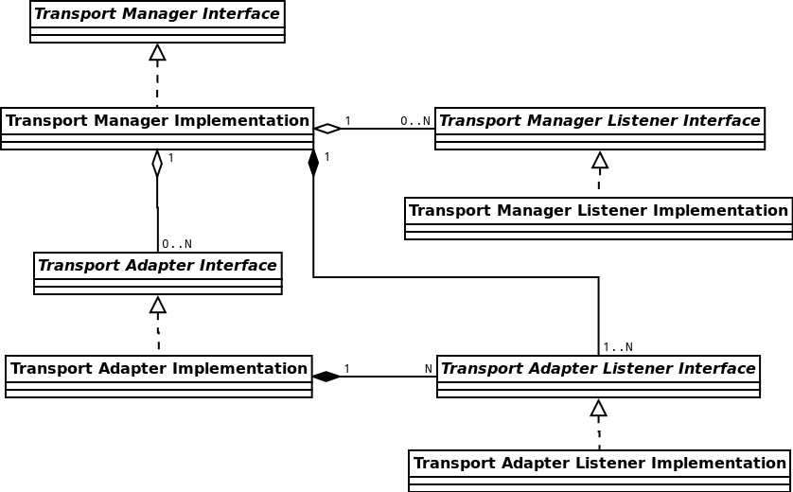

Figure 3: Transport Manager Class Structure Diagram

#### Transport Adapter Structure

The following diagram represents the structure of the Transport Adapter.

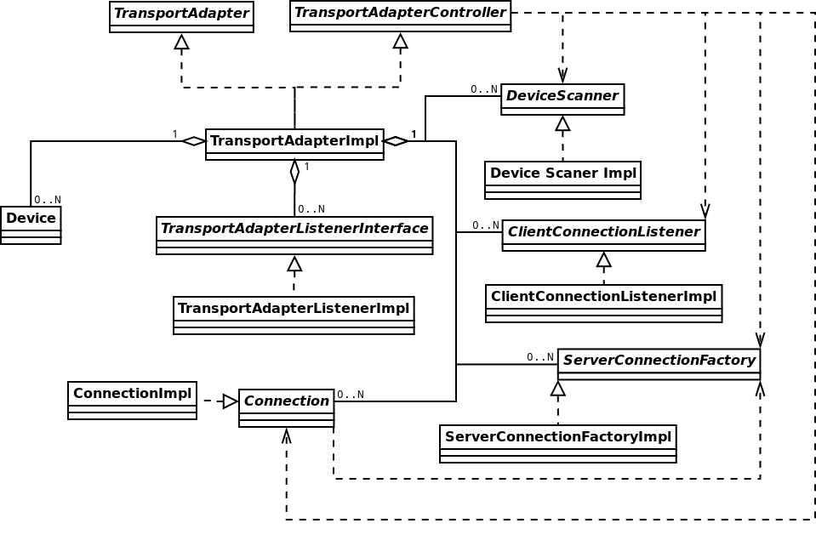

*Figure 4: Transport Adapter Class Structure Diagram*

### Operation Examples (Message Sequence Chart)

#### New device search

Upper level

TM

DA

Searching for device

Iterating adapters

Searching for device

Adapter specific

search routine

Search is done

Device list is updated

Iteration is finished

Search is complete

*Figure 5: Transport Manager Message Sequence Chart for a New Device Search*

#### Device-originating connection

Upper level

TM

DA

Device

Connection request

Connection is done

Connection is established

Application is unwanted

Disconnect application

Disconnect application

Disconnection is done

Disconnection is done

*Figure 6: Transport Manager Message Sequence Chart for Device-Originated Connection*

#### Connection close command

Upper level

TM

DA

Close connection request

Start close connection process

Send accumulated data

New data for connection being closed

Reject incoming data

Sending data is finished

Disconnect command

Disconnection is done

Disconnection is done

*Figure 7: Transport Manager Message Sequence Chart for Connection Close Command*

## Transport Manager (TM) Usage

### General Processing Description

#### TM initialization

* Every time SDL starts working it calls the creation and initialization of TM (the default or developer-defined one).
* TM uses singleton pattern and the instance of TM is created and initialized while being retrieved. And the pointer is provided to the developer.
* If TM is initialized once it must not be initialized again.
* The developer may initialize the customized TM by calling the appropriate ‘init()’ function:
* If the customized TM is based on default implementation, ‘init()’ must NOT be called twice for one and the same TM
* If the customized TM is created from scratch, it is up to developer to choose the initialization mechanism.
* During the initialization process TM creates two threads:
* For processing the message queue of commands from the upper level
* For processing the events coming from devices.
* Also TM creates and initializes all available Transport Adapters (the default and/or customized ones).
* If appropriately configured TM may load the information about previous state and perform necessary actions (e.g. reconnect the last connected application).
* TM becomes initialized:
* When its internal threads are created and are ready for working (i.e. the ‘init()’ function is serial and if it returns the control, the initialization has completed successfully and TM is ready for working).
* And it does not watch whether the Transport Adapter(s) has initialized by this time:
* If any of TAs failed to initialize, this is informed into the log file. TM answers with erroneous messages to the requests related to such TA.
* If there are NO TAs (either not initialized or not defined), TM answers with the error messages to all of the requests.

#### TM structure

* *TM Core*: it is a TransportManagerImpl class. It contains the processing mechanisms (e.g., for procedures of sending/receiving the data, for connecting/disconnecting procedures, etc.).It does not have the embedded default Adapters and Listeners. And it would not work apart of the Wrapper.
* *TM Wrapper*: it is implemented in TransportManagerDefault class. It adds the default Transport Adapter(s) and Listener to the Core completing the fully-featured functionality.

#### TA initialization

* The default Adapters are created and initialized by the default TM Wrapper.
* The customized Adapters should be initialized by the developer himself:
* TM is initialized first
* Then the init() function for the custom Adapter is called
* Then the initialized custom TA and the Listener are added to the initialized TM.
* Transport adapter in its turn creates and initializes all available workers.
* ‘Search Device’ worker creates a separate thread and waits for the ‘Start’ command.
* ‘Client Listener’ creates a separate thread and waits for connections from devices.
* ‘Server Connection’ worker executes all actions on caller’s thread (does not create a thread).

#### Getting started

* When the initialization is complete, TM starts waiting for:
* The user`s command
* The device connection.
* Resumption from “last state” singleton (if such resumption is specified via profile)
* When one of the above happens, TA:
* Creates a separate thread for each connection with device’ application(s)
* Notifies TM on connection created.
* When the connection is established, the Upper Level:
* May start a handshake routine with the application and then notify the user about the application is connected.
* May close the connection by sending an appropriate command to TM if the application or device is unwanted.

#### Errors in TM

* ‘*Immediate*’ error:
* When TM is not able to execute any command it will immediately return the appropriate error code. For example: when connect(app_id) is called and TM is not initialized yet this type of error occurs.
* ‘*Postponed*’ error:
* TM is able to execute a command and there is some error occurred in downstream.
* The component, where the error has occurred, sends the appropriate information to TM.
* Then TM provides a notification to the Upper Level.

#### Messages in TM

* TM is ready to send and receive data after the connection is opened,
* Sending messages:
* Each message destined for the device is posted into the message queue.
* The message is removed from the queue after it is successfully sent to the device.
* The message(s) is returned to the caller if for some reason TM is not able to send it (e.g., unexpected device disconnection),
* Receiving messages:
* TM redirects messages from the Transport Adapter to the Upper Level via notification mechanism.

#### Connection identifiers

* TM uses the pair “Device ID” and “Application ID” for accessing the application on a device and internally for connection establishing.
* Device ID:
* Stands for global unique identifier based on MAC address for network adapters and MAC address like for BT.
* In the default implementation Device ID is logically split into two parts:
* Internal device ID – that is a MAC address string
* External device ID – that is an integer value.
* When the new MAC address is found, the integer value is assigned to it correspondingly (starting from 1 and incremented with every new assignment).
* For persistent connection,
* When the device is marked as “known”, the correspondence of internal and external IDs is stored (even after power off) until the user explicitly asks to “forget about <this> device”.
* When the user requests to ‘forget’ the known device, the MAC address may be assigned with the new integer value on being connected for the next time.
* For one-time connection this correspondence is not saved in long term storage. And if connected later the same MAC address may get the new integer value in correspondence.
* It is not defined what happens if two devices with the same MAC address would connect.
* Application ID: is the application unique identifier. It is the incremental integer value assigned and used internally in TM.
* Connection ID:
* Connection is represented with a unique pair of “Device ID” and “Application ID”.
* Connection ID is a system wide unique identifier (incremented integer value) assigned to each new connection.
* This ID is used for sending/receiving data and for closing the connection.
* There are no certain rules to define how exactly this ID is assigned.

#### Connection closing

* When TM receives ‘close connection’ or ‘disconnect’ commands it tries to finish sending accumulated messages and then closes the connection.
* If connection is lost TM will drain all accumulated messages and confirm connection closure.

#### SDL shutting down

* When SDL is going to shutdown, TM clears all objects which it has created (e.g. default transport adapters).
* Objects created by developer (e.g. developer’s transport adapter or listener) are not removed by TM. The developer must take care of destructing his customized objects by himself.

### Create Default TM Instance

For creating the instance of TM with default configuration it is necessary to use the following code:

#include “transport_manager.h”

#include “transport_manager_default.h”

{

…

TransportManager* transport_manager =

TransportManagerDefault::instance();

…

}

Initialization of TM may take some time due to threads creation and initialization routine. After all is set and done Transport Manager is ready to be used. Till that time any command will be rejected with the error code “NOT INITIALIZED” in return value.

TM implementation uses singleton pattern, thus only one instance of TM will exist at a time. Nevertheless, this is not the rule and may be changed in custom TM.

### Add Custom Listener to TM

* A Listener allows monitoring the events that take place in TM.
* The number of TM Listeners is not limited and may be zero.
* These listeners are provided to TM and are used by any module that needs to receive the notifications from TM.
* The list of Listeners that are called upon any event occurred in TM is stored in TM.
* TM does not create the own listener by default.
* Custom Listener:
* Its logic should be related with implementation of the module that uses this Listener.
* Should implement Transport Manager Listener Interface.

To set up the Listener the following code should be used:

#include “transport_manager.h”

#include “transport_manager_default.h”

class MyTransportManagerListenerImpl1 : public TransportManagerListener

{

//implement here entire interface

}

{

…

TransportManager *tm_impl = TransportManagerDefault::instance();

TransportManagerListener *my_tm_listener = new MyTransportManagerListenerImpl();

tm_impl->addEventListener(my_tm_listener);

…

}

To remove the Listener removeEventListener should be used.

### Add Custom Transport Adapter to Default TM

#### About TA in general

* TM may contain zero to N Transport Adapters (TM with zero Adapters returns the erroneous messages for all of the requests).
* Each Adapter corresponds to specific type of transport (e.g. Bluetooth, LAN, USB, etc.).
* TA implements transport specific search, connect, disconnect and data transfer routines.

#### Several instances of TA

* It is allowed to have several adapters of the same type in one TM.
* The results of using several instances of default TAs are not defined.
* It is developer’s responsibility to create a custom Adapter that operates well under conditions of using several instances of it.

#### Add Custom TA

* The simplest way to add a custom Transport Adapter is to derive the existing implementation of TCP or BT Adapter, adjust some behavior in derived class and add it to TM:

#include “transport_manager.h”

#include “transport_manager_default.h”

{

…

//note: the default implementation of TCP adapter is used in this example.

//developer is free to create his own implementation of transport adapter from scratch

TransportAdapter* my_transport_adapter =

static_cast<TransportAdapter*>(new TcpTransportAdapter);

my_transport_adapter->init();//note: TA must be initialized before getting instance of TM.

TransportManager *tm_impl =

TransportManagerDefault::instance();

//note: when custom TA will be added to TM, the default listener will be assigned to it automatically

tm_impl-> addTransportAdapter(my_transport_adapter);

…

}

#### Initialization

* By default TA is initialized during TM initialization.
* If TA needs to be added to the TM already initialized, this TA should be initialized first.

***Note:***

* *TM has a TCP adapter by default. Adding the new instance of the same Adapter may result the unexpected behavior (because default Adapters are not designed for working in such configuration).*
* *The developer must change the standard behavior of TCP adapter to eliminate the potential problems.*

### Custom TA implementation from scratch

If default implementation of adapter is not suitable for particular case one can create new adapter from scratch:

* Create custom class that implements transport adapter interface. Note that custom TA shall use defined interface TransportAdapterListener for notifying Transport Manager.
* The instance of transport adapter listener will be set by Transport Manager automatically when custom transport adapter is added. If custom adapter does not store its listener then adapter will not be able to notify Transport Manager about events such as OnDataReceiveDone or OnConnectDone.

#include “transport_adapter.h”

class MyTransportAdapterImpl : public TransportAdapter

{

// implement all interface functions here

// use TransportAdapterListener interface to notify transport manager about event happening

}

* Add the following code where the Transport Manager is initialized

#include “transport_manager.h”

#include “my_transport_adapter_impl.h”

{

…

TransportAdapter* my_transport_adapter =

static_cast< MyTransportAdapterImpl*>(new MyTransportAdapterImpl);

//note: TA must be initialized before getting instance of TM

my_transport_adapter->init();

TransportManager *tm_impl = TransportManagerDefault::instance();

//note: when custom TA will be added to TM, the default listener will be assigned to it automatically

tm_impl-> addTransportAdapter(my_transport_adapter);

…

}

All internal logic implementation is up to developer. Developer is responsible to implement:

* Communication with device
* Notification of state changes
* Error handling and so forth.

### Add a New Listener to TA

* A Listener allows monitoring the events that take place in TA.
* The number of TA Listeners is not limited.
* The list of Listeners that are called upon any event occurred in TA is stored in TA.
* Custom Listener for TA:
* The developer can add the Listener to TA through the customizing procedure only. I.e., the developer needs to create his own TA on the base of the default one, and then to add the Listener to it.
* Should implement Transport Manager Listener Interface.

***Important Note:***

* *Working with TA Listener by-passing the TM is dangerous and may lead to the asynchronous behavior of TM and the Adapter.*
* *The custom Listener should be added only together with the new custom Adapter and/or the new custom Transport Manger.*

To set up the Listener the following code should be used:

#include “transport_manager.h”

#include “transport_manager_default.h”

class MyTransportAdapterListener :public TransportAdapterListenerImpl

{

//customize listener here if necessary

}

…

//note: the default implementation of TCP adapter and the default implementation of adapter listener are used in this example.

//developer is free to create his own implementation of transport adapter from scratch

TransportAdapter* my_transport_adapter =

static_cast<TransportAdapter*>(new TcpTransportAdapter);

my_transport_adapter->init();

TransportManager *tm_impl =

TransportManagerDefault::instance();

TransportAdapterListener* my_ta_listener =

new MyTransportAdapterListener(tm_impl);

my_transport_adapter-> addListener(my_listener)

tm_impl-> addTransportAdapter(my_transport_adapter);

…

}

The developer should implement “TransportAdapterListener” interface with the custom logic before the Listener can be used.

### Create TM with Custom TAs Only (with No Default Adapter)

If for some reason the default Adapters are not good enough they can be replaced with developer’s defined Adapter(s). To do this the developer

* Must implement the Adapter’s Interface using own logic
* Provide this new adapter to TM:

#include “transport_manager.h”

#include “transport_manager_impl.h”

class MyTransportManager : public TransportManagerImpl {

virtual int init();

virtual ~MyTransportManager();

MyTransportAdapter *my_adapter_;

explicit MyTransportManager(const TransportManagerAttr &config)

: TransportManagerImpl(config),

my_adapter_ (nullptr){

}

public:

static MyTransportManager* instance();

};

//note: the implementation of all methods above is not defined here just for making the code look simplier

//Obvious MyTransportAdapter should be created and initialized somewhere.

{

…

TransportManager *tm_impl = MyTransportManagerImpl::instance();

…

}

More detailed information on custom Transport Adapter creation is provided in section 3.2.9.

### Transport Manager Customizing

#### Basic information

* TM is responsible for all complex logic and decisions, while Transport Adapter is a primitive entity that operates only with transport specifics.
* Communication interface between TM and TA:
* TM sends a command to TA.
* If TA is unable to execute this command it returns the error code not processing the command.
* Otherwise, TA starts executing the command. Then TA notifies TM on executing completion by using the appropriate callback function.

#### Queues as a fundamental of TM

* Message Queue: for commands coming from the Upper Level.
* Event Queue: for events coming from devices.

#### Rules for developer

Customizing TM, the developer:

* Should implement transport manager interface.
* Should use the Transport Adapter Interface and the Transport Listener Interface for making his implementation work with default Adapters and Listeners.
* Has two options:
* Creating the TM from scratch.
* Deriving from the default implementation:
* If not particularly changed, the default Adapters and Listeners will be used.

### Transport Adapter Customizing

#### Basic information

* TA is highly adaptable to any specific of a real transport.
* TA consists of
* So called *worker classes* that perform a single operation (e.g., device search)
* *Controller* that
* Accumulates event handling from all worker classes,
* Controls the state of all internal data and
* Notifies the Upper Level via callbacks
* *Internal data structures* that contain the information about the device, the connection and other necessary information.

#### Workers of TA

* Device Scanner:
* Implements transport dependent search procedure initiated by the appropriate command from the Transport Manger.
* It is developer’s responsibility to implement this worker.
* It may be absent for transport types that do not support searching.
* When the device is found (and in the current default implementation when all the devices are found) this worker:
* creates a notification and directs this notification to the Controller
* The Controller notifies TM using the TA Listener
* TM receives the notification and sends a command to TA for connecting all available applications
* TM and TA perform a chain of notifications
* TM notifies the Upper Level using TM Listener with the information on each application connected: the connection ID, the application name, the device name.
* Client Connection Listener:
* Implements the transport dependent connection that was originated by device.
* It is developer’s responsibility to implement this worker.
* If transport does not support such ability this worker may be absent.
* Working procedure:
* This worker waits for the connection of a mobile device.
* When the connection request from any of the mobile devices arrives, TA establishes a connection (creates the data path) with this device and the Connection Listener sends a notification through the Controller to the Upper Level with the device and application IDs.
* Server Connection Factory:
* Implements transport dependent connection that was originated by the user.
* It is developer’s responsibility to implement this worker.
* If transport does not support such ability this worker may be absent.
* Creates a connection with the device and the application specified by the user:
* Both the device and the application must be already known to TA by this moment.
* TA may know about the device after ‘search’ routine or after ‘restore previous state’ routine.
* If device is not known Transport Adapter returns the error immediately.
* When the connection is created TA sends a notification through the Controller to the Upper Level.

#### Connection

* The main responsibility of Client and Server connection workers is to create a **Connection**.
* Connection is the entity that is responsible for data transmitting between the core and the device.
* Workers and Connection they use are closely related.
* Customizing:
* Custom implementation of Connection must be used in custom worker(s) only.
* It is not possible to use other types of data exchange in default workers.
* It is possible to use default Connection implementation in custom worker.
* Default connection implementation is based on sockets isolated in separate thread (threaded socket connection).
* Each transport specific worker shall use transport dependent initialization of threaded socket connection.
* If the default implementation is not convenient to developer he can create his own Connection implementing any suitable way of data exchanging (e.g. shared memory connection).
* In this case custom workers shall be also created.

#### Descriptor

Descriptor is used for manipulating with devices and connections inside of the adapter.

#### Create custom Transport Adapter

The create custom TA using the Adapter Concept provided by SDK, the developer should do the following:

* Create a class that is derived from “TransportAdapterImpl” and add the implementation of necessary virtual methods. Let it be “getDeviceType”.

#include "transport_adapter_impl.h"

class MyTransportAdapter : public TransportAdapterImpl

{

protected:

virtual DeviceType getDeviceType() const;

}

* Create a connection class deriving from “ThreadedSocketConnection” and implement virtual methods.

#include "transport_adapter_impl.h"

class MySocketConnection : public ThreadedSocketConnection

{

virtual ~MySocketConnection();

protected:

virtual bool establish(ConnectError** error);

}

* Create a class for the device that will be used by Controller to manage devices and implement all virtual methods.

#include "transport_adapter_impl.h"

class MyDevice : public Device

{

virtual ~Device();

virtual bool isSameAs(const Device* other_device) const;

virtual ApplicationList getApplicationList() const;

}

* Create the necessary worker classes by deriving from appropriate basic worker and fill them with necessary functionality.

#include "transport_adapter_impl.h"

class MyDeviceScanner : public DeviceScanner

{

}

class MyServerConnectionFactory : public ServerConnectionFactory

{

}

class MyClientListener : public ClientConnectionListener

{

}

These workers should use connection and device created in previous steps. For instance scanner should add a list of devices to controller. This list will be used later when ‘connect’ request will be received. To create a data path the connection class should be used.

When connection actually starts it will update Controller with the pointer to this connection.

* When everything is created it is time to combine all together.

#include "transport_adapter_impl.h"

MyTransportAdapter::MyTransportAdapter()

: TransportAdapterImpl(

new MyDeviceScanner(),

new MyServerConnectionFactory(),

new MyClientListener())

{

}

* Create an instance of the new adapter and provide it to the Transport Manager.

#include “transport_manager.h”

#include “transport_manager_impl.h”

#include “my_transport_adapter_impl.h”

{

…

TransportAdapter* my_transport_adapter =

static_cast<TransportAdapter*>(new MyTransportAdapter);

TransportManager *tm_impl =

TransportManagerDefault::instance();

tm_impl-> addTransportAdapter(my_transport_adapter);

…

}

This adapter will use the default connection implementation and default Adapter Listener but three worker classes will implement developer’s logic. Also Transport Adapter will provide device type in developer’s defined way.

TransportAdapterImpl virtual (but not pure virtual) methods Store() and Restore() can be reimplemented to provide resumption mechanism. Default implementations for both methods do nothing.

# Build and Run SDL and Set Up the Environment

This instruction contains the information on how to build and run SDL depending on target OS and HMI emulator type.

## General

To build SDL for QNX, cross-compiling only shall be used. The following configurations are available:

|  |  |  |
| --- | --- | --- |
| **Target OS** | **HMI emulator type** | **Section** |
| Linux | HTML5 | 4.5.2 |
| Linux | QML | 4.5.5 |
| virtualized QNX | HTML5 HMI under Linux Host | 4.5.1 |
| virtualized QNX | QML HMI under Linux Host | 4.5.3 |
| virtualized QNX | with QML HMI under QNX Host | 4.5.4 |

To turn media features (libraries of PulseAudio and GStreamer) on/off please set EXTENDED_MEDIA_MODE to ON/OFF, for example:

cmake -DEXTENDED_MEDIA_MODE=OFF

## Known issues

1. HTML5 HMI does not display icons in case it is running on distant computer (the reason: SDL sends absolute paths on local computer).

2. Bluetooth does not work under QNX (the reason: BT stack absence for QNX).

3. @Todiscuss – any others?

## Preparation steps

Please see section *“4.1 General”* to determine which of the below steps must be used.

### To prepare the Linux Host

***Note:***

*In case Ubuntu/Xubuntu 12.04 is already installed, git repository is cloned and is switched to <Main_Develop> branch, proceed from chapter 4.5 according to required configuration.*

Linux workspace preparation:

1. Install Ubuntu/Xubuntu 12.04 or higher
2. Configure source repositories (check "Canonical Partners" repositories in Update Manager->Settings->SW source).

***Note:*** Fore Ubuntu 12.04 "Update Manager->Settings->Other Software"

1. Perform "sudo apt-get install git" command in terminal.
2. Clone git repository with "git clone https://adc.luxoft.com/stash/scm/ford/applink.git ".

***Note:*** *The permissions to download the repository are required. Apply skoveshnikov@luxoft.com on this matter.*

1. Switch to current release branch: "git checkout release/release_SDL_RB_Yx.x".

***Note:*** you can get list of branches with command "$ git branch -a | grep release_SDL_RB"

***Note:*** in above cases the <Project_Root_Src> is the path to 'Project_Root_Src' git folder (e.g. "/home/user_name/Work/Project_Root_src").

1. SSH configuration on Linux host:
2. Install Open-SSH server (For Xubuntu run "sudo apt-get install ssh", for Ubuntu run "sudo apt-get install openssh-server").

***Note:*** Restart computer if necessary.

***Note:***

*Read the built-in setup environment help ("./setup_env.sh --help") which provides the description of predefined options of setup packages to be installed.*

*Executing ./setup_env.sh without a key will result installing the packages necessary for building SDL under Linux, with HTML5 HMI.*

### To run specially prepared QNX in virtual machine

1. Download and install VMware Player from https://my.vmware.com/web/vmware/downloads
2. Download the archived QNX image for VMware from ftp://ford-applink.luxoft.com/Distrs/QNX/QNX_SDP_6.5.0.tar.gz
3. Extract image from archive and open it in VMware

***Note:*** QNX image has root with empty pass and user with pass 'user'. SSH is configured

1. Log as root.
2. Run “passwd user” and set the new user id (just press enter), group (just press enter) and non-empty password.
3. Run "ssh-keygen -t rsa -f /etc/ssh/ssh_host_rsa_key".
4. Run "ssh-keygen -t dsa -f /etc/ssh/ssh_host_dsa_key".
5. Set up sshd to run at time login.
   1. Create file "/etc/profile.d/sshd.sh" with command "/usr/sbin/sshd"
6. Set up USB access mode
   * + 1. If file "/etc/rc.d/rc.local" is either absent or empty then copy file "<Project_Root_Src>/qnx/rc.local" to folder "/etc/rc.d"
       2. If file "/etc/rc.d/rc.local" exists and is nonempty then append the last line of file "<Project_Root_Src>/qnx/rc.local" to its end

### To make QNX virtual machine from scratch

1. Configure QNX server:

* Download VMware Player <https://my.vmware.com/web/vmware/downloads>
* Download the QNX Software Development Platform 6.5.0 bootable iso image from <http://www.qnx.com/download/download/21182/qnxsdp-6.5.0-x86-201007091524-nto.iso>
* Create a new VMware virtual machine and boot from QNX Software Development Platform bootable iso image

***Note:***

*It is necessary to obtain license key: either trial or commercial one (Register on* [*http://www.qnx.com/*](http://www.qnx.com/) *website, enter 'QNX product evaluation' and apply for a license key).*

1. Configure SSH on QNX server:

* Run “passwd user” and set the new user id (just press enter), group (just press enter) and non-empty password.
* Run "ssh-keygen -t rsa -f /etc/ssh/ssh_host_rsa_key".
* Run "ssh-keygen -t dsa -f /etc/ssh/ssh_host_dsa_key".
* Run SSH server if it is not running "/usr/sbin/sshd".

1. Download *'D-Bus' version 1.7.8* and *'Expat' version 2.1.0*.

***Note:***

*for more details see* [*https://adc.luxoft.com/confluence/display/APPLINK/How+to+install+D-Bus*](https://adc.luxoft.com/confluence/display/APPLINK/How+to+install+D-Bus)

1. Install log4cxx for QNX

* Download log4cxx development archive "*log4cxx.qnx.cross.build.files.zip*" and runtime archive "*log4cxx.qnx.runtime.files.zip*"

***Note:***

*For development use git folder git@adc.luxoft.com:applink/src/thirdPartyLibs/*

*For releases use delivery svn folder*

* Unpack crossbuild archive of log4cxx on Linux host :

unzip ./log4cxx.qnx.cross.build.files.zip -d /

* Download log4cxx runtime archive to QNX

scp <linuxhost_user>@<linuxhost_ip>:/<Delivery_Package_Path>/ log4cxx.qnx.runtime.files.zip ./

* Unpack on QNX server log4cxx binary files of log4cxx QNX port:

unzip ./log4cxx.qnx.runtime.files.zip -d /

(this file is also located in git)

1. Set up dbus-daemon and sshd to run at time login

* Create file *"/etc/profile.d/sshd.sh"* with command:

/usr/sbin/sshd

* Create file *"/etc/profile.d/dbus.sh"* with command:

if test -z "$DBUS_SESSION_BUS_ADDRESS" ;

then

DBUS_SESSION_BUS_ADDRESS=`dbus-daemon --fork --session --print-address`

export DBUS_SESSION_BUS_ADDRESS

fi

1. Set up USB access mode

* If file *"/etc/rc.d/rc.local"* is either absent or empty then copy file *"<Project_Root_Src>/qnx/rc.local"* to folder *"/etc/rc.d".*
* If file *"/etc/rc.d/rc.local"* exists and is nonempty then append the last line of file *"<Project_Root_Src>/qnx/rc.local"* to its end.

### To set up Android Simulator for using instead of real device

1. Install and configure Android Simulator in keeping with the following instructions <https://adc.luxoft.com/confluence/display/APPLINK/How+to+install+and+setup+android+emulator+on+Ubuntu>

## Configuration steps

### HTML5 HMI and SDL to be running on separate computers

***Note:***

*Virtualized QNX is also considered to be running on a separate computer*

1. LinHost: update SDL config file *“<Project_Root_Src>/src/appMain/smartDeviceLink.ini*”: find “ServerAddress = ” there and replace the value with <SDL server address>.
2. LinHost: update HTML5 HMI network parameters: in file *“<Project_Root_Src>/src/components/HMI/ffw/RPCClient.js*” find “url: ” and replace the value ("ws://localhost:8087" or FLAGS.WEBSOCKET_URL) with <SDL server address>. (e.g. "url: "ws://192.168.177.128:8087"")

***Note:***

*<SDL server address> is the IP of the computer where SDL is running.*

### QML HMI and SDL to be running on separate computers

***Note:***

*Virtualized QNX is also considered to be running on a separate computer*

1. QNXServer: add the following lines into the file *"/usr/etc/dbus-1/session.conf":*

"<listen>tcp:host=IP-OF-YOUR-QNX-PC,port=PORT-FOR-LISTEN</listen><allow_anonymous/>"

(for example, "<listen>tcp:host=192.168.243.131,port=8087</listen><allow_anonymous/>”)

1. LinHost: set up "export DBUS_SESSION_BUS_ADDRESS=tcp:host=<HOST>,port=<PORT>" on HMI side

(e.g. "export DBUS_SESSION_BUS_ADDRESS=tcp:host=192.168.243.131,port=8087").

## Build and Run on different configurations

***Note:***

*In below cases the < Project_Root_Src> is the path to 'Project_Root_Src' git folder (e.g. "/home/user_name/Work/Project_Root_src").*

### Build and run on QNX with Web HMI (HTML5)

***Build project:***

1. Run "sudo -E ./setup_env.sh -qnx" to install all mandatory packages.

***Note:*** You should run setup_env.sh only on first building target configuration.

***Note:*** More information about setup_env.sh flags you can get from doc/extra_build_and_run_options.txt

1. Download and install QNX SDP 6.5.0 SP1 cross platform tools for Linux (http://www.qnx.com/download/download/21179/qnxsdp-6.5.0-201007091524-linux.bin).

***Note:*** *it is necessary to obtain license key: either trial or commercial one (Register on http://www.qnx.com/ website, enter 'QNX product evaluation' and apply for a license key).*

***Note:*** *during tools installation mark "GNU Public Licence Utility" check-box.*

1. Make build directory (Linux Host )

"$ mkdir <Project_QNX_Build_WebHMI> && cd <Project_QNX_Build_WebHMI>

1. Configure build:

"$ cmake <Project_Root_Src> -DCMAKE_TOOLCHAIN_FILE=<Project_Root_Src>/qnx_6.5.0_linux_x86.cmake".

1. Make third party libs:

"$ make 3rd_party"

"$ sudo make install-3rd_party"

1. Run build process “$make install”

***Run project***

1. Log as root (QNX host)
2. QnxServ: download binary folder “scp -r <linux_host_user>@<linux_host_ip>:/<Project_QNX_Build_WebHMI>/bin/* ./” .
3. QnxServ: download 3rd party folder “scp -r <linux_host_user>@<linux_host_ip>:/<Project_QNX_Build_WebHMI>/3rd_party/* ./” .
4. Prepare Policy.

"$ LD_LIBRARY_PATH=$LD_LIBRARY_PATH:."

"$ export LD_LIBRARY_PATH"

Note: If libPolicy.so is in other place then use following format:

LD_LIBRARY_PATH=$LD_LIBRARY_PATH:<PATH_TO_POLICY_LIBRARY>

1. Prepare log4cxx

"$ export LD_LIBRARY_PATH=$LD_LIBRARY_PATH:<PATH_TO_3RD_PARTY_LIBS>"

"$ e.g. export LD_LIBRARY_PATH=$LD_LIBRARY_PATH:../3rd_party/lib"

1. QnxHost: update SDL config file “smartDeviceLink.ini”: find “ServerAddress = ” there and replace the value with <SDL server address>.
2. LinHost: update Web HMI network parameters: in file "<Project_Root_Src>/src/components/HMI/app/Flags.js" find “WEBSOCKET_URL: ” and replace the value ("ws://localhost:8087") with <SDL server address>. (e.g. "url: "ws://<SDL adress>:8087"")

***Note:*** <SDL server address> is the IP of the computer where SDL is running.

1. start SDL “su -c ./smartDeviceLinkCore”.
2. LinHost: start Chrome “chromium-browser '<Project_Root_Src>/src/components/HMI/index.html'”.

***Note:*** in case there is no connection with Web HMI probably it is necessary to add QNX Server IP to "no_proxy" config.

### Build and run on Linux with web HMI (HTML5)

***Build project:***

1. Run "sudo -E ./setup_env.sh" to install all mandatory packages.

Note: You should run setup_env.sh before first build of specific configuration.

Note: More information about setup_env.sh flags you can get from doc/extra_build_and_run_options.txt

1. Make build directory "$mkdir <Project_QNX_Build_WebHMI> && cd <Project_QNX_Build_WebHMI>"
2. Configure build "cmake <Project_Root_Src>".
3. Build and install third party libs.

***Note:*** this step has to be done just once for each combination of target system (Linux/QNX) and CPU architecture (x86/armv7).

1. "$ make 3rd_party"
2. "$ sudo make install-3rd_party"
3. Run build process "$make install"

***Run project:***

1. Go to the binary folder "cd <Project_Linux_Build_WebHMI>/bin".
2. If Web HMI and SDL are running on separate computers:
3. LinHost: update SDL config file “<Project_Root_Src>/src/appMain/smartDeviceLink.ini”: find “ServerAddress = ” there and replace the value with <SDL server address>.
4. LinHost: update Web HMI network parameters: in file "<Project_Root_Src>/src/components/HMI/app/Flags.js" find “WEBSOCKET_URL: ” and replace the value ("ws://localhost:8087") with <SDL server address>. (e.g. "url: "ws://<SDL adress>:8087"")

***Note:*** <SDL server address> is the IP of the computer where SDL is running.

1. Prepare Policy.

"$ LD_LIBRARY_PATH=$LD_LIBRARY_PATH:."

"$ export LD_LIBRARY_PATH"

***Note:*** If libPolicy.so is in other place then use following format:

LD_LIBRARY_PATH=$LD_LIBRARY_PATH:<PATH_TO_POLICY_LIBRARY>

Run SDL "$ ./smartDeviceLinkCore".

***Note:*** HMI shall be started automatically.

### Build and run SDLCore on QNX with QML HMI running on Linux

***Build Project***

1. Run "sudo -E ./setup_env.sh -qnx -qt" to install all mandatory packages.

***Note:*** You should run setup_env.sh only on first building target configuration.

***Note:*** More information about setup_env.sh flags you can get from doc/extra_build_and_run_options.txt

1. Download and install QNX SDP 6.5.0 SP1 cross platform tools for Linux (http://www.qnx.com/download/download/21179/qnxsdp-6.5.0-201007091524-linux.bin).

***Note:*** it is necessary to obtain license key: either trial or commercial one (Register on http://www.qnx.com/ website, enter 'QNX product evaluation' and apply for a license key).

***Note:*** during tools installation mark "GNU Public Licence Utility" check-box.

1. Create build directory

"$ mkdir <Project_QNX_Build_Qt> && cd <Project_QNX_Build_Qt>

1. Prepare build:

“$ cmake <Project_Root_Src> -DCMAKE_TOOLCHAIN_FILE=<Project_Root_Src>/qnx_6.5.0_linux_x86.cmake -DHMI=qt -DCMAKE_BUILD_TYPE=Release”.

1. Build and install third party libs.

***Note:*** this step has to be done just once for each combination of target system (Linux/QNX) and CPU architecture (x86/armv7).

"$ make 3rd_party"

"$ sudo make install-3rd_party"

1. Run build process “$ make install”

***Run project***

1. On Linux host set up "export DBUS_SESSION_b BUS_ADDRESS=tcp:host=<HOST>,port=<PORT>" on HMI side (e.g. "export DBUS_SESSION_BUS_ADDRESS=tcp:host=192.168.243.131,port=8087").
2. On qnx host Log as root.
3. QnxServ: download binary folder “scp -r <linux_host_user>@<linux_host_ip>:/<Project_QNX_Build_Qt>/bin/* ./” .
4. QnxServ: download 3rd party folder “scp -r <linux_host_user>@<linux_host_ip>:/<Project_QNX_Build_Qt>/3rd_party/* ./” .
5. Prepare Policy.

"$ LD_LIBRARY_PATH=$LD_LIBRARY_PATH:."

"$ export LD_LIBRARY_PATH"

***Note:*** If libPolicy.so is in other place then use following format:

LD_LIBRARY_PATH=$LD_LIBRARY_PATH:<PATH_TO_POLICY_LIBRARY>

1. Prepare log4cxx

"$ export LD_LIBRARY_PATH=$LD_LIBRARY_PATH:<PATH_TO_3RD_PARTY_LIBS>"

"$ e.g. export LD_LIBRARY_PATH=$LD_LIBRARY_PATH:../3rd_party/lib"

1. Prepare D-Bus:
2. Add the following lines in the file "/usr/etc/dbus-1/session.conf":

"<listen>tcp:host=IP-OF-YOUR-QNX-PC,port=PORT-FOR-LISTEN</listen><allow_anonymous/>"

(e.g. "<listen>tcp:host=192.168.243.131,port=8087</listen><allow_anonymous/>).

1. Execute

"$ DBUS_SESSION_BUS_ADDRESS=`<PATH_TO_DBUS_DAEMON_BINARY>/dbus-daemon --config-file=<PATH_TO_DBUS_DAEMON_CONFIG>/session.conf --fork --print-address`"

(e.g. DBUS_SESSION_BUS_ADDRESS=`../3rd_party/bin/dbus-daemon --config-file=../3rd_party/etc/dbus-1/session.conf --fork --print-address`)

"$ export DBUS_SESSION_BUS_ADDRESS"

***Note:*** it might be necessary to create directory session.d in the same folder with session.conf

e.g. mkdir ../3rd_party/etc/dbus-1/session.d

***Note:*** D-Bus can be started automatically. Copy dbus-daemon binary and config to system folders, e.g.

1. Execute
2. "$ cp ../3rd_party/bin/dbus-daemon /usr/bin"
3. "$ cp -r ../3rd_party/etc/dbus-1 /etc"
4. "$ mkdir /etc/dbus-1/session.d"
5. Create file "/etc/profile.d/dbus.sh" with command

"if test -z "$DBUS_SESSION_BUS_ADDRESS" ; then

DBUS_SESSION_BUS_ADDRESS=`/usr/bin/dbus-daemon --fork --config-file=/etc/dbus-1/session.conf --print-address`

export DBUS_SESSION_BUS_ADDRESS

fi"

***Note:*** In this case system has to be rebooted and this step is no more needed

1. start SDL “su -c ./smartDeviceLinkCore”.

***Note:*** If SDL unexpectedly terminates (with any error) check that real IP of QNX Server is same to IP in "/etc/dbus-1/session.conf"

### On Linux host goto "<Project_Linux_Build_Qt>/bin" folder and execute "<QT_HOME_DIR>/qmlscene -I ./hmi/plugins ./hmi/MainWindow.qml" command.Build and run SDLCore on QNX with QML HMI runing on QNX

***Build Project***

1. 6.1.1: Run "sudo -E ./setup_env.sh -qnx -qt" to install all mandatory packages.

Note: You should run setup_env.sh only on first building target configuration.

Note: More information about setup_env.sh flags you can get from doc/extra_build_and_run_options.txt

1. Download and install QNX SDP 6.5.0 SP1 cross platform tools for Linux (http://www.qnx.com/download/download/21179/qnxsdp-6.5.0-201007091524-linux.bin).

Note: it is necessary to obtain license key: either trial or commercial one (Register on http://www.qnx.com/ website, enter 'QNX product evaluation' and apply for a license key).

Note: during tools installation mark "GNU Public Licence Utility" check-box.

1. Create build directory

"$ mkdir <Project_QNX_Build_Qt> && cd <Project_QNX_Build_Qt>

1. Prepare build:

“$ cmake <Project_Root_Src> -DCMAKE_TOOLCHAIN_FILE=<Project_Root_Src>/qnx_6.5.0_linux_x86.cmake -DHMI=qt -DCMAKE_BUILD_TYPE=Release”.

1. Build and install third party libs.

Note: this step has to be done just once for each combination of target system (Linux/QNX) and CPU architecture (x86/armv7).

"$ make 3rd_party"

"$ sudo make install-3rd_party"

1. Run build process “$ make install”

***Run project***

1. Log as root (QNX host)
2. QnxServ: download binary folder “scp -r <linux_host_user>@<linux_host_ip>:/<Project_QNX_Build_Qt>/bin/* ./” .
3. QnxServ: download 3rd party folder “scp -r <linux_host_user>@<linux_host_ip>:/<Project_QNX_Build_Qt>/3rd_party/* ./” .
4. Prepare Policy.

"$ LD_LIBRARY_PATH=$LD_LIBRARY_PATH:."

"$ export LD_LIBRARY_PATH"

***Note:*** If libPolicy.so is in other place then use following format:

LD_LIBRARY_PATH=$LD_LIBRARY_PATH:<PATH_TO_POLICY_LIBRARY>

1. Prepare log4cxx

"$ export LD_LIBRARY_PATH=$LD_LIBRARY_PATH:<PATH_TO_3RD_PARTY_LIBS>"

"$ e.g. export LD_LIBRARY_PATH=$LD_LIBRARY_PATH:../3rd_party/lib"

1. Prepare D-Bus:
2. Execute

"$ DBUS_SESSION_BUS_ADDRESS=`<PATH_TO_DBUS_DAEMON_BINARY>/dbus-daemon --config-file=<PATH_TO_DBUS_DAEMON_CONFIG>/session.conf --fork --print-address`"

(e.g. DBUS_SESSION_BUS_ADDRESS=`../3rd_party/bin/dbus-daemon --config-file=../3rd_party/etc/dbus-1/session.conf --fork --print-address`)

"$ export DBUS_SESSION_BUS_ADDRESS"

***Note:*** it might be necessary to create directory session.d in the same folder with session.conf

e.g. mkdir ../3rd_party/etc/dbus-1/session.d

***Note:*** D-Bus can be started automatically:

Copy dbus-daemon binary and config to system folders, e.g.

cp ../3rd_party/bin/dbus-daemon /usr/bin

cp -r ../3rd_party/etc/dbus-1 /etc

mkdir /etc/dbus-1/session.d

1. Create file "/etc/profile.d/dbus.sh" with command

"if test -z "$DBUS_SESSION_BUS_ADDRESS" ; then

DBUS_SESSION_BUS_ADDRESS=`/usr/bin/dbus-daemon --fork --config-file=/etc/dbus-1/session.conf --print-address`

export DBUS_SESSION_BUS_ADDRESS

fi"

***Note:*** In this case system has to be rebooted and this step is no more needed

1. start SDL “su -c ./smartDeviceLinkCore”.

***Note:*** If SDL unexpectedly terminates (with any error) check that real IP of QNX Server is same to IP in "/etc/dbus-1/session.conf"

### Build and run on Linux with QML HMI.

***Build Project***

1. Run "sudo -E ./setup_env.sh -qt" to install all mandatory packages.

***Note:*** You should run setup_env.sh only on first building target configuration.

***Note:*** More information about setup_env.sh flags you can get from doc/extra_build_and_run_options.txt

1. Make build directory

"$ mkdir <Project_Linux_Build_Qt> && cd <Project_Linux_Build_Qt>

1. Configure build "cmake <Project_Root_Src> -DHMI=qt".
2. Build and install third party libs.

***Note:*** this step has to be done just once for each combination of target system (Linux/QNX) and CPU architecture (x86/armv7).

"$ make 3rd_party"

"$ sudo make install-3rd_party"

1. Run "sudo ldconfig" to configure dynamic linker run-time bindings.
2. Run build process “$make install”

Run SDL:

1. Go to the binary folder "cd <Project_Linux_Build_Qt>/bin".
2. If HMI and SDL are running on separate computers:

Set up "export DBUS_SESSION_BUS_ADDRESS=tcp:host=<HOST>,port=<PORT>" on HMI side (e.g. "export DBUS_SESSION_BUS_ADDRESS=tcp:host=192.168.243.131,port=8087").

1. Prepare Policy.

"$ LD_LIBRARY_PATH=$LD_LIBRARY_PATH:."

"$ export LD_LIBRARY_PATH"

***Note:*** If libPolicy.so is in other place then use following format:

LD_LIBRARY_PATH=$LD_LIBRARY_PATH:<PATH_TO_POLICY_LIBRARY>

1. Run SDL "$ ./smartDeviceLinkCore".

***Note:*** HMI shall be started automatically.

# Audio/Video Streaming over SDL

## PulseAudio and GStreamer libraries: how to include or exclude from project

### Short overview

**PulseAudio library** enables streaming audio through BlueTooth A2DP over SDL.

**GStreamer library** enables audio capturing from the HU`s microphone over SDL.

### Include

To have SDL project with both libraries included, EXTENDED_MEDIA_MODE flag must be set to ON when building the project (see section ‘*4.5 Build SDL from source on Linux Host ‘*):

-DEXTENDED_MEDIA_MODE=ON

### Exclude

To have SDL project with both libraries excluded, EXTENDED_MEDIA_MODE flag must be set to OFF when building the project (see section ‘*4.5 Build SDL from source on Linux Host ‘*):

-DEXTENDED_MEDIA_MODE=OFF

## Use SyncProxyTester to check audio/video streaming over SDL

1. Follow the appropriate instructions from chapter ‘*4 Build and Run SDL and Set Up the Environment’* to build SDL project (mind to set EXTENDED_MEDIA_MODE flag to ON).
2. Make sure SDL console logging is switched off (e.g. by directing them to file: ./smartDeviceLinkCore > SDL.log), as it is a known fact that logging lowers the performance.
3. Start SyncProxyTester (SPT) of the latest version on mobile device:

* Check ‘Mobile Navi’ box when starting SPT (as only navigation applications are allowed to stream audio/video over SDL)
* Use USB or WiFi transports only (as BlueTooth is not the target transport for the feature).

1. Once SPT is registered, activate it on HMI (choose SPT in the HMI list of registered applications).
2. From SPT on mobile device perform the following:

* For audio streaming:
* Check the *‘Turn On Audio Service’* box (unchecked by default): for SPT to apply for starting audio service. Once SPT receives SDL`s acknowledgement on audio service started, it enables the *‘Start Streaming’* button.
* Press ‘Start Streaming’ button.
* For video streaming:
* Check the *‘Turn On Video Service’* box (unchecked by default): for SPT to apply for starting video service. Once SPT receives SDL`s acknowledgement on video service started, it enables the ‘*Start Streaming’* button.
* Press ‘Start Streaming’ button.

1. The audio and/or video streaming is performed and processed by SDL. Depending on configuration in *smartDeviceLink.ini* file, SDL may forward the received stream to file/ through socket/ through pipe. Please see section 5.2 for details.

## Configuring audio/video streaming parameters in smartDeviceLink.ini file

The below describes the possible configurations in smartDeviceLink.ini file for performing audio/video streaming from SDL to HMI. All the updates in this file might be done after the project is built.

* 1. smartDeviceLink.ini file is stored in the same folder where the project executable is.
  2. The name of the file where audio/video stream is saved to (see p.1.6):

[MEDIA MANAGER]

...

VideoStreamFile = video_stream_file //the value after “=” might be changed

AudioStreamFile = audio_stream_file //the value after “=” might be changed

...

* 1. Choosing socket or pipe:
* The default values (set when the project is built):

[MEDIA MANAGER]

...

;VideoStreamConsumer = socket //video streaming through socket is commented

;AudioStreamConsumer = socket //audio streaming through socket is commented

;VideoStreamConsumer = file //video streaming to file is commented

;AudioStreamConsumer = file //audio streaming to file is commented

VideoStreamConsumer = pipe //video streaming is performed through pipe

AudioStreamConsumer = pipe //audio streaming is performed through pipe

...

* The updates may look like the following:

[MEDIA MANAGER]

...

VideoStreamConsumer = socket //video streaming is performed through socket

AudioStreamConsumer = socket //audio streaming is performed through socket

;VideoStreamConsumer = pipe //video streaming through pipe is commented

;AudioStreamConsumer = pipe //audio streaming through pipe is commented

...

* 1. Pipe name:

[MEDIA MANAGER]

...

;Temp solution: if you change NamedPipePath also change path to pipe in src/components/qt_hmi/qml_model_qtXX/views/SDLNavi.qml

NamedVideoPipePath = /tmp/video_stream_pipe //the value after “=” might be changed

NamedAudioPipePath = /tmp/audio_stream_pipe //the value after “=” might be changed

...

* 1. Socket port:

[HMI]

...

VideoStreamingPort = 5050 //the value after “=” might be changed

AudioStreamingPort = 5080 //the value after “=” might be changed

# II SDL-HMI Integration Guide

# Overview

## Operation System

SDL is installed to vehicle HU operation system, which might be:

* Linux Ubuntu
* QNX
* Any POSIX-compliant system.

## Transports Supported

SDL supports the following transports for communication with HMI:

1. WebSocket (more details please find in section 3)
2. D-Bus (more details please find in section 4)

To communicate with SDL over one of the above transports, the Transport Adapter needs to be created on HMI side with the responsibilities to:

* Establish a connection with SDL
* Send/receive messages of corresponding to chosen transport format
* Translate SDL commands to format/calls understandable by HMI components.

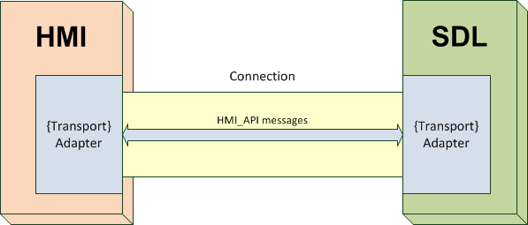

Figure 2.1 SDL-HMI Transport Adapters ({Transport} is the specific transport type).

The Transport Adapters of both WebSocket and D-Bus types are implemented in SDL.

For HMI it is enough to create one Adapter of the transport type chosen for communication.

Still, if there is a necessity, it is possible to expand the SDL with the Transport Adapter of another required type.

## Communication

There are several requirements to HMI for performing the successful communication with SDL:

1. Establish a connection
2. Confirm its readiness to SDL
3. Correctly respond to the messages

# WebSocket Transport

## Connection Opening

### 2.1.1 Requirements to HMI adapter

Once decided to use WebSocket as a transport for communication between SDL and HMI, the below must be taken into consideration on HMI adapter creation.

HMI adapter must:

* Be installed on the same vehicle HU`s OS where SDL is installed (Linux Ubuntu, QNX, or any POSIX-compliant system).
* Create and initialize the components named in correspondence to HMI_API (i.e. BasicCommunication, UI, Buttons, VR, TTS, Navigation, VehicleInfo).
* Establish a separate WebSocket connection with SDL for each of the above components (see ‘Handshake’ Example #1 and Example #3).
* To use the appropriate connection for sending requests/responses/notifications for the definite component (see Example #2).

### 2.1.2 Handshake

For opening a WebSocket connection, a handshake must be performed:

1. Client-Server Relations:

* SDL is the Server (the one who confirms the WebSocket connection establishing)
* HMI adapter is the Client (the one who requests the WebSocket connection opening).

1. Host:

* When started and initialized SDL comes listening on:

127.0.0.1:8087

1. WebSocket Protocol:

* [Version 13](http://tools.ietf.org/html/draft-ietf-hybi-thewebsocketprotocol-13) is used.

1. Sequence of messages:

* HMI adapter sends the handshake requests to SDL for every of the components (see Example #1 and Example #3). Each request must be sent:
* To the mentioned host
* With the individual Sec-WebSocket-Key
* SDL provides the responses to every request with individual Sec-WebSocket-Accept.

### 2.1.3 Components registering

Once all the requested connections are opened, HMI adapter must send the JSON request for registering the component (see section 4.2 for JSON format details and Example #4 for registering example).

Here are the rules applicable to component registering messages only:

* “id” – a multiple of 100 integer value, e.g.:
* 100 – for the first registering component
* 200 – for the second one
* 700 – for the seventh component
* "jsonrpc" : "2.0" - constant field and value for all JSON messages between SDL and HMI adapter.
* "method" : "MB.registerComponent – the request is assigned to SDL`s MessageBroker (MB), where the component name will be associated with the socket ID. Further SDL will send messages related to the named component over the corresponding connection.
* “componentName” – the name of the component being registered. Must correspond to the appropriate component name described in the current Guidelines.

SDL provides the response (Example 4.2) with:

* “id” – the value taken from the corresponding request.
* "result" – value of id multiplied by 10. Should be treated by HMI adapter as the success of registering.

### 2.1.4 Examples

|  |
| --- |
| ***Example #1 – WebSocket Handshake Headers*** |
| 1.1 WS Handshake Request Header (sent from HMI) |
| GET / HTTP/1.1  Upgrade: websocket  Connection: Upgrade  Host: 127.0.0.1:8087  Origin: null  Pragma: no-cache  Cache-Control: no-cache  Sec-WebSocket-Key: b0atvDirYAt6OFfJ3DSGnw==  Sec-WebSocket-Version: 13  Sec-WebSocket-Extensions: x-webkit-deflate-frame |
| 1.2 WS Handshake Response Header (sent from SDL) |
| Connection: Upgrade  Sec-WebSocket-Accept: h195GcH5yhZwfS16giEqe9HiYRk=  Upgrade: WebSocket |

|  |
| --- |
| ***Example #2 – WebSocket Connection Diagram*** |
|  |

|  |
| --- |
| Example #3 – WebSocket Handshake sequence diagram |
|  |

|  |
| --- |
| ***Example #4 – Register Component JSON Messages*** |
| 4.1 Request |
| {  "id" : 700,  "jsonrpc" : "2.0",  "method" : "MB.registerComponent",  “params” :  {  “componentName” : “VehicleInfo”  }  } |
| 4.2 Response |
| {  "id" : 700,  "jsonrpc" : "2.0",  "result" : 7000  } |

## 2.2 JSON Message Format

This chapter describes message structure for communication between SDL and HMI.

JSON RPC 2.0 format is taken as a basis.

Hereinafter within this chapter the actors for exchanging messages will be considered:

* The Client – the one who sends requests and notifications
* The Server – the one who provides the responses and sends notifications

Both SDL and HU components may act as a Client or as a Server.

### 2.2.1 Request

A RPC call is represented by sending a Request object to a Server. The Request object has the following members [[1](http://www.jsonrpc.org/specification)]:

| **Member name** | **Description** |
| --- | --- |
| id | An identifier established by the Client.  **This value MUST be of unsigned int type** in the frames of communication between SDL and HU. This value should normally not be Null.  If ‘id’ is not included the message is assumed to be a notification and should not be responded by the Server.  (e.g. ""id" : 65382). |
| jsonrpc | A String specifying the version of the JSON-RPC protocol.  MUST be exactly "2.0":  (e.g. "jsonrpc" : "2.0"). |
| method | A String containing the information of the method to be invoked.  The format is:  “Component_Name.Method_Name”  (e.g. "method" : "UI.IsReady"). |
| params | A Structured value that holds the parameter values to be used during the invocation of the method. This member MAY be omitted.  (e.g. "params" : { “cmdID” : 2318, “appID” : 409 } ). |

The request might be sent with parameters or without any – please see the examples below.

#### 2.2.1.1 Examples

|  |
| --- |
| ***Example #1 -* A request with NO parameters:** |
| {  "id" : 125,  "jsonrpc" : "2.0",  "method" : "Buttons.GetCapabilities"  } |

|  |
| --- |
| ***Example #2 -* A request WITH parameters:** |
| {  "id" : 92,  "jsonrpc" : "2.0",  "method" : "UI. Alert",  “params” :  {  “alertStrings” :  [  {  “fieldName” : alertText1,  “fieldText” : “WARNING”  },  {  “fieldName” : alertText2,  “fieldText” : “Hard weather conditions”  }  ],  “duration” : 4000,  “softButtons” :  [  “type” : TEXT,  “text” : “OK”,  “softButtonID” : 697,  “systemAction” : STEAL_FOCUS  ],  “appID” : 8218  }  } |

### 2.2.2 Notification

A Notification is a Request object without an ‘id’ member. For all the other members that must be included to notification please see the section 4.1.

The Server must not reply to a Notification, so no Response object needs to be returned to the Client.

#### 2.2.2.1 Examples

|  |
| --- |
| ***Example #1 -* A notification with NO parameters:** |
| {  "jsonrpc" : "2.0",  "method" : "UI.OnReady"  } |

| ***Example #2 -* A notification WITH parameters:** |
| --- |
| {  "jsonrpc" : "2.0",  "method" : "BasicCommunication.OnAppActivated",  "params" :  {  "appID" : 6578  }  } |
| {  "jsonrpc" : "2.0",  "method" : "Buttons.OnButtonPress",  "params" :  {  "mode" : "SHORT",  "name" : "OK"  }  } |

### 2.2.3 Response

On receipt of the Request message, the Server must reply with a Response (except for in the case of Notifications). The Response is expressed as a single JSON Object, with the following members

|  |  |
| --- | --- |
| **Member name** | **Description** |
| id | This member is REQUIRED.  It MUST be **the same** as the value of the **‘id’** member in the **Request** Object.  If there was an error in detecting the id in the Request object (e.g. Parse error/Invalid Request), it MUST be Null.  (e.g. ""id" : 65382). |
| jsonrpc | A String specifying the version of the JSON-RPC protocol.  MUST be exactly "2.0":  (e.g. "jsonrpc" : "2.0"). |
| result | This member :  - is REQUIRED on success.  - MUST NOT exist if there was an error invoking the method.  The ‘result’ field MUST contain:  - The **‘method’ field** that has to include the same “Component_Name.Method_Name” as in originating Request.  (e.g. "method" : "UI.IsReady").  - The **‘code’ field with ‘0’** = success value. No other result codes (described in the Result Enumeration in section 5.1.1) must be sent within the Response object.  (e.g. "code" : 0).  This member MAY include the structured values determined by the method invoked on the Server.  (e.g. "result" :  {  "availabe" : true,  "code" : 0,  "method" : "UI.IsReady"  }  ). |

#### 2.2.3.1 Examples

|  |
| --- |
| ***Example #1 -*** A response with NO parameters (code and method are necessary): |
| {  "id" : 167,  "jsonrpc" : "2.0",  "result" :  {  "code" : 0,  "method": "UI.Alert"  }  } |

|  |
| --- |
| ***Example #2: -*** A response WITH extra parameters |
| {  "id" : 125,  "jsonrpc" : "2.0",  "result" :  {  "capabilities" :  [    {  "longPressAvailable" : true,  "name" : "PRESET_0",  "shortPressAvailable" : true,  "upDownAvailable" : true  },    {  "longPressAvailable" : true,  "name" : "TUNEDOWN",  "shortPressAvailable" : true,  "upDownAvailable" : true  }  ],  "presetBankCapabilities" :  {  "onScreenPresetsAvailable" : true  },  "code" : 0,  "method" : "Buttons.GetCapabilities"  }  } |

### 2.2.4 Error

When a RPC call encounters an error, the Response Object MUST contain the ‘error’ member instead of the ‘result’ one. The error object has the following members:

|  |  |
| --- | --- |
| **Member name** | **Description** |
| id | This member is REQUIRED.  It MUST be **the same** as the value of the **‘**id’ member in the Request Object.  If there was an error in detecting the id in the Request object (e.g. Parse error/Invalid Request), it MUST be Null.  (e.g. ""id" : 65382). |
| jsonrpc | A String specifying the version of the JSON-RPC protocol.  MUST be exactly "2.0":  (e.g. "jsonrpc" : "2.0"). |
| error | This member  - is REQUIRED on error.  - MUST NOT exist if there was no error triggered during invocation.  The ‘error’ field must contain:  - The **‘code’ field** with thevalue that indicates the error type that occurred. The result codes ‘1’ – ‘23’ from the Result Enumeration (described in section 5.1.1) should be used.  (e.g. "code" : 14).  - The **‘message’ field**, containing the string that provides a short description of the error (from the same Result Enumeration). The message SHOULD be limited to a concise single sentence.  (e.g. "message" : “There was a conflict with an already registered name” ).  - The **‘data’ field** that MUST contain the **‘method’ member**. The name in the form of “Component_Name.Method_Name” MUST be the same as in originating request.  (e.g. "data" : { “method” : “UI.Alert” } ). |

#### 2.2.4.1 Examples

| ***Example #1 -*** Erroneous response |
| --- |
| {  "id" : 103,  "jsonrpc" : "2.0",  "error" :  {  "code" : 13,  "message" : "One of the provided IDs is not valid",  "data" :  {  "method" : "VehicleInfo.GetDTCs"  }  }  } |

# 4 D-Bus Transport

Hereinafter within this chapter the actors for exchanging messages will be considered:

1. The Client – the one who sends requests (Method call in D-Bus notation) and notifications (Signal in D-Bus notation)
2. The Server – the one who provides the responses (Method return in D-Bus notation) and sends notifications

SDL acts as a Client, HMI – as a Server.

## 4.1 Overview

D-Bus is an interprocess message exchange subsystem where communication between source and destination high level application objects is presented as a regular function call.

At sender`s side at a low level such call is converted to message with service name, object name, interface name and function name. This message is posted into D-Bus subsystem.

At receiver`s side at a low level this message is converted back to the appropriate function call.

## 4.2 HMI Integration Aspects

To communicate with SDL over D-Bus HMI must publish a service in D-Bus subsystem with “com.ford.sdl.hmi” name. This service must contain one object with “/” (root) name. This object shall provide interfaces according to this document. Each interface name shall start with “com.ford.sdl.hmi.” prefix and provide functions according to API specification described below.

|  |
| --- |
| ***Example #1*** *- High level implementation of D-Bus initialization (at Server side, using Qt)* |
| QDBusConnection::sessionBus().registerObject("/", this); QDBusConnection::sessionBus().registerService("com.ford.sdl.hmi"); |

Any HMI that implements HMI API defined within this document uses optionality of arguments, meaning that some arguments may be present in the function call and others may be not. Such optionality is not supported by D-Bus. To resolve this, the special parameter is used for determining whether the argument is present:

{bool isPresent; valueType value}

a) true isPresent – means the argument is present within function call

b) false isPresent – means the argument is not present.

|  |
| --- |
| ***Example #2*** *– IsPresent parameter* |
| {isPresent = true; appID = 123}  {isPresent = false; customPresets = [“ab”, “cd”]} |

This special type is mapped to D-Bus “struct” type with one Boolean field and one user’s type field – “(b<user_type>)”in D-Bus type notation. For instance let it be optional integer. Then D-Bus signature of such argument will look like “(bi)”.

According to this document SDL Core emits a few notifications. For this purpose SDL core registers a service with “com.ford.sdl.core” name and with one object named “/” in D-Bus subsystem. HMI must subscribe to those notifications by means of D-Bus subsystem (taking into account service name, object name and notification name).

|  |
| --- |
| ***Example #3*** *- Low level implementation of D-Bus initialization (at Client side)* |
| /**  * Well-known bus types. See dbus_bus_get().  */  typedef enum  {  DBUS_BUS_SESSION, /**< The login session bus */  DBUS_BUS_SYSTEM, /**< The systemwide bus */  DBUS_BUS_STARTER /**< The bus that started us, if any */  } DBusBusType;  …  //init error var  dbus_error_init(&err);  //init connection in terms of D-Bus  DBusConnection* conn_ = dbus_bus_get(DBUS_BUS_SESSION, &err);  int ret = dbus_bus_request_name(conn_,  “com.ford.sdl.core”,  DBUS_NAME_FLAG_DO_NOT_QUEUE,  &err); |

SDL core expects that HMI supports the following behavior:

* A request to call the remote function can be synchronous or asynchronous
* All data transfer is performed through function’s arguments
* The successfully executed function returns a common (successful) response with “success” return code
* The failed call returns the successful response with “error” return code
* The notification is distributed on definite event occurred.

## 4.3 Low Level D-Bus processing

Simplified code snippets are presented below.

|  |
| --- |
| ***Example #4*** *- Low level implementation of remote function call at Client side* |
| DBusMessage* msg;  //create D-Bus message  msg = dbus_message_new_method_call(  hmi_service_name, // “com.ford.sdl.hmi”  hmi_object_path, // “/”  (hmi_service_name+"."+hmi_interface_name),// “com.ford.sdl.hmi.BasicCommunication”  hmi_function_name);  //send message to D-Bus  dbus_uint32_t serial;  dbus_connection_send(conn_id, msg, &serial); |

|  |
| --- |
| ***Example #5*** *- Low level implementation of remote function call at Server side* |
| // D-Bus message reading infinite loop  while(true){  // get message from D-Bus  DBusMessage* msg = dbus_connection_pop_message(conn_id);  // get type of call  switch (dbus_message_get_type(msg)) {  case DBUS_MESSAGE_TYPE_METHOD_CALL:  // if it is function call  //get interface and function name  std::string method = dbus_message_get_member(msg);  std::string interface = dbus_message_get_interface(msg);  if (interface == "org.freedesktop.DBus.Introspectable"  && method == "Introspect") {  //call appropriate function at Server side  Introspect(msg);  return false;  }  …  } |

# 5 Getting Started

## 5.1 Readiness confirming

To start communication with SDL HMI must notify about its readiness via BasicCommunication.OnReady notification.

By receipt of OnReady notification SDL starts checking the availability of HMI components via the chain of RPCs:

* UI.IsReady –the display availability
* VR.IsReady –the voice recognition module availability
* TTS.IsReady – the Text-To-Speech module availability
* Navigation.Isready – check whether the navigation engine is available
* VehicleInfo.IsReady – check whether the vehicle information can be collected and provided.

HMI must respond each of the above RPCs.

If the component is responded to be unavailable (“available”: false), SDL will not further communicate with one.

### 5.1.1 Sequence diagram

***Note:***

*In case of WebSocket connection, the RPCs to each of the components is sent within the separate WS connection*

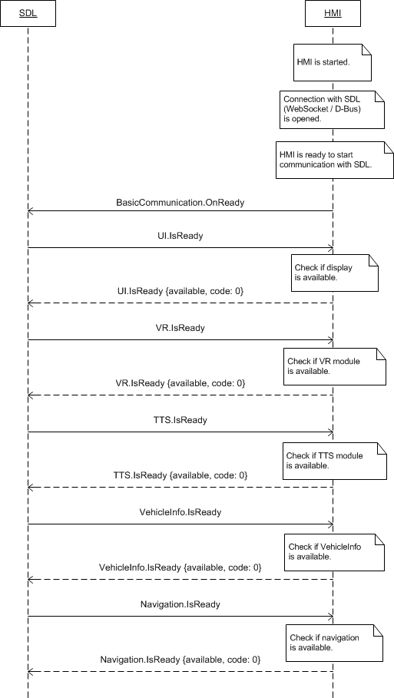

# 6 BasicCommunication Component Description

## 6.1 UpdateDeviceList

### 6.1.1 Description

|  |  |
| --- | --- |
| **Type:** | Function |
| **Sender:** | SDL |
| **Purpose:** | Update HMI`s list of found devices. |

The request comes after SDL has found a new device over one of available transports:

***Notes about device searching:***

*With default SDL`s Transport Manager (TM) and default Transport Adapters (TAs), SDL behaves in the following way:*

***Note:***

*Transport Manager as well as Transport Adapters may be customized or created from scretch, see chapter 3*

*1. BlueTooth transport:*

*1.1. SDL`s TM makes a periodic search routine over BlueTooth.*

*1.2. Once the device is found, SDL starts the procedure of searching SDL-enabled applications on such device.*

*1.3. SDL sends BasicCommunication.UpdateDeviceList with the name and id of the discovered device to HMI.*

*1.4. SDL needs to receive OnDeviceChosen(deviceInfo) or OnFindApplications(deviceInfo) from HMI to allow registering applications running on this device.*

*1.5. After getting OnDeviceChosen(deviceInfo) or OnFindApplications(deviceInfo) from HMI SDL allows registering applications from the named device and sends BasicCommunication.OnAppRegistered to HMI.*

*2. USB transport:*

*2.1. SDL learns about new device connected over USB (notification from TA over TM).*

*2.2. SDL sends BasicCommunication.UpdateDeviceList with the name and id of the discovered device to HMI.*

*2.3. SDL sends BasicCommunication.OnAppRegistered to HMI right after (not waiting for OnDeviceChosen or OnFindApplications notifications.*

*3. WiFi transport:*

*3.1. SDL learns about new device connected over WiFi (notification from TA over TM).*

*2.2. SDL sends BasicCommunication.UpdateDeviceList with the name and id of the discovered device to HMI.*

*2.3. SDL sends BasicCommunication.OnAppRegistered to HMI right after (not waiting for OnDeviceChosen or OnFindApplications notifications.*

### 6.1.2 Request

#### 6.1.2.1 Behavior

***HMI must:***

1. Update its list of found devices (that is, store the provided information).

2. Use this information later when providing the OnDeviceChosen or OnFindApplications notifications.

3. Provide the User with the possibility of choosing among the found devices through either display or voice recognition or both.

#### 6.1.2.2 Parameters

|  |  |  |  |  |
| --- | --- | --- | --- | --- |
| **Param Name** | **Type** | **Mandatory** | **Additional** | **Description** |
| deviceList | Common.DeviceInfo | true | Array = true  minsize = 0  maxsize = 100 | The list of devices (name and ID) found.  If contains the empty array, it means that all the devices have been disconnected or are not connected yet.  See DeviceInfo. |

#### 6.1.2.3 DeviceInfo Structure

| **Param Name** | **Type** | **Mandatory** | **Additional** | **Description** |
| --- | --- | --- | --- | --- |
| name | String | true |  | The name of the device connected |
| id | Integer | true |  | The ID of the device connected. It remains unique during the ignition cycle. |
| transportType | Common.TransportType | false |  | The transport type the named-app's-device is connected over to HU (BlueTooth, USB or WiFi).  Always returned by SDL in OnAppRegistered and UpdateAppList RPCs. |
| isSDLAllowed | Boolean | false |  | Sent by SDL in UpdateDeviceList. ’true’ – if device is allowed for PolicyTable Exchange; ‘false’ – if device is NOT allowed for PolicyTable Exchange |

#### 6.1.2.4 TransportType Enumeration

| **Element name** | **Value** | **Short Description** |
| --- | --- | --- |
| BLUETOOTH | 0 |  |
| USB | 1 |  |
| WIFI | 2 |  |

### 6.1.3 Response

***Note:***

*There is a difference in message type for WebSocket and D-Bus connection (see the table below).*

|  |  |  |  |  |  |
| --- | --- | --- | --- | --- | --- |
| **Result** | **Description** | **Message type** | | **Message Params** | **Notes** |
| **WebSocket** | **D-Bus** |
| Success | SUCCESS:  HMI has stored the list of found devices provided within request. | JSON response | Regular response | code: 0 | - |
| Failure | INVALID_DATA:  The data sent is invalid (json, out of bound parameters etc) | JSON error message | Regular response | code: 11 | Applicable for this RPC result codes.  Please see Result Enumeration for all SDL-supported codes |
| GENERIC_ERROR:  The unknown issue occurred or other codes are not applicable. | code: 22 |

### 6.1.4 Sequence Diagrams

#### 6.1.4.1 UpdateDeviceList after SDL finds a new device over BT and USB

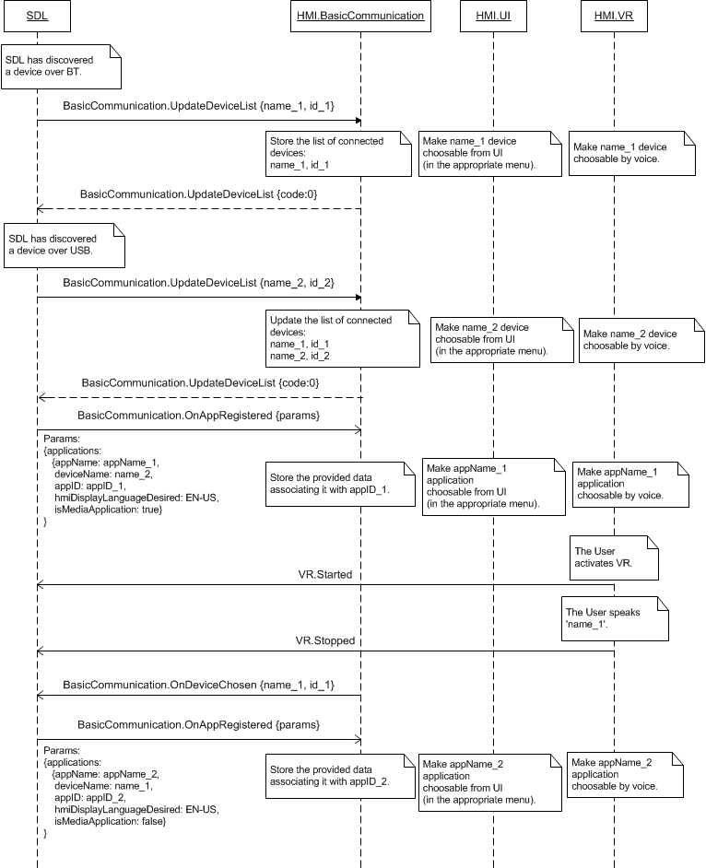

### 6.1.5 JSON Messages Examples

#### 6.1.5.1 Request

|  |
| --- |
| {  "id" : 64,  "jsonrpc" : "2.0",  "method" : "BasicCommunication.UpdateDeviceList",  “params” :  {  "devicelist" :  [  {  "name" : “Jerry`s Phone”,  "id" : 3  },    {  "name" : “XT910”,  "id" : 4  }  ]  }  } |

#### 6.1.5.2 Response

|  |
| --- |
| {  "id" : 64,  "jsonrpc" : "2.0",  "result" :  {  "code" : 0,  "method" : "BasicCommunication.UpdateDeviceList"  }  } |

#### 6.1.5.3 Error message

|  |
| --- |
| {  "id" : 64,  "jsonrpc" : "2.0",  "error" :  {  "code" : 11,  "message" : " The data sent is invalid.",  "data" :  {  "method" : "BasicCommunication.UpdateDeviceList"  }  }  } |

### 6.1.6 D-Bus Messages Examples

#### 6.1.6.1 Request

|  |
| --- |
| method call sender=:1.192 -> dest=com.ford.sdl.hmi serial=61 path=/; interface=com.ford.sdl.hmi.BasicCommunication; member=UpdateDeviceList  array [  struct {  string "10.10.0.13"  int32 1  }  ] |

#### 6.1.6.2 Response

|  |
| --- |
| method return sender=:1.193 -> dest=:1.192 reply_serial=61  int32 0  string "" |

#### 6.1.6.3 Failure

|  |
| --- |
| method return sender=:1.193 -> dest=:1.192 reply_serial=61  int32 11  string "The data sent is invalid." |

## 6.2 ActivateApp

### 6.2.1 Description

|  |  |
| --- | --- |
| **Type:** | Function |
| **Sender:** | SDL |
| **Purpose:** | Activate the named application on HMI. |

Activated application is assumed to receive access to head unit`s display, audio and control systems/modules:

- supported by the head unit

- confirmed to be supported via responses to IsReady requests sent by SDL to every of components (i.e. UI, VR, TTS, Buttons, VehicleInfo, Navigation).

The request may follow:

- After SDL restores application`s previous-to-ignition-off state on HMI.

In case SDL resumes an app to FULL, SDL sends BC.ActivateApp to HMI( see diagram 6.26.2.1 Resume AudioSource for the application in FULL for more details).

In case SDL resumes an app to LIMITED, SDL sends BC.OnResumeAudioSource to HMI.. See diagram 6.26.2.2 OnResumeAudioSource LIMITED HMILevel for more details.

In case of successful HMILevel resumption, SDL first assigns 'default_hmi' level from policies and after **3sec timeout**, resumes the application either to FULL or LIMITED (whichever applicable.

***Note:***

*By the time ActivateApp comes, HMI is already provided with the detailed information on every registered application with OnAppRegistered RPC.*

### 6.2.2 Request

#### 6.2.2.1 Behavior

***HMI must:***

1. Activate the named application on HMI:

1.1. Display the application-related screen.

1.1.a. Display UI.Show related parameters associated with the named appID in case previously requested within ignition cycle..

1.1.b. Display the corresponding template in case previously requested within ignition cycle by UI.SetDispalyLayout for the named application (appID).

1.1.c. Apply UI.SetGlobalProperties associated with the named appID in case previously requested within ignition cycle.

1.1.d. Apply UI.AddCommand associated with the named appID in case previously requested within ignition cycle.

1.1.e. Apply UI.AddSubMenu associated with the named appID in case previously requested within ignition cycle.

* 1. Make VR commands accessible in case previously requested within ignition cycle by VR.AddCommand for the named appID.

1.3. Apply TTS.SetGlobalProperties associated with the named appID in case previously requested within ignition cycle.

2. Assign priority from the priority parameter to the named application. If request comes with omitted parameter, HMI must assign the priority of NONE by default.

3. Respond with SUCCESS result code right after HMI activated the named application. For all of applicable to this RPC result codes please see section 6.2.3. Response.

4. To set-up the application as active audio source in case it is media/navigation type

#### 6.2.2.2 Parameters

|  |  |  |  |
| --- | --- | --- | --- |
| **Param Name** | **Type** | **Mandatory** | **Description** |
| appID | Integer | true | The ID of the application requested to be activated. |
| priority | Common.AppPriority | false | Send to HMI so that it can coordinate order of requests/notifications correspondingly. |
| level | Common.HMILevel | false | This parameter is omitted in case the app needs to be activated in FULL.  The parameter is sent by SDL in case the app needs to be placed in one of LIMITED, BACKGROUND or NONE on HMI. |

#### 6.2.2.3 AppPriority

| **Element name** | **Value** | **Short Description** |
| --- | --- | --- |
| EMERGENCY | 0 |  |
| NAVIGATION | 1 |  |
| VOICE_COMMUNICATION | 2 |  |
| COMMUNICATION | 3 |  |
| NORMAL | 4 |  |
| NONE | 5 |  |

#### 6.2.2.4 HMILevel

| **Element name** | **Value** | **Short Description** |
| --- | --- | --- |
| FULL | 0 | App must be activated to FULL level, that is the app must be granted the access to all of HMI supported resources: UI, VR, TTS, audio. |
| LIMITED | 1 | App must be activated to LIMITED level, that is the app must be granted the access to audio only. |
| BACKGROUND | 2 | App must be activated to LIMITED level, that is the app must be listed in corresponding HMI menu, have no acces to HMI supported resources, allowed to call Alerts only. |
| NONE | 3 | App must be activated to LIMITED level, that is the app must be listed in corresponding HMI menu, have no acces to HMI supported resources. |

### 6.2.3 Response

***Note:***

*There is a difference in message type for WebSocket and D-Bus connection (see the table below).*

|  |  |  |  |  |  |
| --- | --- | --- | --- | --- | --- |
| **Result** | **Description** | **Message type** | | **Message Params** | **Notes** |
| **WebSocket** | **D-Bus** |
| Success | SUCCESS:  HMI has activated the requested application (step 1. Of sub-section 6.2.2.1. is performed successfully).. | JSON response | Regular response | code: 0 | - |
| Failure | INVALID_DATA  Invalid json or parameters are out of bounds | JSON error message | Regular response | code: 11 | Applicable for this RPC result codes.  Please see Result Enumeration for all SDL-supported codes |
| INVALID_ID  Wrong appID (e.g. doesn’t exist)  HMI does not have the named application ID in its list of registered applications (that is, there were no OnAppRegistered with such appID from SDL previously). | code: 13 |
| IGNORED:  The named application is already in the same acitve mode on HMI | code: 6 |
| GENERIC_ERROR:  1) The unknown issue occurred or other codes are not applicable.  2) In case HMI does not respond SDL's request during SDL-default timeout (10 sec), SDL will return the result code to the corresponding mobile app's request. | code: 22 |

### 6.2.4 Sequence Diagrams

#### 6.2.4.1 BasicCommunication.ActivateApp after successsful resumption.

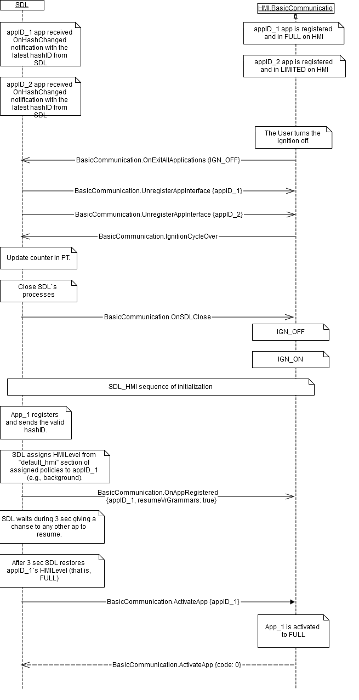

#### 6.2.4.2 BasicCommunication.ActivateApp after UNsuccesssful resumption.

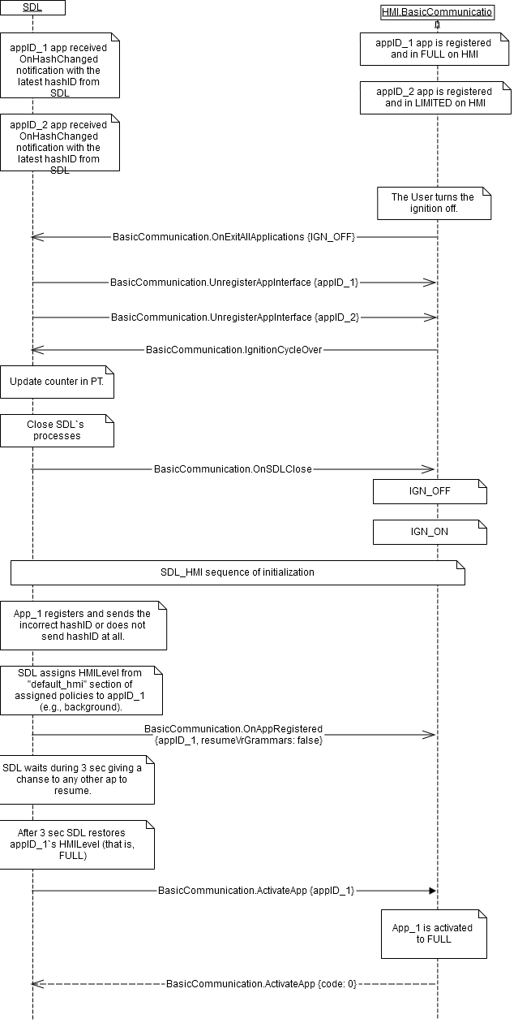

#### 6.2.4.3 BasicCommunication.ActivateApp after unexpected disconnect

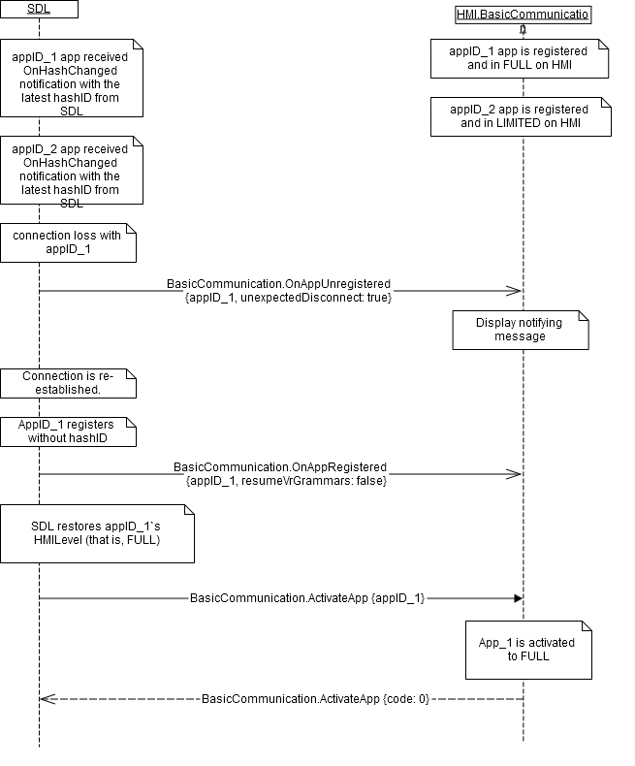

#### 6.2.4.4 BasicCommunication.ActivateApp after the User accepted the data consent prompt

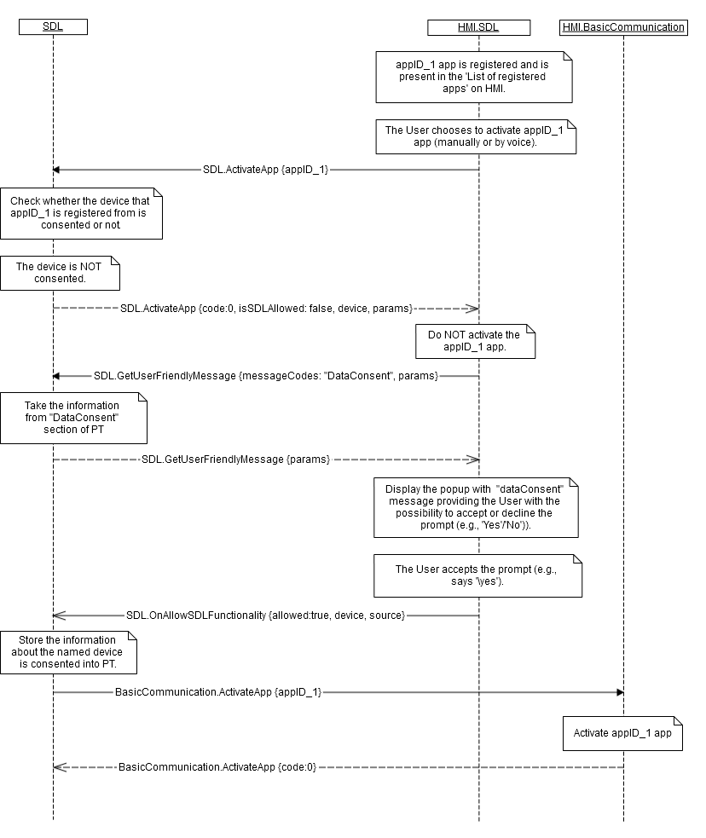

#### 6.2.4.5 BasicCommunication.ActivateApp after the User declined the data consent prompt

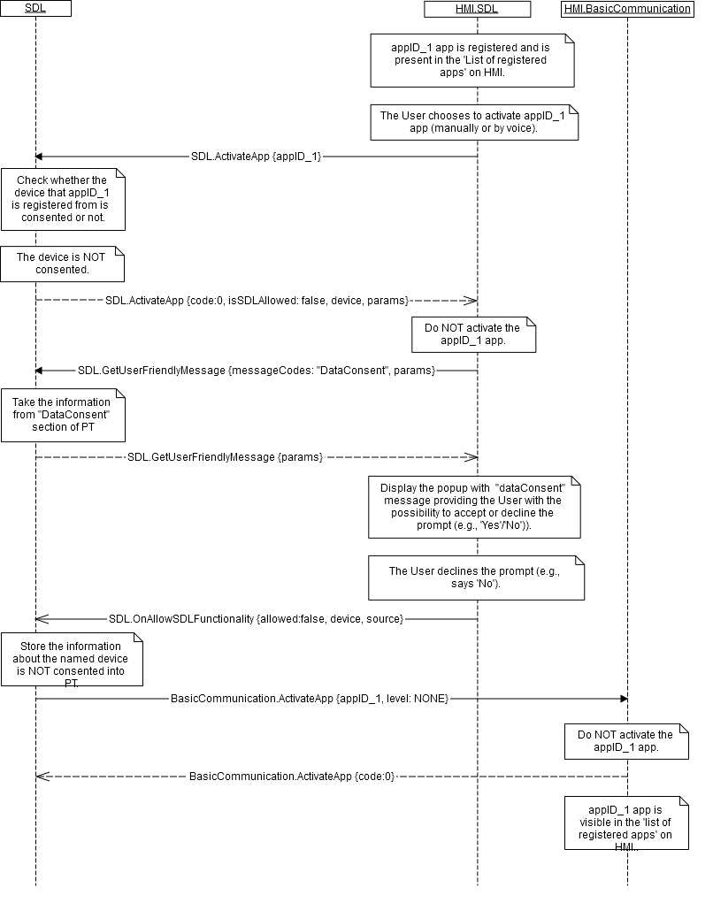

### 6.2.5 JSON Messages Examples

#### 6.2.5.1 Request

|  |
| --- |
| {  "id" : 47,  "jsonrpc" : "2.0",  "method" : "BasicCommunication.ActivateApp",  “result” :  {  "appID" : 65368  }  } |

#### 6.2.5.2 Response

|  |
| --- |
| {  "id" : 47,  "jsonrpc" : "2.0",  "result" :  {  "code" : 0,  "method" : "BasicCommunication.ActivateApp"  }  } |

#### 6.2.5.3 Error message

|  |
| --- |
| {  "id" : 47,  "jsonrpc" : "2.0",  "error" :  {  "code" : 13,  "message" : "One of the provided IDs is not valid.",  "data" :  {  "method" : "BasicCommunication.ActivateApp"  }  }  } |

### 6.2.6 D-Bus Messages Examples

#### 6.2.6.1 Request

|  |
| --- |
|  |

#### 6.2.6.2 Response

|  |
| --- |
|  |

#### 6.2.6.3 Failure

|  |
| --- |
|  |

## 6.3 MixingAudioSupported

### 6.3.1 Description

|  |  |
| --- | --- |
| **Type:** | Function |
| **Sender:** | SDL |
| **Purpose:** | Find out if HMI supports mixing audio. |

‘Mixing audio’ names the ability of vehicle audio system to speak the TTS prompting or to listen to and recognize the VR command while playing audio.

***Note:***

*SDL is able to get the information about ‘mixing audio’ capability of HMI from smartDeviceLink.ini file (this file is usually stored in the same folder where SDL executable is).*

### 6.3.2 Request

#### 6.3.2.1 Behavior

***HMI must:***

Check its mixing audio capabilities and provide the correct response.

***Note:***

*If the request is NOT responded and there is no record in smartDeviceLink.ini file, SDL will consider that mixing audio is NOT supported.*

### 6.3.3 Response

#### 6.3.3.1 Behavior

***Note:***

*There is a difference in message type for WebSocket and D-Bus connection (see the table below).*

|  |  |  |  |  |  |
| --- | --- | --- | --- | --- | --- |
| **Result** | **Description** | **Message type** | | **Message Params** | **Notes** |
| **WebSocket** | **D-Bus** |
| Success | SUCCESS:  HMI provides the information about ‘mixing audio’ supporting. | JSON response | Regular response | attenuatedSupported,  code: 0 | - |
| Failure | GENERIC_ERROR:  The unknown issue occurred or other codes are not applicable. | JSON error message | Regular response | code: 22 | Applicable for this RPC result codes.  Please see Result Enumeration for all SDL-supported codes |

#### 6.3.3.2 Parameters

|  |  |  |  |
| --- | --- | --- | --- |
| **Param Name** | **Type** | **Mandatory** | **Description** |
| attenuatedSupported | Boolean | true | Must be  - ‘true’ if HMI supports mixing audio  - ‘false’ if not. |

### 6.3.4 Sequence Diagrams

#### 6.3.4.1 MixingAudioSupported Messaging

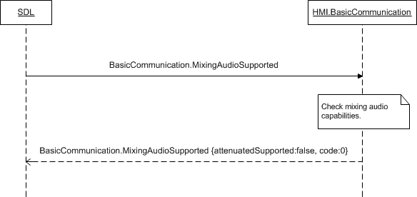

### 6.3.5 JSON Messages Examples

#### 6.3.5.1 Request

|  |
| --- |
| {  "id" : 27,  "jsonrpc" : "2.0",  "method" : "BasicCommunication.MixingAudioSupported"  } |

#### 6.3.5.2 Response

|  |
| --- |
| {  "id" : 27,  "jsonrpc" : "2.0",  "result" :  {  "attenuatedSupported" : true,  "code" : 0,  "method" : "BasicCommunication. MixingAudioSupported"  }  } |

#### 6.3.5.3 Error message

|  |
| --- |
| {  "id" : 27,  "jsonrpc" : "2.0",  "error" :  {  "code" : 22,  "message" : "An unknown error occurred",  "data" :  {  "method" : "BasicCommunication.MixingAudioSupported"  }  }  } |

### 6.3.6 D-Bus Messages Examples

#### 6.3.6.1 Request

|  |
| --- |
|  |

#### 6.3.6.2 Response

|  |
| --- |
|  |

#### 6.3.6.3 Failure

|  |
| --- |
|  |

## 6.4 AllowDeviceToConnect

### 6.4.1 Description

|  |  |
| --- | --- |
| **Type:** | Function |
| **Sender:** | SDL |
| **Purpose:** | Permit device to connect to HU. |

### 6.4.2 Request

#### 6.4.2.1 Behavior

***HMI must:***

- Check in one of predefined ways whether to allow the named device to connect to HU.

*HMI may:*

- Request the User in one of accessible ways (VR, buttons, etc.)

- Have the definite settings to know whether to allow the connection.

#### 6.4.2.2 Parameters

|  |  |  |  |
| --- | --- | --- | --- |
| **Param Name** | **Type** | **Mandatory** | **Description** |
| deviceInfo | Common.DeviceInfo | true | The information about the device requested to be connected: its name and ID.  See DeviceInfo. |

#### 6.4.2.3 DeviceInfo Structure

| **Param Name** | **Type** | **Mandatory** | **Additional** | **Description** |
| --- | --- | --- | --- | --- |
| name | String | true |  | The name of the device connected |
| id | Integer | true |  | The ID of the device connected. It remains unique during the ignition cycle. |
| transportType | Common.TransportType | false |  | The transport type the named-app's-device is connected over to HU (BlueTooth, USB or WiFi).  Always returned by SDL in OnAppRegistered and UpdateAppList RPCs. |
| isSDLAllowed | Boolean | false |  | Sent by SDL in UpdateDeviceList. ’true’ – if device is allowed for PolicyTable Exchange; ‘false’ – if device is NOT allowed for PolicyTable Exchange |

#### 6.4.2.4 TransportType Enumeration

| **Element name** | **Value** | **Short Description** |
| --- | --- | --- |
| BLUETOOTH | 0 |  |
| USB | 1 |  |
| WIFI | 2 |  |

### 6.4.3 Response

#### 6.4.3.1 Behavior

***Note:***

*There is a difference in message type for WebSocket and D-Bus connection (see the table below).*

|  |  |  |  |  |  |
| --- | --- | --- | --- | --- | --- |
| **Result** | **Description** | **Message type** | | **Message Params** | **Notes** |
| **WebSocket** | **D-Bus** |
| Success | SUCCESS:  HMI provides the information about whether the named device is allowed. | JSON response | Regular response | allow,  code: 0 | - |
| Failure | REJECTED  A User rejected the device to be connected | JSON error message | Regular response | code:4 |  |
| IGNORED  The permission has been already done by the user | code:6 |  |
| TIMED_OUT  no answer from a user within predefined timeout on HMI | code:10 |  |
| INVALID_DATA  Wrong JSON or out of bound parameters | code:11 |  |
| @TODO to confirm  OUT_OF_MEMORY | code:17 | @TODO – to clarify if applicable |
| GENERIC_ERROR:  The unknown issue occurred or other codes are not applicable. | code: 22 | Applicable for this RPC result codes.  Please see Result Enumeration for all SDL-supported codes |

#### 6.4.3.2 Parameters

|  |  |  |  |
| --- | --- | --- | --- |
| **Param Name** | **Type** | **Mandatory** | **Description** |
| allow | Boolean | true | Must be  - ‘true’ if connecting the requested device is allowed  - ‘false’ if not. |

### 6.4.4 Sequence Diagrams

#### 6.4.4.1 AllowDeviceToConnect Messaging

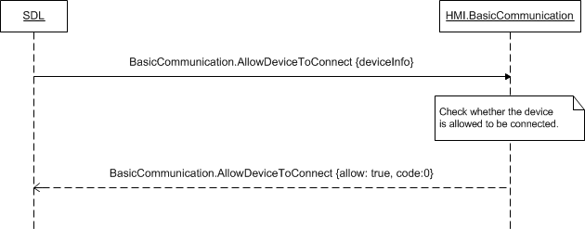

### 6.4.5 JSON Messages Examples

#### 6.4.5.1 Request

|  |
| --- |
| {  "id" : 87,  "jsonrpc" : "2.0",  "method" : "BasicCommunication.AllowDeviceToConnect",  “params” :  [  "deviceInfo" :  {  "name" : “Mary`s Phone”,  "id" : 8  }  ]  } |

#### 6.4.5.2 Response

|  |
| --- |
| {  "id" : 87,  "jsonrpc" : "2.0",  "result" :  {  “allow” : true,  "code" : 0,  "method" : "BasicCommunication.AllowDeviceToConnect"  }  } |

#### 6.4.5.3 Error message

|  |
| --- |
| {  "id" : 87,  "jsonrpc" : "2.0",  "error" :  {  "code" : 22,  "message" : "An unknown error occurred",  "data" :  {  "method" : "BasicCommunication.AllowDeviceToConnect"  }  }  } |

### 6.4.6 D-Bus Messages Examples

#### 6.4.6.1 Request

|  |
| --- |
|  |

#### 6.4.6.2 Response

|  |
| --- |
|  |

#### 6.4.6.3 Failure

|  |
| --- |
|  |

## 6.5 SystemRequest

### 6.5.1 Description

|  |  |
| --- | --- |
| **Type:** | Function |
| **Sender:** | SDL |
| **Purpose:** | Provide the path to the system file that SDL has received from mobile application |

SDL sends BasicCommunication.SystemRequest to HMI in case SDL receives SystemRequest RPC from mobile application.

### 6.5.2 Request

#### 6.5.2.1 Behavior

***HMI must:***

* Notify specific module aboute the location of fully assembled packet of filename file transferred via PutFile based on RequestType allowed

***HMI must*** (for PROPRIATERY request type):

* Decrypt the fileName file

Send OnReceivedPolicyUpdate to SDL right after the fileName file is successfully decrypted.

***SDL related behavior:***

SDL validates all SystemRequests sent from mobile app and returns 'DISALLOWED' result in case app's SystemRequest contains RequestType disallowed by Policies. See 6.5.4 SystemRequest diagram for details.

**Note:** SDL sends the list of RequestTypes allowed by Policies via OnAppPermissionChanged/UpdateAppList or OnAppRegistered API. In case HMI sends OnSystemRequest with a RequestType disallowed by PolicyTable, SDL will ignore it.

***Important (IVSU workflow):***

In Vehicle Software Update Module may request updates from the Cloud. SystemRequst is a part of this sequence. For more details see the sequence below and 6.5.4.2 SystemRequest in IVSU workflow):

1. ***Mobile Proxy***
2. Sends a mobile API SystemRequest to SDLwith requestType=HTTP,filename=”IVSU”
3. ***SDL***
4. Receives SystemRequest from mobile device.
5. Store hybrid data as a file on the system with the file name provided.
6. Send BasicCommunication.SystemRequest(request_type=HTTP, file=”IVSU”,appID) where

appID is the app’s ID that it registered with

1. ***SYNCP***
2. Receives SDL.SystemRequest
3. Requests the list of URLs to request the file *BC.GetURLs(service_type=4)*
4. ***SDL***
5. Responds to BC.GetURLs with an array of serviceInfo data structs (url,appID).

url and appID pairs are the result of querying the policy table

1. ***SYNCP***
2. Encode, sign and encrypt InterrogatorLog file
3. Sends the InterrogatorLog to the Cloud via

BC.OnSystemRequest(request_type=PROPRIETARY,url,appID, InterrogatorLog)

url is from BC.GetURLs

appID is from first BC.SystemRequest (3a)

1. ***SDL***

a) Receives BC.OnSystemRequest(request_type,url, appID, InterrogatorLog)

b) Convert the request into the mobile smartObject request using the following logic:

1. If the requestType=PROPRIETARY, add to mobile API fileType=JSON

2. If the requestType=HTTP, add to mobile API fileType = BINARY

1. Place “file” data into hybrid portion of mobile packet and populate url
2. If appID is “default”, send request to any connected mobile app

If appID is specific, send request to the specific app

1. ***Mobile Proxy***

*a) Receive OnSystemRequest notification and read the hybrid data.*

*If requestType=PROPRIETARY and fileType=JSON, read hybrid file to assemble HTTP header, and pass along “body” information to the URL*

1. ***Cloud***

*a) Sends to mobile* HTTP response with data

1. ***Mobile Proxy***

*a)* Receives HTTP response with data.

b) Populate response in hybrid data field and send SystemRequest to SD

1. ***SDL***

*a) SDL receives SystemRequest from mobile device.*

*If there is hybrid data, store it as a file on the system with the file name provided.*

1. *Send BC.SystemRequest(request_type=HTTP,file,appID)*

*file is generated by SDL appID is the app’s ID that it registered with*

1. ***SYNCP***

a) Decodes and decrypts the contents of filename identifies the service type as 4 and notifies IVSU component

b) IVSU Component/SYNCP Manager sends BC.OnSystemRequest(requestType=FILE_RESUME,url,appID,file) to SDL.

url is from the manifest file

appID is the IVSU app from (3a) SDL.SystemRequest

1. ***SDL***
2. Receives BasicCommunication.OnSystemRequest(request_type,url,appID,file) and will
   1. convert the request into the mobile smartObject request using the following logic:
3. If requestType=FILE_RESUME and hybrid data exists, add mobile API fileType=BINARY
4. Populate url
5. If appID is specific, send request to the specific app.
6. ***Mobile Proxy***
7. Receive OnSystemRequest notification
8. If requestType=FILE_RESUME, begin downloading from URL provided
9. Upon file download send mobile API PutFile with data bytes
10. ***SDL***
11. Receive PutFile and notify IVSU component
12. If hybrid data exists, store it as a file on the system with the file name provided
13. Send BasicCommunication.OnPutFile(offset, length, fileSize, file)

Offset is from mobile proxy API

length is calculated by SDL and is the total size of the data chunk

fileSize is optional (only required when offset = 0) and is provided by the mobile API

***Important (Policies workflow):***

SystemRequest is a part of Policy update workflow. For more details see the sequence below and  6.5.4.3 SystemRequest in Policies workflow

1. ***SDL***

a) Initiates BC.PolicyUpdate(file, timeout, retry)

b) File is the path to policy table snapshot (a json table)

Timeout is a value from the policy table.

Retry is a value read from the policy table

1. ***SYNCP***
2. Receives BC.PolicyUpdate(file, timeout, retry)
3. Requests from SDL the list of cloud URLs via SDL.GetURLs(*service_type=7*)

1. ***SDL***
2. Responds to SDL.GetURLs with an array of <URL, APPID>
3. ***SYNCP***
4. Reads the file from SDL.PolicyUpdate
5. Encrypts and encodes the data into a file. The format of the file is JSON
6. Sends the file to the cloud via BasicCommunication.OnSystemRequest(request_type=PROPRIETARY, url, appID, file)

url <->appID pair is from BC.GetURLs

file is file encoded in #4b

1. ***SDL***
2. Receives BasicCommunication.OnSystemRequest(request_type, url, appID, file) and

convert the request into the mobile smartObject request using the following logic:

If the requestType = PROPRIETARY, add to mobile API fileType = JSON

If the requestType = HTTP, add to mobile API fileType =BINARY

1. Place “file” data into hybrid portion of mobile packet.
2. Populate url
3. If appID is “default”, send request toany connected mobile app

If appID is specific, send request to the specific app.

1. ***Mobile Proxy***
2. Receive OnSystemReqeust notification and read the hybrid data. If requestType =PROPRIETARY and fileType = JSON, read hybrid file to assemble HTTP header,and pass along “body” information to the URL
3. ***Cloud***
4. Process the information from Mobile Proxy
5. Sends HTTP response with data to Mobile Proxy
6. ***MobileProxy***
7. Gets HTTP response with data
8. Populate response in hybrid data field and send SystemRequest (requestType=PROPRIETARY) to SDL
9. ***SDL***
10. Receives SystemRequest from mobile device
11. If the requestType=PROPRIETARY, read the hybrid data and store it as a file on the system with specified file name.
12. Send BC.SystemRequest(request_type=PROPRIETARY, filepath)
13. Filepath is a path to the policy update file generated by SDL
14. ***SYNCP***
15. Decodes and decrypts the contents of filename
16. Identifies the service type as 7 and call BC.OnReceivedPolicyTable(policyfile)
17. ***SDL***
18. Get BC.OnReceivedPolicyTable(policyfile)
19. Check if PTU is correct, apply new PTU

#### 6.5.2.2 Parameters

|  |  |  |  |  |
| --- | --- | --- | --- | --- |
| **Param Name** | **Type** | **Mandatory** | **Additional** | **Description** |
| requestType | Common.RequestType | true | - | The type of system request. |
| fileName | String | true | minlength = 1  maxlength = 255 | The path to the file that SDL stored .in predefined in *smartDeviceLink.ini* file folder. |
| appID | String | true |  | Internal ID of the application that corresponds to the policyAppID |

#### 6.5.2.3 RequestType

| **Element name** | **Value** | **Short Description** |
| --- | --- | --- |
| HTTP | 0 |  |
| FILE_RESUME | 1 |  |
| AUTH_REQUEST | 2 |  |
| AUTH_CHALLENGE | 3 |  |
| AUTH_ACK | 4 |  |
| PROPRIETARY | 5 |  |
| QUERY_APPS | 6 |  |
| LAUNCH_APP | 7 |  |
| LOCK_SCREEN_ICON_URL | 8 |  |
| TRAFFIC_MESSAGE_CHANNEL | 9 |  |
| DRIVER_PROFILE | 10 |  |
| VOICE_SEARCH | 11 |  |
| NAVIGATION | 12 |  |
| PHONE | 13 |  |
| CLIMATE | 14 |  |
| SETTINGS | 15 |  |
| VEHICLE_DIAGNOSTICS | 16 |  |
| EMERGENCY | 17 |  |
| MEDIA | 18 |  |
| FOTA | 19 |  |

### 6.5.3 Response

***Note:***

*There is a difference in message type for WebSocket and D-Bus connection (see the table below).*

|  |  |  |  |  |  |
| --- | --- | --- | --- | --- | --- |
| **Result** | **Description** | **Message type** | | **Message Params** | **Notes** |
| **WebSocket** | **D-Bus** |
| Success | SUCCESS:  HMI recognizes the path to the file and the corresponding request type.. | JSON response | Regular response | code: 0 | - |
| Failuer | INVALID_DATA  Wrong json format or out of bound parameters values | JSON response | Regular response | code: 11 |  |
| INVALID_ID  Wrong appID or policyAppID | code:13 | Actually the check is performed on SDL side, but in case by any reason HMI checks the data too, the code must be return if the appID or policyAppID is invalid |
| OUT_OF_MEMORY | code: 17 | Actually the check is performed on SDL side, but in case by any reason HMI checks the data too, the code must be return if it’s not enough memory to run the request |
| GENERIC_ERROR:  1) The unknown issue occurred or other codes are not applicable. | code: 22 | Applicable for this RPC result codes.  Please see Result Enumeration for all SDL-supported codes |

***Impotant Note:*** In case HMI does not respond SDL's request during SDL-default timeout (10 sec), SDL will return the result code to the corresponding mobile app's request

### 6.5.4 Sequence Diagrams

#### 6.5.4.1 SystemRequest workflow

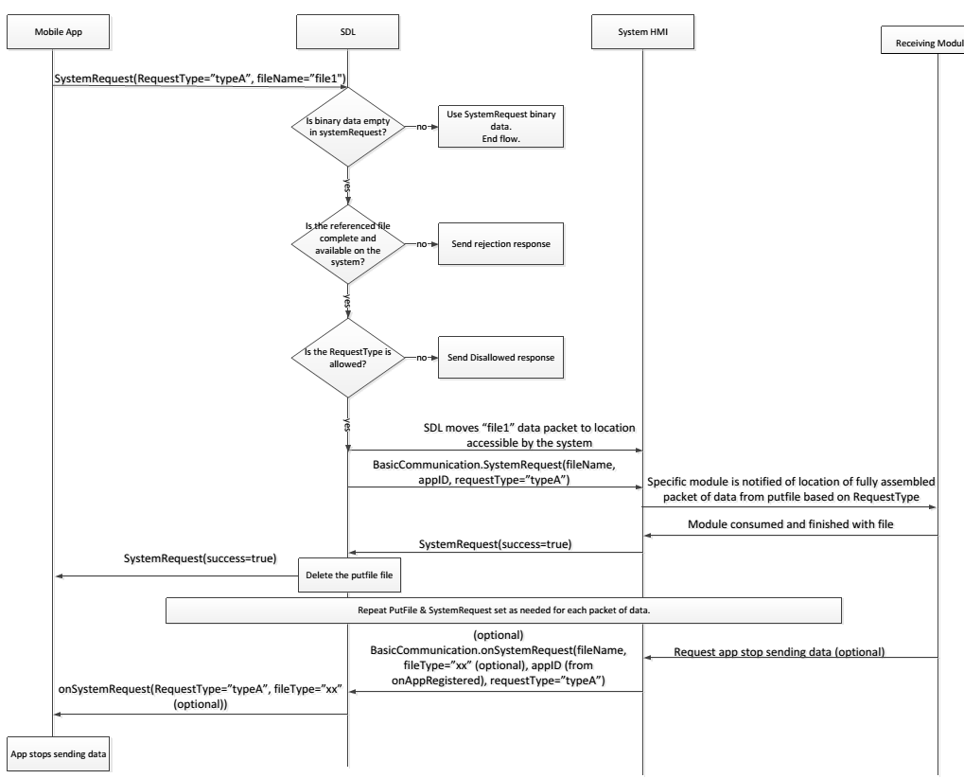

#### 6.5.4.2 SystemRequest in IVSU workflow

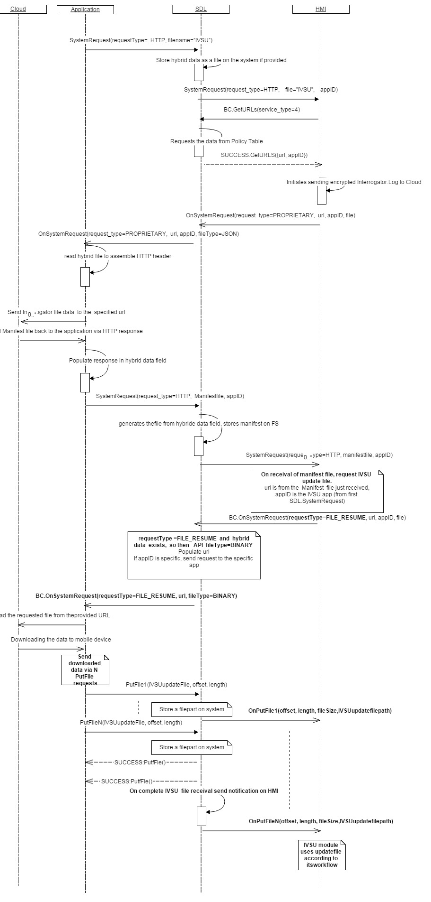

#### 6.5.4.3 SystemRequest in Policies workflow

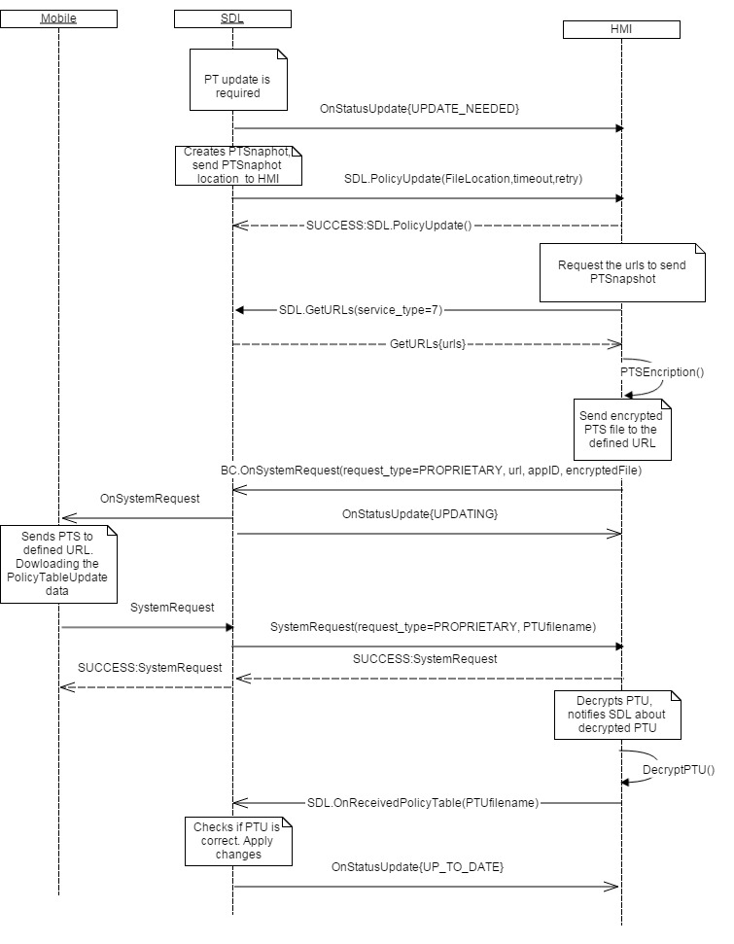

### 6.5.5 JSON Messages Examples

#### 6.5.5.1 Request

|  |
| --- |
| {  "id" : 59,  "jsonrpc" : "2.0",  "method" : "BasicCommunication.SystemRequest"  “params” :  {  "requestType" : FILE_RESUME,  "fileName" : “/tmp/fs/mp/images/ivsu_cache/123.json”,  "appID" : “824587763458”  }  } |

#### 6.5.5.2 Response

|  |
| --- |
| {  "id" : 59,  "jsonrpc" : "2.0",  "result" :  {  "code" : 0,  "method" : "BasicCommunication.SystemRequest"  }  } |

#### 6.5.5.3 Error message

|  |
| --- |
| {  "id" : 59,  "jsonrpc" : "2.0",  "error" :  {  "code" : 11,  "message" : "Invalid data",  "data" :  {  "method" : "BasicCommunication.SystemRequest"  }  }  } |

### 6.5.6 D-Bus Messages Examples

#### 6.5.6.1 Request

|  |
| --- |
|  |

#### 6.5.6.2 Response

|  |
| --- |
|  |

#### 6.5.6.3 Failure

|  |
| --- |
|  |

## 6.6 PolicyUpdate

### 6.6.1 Description

|  |  |
| --- | --- |
| **Type:** | Function |
| **Sender:** | SDL |
| **Purpose:** | Notify HMI that a new PolicyTable Snapshot is ready for encryprion and Policy Table update sequence |

### 6.6.2 Request

#### 6.6.2.1 Behavior

***HMI must:***

1. Upon getting PolicyUpdate request from SDL, read the filepath in the parameters of SDL.PolicyUpdate, find the Policy Snapshot file on a file system and encrypt its data into a new file. The format of the file must be JSON as well.
2. Request the URLs for sending encrypted Policy Snapshot to cloud ( see GetURLs API)

After getting the urls from SDL, send the encrypted file via OnSystemRequest to mobile application.

3) Clear Policy Snapshots after the successful SystemRequest with a path to UpdatedPolicyTable obtained. For more details see the diagram 6.6.4.1 PolicyUpdate

***Note:*** Both Policy tables (snapshot and update) and IVSU updates are stored in **/fs/images/ivsu_cache** folder. Nothing else apart from Policy Snapshot/Update tables and IVSU updates is stored in that folder. The path is configurable in SDL .ini file.

#### 6.6.2.2 Parameters

| **Param Name** | **Type** | **Mandatory** | **Additional** | **Description** |
| --- | --- | --- | --- | --- |
| file | String | true | minlength = 1  maxlength = 255 | Location of policy table snapshot. It’s defined in smartDeviceLink.ini as “PathToSnapshot” parameter |
| timeout | Integer | true | minvalue = 0  maxvalue = 65535 | Send attempt timeout in seconds, it’s a value from the Policy Table. |
| retry | Integer | true | array = true  minvalue = 0  maxvalue = 65535  minsize = 1  maxsize = 5 | Array of delays to wait after failed atempts, it’s a value from the Policy Table |

### 6.6.3 Response

#### 6.6.3.1 Behavior

***Note:***

*There is a difference in message type for WebSocket and D-Bus connection (see the table below).*

|  |  |  |  |  |  |
| --- | --- | --- | --- | --- | --- |
| **Result** | **Description** | **Message type** | | **Message Params** | **Notes** |
| **WebSocket** | **D-Bus** |
| Success | The information is available and provided. | JSON response | Regular response | allow,  Code: 0 | See section 6.6.3.2 |
|  | TIMED_OUT  Failed attempt by timeout to send a snapshot to backend | JSON response | Regular response | code: 10 |  |
| INVALID_DATA  Wrong json format or out of bound parameters values | code: 11 |  |
| GENERIC_ERROR  The information is not available or some failure occurred. | Code: 22 | Result code must correspond to the failure occurred. |

### 6.6.4 Sequence Diagrams

#### 6.6.4.1 PolicyUpdate

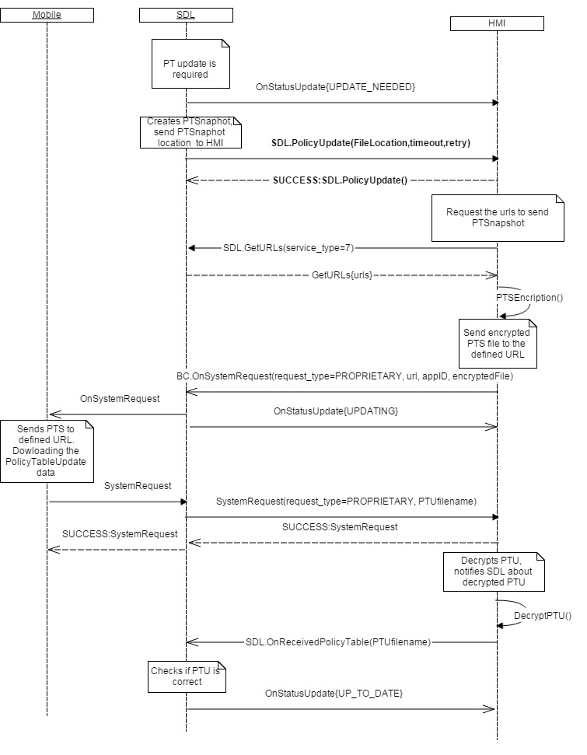

### 6.6.5 JSON Messages Examples

#### 6.6.5.1 Request

|  |
| --- |
| {  "id" : 103,  "jsonrpc" : "2.0",  "method" : "BasicCommunication. PolicyUpdate",  “params” :  {    “file” : “/tmp/fs/mp/PT.json,  "timeout" : 10000,  "retry" : 5    } |

#### 6.6.5.2 Response

|  |
| --- |
| {  "id" : 103,  "jsonrpc" : "2.0",  "result" :  {  "code" : 0,  "method" : "BasicCommunication.PolicyUpdate"  }  } |

#### 6.6.5.3 Error message

|  |
| --- |
| {  "id" : 103,  "jsonrpc" : "2.0",  "error" :  {  "code" : 11  "message" : "PT update file not found",  "data" :  {  "method" : "BasicCommunication.PolicyUpdate"  }  }  } |

### 6.6.6 D-Bus Messages Examples

#### 6.6.6.1 Request

|  |
| --- |
|  |

#### 6.6.6.2 Response

|  |
| --- |
|  |

#### 6.6.6.3 Failure

|  |
| --- |
|  |

## 6.7 GetSystemInfo

### 6.7.1 Description

|  |  |
| --- | --- |
| **Type:** | Function |
| **Sender:** | SDL |
| **Purpose:** | Get information about system information of HU.. |

Request from SDL to HMI to obtain information about head unit system main parameters. This information is used by PolicyManager for updating the policies database (see 6.7.4.1 GetSystemInfo)

### 6.7.2 Request

#### 6.7.2.1 Behavior

***HMI must:***

* Respond on BC.GetSystemInfo and provide the current values of software version of HU, language and WERS country code.

### 6.7.3 Response

***Note:***

*There is a difference in message type for WebSocket and D-Bus connection (see the table below).*

|  |  |  |  |  |  |
| --- | --- | --- | --- | --- | --- |
| **Result** | **Description** | **Message type** | | **Message Params** | **Notes** |
| **WebSocket** | **D-Bus** |
| Success | SUCCESS  The information is available and provided. | JSON response | Regular response | allow,  Code: 0 | See section 6.6.3.2 |
| Failure | DATA_NOT_AVAILABLE  Requested data or a part of the requested data isn’t available | JSON error message | Regular response | parameters which are available,  code:9 |  |
| TIMED_OUT  No response from the system within system defined timeout | code: 10 |  |
| GENERIC_ERROR  The information is not available or some failure occurred. | Code: 22 | Result code must correspond to the failure occurred. |

#### 6.7.3.1 Parameters

| **Param Name** | **Type** | **Mandatory** | **Additional** | **Description** |
| --- | --- | --- | --- | --- |
| ccpu_version | String | true | maxlength = 500 | Software version of the module |
| language | Common.Language | true | - | ISO 639-1 combined with ISO 3166 alpha-2 country code (i.e. en-us) |
| wersCountryCode | String | true | maxlength = 500 | Country code from the Ford system WERS (i.e.WAEGB). |

#### 6.7.3.2 Language Enumeration

| **Element name** | | **Value** | **Short Description** |
| --- | --- | --- | --- |
| AR-SA | | 0 | Arabic – Saudi Arabia |
| CS-CZ | | 1 | Czech – Czech Republic |
| DA-DK | | 2 | Danish – Denmark |
| DE-DE | | 3 | German – Germany |
| EN-AU | | 4 | English – Australia |
| EN-GB | | 5 | English – GB |
| EN-US | 6 | | English – US |
| ES-ES | 7 | | Spanish – Spain |
| ES-MX | 8 | | Spanish – Mexico |
| FR-CA | 9 | | French – Canada |
| FR-FR | 10 | | French – France |
| IT-IT | 11 | | Italian – Italy |
| JA-JP | 12 | | Japanese – Japan |
| KO-KR | 13 | | Korean – South Korea |
| NL-NL | 14 | | Dutch (Standard) – Netherlands |
| NO-NO | 15 | | Norwegian - Norway |
| PL-PL | 16 | | Polish – Poland |
| PT-PT | 17 | | Portuguese – Portugal |
| PT-BR | 18 | | Portuguese – Brazil |
| RU-RU | 19 | | Russian - Russia |
| SV-SE | 20 | | Swedish – Sweden |
| TR-TR | 21 | | Turkish – Turkey |
| ZH-CN | 22 | | Mandarin – China |
| ZH-TW | 23 | | Mandarin – Taiwan |

### 6.7.4 Sequence Diagrams

#### 6.7.4.1 GetSystemInfo

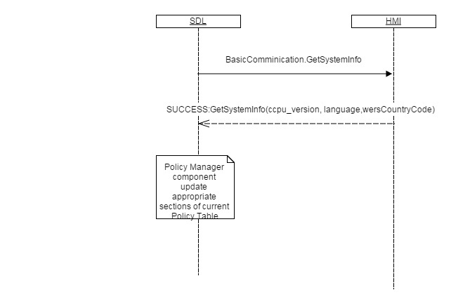

### 6.7.5 JSON Messages Examples

#### 6.7.5.1 Request

|  |
| --- |
| {  "id" : 47,  "jsonrpc" : "2.0",  "method" : "BasicCommunication.GetSystemInfo"  } |

#### 6.7.5.2 Response

|  |
| --- |
| {  "id" : 47,  "jsonrpc" : "2.0",  "result" :  {  "code" : 0,  "method" : "BasicCommunication.GetSystemInfo"  “params” :  {  "ccpu_version" : “12.1.3”,  "language" : “EN-US”,  "wersCountryCode" : “WAEGB”  }  }  } |

#### 6.7.5.3 Error message

|  |
| --- |
| {  "id" : 47,  "jsonrpc" : "2.0",  "error" :  {  "code" : 9,  "message" : " Error in fetching system information ",  "data" :  {  "method" : "BasicCommunication.GetSystemInfo"  }  }  } |

### 6.7.6 D-Bus Messages Examples

#### 6.7.6.1 Request

|  |
| --- |
|  |

#### 6.7.6.2 Response

|  |
| --- |
|  |

#### 6.7.6.3 Failure

|  |
| --- |
|  |

## 6.8 OnReady

### 6.8.1 Description

|  |  |
| --- | --- |
| **Type:** | Notification |
| **Sender:** | HMI |
| **Purpose:** | Inform about readiness to communicate. |

This is the first message in SDL-HMI communication.

***Note:*** SDL ignores all invalid notifications which come from HMI (invalid JSON, invalid data types/bounds etc)

***HMI must:***

Send this notification after the connection is established and HMI is ready for communication:

- For WebSocket connection: right after the handshake for HMI`s BasicCommunication component and its registering with SDL (see section 3.1.2 and section 3.1.3).

- For D-Bus connection: right after the service com.ford.sdl.hmi is published.

### 6.8.2 Sequence Diagrams

#### 6.8.2.1 OnReady after WebSocket connection establishment

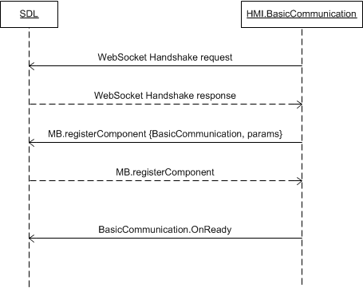

#### 6.8.2.2 OnReady after D-Bus service publishing

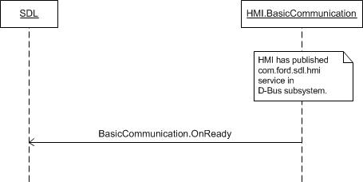

### 6.8.3 JSON Messages Examples

|  |
| --- |
| {  "jsonrpc" : "2.0",  "method" : "BasicCommunication.OnReady"  } |

### 6.8.4 D-Bus Messages Examples

#### 6.8.6.1 Request

|  |
| --- |
|  |

#### 6.8.6.2 Response

|  |
| --- |
|  |

#### 6.8.6.3 Failure

|  |
| --- |
|  |

## 6.9 OnStartDeviceDiscovery

### 6.9.1 Description

|  |  |
| --- | --- |
| **Type:** | Notification |
| **Sender:** | HMI |
| **Purpose:** | Initiate device search. |

On receipt of this notification SDL starts searching for devices on all of available transports. Afterwards, SDL provides the search results via UpdateDeviceList RPC.

***Note:*** SDL ignores all invalid notifications which come from HMI (invalid JSON, invalid data types/bounds etc)

***HMI must:***

- Provide the User with the possibility to choose the device discovery in one of accessible ways (VR, buttons, etc.).

- Send OnStartDeviceDiscovery notification when the User has chosen to search for devices.

***Note:***

*The difference:*

*- OnStartDeviceDiscovery initiates SDL to start the new search procedure*

*- OnUpdateDeviceList results SDL to provide the updates of the recent search.*

### 6.9.2 Sequence Diagrams

#### 6.9.2.1 OnStartDeviceDiscovery upon User`s request and resulting UpdateDeviceList

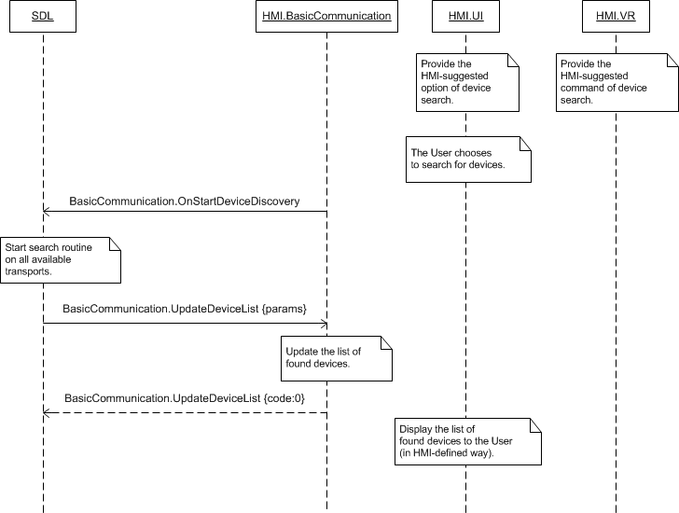

### 6.9.3 JSON Messages Examples

|  |
| --- |
| {  "jsonrpc" : "2.0",  "method" : "BasicCommunication.OnStartDeviceDiscovery"  } |

### 6.9.4 D-Bus Messages Examples

|  |
| --- |
| method call sender=:1.167 -> dest=org.freedesktop.DBus serial=12 path=/org/freedesktop/DBus; interface=org.freedesktop.DBus; member=AddMatch  string "type='signal', sender='com.ford.sdl.hmi', path='/', interface='com.ford.sdl.hmi.BasicCommunication', member='OnStartDeviceDiscovery'" |

## 6.10 OnDeviceChosen

### 6.10.1 Description

|  |  |
| --- | --- |
| **Type:** | Notification |
| **Sender:** | HMI |
| **Purpose:** | Open the connection with the named device. |

On receipt of this notification SDL opens the connection with the named device and starts session with the application(s) running on it. @TODO USB – onDevice chosen when plug-unplug

***HMI must:***

- Provide the User with the possibility to choose among the list of found devices in one of accessible ways (VR, buttons, etc.).

- Send OnDeviceChosen notification when the User has chosen the device.

***Notes:***

*The list of found devices (that HMI may provide to the User for choosing) is provided by SDL within* *UpdateDeviceList* *request.*

SDL ignores all invalid notifications which come from HMI (invalid JSON, invalid data types/bounds etc)

#### 6.10.1.1 Parameters

|  |  |  |  |
| --- | --- | --- | --- |
| **Param Name** | **Type** | **Mandatory** | **Description** |
| deviceInfo | Common.DeviceInfo | true | The information about the device chosen by the User: its name and ID.  See DeviceInfo. |

#### 6.10.1.2 DeviceInfo Structure

| **Param Name** | **Type** | **Mandatory** | **Additional** | **Description** |
| --- | --- | --- | --- | --- |
| name | String | true |  | The name of the device connected |
| id | Integer | true |  | The ID of the device connected. It remains unique during the ignition cycle. |
| transportType | Common.TransportType | false |  | The transport type the named-app's-device is connected over to HU (BlueTooth, USB or WiFi).  Always returned by SDL in OnAppRegistered and UpdateAppList RPCs. |
| isSDLAllowed | Boolean | false |  | Sent by SDL in UpdateDeviceList. ’true’ – if device is allowed for PolicyTable Exchange; ‘false’ – if device is NOT allowed for PolicyTable Exchange |

#### 6.10.1.3 TransportType Enumeration

| **Element name** | **Value** | **Short Description** |
| --- | --- | --- |
| BLUETOOTH | 0 |  |
| USB | 1 |  |
| WIFI | 2 |  |

### 6.10.2 Sequence Diagrams

#### 6.10.2.1 OnDevcieChosen with preceding UpdateDeviceList

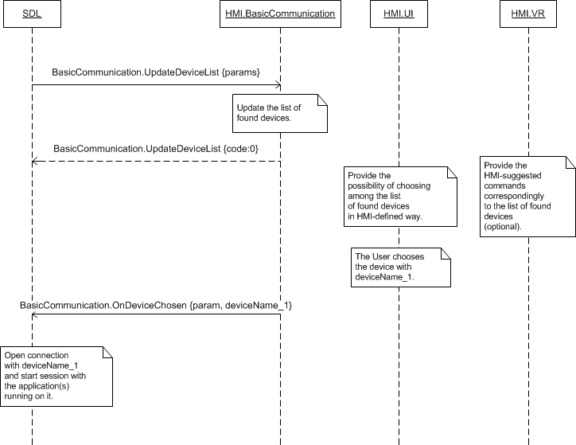

### 6.10.3 JSON Messages Examples

|  |
| --- |
| {  "jsonrpc" : "2.0",  "method" : "BasicCommunication.OnDevcieChosen",  "params" :  {  "deviceInfo" :  {  "name" : “Jerry`s Phone”,  "id" : 3  }  }  } |

### 6.10.4 D-Bus Messages Examples

#### 6.9.9.1 Request

|  |
| --- |
|  |

#### 6.9.6.2 Response

|  |
| --- |
|  |

#### 6.9.6.3 Failure

|  |
| --- |
|  |

## 6.11 OnFindApplications

### 6.11.1 Description

|  |  |
| --- | --- |
| **Type:** | Notification |
| **Sender:** | HMI |
| **Purpose:** | Initiate the search for applications on the named device. |

On receipt of this notification SDL provides the list of registered applications for the named device via UpdateAppList RPC.

***Note:*** SDL ignores all invalid notifications which come from HMI (invalid JSON, invalid data types/bounds etc)

***HMI must:***

- Send OnFindApplications notification upon User`s request (e.g. after choosing the device in the list of found devices or on definite button click)..

#### 6.11.1.1 Parameters

|  |  |  |  |
| --- | --- | --- | --- |
| **Param Name** | **Type** | **Mandatory** | **Description** |
| deviceInfo | Common.DeviceInfo | true | The information about the device chosen by the User: its name and ID.  See DeviceInfo. |

#### 6.11.1.2 DeviceInfo Structure

| **Param Name** | **Type** | **Mandatory** | **Additional** | **Description** |
| --- | --- | --- | --- | --- |
| name | String | true |  | The name of the device connected |
| id | Integer | true |  | The ID of the device connected. It remains unique during the ignition cycle. |
| transportType | Common.TransportType | false |  | The transport type the named-app's-device is connected over to HU (BlueTooth, USB or WiFi).  Always returned by SDL in OnAppRegistered and UpdateAppList RPCs. |
| isSDLAllowed | Boolean | false |  | Sent by SDL in UpdateDeviceList. ’true’ – if device is allowed for PolicyTable Exchange; ‘false’ – if device is NOT allowed for PolicyTable Exchange |

#### 6.11.1.3 TransportType Enumeration

| **Element name** | **Value** | **Short Description** |
| --- | --- | --- |
| BLUETOOTH | 0 |  |
| USB | 1 |  |
| WIFI | 2 |  |

### 6.11.2 Sequence Diagrams

#### 6.11.2.1 OnFindApplications upon User`s choice and resulting OnAppRegistered

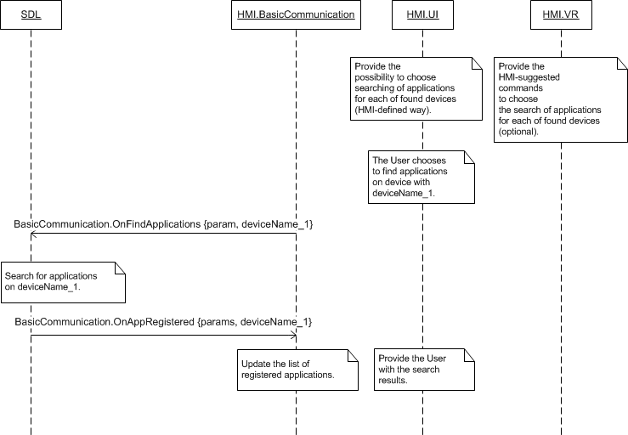

#### 6.11.2.2 OnFindApplications upon User`s choosing the device in the list of found devices and resulting OnAppRegistered

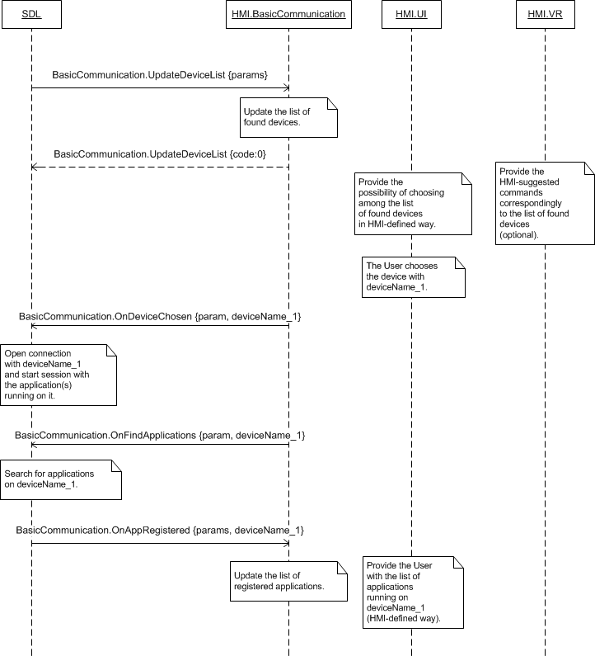

### 6.11.3 JSON Messages Examples

|  |
| --- |
| {  "jsonrpc" : "2.0",  "method" : "BasicCommunication.OnFindApplications",  "params" :  {  "deviceinfo" :  {  "name" : “XT910”,  "id" : 4  }  }  } |

### 6.11.4 D-Bus Messages Examples

#### 6.11.9.1 Request

|  |
| --- |
|  |

#### 6.11.6.2 Response

|  |
| --- |
|  |

#### 6.11.6.3 Failure

|  |
| --- |
|  |

## 6.12 OnAppActivated

### 6.12.1 Description

|  |  |
| --- | --- |
| **Type:** | Notification |
| **Sender:** | HMI |
| **Purpose:** | Inform about the User has chosen to activate the application. |

SDL requires this notification for allowing the application on mobile device to send the RPCs related to HMI`s functionality (e.g. add commands for VR, start interaction with the User, speak the text via TTS, etc.).

On coming of OnAppActivated notification SDL provides ActivateApp RPC confirming the named application may be activated.

***HMI must:***

- Send OnAppActivated notification when the User chooses (in one of HMI-suggested ways).to activate the application on HMI.

- Wait for ActivateApp RPC and only then display the named application related screen.

***Notes:***

*The information about the application (name, ID, etc.) is provided by SDL via either* *UpdateAppList* *or OnAppRegistered RPCs.*

SDL ignores all invalid notifications which come from HMI (invalid JSON, invalid data types/bounds etc)

***Note:***

*The difference:*

*- OnAppActivated shows User`s intension to activate the named application.*

*- ActivateApp is SDL`s request and permission for the named application to be granted with the access to HMI`s functionality.*

#### 6.12.1.1 Parameters

|  |  |  |  |
| --- | --- | --- | --- |
| **Param Name** | **Type** | **Mandatory** | **Description** |
| appID | Integer | true | ID of the application to be activated on HMI. |

### 6.12.2 Sequence Diagrams

#### 6.12.2.1 OnAppActivated upon User`s choice and resulting ActivateApp

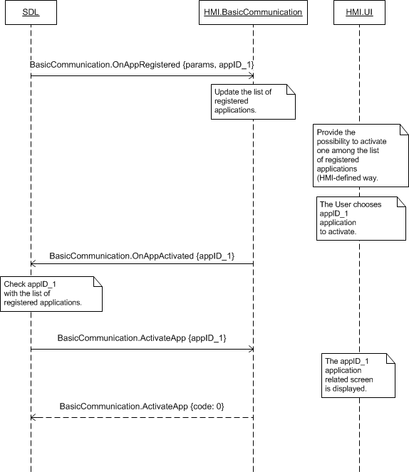

### 6.12.3 JSON Messages Examples

|  |
| --- |
| {  "jsonrpc" : "2.0",  "method" : "BasicCommunication.OnAppActivated",  "params" :  {  "appID" : 65544  }  } |

### 6.12.4 D-Bus Messages Examples

#### 6.12.9.1 Request

|  |
| --- |
|  |

#### 6.12.6.2 Response

|  |
| --- |
|  |

#### 6.12.6.3 Failure

|  |
| --- |
|  |

## 6.13 OnAppDeactivated

### 6.13.1 Description

|  |  |
| --- | --- |
| **Type:** | Notification |
| **Sender:** | HMI |
| **Purpose:** | Inform about the application is no longer active on HMI. |

SDL requires this notification for restricting the application on mobile device from sending the RPCs related to HMI`s functionality (e.g. adding commands for VR, starting interaction with the User, speaking the text via TTS, etc.)..

On receipt of OnAppDeactivated SDL deletes the application-related temporary data (e.g. VR commands, UI submenus/commands, changes VR/TTS properties to default ones, etc.) using the appropriate RPCs described in the current document.

***HMI must:***

- Send OnAppDeactivated notification when the User has navigated away from the application persistent screen.

***Note:***

*The information about the application (name, ID, etc.) is provided by SDL via either* *UpdateAppList* *or OnAppRegistered RPCs.*

SDL ignores all invalid notifications which come from HMI (invalid JSON, invalid data types/bounds etc)

#### 6.13.1.1 Parameters

|  |  |  |  |
| --- | --- | --- | --- |
| **Param Name** | **Type** | **Mandatory** | **Description** |
| appID | Integer | true | ID of the application deactivated. |
| reason | Common.DeactivateReason | true | Specifies the functionality the User has switched to.  See DeactivateReason. |

#### 6.13.1.2 DeactivateReason Enumeration

| **Element name** | **Short Description** |
| --- | --- |
| AUDIO | The User has navigated to audio (radio, etc.) |
| PHONECALL | The User has navigated to make a call. |
| NAVIGATIONMAP | The User has navigated to navigation screen. |
| PHONEMENU | The User has navigated to phone menu. |
| SYNCSETTINGS | The User has navigated to HU settings menu. |
| GENERAL | Other screens navigation apart from other mobile app. |

### 6.13.2 Sequence Diagrams

#### 6.13.2.1 OnAppDeactivated Simple Messaging Example

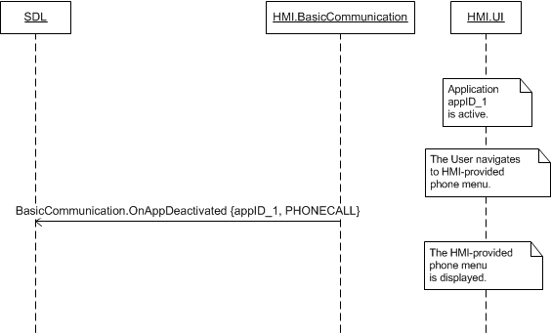

#### 6.13.2.1 OnAppDeactivated with preceding registering, activation, adding UI/VR commands and resulting deleting UI/VR commands

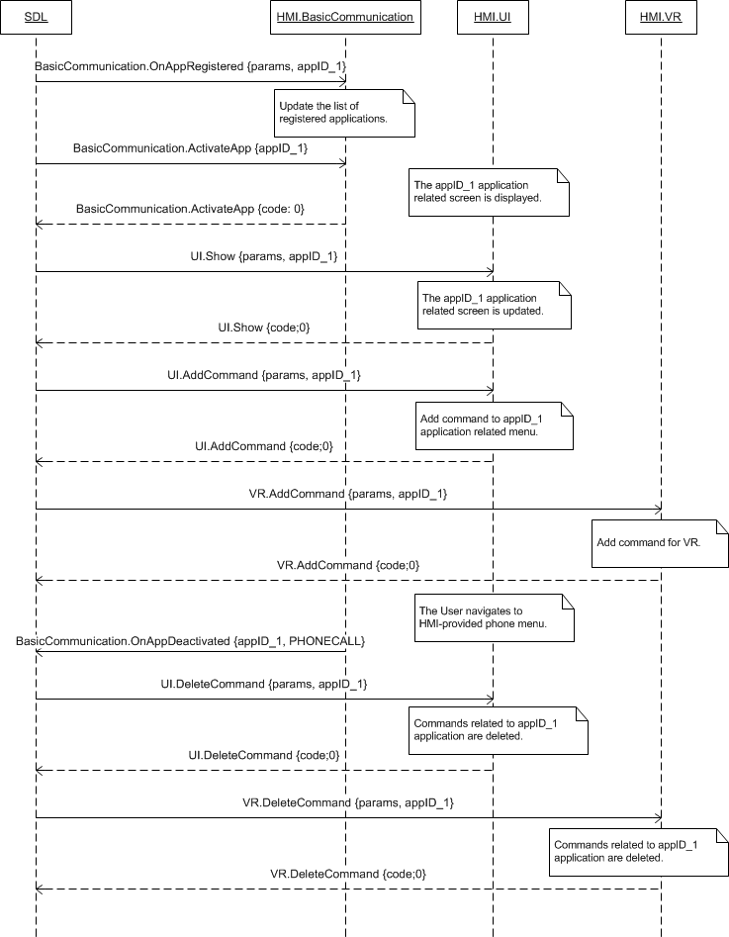

### 6.13.3 JSON Messages Examples

|  |
| --- |
| {  "jsonrpc" : "2.0",  "method" : "BasicCommunication.OnAppDeactivated",  "params" :  {  "appID" : 65544,  “reason” : PHONECALL  }  } |

### 6.13.4 D-Bus Messages Examples

|  |
| --- |
| signal sender=:1.151 -> dest=(null destination) serial=60 path=/;  interface=com.ford.sdl.hmi.BasicCommunication;  member=OnAppDeactivated  int32 65537  int32 5 |

## 6.14 OnAppRegistered

### 6.14.1 Description

|  |  |
| --- | --- |
| **Type:** | Notification |
| **Sender:** | SDL |
| **Purpose:** | Update the HMI`s list of registered applications and resume the Audio Source on HMI. |

SDL may send the notification:

- After SDL-enabled application has registered itself on SDL successfully (either for the very 1st time or registered in previous ignition cycles). - When the device was re-connected to HU after unexpected disconnect/ and previously registered SDL-enabled application has re-registered on SDL successfully. SDL makes decision if data resumption process is applicable for the application

- Upon User`s request delivered by HMI via OnFindApplications notification, in case any new applications are registered.

**Note:** SDL sends the list of RequestTypes allowed by Policies via OnAppRegistered API. In case HMI sends OnSystemRequest with a RequestType disallowed by PolicyTable, SDL will ignore it).

***Note about Data resumption:***

Data resumption means that app may request to restore data operated in the previous ign cycle(s)/after unexpected disconnect. .

* *For data resumption purposes SDL must keep storing such application-related data like commands, application global properties and show data during three ignition cycles after unexpected disconnect or ignition off. Upon the forth “Ignition On” SDL clears all corresponding-application-related data for resumption.*
* *HMI must store only Vrgrammars compiled for the applications ungeristered by unexpected disconnect or Ignotion Off*

*If the application resumes data successfully*

* *SDL will provide OnAppRegistered with* resumeVrGrammars*:true to notify HMI about VRGrammars must be resumed*
* *SDL must restore application-related data:*

*• AddCommand (Menu +VR)*

*• AddSubMenu*

*• CreateInteractionChoiceSet*

*• SetGlobalProperties*

*• SubscribeButton*

*• SubscribeVehicleData*

* *SDL must send the following restored data to HMI right after OnAppRegistered notification sent:*

*• AddCommand (Menu only)*

*• AddSubMenu*

*• CreateInteractionChoiceSet*

*• SetGlobalProperties*

*• SubscribeButton*

*• SubscribeVehicleData*

* *HMI is notified about application resumption case via OnAppRegistered with* resumeVrGrammars*:true . On this event, HMI must restore the application related VRGrammars previously stored for the application with appID received in OnAppRegistered notification*

*If the application does NOT resume data successfully:*

* SDL will provide OnAppRegistered with *resumeVrGrammars:false* or no resume parameter
* SDL cleans up all previously stored application data for the application that failed to resume its dataHMI must clean up previously compiled VRGrammars for the application with appID received via *OnAppRegistered* notification

After failed data resumption, application will send new data required for its operation through SDL to HMI. In this case a new cycle of collecting app's data for resumption must begin on both SDL and HMI sides

***Impotant:***

When the application is registering after unexpected disconnect or Ignition Off, not only the application data but Active Source may be resumed on HMI. These data and audio source resumption processes are independent to each other. To review the cases of AudioSource resumption refer to BC.OnResumeAudioSource and BC.OnAppActivated chapters.

***HMI must:***

- Update its list of registered applications.

- Store the application data sent with applications parameter (application name, icon, name of corresponding device, appID and etc. that is described in section 6.14.1.2 HMIApplication).

***Note:*** The value of appID provided by SDL will be the same between registrations only in case of "resumeVrGrammers:true". Otherwise, SDL provides different appIDs for one and the same application between the registration- Remember the value of ttsName parameter and speak this information (which is the application name) when the User speaks ‘Help’ in the VR layer that corresponds ‘the list of registered applications’ on UI.

- Compile and store VRGrammars for vrSynonyms parameter and use them when arranging the possibility for the User to choose among the registered applications by VR. The commands must be accessible on the layer correspondent to the following entries on UI:

* The list of registered applications
* Any active application (that is, HMI must provide the possibility to activate any of registered applications by VR if anyother application is currently active).

- Provide the User with the possibility to choose among registered applications on UI.

***Note:***

*HMI must provide OnAppActivated with the corresponding appID whenever the User activates the application from UI or via VR.*

- Use appID provided via notification when use other API (e.g. OnAppActivated, OnCommand and other) related to the corresponding application on SDL.

#### 6.14.1.1 Parameters

|  |  |  |  |  |
| --- | --- | --- | --- | --- |
| **Param Name** | **Type** | **Mandatory** | **Additional** | **Description** |
| application | Common.HMIApplication | true | - | The parameter contains the detailed information about each application: its name, ID, type and other.  See HMIApplication.  ***Note:*** *the value of appID for one and the same application most often varies between ignition cycles but is obligatory the same within reconnections.* |
| ttsName | Common.TTSChunk | false | Array = true  Minsize = 1  Maxsize = 100 | App’s name for Text to Speech system. HMI must speak app’s name when the User speaks ‘Help’ to VR module |
| vrSynonyms | String | false | Array = true  Minsize = 1  Maxsize = 100  Maxlength = 40 | Voice recognition commands that HMI must use when arranging the possibility for the User to choose among the registered applications by VR.  The commands must be accessible on the layer correspondent to:  - UI: ‘list of registered applications’  - UI: any active application (that is, HMI must provide the possibility to activate any of registered applications by VR when whichever another application is currently active).  @TODO toClarifyWhen any of provided commands is recognized (that is, application is chosen by VR), HMI must send OnAppActivated with the corresponding appID to SDL. |
| resumeVrGrammars | Boolean | false | - | Informs whether the application-related VR grammars must be restored. |
| priority | Common.AppPriority | false | - | Send to HMI so that it can coordinate order of requests/notifications |

#### 6.14.1.2 HMIApplication Structure

| **Param Name** | **Type** | **Mandatory** | **Additional** | **Description** |
| --- | --- | --- | --- | --- |
| appName | String | true | Maxlength = 100 | The mobile application name. It is unique over all applications. |
| ngnMediaScreenAppName | String | false | Maxlength = 100 | Provides an abbreviated version of the application name (may be displayed on the NGN media screen).  If not provided, the appName should be used instead (and may be truncated if too long) |
| icon | String | false | – | Path to the application icon stored on HU hard disc. |
| deviceInfo | Common.DeviceInfo | true | – | The ID, serial number, transport type the named-app's-device is connected over to HU. |
| policyAppID | String | true | minlength="1"  maxlength="50" | Policy appID the ID the app is registrering with and recognized by policy table |
| appID | Integer | true | – | The application ID that remains unique during the ignition cycle.  This ID will be sent by SDL further and must be provided by HMI within all the RPCs related to this application. |
| hmiDisplayLanguageDesired | Common.Language | false | – | The language that the application intends to use.  See Language. |
| isMediaApplication | Boolean | false | – | Indicates whether the application is a media or a non-media one.  Only media applications are allowed by SDL to stream audio to HU that is audible outside of the BT media source. |
| appType | Common.AppHMIType | false | array = true Minsize = 1 maxsize = 100 | The HMI may use this information for determining what functionality should be available for the application (e.g. navigation type of application will require displaying the information and not playing the audio).  See AppHMIType. |
| requestType | Common.RequestType | false | Minsize = 0  Maxsize =100  array="true" | The list of SystemRequest's RequestTypes allowed by policies for the named application  (The app's SystemRequest sent with RequestType out of this list will get 'disallowed' response from SDL).  If SDL sends an empty array - any RequestType is allowed for this app.  If SDL omits this parameter - none RequestType is allowed for this app  (either this is a pre-registered app or such is dictated by policies). |

#### 6.14.1.3 AppHMIType Enumeration

| **Element name** | **Short Description** |
| --- | --- |
| DEFAULT | The application of default type. |
| COMMUNICATION | The application for communication |
| MEDIA | The media application |
| MESSAGING | The application of messaging type |
| NAVIGATION | The application of navigation type |
| INFORMATION | The application of information type |
| SOCIAL | The application of social type |
| BACKGROUND_PROCESS | The application does not require displaying the information |
| TESTING | The application of testing type |
| SYSTEM | The application of system type |

#### AppPriority Enumeration

| **Element name** | **Value** | **Short Description** |
| --- | --- | --- |
| EMERGENCY | 0 |  |
| NAVIGATION | 1 |  |
| VOICE_COMMUNICATION | 2 |  |
| COMMUNICATION | 3 |  |
| NORMAL | 4 |  |
| NONE | 5 |  |

#### RequestType

| **Element name** | **Value** | **Short Description** |
| --- | --- | --- |
| HTTP | 0 |  |
| FILE_RESUME | 1 |  |
| AUTH_REQUEST | 2 |  |
| AUTH_CHALLENGE | 3 |  |
| AUTH_ACK | 4 |  |
| PROPRIETARY | 5 |  |
| QUERY_APPS | 6 |  |
| LAUNCH_APP | 7 |  |
| LOCK_SCREEN_ICON_URL | 8 |  |
| TRAFFIC_MESSAGE_CHANNEL | 9 |  |
| DRIVER_PROFILE | 10 |  |
| VOICE_SEARCH | 11 |  |
| NAVIGATION | 12 |  |
| PHONE | 13 |  |
| CLIMATE | 14 |  |
| SETTINGS | 15 |  |
| VEHICLE_DIAGNOSTICS | 16 |  |
| EMERGENCY | 17 |  |
| MEDIA | 18 |  |
| FOTA | 19 |  |

#### 6.14.1.6 DeviceInfo Structure

| **Param Name** | **Type** | **Mandatory** | **Additional** | **Description** |
| --- | --- | --- | --- | --- |
| name | String | true |  | The name of the device connected |
| id | Integer | true |  | The ID of the device connected |
| transportType | Common.TransportType | false |  | The transport type the named-app's-device is connected over to HU (BlueTooth, USB or WiFi).  Always returned by SDL in OnAppRegistered and UpdateAppList RPCs. |
| isSDLAllowed | Boolean | false |  | Sent by SDL in UpdateDeviceList. ’true’ – if device is allowed for PolicyTable Exchange; ‘false’ – if device is NOT allowed for PolicyTable Exchange |

#### 6.14.1.7 TransportType Enumeration

| **Element name** | **Value** | **Short Description** |
| --- | --- | --- |
| BLUETOOTH | 0 |  |
| USB | 1 |  |
| WIFI | 2 |  |

### 6.14.2 Sequence Diagrams

#### 6.14.2.1 OnAppRegistered with resume=true after unexpected disconnect

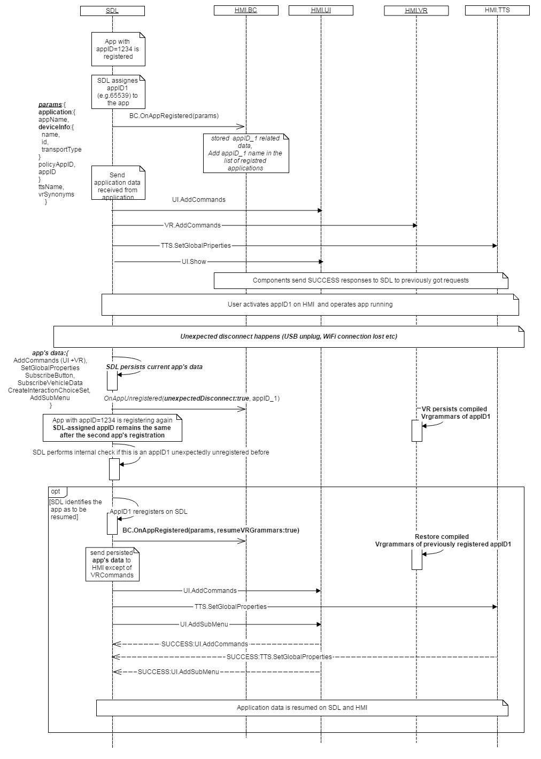

#### 6.14.2.2 OnAppRegistered with ‘resume’=false parameter after unexpected disconnect

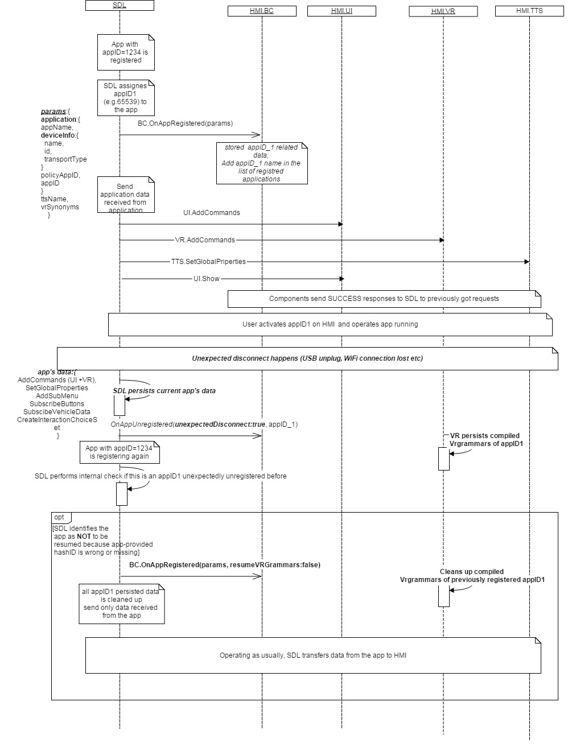

### 6.14.3 JSON Messages Examples

|  |
| --- |
| {  "jsonrpc" : "2.0",  "method" : "BasicCommunication.OnAppRegistered",  "params" :  {  "application" :  {  "appName" : “TryMe”,  "ngnMediaScreenAppName " : “TryMe”,  "deviceInfo":  { "name" : “GT-I9300”,  "id" : 1563462,  "transportType" : “BLUETOOTH”  },  "policyAppID" : 123,  "appID" : 65540,  "hmiDisplayLanguageDesired" : ES-ES,  "isMediaApplication" : false  }  “resumeVRGrammars” : true  }  } |

### 6.14.4 D-Bus Messages Examples

|  |
| --- |
| signal sender=:1.196 -> dest=(null destination) serial=100 path=/; interface=com.ford.sdl.core.BasicCommunication; member=OnAppRegistered  struct {  string "Hugo"  struct {  boolean true  string "Hugo"  }  struct {  boolean true  string ""  }  string "127.0.0.1"  int32 65538  int32 0  boolean true  struct {  boolean false  array [  ]  }  } |

## 6.15 OnAppUnregistered

### 6.15.1 Description

|  |  |
| --- | --- |
| **Type:** | Notification |
| **Sender:** | SDL |
| **Purpose:** | Inform about the application has unregistered. |

SDL sends this notification when

- The named application has unregistered from the side of mobile device via appropriate RPC

- The connection and the corresponding session(s) are closed due to transport issues (for example, WiFi/BT connection closing on mobile device, USB unplugging, etc.).

- The HeartBeat Timeout between mobile application and SDL occurs (one of SDL or application does not respond with HeartBeat message during timeout defined in *smartDeviceLink.ini* file, thus the session is closed by the responsible side).

- The User chooses the ‘Master Reset’ or ‘Factory Defalts’ options on HMI. See OnExitAllApplications (MASTER_RESET and FACTORY_DEFAULTS) for more details

- The User ends the key-on session (that is, ignition cycle is over). See OnExitAllApplications (IGNITION_OFF) for more details.

1. ***HMI must:***Distinguish ‘unexpected disconnect’ and ‘regular exit’ events by "unexpectedDisconnect" parameter:
   1. In case of **"unexpectedDisconnect: true”** arrives for the active app: HMI must

a) Display the informational HMI-defined popup of the kind: “The connection with “%AppName%” application has been unexpectedly lost”.

b) Switch the display to HMI-defined screen/page (e.g. ‘Home’ page, screen showing the list of registered applications, etc.).

* 1. In case **"unexpectedDisconnect: false”**: HMI must proceed with step 2.

1. Switch the display to HMI-defined screen/page (e.g. ‘Home’ page, screen showing the list of registered applications, etc.) if the named application is active when this notification comes. .
2. Remove the named application from the list of registered applications.
3. Delete all the data related to this application.

***Note:***

*The information about the application (name, ID, etc.) is provided by SDL via either* *UpdateAppList* *or* *OnAppRegistered* *RPCs.*

#### 6.15.1.1 Parameters

|  |  |  |  |
| --- | --- | --- | --- |
| **Param Name** | **Type** | **Mandatory** | **Description** |
| appID | Integer | true | ID of the application having been unregistered. |
| unexpectedDisconnect | Boolean | true | Defines whether the connection with the app was unexpectedly lost or this was the regular app`s exit. |

### 6.15.2 Sequence Diagrams

#### 6.15.2.1 OnAppUnregistered of active application

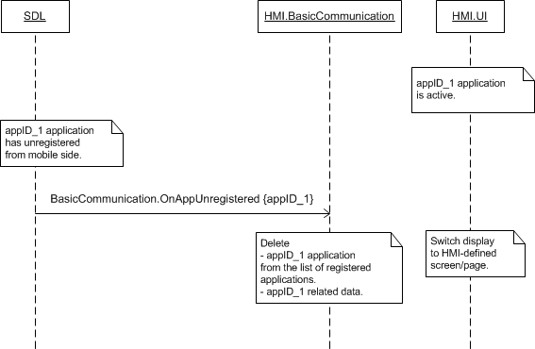

### 6.15.3 JSON Messages Examples

|  |
| --- |
| {  "jsonrpc" : "2.0",  "method" : "BasicCommunication.OnAppUnregistered",  "params" :  {  "appID" : 65539,  “unexpectedDisconnect”:”false”  }  } |

### 6.15.4 D-Bus Messages Examples

|  |
| --- |
|  |

## 6.16 OnExitApplication

### 6.16.1 Description

|  |  |
| --- | --- |
| **Type:** | Notification |
| **Sender:** | HMI |
| **Purpose:** | Inform SDL that an application must be unregistered/put to NONE because of some specified reason on HMI |

***HMI must:***

1) Provide the possibility for the User to EXIT any of registered applications (e.g. by HMI-defined button, VR command, etc.).

2) Track that the application being active or in background on HMI complies with the DRIVER DISTRACTION rules of the system

3) Track if the transport type is correspondent to the application running (Navigation applications aren’t allowed to be run on Bluetooth transport)

4) Ignore all SDL API after defining the application as prohibited to be run on specified transport type

-5) Send OnExitApplication notification to SDL when

a) The User choses to exit the application in one of HMI-suggested ways.

b) Some of DRIVER DISTRACTION rules applied on the system and require to swich the application into HMI NONE level

c) Navigation application is registered via BT transport type not allowed to be used for this type ofthe applications

6) Deactivate the application with DeactivateReason specified according to HMI workflow right after sending OnExitApplication notification to SDL

***Note:***

*- The information about the application (name, ID, etc.) is provided by SDL via either UpdateAppList or OnAppRegistered RPCs.*

- SDL ignores all invalid notifications which come from HMI (invalid JSON, invalid data types/bounds etc)

#### 6.16.1.1 Parameters

|  |  |  |  |
| --- | --- | --- | --- |
| **Param Name** | **Type** | **Mandatory** | **Description** |
| reason | Common. ApplicationExitReason | true | The reason why the named application should be unregistered/put to NONE HMI Level |
| appID | Integer | true | ID of the application chosen to be unregistered/put to NONE. |

#### 6.16.1.2 ApplicationExitReason

| **Element name** | **Value** | **Short Description** |
| --- | --- | --- |
| DRIVER_DISTRACTION_VIOLATION | 0 | Driver distraction rules violating observed. On getting this value, SDL puts the named app to NONE HMILevel</description |
| USER_EXIT | 1 | User made Exit choice for the named application on HMI. On getting this value, SDL puts the named app to NONE HMILevel |
| **UNAUTHORIZED_TRANSPORT_REGISTRATION** | 2 | On getting this value, SDL unregisters the named application because tansport type is not compatible with the application which uses it |

### 6.16.2 Sequence Diagrams

#### 6.16.2.1 OnExitApplication USER_EXIT

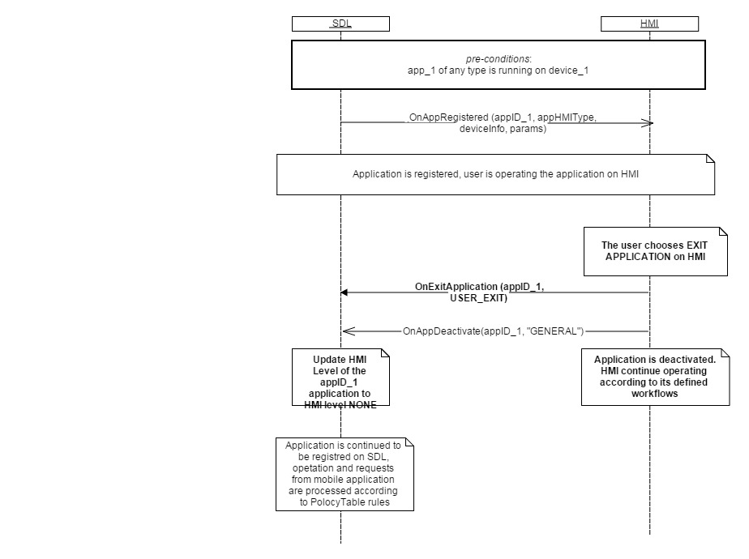

#### 6.16.2.2 OnExitApplication UNAUTHORIZED_TRANSPORT_REGISTRATION

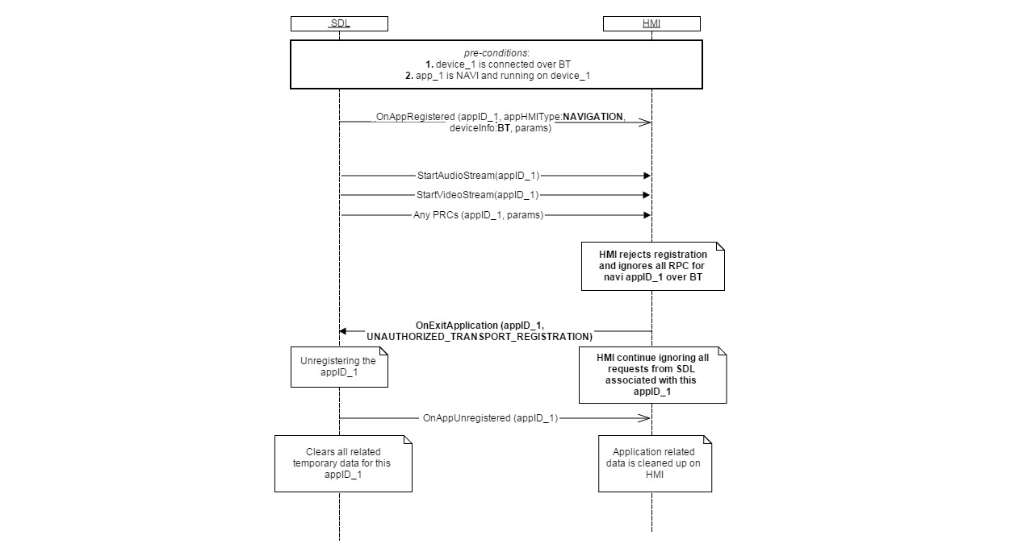

### 6.16.3 JSON Messages Examples

|  |
| --- |
| {  "jsonrpc" : "2.0",  "method" : "BasicCommunication.OnExitApplication",  "params" :  {  "appID" : 65544,  “reason” : “USER_EXIT”  }  } |

### 6.16.4 D-Bus Messages Examples

|  |
| --- |
|  |

## 6.17 OnExitAllApplications

### 6.17.1 Description

|  |  |
| --- | --- |
| **Type:** | Notification |
| **Sender:** | HMI |
| **Purpose:** | Inform about the event that causes exit of all applications. |

SDL requires this notification to accurately close the sessions with the registered applications before reloading/shutting down by the reason of User`s actions.

***HMI must:***

- Send the notification upon one of the following results of User`s actions:

* Key off
* Master reset
* Return to factory defaults.

***Note:*** SDL ignores all invalid notifications which come from HMI (invalid JSON, invalid data types/bounds etc)

#### 6.17.1.1 Parameters

|  |  |  |  |
| --- | --- | --- | --- |
| **Param Name** | **Type** | **Mandatory** | **Description** |
| reason | Common.ApplicationsCloseReason | true | The reason for exiting all the applications.  See ApplicationsCloseReason. |

#### 6.17.1.2 ApplicationsCloseReason Enumeration

| **Element name** | **Short Description** |
| --- | --- |
| IGNITION_OFF | Key off. |
| MASTER_RESET | Master reset. |
| FACTORY_DEFAULTS | Return to factory defaults. |
| SUSPEND | Notifies SDL to perform persistence of data for resumption. |

### 6.17.2 Sequence Diagrams

#### 6.17.2.1 OnExitAllApplications

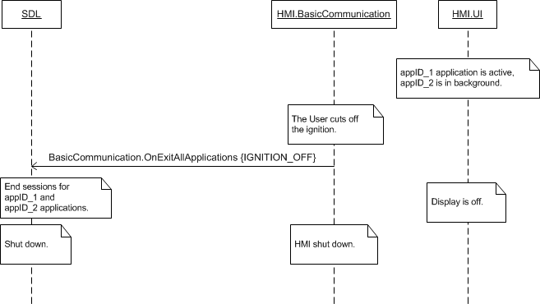

### 6.17.3 JSON Messages Examples

|  |
| --- |
| {  "jsonrpc" : "2.0",  "method" : "BasicCommunication.OnExitAllApplications",  "params" :  {  "reason" : IGNITION_OFF  }  } |

### 6.17.4 D-Bus Messages Examples

|  |
| --- |
|  |

## 6.18 PlayTone

### 6.18.1 Description

|  |  |
| --- | --- |
| **Type:** | Notification |
| **Sender:** | SDL |
| **Purpose:** | Play HMI standard notifying sound. |

This notification may follow some SDL request that brings changes on HMI and is desirable to be noticed or reacted by the User (e.g. alert message displayed, audio capturing started, etc.).

### 6.18.2 Request

#### 6.18.2.1 Parameters

***HMI must:***

- Play HMI standard notifying sound for appropriate type of the request which is defined in “methodName’. parameter

|  |  |  |  |
| --- | --- | --- | --- |
| **Param Name** | **Type** | **Mandatory** | **Description** |
| appID | Integer | true | ID of the application that invoked this notification |
| methodName | Common.MethodName | true | Defines the type of the request which initiates playing a tone |

#### 6.18.2.2 MethodName

| **Element name** | **Value** | **Short Description** |
| --- | --- | --- |
| ALERT | 0 | Defines that “Alert” mobile request initiates a current PlayTone |
| SPEAK | 1 | Defines that “Speak” mobile request initiates a current PlayTone |
| AUDIO_PASS_THROUGH | 2 | Defines that “PerformAudioPassThru” mobile request which initiates a current PlayTone |
| ALERT_MANEUVER | 3 | Defines the type of the mobile API request (AlertMeneuver mobile API) which initiates the request on HMI e.g. (TTS.Speak, BC.PlayTone) |

### 6.18.3 Response

***Note:***

*There is a difference in message type for WebSocket and D-Bus connection (see the table below).*

|  |  |  |  |  |  |
| --- | --- | --- | --- | --- | --- |
| **Result** | **Description** | **Message type** | | **Message Params** | **Notes** |
| **WebSocket** | **D-Bus** |
| Success | SUCCESS | JSON response | Regular response | allow,  Code: 0 | See section 6.6.3.2  The information is available and provided. |
| Failure | INVALID_DATA | JSON error message | Regular response | Code: 11 | appID is out of range |
| APPLICATION_NOT_REGISTERED/INVALID_ID | Code:15/13 | The app with the appID doesn’t exist on HMI |
| OUT_OF_MEMORY | Code: 17 |  |
| GENERIC_ERROR | Code: 22 | Some failure occurred. |

### 6.18.4 Sequence Diagrams

#### 6.18.4.1 PlayTone with Alert request

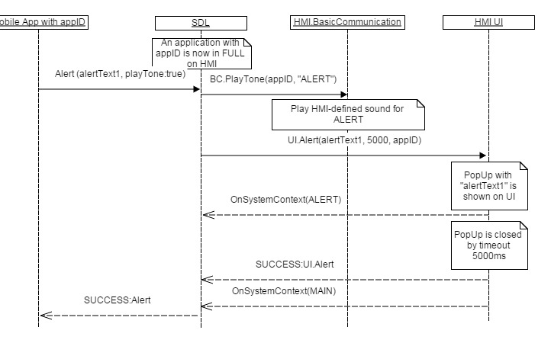

### 6.18.5 JSON Messages Examples

#### 6.18.5.1 Request

|  |
| --- |
| {  "jsonrpc" : "2.0",  "method" : "BasicCommunication.PlayTone"  "params" :  {  "appID" : 123,  “methodName”: “ALERT”  }  } |

#### 6.18.5.2 Response

|  |
| --- |
| {  "id" : 47,  "jsonrpc" : "2.0",  "result" :  {  "code" : 0,  "method" : "BasicCommunication. PlayTone"  }  } |

#### 6.18.5.3 Error message

|  |
| --- |
| {  "id" : 47,  "jsonrpc" : "2.0",  "error" :  {  "code" : 22,  "message" : " Unknown system error",  "method" : "BasicCommunication.PlayTone"  }  } |

### 6.18.5 D-Bus Messages Examples

|  |
| --- |
|  |

## 6.19 OnSystemRequest

### 6.19.1 Description

|  |  |
| --- | --- |
| **Type:** | Notification |
| **Sender:** | HMI |
| **Purpose:** | A request to mobile app for initiating the download of data. |

Thre’re 2 types of using OnSystemRequest:

* As an asynchronous request from the system for a specific data from the device or the cloud
* As a response to a request from the device or cloud. Binary data can be included in hybrid part of message for some requests (such as Authentication request responses)

RequestType defines the type of the requested data from a mobile device or a cloud. The module may request this data but it’s SDL’s responsibility to block SystemRequest in case it intends to transfer the data of the type not allowed by Policy Table.

To inform HMI about requestTypes allowed the following HMI_API commands are also used:

* OnAppPermissionChanged – sent from SDL to HMI when a PT update comes in and changes the app policy.
* OnAppRegistered – sent from SDL to HMI when an app registers with SDL

**Note** In case HMI sends OnSystemrequest with a RequestType disallowed by PolicyTable, SDL will ignore it.

Also SDL ignores all invalid notifications which come from HMI (invalid JSON, invalid data types/bounds etc)

***HMI must:***

* Send OnSystemRequest in case some specific data is requested from mobile device/cloud or some binary data need to be sent to mobile side

***Important (IVSU workflow):***

In Vehicle Software Update Module may request updates from the Cloud. OnSystemRequst is a part of this sequence. For more details see the sequence below and 6.19.2.2 OnSystemRequest in IVSU workflow):

1. ***Mobile Proxy***
2. Sends a mobile API SystemRequest to SDLwith requestType=HTTP,filename=”IVSU”
3. ***SDL***
4. Receives SystemRequest from mobile device.
5. Store hybrid data as a file on the system with the file name provided.
6. Send BasicCommunication.SystemRequest(request_type=HTTP, file=”IVSU”,appID) where

appID is the app’s ID that it registered with

1. ***SYNCP***
2. Receives SDL.SystemRequest
3. Requests the list of URLs to request the file *BC.GetURLs(service_type=4)*
4. ***SDL***
5. Responds to BC.GetURLs with an array of serviceInfo data structs (url,appID).

url and appID pairs are the result of querying the policy table

1. ***SYNCP***
2. Encode, sign and encrypt InterrogatorLog file
3. Sends the InterrogatorLog to the Cloud via

BC.OnSystemRequest(request_type=PROPRIETARY,url,appID, InterrogatorLog)

url is from BC.GetURLs

appID is from first BC.SystemRequest (3a)

1. ***SDL***

a) Receives BC.OnSystemRequest(request_type,url, appID, InterrogatorLog)

b) Convert the request into the mobile smartObject request using the following logic:

1. If the requestType=PROPRIETARY, add to mobile API fileType=JSON

2. If the requestType=HTTP, add to mobile API fileType = BINARY

1. Place “file” data into hybrid portion of mobile packet and populate url
2. If appID is “default”, send request to any connected mobile app

If appID is specific, send request to the specific app

1. ***Mobile Proxy***

*a) Receive OnSystemRequest notification and read the hybrid data.*

*If requestType=PROPRIETARY and fileType=JSON, read hybrid file to assemble HTTP header, and pass along “body” information to the URL*

1. ***Cloud***

*a) Sends to mobile* HTTP response with data

1. ***Mobile Proxy***

*a)* Receives HTTP response with data.

b) Populate response in hybrid data field and send SystemRequest to SD

1. ***SDL***

*a) SDL receives SystemRequest from mobile device.*

*If there is hybrid data, store it as a file on the system with the file name provided.*

1. *Send BC.SystemRequest(request_type=HTTP,file,appID)*

*file is generated by SDL appID is the app’s ID that it registered with*

1. ***SYNCP***

a) Decodes and decrypts the contents of filename identifies the service type as 4 and notifies IVSU component

b) IVSU Component/SYNCP Manager sends BC.OnSystemRequest(requestType=FILE_RESUME,url,appID,file) to SDL.

url is from the manifest file

appID is the IVSU app from (3a) SDL.SystemRequest

1. ***SDL***
2. Receives BasicCommunication.OnSystemRequest(request_type,url,appID,file) and will
   1. convert the request into the mobile smartObject request using the following logic:
3. If requestType=FILE_RESUME and hybrid data exists, add mobile API fileType=BINARY
4. Populate url
5. If appID is specific, send request to the specific app.
6. ***Mobile Proxy***
7. Receive OnSystemRequest notification
8. If requestType=FILE_RESUME, begin downloading from URL provided
9. Upon file download send mobile API PutFile with data bytes
10. ***SDL***
11. Receive PutFile and notify IVSU component
12. If hybrid data exists, store it as a file on the system with the file name provided
13. Send BasicCommunication.OnPutFile(offset, length, fileSize, file)

Offset is from mobile proxy API

length is calculated by SDL and is the total size of the data chunk

fileSize is optional (only required when offset = 0) and is provided by the mobile API

***Important (Policies workflow):***

OnSystemRequest is a part of Policy update workflow. For more details see the sequence below and 6.19.2.3 OnSystemRequest in Policies workflow

1. ***SDL***

a) Initiates BC.PolicyUpdate(file, timeout, retry)

b) File is the path to policy table snapshot (a json table)

Timeout is a value from the policy table.

Retry is a value read from the policy table

1. ***SYNCP***
2. Receives BC.PolicyUpdate(file, timeout, retry)
3. Requests from SDL the list of cloud URLs via SDL.GetURLs(*service_type=7*)

1. ***SDL***
2. Responds to SDL.GetURLs with an array of <URL, APPID>
3. ***SYNCP***
4. Reads the file from SDL.PolicyUpdate
5. Encrypts and encodes the data into a file. The format of the file is JSON
6. Sends the file to the cloud via BasicCommunication.OnSystemRequest(request_type=PROPRIETARY, url, appID, file)

url <->appID pair is from BC.GetURLs

file is file encoded in #4b

1. ***SDL***
2. Receives BasicCommunication.OnSystemRequest(request_type, url, appID, file) and

convert the request into the mobile smartObject request using the following logic:

If the requestType = PROPRIETARY, add to mobile API fileType = JSON

If the requestType = HTTP, add to mobile API fileType =BINARY

1. Place “file” data into hybrid portion of mobile packet.
2. Populate url
3. If appID is “default”, send request toany connected mobile app

If appID is specific, send request to the specific app.

1. ***Mobile Proxy***
2. Receive OnSystemReqeust notification and read the hybrid data. If requestType =PROPRIETARY and fileType = JSON, read hybrid file to assemble HTTP header,and pass along “body” information to the URL
3. ***Cloud***
4. Process the information from Mobile Proxy
5. Sends HTTP response with data to Mobile Proxy
6. ***MobileProxy***
7. Gets HTTP response with data
8. Populate response in hybrid data field and send SystemRequest (requestType=PROPRIETARY) to SDL
9. ***SDL***
10. Receives SystemRequest from mobile device
11. If the requestType=PROPRIETARY, read the hybrid data and store it as a file on the system with specified file name.
12. Send BC.SystemRequest(request_type=PROPRIETARY, filepath)
13. Filepath is a path to the policy update file generated by SDL
14. ***SYNCP***
15. Decodes and decrypts the contents of filename
16. Identifies the service type as 7 and call BC.OnReceivedPolicyTable(policyfile)
17. ***SDL***
18. Get BC.OnReceivedPolicyTable(policyfile)
19. Check if PTU is correct, apply new PTU

#### 6.19.1.1 Parameters

|  |  |  |  |  |
| --- | --- | --- | --- | --- |
| **Param Name** | **Type** | **Mandatory** | **Additional** | **Description** |
| requestType | Common.RequestType | true | - | The type of system request. |
| url | string | false | minlength = 1  maxlength = 1000 | Optional array of URL(s) for HTTP requests. |
| fileType | Common.FileType | false | - | Optional file type (meant for HTTP file requests). |
| offset | Integer | false | minvalue = 0 maxvalue = 100000000000 | Optional offset in bytes for resuming partial data chunks |
| length | Integer | false | minvalue = 0 maxvalue = 100000000000 | Optional length in bytes for resuming partial data chunks. |
| timeout | Integer | false | minvalue = 0 maxvalue = 2000000000 |  |
| fileName | string | true | minlength = 1  maxlength = 255 | File reference name. |
| appID | Integer | false |  | Internal ID of the application that corresponds to the policyAppID |

#### 6.19.1.2 RequestType Enumeration

| **Element name** | **Value** | **Short Description** |
| --- | --- | --- |
| HTTP | 0 |  |
| FILE_RESUME | 1 |  |
| AUTH_REQUEST | 2 |  |
| AUTH_CHALLENGE | 3 |  |
| AUTH_ACK | 4 |  |
| PROPRIETARY | 5 |  |
| QUERY_APPS | 6 |  |
| LAUNCH_APP | 7 |  |
| LOCK_SCREEN_ICON_URL | 8 |  |
| TRAFFIC_MESSAGE_CHANNEL | 9 |  |
| DRIVER_PROFILE | 10 |  |
| VOICE_SEARCH | 11 |  |
| NAVIGATION | 12 |  |
| PHONE | 13 |  |
| CLIMATE | 14 |  |
| SETTINGS | 15 |  |
| VEHICLE_DIAGNOSTICS | 16 |  |
| EMERGENCY | 17 |  |
| MEDIA | 18 |  |
| FOTA | 19 |  |

#### 6.19.1.3 FileType Enumeration

| **Element name** | **Value** | **Short Description** |
| --- | --- | --- |
| GRAPHIC_BMP | 0 |  |
| GRAPHIC_JPEG | 1 |  |
| GRAPHIC_PNG | 2 |  |
| AUDIO_WAVE | 3 |  |
| AUDIO_MP3 | 4 |  |
| AUDIO_AAC | 5 |  |
| BINARY | 6 |  |
| JSON | 7 |  |

### 6.19.2 Sequence Diagrams

#### 6.19.2.1 OnSystemRequest requests the file to download from Cloud

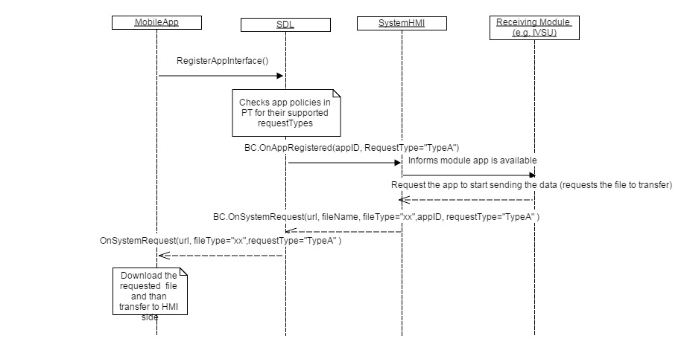

#### 6.19.2.2 OnSystemRequest in IVSU workflow

#### C:\Users\Alena\Downloads\IVSU (2).jpg6.19.2.3 OnSystemRequest in Policies workflow



### 6.19.3 JSON Messages Examples

|  |
| --- |
| {  "jsonrpc" : "2.0",  "method" : "BasicCommunication.OnSystemRequest",  "params" :  {  "requestType" : HTTP      }  } |

### 6.19.4 D-Bus Messages Examples

|  |
| --- |
|  |

## 6.20 OnPutFile

### 6.20.1 Description

|  |  |
| --- | --- |
| **Type:** | Notification |
| **Sender:** | SDL |
| **Purpose:** | Inform about application-related file storing |

Notification, that comes to HMI when mobile sents file with systemFile flag

***HMI must:***

#### 6.20.1.1 Parameters

|  |  |  |  |  |
| --- | --- | --- | --- | --- |
| **Param Name** | **Type** | **Mandatory** | **Additional** | **Description** |
| offset | Integer | false | minvalue = 0 maxvalue = 100000000000 | Optional offset in bytes for resuming partial data chunks |
| length | Integer | false | minvalue = 0 maxvalue = 100000000000 | Optional length in bytes for resuming partial data chunks |
| fileSize | Integer | false | minvalue = 0 maxvalue = 100000000000 | Full Size of file. sends in first OnPutFile notification if file is splited into many PutFiles |
| FileName | String | true | maxlength = 255 | File reference name. |
| syncFileName | String | true | maxlength = 255 | File reference name. |
| fileType | Common.FileType | true | - | Selected file type. |
| persistentFile | Boolean | false | - | Indicates if the file is meant to persist between sessions / ignition cycles.  If set to TRUE, then the system will aim to persist this file through session / cycles.  While files with this designation will have priority over others, they are subject to deletion by the system at any time.  In the event of automatic deletion by the system, the app will receive a rejection and have to resend the file.  If omitted, the value will be set to false. |

### 6.20.2 Sequence Diagrams

#### 6.20.2.1 OnPutFile

### 6.20.3 JSON Messages Examples

|  |
| --- |
| {  "jsonrpc" : "2.0",  "method" : "BasicCommunication.OnPutFile"  } |

### 6.20.4 D-Bus Messages Examples

|  |
| --- |
|  |

## 6.21 OnFileRemoved

### 6.21.1 Description

|  |  |
| --- | --- |
| **Type:** | Notification |
| **Sender:** | SDL |
| **Purpose:** | Inform about application-related file removing |

Each application file which is used by SDL must be sent to SDL via PutFile by the application. The file is stored in the appropriate folder by SDL.

When the file is requested to be removed by the application, SDL must notify HMI which file was removed to be able to clean up appropriate data on HMI (e.g. change the icon to the default one)

***HMI must:***

Change the icon to the default one or not to display any picture instead of removed file (depends on HMI)

#### 6.21.1.1 Parameters

|  |  |  |  |  |
| --- | --- | --- | --- | --- |
| **Param Name** | **Type** | **Mandatory** | **Additional** | **Description** |
| fileName | String | true | minlength = 1  maxlength = 30 | The full path to the file that has been removed |
| fileType | Common.FileType | true | - | The file type. See FileType. |
| appID | Integer | true | - | ID of the application. |

### 6.21.2 Sequence Diagrams

#### 6.21.2.1 OnFileRemoved

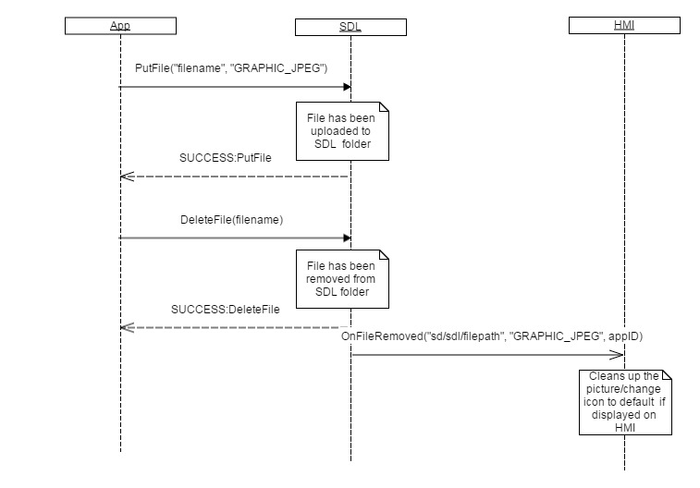

### 6.21.3 JSON Messages Examples

|  |
| --- |
| {  "jsonrpc" : "2.0",  "method" : "BasicCommunication.OnFileRemoved"  "params" :  {  "appID" : 31780,  "fileName" : "/fs/rwdata/storage/sdl/Emergency584421907/syncFileName",  "fileType" : "GRAPHIC_BMP"  }  } |

### 6.21.4 D-Bus Messages Examples

|  |
| --- |
|  |

## 6.22 OnSystemInfoChanged

### 6.22.1 Description

|  |  |
| --- | --- |
| **Type:** | Notification |
| **Sender:** | HMI |
| **Purpose:** | Inform about some system parameter has been changed |

Issued by HU to SDL to notify that some system param has changed. Currently applied only for system Language. This information is used by PolicyManager according to its internal rules.

***Note:*** SDL ignores all invalid notifications which come from HMI (invalid JSON, invalid data types/bounds etc)

***HMI must:***

- send OnSystemInfoChanged with new language value to SDL in case system language has been changed by any reason

#### 6.22.1.1 Parameters

|  |  |  |  |
| --- | --- | --- | --- |
| **Param Name** | **Type** | **Mandatory** | **Description** |
| language | Common.Language | true |  |

#### 6.22.1.2 Language Enumeration

| **Element name** | **Short Description** |
| --- | --- |
| AR-SA | Arabic – Saudi Arabia |
| CS-CZ | Czech – Czech Republic |
| DA-DK | Danish – Denmark |
| DE-DE | German – Germany |
| EN-AU | English – Australia |
| EN-GB | English – GB |
| EN-US | English – US |
| ES-ES | Spanish – Spain |
| ES-MX | Spanish – Mexico |
| FR-CA | French – Canada |
| FR-FR | French – France |
| IT-IT | Italian – Italy |
| JA-JP | Japanese – Japan |
| KO-KR | Korean – South Korea |
| NL-NL | Dutch (Standard) – Netherlands |
| NO-NO | Norwegian - Norway |
| PL-PL | Polish – Poland |
| PT-PT | Portuguese – Portugal |
| PT-BR | Portuguese – Brazil |
| RU-RU | Russian - Russia |
| SV-SE | Swedish – Sweden |
| TR-TR | Turkish – Turkey |
| ZH-CN | Mandarin – China |
| ZH-TW | Mandarin – Taiwan |

### 6.22.2 Sequence Diagrams

#### 6.22.2.1 OnSystemInfoChanged

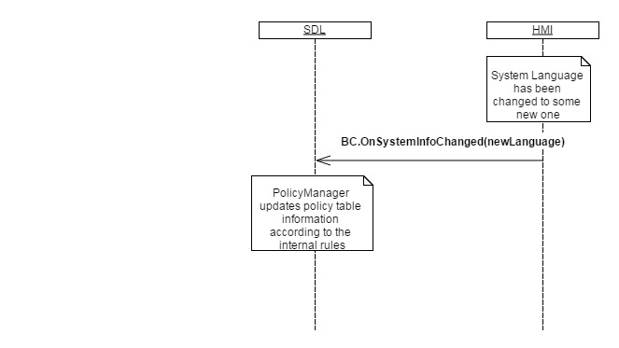

### 6.22.3 JSON Messages Examples

|  |
| --- |
| {  "jsonrpc" : "2.0",  "method" : "BasicCommunication.OnSystemInfoChanged"  "params" :  {  "language" : "FR-FR"  }  } |

### 6.22.4 D-Bus Messages Examples

|  |
| --- |
|  |

## 6.23 OnIgnitionCycleOver

### 6.23.1 Description

|  |  |
| --- | --- |
| **Type:** | Notification |
| **Sender:** | HMI |
| **Purpose:** | Inform SDL about ignition cycle is over |

Notification from system to SDL to let it know that ignition cycle is over on the system. This information is required by PolicyManager which updates PolicyTable data with appropriate ignition counter value.

***Note:*** SDL ignores all invalid notifications which come from HMI (invalid JSON, invalid data types/bounds etc)

***HMI must*** send the **both** notifications to SDL:

* BasicCommunication.OnExitAllApplications(IGNITION_OFF) for SDL to notify SDL to prepare for ignition off
* BasicCommunication.OnIgnitionCycleOver for SDL’s Policy Manager to update the ignition-cycle-related fields in Policy Table.

### 6.23.2 Sequence Diagrams

#### 6.23.2.1 OnIgnitionCycleOver

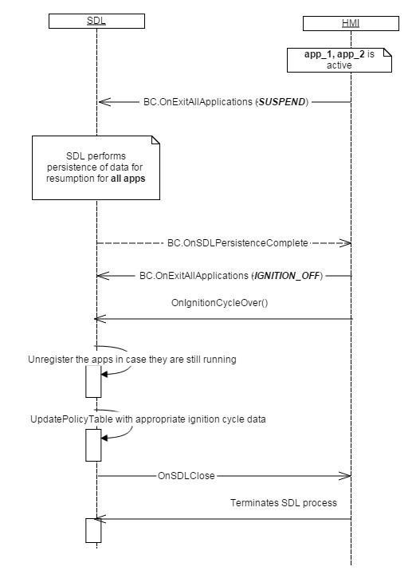

### 6.23.3 JSON Messages Examples

|  |
| --- |
| {  "jsonrpc" : "2.0",  "method" : "BasicCommunication.OnIgnitionCycleOver"  } |

### 6.23.4 D-Bus Messages Examples

|  |
| --- |
|  |

## 6.24 OnSDLClose

### 6.24.1 Description

|  |  |
| --- | --- |
| **Type:** | Notification |
| **Sender:** | SDL |
| **Purpose:** | Inform about SDL has ended its activities and ready to be terminated by system |

OnSDLClose notification received from SDL means that SDL has terminated its activities and notifies HMI that all necessary data is saved/cleaned up, apps are unregistered and the process is ready to be closed by system.

***HMI must:***

* Notify SDL about intention to terminate it because of one of the reasons (IGNITION_OFF /FACTORY_RESET /MASTER_RESET) via OnExitAllApplications
* Terminate SDL process only after OnSDLClose is received. Otherwise, application data may be lost on SDL side

**SDL information:**

* SDL unregisters the apps if the transports are still available in case of IGNITION_OFF reason
* SDL cleans up applications persistant data in case of FACTORY_RESET/MASTER_RESET reason of OnExitAllApplications

### 6.24.2 Sequence Diagrams

#### 6.24.2.1 OnSDLClose IGNITION_OFF

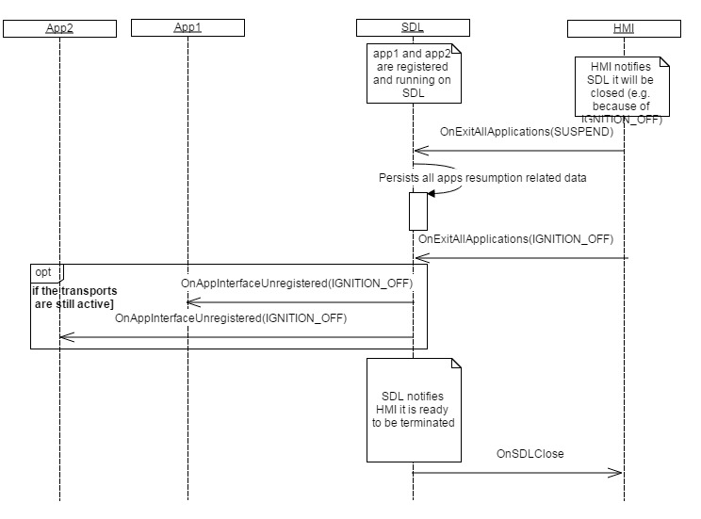

#### 6.24.2.1 OnSDLClose MASTER_RESET

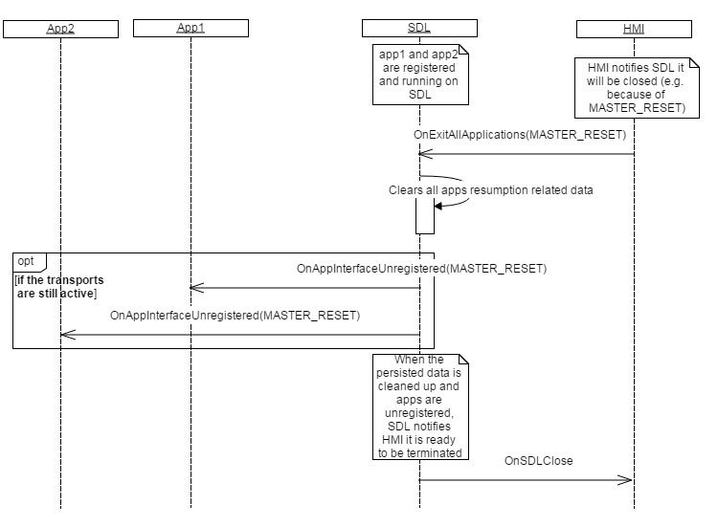

### 6.24.3 JSON Messages Examples

|  |
| --- |
| {  "jsonrpc" : "2.0",  "method" : "BasicCommunication.OnSDLClose"  } |

### 6.24.4 D-Bus Messages Examples

|  |
| --- |
|  |

## 6.25 OnUpdateDeviceList

### 6.25.1 Description

|  |  |
| --- | --- |
| **Type:** | Notification |
| **Sender:** | HMI |
| **Purpose:** | Get the updated list of found devices. |

On receipt of this notification SDL provides the list of devices found during the recent search procedure sending UpdateDeviceList RPC.

***HMI must:***

- Provide the User with the possibility to initiate the device list updating in one of accessible ways (VR, buttons, etc.).

- Send OnUpdateDeviceList notification when the User has chosen to update the device list.

***Note:***

*The difference:*

*- OnUpdateDeviceList results SDL to provide the updates of the recent search.*

*- OnStartDeviceDiscovery initiates SDL to start the new search procedure*

***Note:*** SDL ignores all invalid notifications which come from HMI (invalid JSON, invalid data types/bounds etc)

### 6.25.2 Sequence Diagrams

#### 6.25.2.1 OnUpdateDeviceList upon User`s request and resulting UpdateDeviceList

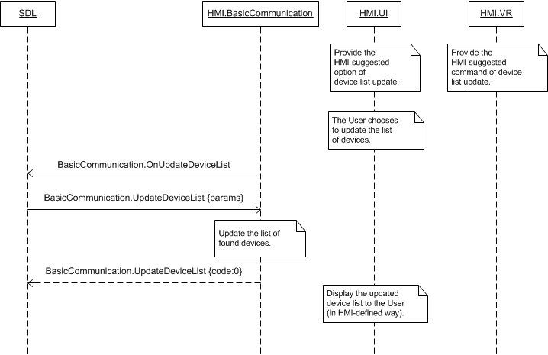

### 6.25.3 JSON Messages Examples

|  |
| --- |
| {  "jsonrpc" : "2.0",  "method" : "BasicCommunication.OnUpdateDeviceList"  } |

### 6.25.4 D-Bus Messages Examples

|  |
| --- |
|  |

## 6.26 OnResumeAudioSource

### 6.26.1 Description

|  |  |
| --- | --- |
| **Type:** | Notification |
| **Sender:** | SDL |
| **Purpose:** | Inform about the named application being resumed needs to become audible on HMI |

SDL sends OnResumeAudioSource to HMI only in case when as a result of AudioSource ‘resumption’ procedure SDL has detected the application had the state of ‘LIMITED, AUDIBLE’ on HMI before the previous ignition off.

In case of successful HMILevel resumption, SDL first assigns 'default_hmi' level from policies and after **3sec timeout**, resumes the application either to FULL or LIMITED (whichever applicable.***Important SDL note:***

When SDL resumes the application into **FULL** HMILevel with **AUDIBLE** AudioStreamingState, OnResumeAudioSource **MUST NOT** be sent to HMI. Only the following sequence is applicable:

* 1. SDL -> HMI: BasicCommunication.OnAppRegistered
  2. SDL -> HMI: BasicCommunication.ActivateApp

***Impotant note:***

SDL performs AudioSource resumption only if the applications which met the both conditions:

1. Running 30 minutes prior to OnExitAllApplication(SUSPEND) received from HMI
2. Reconnecting back not later than 30 seconds after BC.OnReady is received after new ignition cycle started

SDL will postpone the HMILevel resumption **in case** occurred during the **active phone call**( see the diagrams 6.26.2.3 – 6.26.2.4):  
a) first SDL will assign the default_hmi from policies  
b) after the phone call ends, SDL will resume the HMILevel of this app .

***HMI must:***

* Activate the audio source for the application with appID received.
* Not to activate the application itself (application’s layout is not shown to the user). The named application must stay on screen layout’s background on HMI.

#### 6.26.1.1 Parameters

|  |  |  |  |  |
| --- | --- | --- | --- | --- |
| **Param Name** | **Type** | **Mandatory** | **Additional** | **Description** |
| appID | Integer | true | – | The ID of the application that HMI must activate the audio source for. |

### 6.26.2 Sequence Diagrams

#### 6.26.2.1 AudioSource resumption for the app with FULL HMILevel

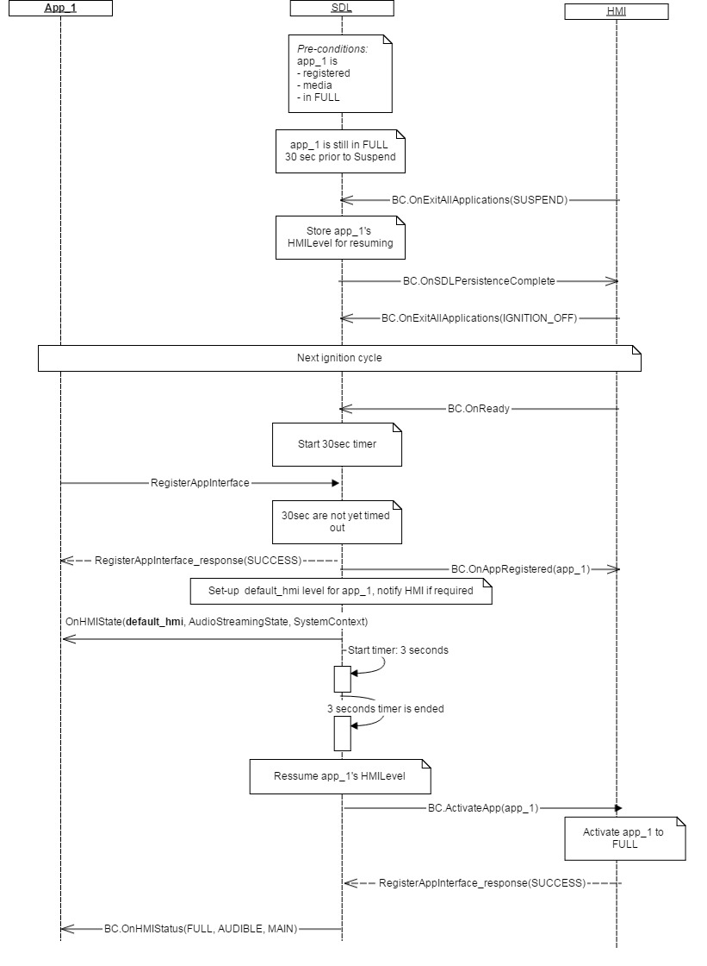

#### 6.26.2.2 OnResumeAudioSource for the app with LIMITED HMILevel

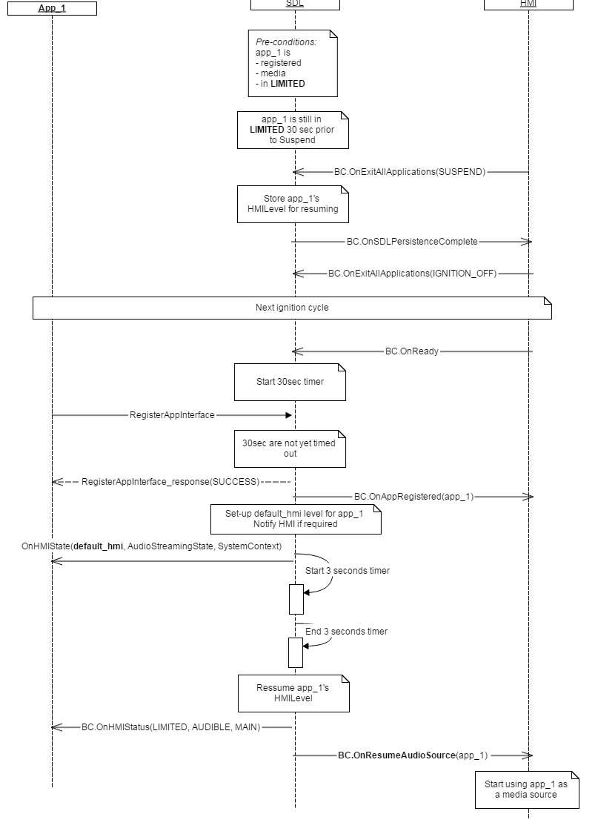

#### 6.26.2.3 OnResumeAudioSource for the app with LIMITED HMILevel (Phone call is active)

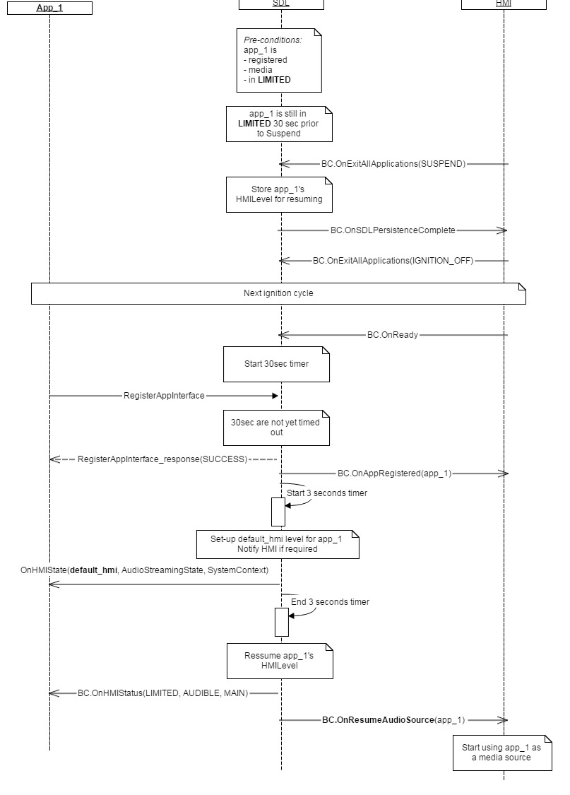

#### 6.26.2.4 AudioSource resume for the app_1 with FULL HMILevel and app_2 just registered while Phone call is active

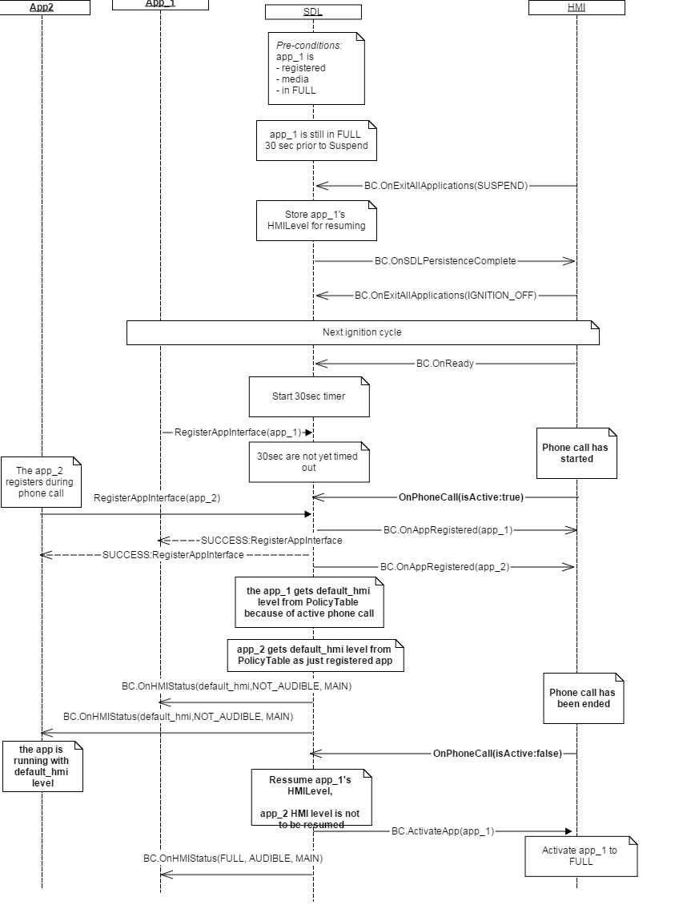

### 6.26.3 JSON Messages Examples

|  |
| --- |
| {  "jsonrpc" : "2.0",  "method" : "BasicCommunication.OnResumeAudioSource"  “params” :  {  "appID" : 123  }  } |

### 6.26.4 D-Bus Messages Examples

|  |
| --- |
|  |

## 6.27 UpdateAppList

### 6.27.1 Description

|  |  |
| --- | --- |
| **Type:** | Function |
| **Sender:** | SDL |
| **Purpose:** | Update HMI`s list of registered applications. |

The request may come:

* After SDL connected the device and the SDL-enabled application has registered itself with SDL successfully.
* Upon User`s request delivered by HMI via OnFindApplications notification.

### 6.27.2 Request

#### 6.27.2.1 Behavior

***HMI must:***

- Update its list of registered applications.

- Use the appID provided within this request when sending the definite notifications or requests (e.g. ActivateApp, OnCommand and other) related to the corresponding application to SDL.

- Provide the User with the possibility to choose among the registered applications on UI.

***Note:***

*SDL adds the VR synonyms of all registered applications to HMI via VR.AddCommand.*

#### 6.27.2.2 Parameters

|  |  |  |  |  |
| --- | --- | --- | --- | --- |
| **Param Name** | **Type** | **Mandatory** | **Additional** | **Description** |
| applications | Common.HMIApplication | true | Array = true  Minsize = 0  Maxsize = 100 | The list of registered applications. The array contains the detailed information about each application: its name, ID, type and other.  See HMIApplication. |

#### 6.27.2.3 HMIApplication Structure

| **Param Name** | **Type** | **Mandatory** | **Additional** | **Description** |
| --- | --- | --- | --- | --- |
| appName | String | true | Maxlength = 100 | The mobile application name. It is unique over all applications. |
| ngnMediaScreenAppName | String | false | Maxlength = 100 | Provides an abbreviated version of the application name (may be displayed on the NGN media screen).  If not provided, the appName should be used instead (and may be truncated if too long) |
| icon | String | false | – | Path to the application icon stored on HU hard disc. |
| deviceName | String | true | – | The name of the device where the identified application is running on. |
| appID | Integer | true | – | The application ID that remains unique during the ignition cycle.  This ID will be sent by SDL further and must be provided by HMI within all the RPCs related to this application. |
| hmiDisplayLanguageDesired | Common.Language | false | – | The language that the application intends to use.  See Language. |
| isMediaApplication | Boolean | false | – | Indicates whether the application is a media or a non-media one.  Only media applications are allowed by SDL to stream audio to HU that is audible outside of the BT media source. |
| appType | Common.AppHMIType | false | array = true Minsize = 1 maxsize = 100 | The HMI may use this information for determining what functionality should be available for the application (e.g. navigation type of application will require displaying the information and not playing the audio).  See AppHMIType. |
| requestType | Common.RequestType | false | Minsize = 0  Maxsize =100  array="true" | The list of SystemRequest's RequestTypes allowed by policies for the named application  (The app's SystemRequest sent with RequestType out of this list will get 'disallowed' response from SDL).  If SDL sends an empty array - any RequestType is allowed for this app.  If SDL omits this parameter - none RequestType is allowed for this app  (either this is a pre-registered app or such is dictated by policies). |

#### 6.27.2.4 AppHMIType Enumeration

| **Element name** | **Short Description** |
| --- | --- |
| DEFAULT | The application of default type. |
| COMMUNICATION | The application for communication |
| MEDIA | The media application |
| MESSAGING | The application of messaging type |
| NAVIGATION | The application of navigation type |
| INFORMATION | The application of information type |
| SOCIAL | The application of social type |
| BACKGROUND_PROCESS | The application does not require displaying the information |
| TESTING | The application of testing type |
| SYSTEM | The application of system type |

### 6.27.3 Response

***Note:***

*There is a difference in message type for WebSocket and D-Bus connection (see the table below).*

|  |  |  |  |  |  |
| --- | --- | --- | --- | --- | --- |
| **Result** | **Description** | **Message type** | | **Message Params** | **Notes** |
| **WebSocket** | **D-Bus** |
| Success | The HMI`s list of registered applications is updated. | JSON response | Regular response | Code: 0 | - |
| Failure | The HMI`s list of registered applications is NOT updated | JSON error message | Regular response | Code: 1...23 | Result code must correspond to the failure occurred. |

### 6.27.4 Sequence Diagrams

#### 6.27.4.1 UpdateAppList after application has just registered with SDL

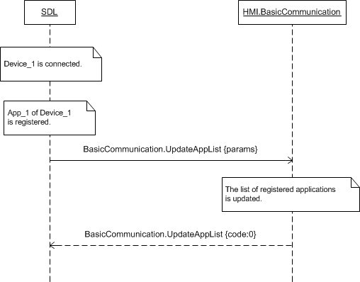

#### 6.27.4.2 UpdateAppList on User`s Request

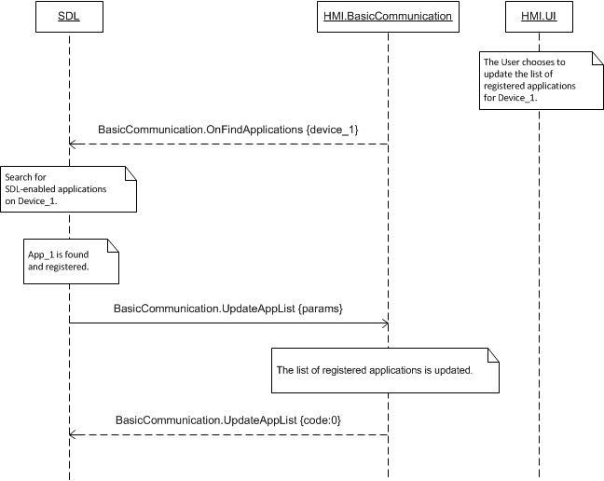

### 6.27.5 JSON Messages Examples

#### 6.27.5.1 Request

|  |
| --- |
| {  "id" : 75,  "jsonrpc" : "2.0",  "method" : "BasicCommunication.UpdateAppList",  “params” :  {  "applications" :  [  {  "appName" : “Beautiful Sound”,  "ngnMediaScreenAppName " : “BeauSo”,  "deviceName" : “Jerry`s Phone”,  "appID" : 65544,  "hmiDisplayLanguageDesired" : DE-DE,  "isMediaApplication" : true  },    {  "appName" : “Go Travel”,  "icon" : “tmp/SDL/app/Go_Travel/icon.png”,  "deviceName" : “XT910”,  "appID" : 65545,  "hmiDisplayLanguageDesired" : EN-US,  "isMediaApplication" : false, "appType" : INFORMATION  }  ]  }  } |

#### 6.27.5.2 Response

|  |
| --- |
| {  "id" : 75,  "jsonrpc" : "2.0",  "result" :  {  "code" : 0,  "method" : "BasicCommunication.UpdateAppList"  }  } |

#### 6.27.5.3 Error message

|  |
| --- |
| {  "id" : 75,  "jsonrpc" : "2.0",  "error" :  {  "code" : 22,  "message" : "During the API call the unknown error has occurred.",  "data" :  {  "method" : "BasicCommunication.UpdateAppList"  }  }  } |

### 6.27.6 D-Bus Messages Examples

#### 6.27.6.1 Request

|  |
| --- |
|  |

#### 6.27.6.2 Response

|  |
| --- |
|  |

#### 6.27.6.3 Failure

|  |
| --- |
|  |

## 6.28 OnSDLPersistenceComplete

### 6.28.1 Description

|  |  |
| --- | --- |
| **Type:** | Notification |
| **Sender:** | SDL |
| **Purpose:** | Inform about the applications data persistence are completed |

SDL sends OnSDLPersistenceComplete right after all the data persistence operations are completed on SDL. This data is persisted for future resumption scenarios (e.g. in case SDL will get IGNITION_OFF from HMI), See 6.28.2.1 OnSDLPersistanceComplete diagram for more information.

***SDL Information:***

* When SDL gets*OnExitAllApplications{SUSPEND} from HMI it persists the data for the case if IGNITION will be OFF*

***HMI must:***

* Send *OnExitAllApplications{SUSPEND} to initiate data persistence process for the apps being active on SDL*
* Wait for OnSDLPersistenceComplete before sending OnExitAllApplications{IGNITION_OFF}

### 6.28.2 Sequence Diagrams

#### 6.28.2.1 OnSDLPersistenceComplete

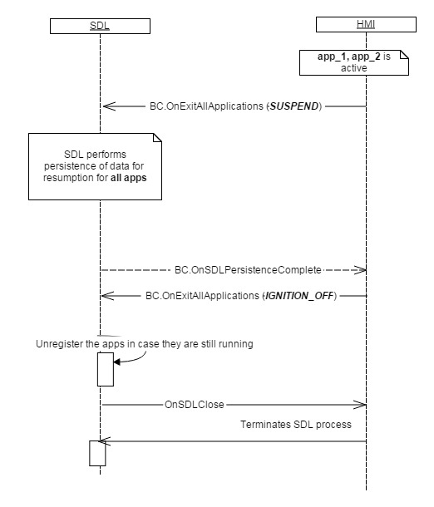

### 6.28.3 JSON Messages Examples

|  |
| --- |
| {  "jsonrpc" : "2.0",  "method" : "BasicCommunication.OnSDLPersistenceComplete"  } |

### 6.28.4 D-Bus Messages Examples

|  |
| --- |
|  |

## 6.29 OnPhoneCall

### 6.29.1 Description

|  |  |
| --- | --- |
| **Type:** | Notification |
| **Sender:** | HMI->SDL |
| **Purpose:** | Notify SDL about Phone Call event started or ended |

**Information:** When SDL receives BC.OnPhoneCall (isActive: **true**) from HMI, it changes the HMILevel of all applications currently in FULL and-or LIMITED to BACKGROUND. After getting OnPhoneCall (isActive: false) from HMI, SDL internally returns applications to the previous-to-phonecall HMILevel. SDL does not send BC.ActivateApp or BC.OnResumeAudioSource to HMI after the phone call is ended.

***Note:*** SDL ignores all invalid notifications which come from HMI (invalid JSON, invalid data types/bounds etc)

***HMI must:***

* Send notification with appropriate parameter value when active call on HMI has been started/ended
* Change internally on HMI HMILevels of the apps in FULL and-or LIMITED to BACKGROUND after phone call started

#### Resume the applications to the previous-to-phonecall state on HMI (as SDL does not send BC.ActivateApp or BC.OnResumeAudioSource to HMI after the phone call is ended6.29.1.1 Parameters

|  |  |  |  |  |
| --- | --- | --- | --- | --- |
| **Param Name** | **Type** | **Mandatory** | **Additional** | **Description** |
| isActive | Boolean | true |  | Must be 'true' - when a phone call is started on HMI. Must be 'false' when the phone call is ended on HMI |

### 6.29.2 Sequence Diagrams

#### 6.29.2.1 OnPhoneCall

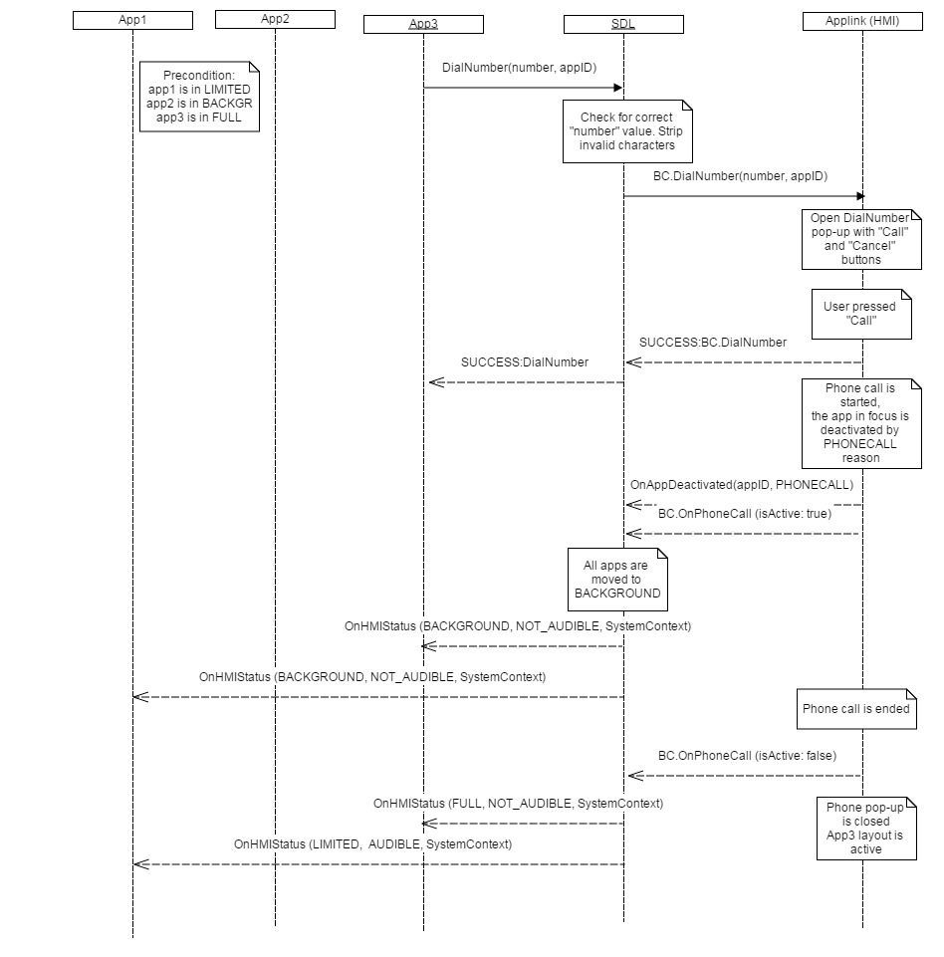

### 6.29.3 JSON Messages Examples

|  |
| --- |
| {  "jsonrpc" : "2.0",  "method" : "BasicCommunication.OnPhoneCall"  “params” :  {  “isActive”: true  }  } |

### 6.29.4 D-Bus Messages Examples

|  |
| --- |
|  |

## 6.30 OnEmergencyEvent

### 6.30.1 Description

|  |  |
| --- | --- |
| **Type:** | Notification |
| **Sender:** | HMI->SDL |
| **Purpose:** | For SDL to change the audioStreamingState of the related apps to NOT_AUDIBLE when "enabled:true" and back to AUDIBLE when "enabled:false" |

Safety Feature is HMI`s specific mode when "911 Assist” or «Rear view camera" are active modes. The main idea from SDL<->HMI point of view is that navigation/audio streamming mustn’t interfere with Safety Feature mode. HMI is responsible for managing audio/video data during “911”/”RearCamera” modes.

***Note:*** When receive OnEmergencyEvent(enabled:true), SDL moves all apps with AudioStreamingState AUDIBLE to NOT_AUDIBLE state and return to previous state when get OnEmergencyEvent(enabled:false),

***HMI must:***

* - send OnEmergencyEvent when "911 Assist” become active mode
* send OnEmergencyEvent when «Rear view camera" become active mode
* reject navigation requests request since the given Safety Feature is active
* govern Safety Features and how they coexist with SDL

***Note:*** SDL ignores all invalid notifications which come from HMI (invalid JSON, invalid data types/bounds etc)

#### 6.30.1.1 Parameters

|  |  |  |  |  |
| --- | --- | --- | --- | --- |
| **Param Name** | **Type** | **Mandatory** | **Additional** | **Description** |
| enabled | Boolean | true |  | Defines if the “911 Assist” mode or rear view camera has been activated on HMI |

### 6.30.2 Sequence Diagrams

#### 6.30.2.1 OnEmergencyEvent

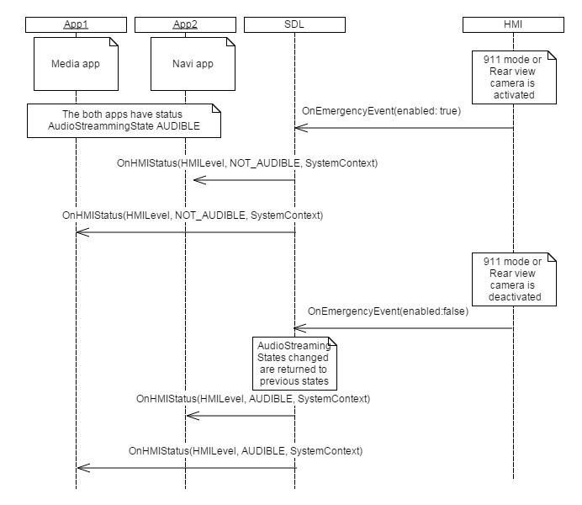

### 6.30.3 JSON Messages Examples

|  |
| --- |
| {  "jsonrpc" : "2.0",  "method" : "BasicCommunication. OnEmergencyEvent"  “params” :  {  "enabled" : “true”  }  } |

### 6.30.4 D-Bus Messages Examples

|  |
| --- |
|  |

## 6.31 OnAwakeSDL

### 6.31.1 Description

|  |  |
| --- | --- |
| **Type:** | Notification |
| **Sender:** | HMI->SDL |
| **Purpose:** | To notify SDL to return to normal operating after 'Suspend' event |

***The notification is sent to SDL to notify it there won’t be IGNITION_OFF which had to go after OnExitAllApplications(SUSPEND) notification which had been sent before by HMI.***

***Note:*** SDL ignores all invalid notifications which come from HMI (invalid JSON, invalid data types/bounds etc)

***HMI must:***

* ***Send OnAwakeSDL on ACC key state not being changed during the door is opened and closed for 2 timesSend OnAwakeSDL on ACC key position is changed to ON state***

### 6.31.2 Sequence Diagrams

#### 6.30.2.1 OnAwakeSDL

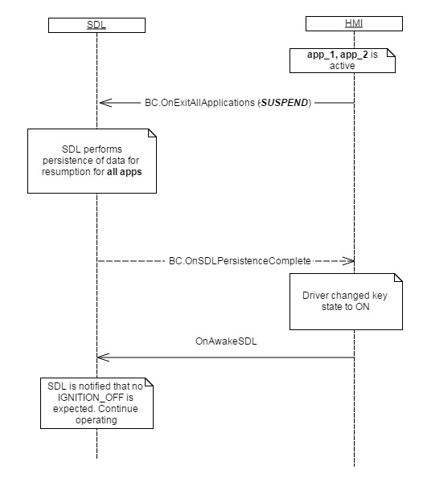

### 6.31.3 JSON Messages Examples

|  |
| --- |
| {  "jsonrpc" : "2.0",  "method" : "BasicCommunication. OnAwakeSDL "  } |

### 6.31.4 D-Bus Messages Examples

|  |
| --- |
|  |

## 6.32 DialNumber

### 6.32.1 Description

|  |  |
| --- | --- |
| **Type:** | Function |
| **Sender:** | SDL |
| **Purpose:** | SDL initates a call to a specific phone number. |

### 6.32.2 Request

6.32.2.1 BehaviorThe request is considered to be executed successfully in case the user presses “Call” button on DialNumber phone dialog. **SDL makes check** for correct phone number on it’s side and transfers stripped number to HMI. It makes checks :

1. Strip any characters except of 0-9 and * # , ;+
2. Return INVALID_DATA to mobile side without transferring to HMI in case characters **"/n"** , **"/t", the space/s** are a part of the number or as a result of strip the "number" param became empty.

***HMI must:***

* *Show Dial Number pop-up on HMI with 2 buttons “Call” and “Cancel”*
* *Send OnAppDeactivated(PHONECALL) notification to SDL when the active phone call has been started on HMI*
* *Send BC.OnOnPhoneCal(isActive:true) notification to SDL when the active phone call has been started on HMI*
* Always respond on BC.DialNumber back with one of the Results (see 6.32.3)

***Note:***In case HMI doesn’t return the response to BasicCommunication.DialNumber, mobile side will never get an anwer from SDL. SDL’s default timeout response isn’t applicable for DialNumber mobile API.

#### 6.32.2.1 Parameters

| **Param Name** | **Type** | **Mandatory** | **Additional** | **Description** |
| --- | --- | --- | --- | --- |
| number | String | true | maxlength = 40 | The number to dial. All characters shall be stripped from string by SDL except digits 0-9 and * # , ;+ |
| appID | Integer | true |  | ID of application that initiates the call |

### 6.32.3 Response

|  |  |  |  |  |  |
| --- | --- | --- | --- | --- | --- |
| **Result** | **Description** | **Message type** | | **Message Params** | **Notes** |
| **WebSocket** | **D-Bus** |
| Success | SUCCESS  Phone call started on HMI (he user presses ‘call’ button) | JSON response | Regular response | code: 0 | Request executed successfully |
| Failure | REJECTED  2) HMI is busy with higher priority RPC | JSON response | Regular response | code: 4 |  |
| TIMED_OUT  when the DialNumber dialog is closed by HMI-defined default timeout. | code: 10 |  |
| ABORTED  a) when the user has not yet done his choice and some higher-priority event interrupted the DialNumber dialog b) when the user presses ‘cancel’ button | code: 5 |  |
| GENERIC_ERROR  When anything else unpredictable happened on HMI (except of other codes) | code: 22 |  |

#### 6.32.3.1 Behavior

### 6.32.4 Sequence Diagrams

#### 6.32.5.1 DialNumber Success

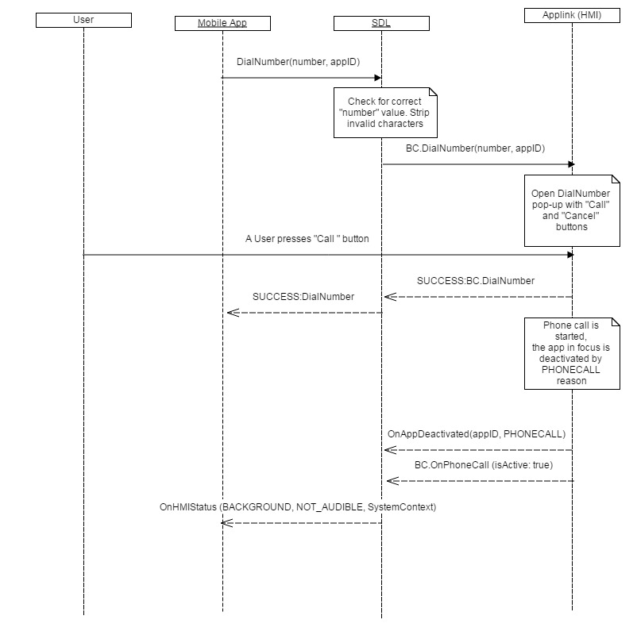

#### 6.32.5.1 DialNumber Failed

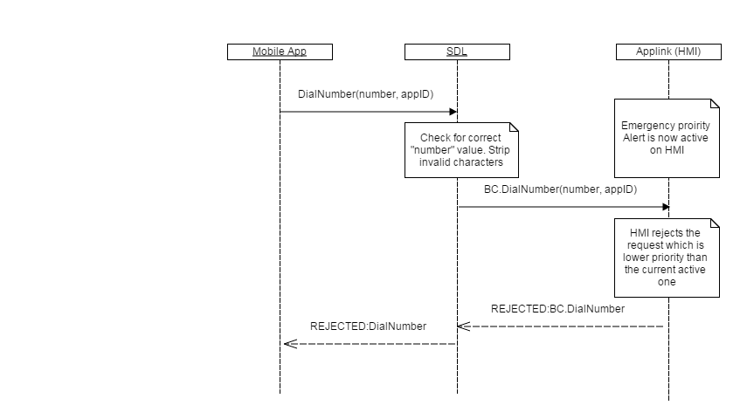

### 6.32.5 JSON Messages Examples

#### 6.32.5.1 Request

|  |
| --- |
| {  "id" : 59,  "jsonrpc" : "2.0",  "method" : "BasicCommunication. DialNumber",  “params” :  {  "number" : “*111#”,  "appID" : 65537  }  } |

#### 6.32.5.2 Response

|  |
| --- |
| {  "id" : 59,  "jsonrpc" : "2.0",  "result" :  {  "code" : 0,  "method" : "BasicCommunication.DialNumber"  }  } |

#### 6.32.5.3 Error message

|  |
| --- |
| {  "id" : 59,  "jsonrpc" : "2.0",  "error" :  {  "code" : 5,  "message" : " HMI is busy with higher priority RPC ",  "data" :  {  "method" : "BasicCommunication.DialNumber"  }  }  } |

### 6.32.6 D-Bus Messages Examples

#### 6.32.6.1 Request

|  |
| --- |
|  |

#### 6.32.6.2 Response

|  |
| --- |
|  |

#### 6.32.6.3 Failure

|  |
| --- |
|  |

# 7 UI Component Description

## 7.1 IsReady

### 7.1.1 Description

|  |  |
| --- | --- |
| **Type:** | Function |
| **Sender:** | SDL |
| **Purpose:** | Know if UI module is ready. |

The request comes after HMI`s readiness is confirmed via OnReady notification. SDL requires the information about whether the display is physically present on HU and if so whether it is working.

***Note:***

*If UI module is responded to be unavailable, SDL will not further send the requests related to it.*

### 7.1.2 Request

#### 7.1.2.1 Behavior

***HMI must:***

- Check whether UI module is present and ready

- Respond correspondingly to results of this check.

### 7.1.3 Response

***Note:***

*There is a difference in message type for WebSocket and D-Bus connection (see the table below).*

|  |  |  |  |  |  |
| --- | --- | --- | --- | --- | --- |
| **Result** | **Description** | **Message type** | | **Message Params** | **Notes** |
| **WebSocket** | **D-Bus** |
| Success | SUCCESS  HMI has the information about UI availability. | JSON response | Regular response | available,  Code: 0 | See the table below. |
| Failure | GENERIC_ERROR  HMI doesn’t have the information about UI availability or some failure occured | JSON response | Regular response | Code: 22 | . |

#### 7.1.3.1 Parameters

|  |  |  |  |
| --- | --- | --- | --- |
| **Param Name** | **Type** | **Mandatory** | **Description** |
| availabe | Boolean | true | Must be  - ‘true’ if UI is present and ready  - ‘false’ if not. |

### 7.1.4 Sequence Diagrams

#### 7.1.4.1 UI.IsReady and preceding OnReady

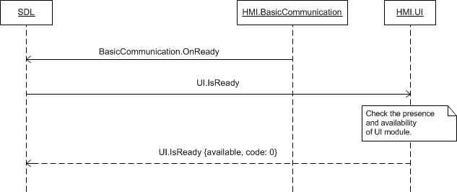

### 7.1.5 JSON Messages Examples

#### 7.1.5.1 Request

|  |
| --- |
| {  "id" : 8,  "jsonrpc" : "2.0",  "method" : "UI.IsReady"  } |

#### 7.1.5.2 Response

|  |
| --- |
| {  "id" : 8,  "jsonrpc" : "2.0",  "result" :  {  "availabe" : false,  "code" : 0,  "method" : "UI.IsReady"  }  } |

#### 7.1.5.3 Error message

|  |
| --- |
| {  "id" : 8,  "jsonrpc" : "2.0",  "error" :  {  "code" : 22,  "message" : " HMI doesn’t have the information about UI availability or some failure occured ",  "data" :  {  "method" : "UI.IsReady"  }  }  } |

### 7.1.6 D-Bus Messages Examples

#### 7.1.6.1 Request

|  |
| --- |
|  |

#### 7.1.6.2 Response

|  |
| --- |
|  |

#### 7.1.6.3 Failure

|  |
| --- |
|  |

## 7.2 GetCapabilities

### 7.2.1 Description

|  |  |
| --- | --- |
| **Type:** | Function |
| **Sender:** | SDL |
| **Purpose:** | Learn the UI capabilities of HU. |

Once UI module is confirmed to be ready (via response to IsReady RPC) SDL starts discovering its capabilities via GetCapabilities and GetSupportedLanguages RPCs.

The response to UI.GetCapabilities is assumed to bring all the information required for correct configuring the ‘display’ requests to UI.

### 7.2.2 Request

#### 7.2.2.1 Behavior

***HMI must:***

- Check the capabilities of:

* Display: its type, the fields supported, the format of media clock supported, whether displaying images is supported and of what type if so.
* Zone the UI is located in (front/back).
* Soft buttons: whether the notifications on events of button depress/release and on button presses of short/long are supported.
* Embedded Navigation supported
* Phone calles supported
* Audio capturing: the sampling rate, bits per sample, audio type supported.

- Respond correspondingly to results of this check.

***Note:***

*The expected UI capabilities are described in the section* *7.2.3.1 Parameters* *linked to the corresponding structures and enumerations with more detailed information.*

### 7.2.3 Response

***Note:***

*There is a difference in message type for WebSocket and D-Bus connection (see the table below).*

|  |  |  |  |  |  |
| --- | --- | --- | --- | --- | --- |
| **Result** | **Description** | **Message type** | | **Message Params** | **Notes** |
| **WebSocket** | **D-Bus** |
| Success | SUCCESS  HMI has the information about UI capabilities. | JSON response | Regular response | displayCapabilities,  hmiZoneCapabilities,  softButtonCapabilities,  audioPassThruCapabilities,  Code: 0 | See section *7.2.3.1 Parameters*. |
| Failure | GENERIC_ERROR  Some failure occurred | JSON error message | Regular response | Code: 22 | . |

#### 7.2.3.1 Parameters

|  |  |  |  |  |
| --- | --- | --- | --- | --- |
| **Param Name** | **Type** | **Mandatory** | **Additional** | **Description** |
| displayCapabilities | Common.DisplayCapabilities | true |  | The capabilities of HMI`s display: its type, supported textfields, whether the graphics displaying is supported, the supported formats of media clock.  See DisplayCapabilities. |
| hmiCapabilities | HMICapabilities | false |  | Specifies the HMI capabilities of navigation and phonecall support. See HMICapabilities |
| softButtonCapabilities | Common.SoftButtonCapabilities | false | Array = true  minsize = 0  maxsize = 100 | Must be returned if the platform supports on-screen soft buttons.  Contains the soft buttons capabilities: whether the up/down events, long/short press, referencing image are supported.  See SoftButtonCapabilities. |
| hmiZoneCapabilities | Common.HmiZoneCapabilities | true |  | Specifies HMI Zones in the vehicle (front/back).  See HmiZoneCapabilities. |
| audioPassThruCapabilities | Common.AudioPassThruCapabilities | true |  | Specifies the capabilities of audio capturing: sampling rate, bits per sample, audio type.  See AudioPassThruCapabilities. |

#### 7.2.3.2 DisplayCapabilities Structure

| **Param Name** | **Type** | **Mandatory** | **Additional** | **Description** |
| --- | --- | --- | --- | --- |
| displayType | Common.DisplayType | true | - | The type of the display that is installed on HU.  See DisplayType. |
| textFields | Common.TextField | true | Array = true  minsize = 0  maxsize = 100 | A set of all fields that support displaying text data.  If there are no textfields supported HMI must send the empty array.  See TextField. |
| imageFields | Common.ImageField | false | Array = true  minsize = 1  maxsize = 100 | A set of all fields that support images. See ImageField |
| mediaClockFormats | Common.MediaClockFormat | true | Array = true  minsize = 1  maxsize = 100 | A set of all supported formats of the media clock.  See MediaClockFormat. |
| imageCapabilities | Common.ImageType | false | Array = true  minsize = 0  maxsize = 2 | The array of supported image types (static and/or dynamic).  The empty array should be returned if the platform does not support displaying images.  See ImageType. |
| graphicSupported | Boolean | true | - | Must be:  - ‘true’ if display's persistent screen supports referencing a static or dynamic image.  - ‘false’ if not. |
| templatesAvailable | String | true | Array = true  minsize = 0  maxsize = 100  maxlength = 100 | A set of all predefined persistent display templates available on headunit. To be referenced in SetDisplayLayout. |
| screenParams | Common.ScreenParams | false | - | A set of all parameters related to a prescribed screen area (e.g. for video / touch input). |
| numCustomPresetsAvailable | Integer | false | minvalue = 1  maxvalue = 100 |  |

*Back to Parameters*

#### 7.2.3.3 DisplayType Enumeration

| **Element name** | **Short Description** |
| --- | --- |
| CID | Center Information Display.  This display type provides a 2-line x 20 character "dot matrix" display. |
| TYPE2 | TYPE II display. 1 line older radio head unit. |
| TYPE5 | TYPE V display  Old radio head unit. |
| NGN | Next Generation Navigation display. |
| GEN2_8_DMA | GEN-2, 8 inch display. |
| GEN2_6_DMA | GEN-2, 6 inch display. |
| MFD3 | 3 inch GEN1.1 display |
| MFD4 | 4 inch GEN1.1 display |
| MFD5 | 5 inch GEN1.1 display |
| GEN3_8-INCH | GEN-3, 8 inch display. |

*Back to DisplayCapabilities*

#### 7.2.3.4 TextFieldName Enumeration

| **Element name** | **Short Description** |
| --- | --- |
| mainField1 | The text that must be displayed in a single or upper display line.  If this value is not set, the text of mainField1 must stay unchanged.  If this text is empty "", the field must be cleared.  Applies to Show, section 7.5. |
| mainField2 | The text that must be displayed on the second display line.  If this text is not set, the text of mainField2 must stay unchanged.  If this text is empty "", the field must be cleared.  Applies to Show, section 7.5. |
| mainField3 | The text that must be displayed on the second "page" first display line.  If this text is not set, the text of mainField3 must stay unchanged.  If this text is empty "", the field must be cleared.  Applies to Show, section 7.5. |
| mainField4 | The text that must be displayed on the second "page" second display line.  If this text is not set, the text of mainField4 must stay unchanged.  If this text is empty "", the field must be cleared.  Applies to Show, section 7.5. |
| statusBar | The text is placed in the status bar area.  ***Note:*** *This relates to navigation displays*  If this parameter is omitted, the status bar text must remain unchanged.  If this parameter is an empty string, the field must be cleared.  If provided and the display has no status bar, this parameter must be ignored.  Applies to Show, section 7.5. |
| mediaClock | Text value for MediaClock field. Shall arrive in the form as described in the MediaClockFormat enumeration  If this text is set, any automatic media clock updates previously set with SetMediaClockTimer must be stopped.  Applies to Show, section 7.5. |
| mediaTrack | The text that should be displayed in the track field. This field should be valid only for media applications on.  If this text is not set, the text of mediaTrack must stay unchanged.  If this text is empty "", the field must be cleared.  Applies to Show, section 7.5. |
| alertText1 | The text that must be displayed in the top field of the display during the Alert.  Applies to Alert, section 7.4. |
| alertText2 | The text that must be displayed in the bottom field of the display during the Alert.  Applies to Alert, section 7.4. |
| alertText3 | The optional third line of the alert text field.  Applies to Alert, section 7.4. |
| scrollableMessageBody | The long form body of text that can include newlines and tabs.  Applies to ScrollableMessage, section 7.19. |
| initialInteractionText | Must be displayed when the interaction begins. The text must be displayed on the first line of a multiline display, and must be centered.  Applies to PerformInteraction, section 7.12. |
| navigationText1 | The text that must be displayed on the first line of navigation text.  Applies to ShowConstantTBT, section 12.3. |
| navigationText2 | The text that must be displayed on the second line of navigation text.  Applies to ShowConstantTBT, section 12.3. |
| ETA | Estimated Time of Arrival for navigation.  Applies to ShowConstantTBT, section 12.3. |
| totalDistance | Total distance to destination for navigation.  Applies to ShowConstantTBT, section 12.3. |
| navigationText | Navigation text for UpdateTurnList.  Applies to Turn, section 12.4. |
| audioPassThruDisplayText1 | The first line of text that must be displayed during audio capture.  Applies to PerformAudioPassThru, section 7.20. |
| audioPassThruDisplayText2 | The second line of text that must be displayed during audio capture.  Applies to PerformAudioPassThru, section 7.20. |
| sliderHeader | The text that must be displayed on the header of slider.  Applies to Slider, section 7.18. |
| sliderFooter | The text that must be displayed on the footer of slider.  Applies to Slider, section 7.18. |
| notificationText | The text that must be displayed to notify the User on some event.  Applies to ShowNotification, section 7.31. |
| menuName | Primary text for Choice.  Applies to PerformInteraction, section 7.12. |
| secondaryText | Secondary text for Choice.  Applies to PerformInteraction, section 7.12. |
| tertiaryText | Tertiary text for Choice.  Applies to PerformInteraction, section 7.12. |
| menuTitle | Optional text to label an app menu button (for certain touchscreen platforms). |
| timeToDestination | The line to display the time to destination.  Applies to ShowConstantTBT, section 12.3. |
| turnText | Currently not used. |

*Back to DisplayCapabilities*

#### 7.2.3.5 ImageField Structure

| **Param Name** | **Type** | **Mandatory** | **Additional** | **Description** |
| --- | --- | --- | --- | --- |
| name | Common.ImageFieldName | true | - | The name that identifies the field. See ImageFieldName. |
| imageTypeSupported | Common.FileType | false | array = true  minsize = 1  maxsize = 100 | The image types that are supported in this field. See FileType. |
| imageResolution | Common.ImageResolution | false | - | The image resolution of this field. |

#### 7.2.3.6 ImageFieldName Enumeration

| **Element name** | **Value** | **Short Description** |
| --- | --- | --- |
| softButtonImage | 0 | The image field for SoftButton |
| choiceImage | 1 | The first image field for Choice |
| choiceSecondaryImage | 2 | The secondary image field for Choice |
| vrHelpItem | 3 | The image field for vrHelpItem |
| turnIcon | 4 | The image field for Turn |
| menuIcon | 5 | The image field for the menu icon in SetGlobalProperties |
| cmdIcon | 6 | The image field for AddCommand |
| appIcon | 7 | The image field for the app icon (set by setAppIcon) |
| graphic | 8 | The image field for Show |
| showConstantTBTIcon | 9 | The primary image field for ShowConstantTBT |
| showConstantTBTNextTurnIcon | 10 | The secondary image field for ShowConstantTBT |
| locationImage | 11 | The optional image of a destination / location |

#### 7.2.3.7 FileType Enumeration

| **Element name** | **Value** | **Short Description** |
| --- | --- | --- |
| GRAPHIC_BMP | 0 |  |
| GRAPHIC_JPEG | 1 |  |
| GRAPHIC_PNG | 2 |  |
| AUDIO_WAVE | 3 |  |
| AUDIO_MP3 | 4 |  |
| AUDIO_AAC | 5 |  |
| BINARY | 6 |  |
| JSON | 7 |  |

#### 7.2.3.8 ImageResolution Structure

| **Param Name** | **Type** | **Mandatory** | **Additional** | **Description** |
| --- | --- | --- | --- | --- |
| resolutionWidth | Integer | true | minvalue = 1  maxvalue = 10000 | The image resolution width. |
| resolutionHeight | Integer | true | minvalue = 1  maxvalue = 10000 | The image resolution height. |

#### 7.2.3.9 MediaClockFormat Enumeration

| **Element name** | **Short Description** |
| --- | --- |
| CLOCK1 | minutesFieldWidth = 2; minutesFieldMax = 19;  secondsFieldWidth = 2; secondsFieldMax = 99;  maxHours = 19;  maxMinutes = 59;  maxSeconds = 59;  Is used for Type II, NGN and CID head units. |
| CLOCK2 | minutesFieldWidth = 3; minutesFieldMax = 199;  secondsFieldWidth = 2; secondsFieldMax = 99;  maxHours = 59;  maxMinutes = 59;  maxSeconds = 59;  Is used for Type V head units. |
| CLOCK3 | minutesFieldWidth = 2; minutesFieldMax = 59;  secondsFieldWidth = 2; secondsFieldMax = 59;  maxHours = 9;  maxMinutes = 59;  maxSeconds = 59;  Is used for GEN1.1 (i.e. MFD3/4/5) head units. |
| CLOCKTEXT1 | 5 characters possible  Format: 1|sp c :|sp c c  1|sp : digit "1" or space  c : character out of following character set: sp|0-9|[letters  :|sp : colon or space  Is used for Type II head unit |
| CLOCKTEXT2 | 5 chars possible  Format: 1|sp c :|sp c c  1|sp : digit "1" or space  c : character out of following character set: sp|0-9|[letters  :|sp : colon or space  Is used for CID and NGN head unit. |
| CLOCKTEXT3 | 6 chars possible  Format: 1|sp c c  :|sp c c 1|sp : digit "1" or space  c : character out of following character set: sp|0-9|[letters  :|sp : colon or space  Is used for Type V head unit. |
| CLOCKTEXT4 | 6 chars possible  Format: c :|sp c  c : c c :|sp : colon or space c : character out of following character set: sp|0-9|[letters].  Is used for GEN1.1 (i.e. MFD3/4/5) head units. |

*Back to DisplayCapabilities*

#### 7.2.3.10 ImageType Enumeration

| **Element name** | **Short Description** |
| --- | --- |
| STATIC | Static image. The image that is sent as the binary or hex code within the request. |
| DYNAMIC | Dynamic image. The image that is stored on HMI and just a link to it is further used within requests. |

*Back to DisplayCapabilities*

#### 7.2.3.11 ScreenParams Structure

| **Param Name** | **Type** | **Mandatory** | **Description** |
| --- | --- | --- | --- |
| resolution | Common.ImageResolution | true | The resolution of the prescribed screen area.  See ImageResolution. |
| touchEventAvailable | Common.TouchEventCapabilities | false | Types of screen touch events available in screen area. |

#### 7.2.3.12 TouchEventCapabilities Structure

| **Param Name** | **Type** | **Mandatory** | **Description** |
| --- | --- | --- | --- |
| pressAvailable | Boolean | true |  |
| multiTouchAvailable | Boolean | true |  |
| doublePressAvailable | Boolean | true |  |

#### 7.2.3.13 SoftButtonCapabilities Structure

| **Param Name** | **Type** | **Mandatory** | **Description** |
| --- | --- | --- | --- |
| shortPressAvailable | Boolean | true | Must be  - ‘true’ if soft buttons support a short press  - ‘false’ if not.  See ButtonPressMode for more information. |
| longPressAvailable | Boolean | true | Must be  - ‘true’ if soft buttons support a LONG press  - ‘false’ if not.  See ButtonPressMode for more information. |
| upDownAvailable | Boolean | true | Must be  - ‘true’ if soft buttons support "button down" and "button up".  - ‘false’ if not.  See ButtonEventMode for more information. |
| imageSupported | Boolean | true | Must be  - ‘true’ if soft buttons support referencing image  - ‘false’ if not. |

*Back to Parameters*

#### 7.2.3.14 HmiZoneCapabilities Enumeration

| **Element name** | **Short Description** |
| --- | --- |
| FRONT | Indicates UI available to front seat passengers. |
| BACK | Indicates UI available to rear seat passengers. |

*Back to Parameters*

#### 7.2.3.15 AudioPassThruCapabilities Structure

|  |  |  |  |
| --- | --- | --- | --- |
| **Param Name** | **Type** | **Mandatory** | **Description** |
| samplingRate | Common.SamplingRate | true | The number of samples per second.  Defines the sampling rate supported by the HU for audio capturing (e.g. 8 kHz, 16 kHz, etc.).  See SamplingRate. |
| bitsPerSample | Common.BitsPerSample | true | The number of bits of information in each sample.  Defines the quality of audio capturing supported by HU.  See BitsPerSample. |
| audioType | Common.AudioType | true | Specifies the type of audio data being requested.  See AudioType. |

*Back to Parameters*

#### 7.2.3.16 SamplingRate Enumeration

|  |  |
| --- | --- |
| **Element name** | **Short Description** |
| 8KHZ | Sampling rate of 8 kHz |
| 16KHZ | Sampling rate of 16 kHz |
| 22KHZ | Sampling rate of 22 kHz |
| 44KHZ | Sampling rate of 44 kHz |

*Back to AudioPassThruCapabilities*

#### 7.2.3.17 BitsPerSample Enumeration

|  |  |
| --- | --- |
| **Element name** | **Short Description** |
| 8_BIT | 8 bit per sample |
| 16_BIT | 16 bit per sample |

*Back to AudioPassThruCapabilities*

#### 7.2.3.18 AudioType Enumeration

|  |  |
| --- | --- |
| **Element name** | **Short Description** |
| PCM | Pulse Code Modulated audio. |

*Back to AudioPassThruCapabilities*

#### 7.2.3.19 HMICapabilities structure

| **Param Name** | **Type** | **Mandatory** | **Additional** | **Description** |
| --- | --- | --- | --- | --- |
| navigation | boolean | false |  | Availability of build in Navigation. True: available, False: not available |
| phoneCall | boolean | false |  | Availability of build in phone. True: available, False: not available |

*Back to Parameters*

### 7.2.4 Sequence Diagrams

#### 7.2.4.1 UI.GetCapabilities and preceding IsReady

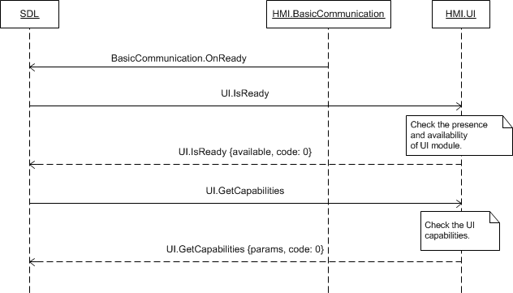

### 7.2.5 JSON Messages Examples

#### 7.2.5.1 Request

|  |
| --- |
| {  "id" : 18,  "jsonrpc" : "2.0",  "method" : "UI.GetCapabilities"  } |

#### 7.2.5.2 Response

|  |
| --- |
| {  "id" : 18,  "jsonrpc" : "2.0",  "result" :  {  "displayCapabilities" :  {  "displayType" : GEN2_8_DMA,  "textFields" : [mainField1, mainField2, mediaclock, mediaTrack], alertText1, alertText2, alertText3, scrollableMessageBody, initialInteractionText, navigationText1, navigationText2, audioPassThruDisplayText1, audioPassThruDisplayText2, notificationText]  "mediaClockFormats" : [CLOCK1, CLOCKTEXT4],  "graphicSupported" : true,  "imageCapabilities": [DYNAMIC]  },  “hmiCapabilities” :  {  “navigation” : true,  “phoneCall” : true  },  “softButtonCapabilities” :  {  “shortPressAvailable” : true,  “longPressAvailable” : true,  “upDownAvailable” : true,  “imageSupported” : true  },  "hmiZoneCapabilities" : FRONT,  "audioPassThruCapabilities" :  {  "samplingRate" : 44KHZ,  "bitsPerSample" : 8_BIT,  "audioType" : PCM  },  "code" : 0,  "method" : "UI.GetCapabilities"  }  } |

#### 7.2.5.3 Error message

|  |
| --- |
| {  "id" : 18,  "jsonrpc" : "2.0",  "error" :  {  "code" : 22,  "message" : "During API call the unknown error has occured",  "data" :  {  "method" : "UI.GetCapabilities"  }  }  } |

### 7.2.6 D-Bus Messages Examples

#### 7.2.6.1 Request

|  |
| --- |
|  |

#### 7.2.6.2 Response

|  |
| --- |
|  |

#### 7.2.6.3 Failure

|  |
| --- |
|  |

## 7.3 GetSupportedLanguages

### 7.3.1 Description

|  |  |
| --- | --- |
| **Type:** | Function |
| **Sender:** | SDL |
| **Purpose:** | Get the UI supported languages. |

Once UI module is confirmed to be ready (via response to IsReady RPC) SDL starts discovering its capabilities via GetCapabilities and GetSupportedLanguages RPCs.

Response to UI.GetSupportedLanguages is assumed to bring the information about what languages are supported for displaying the text information on UI. Having obtained this information SDL will monitor the language parameter within RPCs from mobile application(s) and reject the requests containing language not supported by HMI.

***Note:***

*The list of languages recognized by SDL is provided in the section* *7.3.3.2 Language Enumeration**.*

### 7.3.2 Request

#### 7.3.2.1 Behavior

***HMI must:***

- Check the UI supported languages

- Respond correspondingly to results of this check.

### 7.3.3 Response

***Note:***

*There is a difference in message type for WebSocket and D-Bus connection (see the table below).*

|  |  |  |  |  |  |
| --- | --- | --- | --- | --- | --- |
| **Result** | **Description** | **Message type** | | **Message Params** | **Notes** |
| **WebSocket** | **D-Bus** |
| Success | SUCCESS  HMI has the information about UI supported languages. | JSON response | Regular response | languages,  code: 0 | See the table below. |
| Failure | DATA_NOT_AVAILABLE  The information about UI supported languages is not available. | JSON error message | Regular response | code: 9 | Applicable for this RPC result codes.  Please see Result Enumeration for all SDL-supported codes. |
| INVALID_DATA  The data sent is invalid (invalid JSON syntax) | code: 11 |
| GENERIC_ERROR  The unknown issue occurred or other codes are not applicable. | code: 22 |

#### 7.3.3.1 Parameters

|  |  |  |  |  |
| --- | --- | --- | --- | --- |
| **Param Name** | **Type** | **Mandatory** | **Additional** | **Description** |
| languages | Common.Language | true | Array = true  minsize = 1  maxsize = 100 | List of UI supported languages.  See Language. |

#### 7.3.3.2 Language Enumeration

| **Element name** | **Short Description** |
| --- | --- |
| AR-SA | Arabic – Saudi Arabia |
| CS-CZ | Czech – Czech Republic |
| DA-DK | Danish – Denmark |
| DE-DE | German – Germany |
| EN-AU | English – Australia |
| EN-GB | English – GB |
| EN-US | English – US |
| ES-ES | Spanish – Spain |
| ES-MX | Spanish – Mexico |
| FR-CA | French – Canada |
| FR-FR | French – France |
| IT-IT | Italian – Italy |
| JA-JP | Japanese – Japan |
| KO-KR | Korean – South Korea |
| NL-NL | Dutch (Standard) – Netherlands |
| NO-NO | Norwegian - Norway |
| PL-PL | Polish – Poland |
| PT-PT | Portuguese – Portugal |
| PT-BR | Portuguese – Brazil |
| RU-RU | Russian - Russia |
| SV-SE | Swedish – Sweden |
| TR-TR | Turkish – Turkey |
| ZH-CN | Mandarin – China |
| ZH-TW | Mandarin – Taiwan |

### 7.3.4 Sequence Diagrams

#### 7.1.4.1 GetSupportedLanguages with preceding IsReady

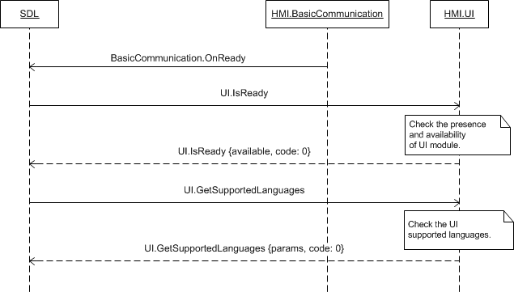

### 7.3.5 JSON Messages Examples

#### 7.3.5.1 Request

|  |
| --- |
| {  "id" : 99,  "jsonrpc" : "2.0",  "method" : "UI.GetSupportedLanguages"  } |

#### 7.3.5.2 Response

|  |
| --- |
| {  "id" : 99,  "jsonrpc" : "2.0",  "result" :  {  "languages" : [AR-SA, DE-DE, EN-GB, EN-US, ES-ES, FR-FR, IT-IT],  "code" : 0,  "method" : "UI.GetSupportedLanguages"  }  } |

#### 7.3.5.3 Error message

|  |
| --- |
| {  "id" : 99,  "jsonrpc" : "2.0",  "error" :  {  "code" : 9,  "message" : "The requested data is not available",  "data" :  {  "method" : "UI.GetSupportedLanguages"  }  }  } |

### 7.3.6 D-Bus Messages Examples

#### 7.1.6.1 Request

|  |
| --- |
|  |

#### 7.1.6.2 Response

|  |
| --- |
|  |

#### 7.1.6.3 Failure

|  |
| --- |
|  |

## 7.4 Alert

### 7.4.1 Description

|  |  |
| --- | --- |
| **Type:** | Function |
| **Sender:** | SDL |
| **Purpose:** | Display alert message on HMI. |

UI.Alert request notify the user by some readable information. It’s expected to be a pop-up with some text, sent by the mobile application. SDL transfers the text to HMI by UI.Alert request.

***Note:***

*SDL uses the information received via response to* *UI.GetCapabilities* *for forming the request (uses the supported text fields names, provides image for soft buttons once confirmed to be supported by HMI, etc.).*

Together with UI.Alert method SDL may also send

- BasicCommunication.PlayTone for turning the User`s attention to the Alert message with the help of HMI standard notifying sound

- TTS.Speak for providing the audible part of Alert to the User.

There’re 2 cases of using Alert on HMI. An application may send an Alert message with or without TTS portion (TTSChunks):

1) In case TTS portion is present in app’s Alert ->

SDL->HMI: UI.Alert (params, alertType: BOTH)

SDL->HMI: TTS.Speak

2) In case TTS portion is omitted in app’s Alert ->

SDL->HMI: UI.Alert (params, alertType: UI)

More details about around Alert messaging please find in section 7.4.4 Sequence Diagrams.

***Note:***

If Alert request comes together with PlayTone and Speak RPCs, HMI must:

- At first play the notifying sound (see also 6.18 PlayTone)

- Then speak the requested text

HMI must respond to UI.Alert not earlier than TTS.Speak is received:

SDL->HMI: UI.Alert (params, alertType: BOTH)

SDL->HMI: TTS.Speak

HMI->SDL: UI.Alert_response

SDL->HMI: StopSpeaking

HMI->SDL: StopSpeaking_response

HMI->SDL: Speak_response

If UI.Alert (params, alertType: UI) is received, HMI may respond to UI.Alert at any time when applicable by HMI flows.

**OnSystemContext related to successful Alert: 'appID' parameter optionality:**

1. HMI ought to not send AppID for MENU and HMI_OBCSURED system contexts. Only the apps in FULL may get these updates.  
2 .In case HMI sends OnSystemContext of MENU and HMI_OBCSUREDwith appID by HMI, appID is ignored and anyway the notification is transfered to the app in FULL HMI Level  
3. HMI must send OnSystemContext with appID parameter for MAIN and ALERT values. In case there's no such application with appID recieved, the notifications will be ignored by SDL

### 7.4.2 Request

#### 7.4.2.1 Behavior

***HMI must:***

1. Notify about the Alert context via OnSystemContext notification (see the rules in 7.4.1).

2. HMI must respond UI.Alert earlier than SDL’s default timeout of 10sec (applicable only to Alert without softButtons)

3. Display the alert dialog with:

* The text information in the named fields (up to three fields may be requested)
* Up to four soft buttons (optional)
* Progress indicator showing the time to dialog closing.

***Note:***

*The Alert dialog possible view is provided in the section 7.4.5 Possible Layout.*

3. React on requested soft button(s) press with:

* Sending OnButtonPress/OnButtonEvent notifications
* Predefined behavior depending on the soft button type:
* DEFAULT_ACTION type button press is assumed to close the alert dialog and return to the previously displayed screen
* KEEP_CONTEXT type button press is assumed to renew the timeout for the alert dialog being displayed. OnResetTimeout() must be sent my HMI in case of pressing a button with KEEP_CONTEXT
* STEAL_FOCUS type button press is assumed to
* Activate the application that has sent the Alert message while being not active on HMI
* Return to the screen previously displayed if the application that sent the Alert RPC is active on HMI.

***Note:***

*The diagrams describing the sequence of button press, notifications, messages is provided in section 7.4.4 Sequence Diagrams.*

4. Display the alert dialog and then close it

* By the timeout requested by SDL
* Or upon the events:
* One of the SDL-defined soft buttons press
* HMI-defined ‘Close’/’Back’/’Return’ button press
* VR activation
* Another application activation or switching to any of HMI screens
* Another RPC of a higher priority arrival.

5. Respond correspondingly after the definite event occurred (timeout, soft button press, etc.).

6. Notify via OnSystemContext about the system context is changed to main.

***Note:***

*The detailed information about the events occurred and the applicable response codes are described in the section* *7.4.3 Response**.*

*HMI may:*

Display the HMI-defined ‘Close’/’Back’/’Return’ button for providing the User with the possibility to dismiss the dialog. When such button is pressed

- The notification OnButtonPress/OnButtonEvent should not be sent to SDL

- The dialog must be closed

- The Alert RPC must be responded.

#### 7.4.2.2 Parameters

| **Param Name** | **Type** | **Mandatory** | **Additional** | **Description** |
| --- | --- | --- | --- | --- |
| alertStrings | Common.TextFieldStruct | true | Array = true  Minsize = 0  Maxsize = 3 | Array of lines of alert text fields that must be displayed. See TextFieldStruct.  Uses alertText1, alertText2, alertText3 from TextFieldName.  If empty array is sent, the displayed alert message should not contain any text. |
| duration | Integer | true | Minvalue = 3000  Maxvalue = 10000 | Timeout in milliseconds. |
| softButtons | Common.SoftButton | false | Array = true  Minsize = 0  Maxsize = 4 | Application-defined soft buttons.  If omitted or the empty array is sent, the displayed alert message should not have any soft buttons.  See section 5. Soft Buttons Behavior on HMI |
| progressIndicator | Boolean | false | - | If supported on the given platform, the alert dialog should include some sort of animation indicating that loading of a feature is progressing. e.g. a spinning wheel or hourglass, etc. |
| alertType | Common.AlertType | true | - | Defines if only UI or BOTH portions of the Alert request are being sent to HMI Side |
| appID | Integer | true | – | ID of the application related to this RPC. |

#### 7.4.2.3 TextFieldStruct Structure

| **Param Name** | **Type** | **Mandatory** | **Additional** | **Description** |
| --- | --- | --- | --- | --- |
| fieldName | Common.TextFieldName | true | – | The name of the field where the text must be displayed in. |
| fieldText | String | true | Maxlength = 500 | The text to be displayed. |

#### 7.4.2.4 TextFieldName Enumeration

Only the text fields applicable to Alert RPC are described within this section. All the text fields names recognized by SDL are described in the section *13.1.14 TextFieldName*.

| **Element name** | **Short Description** |
| --- | --- |
| alertText1 | The first line in the top of the alert dialog for displaying the text. |
| alertText2 | The second line of the alert dialog for displaying the text. |
| alertText3 | The third line of the alert dialog for displaying the text. |

#### 7.4.2.4 AlertType Enumeration

| **Element name** | **Short Description** |
| --- | --- |
| UI | Alert RPC needs to be displayed only (no TTS portion). |
| BOTH | Alert RPC has TTS portion in addition to displayed pop-up. |

### 7.4.3 Response

***Note:***

*There is a difference in message type for WebSocket and D-Bus connection (see the table below).*

|  |  |  |  |  |  |
| --- | --- | --- | --- | --- | --- |
| **Result** | **Description** | **Message type** | | **Message Params** | **Notes** |
| **WS** | **D-Bus** |
| Success | SUCCESS  - The alert dialog has been displayed  AND  - Now is closed by one of the following reasons:   * The timeout. * The soft button with DEFAULT_ACTION system action press. * The soft button with STEAL_FOCUS system action press. | JSON response | Regular response | code: 0 | - |
| UNSUPPORTED_RESOURCE  When images are sent by SDL but they aren’t supported by HMI or HMI doesn’t support the type of images sent (STATIC/DYNAMIC).  The request is considered to be successfully executed anyway if the the request informed the user with Alert information. | code:2 |  |
| Failure | ABORTED  - The alert dialog has been displayed  AND  - Now is **aborted** by:   * HMI-defined ‘Close’ button press. * VR session. * Another application activation or switching to HMI screen * Another RPC of a higher priority. | JSON error message | Regular response | code: 5 | Applicable for this RPC result codes.  Please see Result Enumeration for all SDL-supported codes. |
| REJECTED  The Alert RPC is **rejected** because the higher priority RPC is now displayed on HMI. | tryAgainTime,  code: 4 | See section  7.4.3.1 Parameters |
| INVALID_ID  Wrong appID (e.g. no app being registered with this appID value) | Code: 13 |  |
| INVALID_DATA  The data sent is **invalid** (out of bounds parameters, wrong JSON structure) | code: 11 |  |
| OUT_OF_MEMORY | code:17 | The check is actually performed by SDL. Optionally, HMI may also perform the check, In this casу the code must be returned |
| GENERIC_ERROR  The unknown issue occurred or other codes are not applicable. | code: 22 |  |

#### 7.4.3.1 Parameters

|  |  |  |  |  |
| --- | --- | --- | --- | --- |
| **Param Name** | **Type** | **Mandatory** | **Additional** | **Description** |
| tryAgainTime | Integer | false | Minvalue = 0  Maxvalue = 360000 | Amount of time (in milliseconds) that SDL must wait before resending an alert.  Must be returned only with REJECTED (code: 4) result. |

### 7.4.4 Sequence Diagrams

#### 7.4.4.1 Alert together with PlayTone and Speak RPCs and closed by the timeout

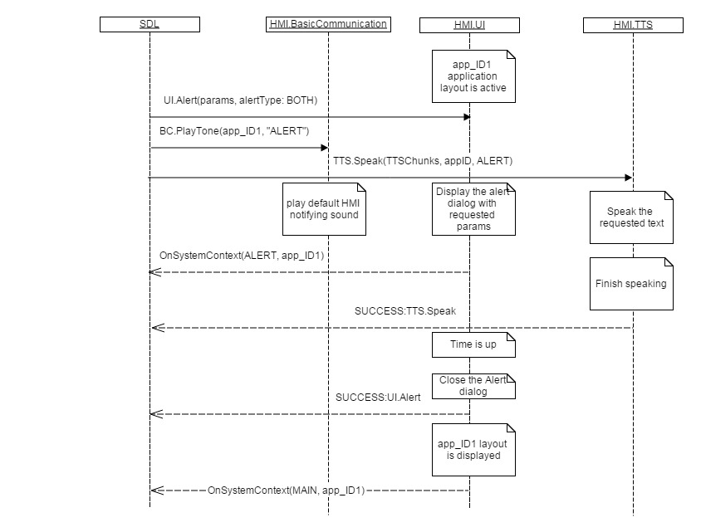

#### 7.4.4.2 Alert displayed and closed by DEFAULT_ACTION soft button press

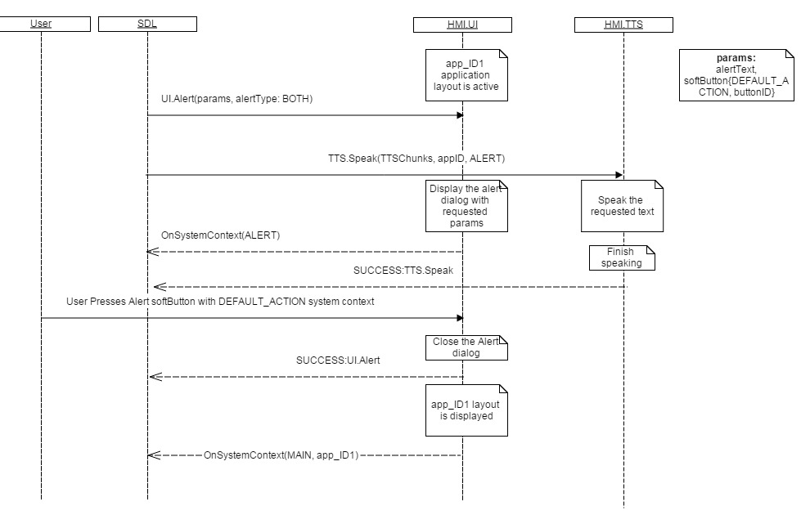

#### 7.4.4.3 Alert for non-activa application displayed and closed by STEAL_FOCUS soft button press

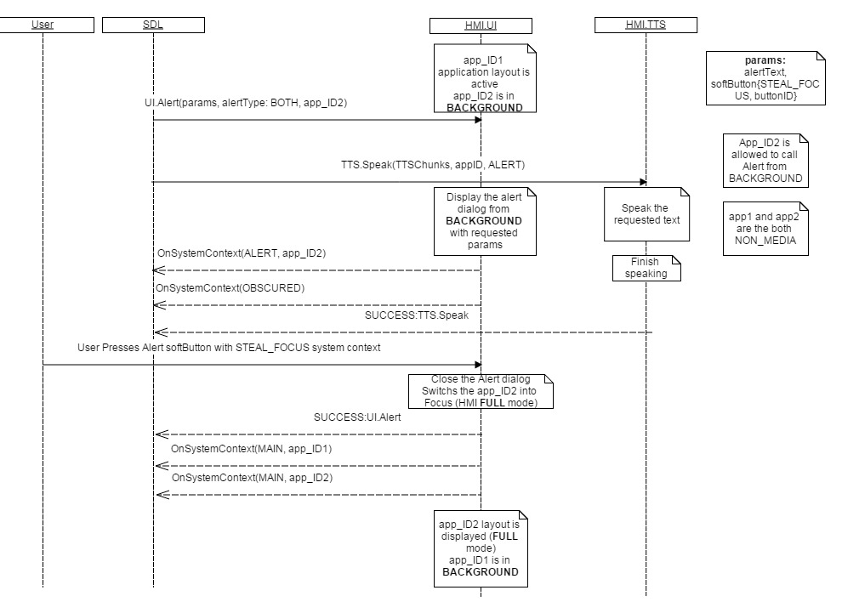

#### 7.4.4.4 Alert is displayed and then aborted by VR session started

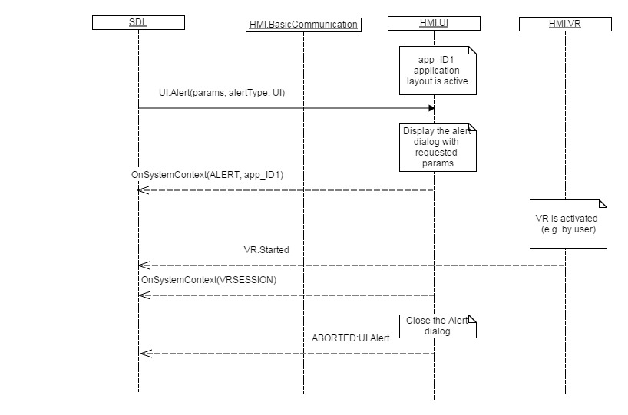

#### 7.4.4.5 Alert is rejected because of RPC of a higher priority currently presented on UI

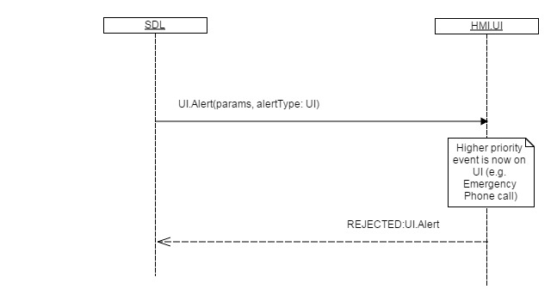

#### 7.4.4.6 Alert BOTH when UI is closed earlier than TTS has finished speaking

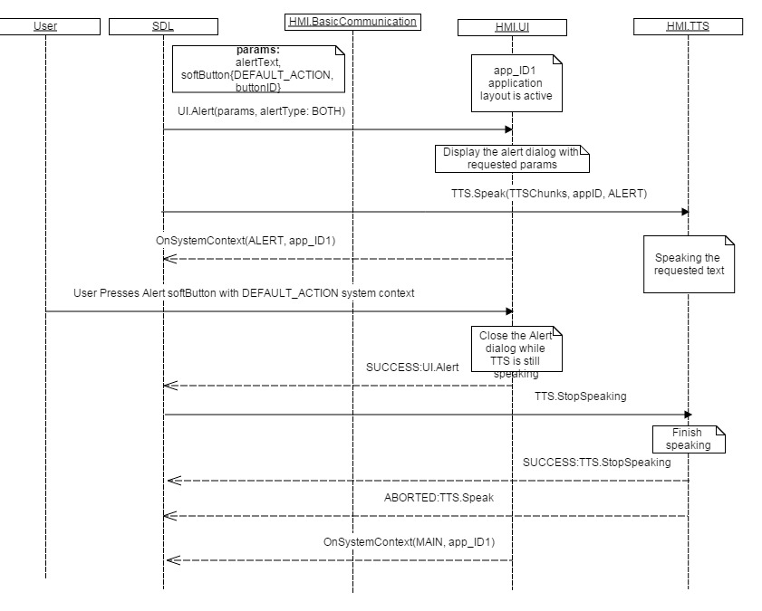

### 7.4.5 Possible Layout

#### 7.4.5.1 Alert dialog with text fields and NO soft buttons

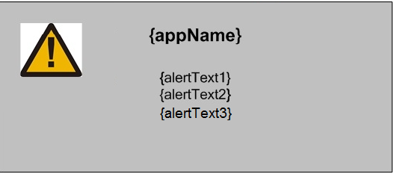

#### 7.4.5.2 Alert dialog with text fields, one soft button and progress indicator

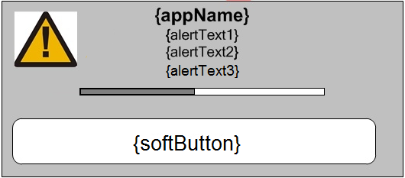

#### 7.4.5.3 Alert dialog with text fields and four soft buttons

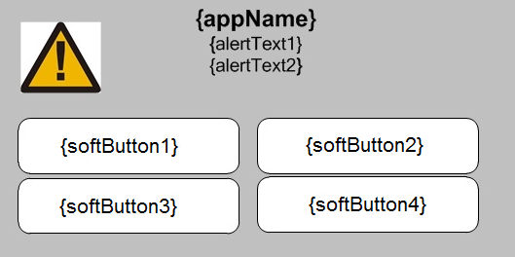

### 7.4.6 JSON Messages Examples

#### 7.4.6.1 Request

|  |
| --- |
| {  "id" : 92,  "jsonrpc" : "2.0",  "method" : "UI. Alert",  “params” :  {  “alertStrings” :  [  {  “fieldName” : alertText1,  “fieldText” : “WARNING”  },  {  “fieldName” : alertText2,  “fieldText” : “Hard weather conditions”  }  ],  “duration” : 5000,  “softButtons” :  {  “type” : TEXT,  “text” : “OK”,  “softButtonID” : 697,  “systemAction” : DEFAULT_ACTION  },  “appID” : 65539  }  } |

#### 7.4.6.2 Response

|  |
| --- |
| {  "id" : 92,  "jsonrpc" : "2.0",  "result" :  {  "code" : 0,  "method" : "UI.Alert"  }  } |

#### 7.4.6.3 Error message

|  |
| --- |
| {  "id" : 92,  "jsonrpc" : "2.0",  "error" :  {  "code" : 4,  "message" : " The requested command was rejected.",  "data" :  {  “tryAgainTime” : 10000,  "method" : "UI.Alert"  }  }  } |

### 7.4.7 D-Bus Messages Examples

#### 7.4.7.1 Request

|  |
| --- |
|  |

#### 7.4.7.2 Response

|  |
| --- |
|  |

#### 7.4.7.3 Failure

|  |
| --- |
|  |

## 7.5 Show

### 7.5.1 Description

|  |  |
| --- | --- |
| **Type:** | Function |
| **Sender:** | SDL |
| **Purpose:** | Update the application persistent display on HMI. |

With this RPC SDL requests HMI to update the supported fields for the application persistent display.

***Note:***

*SDL uses the information received via response to* *UI.GetCapabilities* *for forming the request (uses the supported text fields names, provides the images of supported type, etc.).*

The request may follow

- After the application is first activated on HMI

- For the application that is not currently active on HMI

### 7.5.2 Request

#### 7.5.2.1 Behavior

***HMI must:***

1. Store the data sent within RPC

2. Be able to correlate the stored information with the application identified with appID.

3. Display the requested data (text, image, soft buttons, presets):

* Right after the Show RPC arrived if the application is active on HMI
* After the application is activated if the Show RPC:
* Arrives while the application is not active on HMI.
* Arrived for the active application that has then been deactivated.

***Note:***

*Together with items requested with Show, HMI must also display the in-application commands menu (e.g. named ‘Options’) providing the possibility for the User to enter this menu (empty by default) and to choose among its elements (once added via* *AddCommand* *and/or* *AddSubMenu**).*

***Note:***

*Pressing the soft button of any system action must cause*

*- NO changes for application related persistent display on HMI*

*- Sending OnButtonPress/OnButtonEvent notifications.*

***Note:***

*The sequence diagrams describing the expected HMI behavior are provided in the section 7.5.4 Sequence Diagrams*

#### 7.5.2.2 Parameters

| **Param Name** | **Type** | **Mandatory** | **Additional** | **Description** |
| --- | --- | --- | --- | --- |
| showStrings | Common.TextFieldStruct | true | Array = true  Minsize = 0  Maxsize = 7 | Array of text lines to be displayed in the named text fields.  The previously displayed text must not be changed on this RPC receipt if:  - The corresponding textfield parameter is not provided within a request.  - The empty array is sent.  The previously displayed text must be cleared if the corresponding textfield parameter has the value of “” (empty string).  See TextFieldStruct, TextFieldName |
| alignment | Common.TextAlignment | false | – | Specifies the way mainField1 and mainField2 texts must be aligned on the display.  If omitted, texts must be centered.  See TextAlignment. |
| graphic | Common.Image | false | – | Path to the optional dynamic image or the static binary image itself.  If omitted, the displayed graphic must not be changed.  See Image. |
| secondaryGraphic | Common.Image | false | – | Image struct determining whether static or dynamic secondary image to display in app.  If omitted on supported displays, the displayed secondary graphic shall not change. |
| softButtons | Common.SoftButton | false | Array = true  Minsize = 0  Maxsize = 8 | App defined soft buttons.  Pressing the soft button with defined system action must cause no changes on HMI.  For all of the soft buttons the notifications OnButtonPress/OnButtonEvent must be provided by HMI.  If omitted or the empty array is sent, the currently displayed soft button values must not be changed.  See SoftButton. |
| customPresets | String | false | Array = true  Minsize = 0  Maxsize = 10  Maxlength = 500 | App labeled on-screen presets.  If omitted or the empty array is sent, the presets must be shown as not defined (with default names "PRESET_1", "PRESET_2", "PRESET_3" etc). |
| appID | Integer | true | - | ID of the application requested this RPC. |

#### 7.5.2.3 TextFieldStruct Structure

| **Param Name** | **Type** | **Mandatory** | **Additional** | **Description** |
| --- | --- | --- | --- | --- |
| fieldName | Common.TextFieldName | true | – | The name of the field where the text must be displayed in. |
| fieldText | String | true | Maxlength = 500 | The text to be displayed. |

#### 7.5.2.4 TextFieldName Enumeration

Only the text fields applicable to Alert RPC are described within this section. All the text fields names recognized by SDL are described in the section *13.1.14 TextFieldName*.

| **Element name** | **Short Description** |
| --- | --- |
| mainField1 | The text that must be displayed in a single or upper display line.  If this value is not set, the text of mainField1 must stay unchanged.  If this text is empty "", the field must be cleared. |
| mainField2 | The text that must be displayed on the second display line.  If this text is not set, the text of mainField2 must stay unchanged.  If this text is empty "", the field must be cleared.. |
| mainField3 | The text that must be displayed on the second "page" first display line.  If this text is not set, the text of mainField3 must stay unchanged.  If this text is empty "", the field must be cleared.. |
| mainField4 | The text that must be displayed on the second "page" second display line.  If this text is not set, the text of mainField4 must stay unchanged.  If this text is empty "", the field must be cleared.. |
| statusBar | The text is placed in the status bar area.  ***Note:*** *This relates to navigation displays*  If this parameter is omitted, the status bar text must remain unchanged.  If this parameter is an empty string, the field must be cleared.  If provided and the display has no status bar, this parameter must be ignored.. |
| mediaClock | Text value for MediaClock field. Shall arrive in the form as described in the MediaClockFormat enumeration  If this text is set, any automatic media clock updates previously set with SetMediaClockTimer must be stopped.. |
| mediaTrack | The text that should be displayed in the track field. This field should be valid only for media applications on.  If this text is not set, the text of mediaTrack must stay unchanged.  If this text is empty "", the field must be cleared.. |

#### 7.5.2.5 TextAlignment Enumeration

| **Element name** | **Short Description** |
| --- | --- |
| LEFT_ALIGNED | Text of mainField1 and mainField2 is left aligned. |
| RIGHT_ALIGNED | Text of mainField1 and mainField2 is right aligned. |
| CENTERED | Text of mainField1 and mainField2 is centered. |

### 7.5.3 Response

***Note:***

*There is a difference in message type for WebSocket and D-Bus connection (see the table below).*

|  |  |  |  |  |  |
| --- | --- | --- | --- | --- | --- |
| **Result** | **Description** | **Message type** | | **Message Params** | **Notes** |
| **WebSocket** | **D-Bus** |
| Success | SUCCESS  HMI has stored the requested data correlating it with the application ID and updated the display areas if the requested application is currently active. | JSON response | Method return | code: 0 |  |
|  | UNSUPPORTED_RESOURCE  When images are sent by SDL but they aren’t supported by HMI or HMI doesn’t support the type of images sent (STATIC/DYNAMIC).  The request is considered to be successfully executed anyway if the the request informed the user with other Show information. |  |  | code:2 |  |
| Failure | REJECTED  HMI is expected to return REJECTED result code in case HMI is currently busy with a higher-priority event. | JSON error message | Method return | code:4 |  |
| INVALID_ID  Wrong appID (e.g. no app being registered with this appID value) | code:13 |  |
| INVALID_DATA  The data sent is invalid (invalid JSON syntax, parameters out of bounds or of wrong type) | code: 11 | Applicable for this RPC result codes.  Please see Result Enumeration for all SDL-supported codes. |
| GENERIC_ERROR:  1) The unknown issue occurred or other codes are not applicable.  2) In case HMI does not respond SDL's request during SDL-default timeout (10 sec), SDL will return the result code to the corresponding mobile app's request. | code: 22 |

### 7.5.4 Sequence Diagrams

#### 7.5.4.1 Show for the active application that is then deactivated and activated again

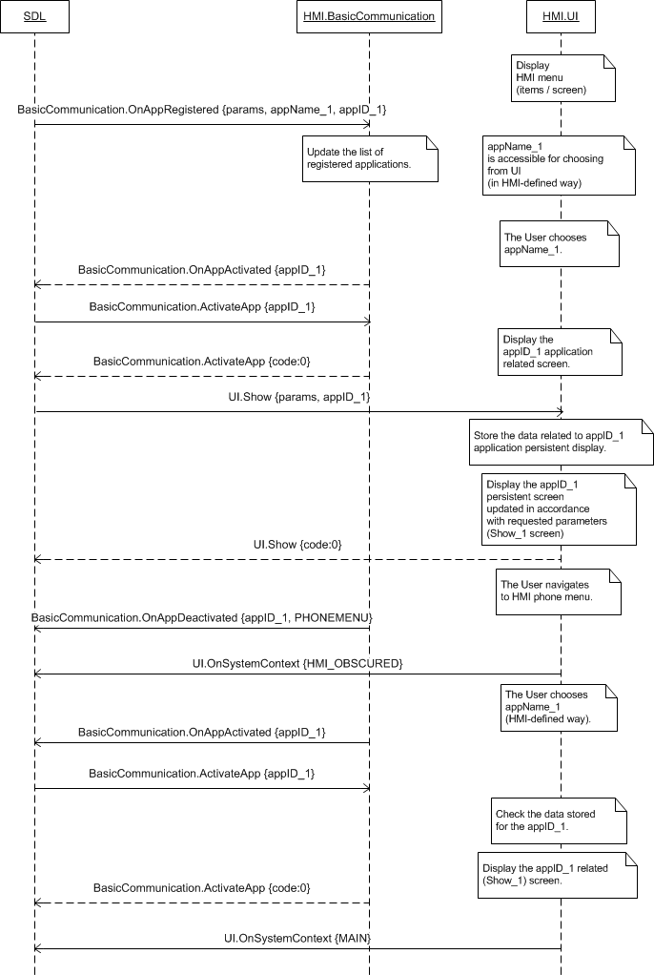

#### 7.5.4.2 Show for the application currently not active on HMI

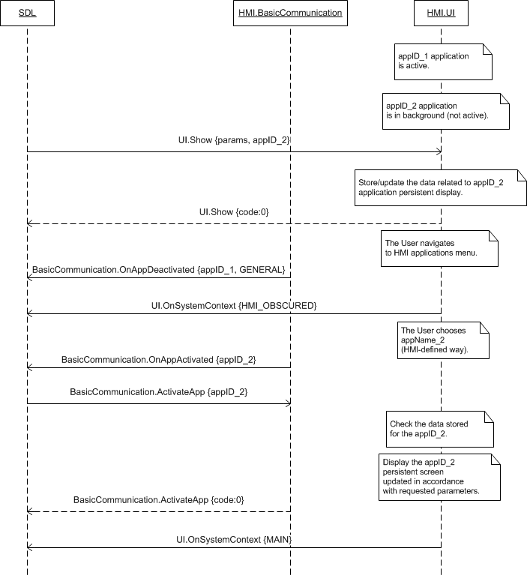

#### 7.5.4.3 Requested with Show soft button press

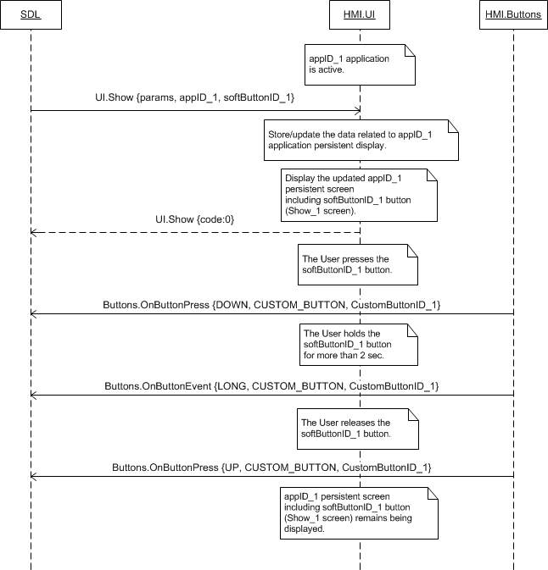

***Note:***

*CustomButtonID parameter returned via OnButtonEvent/OnButtonPress notifications must have the same value as the softButtonID parameter sent via Show RPC.*

#### 7.5.4.4 Show text fields expected behavior

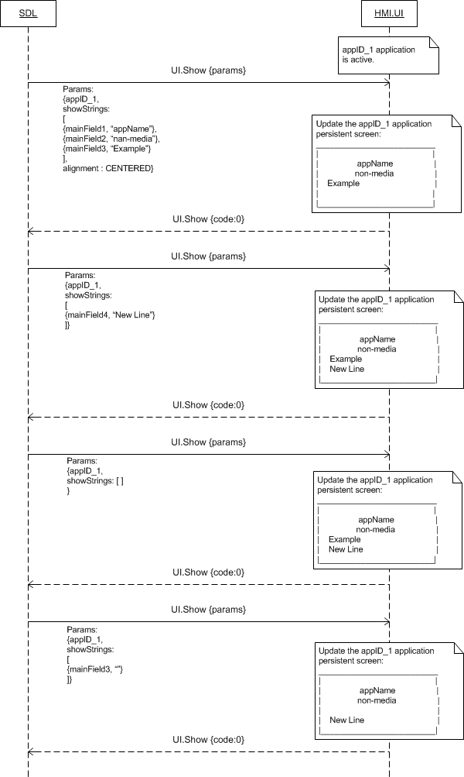

### 7.5.5 Possible Layout

#### 7.5.5.1 Persistent display areas updated with Show for media applications

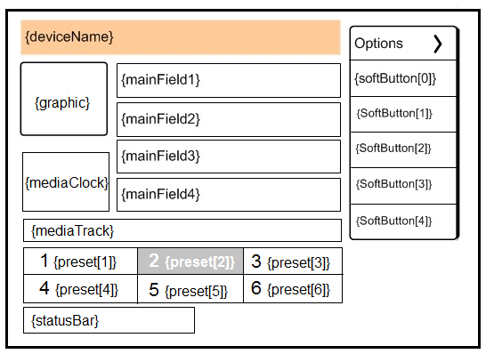

#### 7.5.5.2 Persistent display areas updated with Show for non-media applications

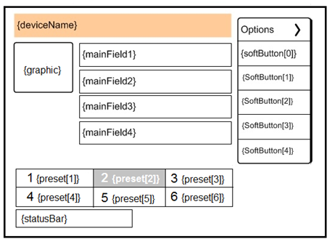

### 7.5.6 JSON Messages Examples

#### 7.5.6.1 Request

|  |
| --- |
| {  "id" : 120,  "jsonrpc" : "2.0",  "method" : "UI. Show",  “params” :  {  “showStrings” :  [  {  “fieldName” : mainField1,  “fieldText” : “Favourite Album”  },  {  “fieldName” : mediaClock,  “fieldText” : “1:45:12”  },  {  “fieldName” : mediaTrack,  “fieldText” : “Ironic – The Collection – Alanis Morissette”  }  ],  “alignment” : LEFT_ALIGNED,  “graphic” :  {  “value” : “tmp/SDL/app/Best_Media/AM-Collection-cover.png”,  “imageType” : DYNAMIC  },  “softButtons” :  [  {  “type” : BOTH,  “text” : “Change Album”,  “image” :  [  “value” : “tmp/SDL/app/Best_Media/change_alb_icon.jpg”,  “imageType” : DYNAMIC  ],  “softButtonID” : 48,  “systemAction” : DEFAULT_ACTION  },  {  “type” : TEXT,  “text” : “Change Artist”,  “softButtonID” : 57  },  ],  “customPresets” : [“Like Song”, “Like Album”],  “appID” : 8726  }  } |

#### 7.5.6.2 Response

|  |
| --- |
| {  "id" : 120,  "jsonrpc" : "2.0",  "result" :  {  "code" : 0,  "method" : "UI.Show"  }  } |

#### 7.5.6.3 Error message

|  |
| --- |
| {  "id" : 120,  "jsonrpc" : "2.0",  "error" :  {  "code" : 22,  "message" : " The unknown issue occurred ",  "data" :  {  "method" : "UI.Show"  }  }  } |

### 7.5.7 D-Bus Messages Examples

#### 7.5.7.1 Request

|  |
| --- |
|  |

#### 7.5.7.2 Response

|  |
| --- |
|  |

#### 7.5.7.3 Failure

|  |
| --- |
|  |

## 7.6 AddCommand

### 7.6.1 Description

|  |  |
| --- | --- |
| **Type:** | Function |
| **Sender:** | SDL |
| **Purpose:** | Add a command to the in-application menu or sub menu. |

This RPC represents a request to HMI to add a command to in-application menu or sub-menu (the latter follows after AddSubMenu RPC).

The request may arrive in both cases of activated and deactivated application on HMI.

### 7.6.2 Request

#### 7.6.2.1 Behavior

***HMI must:***

1. Provide the in-application menu (e.g. named ‘Options’) displayed right after the application is activated on HMI.

2. Provide the possibility for the User to enter this menu (empty by default) and to choose among its elements (once added via UI.AddCommand and/or AddSubMenu).

3. Check that the limit of menu / sub menu (depending on where the command is requested to be added to, see point 5. below) items is not exhausted by the command being requested (and if so, reject the request with the corresponding result code).

4. Store the data provided within this RPC correlating it with the appID.

5. Add the command with requested parameters (name, position) to:

* The top level menu (e.g. ‘Options’) if parentID is not provided within RPC.
* The sub menu with the ID corresponding to the parentID provided within RPC.

6. Provide the response correspondingly to the result of RPC execution.

***Note:***

*The applicable to this RPC result codes are provided in section* *7.8.3 Response**.*

7. Provide the UI.OnCommand notification with the cmdID corresponding to the command chosen by the User.

***Important Note:***

*Once commands are added for the named application, they must remain accessible for the User (until UI.DeleteCommand comes) when this application is activated after having been deactivated.*

*In case the app sends AddCommand with the both UI and VR portions and adding one of the portions ended with erroneous response or no resonse at all, SDL must send DeleteCommand for a successfully added portion(VR or UI) in the following cases (see diagrams for more detailes* *7.6.4.6-7.6.4.9**) :*

* 1. *In case SDL sends both UI.AddCommand and VR.AddCommand with one and the same cmdID to HMI AND* ***UI.AddCommand gets successful response*** *from HMI in return AND VR.AddCommand gets any *erroneous response*/no response from HMI - SDL must send* ***UI.DeleteCommand*** *for the successfully added cmdID to HMI.*
  2. *In case SDL sends both UI.AddCommand and VR.AddCommand with one and the same cmdID to HMI AND* ***VR.AddCommand gets successful response*** *from HMI in return AND UI.AddCommand gets *erroneous response except of WARNINGS and UNSUPPORTED_RESOURCE*/ no response from HMI - SDL must send* ***VR.DeleteCommand*** *for the successfully added cmdID to HMI*

#### 7.6.2.2 Parameters

| **Param Name** | **Type** | **Mandatory** | **Additional** | **Description** |
| --- | --- | --- | --- | --- |
| cmdID | Integer | true | Minvalue = 0 | ID of the command to be added.  This ID is unique within the application related to this request.  This ID:  - Must be returned by HMI later within OnCommand notification to identify the command selected by the user.  - Might be provided by SDL later within DeleteCommand request. |
| menuParams | Common.MenuParams | false | – | Defines the name of the command, its position, ID of the submenu for the command to be added to.  If not provided, the command must be added to the end of the list of items of the top-level menu.  See MenuParams. |
| cmdIcon | Common.Image | false | – | Image to be displayed for representing the command: either the path to dynamic image stored on HU or the static binary image itself.  If not provided, no image or the default one if applicable should be displayed.  See Image. |
| appID | Integer | true | – | ID of the application related to this RPC. |

#### 7.6.2.3 MenuParams

|  |  |  |  |  |
| --- | --- | --- | --- | --- |
| **Param Name** | **Type** | **Mandatory** | **Additional** | **Description** |
| parentID | Integer | false | minvalue = 0  maxvalue = 2000000000 | - Unique ID of the sub menu, the command must be added to.  - If not provided, the command must be added to the top-level application menu. |
| position | Integer | false | minvalue = 0  maxvalue = 1000 | This value is the position within the elements of top-level application menu / sub menu where the command must be added to:  - If 0, the item must be inserted to the first position.  - If 1, the item must be inserted to the second position.  - Etc.  If the next command comes with the same position value, it must be added as the next item within corresponding ‘position block’. (e.g. the command with position 0 must be added  - after the previous item with position 0  - and before the first item with position 1).  If the value is greater than or equal to the number of elements of the top-level application menu, the command must be appended to the end of the list.  If omitted the item must be added to the end of the list. |
| menuName | String | true | maxlength = 500 | The text that must be shown as a name of a command. |

### 7.6.3 Response

***Note:***

*There is a difference in message type for WebSocket and D-Bus connection (see the table below).*

|  |  |  |  |  |  |
| --- | --- | --- | --- | --- | --- |
| **Result** | **Description** | **Message type** | | **Message Params** | **Notes** |
| **WebSocket** | **D-Bus** |
| Success | HMI has stored the data correlating it with appID and added the command with the corresponding parameters to the in-application menu/sub menu. | JSON response | Method return | code: 0 |  |
|  | UNSUPPORTED_RESOURCE  When images are sent by SDL but they aren’t supported by HMI or HMI doesn’t support the type of images sent by SDL (STATIC/DYNAMIC). |  |  | Code: 2 |  |
| Failure | REJECTED  1) The limit of position items of the top level menu is exhausted.  2) The limit of position items of the corresponding sub menu the command to be added to is exhausted. | JSON error message | Method return | Code: 4 | Applicable for this RPC result codes.  Please see Result Enumeration for all SDL-recognized codes. |
| INVALID_DATA  The data sent is invalid (invalid JSON syntax, parameters out of bounds or of wrong type) | code: 11 |
| INVALID_ID  1) The command with requested cmdID is already added for the named application.  2) The sub menu with requested parentID does not exist. | code: 13 |
| GENERIC_ERROR:  1) The unknown issue occurred or other codes are not applicable.  2) In case HMI does not respond SDL's request during SDL-default timeout (10 sec), SDL will return the result code to the corresponding mobile app's request. | code: 22 |

### 7.6.4 Sequence Diagrams

#### 7.6.4.1 AddCommand for the active application on HMI, the command is chosen by the User.

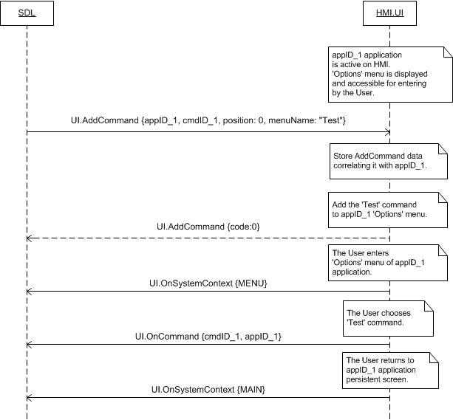

#### 7.6.4.2 AddCommand for the application not active on HMI

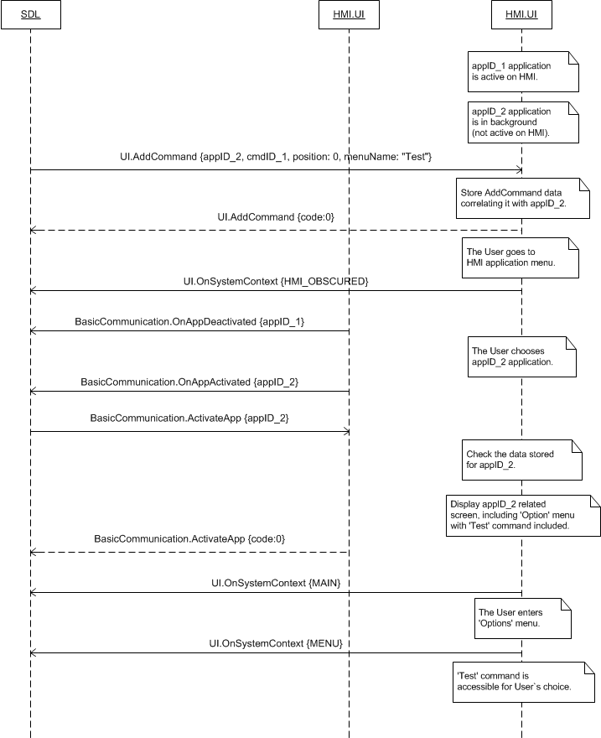

#### 7.6.4.3 AddCommand: adding command to sub menu

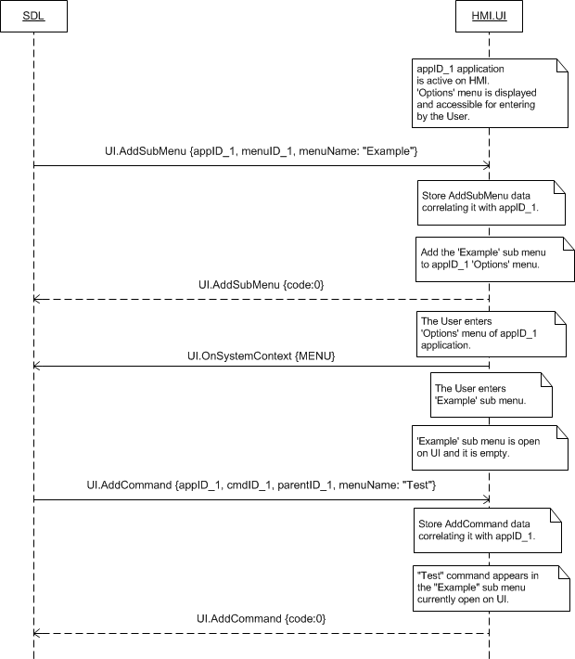

***Note:***

*The value of parentID sent via UI.AddCommand is equal to the value of menuID previously provided via AddSubMenu.*

#### 7.6.4.4 AddCommand: expected behavior of adding commands depending on position parameter

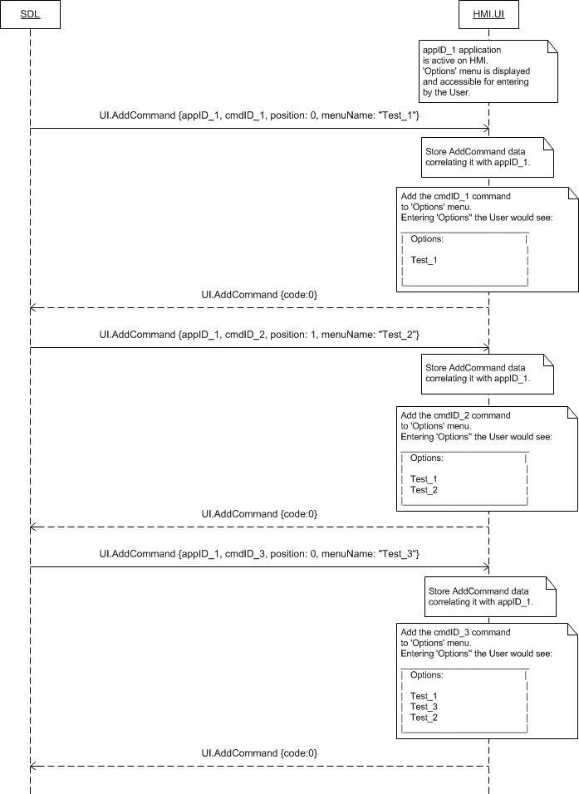

#### 7.6.4.5 AddCommand rejected because of the limit of menu items exhausted

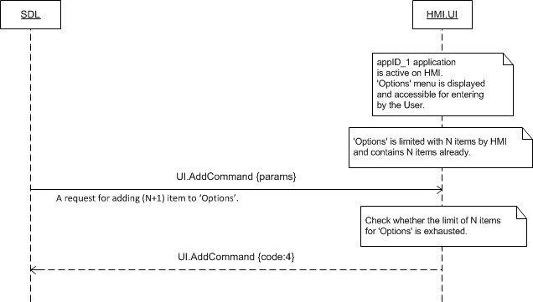

#### 7.6.4.6 UI.AddCommand returnes SUCCESS, VR portion failed

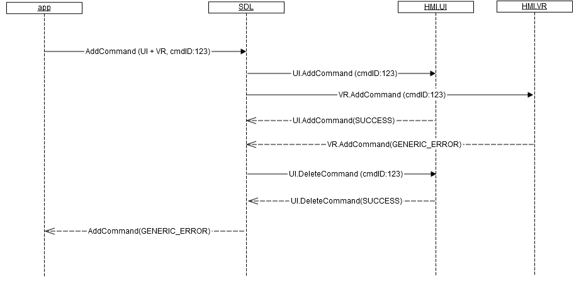

#### 7.6.4.7 UI.AddCommand returnes SUCCESS, VR portion no response

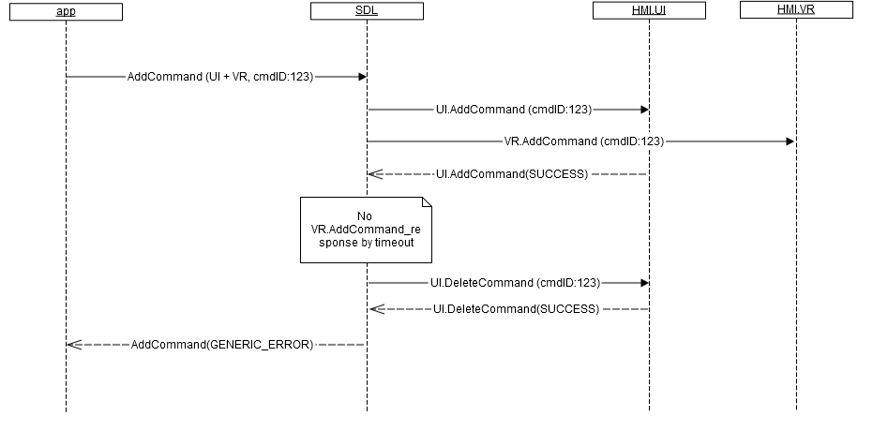

#### 7.6.4.8 UI.AddCommand fails, VR portion SUCCESS

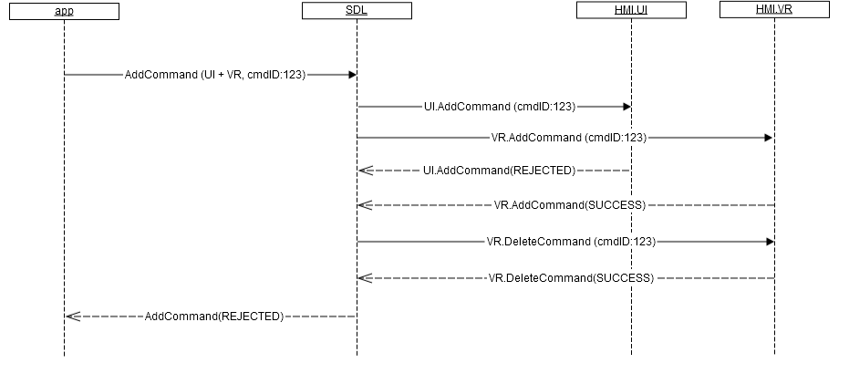

#### 7.6.4.9 UI.AddCommand no response, VR portion SUCCESS

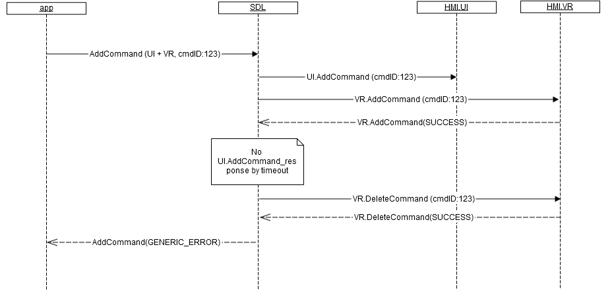

***Note:***

*“Top level menu (e.g. ‘Options’) items” are considered to be both commands and sub menus.*

### 7.6.5 Possible Layout

#### 7.6.5.1 Application main menu with sub menus and commands

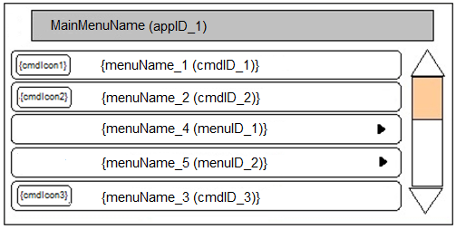

#### 7.6.5.2 Application sub menu with commands

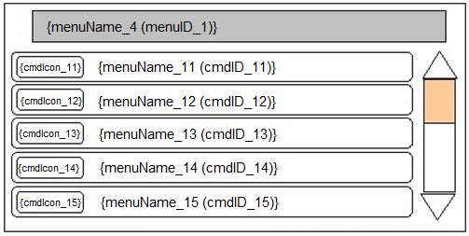

### 7.6.6 JSON Messages Examples

#### 7.8.6.1 Request

|  |
| --- |
| {  "id" : 215,  "jsonrpc" : "2.0",  "method" : "UI. AddCommand",  “params” :  {  “cmdID” : 2318,  “menuParams” :  {  “parentID” : 6,  “position” : 0,  “menuName” : “Show weather for tomorrow”  },  “cmdIcon” :  {  “value” : “tmp/SDL/app/Gis_meteo/1245_28.jpeg”,  “imageType” : DYNAMIC  },  “appID” : 65409  }  } |

#### 7.6.6.2 Response

|  |
| --- |
| {  "id" : 215,  "jsonrpc" : "2.0",  "result" :  {  "code" : 0,  "method" : "UI.AddCommand"  }  } |

#### 7.6.6.3 Error message

|  |
| --- |
| {  "id" : 215,  "jsonrpc" : "2.0",  "error" :  {  "code" : 13,  "message" : "There’s no app with received appID registered",  "data" :  {  "method" : "UI.AddCommand"  }  }  } |

### 7.8.7 D-Bus Messages Examples

#### 7.8.7.1 Request

|  |
| --- |
|  |

#### 7.8.7.2 Response

|  |
| --- |
|  |

#### 7.8.7.3 Failure

|  |
| --- |
|  |

## 7.9 DeleteCommand

### 7.9.1 Description

|  |  |
| --- | --- |
| **Type:** | Function |
| **Sender:** | SDL |
| **Purpose:** | Delete the command from in-application menu |

SDL requests to delete the command from in-application menu or sub menu of the named application previously added via UI.AddCommand.

The request may arrive in both cases of activated and deactivated application on HMI.

### 7.9.2 Request

#### 7.9.2.1 Behavior

***HMI must:***

1. Update the named application stored data correspondingly to the RPC arrived.

2. Delete the command identified with cmdID.

3. Display updates:

* Right away if the named application is active and the corresponding menu/sub menu is open on UI.
* After the corresponding menu/sub menu is opened on UI upon User`s request:
* If the RPC arrived when the named application was active and had another menu or persistent display visible on UI
* If the RPC arrived when the named application was not active on HMI.

5. Provide the response corresponding to the result of RPC execution.

***Note:***

*The applicable to this RPC result codes are provided in section 7.9.3 Response.*

***Note:***

*- The value of cmdID is previously sent via UI.AddCommand.*

*- The value of appID is previously sent via UpdateAppList or OnAppRegistered.*

#### 7.9.2.2 Parameters

|  |  |  |  |
| --- | --- | --- | --- |
| **Param Name** | **Type** | **Mandatory** | **Description** |
| cmdId | Integer | true | ID of the command to be deleted (the one sent within the AddCommand request). |
| appID | Integer | true | ID of the application that concerns this RPC. |

### 7.9.3 Response

***Note:***

*There is a difference in message type for WebSocket and D-Bus connection (see the table below).*

|  |  |  |  |  |  |
| --- | --- | --- | --- | --- | --- |
| **Result** | **Description** | **Message type** | | **Message Params** | **Notes** |
| **WebSocket** | **D-Bus** |
| Success | SUCCESS  HMI has updated the named application related data and deleted the requested command. | JSON response | Method return | code: 0 | . |
| Failure | INVALID_DATA  The data sent is invalid (invalid JSON syntax, parameters are out of bounds or of wrong type) | JSON error message | Method return | code: 11 | Applicable for this RPC result codes.  Please see Result Enumeration for all SDL-recognized codes. |
| INVALID_ID  The command with requested cmdID does not exist on HMI for the named application.  The app with appID in the request isn’t registered | Code: 13 |
| GENERIC_ERROR:  1) The unknown issue occurred or other codes are not applicable.  2) In case HMI does not respond SDL's request during SDL-default timeout (10 sec), SDL will return the result code to the corresponding mobile app's request. | code: 22 |

### 7.9.4 Sequence Diagrams

#### 7.9.4.1 DeleteCommand, for the application active on HMI, for the command from the menu currently open on UI and preceding AddCommand

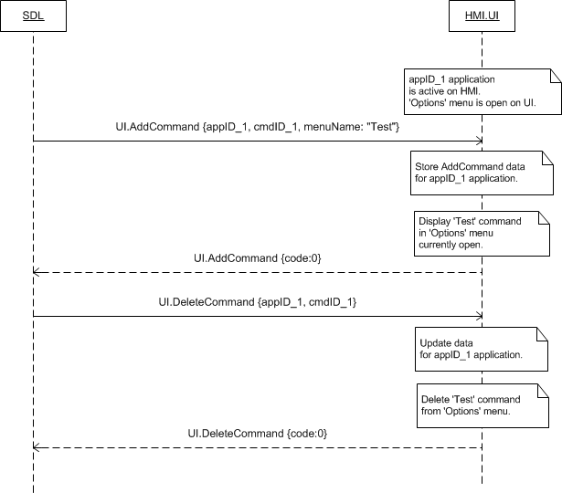

#### 7.9.4.2 DeleteCommand for the application not active on HMI

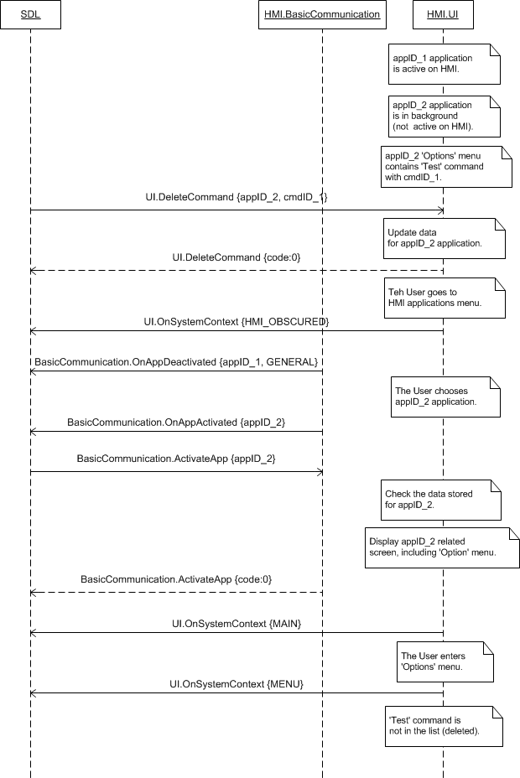

### 7.9.5 JSON Messages Examples

#### 7.9.5.1 Request

|  |
| --- |
| {  "id" : 70,  "jsonrpc" : "2.0",  "method" : "UI. DeleteCommand",  “params” :  {  “cmdID” : 2318,  “appID” : 65409  }  } |

#### 7.9.5.2 Response

|  |
| --- |
| {  "id" : 70,  "jsonrpc" : "2.0",  "result" :  {  "code" : 0,  "method" : "UI. DeleteCommand"  }  } |

#### 7.9.5.3 Error message

|  |
| --- |
| {  "id" : 70,  "jsonrpc" : "2.0",  "error" :  {  "code" : 13,  "message" : "One of the provided IDs is not valid",  "data" :  {  "UI. DeleteCommand"  }  }  } |

### 7.9.6 D-Bus Messages Examples

#### 7.9.6.1 Request

|  |
| --- |
|  |

#### 7.9.6.2 Response

|  |
| --- |
|  |

#### 7.9.6.3 Failure

|  |
| --- |
|  |

## 7.10 AddSubMenu

### 7.10.1 Description

|  |  |
| --- | --- |
| **Type:** | Function |
| **Sender:** | SDL |
| **Purpose:** | Add a sub menu to in-application menu |

This RPC represents a request to HMI to add a command to in-application main menu. The sub menu is never requested to be added to sub menu.

Further SDL may request to add commands via AddCommands RPC to this sub menu identified with menuID.

The request may arrive in both cases of activated and deactivated application on HMI.

### 7.10.2 Request

#### 7.10.2.1 Behavior

***HMI must:***

1. Provide the in-application main menu (e.g. named ‘Options’) displayed right after the application is activated on HMI.

2. Provide the possibility for the User to enter this menu (empty by default) and to choose among its elements (once added via UI.AddCommand and/or AddSubMenu).

3. Check that the limit of the main menu items is not exhausted by the sub menu being requested (and if so, reject the request with the corresponding result code).

4. Store the data provided within this RPC correlating it with the appID.

5. Add the sub menu with requested parameters (name, position) to the top level in-application menu.

6. Provide the response correspondingly to the result of RPC execution.

***Note:***

*The applicable to this RPC result codes are provided in section 7.10.3 Response.*

7. Provide the possibility for the User to enter this sub menu (empty by default) and choose among its elements (once added by SDL via UI.AddCommand).

***Important Note:***

*Once the sub menus are added for the named application, they must remain accessible for the User (until UI.DeleteSubMenu comes) when this application is activated after having been deactivated.*

#### 7.10.2.2 Parameters

|  |  |  |  |  |
| --- | --- | --- | --- | --- |
| **Param Name** | **Type** | **Mandatory** | **Additional** | **Description** |
| menuID | Integer | true | Minvalue = 1  Maxvalue =  2000000000 | ID of the sub menu to be added. It is unique within the application concerned. |
| menuParams | Common.MenuParams | true | – | The name of the sub-menu to be added and its positions within menu items.  See MenuParams. |
| appID | Integer | true | – | ID of the application requested this RPC. |

#### 7.10.2.3 MenuParams

|  |  |  |  |  |
| --- | --- | --- | --- | --- |
| **Param Name** | **Type** | **Mandatory** | **Additional** | **Description** |
| position | Integer | false | minvalue = 0  maxvalue = 1000 | This value is the position within the elements of top-level application menu where the sub-menu must be added to:  - If 0, the item must be inserted to the first position.  - If 1, the item must be inserted to the second position.  - Etc.  If the next sub menu comes with the same position, it must be added as the next item within corresponding ‘position block’. (e.g. the sub menu with position 0 must be added  - after the previous item with position 0  - and before the first item with position 1).  If the value is greater than or equal to the number of elements of the top-level application menu, the sub menu must be appended to the end of the list.  If omitted the entry must be added to the end of the list. |
| menuName | String | true | maxlength = 500 | The text that must be shown as a name of a sub -menu. |

### 7.10.3 Response

***Note:***

*There is a difference in message type for WebSocket and D-Bus connection (see the table below).*

|  |  |  |  |  |  |
| --- | --- | --- | --- | --- | --- |
| **Result** | **Description** | **Message type** | | **Message Params** | **Notes** |
| **WebSocket** | **D-Bus** |
| Success | HMI has stored the data correlating it with appID and added the sub menu with the corresponding parameters to the in-application main menu. | JSON response | Method return | code: 0 |  |
|  | OUT_OF_MEMORY @TODO to clarify |  |  | Code:17 |  |
|  | DUPLICATE_NAME  The submenu with the same menuName is already registered. |  |  | Code:14 |  |
| Failure | REJECTED  The limit of position items of the top level menu is exhausted. | JSON error message | Method return | Code: 4 | Applicable for this RPC result codes.  Please see Result Enumeration for all SDL-recognized codes. |
| INVALID_DATA  The data sent is invalid (invalid JSON syntax, parameters out of bounds or of wrong type) | code: 11 |
| INVALID_ID  The sub menu with requested menuID is already added for the named application.  The app with appID in the request isn’t registered | code: 13 |
| GENERIC_ERROR:  1) The unknown issue occurred or other codes are not applicable.  2) In case HMI does not respond SDL's request during SDL-default timeout (10 sec), SDL will return the result code to the corresponding mobile app's request. | code: 22 |

### 7.10.4 Sequence Diagrams

#### 7.10.4.1 AddSubMenu for the application active on HMI

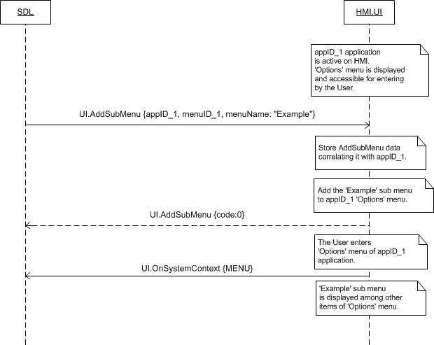

#### 7.10.4.2 AddSubMenu for the application not active on HMI

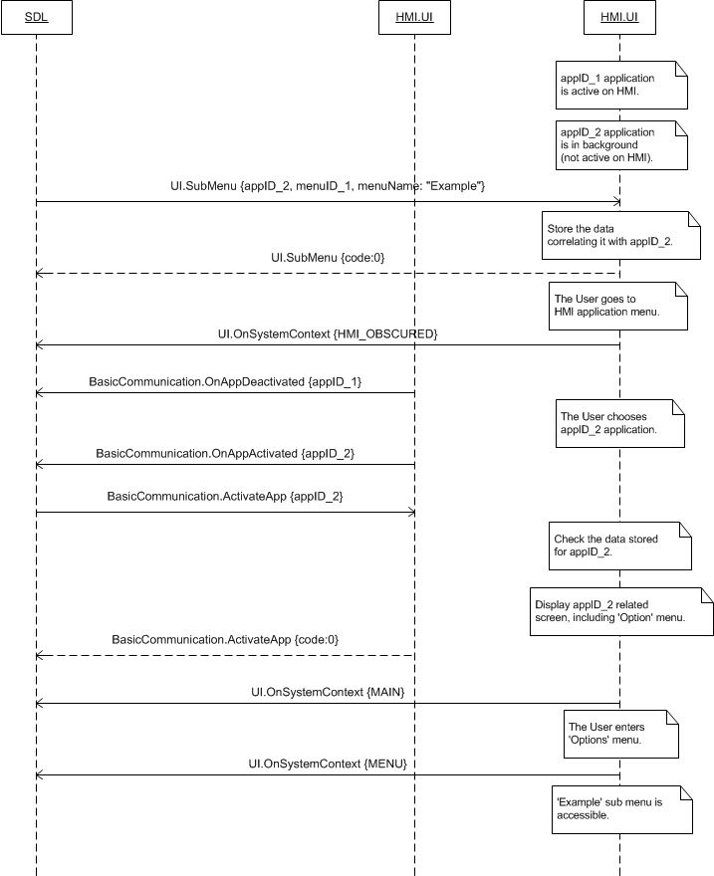

#### 7.10.4.3 AddSubMenu: expected behavior of adding sub menus depending on position parameter

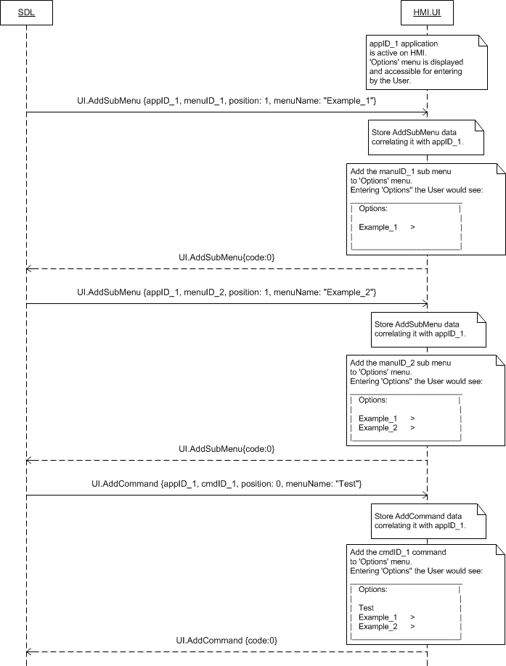

***Note:***

*HMI should sort the in-application main menu items by position parameter independently of item type (sub menu/command).*

#### 7.10.4.4 AddSubMenu rejected because of the limit of menu items exhausted

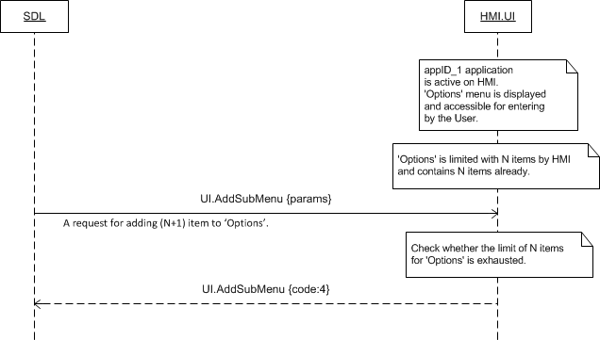

### 7.10.5 Possible Layout

#### 7.10.5.1 Application main menu with sub menus and commands



### 7.10.6 JSON Messages Examples

#### 7.10.6.1 Request

|  |
| --- |
| {  "id" : 112,  "jsonrpc" : "2.0",  "method" : "UI.AddSubMenu",  “params” :  {  “menuID” : 345,  “menuParams” :  {  “position” : 2,  “menuName” : “Settings”  },  “appID” : 65464  }  } |

#### 7.10.6.2 Response

|  |
| --- |
| {  "id" : 112,  "jsonrpc" : "2.0",  "result" :  {  "code" : 0,  "method" : "UI.AddSubMenu"  }  } |

#### 7.10.6.3 Error message

|  |
| --- |
| {  "id" : 112,  "jsonrpc" : "2.0",  "error" :  {  "code" : 14,  "message" : "Duplicate name: there was a conflict with an already registered name of SubMenu",  "data" :  {  "method" : "UI.AddSubMenu"  }  }  } |

### 7.10.7 D-Bus Messages Examples

#### 7.10.7.1 Request

|  |
| --- |
|  |

#### 7.10.7.2 Response

|  |
| --- |
|  |

#### 7.10.7.3 Failure

|  |
| --- |
|  |

## 7.11 DeleteSubMenu

### 7.11.1 Description

|  |  |
| --- | --- |
| **Type:** | Function |
| **Sender:** | SDL |
| **Purpose:** | Delete the sub menu from in-application menu. |

SDL requests to delete the command from in-application menu of the named application previously added via UI.AddSubMenu.

The request may arrive in both cases of activated and deactivated application on HMI.

### 7.11.2 Request

#### 7.11.2.1 Behavior

***HMI must:***

1. Check whether the named sub menu is currently open on UI and:

* If so, NOT delete this sub menu responding with appropriate result code (see section 7.11.3).
* If not, continue processing the request.

2. Update the named application stored data correspondingly.

3. Delete

* The sub menu identified with menuID.
* The commands that are related to this sub menu (which have parentID of the named menuID value)

4. Display updates:

* Right away if the named application is active and the main menu is open on UI.
* After the main menu is opened on UI upon User`s request:
* If the RPC arrived when the named application was active and had another menu or persistent display visible on UI
* If the RPC arrived when the named application was not active on HMI.

5. Provide the response corresponding to the result of RPC execution.

***Note:***

*The applicable to this RPC result codes are provided in section 7.11.3 Response.*

***Note:***

*- The value of menuID is previously sent via AddSubMenu.*

*- The value of appID is previously sent via UpdateAppList or OnAppRegistered.*

#### 7.11.2.2 Parameters

| **Param Name** | **Type** | **Mandatory** | **Additional** | **Description** |
| --- | --- | --- | --- | --- |
| menuID | Integer | true | Minvalue = 1  Maxvalue =  2000000000 | ID that identifies the submenu to be deleted (the one that was previously provided via AddSubMenu). |
| appID | Integer | true | – | ID of the application that requested this RPC. |

### 7.11.3 Response

***Note:***

*There is a difference in message type for WebSocket and D-Bus connection (see the table below).*

|  |  |  |  |  |  |
| --- | --- | --- | --- | --- | --- |
| **Result** | **Description** | **Message type** | | **Message Params** | **Notes** |
| **WebSocket** | **D-Bus** |
| Success | SUCCESS  HMI has updated the named application related data and deleted the requested sub menu. | JSON response | Method return | code: 0 | . |
| Failure | IN_USE  The named sub menu is currently open on UI. | JSON error message | Method return | Code: 8 | Applicable for this RPC result codes.  Please see Result Enumeration for all SDL-recognized codes. |
| INVALID_DATA  The data sent is invalid (invalid JSON syntax, parameters are out of bounds or of wrong type) | code: 11 |
| INVALID_ID  The sub menu with requested menuID does not exist on HMI for the named application.  appID provided is not valid. | Code: 13 |
| GENERIC_ERROR:  1) The unknown issue occurred or other codes are not applicable.  2) In case HMI does not respond SDL's request during SDL-default timeout (10 sec), SDL will return the result code to the corresponding mobile app's request. | code: 22 |

### 7.11.4 Sequence Diagrams

#### 7.11.4.1 DeleteSubMenu: the application is active on HMI, the main menu is currently open on UI, AddSubMenu precedes

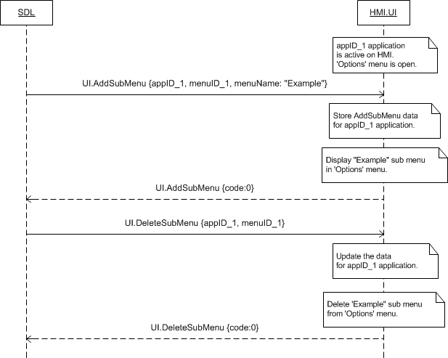

#### 7.11.4.2 DeleteSubmenu which contains the commands @TODO create the diagram

### 7.11.5 JSON Messages Examples

#### 7.11.5.1 Request

|  |
| --- |
| {  "id" : 70,  "jsonrpc" : "2.0",  "method" : "UI. DeleteSubMenu",  “params” :  {  “menuID” : 345,  “appID” : 65464  }  } |

#### 7.11.5.2 Response

|  |
| --- |
| {  "id" : 70,  "jsonrpc" : "2.0",  "result" :  {  "code" : 0,  "method" : "UI. DeleteSubMenu "  }  } |

#### 7.11.5.3 Error message

|  |
| --- |
| {  "id" : 70,  "jsonrpc" : "2.0",  "error" :  {  "code" : 8,  "message" : "The data may not be changed because it is currently in use",  "data" :  {  "UI. DeleteSubMenu "  }  }  } |

### 7.11.6 D-Bus Messages Examples

#### 7.11.6.1 Request

|  |
| --- |
|  |

#### 7.11.6.2 Response

|  |
| --- |
|  |

#### 7.11.6.3 Failure

|  |
| --- |
|  |

## 7.12 UI.PerformInteraction

### 7.12.1 Description

|  |  |
| --- | --- |
| **Type:** | Function |
| **Sender:** | SDL |
| **Purpose:** | Perform a UI interaction with the User. |

SDL uses PerformInteraction for requesting an interaction with the User, for example:

- To confirm a command

- To make a choice between several suggested ones.

The request concerns the application currently active on HMI.

***Notes about PerformInteraction***

1. *SDL may intend to perform one of three modes of interaction:*
   1. *‘Manual only’ – when the User is expected to make a choice manually only (display, buttons, soft buttons are involved).*
   2. *‘VR only’ – when the User is expected to make a choice by voice only (voice recognition module is involved).*
   3. *‘Both’ – when the User is expected to make a choice whichever by voice or manually (display, buttons, soft buttons, VR module are involved).*
2. *SDL sends both VR.PerformInteraction and UI.PerformInteraction for each of above types of interaction. HMI`s expected behavior differs depending on interaction mode (see section 7.12.2.1 Behavior).*
3. *SDL provides HMI with the set(s) of choices to be presented to the User. See the below Notes of CreateInteractionChoiceSet.*

***Notes about CreateInteractionChoiceSet:***

1. *Mobile application in advance creates a set (or several sets) of choices on SDL to be further used in PerformIntercation.*
2. *SDL in advance provides HMI with VR synonyms of created choices via VR.AddCommand (see section 9.4 for details). They are then referenced in VR.PerformaInteraction (see section 9.12).*
3. *SDL sends UI choices (those to be displayed) within UI.PerformIntercation directly.*

### 7.12.2 Request

#### 7.12.2.1 Behavior

***HMI must:***

1. Distinguish the interaction mode by the following charachteristics:

| **Mode** | **SDL sends both RPCs with the following parameters:** | **Note** |
| --- | --- | --- |
| VR_ONLY | VR.PerformInteraction {**grammarID**, params} | grammarID is present |
| UI.PerformInteraction {params} | No choiceSet |
| MANUAL_ONLY | VR.PerformInteraction {params} | No grammarID |
| UI.PerformInteraction {**choiceSet**, params} | choiceSet is present |
| BOTH | VR.PerformInteraction {**grammarID**, params} | grammarID is present |
| UI.PerformInteraction {**choiceSet**, params} | choiceSet is present |

**I. ‘VR only’ interaction mode:**

***HMI must:***

1. Display the dialog with the information provided within:

* vrHelpTitle parameter – as a title of the message
* vrHelp parameter – as a list of commands accessible for voice recognition.

***Note:***

*In ‘VR only’ interaction mode HMI must display the help information only.*

2. Respond with SUCCESS result code right after the dialog is displayed (for all of applicable result codes please see section 7.12.3 Response).

3. Close the dialog upon the corresponding VR.PerformInteraction completes (by either the User`s choice, or by timeout, or being aborted by system event of a higher priority).

***Note:***

*Please see diagram in section 7.12.4.1 UI.PerfromInteraction in ‘VR only’ mode.*

**II. ‘Manual only’ interaction mode:**

1. Start timeout provided within timeout parameter.

2. Display the PerformInteraction dialog which layout must depend on interactionLayout parameter:

2.1. ICON_ONLY layout:

2.1.a) Use value of initialText parameter – to display the text on the first line of the display (mostly used as a promting to the User to start the interaction).

2.1.b) Use values of choiceSet parameter – to display the choices-related information (text and/or image) in the form of icons.

2.1.c) Proceed with step 3. when the User clicks one of the choice-icons.

2.2. ICON_WITH_SEARCH layout:

2.2.a) Use value of initialText parameter – to display the text on the first line of the display (mostly used as a promting to the User to start the interaction).

2.2.b) Use values of choiceSet parameter – to display the choices-related information (text and/or image) in the form of icons.

2.2.c) Display a ‘Search tab’ together with ‘Search’ button in the top of the dialog.

2.2.c.1) Display the touchscreen keyboard overlaying both choices and text when the user clicks the ‘Search tab’ area.

2.2.c.2) Provide OnKeyboardInput notification (s) (the sequence depends on KeyboardProperties defined by SDL within UI.SetGlobalProperties. Please see section 7.26 OnKeyboardInput for description and diagrams).

2.2.c.3) Proceed with step 3. When the User presses the ‘Search’ button.

2.2.d) Proceed with step 3. when the User clicks one of the choices in the list.

2.3. LIST_ONLY layout:

2.3.a) Use value of initialText parameter – to display the text on the first line of the display (mostly used as a promting to the User to start the interaction).

2.3.b) Use values of choiceSet parameter – to display the choices-related information (text and/or image) in the form of the list.

2.3.c) Proceed with step 3. when the User clicks one of the choices in the list.

2.4. LIST_WITH_SEARCH layout:

2.4.a) Use value of initialText parameter – to display the text on the first line of the display (mostly used as a promting to the User to start the interaction).

2.4.b) Use values of choiceSet parameter – to display the choices-related information (text and/or image) in the form of the list.

2.4.c) Display a ‘Search tab’ together with ‘Search’ button in the top of the dialog.

2.4.c.1) Display the touchscreen keyboard overlaying both choices and text when the user clicks the ‘Search tab’ area.

2.4.c.2) Provide OnKeyboardInput notification(s) (the sequence depends on KeyboardProperties defined by SDL within UI.SetGlobalProperties. Please see section 7.26 OnKeyboardInput for description and diagrams).

2.4.c.3) Proceed with step 3. when the User presses the ‘Search’ button.

2.4.d) Proceed with step 3. When the User clicks one of the choices in the list.

2.5. KEYBOARD layout:

2.5.a) Display the touchscreen keyboard with ‘Search’ button.

2.5.b) Provide OnKeyboardInput notification(s) (the sequence depends on KeyboardProperties defined by SDL within UI.SetGlobalProperties. Please see section 7.26 OnKeyboardInput for description and diagrams).

2.5.c) Proceed with step 3. when the User presses the ‘Search’ button.

3. Respond with SUCCESS result code after the User has made a choice AND provide the value of:

3.1. choiceID parameter for the steps of ‘2.1.c)’, ‘2.2.d)’, ‘2.3.c)’, ‘2.4.d)’.

3.2. manualTextEntry parameter for the steps of ‘2.2.c.3)’, ‘2.4.c.3)’, ‘2.5.c’.

(for all of applicable result codes please see section 7.12.3 Response).

**III. ‘Both’ interaction mode:**

1. Display the dialog with the information provided within:

* vrHelpTitle parameter – as a title of the message
* vrHelp parameter – as a list of commands accessible for voice recognition.

***Note:***

*This ‘VR Help’-dialog must be kept in correspondence with currently active VR session that SDL requests via VR.PerformInteraction.*

2. Close ‘VR Help’-dialog when the corresponding VR session:

2.1. Completes successfully by the User`s VR choice. Proceed with **step 3**.

2.2. Completes by the timeout. Proceed with **step 4**.

2.3. Is aborted by the User. Proceed with **step 4**.

3. Respond with SUCCESS result code (for all of applicable result codes please see section 7.12.3 Response).

4. Start ‘Manual only’ interaction mode.

4.1. Start timeout provided within timeout parameter.

4.2. Display the PerformInteraction dialog which layout must depend on interactionLayout parameter:

4.2.1. ICON_ONLY layout:

4.2.1.a) Use value of initialText parameter – to display the text on the first line of the display (mostly used as a promting to the User to start the interaction).

4.2.1.b) Use values of choiceSet parameter – to display the choices-related information (text and/or image) in the form of icons.

4.2.1.c) Proceed with step 4.3. when the User clicks one of the choice-icons.

4.2.2. ICON_WITH_SEARCH layout:

4.2.2.a) Use value of initialText parameter – to display the text on the first line of the display (mostly used as a promting to the User to start the interaction).

4.2.2.b) Use values of choiceSet parameter – to display the choices-related information (text and/or image) in the form of icons.

4.2.2.c) Display a ‘Search tab’ together with ‘Search’ button in the top of the dialog.

4.2.2.c.1) Display the touchscreen keyboard overlaying both choices and text when the user clicks the ‘Search tab’ area.

4.2.2.c.2) Provide OnKeyboardInput notification (s) (the sequence depends on KeyboardProperties defined by SDL within UI.SetGlobalProperties. Please see section 7.26 OnKeyboardInput for description and diagrams).

4.2.2.c.3) Proceed with step 4.3. When the User presses the ‘Search’ button.

4.2.2.d) Proceed with step 4.3. when the User clicks one of the choices in the list.

4.2.3. LIST_ONLY layout:

4.2.3.a) Use value of initialText parameter – to display the text on the first line of the display (mostly used as a promting to the User to start the interaction).

4.2.3.b) Use values of choiceSet parameter – to display the choices-related information (text and/or image) in the form of the list.

4.2.3.c) Proceed with step 4.3. when the User clicks one of the choices in the list.

4.2.4. LIST_WITH_SEARCH layout:

4.2.4.a) Use value of initialText parameter – to display the text on the first line of the display (mostly used as a promting to the User to start the interaction).

4.2.4.b) Use values of choiceSet parameter – to display the choices-related information (text and/or image) in the form of the list.

4.2.4.c) Display a ‘Search tab’ together with ‘Search’ button in the top of the dialog.

4.2.4.c.1) Display the touchscreen keyboard overlaying both choices and text when the user clicks the ‘Search tab’ area.

4.2.4.c.2) Provide OnKeyboardInput notification(s) (the sequence depends on KeyboardProperties defined by SDL within UI.SetGlobalProperties. Please see section 7.26 OnKeyboardInput for description and diagrams).

4.2.4.c.3) Proceed with step 4.3. when the User presses the ‘Search’ button.

4.2.4.d) Proceed with step 4.3. When the User clicks one of the choices in the list.

4.2.5. KEYBOARD layout:

4.2.5.a) Display the touchscreen keyboard with ‘Search’ button.

4.2.5.b) Provide OnKeyboardInput notification(s) (the sequence depends on KeyboardProperties defined by SDL within UI.SetGlobalProperties. Please see section 7.26 OnKeyboardInput for description and diagrams).

4.2.5.c) Proceed with step 4.3. when the User presses the ‘Search’ button.

4.3. Respond with SUCCESS result code after the User has made a choice AND provide the value of:

4.3.1. choiceID parameter for the steps of ‘4.2.1.c)’, ‘4.2.2.d)’, ‘4.2.3.c)’, ‘4.2.4.d)’.

4.3.2. manualTextEntry parameter for the steps of ‘4.2.2.c.3)’, ‘4.2.4.c.3)’, ‘4.2.5.c’.

(for all of applicable result codes please see section 7.12.3 Response).

#### 7.12.2.2 Parameters

| **Param Name** | **Type** | **Mandatory** | **Additional** | **Description** |
| --- | --- | --- | --- | --- |
| initialText | Common.TextFieldStruct | false | – | The text that must be displayed:  - When the interaction begins  - On the first line of a multiline screen  - Centered.  See TextFieldStruct, TextFieldName (uses initialInteractionText). |
| choiceSet | Common.Choice | false | Array = true  Minsize = 1  Maxsize = 100 | Array of one or more Choice Sets. Each one is represented with:  - The mandatory ID (to be returned by HMI in the response if the corresponding Choice Set is selected by the User)  - Optional name and/or picture.  See Choice.  HMI must provide the possibility for the User to choose among these choices. |
| vrHelpTitle | String | false | Maxlength = 500 | VR Help Title text.  If omitted on supported displays, the default HU system help title should be used. |
| vrHelp | Common.VrHelpItem | false | Array = true  Minsize = 1  Maxsize = 100 | VR Help Items that must be displayed on-screen after HMI recognizes ‘Help’ command during PerformInteraction.  See VrHelpItem. |
| timeout | Integer | true | Minvalue = 5000  Maxvalue =  100000  Defvalue = 10000 | Timeout in milliseconds.  The amount of time the HMI must wait for the User to make a choice.  After the time is up HMI respond with timed_out result code. |
| interactionLayout | Common.LayoutMode | false | - | See LayoutMode. |
| appID | Integer | true | – | ID of the application related to this RPC. |

#### 7.4.2.3 TextFieldStruct Structure

| **Param Name** | **Type** | **Mandatory** | **Additional** | **Description** |
| --- | --- | --- | --- | --- |
| fieldName | Common.TextFieldName | true | – | The name of the field where the text must be displayed in. |
| fieldText | String | true | Maxlength = 500 | The text to be displayed. |

#### 7.12.2.4 TextFieldName

| **Element name** | **Short Description** |
| --- | --- |
| initialInteractionText | Must be displayed when the interaction begins. The text must be displayed on the first line of a multiline display, and must be centered.  Applies to PerformInteraction |

#### 7.12.2.5 Choice

| **Param Name** | **Type** | **Mandatory** | **Additional** | **Description** |
| --- | --- | --- | --- | --- |
| choiceID | Integer | true | minvalue = 0  maxvalue = 65535 | The unique within the concerned application identifier for this choice |
| menuName | String | false | Maxlength = 500 | The text to be displayed in the onscreen menu indicating the name of the choice (e.g. ‘Yes’). |
| image | Common.Image | false | – | Image that must appear in the menu, representing this choice.  See Image |
| secondaryText | String | false | Maxlength = 500 | Optional secondary text to display; e.g. address of POI in a search result entry |
| tertiaryText | String | false | Maxlength = 500 | Optional tertiary text to display; e.g. distance to POI for a search result entry |
| secondaryImage | Common.Image | false | - | Optional secondary image struct for choice |

#### 7.12.2.6 VrHelpItem

| **Param Name** | **Type** | **Mandatory** | **Additional** | **Description** |
| --- | --- | --- | --- | --- |
| text | String | True | maxlength = 500 | The text that must be displayed as a name for VR Help item. |
| image | Common.Image | False | – | Image that must be displayed by HU to represent the VR Help item.  See Image |
| position | Integer | false | minvalue = 1  maxvalue = 100 | This value is the position within the elements of VR Help menu where the item must be added to: |

#### 7.12.2.7 LayoutMode

|  |  |
| --- | --- |
| **Element name** | **Short Description** |
| ICON_ONLY | This mode causes the interaction to display the previous set of choices as icons |
| ICON_WITH_SEARCH | This mode causes the interaction to display the previous set of choices as icons along with a search field in the HMI. |
| LIST_ONLY | This mode causes the interaction to display the previous set of choices as a list |
| LIST_WITH_SEARCH | This mode causes the interaction to display the previous set of choices as a list along with a search field in the HMI. |
| KEYBOARD | This mode causes the interaction to immediately display a keyboard entry through the HMI. |

### 7.12.3 Response

***Note:***

*There is a difference in message type for WebSocket and D-Bus connection (see the table below).*

|  |  |  |  |  |  |
| --- | --- | --- | --- | --- | --- |
| **Result** | **Description** | **Message type** | | **Message Params** | **Notes** |
| **WebSocket** | **D-Bus** |
| Success | SUCCESS  The cases described in 7.12.2:  ‘I.2’, ‘II.3’, ‘III.3’, ‘III.4.3’. | JSON response | Regular response | choiceID,  manualTextEntry,  code: 0 | See section 7.12.4 Parameters. |
|  | INVALID_DATA  The data sent is invalid (invalid JSON syntax, parameters are out of bounds or of wrong type) | JSON response | Regular response | code:11 |  |
| INVALID_ID  ChoiceID or appID is invalid (e.g. doesn’t exist) | code:13 |
| ABORTED  The interaction is aborted by the User or system event of higher priority. | code: 5 |
| TIMED_OUT  The User has not made a choice during timeout defined within request. | code: 10 |
| GENERIC_ERROR:  1) The unknown issue occurred or other codes are not applicable.  2) In case HMI does not respond SDL's request during timeout defined in a request, SDL will return the result code to the corresponding mobile app's request. | code: 22 |

#### 7.12.4 Parameters

| **Param Name** | **Type** | **Mandatory** | **Additional** | **Description** |
| --- | --- | --- | --- | --- |
| choiceID | Integer | false | minvalue = 0  maxvalue =  2000000000 | ID that represents the choice made by the User (one among those provided within the request). |
| manualTextEntry | String | false | minlength = 0  maxvlength = 500 | Manually entered text selection, e.g. through keyboard  Can be returned in lieu of choiceID, depending on trigger source |

### 7.12.4 Sequence Diagrams

#### 7.12.4.1 UI.PerfromInteraction in ‘VR only’ mode successfully completed

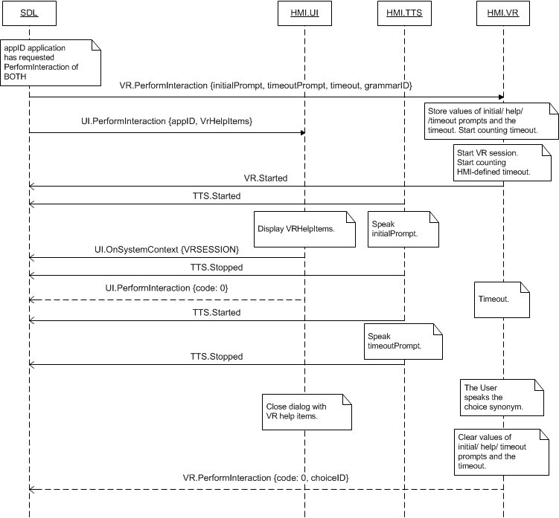

#### 7.12.4.2 UI.PerfromInteraction in ‘Manual only’ mode successfully completed

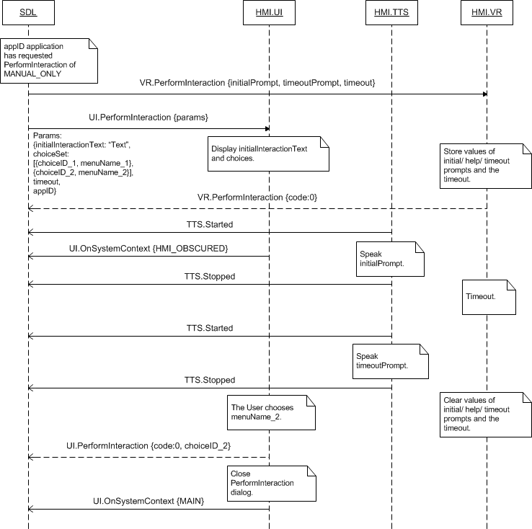

#### 7.12.4.3 UI.PerfromInteraction in ‘Both’ mode timed out

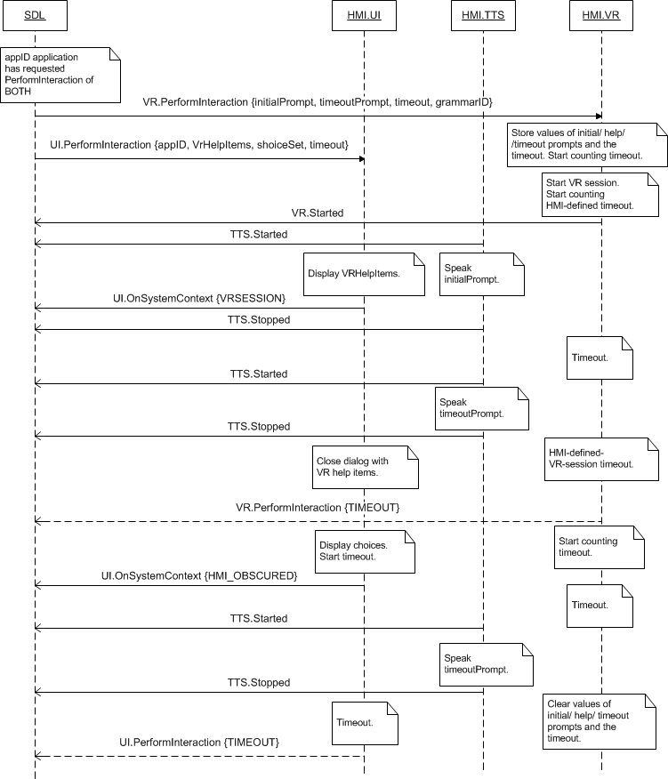

### 7.12.5 JSON Messages Examples

#### 7.12.5.1 Request

|  |
| --- |
| {  "id" : 79,  "jsonrpc" : "2.0",  "method" : "UI.PerformInteraction",  “params” :  {  “initialText” :  {  “fieldName” : initialInteractionText,  “fieldText” : “Choose the station:”  },  “choiceSet” :  [  {  “choiceID” : 2415,  “menuName” : “Sky.FM”  },  {  “choiceID” : 2416,  “menuName” : “Paradise”  },  {  “choiceID” : 2417,  “menuName” : “100 XR”  }  ],  “vrHelp” :  [  {  “text” : “Sky FM”,  “image” :  [  “value” : “tmp/SDL/app/Pandora/icon_5410.jpg”,  “imageType” : DYNAMIC  ],  “position” : 1  },  {  “text” : “Paradise”,  “image” :  [  “value” : “tmp/SDL/app/Pandora/icon_5423.jpeg”,  “imageType” : DYNAMIC  ],  “position” : 2  },  {  “text” : “100 XR”,  “image” :  [  “value” : “tmp/SDL/app/Pandora/icon_5465.jpeg”,  “imageType” : DYNAMIC  ],  “position” : 3  }  ],  “timeout” : 15000,  “appID” : 6493  }  } |

#### 7.12.5.2 Response

|  |
| --- |
| {  "id" : 79,  "jsonrpc" : "2.0",  "result" :  {  “choiceID” : 2416  "code" : 0,  "method" : "UI.PerformInteraction"  }  } |

#### 7.12.5.3 Error message

|  |
| --- |
| {  "id" : 79,  "jsonrpc" : "2.0",  "error" :  {  "code" : 10,  "message" : "Overlay reached the maximum timeout and closed",  "data" :  {  "method" : "UI.PerformInteraction"  }  }  } |

### 7.12.6 D-Bus Messages Examples

#### 7.12.6.1 Request

|  |
| --- |
|  |

#### 7.12.6.2 Response

|  |
| --- |
|  |

#### 7.12.6.3 Failure

|  |
| --- |
|  |

## 7.13 SetMediaClockTimer

### 7.13.1 Description

|  |  |
| --- | --- |
| **Type:** | Function |
| **Sender:** | SDL |
| **Purpose:** | Set a value and the update mode of the media clock. |

With this RPC SDL requests to

- set the initial value of media clock (in case not PAUSE/RESUME)

- update it correspondingly to the provided parameters.

The request may concern the application not being currently active on HMI.

***Note:***

*SDL uses the information about:*

*- mediaClock field*

*- the format of time value*

*confirmed to be supported by HMI within response to UI.GetCapabilities*

*SDL will not send the request if mediaClock field is not supported.*

### 7.13.2 Request

#### 7.13.2.1 Behavior

***HMI must:***

1. Perform the following depending on the updateMode parameter:

***Important Note:***

*If the request comes for the application*

*- Currently active on HMI, the requested updates must be immediately displayed*

*- Currently NOT active (being in background) on HMI, HMI must*

* *Perform the requested updates in background*
* *Display the value of the media clock valid at the time the corresponding application becomes activated on HMI.*
* COUNTUP / COUNTDOWN modes:
* Start counting up / down from the requested startTime value with the step of 1 second
* Continue counting up / down until:
* The next request of SetMediaClockTimer with appropriate parameters comes
* .Zero value in case of COUNTDOWN.
* PAUSE mode:
* Pause the clock that is counting up / down
* If startTime and endTime are provided, the values must be updated on HMI.
* RESUME mode:
* Continue counting up / down (in the mode that was in effect before pausing) the clock that has been paused.
* CLEAR mode:
* Clear the clock value (whatever being currently updated or paused). It is up to HMI to determine the way the media clock timer is cleared: either to remove it from display or to set it to zero.

***Important Note:***

*HMI must remember the mode and the value (continuing to update it in case of COUNTUP / COUNTDOWN) of the media clock timer associated with appID and display the accurate values whenever the appID application is activated after having been deactivated.*

***Note:***

*Initially, the appID together with other application-related information is provided by SDL within one of UpdateAppList and OnAppRegistered RPCs.*

2. Respond with the result code correspondingly to the results of this RPC execution.

***Note:***

*The applicable to this RPC result codes are provided in section 7.13.3 Response.*

***Note:***

*The sequence diagrams describing the expected HMI behavior are provided in the section 7.13.4 Sequence Diagrams*

#### 7.13.2.2 Parameters

| **Param Name** | **Type** | **Mandatory** | **Description** |
| --- | --- | --- | --- |
| startTime | Common.TimeFormat | false | The starting time value to be counted up / down from.  See TimeFormat |
| updateMode | Common.ClockUpdateMode | true | The update method of the clock value: countup, countdown, pause, resume, clear.  In case of resume, or clear, the startTime value should be ignored and left out if provided.  See ClockUpdateMode. |
| appID | Integer | true | ID of the application that concerns this RPC. |

#### 7.13.2.3 TimeFormat

| **Param Name** | **Type** | **Mandatory** | **Additional** | **Description** |
| --- | --- | --- | --- | --- |
| hours | Integer | true | minvalue = 0  maxvalue = 59 | The hour of the media clock. |
| minutes | Integer | true | minvalue = 0  maxvalue = 59 | The minute. |
| seconds | Integer | true | minvalue = 0  maxvalue = 59 | The second. |

#### 7.13.2.4 ClockUpdateMode

| **Element name** | **Short Description** |
| --- | --- |
| COUNTUP | HMI must start the media clock timer counting upwards, as in time elapsed, in increments of 1 second. |
| COUNTDOWN | HMI must start the media clock timer counting downwards, as in time remaining, in decrements of 1 second. |
| PAUSE | HMI must pause the media clock timer. |
| RESUME | HMI must resume the media clock timer The timer must resume counting in whatever mode was in effect before pausing (i.e. COUNTUP or COUNTDOWN). |
| CLEAR | HMI must clear the media clock timer. |

### 7.13.3 Response

***Note:***

*There is a difference in message type for WebSocket and D-Bus connection (see the table below).*

|  |  |  |  |  |  |
| --- | --- | --- | --- | --- | --- |
| **Result** | **Description** | **Message type** | | **Message Params** | **Notes** |
| **WebSocket** | **D-Bus** |
| Success | SUCCESS:  1) HMI has started counting up / down the media clock from the requested value (in case of COUNTUP / COUNTDOWN requested mode).  2) HMI has paused the media clock value (PAUSE requested mode).  3) HMI has resumed the media clock in the mode that had been in effect before pausing, i.e. has started counting up or down (RESUME requested mode).  4) HMI has cleared the existing media clock value (CLEAR requested mode). | JSON response | Method return | code: 0 | HMI must respond right after the action requested with updateMode parameter has been performed.  See section 7.13.4 Sequence Diagrams for details. |
| Failure | IGNORED:  1) Request with RESUME mode arrives when the media clock is counting, already resumed or cleared with the previous request.  2) Request with PAUSE mode arrives when the media clock is paused or cleared with the previous request. | JSON error message | Method return | code: 6 | Applicable to this RPC result codes.  Please see Result Enumeration for all SDL-supported codes. |
| INVALID_DATA:  The data sent is invalid (invalid JSON syntax or parameters out of bounds or of wrong type) | code: 11 |
| INVALID_ID  appID is invalid (e.g. doesn’t exist) | code: 13 |
| GENERIC_ERROR:  1) The unknown issue occurred or other codes are not applicable.  2) In case HMI does not respond SDL's request during SDL-default timeout (10 sec), SDL will return the result code to the corresponding mobile app's request. | code: 22 |

### 7.13.4 Sequence Diagrams

#### 7.13.4.1 SetMediaClockTimer of COUNTUP and COUNTDOWN modes for the cases of active and background applications

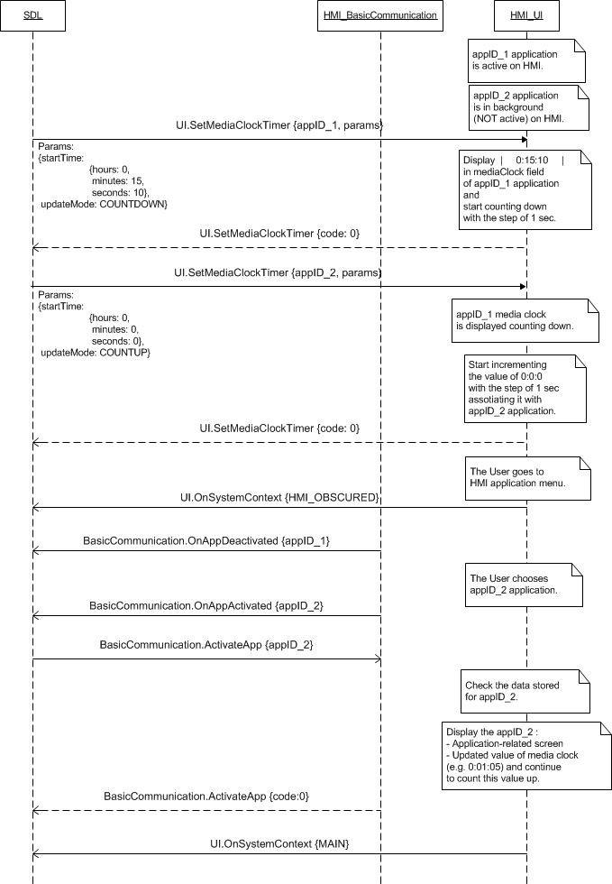

#### 7.13.4.2 SetMediaClockTimer of PAUSE and RESUME for the application active on HMI

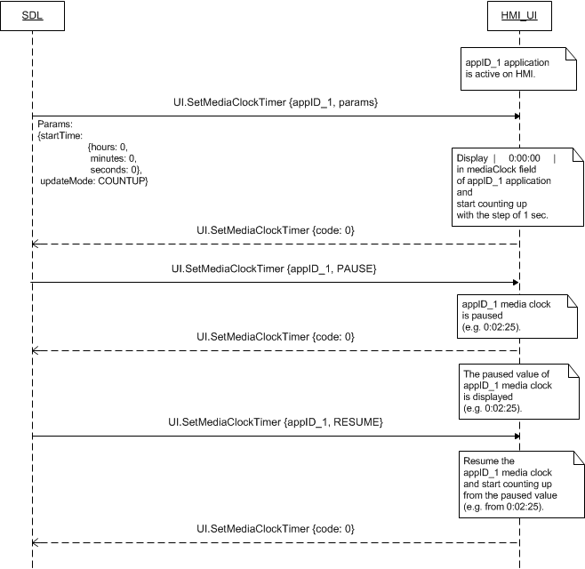

#### 7.13.4.3 SetMediaClockTimer of COUNTDOWN for the active application that is then deactivated and activated again and SetMediaClockTimer of CLEAR for thw active application.

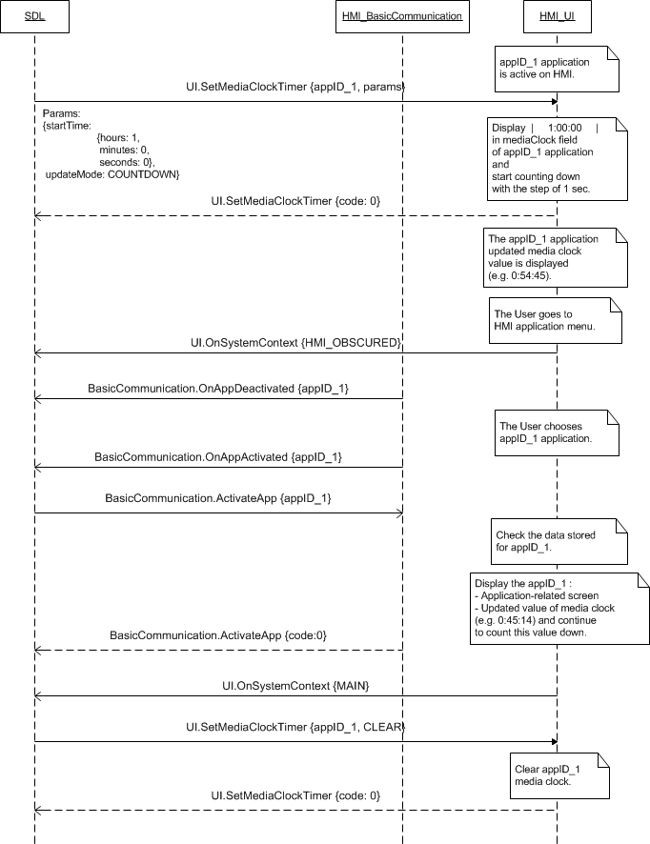

### 7.13.5 JSON Messages Examples

#### 7.13.5.1 Request

|  |
| --- |
| {  "id" : 109,  "jsonrpc" : "2.0",  "method" : "UI.SetMediaClockTimer",  “params” :  {  “startTime” :  {  “hours” : 0,  “minutes” : 18,  “seconds” : 17  },  “updateMode” : COUNTUP,  “appID” : 65146  }  } |

#### 7.13.5.2 Response

|  |
| --- |
| {  "id" : 109,  "jsonrpc" : "2.0",  "result" :  {  "code" : 0,  "method" : "UI.SetMediaClockTimer"  }  } |

#### 7.13.5.3 Error message

|  |
| --- |
| {  "id" : 109,  "jsonrpc" : "2.0",  "error" :  {  "code" : 11,  "message" : "Invalid data",  "data" :  {  "method" : "UI.SetMediaClockTimer"  }  }  } |

### 7.13.6 D-Bus Messages Examples

#### 7.13.6.1 Request

|  |
| --- |
|  |

#### 7.13.6.2 Response

|  |
| --- |
|  |

#### 7.13.6.3 Failure

|  |
| --- |
|  |

## 7.14 SetGlobalProperties

### 7.14.1 Description

|  |  |
| --- | --- |
| **Type:** | Function |
| **Sender:** | SDL |
| **Purpose:** | Set the UI properties of application. |

SDL requests to set the values for VR help, the name and icon for in-application menu and the properties of touchscreen keyboard.

The request may arrive for the application whatever being active or in background on HMI.

### 7.14.2 Request

#### 7.14.2.1 Behavior

***HMI must:***

1. Store the information associating it with appID.

***Note:***

*Initially, the appID together with other application-related information is provided by SDL within UpdateAppList or OnAppRegistered RPCs.*

2. Set the requested values for:

* VR help: whenever the User activates VR, HMI must display the list of commands availbale for voice recognition. SDL provides the title for this list (vrHelpTitle parameter) and the list of commands itself (vrHelp parameter which is the array of VrHelpItem-s).

***Important Note:***

*If HMI-defined VR commands are accessible together with those provided by SDL via VR.AddCommand, HMI must:*

*- Add the corresponding VR synonyms to the list of VR help items provided by SDL via UI.SetGlobalProperties*

*- Display the complete list of available VR commands (SDL-defined and HMI-defined ones) when the User activates VR.*

* In-application menu: HMI must display the in-application menu for every active application, where the SDL-requested commands (UI.AddCommand) and sub menus (UI.AddSubMenu) must be added to. SDL provides the values for the name (menuTitle parameter) and for the icon (menuIcon parameter) of this in-application menu.
* Touchscreen keyboard: if supported HMI displays the onscreen keyboard upon User`s request. SDL provides the properties of this keyboard:

***Note:***

*The values for in-application menu and touchscreen keyboard will be allowed by SDL for navigation type of application only.*

3. Respond to the request.

***Note:***

*The applicable to this RPC result codes are provided in section 7.14.3 Response.*

***Note:***

*The sequence diagrams describing the expected HMI behavior are provided in the section 7.14.4 Sequence Diagrams*

#### 7.14.2.2 Parameters

| **Param Name** | **Type** | **Mandatory** | **Additional** | **Description** |
| --- | --- | --- | --- | --- |
| vrHelpTitle | String | false | Maxlength = 500 | The text that must be displayed as a title of VR Help Menu. |
| vrHelp | Common.VrHelpItem | false | Array = true  Minsize = 1  Maxsize = 100 | VR help items – i.e. the text strings to be displayed, and when pronounced by the user the recognision of any of which must trigger the corresponding VR command.  See VrHelpItem. |
| menuTitle | String | false | Maxlength = 500 | Optional text to label an app menu button (for certain touchscreen platforms). |
| menuIcon | Common.Image | false | - | Optional icon to draw on an app menu button (for certain touchscreen platforms). |
| keyboardProperties | Common.KeyboardProperties | false | - | On-screen keybaord configuration (if available). |
| appID | Integer | true | – | ID of the application that concerns this RPC. |

#### 7.14.2.6 VrHelpItem

| **Param Name** | **Type** | **Mandatory** | **Additional** | **Description** |
| --- | --- | --- | --- | --- |
| text | String | True | maxlength = 500 | The text that must be displayed as a name for VR Help item. |
| image | Common.Image | False | – | Image that must be displayed by HU to represent the VR Help item.  See Image |
| position | Integer | false | minvalue = 1  maxvalue = 100 | This value is the position within the elements of VR Help menu where the item must be added to: |

#### 7.14.2.4 KeyboardProperties

|  |  |  |  |  |
| --- | --- | --- | --- | --- |
| **Param Name** | **Type** | **Mandatory** | **Additional** | **Description** |
| language | Common.Language | false | - | The keyboard language. |
| keyboardLayout | Common.KeyboardLayout | false | - | Desired keyboard layout. |
| sendDynamicEntry | Boolean | false | - | In this mode, all keypresses will be sent as they occur.  If disabled, entire string of text will be returned only once submitted by user.  If omitted, this value will be set to FALSE. |
| keypressMode | Common.KeypressMode | false | - | Desired keypress mode.If omitted, this value will be set to RESEND_CURRENT_ENTRY. |
| limitedCharacterList | String | false | Array = true  maxlength = 1  minsize = 1  maxsize = 100 | Array of keyboard characters to enable.  All omitted characters will be greyed out (disabled) on the keyboard.  If omitted, the entire keyboard will be enabled. |
| autoCompleteText | String | false | maxlength = 1000 | Allows an app to prepopulate the text field with a suggested or completed entry as the user types |

#### 7.14.2.5 KeyboardLayout

|  |  |
| --- | --- |
| **Element name** | **Short Description** |
| QWERTY | QWERTY layout (the name comes from the first six keys appearing on the top left letter row of the keyboard and read from left to right) |
| QWERTZ | QWERTZ layout (the name comes from the first six keys appearing on the top left letter row of the keyboard and read from left to right) |
| AZERTY | AZERTY layout (the name comes from the first six keys appearing on the top left letter row of the keyboard and read from left to right) |

### 7.14.3 Response

***Note:***

*There is a difference in message type for WebSocket and D-Bus connection (see the table below).*

|  |  |  |  |  |  |
| --- | --- | --- | --- | --- | --- |
| **Result** | **Description** | **Message type** | | **Message Params** | **Notes** |
| **WebSocket** | **D-Bus** |
| Success | SUCCESS:  HMI has set the requested properties.. | JSON response | Method return | code: 0 |  |
|  | INVALID_ID  appID is not valid (e.g. doesn’t exist) | JSON error message |  | code:13 | Applicable for this RPC result codes.  Please see Result Enumeration for all SDL-supported codes. |
| Failure | INVALID_DATA:  The data sent is invalid (invalid JSON syntax or parameters out of bounds or of wrong type) | Method return | code: 11 |
| GENERIC_ERROR:  1) The unknown issue occurred or other codes are not applicable.  2) In case HMI does not respond SDL's request during SDL-default timeout (10 sec), SDL will return the result code to the corresponding mobile app's request. | code: 22 |

### 7.14.4 Sequence Diagrams

#### 7.14.4.1 SetGlobalProperties for the application active on HMI and the later VR activation

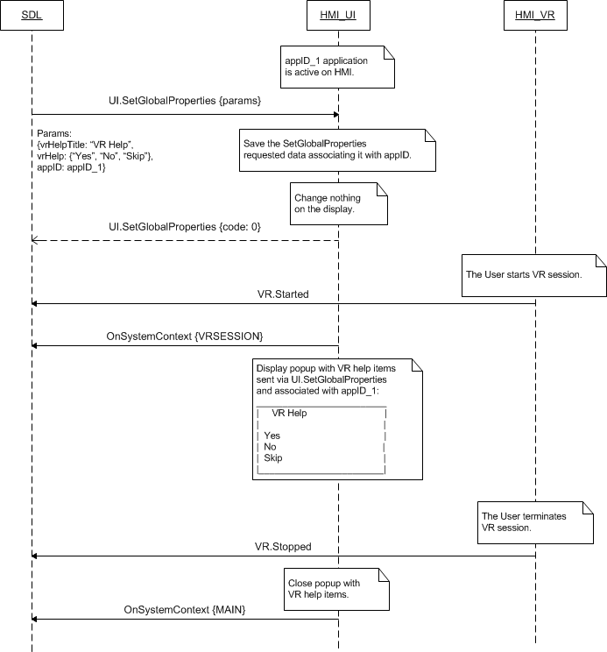

### 7.14.5 JSON Messages Examples

#### 7.14.5.1 Request

|  |
| --- |
| {  "id" : 116,  "jsonrpc" : "2.0",  "method" : "UI.SetGlobalProperties",  “params” :  {  “vrHelpTitle” : “Choose the action”,  “vrHelp” :  [  {  “text” : “Pause”,  “image” :  [  “value” : “tmp/SDL/app/Pandora/icon_1067.jpg”,  “imageType” : DYNAMIC  ],  “position” : 1  },  {  “text” : “Resume”,  “image” :  [  “value” : “tmp/SDL/app/Pandora/icon_1083.jpeg”,  “imageType” : DYNAMIC  ],  “position” : 2  },  {  “text” : “Skip”,  “image” :  [  “value” : “tmp/SDL/app/Pandora/icon_1013.jpeg”,  “imageType” : DYNAMIC  ],  “position” : 3  },  {  “text” : “Bookmark”,  “image” :  [  “value” : “tmp/SDL/app/Pandora/icon_1046.jpeg”,  “imageType” : DYNAMIC  ],  “position” : 4  }  ],  “appID” : 53880  }  } |

#### 7.14.5.2 Response

|  |
| --- |
| {  "id" : 116,  "jsonrpc" : "2.0",  "result" :  {  "code" : 0,  "method" : "UI.SetGlobalProperties"  }  } |

#### 7.14.5.3 Error message

|  |
| --- |
| {  "id" : 116,  "jsonrpc" : "2.0",  "error" :  {  "code" : 11,  "message" : "Invalid data",  "data" :  {  "method" : "UI.SetGlobalProperties"  }  }  } |

### 7.14.6 D-Bus Messages Examples

#### 7.14.6.1 Request

|  |
| --- |
| method call sender=:1.128 -> dest=com.ford.sdl.hmi serial=85 path=/;  interface=com.ford.sdl.hmi.UI;  member=SetGlobalProperties  struct {  boolean true  string "This is the VR help title"  }  struct {  boolean true  array [  struct {  string "VR help item"  struct {  boolean true  struct {  string "/home/abritanova/Work/smartdevicelink/applink/RB_E3.0/bin/Hugo/action.png"  int32 1  }  }  int32 1  }  struct {  string "Help Item 2"  struct {  boolean true  struct {  string "/home/abritanova/Work/smartdevicelink/applink/RB_E3.0/bin/Hugo/action.png"  int32 1  }  }  int32 2  }  struct {  string "third item"  struct {  boolean true  struct {  string "/home/abritanova/Work/smartdevicelink/applink/RB_E3.0/bin/Hugo/action.png"  int32 1  }  }  int32 3  }  ]  }  struct {  boolean false  string ""  }  struct {  boolean false  struct {  string ""  int32 -1  }  }  struct {  boolean false  struct {  struct {  boolean false  int32 -1  }  struct {  boolean false  int32 -1  }  struct {  boolean false  boolean false  }  struct {  boolean false  int32 -1  }  struct {  boolean false  array [  ]  }  struct {  boolean false  string ""  }  }  }  int32 65537 |

#### 7.14.6.2 Response

|  |
| --- |
| method return sender=:1.129 -> dest=:1.128 reply_serial=85  int32 0  string "" |

#### 7.14.6.3 Failure

|  |
| --- |
| method return sender=:1.129 -> dest=:1.128 reply_serial=85  int32 11  string "The data sent is invalid" |

## 7.15 ChangeRegistration

### 7.15.1 Description

|  |  |
| --- | --- |
| **Type:** | Function |
| **Sender:** | SDL |
| **Purpose:** | Change the display language for the named application on HMI |

SDL requests to set a display language for the named application on HMI.

The request may arrive for the application whatever being active or in background on HMI.

***Note:***

*SDL will send the language value confirmed to be supported by HMI via UI.GetCapabilities.*

### 7.15.2 Request

#### 7.15.2.1 Behavior

***HMI must:***

1. Store the provided information associating it with application`s appID.

2. Respond to the request.

***Note:***

*The applicable to this RPC result codes are provided in section 7.14.3 Response.*

***Note:***

*The sequence diagrams describing the expected HMI behavior are provided in the section 7.14.4 Sequence Diagrams*

#### 7.15.2.2 Parameters

| **Param Name** | **Type** | **Mandatory** | **Additional** | **Description** |
| --- | --- | --- | --- | --- |
| appName | string | false | maxlength = 100 | Request new app name registration  Needs to be unique over all applications.  May not be empty. May not start with a new line character.  May not interfere with any name or synonym of any registered applications.  Applications with the same name will be rejected. (SDL makes all the checks) |
| ngnMediaScreenAppName | string | false | maxlength = 100 | Request new app short name registration |
| language | Common.Language | true |  | The language requested to be switched to.  See Language. |
| appHMIType | Common.AppHMIType | false | minsize=1 maxsize=100 array="true" | Sent when app's requested-during-registration AppHMIType is changed to the different one due to Policies update. Contains the updated list of all allowed app's AppHMITypes. |
| appID | Integer | true |  | ID of the application that relates to this RPC. |

#### 7.15.2.3 Language

| **Element Name** | **Value** | **Description** |
| --- | --- | --- |
| EN-US | 0 | English – US |
| ES-MX | 1 | Spanish – Mexico |
| FR-CA | 2 | French – Canada |
| DE-DE | 3 | German – Germany |
| ES-ES | 4 | Spanish – Spain |
| EN-GB | 5 | English – GB |
| RU-RU | 6 | Russian - Russia |
| TR-TR | 7 | Turkish – Turkey |
| PL-PL | 8 | Polish – Poland |
| FR-FR | 9 | French – France |
| IT-IT | 10 | Italian – Italy |
| SV-SE | 11 | Swedish – Sweden |
| PT-PT | 12 | Portuguese – Portugal |
| NL-NL | 13 | Dutch (Standard) – Netherlands |
| EN-AU | 14 | English – Australia |
| ZH-CN | 15 | Mandarin – China |
| ZH-TW | 16 | Mandarin – Taiwan |
| JA-JP | 17 | Japanese – Japan |
| AR-SA | 18 | Arabic – Saudi Arabia |
| KO-KR | 19 | Korean – South Korea |
| PT-BR | 20 | Portuguese - Brazil |
| CS-CZ | 21 | Czech – Czech Republic |
| DA-DK | 22 | Danish – Denmark |
| NO-NO | 23 | Norwegian - Norway |

### 7.15.3 Response

***Note:***

*There is a difference in message type for WebSocket and D-Bus connection (see the table below).*

|  |  |  |  |  |  |
| --- | --- | --- | --- | --- | --- |
| **Result** | **Description** | **Message type** | | **Message Params** | **Notes** |
| **WebSocket** | **D-Bus** |
| Success | SUCCESS:  HMI has changed the UI language for the named application. | JSON response | Method return | code: 0 |  |
| Failure | INVALID_ID  appID is not valid | JSON error message | Method return | code:13 | Applicable for this RPC result codes.  Please see Result Enumeration for all SDL-supported codes. |
| WRONG_LANGUAGE  Language isn’t supported by UI @TODO to clarify if the functionality actual | code:16 |
| INVALID_DATA:  The data sent is invalid (invalid JSON syntax or parameters out of bounds or of wrong type) | code: 11  message |
| GENERIC_ERROR:  1) The unknown issue occurred or other codes are not applicable.  2) In case HMI does not respond SDL's request during SDL-default timeout (10 sec), SDL will return the result code to the corresponding mobile app's request. | code: 22  message |

### 7.15.4 Sequence Diagrams

#### 7.15.4.1 ChangeRegistration @TODO to add

### 7.15.5 JSON Messages Examples

#### 7.15.5.1 Request

|  |
| --- |
| {  "id" : 117,  "jsonrpc" : "2.0",  "method" : "UI.ChangeRegistration",  “params” :  {  “Language” : PT-PT,  “appID” : 65146  }  } |

#### 7.15.5.2 Response

|  |
| --- |
| {  "id" : 117,  "jsonrpc" : "2.0",  "result" :  {  "code" : 0,  "method" : "UI.ChangeRegistration"  }  } |

#### 7.15.5.3 Error message

|  |
| --- |
| {  "id" : 117,  "jsonrpc" : "2.0",  "error" :  {  "code" : 11,  "message" : "Invalid data",  "data" :  {  "method" : "UI.ChangeRegistration"  }  }  } |

### 7.15.6 D-Bus Messages Examples

Note:

#### 7.15.6.1 Request

|  |
| --- |
| method call //message type (request)  sender=:1.139 //unique for-the-lifetime-of-the-bus name automatically assigned to SDL  -> dest=com.ford.sdl.hmi //the name (requested by and assigned to HMI) to receive a message  serial=108 //serial number of the message  path=/; //the path to the object instance  interface=com.ford.sdl.hmi.UI;  member=ChangeRegistration  int32 2 // language (FR-CA)  int32 65538 // appID |

#### 7.15.6.2 Response

|  |
| --- |
| method return //message type (successful response)  sender=:1.140 //unique for-the-lifetime-of-the-bus name automatically assigned to HMI  -> dest=:1.139 //unique for-the-lifetime-of-the-bus name automatically assigned to SDL  reply_serial=108 //serial number of the corresponding method_call message  int32 0 //code (SUCCESS)  string "" //message |

#### 7.15.6.3 Failure

|  |
| --- |
| method return //message type (error response)  sender=:1.140 //unique for-the-lifetime-of-the-bus name automatically assigned to HMI  -> dest=:1.139 //unique for-the-lifetime-of-the-bus name automatically assigned to SDL  reply_serial=108 //serial number of the corresponding method_call message  int32 22 // code (GENERIC_ERROR)  string "During the API call an unknown error has occurred." |

## 7.16 GetLanguage

### 7.16.1 Description

|  |  |
| --- | --- |
| **Type:** | Function |
| **Sender:** | SDL |
| **Purpose:** | Find out the current HMI display language. |

SDL inquires the current HMI display language.

***Note:***

*‘HMI display language’ is meant to be the language of HMI-defined menus, screens, popups, etc.*

*HMI display language and application display language (requested via UI.ChangeRegistration) might be different.*

This RPC is sent by SDL after UI readiness is confirmed by UI.IsReady. If later the User changes the HMI display language, HMI must inform SDL about this event via UI.OnLanguageChange notification.

### 7.16.2 Request

#### 7.16.2.1 Behavior

***HMI must:***

1. Check the HMI display language currently in effect.

2. Respond providing SDL with the results of this check.

***Note:***

*The applicable to this RPC result codes are provided in section 7.16.3 Response.*

***Note:***

*The sequence diagrams describing the expected HMI behavior are provided in the section 7.14.4 Sequence Diagrams*

### 7.16.3 Response

***Note:***

*There is a difference in message type for WebSocket and D-Bus connection (see the table below).*

|  |  |  |  |  |  |
| --- | --- | --- | --- | --- | --- |
| **Result** | **Description** | **Message type** | | **Message Params** | **Notes** |
| **WebSocket** | **D-Bus** |
| Success | SUCCESS:  The current HMI display language is provided. | JSON response | Method return | language,  code: 0 |  |
| Failure | INVALID_DATA:  The data sent is invalid (invalid JSON syntax) | JSON error message | Method return | code: 11 | Applicable for this RPC result codes.  Please see Result Enumeration for all SDL-supported codes. |
| DATA_NOT_AVAILABLE:  The information of the current HMI display language cannot be provided. | Code: 9 |
| GENERIC_ERROR:  The unknown issue occurred or other codes are not applicable. | code: 22 |

#### 7.16.3.1 Parameters

|  |  |  |  |
| --- | --- | --- | --- |
| **Param Name** | **Type** | **Mandatory** | **Description** |
| language | Common.Language | true | UI language that is currently active.  See Language. |

#### 7.15.2.3 Language

| **Element Name** | **Value** | **Description** |
| --- | --- | --- |
| EN-US | 0 | English – US |
| ES-MX | 1 | Spanish – Mexico |
| FR-CA | 2 | French – Canada |
| DE-DE | 3 | German – Germany |
| ES-ES | 4 | Spanish – Spain |
| EN-GB | 5 | English – GB |
| RU-RU | 6 | Russian - Russia |
| TR-TR | 7 | Turkish – Turkey |
| PL-PL | 8 | Polish – Poland |
| FR-FR | 9 | French – France |
| IT-IT | 10 | Italian – Italy |
| SV-SE | 11 | Swedish – Sweden |
| PT-PT | 12 | Portuguese – Portugal |
| NL-NL | 13 | Dutch (Standard) – Netherlands |
| EN-AU | 14 | English – Australia |
| ZH-CN | 15 | Mandarin – China |
| ZH-TW | 16 | Mandarin – Taiwan |
| JA-JP | 17 | Japanese – Japan |
| AR-SA | 18 | Arabic – Saudi Arabia |
| KO-KR | 19 | Korean – South Korea |
| PT-BR | 20 | Portuguese - Brazil |
| CS-CZ | 21 | Czech – Czech Republic |
| DA-DK | 22 | Danish – Denmark |
| NO-NO | 23 | Norwegian - Norway |

### 7.16.4 Sequence Diagrams

#### 7.16.4.1 GetLanguage

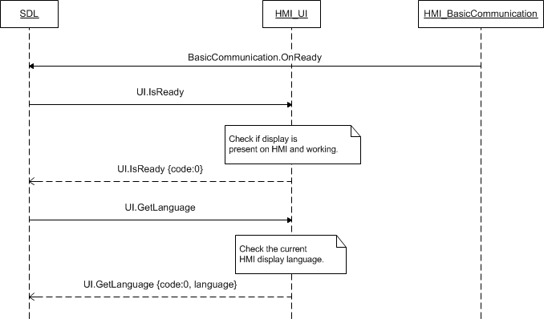

### 7.16.5 JSON Messages Examples

#### 7.16.5.1 Request

|  |
| --- |
| {  "id" : 167,  "jsonrpc" : "2.0",  "method" : "UI.GetLanguage"  } |

#### 7.16.5.2 Response

|  |
| --- |
| {  "id" : 167,  "jsonrpc" : "2.0",  "result" :  {  "language" : ES-ES,  "code" : 0,  "method" : "UI.GetLanguage"  }  } |

#### 7.16.5.3 Error message

|  |
| --- |
| {  "id" : 167,  "jsonrpc" : "2.0",  "error" :  {  "code" : 11,  "message" : "Invalid data",  "data" :  {  "method" : "UI.GetLanguage"  }  }  } |

### 7.16.6 D-Bus Messages Examples

#### 7.16.6.1 Request

|  |
| --- |
| method call //message type (request)  sender=:1.139 //unique for-the-lifetime-of-the-bus name automatically assigned to SDL  -> dest=com.ford.sdl.hmi //the name (requested by and assigned to HMI) to receive a message  serial=68 //serial number of the message  path=/; //the path to the object instance  interface=com.ford.sdl.hmi.UI;  member=GetLanguage |

#### 7.16.6.2 Response

Note:

In successful response the first returned value is always code parameter and the second one is language parameter.

|  |
| --- |
| method return //message type (successful response)  sender=:1.140 //unique for-the-lifetime-of-the-bus name automatically assigned to HMI  -> dest=:1.139 //unique for-the-lifetime-of-the-bus name automatically assigned to SDL  reply_serial=68 //serial number of the corresponding method_call message  int32 0 //code (SUCCESS)  int32 1 //language  string "" //message |

#### 7.16.6.3 Failure

|  |
| --- |
| method return //message type (erroneous response)  sender=:1.140 //unique for-the-lifetime-of-the-bus name automatically assigned to HMI  -> dest=:1.139 //unique for-the-lifetime-of-the-bus name automatically assigned to SDL  reply_serial=68 //serial number of the corresponding method_call message  int32 9 //code (DATA_NOT_AVAILABLE)  string "" //message |

## 7.17 SetAppIcon

### 7.17.1 Description

|  |  |
| --- | --- |
| **Type:** | Function |
| **Sender:** | SDL |
| **Purpose:** | Display the icon together with application name. |

SDL requests to display the icon together with the specified application name (sent via OnAppRegistered or UpdateAppList to HMI) in the HMI list of registered applications. The path to the icon stored on HU is provided within request.

### 7.17.2 Request

#### 7.17.2.1 Behavior

***HMI must:***

1. Store the provided data associating it with application appID.

2. Display the requested icon together with the application name in the HMI list of registered applications:

* Right away if the screen with the list of registered applications is currently displayed
* When the list of registered applications is displayed upon User`s request on HMI.

3. Respond the request.

***HMI may:***

*Display the HMI default icons for those applications that did not send the SetAppIcon request.*

***Note:***

*- The applicable to this RPC result codes are provided in section 7.17.3 Response.*

*- The sequence diagrams describing the expected HMI behavior are provided in the section 7.17.4 Sequence Diagrams*

*- The picture of “ Slider” screen is added to the section 7.17.5 Possible Layout.*

#### 7.17.2.2 Parameters

| **Param Name** | **Type** | **Mandatory** | **Description** |
| --- | --- | --- | --- |
| syncFileName | Common.Image | true | - The path to the image stored on HU  - Or the binary image itself.  See Image. |
| appID | Integer | true | ID of the application related to this RPC. |

#### 7.17.2.3 Image

|  |  |  |  |  |
| --- | --- | --- | --- | --- |
| **Param Name** | **Type** | **Mandatory** | **Additional** | **Description** |
| value | String | true | maxlength = 65535 | - The path to the dynamic image stored on HU  - Or the static binary image itself |
| imageType | Common.ImageType | true | - | Describes, whether it is a static or dynamic image. |

#### 7.17.2.4 ImageType

| **Element name** | **Value** | **Short Description** |
| --- | --- | --- |
| STATIC | 0 | Static image. The image that is sent as the binary or hex code within the request. |
| DYNAMIC | 1 | Dynamic image. The image that is stored on HMI and just a link to it is further used within requests. |

### 7.17.3 Response

***Note:***

*There is a difference in message type for WebSocket and D-Bus connection (see the table below).*

|  |  |  |  |  |  |
| --- | --- | --- | --- | --- | --- |
| **Result** | **Description** | **Message type** | | **Message Params** | **Notes** |
| **WebSocket** | **D-Bus** |
| Success | SUCCESS:  The requested icon is displayed for the named application in the HMI list of registered applications. | JSON response | Method return | code: 0 |  |
| Failure | INVALID_DATA:  The data sent is invalid (invalid JSON syntax or parameters out of bounds or of wrong type) | JSON error message | Method return | code: 11 | Applicable for this RPC result codes.  Please see Result Enumeration for all SDL-supported codes. |
| @TODO to discuss the new code FILE_NOT_FOUND  Static or Dynamic icon file not found by System | сode:? |
| INVALID_ID  appID is invalid (e.g. doesn’t exist) | code:13 |
| UNSUPPORTED_RESOURCE  When icon is sent by SDL but HMI doesn’t support the type of images sent by SDL (STATIC/DYNAMIC). | code:2 |
| GENERIC_ERROR:  1) The unknown issue occurred or other codes are not applicable.  2) In case HMI does not respond SDL's request during SDL-default timeout (10 sec), SDL will return the result code to the corresponding mobile app's request. | code: 22 |

### 7.17.4 Sequence Diagrams

#### 7.17.4.1 SetAppIcon

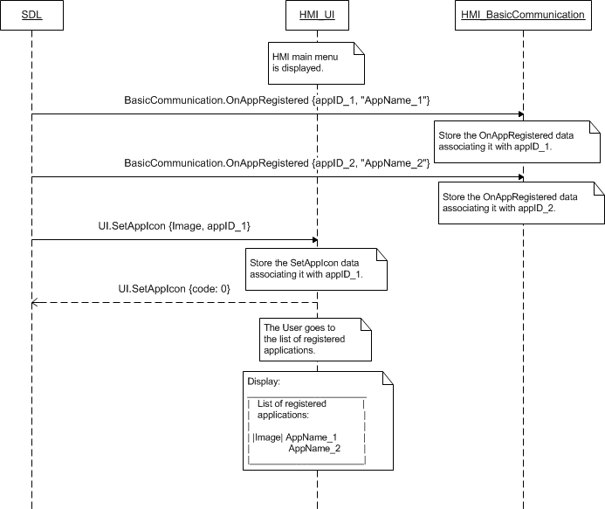

### 7.17.5 Possible Layout

#### 7.17.5.1 The list of registered applications with and without icons

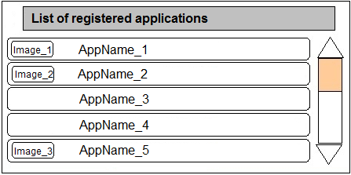

### 7.17.6 JSON Messages Examples

#### 7.17.6.1 Request

|  |
| --- |
| {  "id" : 88,  "jsonrpc" : "2.0",  "method" : "UI.SetAppIcon",  “params” :  {  “syncFileName” :  {  “value” : “tmp/SDL/app/Best_Media/12345.jpg”,  “imageType” : DYNAMIC  },  “appID” : 65146  }  } |

#### 7.17.6.2 Response

|  |
| --- |
| {  "id" : 88,  "jsonrpc" : "2.0",  "result" :  {  "code" : 0,  "method" : "UI.SetAppIcon"  }  } |

#### 7.17.6.3 Error message

|  |
| --- |
| {  "id" : 88,  "jsonrpc" : "2.0",  "error" :  {  "code" : 2,  "message" : "Unsupported resourse",  "data" :  {  "method" : "UI.SetAppIcon"  }  }  } |

### 7.17.7 D-Bus Messages Examples

#### 7.17.7.1 Request

|  |
| --- |
| method call //message type (request)  sender=:1.111 //unique for-the-lifetime-of-the-bus name automatically assigned to SDL  -> dest=com.ford.sdl.hmi //the name (requested by and assigned to HMI) to receive a message  serial=84 //serial number of the message  path=/; //the path to the object instance  interface=com.ford.sdl.hmi.UI;  member=SetAppIcon  struct  {  string “tmp/SDL/app/Best_Media/12345.png” //value  int32 1 //imageType  }  int32 65537 //appID |

#### 7.17.7.2 Response

|  |
| --- |
| method return //message type (successful response)  sender=:1.112 //unique for-the-lifetime-of-the-bus name automatically assigned to HMI  -> dest=:1.111 //unique for-the-lifetime-of-the-bus name automatically assigned to SDL  reply_serial=84 //serial number of the corresponding method_call message  int32 0 //code (SUCCESS)  string "" //message |

#### 7.17.7.3 Failure

|  |
| --- |
| method return //message type (erroneous response)  sender=:1.112 //unique for-the-lifetime-of-the-bus name automatically assigned to HMI  -> dest=:1.111 //unique for-the-lifetime-of-the-bus name automatically assigned to SDL  reply_serial=84 //serial number of the corresponding method_call message  int32 11 //code (INVALID_DATA)  string "The data sent is invalid" //message |

## 7.18 Slider

### 7.18.1 Description

|  |  |
| --- | --- |
| **Type:** | Function |
| **Sender:** | SDL |
| **Purpose:** | Display the user-controlled slider. |

SDL requests to display the user-controlled full screen or popup slider (see the picture in section 7.18.5 Possible Layout).

The request arrives only for the application currently active on HMI.

### 7.18.2 Request

#### 7.18.2.1 Behavior

***HMI must:***

1. Display the user-controlled slider (see the picture in section 7.18.5 Possible Layout) with:

* The number of ticks defined by nnumTicks parameter
* The initial position of the slider control corresponding to position perameter
* The header defined by sliderHeader parameter
* The footer defined by sliderFooter parameter:
* Static – a single text string that must be displayed throughout the positions chosen.
* Dynamic – an array of strings that must be assigned for every position and displayed when position is set by the User.

2. Keep displaying slider until one of the following occurs:

* Timeout defined by timeout parameter
* The slider is aborted by the User or any RPC of the higher priority
* The User presses HMI-defined ‘OK’ button.

3. Respond the request (providing position parameter in case the slider is closed by ‘OK’ button press or aborted, see section 7.18.3 Response).

***HMI may:***

*Display the HMI-defined ‘Close’/’Back’ button by the press of which the slider popup/screen must be closed (HMI must not provide any notifications to SDL upon such button press).*

***Note:***

*- The applicable to this RPC result codes are provided in section 7.18.3 Response.*

*- The sequence diagrams describing the expected HMI behavior are provided in the section 7.18.4 Sequence Diagrams*

*- The picture of “Slider” screen is added to the section 7.18.5 Possible Layout.*

#### 7.18.2.2 Parameters

| **Param Name** | **Type** | **Mandatory** | **Additional** | **Description** |
| --- | --- | --- | --- | --- |
| numTicks | Integer | true | minvalue = 2  maxvalue = 26 | Number of selectable items on a horizontal axis to be displayed. |
| position | Integer | true | minvalue = 1  maxvalue = 26 | Initial position of the slider control. |
| sliderHeader | String | true | maxlength = 500 | Text header of the slider to be displayed. |
| sliderFooter | String | false | Array = true  maxlength = 500  minsize = 1  maxsize = 26 | Text footer to be displayed.  For the *static* text footer, only one footer string is provided in the array.  For a *dynamic* text footer:  - The number of footer text strings in the array always matches the numTicks value.  - Text array string should correlate with potential slider position index.  If omitted, no footer text must be displayed. |
| timeout | Integer | true | minvalue = 1000  maxvalue = 65535 | The timeout in milliseconds.  It is the amount of time the HMI must wait for User`s actions while displaying the slider.  When the amount of time defined has elapsed, the HMI must close the dialog with slider and return to the screen previously displayed. |
| appID | Integer | true | – | ID of the application related to this RPC. |

### 7.18.3 Response

***Note:***

*There is a difference in message type for WebSocket and D-Bus connection (see the table below).*

|  |  |  |  |  |  |
| --- | --- | --- | --- | --- | --- |
| **Result** | **Description** | **Message type** | | **Message Params** | **Notes** |
| **WebSocket** | **D-Bus** |
| Success | SUCCESS:  HMI displayed the slider with requested parameters and has just closed it by ‘OK’ button press. The last slider poeition must be returned. | JSON response | Method return | sliderPosition,  code: 0 |  |
| Failure | ABORTED:  HMI has displayed the slider with requested parameters and has just closed it by:  1) HMI-defined ‘Return’/’Back’ button press.  2) A higher priority RPC.  The last slider position must be returned. | JSON error message | Method return | sliderPosition,  code: 5 | Applicable for this RPC result codes.  Please see Result Enumeration for all SDL-supported codes. |
| TIMED_OUT:  HMI displayed the slider with requested parameters and has just closed it by timeout. | code: 10 |
| INVALID_DATA:  The data sent is invalid (invalid JSON syntax or parameters out of bounds or of wrong type) | code: 11 |
| INVALID_ID  appID is invalid (e.g. doesn’t exist) | code:13 |
| GENERIC_ERROR:  1) The unknown issue occurred or other codes are not applicable.  2) In case HMI does not respond SDL's request during request/SDL defined timeout, SDL will return the result code to the corresponding mobile app's request. | code: 22 |

#### 7.18.3.1 Parameters

|  |  |  |  |  |
| --- | --- | --- | --- | --- |
| **Param Name** | **Type** | **Mandatory** | **Additional** | **Description** |
| sliderPosition | Integer | true | minvalue = 1  maxvalue = 26 | Current slider value to be returned when the slider is closed by the timeout or aborted. |

### 7.18.4 Sequence Diagrams

#### 7.18.4.1 Slider with static footer displayed then closed by the timeout

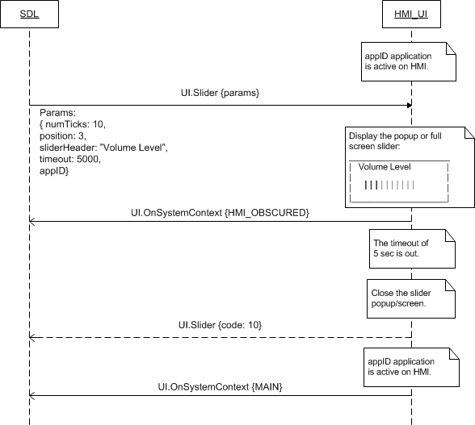

#### 7.18.4.2 Slider with dynamic footer displayed then aborted

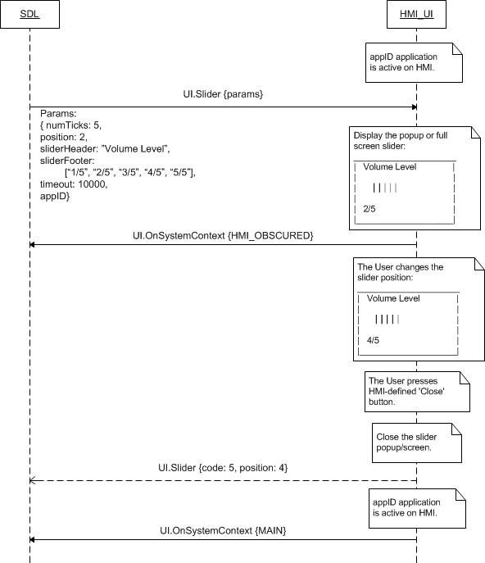

#### 7.18.4.2 Slider with static footer displayed then closed by ‘OK’ button press

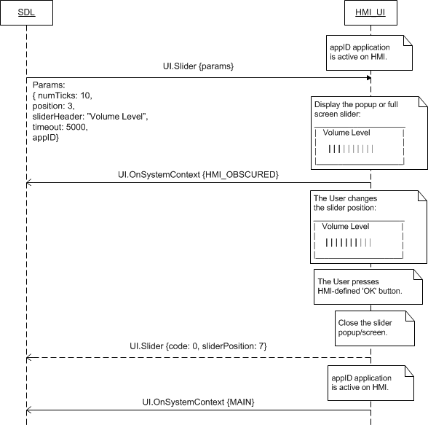

### 7.18.5 Possible Layout

#### 7.18.5.1 Slider

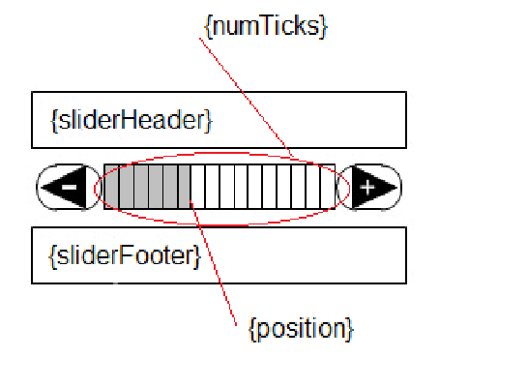

#### 7.18.5.2 Slider with dynamic footer

|  |  |
| --- | --- |
|  |  |
|  |  |

### 7.18.6 JSON Messages Examples

#### 7.18.6.1 Request

|  |
| --- |
| {  "id" : 133,  "jsonrpc" : "2.0",  "method" : "UI.Slider",  “params” :  {  “numTicks” : 5,  “position” : 2,  “sliderHeader” : “Volume Level”,  “sliderFooter” : [ “1/5”, 2/5”, “3/5”, “4/5”, “5/5” ],  “timeout” : 10000,  “appID” : 4328  }  } |

#### 7.18.6.2 Response

|  |
| --- |
| {  "id" : 133,  "jsonrpc" : "2.0",  "result" :  {  “sliderPosition” : 4,  "code" : 0,  "method" : "UI.SLider"  }  } |

#### 7.18.6.3 Error message

|  |
| --- |
| {  "id" : 133,  "jsonrpc" : "2.0",  "error" :  {  "code" : 5,  "message" : "A command was aborted due to user interaction",  "data" :  {  “sliderPosition” : 5  "method" : "UI.SLider"  }  }  } |

|  |
| --- |
| {  "id" : 133,  "jsonrpc" : "2.0",  "error" :  {  "code" : 13,  "message" : "One of the provided IDs is not valid",  "data" :  {  "method" : "UI.SLider"  }  }  } |

### 7.18.7 D-Bus Messages Examples

#### 7.18.7.1 Request

|  |
| --- |
| method call //message type (request)  sender=:1.111 //unique for-the-lifetime-of-the-bus name automatically assigned to SDL  -> dest=com.ford.sdl.hmi //the name (requested by and assigned to HMI) to receive a message  serial=90 //serial number of the message  path=/; //the path to the object instance  interface=com.ford.sdl.hmi.UI;  member=Slider  int32 24 //numTicks  int32 1 //position  string "Slider Header" //sliderHeader  struct //sliderFooter array  {  boolean true //IsPresent (d-bus indicator)  array  [  string "Slider Footer"  ]  }  int32 5000 //timeout  int32 65537 //appID |

#### 7.18.7.2 Response

|  |
| --- |
| method return  sender=:1.112  -> dest=:1.111  reply_serial=90  int32 0 //code (SUCCESS)  string "" //message  struct  {  boolean true //IsPresent (d-bus indicator: value for param is provided)  int32 19 //position  } |

#### 7.18.7.3 Failure

|  |
| --- |
| method return  sender=:1.112  -> dest=:1.111  reply_serial=90  int32 11 //code (INVALID_DATA)  string "The data sent is invalid" //message  struct  {  boolean false //IsPresent (d-bus indicator: value of the param is NOT present)  int32 -1 //’trash’  } |

## 7.19 ScrollableMessage

### 7.19.1 Description

|  |  |
| --- | --- |
| **Type:** | Function |
| **Sender:** | SDL |
| **Purpose:** | Display the dialog that may contain new lines and tabs. |

SDL requests to display a popup or full screen overlay with the text that might be formatted with the tabs and new lines.

The request may arrive in both cases of active and background application on HMI.

### 7.19.2 Request

#### 7.19.2.1 Behavior

***HMI must:***

1. Display the popup or full screen overlay of formatted text together with up to 8 soft buttons (or without any, depending on parameters received).

***Important Note:***

*HMI must provide OnButtonPress/OnButtonEvent notifications for every soft button defined within request.*

2. Keep displaying the message until:

* The timeout defined by the timeout parameter

***Important Note:***

*HMI must renew the timeout informing SDL about this event via UI.OnResetTimeout notification after*

1. *Every User`s action over the message (e.g. the User scrolls the message)*
2. *KEEP_CONTEXT soft button (defined within this RPC) press.*

* One of the below occurs:
* HMI-defined ‘Close” button press
* ClosePopup RPC from SDL
* RPC or system event of a higher priority
* Soft button of DEFAULT_ACTION or STEL_FOCUS press (if the soft button of such system action is defined within ScrollableMessage request)

3. Respond the request.

***Note:***

*- The applicable to this RPC result codes are provided in section 7.18.3 Response.*

*- The sequence diagrams describing the expected HMI behavior are provided in the section 7.18.4 Sequence Diagrams*

*- The picture of scrollable message screen is added to the section 7.18.5 Possible Layout.*

#### 7.19.2.2 Parameters

|  |  |  |  |  |
| --- | --- | --- | --- | --- |
| **Param Name** | **Type** | **Mandatory** | **Additional** | **Description** |
| messageText | Common.TextFieldStruct | true | – | The body of text that can include newlines and tabs and can be scrolled up. See TextFieldStruct.  Uses scrollableMessageBody (see TextFieldName). |
| timeout | Integer | true | Minvalue = 1000  maxvalue = 65535 | The timeout in milliseconds defined by the application.  It is the amount of time that  - HMI must keep displaying the message  - Must be renewed after every User`s action (e.g. scrolling the message) with sending UI.OnResetTimeout notification to SDL.  When the defined amount of time has elapsed, HMI must  - close the message popup/screen  - send the successful response. |
| softButtons | Common.SoftButton | false | Array = true  Minsize = 0  Maxsize = 8 | Application defined soft buttons (See SoftButton).  HMI must provide OnButtonPress/OnButtonEvent notifications for every soft button defined within request.  If omitted HMI may display the system-defined “Close” soft button providing the response with ABORTED Result code when it is pressed. HMI must not send any notifications to SDL for such button. |
| appID | Integer | true | – | ID of the application that concerns this RPC. |

#### 7.19.2.3 TextFieldStruct Structure

| **Param Name** | **Type** | **Mandatory** | **Additional** | **Description** |
| --- | --- | --- | --- | --- |
| fieldName | Common.TextFieldName | true | – | The name of the field where the text must be displayed in. |
| fieldText | String | true | Maxlength = 500 | The text to be displayed. |

#### 7.19.2.4 TextFieldName Enumeration

Only the text fields applicable to Alert RPC are described within this section. All the text fields names recognized by SDL are described in the section *13.1.14 TextFieldName*.

| **Element name** | **Short Description** |
| --- | --- |
| scrollableMessageBody | The long form body of text that can include newlines and tabs.  Applies to ScrollableMessage, section 7.1.17. |

### 7.19.3 Response

***Note:***

*There is a difference in message type for WebSocket and D-Bus connection (see the table below).*

|  |  |  |  |  |  |
| --- | --- | --- | --- | --- | --- |
| **Result** | **Description** | **Message type** | | **Message Params** | **Notes** |
| **WebSocket** | **D-Bus** |
| Success | SUCCESS:  HMI displayed the message with requested parameters and has just closed it by  1) The timeout.  2) STEAL_FOCUS soft button (defined within this RPC) press. | JSON response | Method return | code: 0 |  |
| Failure | ABORTED:  HMI displayed the message with requested parameters and has just closed it by:  1) HMI-defined ‘Close’/’Back’ button press.  2) A higher priority RPC.or system event  3) DEFAUL_ACTION soft button (defined within this RPC) press. | JSON error message | Method return | code: 5 | Applicable for this RPC result codes.  Please see Result Enumeration for all SDL-supported codes. |
| CHAR_LIMIT_EXCEEDED  There’s char limit exceeded for the whole text of Slider message on the screen | code:12 |
| INVALID_DATA:  The data sent is invalid (invalid JSON syntax or parameters out of bounds or of wrong type) | code: 11 |
| INVALID_ID  appID is invalid (e.g. doesn’t exist) | code:13 |
| GENERIC_ERROR:  1) The unknown issue occurred or other codes are not applicable.  2) In case HMI does not respond SDL's request during SDL/request defined timeout, SDL will return the result code to the corresponding mobile app's request. | code: 22 |

### 7.19.4 Sequence Diagrams

#### 7.19.4.1 ScrollableMessage displayed, scrolled by the User and closed by the timeout

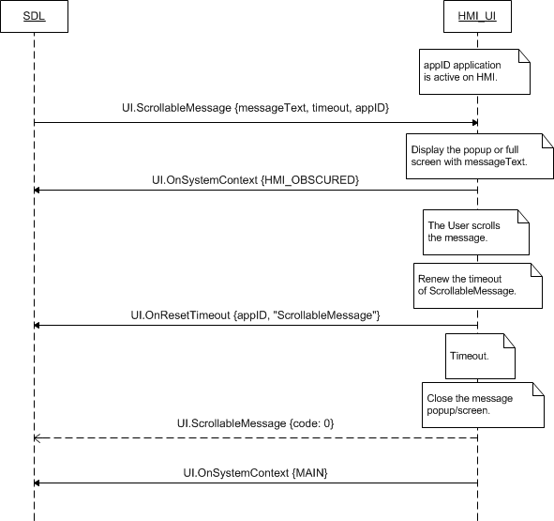

#### 7.19.4.2 ScrollableMessage with soft buttons of DEFAULT_ACTION and KEEP_CONTEXT system action pressed by the User

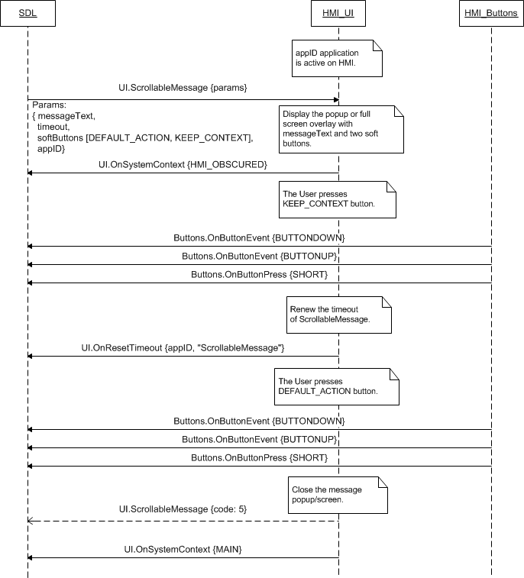

#### 7.19.4.3 ScrollableMassage with STEAL_FOCUS soft button for the application not active on HMI

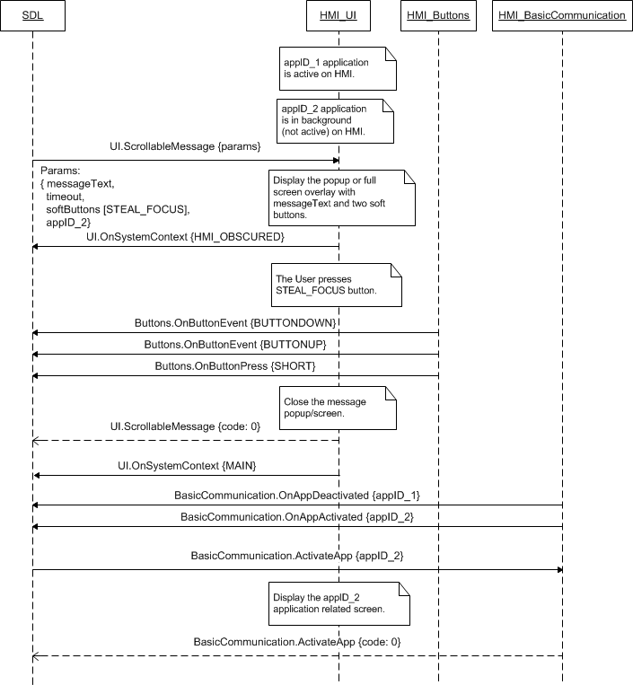

### 7.19.5 JSON Messages Examples

#### 7.19.5.1 Request

|  |
| --- |
| {  "id" : 138,  "jsonrpc" : "2.0",  "method" : "UI.ScrollableMessage",  “params” :  {  “messageText” :  {  “fieldName” : scrollableMessageBody,  “fieldText” : “Create a Station  Enter an artist, song or composer in the Search box in the top left corner. We'll create a radio station featuring that music and more like it.  You can also create a new station from the song or artist currently playing by hovering over the album artwork, clicking the white up-arrow and selecting New Station—you can choose From Song or From Artist.”  },  “timeout” : 10000,  “softButtons” :  [  {  “type” : TEXT,  “text” : “Leave onscreen”,  “softButtonID” : 15,  “systemAction” : KEEP_CONTEXT  },  {  “type” : TEXT,  “text” : “Cancel”,  “softButtonID” : 16,  “systemAction” : STEAL_FOCUS  }  ],  “appID” : 6527  }  } |

#### 7.19.5.2 Response

|  |
| --- |
| {  "id" : 138,  "jsonrpc" : "2.0",  "result" :  {  "code" : 0,  "method" : "UI.ScrollableMessage"  }  } |

#### 7.19.5.3 Error message

|  |
| --- |
| {  "id" : 138,  "jsonrpc" : "2.0",  "error" :  {  "code" : 12,  "message" : "The string data is too ling",  "data" :  {  "method" : "UI.ScrollableMessage"  }  }  } |

### 7.19.6 D-Bus Messages Examples

#### 7.19.6.1 Request

|  |
| --- |
| method call  sender=:1.138  -> dest=com.ford.sdl.hmi  serial=111  path=/;  interface=com.ford.sdl.hmi.UI;  member=ScrollableMessage  struct //messageText  {  int32 10 //fieldName  string "Text text text. //fieldText  Text text.  Text text text.  Text."  }  int32 30000 //timeout  struct //softButtons  {  boolean true //isPresent: the optional param is provided  array  [  struct //the first element of soft button in the array  {  int32 0 //type: TEXT  struct //text to display on the button  {  boolean true //isPresent: the optional param is provided  string "Keep" //text  }  struct //image to display on the button  {  boolean false //isPresent: the optional param is not provided  struct //the values that must be ignored  {  string ""  int32 -1  }  }  struct //to highlight a button or not  {  boolean true //isPresent: the optional param is provided  boolean true //isHighlighted  }  int32 5500 //softButtonID  struct //system action to be assigned  {  boolean true //isPresent: the optional param is provided  int32 2 //systemAction: KEEP_CONTEXT  }  }  struct //the second element of soft button in the array  {  int32 0 //type: TEXT  struct //text to display on the button  {  boolean true //isPresent: the optional param is provided  string "Close" //text  }  struct //image to display on the button  {  boolean false //isPresent: the optional param is not provided  struct //the values that must be ignored  {  string ""  int32 -1  }  }  struct //to highlight a button or not  {  boolean true //isPresent: the optional param is provided  boolean false //isHighlighted  }  int32 5501 //softButtonID  struct //system action to be assigned  {  boolean true //isPresent: the optional param is provided  int32 0 //systemAction: DEFAULT_ACTION  }  }  ]  }  int32 65540 //appID |

#### 7.19.6.2 Response

|  |
| --- |
| method return  sender=:1.139  -> dest=:1.138  reply_serial=111  int32 0 //code (SUCCESS)  string "" //message |

#### 7.19.6.3 Failure

|  |
| --- |
| method return  sender=:1.139  -> dest=:1.138  reply_serial=111  int32 5 //code (ABORTED)  string "The method was aborted" //message |

## 7.20 PerformAudioPassThru

### 7.20.1 Description

|  |  |
| --- | --- |
| **Type:** | Function |
| **Sender:** | SDL |
| **Purpose:** | Start audio capturing. |

SDL prompts HMI to start audio capturing and inform the User about the event by displaying the dialog with the requested text information.

The request may arrive in both cases of active and background application on HMI.

***Note:***

*This RPC may arrive together with TTS.Speak which purpose is to inform the User about start of audio capturing by the means of TTS module.*

### 7.20.2 Request

#### 7.20.2.1 Behavior

***HMI must:***

1. Attenuate or make any audio stream not audible except of TTS speaking (depending on HMI capabilities).

2. Display the dialog with requested text. (audioPassThruDisplayText1 and audioPassThruDisplayText2 text fields).

3. Start the audio capturing from the microphone.

***Important Note:***

*If PerfromAudioPassThru request is accompanied with TTS.Speak RPC, HMI must start the audio capturing only after TTS finishes speaking the requested text.*

4. Keep displaying the dialog and capturing the audio until:

* The value of maxDuration is reached.
* The User presses any of HMI-defined ‘Cancel’/’Done’/’Retry’ buttons.
* The request of EndAudioPassThru comes from SDL.

5. Respond the request.

***HMI may:***

Display the HMI-defined ‘Done’, ‘Retry’, ‘Cancel’ soft buttons. HMI must not return the OnButtonEvent/OnButtonPress notifications to SDL when such soft button is pressed by the User.

***Note:***

*- The applicable to this RPC result codes are provided in section 7.20.3 Response.*

*- The sequence diagrams describing the expected HMI behavior are provided in the section 7.20.4 Sequence Diagrams*

*- The picture of performAudioPassThru screen is added to the section 7.18.5 Possible Layout.*

#### 7.20.2.2 Parameters

|  |  |  |  |  |
| --- | --- | --- | --- | --- |
| **Param Name** | **Type** | **Mandatory** | **Additional** | **Description** |
| audioPassThruDisplayTexts | Common.TextFieldStruct | true | Array = true  minsize = 0  maxsize = 2 | The text to be displayed upon the start of audio capturing.  See TextFieldStruct.  Uses audioPassThruDisplayText1 and  audioPassThruDisplayText2  (See TextFieldName) |
| maxDuration | Integer | true | Minvalue = 1  Maxvalue = 1000000 | The maximum duration of audio recording in milliseconds |
| muteAudio | Boolean | true | - | Defines if the current audio source should be muted during the APT session. If not, the audio source will play without interruption.If omitted, the value is set to true |
| appID | Integer | true | – | ID of the application that requested this RPC. |

#### 7.20.2.3 TextFieldStruct Structure

| **Param Name** | **Type** | **Mandatory** | **Additional** | **Description** |
| --- | --- | --- | --- | --- |
| fieldName | Common.TextFieldName | true | – | The name of the field where the text must be displayed in. |
| fieldText | String | true | Maxlength = 500 | The text to be displayed. |

#### 7.20.2.4 TextFieldName Enumeration

Only the text fields applicable to PerformAudioPassThru RPC are described in this sub-section. All the text fields names recognized by SDL are described in the section *13.1.14 TextFieldName*.

| **Element name** | **Short Description** |
| --- | --- |
| audioPassThruDisplayText1 | The first line of text that must be displayed during audio capture. |
| audioPassThruDisplayText2 | The second line of text that must be displayed during audio capture. |

### 7.20.3 Response

***Note:***

*There is a difference in message type for WebSocket and D-Bus connection (see the table below).*

|  |  |  |  |  |  |
| --- | --- | --- | --- | --- | --- |
| **Result** | **Description** | **Message type** | | **Message Params** | **Notes** |
| **WebSocket** | **D-Bus** |
| Success | SUCCESS:  HMI displayed the PerformAudioPassTru dialog with requested parameters, has just closed it and stopped the audio capturing by:  1) The value of maxDuration reached  2) The HMI-defined ‘Ok’/’Done’ button press  3) EndAudioPassTru request from SDL. | JSON response | Method return | code: 0 |  |
| Failure | ABORTED:  HMI displayed the PerformAudioPassTru dialog with requested parameters, has just closed it and stopped the audio capturing by HMI-defined ‘Cancel’ button press. | JSON error message | Method return | code: 5 | Applicable for this RPC result codes.  Please see Result Enumeration for all SDL-supported codes. |
| RETRY:  HMI displayed the PerformAudioPassTru dialog with requested parameters, has just closed it and stopped the audio capturing by HMI-defined ‘Retry’ button press. | Code: 7 |
| INVALID_DATA:  The data sent is invalid (invalid JSON syntax or parameters out of bounds or of wrong type) | code: 11 |
| INVALID_ID  appID is invalid (e.g. doesn’t exist) | code: 13 |
| OUT_OF_MEMORY  @TODO to clarify if required | code: 17 |
| GENERIC_ERROR:  1) The unknown issue occurred or other codes are not applicable.  2) In case HMI does not respond SDL's request during max defined duration, SDL will return the result code to the corresponding mobile app's request. | code: 22 |

### 7.20.4 Sequence Diagrams

#### 7.20.4.1 PerformAudioPassTru requested together with TTS.Speak, processed and then finished by ‘Retry’ soft button press

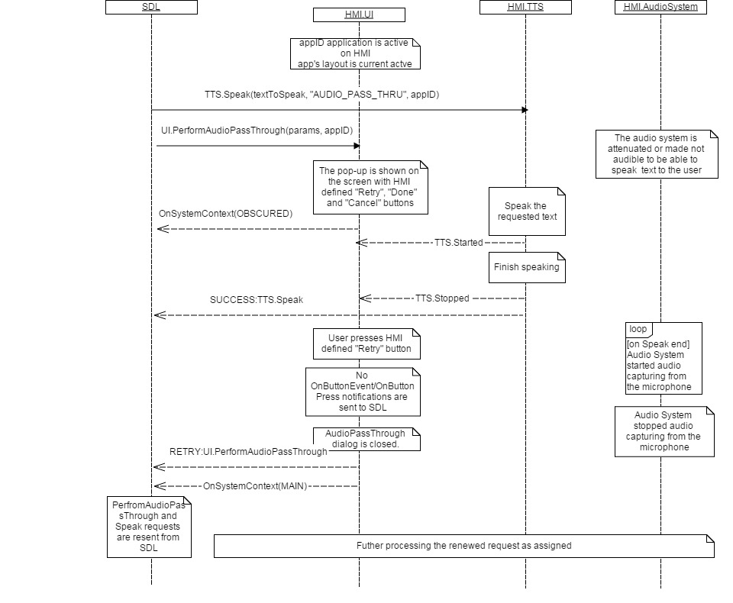

#### 7.20.4.2 PerformAudioPassTru for the application not active on HMI, processed and then finished by EndAudioPassThru

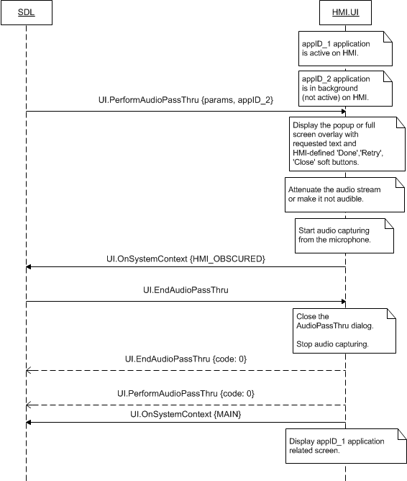

### 7.20.5 JSON Messages Examples

#### 7.20.5.1 Request

|  |
| --- |
| {  "id" : 79,  "jsonrpc" : "2.0",  "method" : "UI.PerformAudioPassThru",  “params” :  {  “audioPassThruDisplayTexts” :  {  “fieldName” : audioPassThruDisplayText1,  “fieldText” : “The audio capturing is in progress”  },  “maxDuration” : 10000,  }  } |

#### 7.20.5.2 Response

|  |
| --- |
| {  "id" : 79,  "jsonrpc" : "2.0",  "result" :  {  "code" : 0,  "method" : "UI.PerformAudioPassThru"  }  } |

#### 7.20.5.3 Error message

|  |
| --- |
| {  "id" : 79,  "jsonrpc" : "2.0",  "error" :  {  "code" : 7,  "message" : "The user interrupted the RPC and indicated to start over",  "data" :  {  "method" : "UI.PerformAudioPassThru"  }  }  } |

### 7.20.6 D-Bus Messages Examples

#### 7.20.6.1 Request

|  |
| --- |
| method call  sender=:1.186  -> dest=com.ford.sdl.hmi  serial=85  path=/;  interface=com.ford.sdl.hmi.UI;  member=PerformAudioPassThru  array //audioPassThruDisplayTexts  [  struct //the first element  {  int32 17 //fieldname: audioPassThruDisplayText1  string "AudioPassThru Display Text 1" //fieldText  }  struct //the second element  {  int32 18 //fieldname: audioPassThruDisplayText2  string "AudioPassThru Display Text 2" //fieldText  }  ]  int32 10000 //maxDuration  int32 65537 //appID |

#### 7.20.6.2 Response

|  |
| --- |
| method return  sender=:1.187  -> dest=:1.186  reply_serial=85  int32 0  string "" |

#### 7.20.6.3 Failure

|  |
| --- |
| method return  sender=:1.187  -> dest=:1.186  reply_serial=85  int32 7  string "The User interrupted the method call and indicated to start over" |

## 7.21 EndAudioPassThru

### 7.21.1 Description

|  |  |
| --- | --- |
| **Type:** | Function |
| **Sender:** | SDL |
| **Purpose:** | Stop audio capturing. |

SDL prompts HMI to stop audio capturing and close the AudioPassThru dialog on UI.

### 7.21.2 Request

#### 7.21.2.1 Behavior

***HMI must:***

1. Stop audio capturing started by PerformAudioPassThru RPC.

2. Close the PerformAudioPassThru dialog.

3. Respond the request.

***Note:***

*HMI must first respond the EndAudioPassThru request, and then provide the response to the corresponding PerformAudioPassThru request.*

***Note:***

*- The applicable to this RPC result codes are provided in section 7.21.3 Response.*

*- The sequence diagrams describing the expected HMI behavior are provided in the section 7.21.4 Sequence Diagrams*

### 7.21.3 Response

***Note:***

*There is a difference in message type for WebSocket and D-Bus connection (see the table below).*

|  |  |  |  |  |  |
| --- | --- | --- | --- | --- | --- |
| **Result** | **Description** | **Message type** | | **Message Params** | **Notes** |
| **WebSocket** | **D-Bus** |
| Success | SUCCESS:  HMI has stopped audio capturing upon this request receipt. | JSON response | Method return | code: 0 |  |
| Failure | REJECTED:  PerformAudioPassThru has already finished by the time this request arrived. | JSON error message | Method return | code: 4 | Applicable for this RPC result codes.  Please see Result Enumeration for all SDL-supported codes. |
| INVALID_DATA:  The data sent is invalid (invalid JSON syntax or parameters out of bounds or of wrong type) | code: 11 |
| GENERIC_ERROR  1) The unknown issue occurred or other codes are not applicable.  2) In case HMI does not respond SDL's request during SDL default timeout (10 sec), SDL will return the result code to the corresponding mobile app's request. | code: 22 |

### 7.21.4 Sequence Diagrams

#### 7.21.4.1 EndAudioPassThru that stops the audio capturing

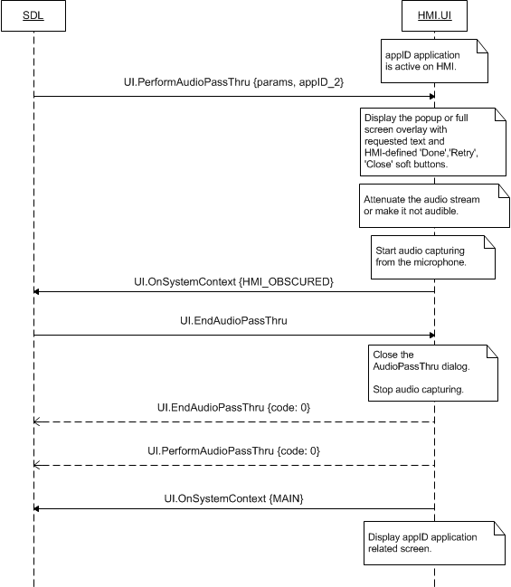

#### 7.21.4.2 EndAudioPassThru for the case when audio capturing is already over

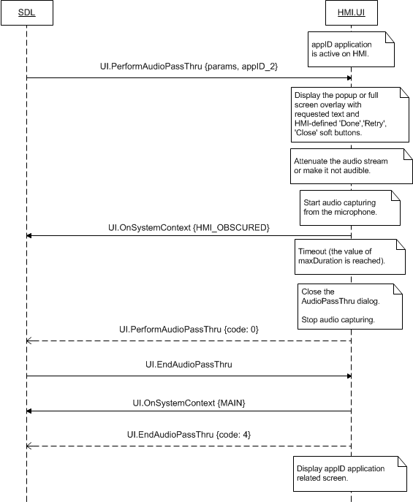

### 7.21.5 JSON Messages Examples

#### 7.21.5.1 Request

|  |
| --- |
| {  "id" : 79,  "jsonrpc" : "2.0",  "method" : "UI.EndAudioPassThru",  } |

#### 7.21.5.2 Response

|  |
| --- |
| {  "id" : 79,  "jsonrpc" : "2.0",  "result" :  {  "code" : 0,  "method" : "UI.EndAudioPassThru"  }  } |

#### 7.21.5.3 Error message

|  |
| --- |
| {  "id" : 79,  "jsonrpc" : "2.0",  "error" :  {  "code" : 4,  "message" : "Rejected: no PerformAudioPassThru is now active",  "data" :  {  "method" : "UI.EndAudioPassThru"  }  }  } |

### 7.21.6 D-Bus Messages Examples

#### 7.21.6.1 Request

|  |
| --- |
| method call //message type (request)  sender=:1.186 //unique for-the-lifetime-of-the-bus name automatically assigned to SDL  -> dest=com.ford.sdl.hmi //the name (requested by and assigned to HMI) to receive a message  serial=89 //serial number of the message  path=/; //the path to the object instance  interface=com.ford.sdl.hmi.UI;  member=EndAudioPassThru |

#### 7.21.6.2 Response

|  |
| --- |
| method return  sender=:1.187  -> dest=:1.186  reply_serial=89  int32 0 //code (SUCCESS)  string "" //message |

#### 7.21.6.3 Failure

|  |
| --- |
| method return  sender=:1.187  -> dest=:1.186  reply_serial=89  int32 4 //code (REJECTED)  string " Rejected: no PerformAudioPassThru is now active " //message |

## 7.22 ClosePopUp

### 7.22.1 Description

|  |  |
| --- | --- |
| **Type:** | Function |
| **Sender:** | SDL |
| **Purpose:** | Close the popup currently displayed. |

SDL prompts HMI to close the application-related dialog (popup/screen) currently displayed on UI.

### 7.22.2 Request

#### 7.22.2.1 Behavior

***HMI must:***

1. Close the application-related dialog (popup/screen) called by the methodName method and currently displayed on UI.

2. Respond the request.

***Note:***

*HMI must first reply the ClosePopUp method, and then reply the method having been interrupted.*

***Note:***

*- The applicable to this RPC result codes are provided in section 7.21.3 Response.*

*- The sequence diagrams describing the expected HMI behavior are provided in the section 7.21.4 Sequence Diagrams*

#### 7.22.2.2 Parameters

|  |  |  |  |
| --- | --- | --- | --- |
| **Param Name** | **Type** | **Mandatory** | **Description** |
| methodName | String | false | Method that to be closed |

### 7.22.3 Response

***Note:***

*There is a difference in message type for WebSocket and D-Bus connection (see the table below).*

|  |  |  |  |  |  |
| --- | --- | --- | --- | --- | --- |
| **Result** | **Description** | **Message type** | | **Message Params** | **Notes** |
| **WebSocket** | **D-Bus** |
| Success | SUCCESS:  HMI has closed the dialog (popup/screen) displayed on UI at the time the request arrived. | JSON response | Method return | code: 0 |  |
|  | REJECTED  The pop-up on the screen isn’t allowed closed by SDL. @TODO to clarify if it’s possible scenario |  |  | Code:4 |  |
| Failure | INVALID_DATA:  The data sent is invalid (invalid JSON syntax or parameters out of bounds or of wrong type), there’s no pop-up of the named request on the screen now | JSON error message | Method return | code: 11 | Applicable for this RPC result codes.  Please see Result Enumeration for all SDL-supported codes. |
| GENERIC_ERROR:  The unknown issue occurred or other codes are not applicable. | code: 22 |

### 7.22.4 Sequence Diagrams

#### 7.22.4.1 ClosePopUp for UI.PerformIntercation

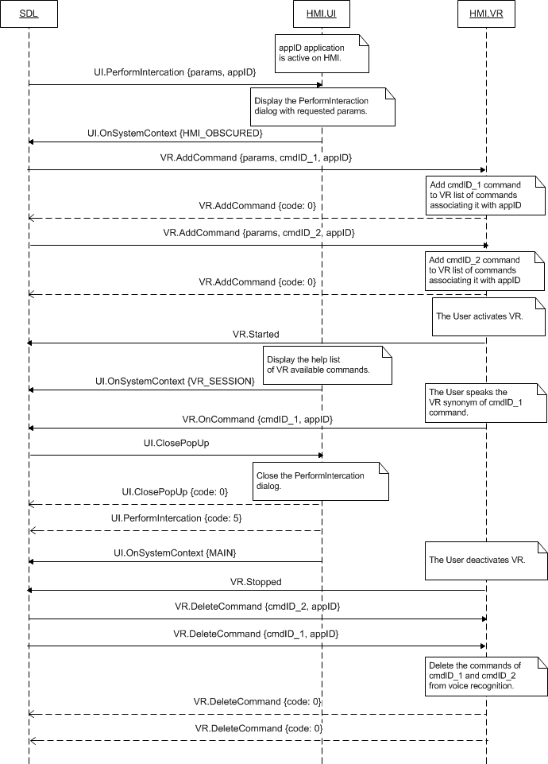

### 7.22.5 JSON Messages Examples

#### 7.22.5.1 Request

|  |
| --- |
| {  "id" : 79,  "jsonrpc" : "2.0",  "method" : "UI.ClosePopUp",  } |

#### 7.22.5.2 Response

|  |
| --- |
| {  "id" : 79,  "jsonrpc" : "2.0",  "result" :  {  "code" : 0,  "method" : "UI.ClosePopUp"  }  } |

#### 7.22.5.3 Error message

|  |
| --- |
| {  "id" : 79,  "jsonrpc" : "2.0",  "error" :  {  "code" : 22,  "message" : "During API call an unknown error has occurred",  "data" :  {  "method" : "UI.ClosePopUp"  }  }  } |

### 7.22.6 D-Bus Messages Examples

#### 7.22.6.1 Request

|  |
| --- |
| method call //message type (request)  sender=:1.186 //unique for-the-lifetime-of-the-bus name automatically assigned to SDL  -> dest=com.ford.sdl.hmi //the name (requested by and assigned to HMI) to receive a message  serial=109 //serial number of the message  path=/; //the path to the object instance  interface=com.ford.sdl.hmi.UI;  member=ClosePopUp |

#### 7.22.6.2 Response

|  |
| --- |
| method return  sender=:1.187  -> dest=:1.186  reply_serial=89  int32 0 //code (SUCCESS)  string "" //message |

#### 7.22.6.3 Failure

|  |
| --- |
| method return  sender=:1.187  -> dest=:1.186  reply_serial=89  int32 22 //code (GENERIC_ERROR)  string "During method call an unknown error has occurred" //message |

## 7.23 OnCommand

### 7.23.1 Description

|  |  |
| --- | --- |
| **Type:** | Notification |
| **Sender:** | HMI |
| **Purpose:** | Inform about the command chosen by the User from UI. |

Initially SDL adds the commands to the in-application menu (see UI.AddCommand) or sub-menu (see UI.AddSubMenu) on UI. The UI.OnCommand notification is required by SDL to know the SDL-defined command has been chosen by the User.

***Note:*** SDL ignores all invalid notifications which come from HMI (invalid JSON, invalid data types/bounds etc)

***HMI must:***

Send UI.OnCommand notification upon User`s choosing the SDL-defined command on UI providing the values of:

* Command ID (cmdID) initially provided by SDL via UI.AddCommand
* Application ID (appID) initially provided by SDL via OnAppRegistered or UpdateAppList.

#### 7.23.1.1 Parameters

|  |  |  |  |  |
| --- | --- | --- | --- | --- |
| **Param Name** | **Type** | **Mandatory** | **Additional** | **Description** |
| cmdID | Integer | true | minvalue = 0  maxvalue = 2000000000 | ID of the command that corresponds to the chosen menu item.  This ID was previously sent by SDL within AddCommand request. |
| appID | Integer | true | – | ID of the application that concerns this RPC.  Initially is provided by SDL via OnAppRegistered or UpdateAppList. |

### 7.23.2 Sequence Diagrams

#### 7.23.2.1 OnCommand

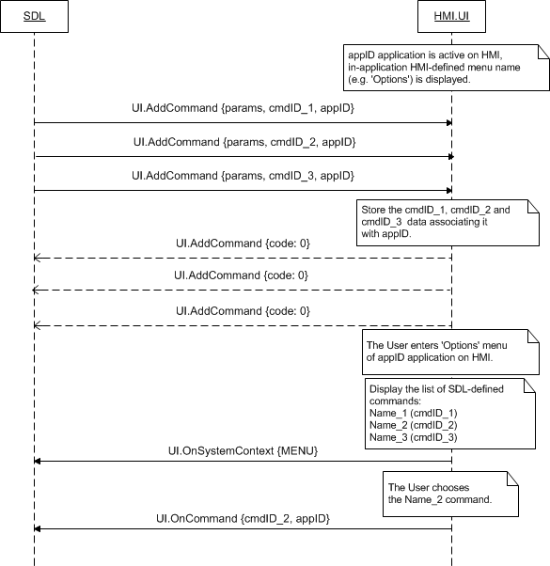

### 7.23.3 JSON Messages Examples

|  |
| --- |
| {  "jsonrpc" : "2.0",  "method" : "UI.OnCommand",  "params" :  {  "cmdID" : 2318,"appID" : 65409  }  } |

### 7.23.4 D-Bus Messages Examples

|  |
| --- |
| signal  sender=:1.209  -> dest=(null destination)  serial=83  path=/;  interface=com.ford.sdl.hmi.UI;  member=OnCommand  int32 6 //cmdID  int32 65537 //appID |
|  |

## 7.24 OnSystemContext

### 7.24.1 Description

|  |  |
| --- | --- |
| **Type:** | Notification |
| **Sender:** | HMI |
| **Purpose:** | Inform about the User-initiated interaction on HMI. |

SDL requires the information about the state of HMI and whether the User-initiated interaction is currently taking place on it.

***Note:*** SDL ignores all invalid notifications which come from HMI (invalid JSON, invalid data types/bounds etc)

***HMI must:***

Send the OnSystemContext notification of:

* MAIN: when the User doesn't interact with application via persistant display (neither the in-application menu nor dialog/overlay is currently displayed).
* VRSESSION: when VR becomes active
* as a result of PTT with help list of VR synonyms displayed
* as a result of UI.PerformIntercation (of BOTH or VR_ONLY mode) request from SDL
* MENU: when the User enters in-application menu (e.g. ‘Options’) on UI.
* HMI_OBSCURED: when HMI is currently obscuring the application persistenr display with:
* The dialog of ScrollableMessage, Slider, PerfromInteraction (MANUAL_ONLY and BOTH mode), PerfromAudioPassThru.
* Any HMI-defined (system) dialog.
* ALERT: when SDL-requested Alert dialog is displayed.

**OnSystemContext related to successful Alert: 'appID' parameter optionality**

1. HMI ought to not send AppID for MENU and HMI_OBCSURED system contexts. Only the apps in FULL may get these updates.  
2 .In case HMI sends OnSystemContext of MENU and HMI_OBCSUREDwith appID by HMI, appID is ignored and anyway the notification is transfered to the app in FULL HMI Level  
3. HMI must send OnSystemContext with appID parameter for MAIN and ALERT values. In case there's no such application with appID recieved, the notifications will be ignored by SDL

***Note:***

*The OnSystemContext must be sent right after the event has occurred.*

#### 7.24.1.1 Parameters

|  |  |  |  |
| --- | --- | --- | --- |
| **Param Name** | **Type** | **Mandatory** | **Description** |
| systemContext | Common.SystemContext | true | The context the application is brought into.  See SystemContext. |
| appID | integer | false |  |

#### 7.24.1.2 SystemContext

| **Element name** | **Value** | **Short Description** |
| --- | --- | --- |
| MAIN | 0 | If there is currently no user interaction (user-initiated or app-initiated) with the HMI, HMI must notify the SystemContext is MAIN. |
| VRSESSION | 1 | Must be sent if there is a current VR-oriented user interaction (VR becomes active as a result of PTT or PerformInteraction). |
| MENU | 2 | Must be sent if HMI is currently displaying an in-application menu onscreen. |
| HMI_OBSCURED | 3 | Must be sent if HMI is currently obscuring the application display either with a system or with application overlay (except of Alert element). |
| ALERT | 4 | Must be sent if the Alert message is currently displayed onscreen. |

### 7.24.2 Sequence Diagrams

#### 7.24.2.1 OnSystemContext on different HMI states

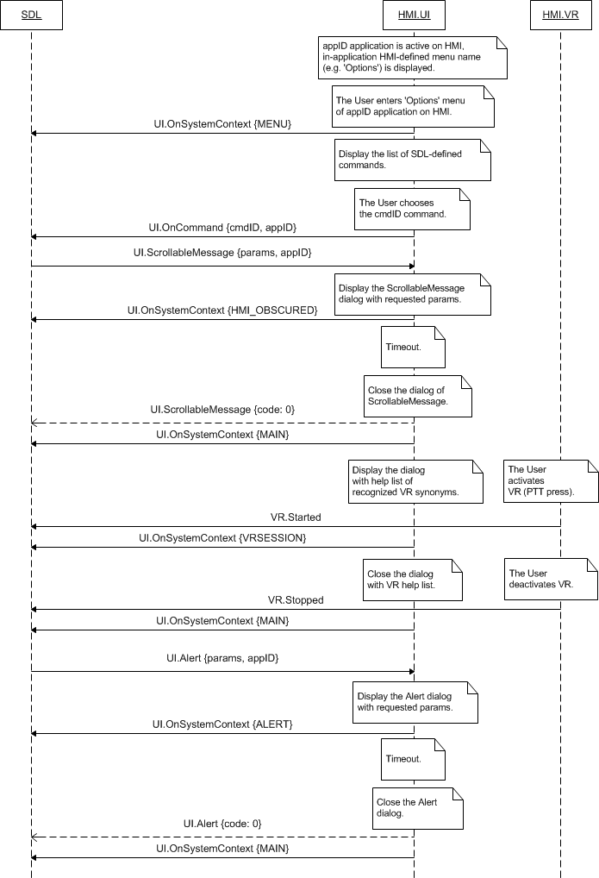

### 7.24.3 JSON Messages Examples

|  |
| --- |
| {  "jsonrpc" : "2.0",  "method" : "UI.OnSystemContext",  "params" :  {  "systemContext" : VRSESSION  }  } |

### 7.24.4 D-Bus Messages Examples

|  |
| --- |
| signal  sender=:1.209  -> dest=(null destination)  serial=84  path=/;  interface=com.ford.sdl.hmi.UI;  member=OnSystemContext  int32 0 //systemContext: MAIN |

## 7.25 OnLanguageChange

### 7.25.1 Description

|  |  |
| --- | --- |
| **Type:** | Notification |
| **Sender:** | HMI |
| **Purpose:** | Inform about the UI language is changed. |

SDL needs to be in the know when the User changes the HMI display language: Upon the receipt of OnLanguageChange notification SDL will unregister the applications of different language to provide them with possibility to re-register with the correct (new HMI) display language.

***Note:*** SDL ignores all invalid notifications which come from HMI (invalid JSON, invalid data types/bounds etc)

***HMI must:***

Send the UI.OnLanguageChange notification when the User switches HMI to another language and provide this new value with the language parameter.

#### 7.25.1.1 Parameters

|  |  |  |  |
| --- | --- | --- | --- |
| **Param Name** | **Type** | **Mandatory** | **Description** |
| language | Common.Language | true | Language that UI has switched to. |

#### 7.25.1.2 Language

| **Element Name** | **Value** | **Description** |
| --- | --- | --- |
| EN-US | 0 | English – US |
| ES-MX | 1 | Spanish – Mexico |
| FR-CA | 2 | French – Canada |
| DE-DE | 3 | German – Germany |
| ES-ES | 4 | Spanish – Spain |
| EN-GB | 5 | English – GB |
| RU-RU | 6 | Russian - Russia |
| TR-TR | 7 | Turkish – Turkey |
| PL-PL | 8 | Polish – Poland |
| FR-FR | 9 | French – France |
| IT-IT | 10 | Italian – Italy |
| SV-SE | 11 | Swedish – Sweden |
| PT-PT | 12 | Portuguese – Portugal |
| NL-NL | 13 | Dutch (Standard) – Netherlands |
| EN-AU | 14 | English – Australia |
| ZH-CN | 15 | Mandarin – China |
| ZH-TW | 16 | Mandarin – Taiwan |
| JA-JP | 17 | Japanese – Japan |
| AR-SA | 18 | Arabic – Saudi Arabia |
| KO-KR | 19 | Korean – South Korea |
| PT-BR | 20 | Portuguese - Brazil |
| CS-CZ | 21 | Czech – Czech Republic |
| DA-DK | 22 | Danish – Denmark |
| NO-NO | 23 | Norwegian - Norway |

### 7.25.2 Sequence Diagrams

#### 7.25.2.1 OnLanguageChange

***Note:***

*In case of several applications registered with HMI, upon OnLanguageCgange receipt SDL will send the following to HMI:*

* *RPCs to delete the sub-menus and UI/VR commands associated with every of appIDs*
* *OnAppUnregistered notifications for each of appIDs.*

*After the applications re-register with the new (provided via OnLanguageChange) hmiDisplayLanguageDesired, SDL will send the corresponding OnAppRegistered notifications to HMI.*

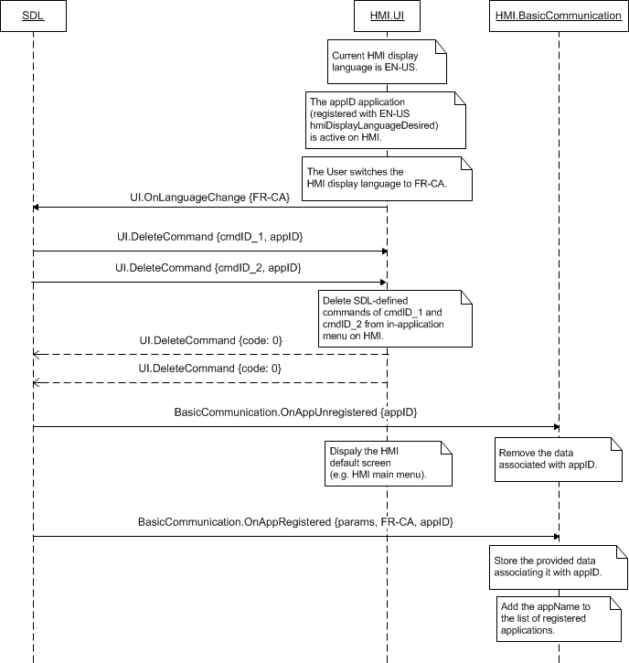

### 7.25.3 JSON Messages Examples

|  |
| --- |
| {  "jsonrpc" : "2.0",  "method" : "UI.OnLanguageChange",  "params" :  {  "language" : FR-CA  }  } |

### 7.25.4 D-Bus Messages Examples

|  |
| --- |
| signal  sender=:1.226  -> dest=(null destination)  serial=50  path=/;  interface=com.ford.sdl.hmi.UI;  member=OnLanguageChange  int32 2 |

## 7.26 OnKeyboardInput

### 7.26.1 Description

|  |  |
| --- | --- |
| **Type:** | Notification |
| **Sender:** | HMI |
| **Purpose:** | Inform the keyboard event. |

HMI may be requested by SDL to display the touchscreen keybord via:

* PerformInteraction with layoutMode: KEYBOARD – keyboard to be displayed
* PerformInteraction with layoutMode: ICONS_WITH_SEARCH – choices as icons to be displayed, the keyboard to be displayed upon User`s clicking in search bar area.
* PerformInteraction with layoutMode: LIST_WITH_SEARCH– choices as a list to be displayed, the keyboard to be displayed upon User`s clicking in search bar area.

HMI is expected to display a keyboard in case initiated by the user:

- as a result of appropriate button press at the 'navigation' template  
- as the result of recognized VR command that requests a keyboard search at the 'navigation' template

***HMI expected behavior:*** When a voice PTT button was pressed for a request to search via voice, HMI encodes user’s speech and sends user’s requested data via OnKeyboardInput(ENTRY_VOICE, data). The notification reflects that the "voice" button was pressed on the screen and the user uses voice search instead of typing. For more details see 7.26.2.5 OnKeyboardInput for ENTRY_VOICE diagram

**Note:** ENTRY_VOICE is**not**related to UI.PerformInteraction(KEYBOARD).

The keyboard layout, language, way of sending the entry are defined by SDL via UI.SetGlobalProperties (keyboardProperties structure) RPC.

Depending on keypressMode value (from keyboardProperties structure of UI.SetGlobalProperties), HMI must send the onKeyboardInput notification with the following data:

* SINGLE_KEYPRESS: each and every User`s keypress must be reported (new notification for every newly entered single symbol).
* QUEUE_KEYPRESSES: the whole entry is reported only after the User submits it (by ‘Search’ button click displayed on touchscreen keyboard)
* RESEND_CURRENT_ENTRY: the whole entry must be reported each and every time the User makes a new keypress (new notification with all previously entered symbols and a newly entered one appended).

***HMI must:***

Send the OnKeyboardInput notification providing the data entered from and the event occurred over the keyboard.

***Note:*** SDL ignores all invalid notifications which come from HMI (invalid JSON, invalid data types/bounds etc)

#### 7.26.1.1 Parameters

|  |  |  |  |  |
| --- | --- | --- | --- | --- |
| **Param Name** | **Type** | **Mandatory** | **Additional** | **Description** |
| event | Common.KeyboardEvent | true | - | The event occurred over the touchscreen keyboard. |
| data | String | false | Maxlength = 500  Minlength = 0 | On-screen keyboard input data:  - A single symbol in case keypressMode is defined as SINGLE_KEYPRESS via UI.SetGlobalProperties.  - The whole entry after the User has pressed ‘Search’ button in case keypressMode is defined as QUEUE_KEYPRESS via UI.SetGlobalProperties.  - The whole entry every time the User makes a new keypress in case keypressMode is defined as RESEND_CURRENT_ENTRY via UI.SetGlobalProperties. |

#### 7.26.1.2 KeyboardEvent

|  |  |  |
| --- | --- | --- |
| **Element name** | **Short Description** | |
| KEYPRESS | The User has pressed the keyboard key (applies to both SINGLE_KEYPRESS and RESEND_CURRENT_ENTRY modes). | |
| ENTRY_SUBMITTED | The User has finished entering text from the keyboard and submitted the entry. | |
| ENTRY_VOICE | | Indicates that a voice button was pressed for a request to search via voice |
| ENTRY_CANCELLED | The User has pressed the HMI-defined ‘Cancel’ button. | |
| ENTRY_ABORTED | The User has not finished entering text and the keyboard is aborted with the event of higher priority. | |

### 7.26.2 Sequence Diagrams

#### 7.26.2.1 OnKeyboardInput for SINGLE_KEYPRESS keypressMode

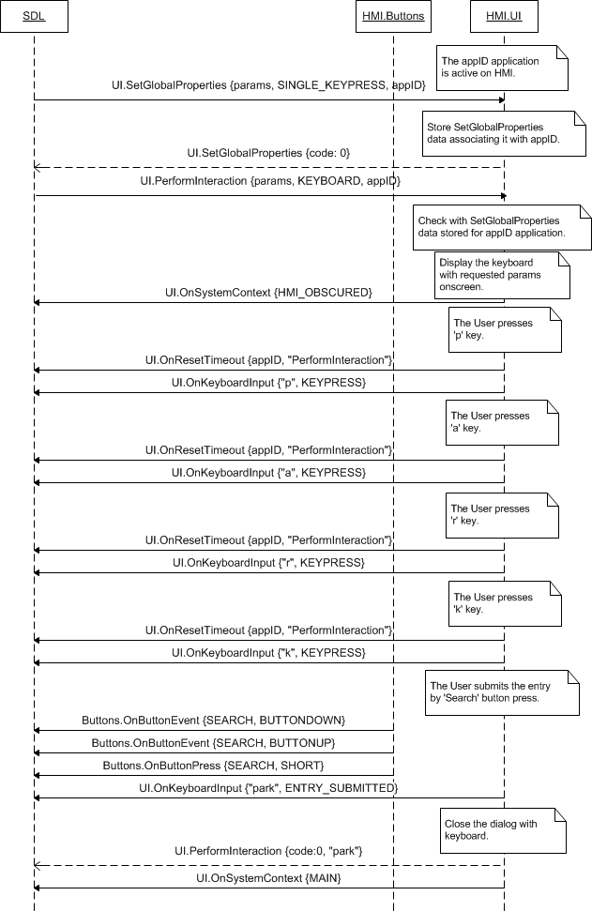

#### 7.26.2.2 OnKeyboardInput for QUEUE_KEYPRESSES keypressMode

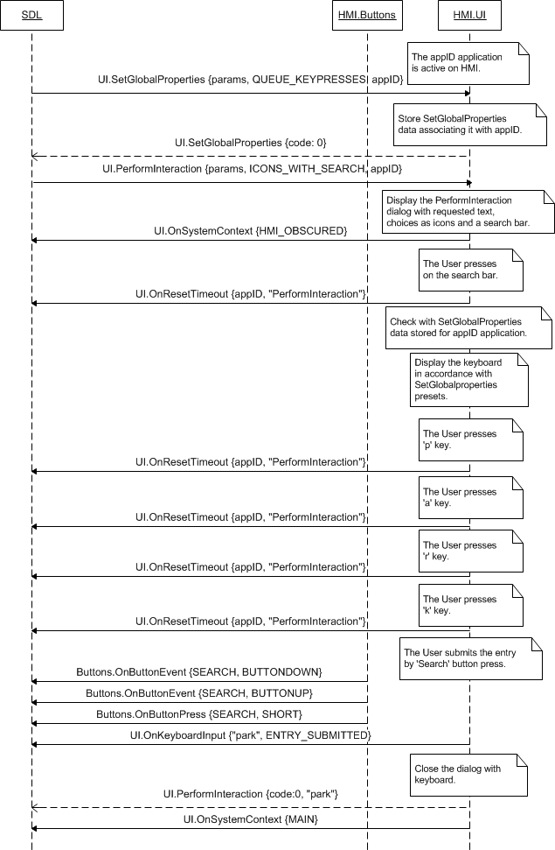

#### 7.26.2.3 OnKeyboardInput for RESEND_CURRENT_ENTRY keypressMode

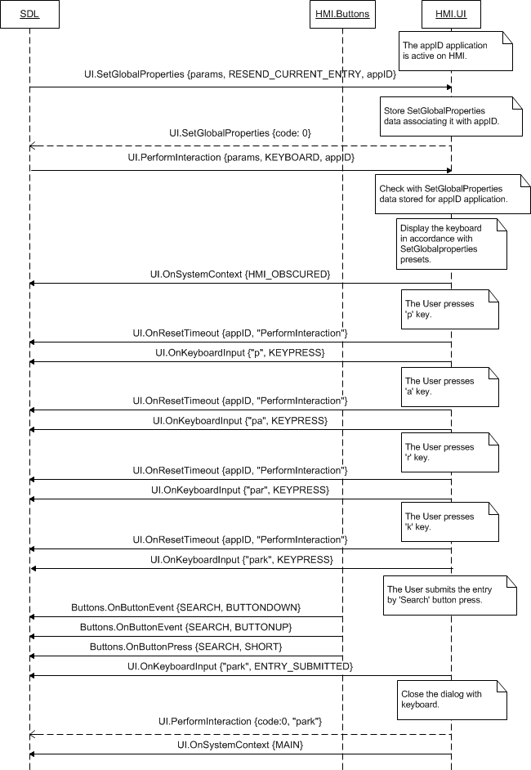

#### 7.26.2.4 OnKeyboardInput for cancelled entry

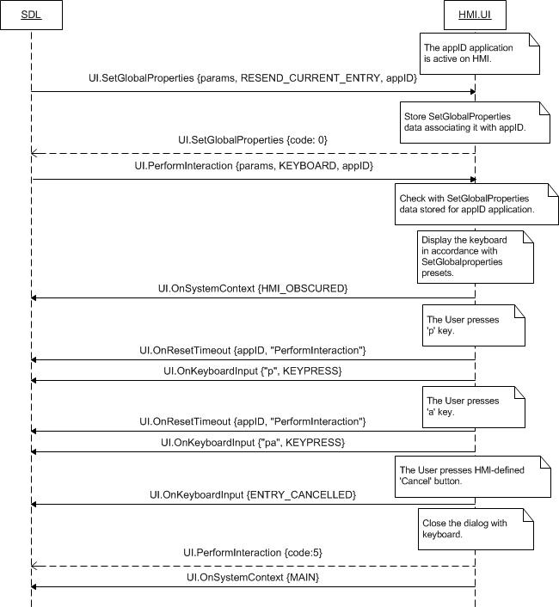

#### 7.26.2.5 OnKeyboardInput for ENTRY_VOICE

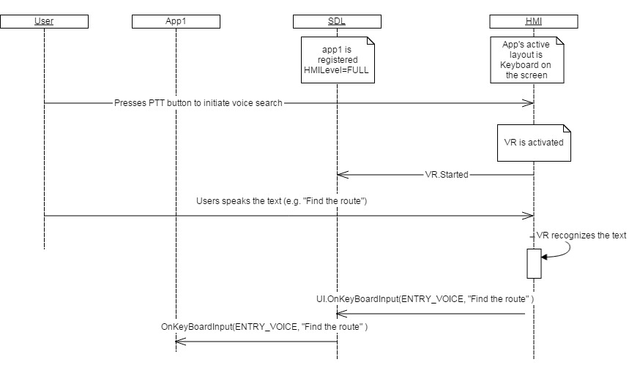

### 7.26.3 JSON Messages Examples

|  |
| --- |
| {  "jsonrpc" : "2.0",  "method" : "UI.OnKeyboardInput",  "params" :  {  "event" : ENTRY_CANCELLED  }  } |

### 7.26.4 D-Bus Messages Examples

|  |
| --- |
| signal  sender=:1.226  -> dest=(null destination)  serial=50  path=/;  interface=com.ford.sdl.hmi.UI;  member=OnLanguageChange  int32 0 //event: KEYPRESS  struct  {  boulean true //IsPresent: the optional param is provided  string “p” //data  } |

## 7.27 OnTouchEvent

### 7.27.1 Description

|  |  |
| --- | --- |
| **Type:** | Notification |
| **Sender:** | HMI |
| **Purpose:** | Inform the touch event has occurred. |

SDL needs to be informed about every User`s touching the touch screen during the navi streaming is active sceen layout.

- SDL supports up to 10 touches in a one touch event (this covers touch and multitouch events at the same - time), - When a single touch happens, “event” parameter contains the only element in the array, in case other fingers joined, an array contains the event data for every finger.

***HMI must:***

* Notify the user about touch events on the navi streaming screen via OnTouchEvent notifications during all active navi streaming for the application in focus.
* - For MOVE TouchType OnTouchEvent is sent for every coordinate got while the user ismoving a finger on the screen (means a single element in “c” parameter array).
* In case any type touch event has been performed for more than one finger, the notificationmustcontain TouchEvent data for each finger took part in the touch.

***Note:*** SDL ignores all invalid notifications which come from HMI (invalid JSON, invalid data types/bounds etc)

#### 7.27.1.1 Parameters

|  |  |  |  |  |
| --- | --- | --- | --- | --- |
| **Param Name** | **Type** | **Mandatory** | **Additional** | **Description** |
| type | Common.TouchType | true | - | The type of touch event. |
| event | Common.TouchEvent | true | array = true  minsize = 1  maxsize = 10 | List of all individual touches involved in this event. |

#### 7.27.1.2 TouchEvent

|  |  |  |  |  |
| --- | --- | --- | --- | --- |
| **Param Name** | **Type** | **Mandatory** | **Additional** | **Description** |
| id | Integer | true | minvalue = 0  maxvalue = 9 | A touch's unique identifier. The application can track the current touch events by id.  If a touch event has type begin, the id should be added to the set of touches.  If a touch event has type end, the id should be removed from the set of touches. |
| ts | Integer | true | Array = true  minvalue = 0  maxvalue = 2147483647  minsize = 1  maxsize = 1000 | The time that the touch was recorded. This number can the time since the beginning of the session or something else as long as the units are in milliseconds.  The timestamp is used to determined the rate of change of position of a touch.  The application also uses the time to verify whether two touches, with different ids, are part of a single action by the user. |
| c | Common.TouchCoord | true | Array = true  minsize = 1  maxsize = 1000 | The coordinates of the screen area where the touch event occurred. |

#### 7.27.1.2 TouchCoord

|  |  |  |  |  |
| --- | --- | --- | --- | --- |
| **Param Name** | **Type** | **Mandatory** | **Additional** | **Description** |
| x | Integer | true | minvalue = 0  maxvalue = 10000 | The x coordinate of the touch. |
| y | Integer | true | minvalue = 0  maxvalue = 10000 | The y coordinate of the touch. |

#### 7.27.1.2 TouchType

|  |  |  |
| --- | --- | --- |
| **Element name** | **Value** | **Short Description** |
| BEGIN | 0 | The user has touched the screen. |
| MOVE | 1 | The User has moved his finger over the screen. |
| END | 2 | The User has removed his finger from the screen. |

### 7.27.2 Sequence Diagrams

#### 7.27.2.1 OnTouchEvent moving two fingers stopped together

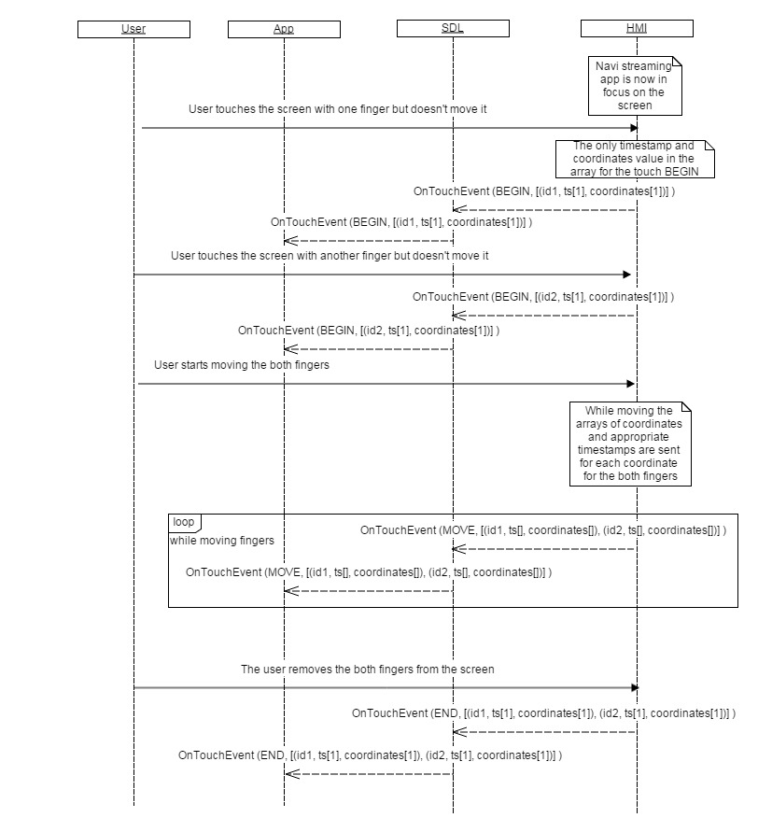

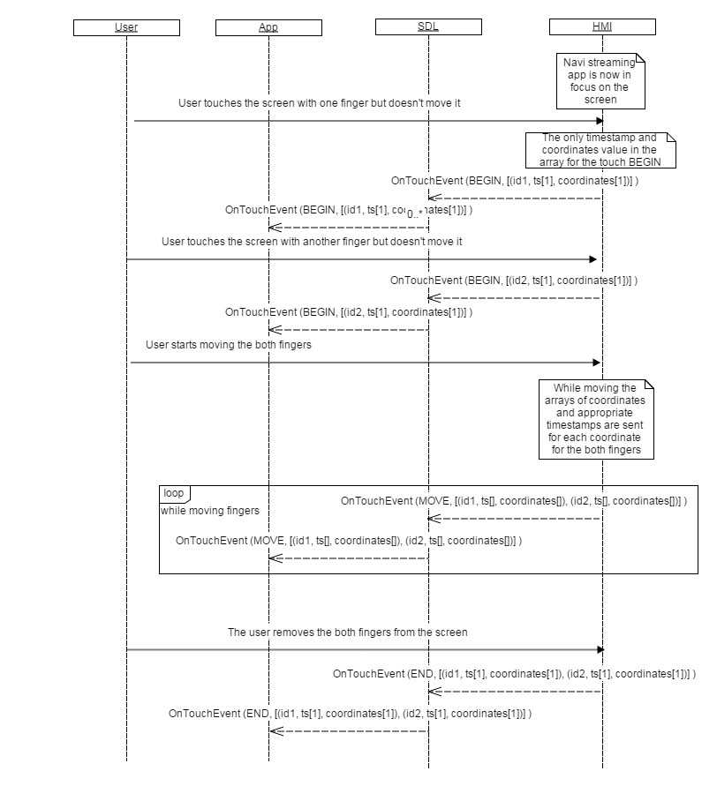

#### 7.27.2.2 OnTouchEvent moving two fingers, one stopped earlier

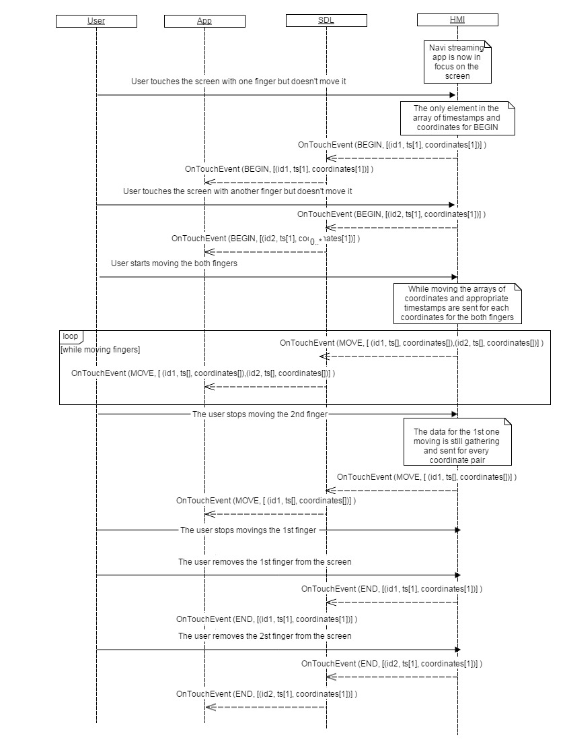

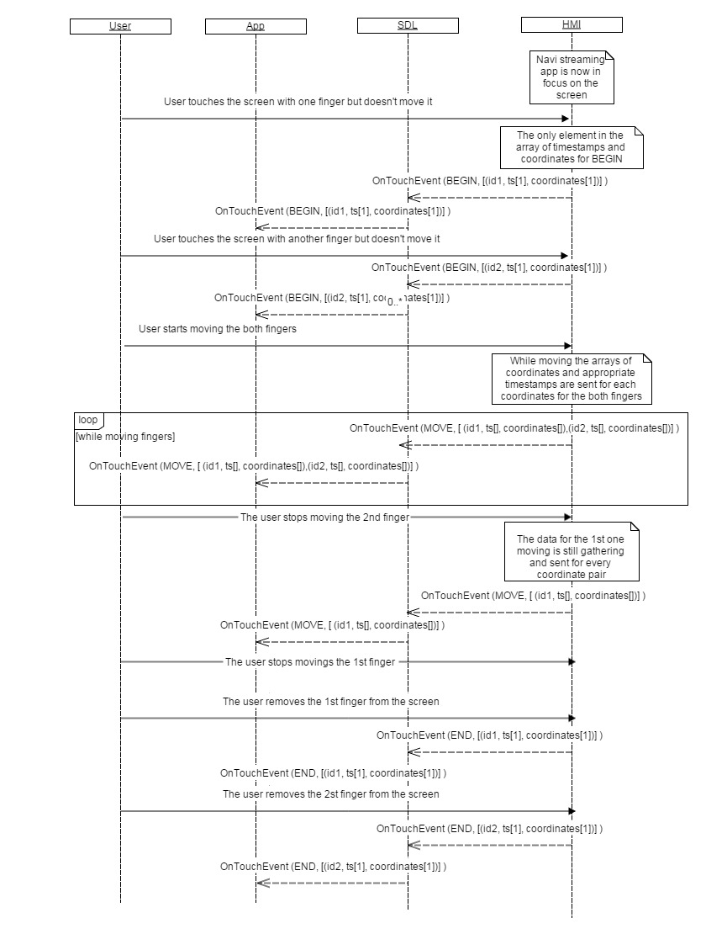

### 7.27.3 JSON Messages Examples

|  |
| --- |
| {  "jsonrpc" : "2.0",  "method" : "UI.OnTouchEvent",  "params" :  {  "type" : START,  " event" :[  {  "id":0,  "ts":[49013],  "c":[{"x":323,"y":259}],  }  ]  }  } |

### 7.27.4 D-Bus Messages Examples

|  |
| --- |
|  |

## 7.28 OnResetTimeout

### 7.28.1 Description

|  |  |
| --- | --- |
| **Type:** | Notification |
| **Sender:** | HMI |
| **Purpose:** | Inform about timeout reset for the named function. |

SDL needs to be in the know when the timeout of the recently called UI RPC is reset by definite User`s actions.

***HMI must:***

Send the OnResetTimeout notification in the following cases :

* PerfromInteraction of KEYBOARD layoutMode – upon every User`s keypress.
* ScrollableMessage:
* Upon User`s actions over the message (e.g. scrolling)
* Upon KEEP_CONTEXT soft button (defined within ScrollableMessage RPC) press.
* Alert – upon KEEP_CONTEXT soft button (defined within Alert RPC) press

***Note:*** SDL ignores all invalid notifications which come from HMI (invalid JSON, invalid data types/bounds etc)

#### 7.28.1.1 Parameters

|  |  |  |  |
| --- | --- | --- | --- |
| **Param Name** | **Type** | **Mandatory** | **Description** |
| appID | Integer | true | Id of application that invoked notifcation. |
| methodName | String | true | Currently used method name on which was triggered action |

### 7.28.2 Sequence Diagrams

#### 7.28.2.1 OnResetTimeout upon keypress during PerformInteraction (KEYBOARD)

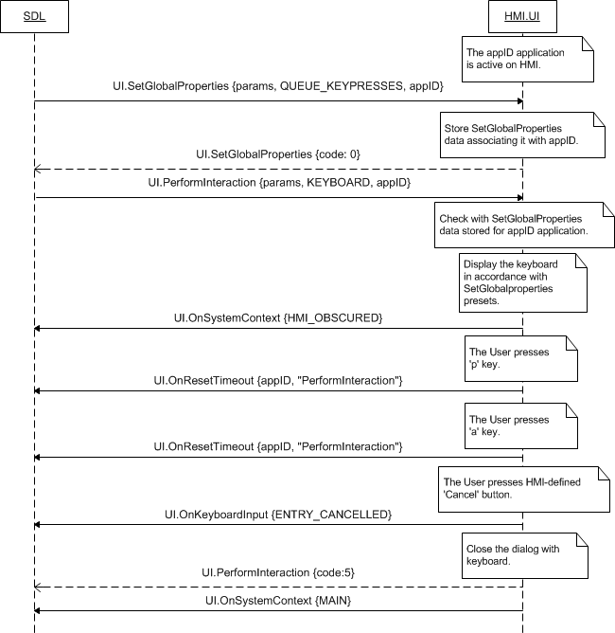

#### 7.28.2.2 OnResetTimeout upon User`s scrolling the message during ScrollableMessage

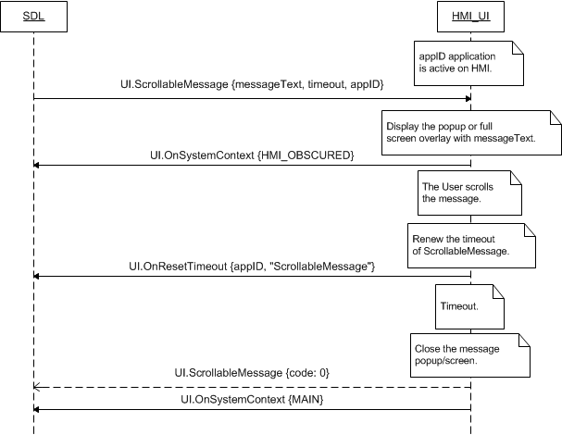

#### 7.28.2.2 OnResetTimeout upon KEEP_CONTEXT soft button press during Alert

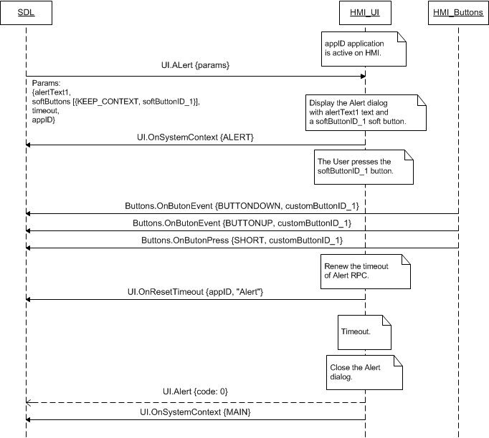

### 7.28.3 JSON Messages Examples

|  |
| --- |
| {  "jsonrpc" : "2.0",  "method" : "UI.OnResetTimeout",  } |

### 7.28.4 D-Bus Messages Examples

|  |
| --- |
|  |

## 7.29 OnDriverDistraction

### 7.29.1 Description

|  |  |
| --- | --- |
| **Type:** | Notification |
| **Sender:** | HMI |
| **Purpose:** | Inform about changes of driver distraction state. |

***HMI must:***

- Inform SDL via OnDriverDistraction whenever the driver distraction rules are changed on HMI.

- SDL requires this information for determining which RPCs to allow for the application.

***Note:*** SDL ignores all invalid notifications which come from HMI (invalid JSON, invalid data types/bounds etc)

#### 7.29.1.1 Parameters

|  |  |  |  |
| --- | --- | --- | --- |
| **Param Name** | **Type** | **Mandatory** | **Description** |
| state | Common.DriverDistractionState | true | Notifies the application of the current driver distraction state |

#### 7.29.1.2 DriverDistractionState

| **Element name** | **Value** | **Short Description** |
| --- | --- | --- |
| DD_ON | 0 | Driver Distraction rules are in effect. |
| DD_OFF | 1 | Driver Distraction rules are not in effect. |

### 7.29.2 Sequence Diagrams

#### 7.29.2.1 OnDriverDistraction notification

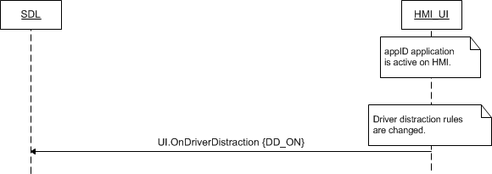

### 7.29.3 JSON Messages Examples

|  |
| --- |
| {  "jsonrpc" : "2.0",  "method" : "UI.OnDriverDistraction",  "params" :  {  "state" : DD_ON  }  } |

### 7.29.4 D-Bus Messages Examples

|  |
| --- |
|  |

## 7.30 OnRecordStart

### 7.30.1 Description

|  |  |
| --- | --- |
| **Type:** | Notification |
| **Sender:** | SDL |
| **Purpose:** | Start capturing audio data from the microphone |

There’re 2 conditions when SDL sends the notification for starting recording while PerformAudioPassThru is performing on HMI:

* Right after TTS.Speak portion of PerformAudioPassThru ended on HMI (see 7.30.2.1 diagram)
* In case just UI.PerfromAudioPassThru portion should be performed, the notification must be send by SDL right after UI.PerfromAudioPassThru has been sent to HMI.

***HMI must:***

* Start capturing data from the microphone as soon as get OnRecordStart. Audio data must be written into the directory on a platform and available to SDL (one directory up above SDL folder)

#### 7.30.1.1 Parameters

|  |  |  |  |
| --- | --- | --- | --- |
| **Param Name** | **Type** | **Mandatory** | **Description** |
| appID | Integer | true | ID of application related to this RPC. |

### 7.30.2 Sequence Diagrams

#### 7.30.2.1 OnRecordStart with TTS.Speak

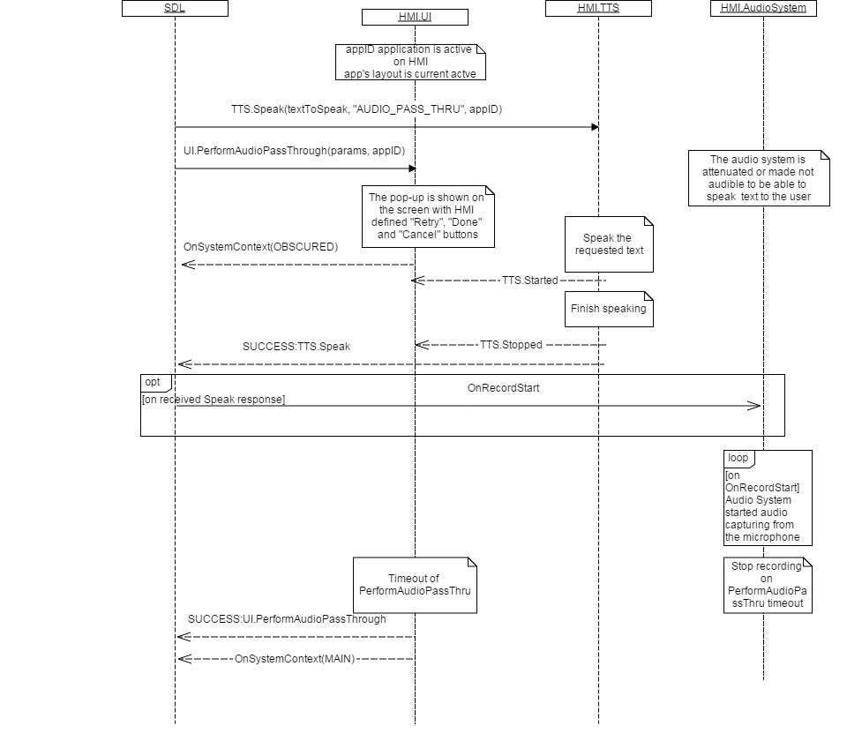

#### 7.30.2.2 OnRecordStart without TTS.Speak

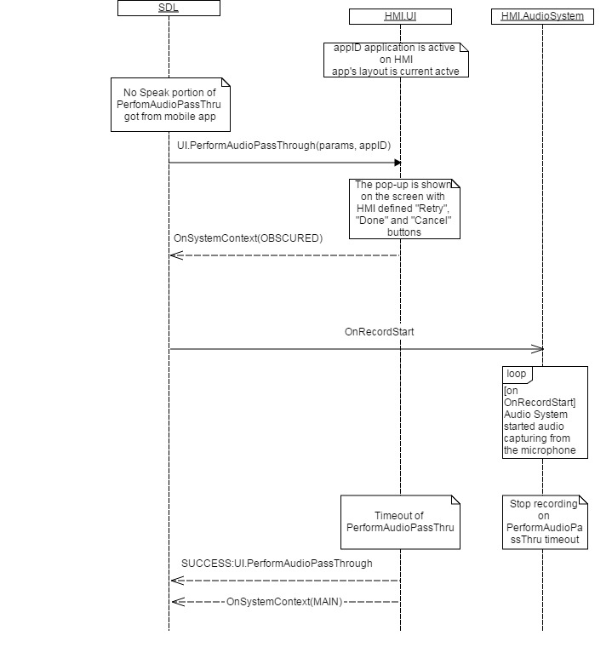

#### 7.30.2.2 OnRecordStart NOT sent if UI.PerformAudioPassThru is REJECTED

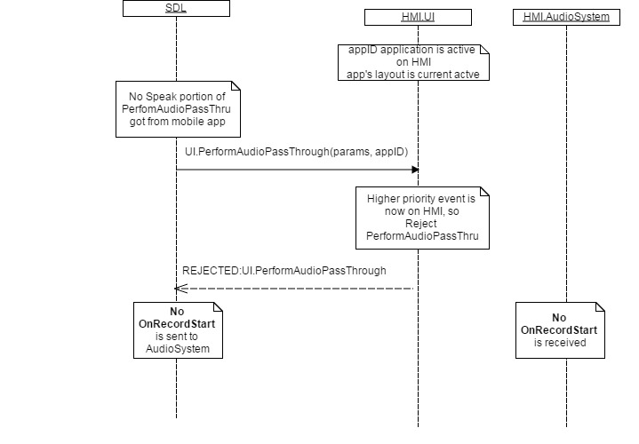

### 7.30.3 JSON Messages Examples

|  |
| --- |
| {  "jsonrpc" : "2.0",  "method" : "UI.OnRecordStart",  "params" :  {  "appID" : 65537  }  } |

### 7.30.4 D-Bus Messages Examples

|  |
| --- |
|  |

## 7.31 SetDisplayLayout

### 7.31.1 Description

|  |  |
| --- | --- |
| **Type:** | Function |
| **Sender:** | SDL |
| **Purpose:** | Set HMI-predefined display template for the named application. |

With SetDisplayLayout SDL requests HMI to use the named template when arranging the display layout of the named application.

Within SetDisplayLayout request SDL will use the template name (see section 7.32.2.2 Parameters) that HMI previously provides within response to UI.GetCapabilities (see section 7.2.3 Response and the below extract of corresponding JSON message).

|  |
| --- |
| **Extract of JSON response to UI.GetCapabilities that contains templates names** |
| "method" : “UI.GetCapabilities”,  “params”:  {...,  “displayCapabilities” :  {...,  “templatesAvailable” : [“template_1”, “template_2”],  ...  },  ...  } |

### 7.31.2 Request

#### 7.31.2.1 Behavior

***HMI must:***

1. Check whether the displayLayout parameter (see table in section 7.32.2.2) contains the correct template name (string value):

* If correct, proceed with steps 2,3,4.
* If not correct or some error occured, proceed with step 3 only.

2. Associate the named template of displayLayout with the provided application appID (see table in section 7.32.2.2).

3. Respond with one of the appropriate result codes (see section 7.32.3 Response for applicable result codes). And in case of SUCCESS return the capabilities of the named template:

* displayCapabilities: the type of display, supported text and image fields, supported formats of media clock and other that is described in section 7.32.3.2.
* buttonCapabilities: capabilities of hardware buttons: the names of available buttons, information about whether notifications on short/long presses and up/down events are supported by HMI (see section 7.32.3.13).
* softButtonCapabilities: capabilities of soft buttons: information about whether HMI supports referencing image and notifying on short/long presses and up/down events (see section 7.32.3.15).
* presetBankCapabilities: information about whether HMI supports duplicating the hardware custom presets with onscreen buttons (see section 7.32.3.16).

4. When the appID application is activated on HMI, HMI must switch to the corresponding template (associated in step 2.) that implements the corresponding capabilities (reported in step 3.).

***Note:***

*- The applicable to this RPC result codes are provided in section 7.32.3 Response.*

*- The sequence diagrams describing the expected HMI behavior are provided in the section 7.32.4 Sequence Diagrams*

#### 7.31.2.2 Parameters

| **Param Name** | **Type** | **Mandatory** | **Additional** | **Description** |
| --- | --- | --- | --- | --- |
| displayLayout | String | true | Maxlength = 500 | The name of predefined or dynamically created screen layout.  Currently only predefined screen layouts are defined.  See section 7.32.3.17 PredefinedLayout for the variants of template names. Still, HMI is not limited with these values and is free to create the name(s) that fit the template behavior/purpose/capabilities, etc. |
| appID | Integer | true | – | ID of the application that requested this RPC. |

### 7.31.3 Response

***Note:***

*There is a difference in message type for WebSocket and D-Bus connection (see the table below).*

|  |  |  |  |  |  |
| --- | --- | --- | --- | --- | --- |
| **Result** | **Description** | **Message type** | | **Message Params** | **Notes** |
| **WebSocket** | **D-Bus** |
| Success | SUCCESS:  HMI recognizes the requested.template name and provides the capabilities of this template. | JSON response | Method return | displayCapabilities,  buttonCapabilities,  softButtonCapabilities,  presetBankCapabilities,  code: 0 | See section 7.32.3.1. |
| Failure | UNSUPPORTED_RESOURCE:  HMI does not support any or one display templates at all (response to UI.GetCapabilities contains an empty array of templatesAvailable). | JSON error message | Method return | code: 2 | Applicable for this RPC result codes.  Please see Result Enumeration for all SDL-supported codes. |
| IGNORED:  The named template is already associated with the named appID application | code: 6 |
| INVALID_DATA:  The requested template name is not valid. | code: 11 |
| INVALID_ID  appID is invalid (e.g. doesn’t exist) | code:13 |
| GENERIC_ERROR  1) The unknown issue occurred or other codes are not applicable.  2) In case HMI does not respond SDL's request during SDL default timeout (10 sec), SDL will return the result code to the corresponding mobile app's request. | code: 22 |

#### 7.31.3.1 Parameters

| **Param Name** | **Type** | **Mandatory** | **Additional** | **Description** |
| --- | --- | --- | --- | --- |
| displayCapabilities | Common.DisplayCapabilities | false | - | The type of display, supported text and image fields, formats of media clock and other that is described in section 7.32.3.2. |
| buttonCapabilities | Common.ButtonCapabilities | false | Array = true  Minsize = 1  Maxsize = 100 | Capabilities of hardware buttons: the names of available buttons, information about whether notifications on short/long presses and up/down events are supported by HMI (see section 7.32.3.13). |
| softButtonCapabilities | Common.SoftButtonCapabilities | false | Array = true  Minsize = 1  Maxsize = 100 | Must be returned when the template supports on-screen SoftButtons.  Capabilities of soft buttons: information about whether HMI supports referencing image and notifying on short/long presses and up/down events (see section 7.32.3.15). |
| presetBankCapabilities | Common.PresetBankCapabilities | false | - | Must be returned when the template supports custom on-screen presets.  Information about whether HMI supports duplicating the hardware custom presets with onscreen buttons (see section 7.32.3.16). |

#### 7.31.3.2 DisplayCapabilities

| **Param Name** | **Type** | **Mandatory** | **Additional** | **Description** |
| --- | --- | --- | --- | --- |
| displayType | Common.DisplayType | true | - | The type of the display that is installed on HU.  See section 7.32.3.3 DisplayType. |
| textFields | Common.TextField | true | Array = true  minsize = 0  maxsize = 100 | A set of all fields that support displaying text data.  If there are no textfields supported HMI must send the empty array.  See section 7.32.3.4 TextField. |
| imageFields | Common.ImageField | false | Array = true  minsize = 1  maxsize = 100 | A set of all fields that support images. See section 7.32.3.5 ImageField |
| mediaClockFormats | Common.MediaClockFormat | true | Array = true  minsize = 1  maxsize = 100 | A set of all supported formats of the media clock.  See section 7.32.3.9 MediaClockFormat. |
| imageCapabilities | Common.ImageType | false | Array = true  minsize = 0  maxsize = 2 | The array of supported image types (static and/or dynamic).  The empty array should be returned if the platform does not support displaying images.  See section 7.32.3.10 ImageType. |
| graphicSupported | Boolean | true | - | Must be:  - ‘true’ if display's persistent screen supports referencing a static or dynamic image.  - ‘false’ if not. |
| templatesAvailable | String | true | Array = true  minsize = 0  maxsize = 100  maxlength = 100 | A set of all predefined persistent display templates available on headunit.  See section 7.32.3.17 PredefinedLayout for the variants of template names. Still, HMI is not limited with these values and is free to create the name(s) that fit the template behavior/purpose/capabilities, etc. |
| screenParams | Common.ScreenParams | false | - | A set of all parameters related to a prescribed screen area (e.g. for video / touch input).  See section 7.32.3.11 ScreenParams. |
| numCustomPresetsAvailable | Integer | false | minvalue = 1  maxvalue = 100 | The number of on-screen custom presets available (if any); otherwise omitted. |

#### 7.31.3.3 DisplayType Enumeration

| **Element name** | **Short Description** |
| --- | --- |
| CID | Center Information Display.  This display type provides a 2-line x 20 character "dot matrix" display. |
| TYPE2 | TYPE II display. 1 line older radio head unit. |
| TYPE5 | TYPE V display  Old radio head unit. |
| NGN | Next Generation Navigation display. |
| GEN2_8_DMA | GEN-2, 8 inch display. |
| GEN2_6_DMA | GEN-2, 6 inch display. |
| MFD3 | 3 inch GEN1.1 display |
| MFD4 | 4 inch GEN1.1 display |
| MFD5 | 5 inch GEN1.1 display |
| GEN3_8-INCH | GEN-3, 8 inch display. |

#### 7.31.3.4 TextField

| **Param Name** | **Type** | **Mandatory** | **Additional** | **Description** |
| --- | --- | --- | --- | --- |
| name | Common.TextFieldName | true | - | The name that identifies the field. See TextFieldName. |
| characterSet | Common.CharacterSet | true | - | The character set that is supported in this field. See CharacterSet. |
| width | Integer | true | minvalue="1" maxvalue="500" | The number of characters in one row of this field. |
| rows | Integer | true | minvalue="1" maxvalue="3" | The number of rows of this field. |

#### 7.31.3.5 TextFieldName Enumeration

| **Element name** | **Short Description** |
| --- | --- |
| mainField1 | The text that must be displayed in a single or upper display line.  If this value is not set, the text of mainField1 must stay unchanged.  If this text is empty "", the field must be cleared.  Applies to Show, section 7.5. |
| mainField2 | The text that must be displayed on the second display line.  If this text is not set, the text of mainField2 must stay unchanged.  If this text is empty "", the field must be cleared.  Applies to Show, section 7.5. |
| mainField3 | The text that must be displayed on the second "page" first display line.  If this text is not set, the text of mainField3 must stay unchanged.  If this text is empty "", the field must be cleared.  Applies to Show, section 7.5. |
| mainField4 | The text that must be displayed on the second "page" second display line.  If this text is not set, the text of mainField4 must stay unchanged.  If this text is empty "", the field must be cleared.  Applies to Show, section 7.5. |
| statusBar | The text is placed in the status bar area.  ***Note:*** *This relates to navigation displays*  If this parameter is omitted, the status bar text must remain unchanged.  If this parameter is an empty string, the field must be cleared.  If provided and the display has no status bar, this parameter must be ignored.  Applies to Show, section 7.5. |
| mediaClock | Text value for MediaClock field. Shall arrive in the form as described in the MediaClockFormat enumeration  If this text is set, any automatic media clock updates previously set with SetMediaClockTimer must be stopped.  Applies to Show, section 7.5. |
| mediaTrack | The text that should be displayed in the track field. This field should be valid only for media applications on.  If this text is not set, the text of mediaTrack must stay unchanged.  If this text is empty "", the field must be cleared.  Applies to Show, section 7.5. |
| alertText1 | The text that must be displayed in the top field of the display during the Alert.  Applies to Alert, section 7.4. |
| alertText2 | The text that must be displayed in the bottom field of the display during the Alert.  Applies to Alert, section 7.4. |
| alertText3 | The optional third line of the alert text field.  Applies to Alert, section 7.4. |
| scrollableMessageBody | The long form body of text that can include newlines and tabs.  Applies to ScrollableMessage, section 7.19. |
| initialInteractionText | Must be displayed when the interaction begins. The text must be displayed on the first line of a multiline display, and must be centered.  Applies to PerformInteraction, section 7.12. |
| navigationText1 | The text that must be displayed on the first line of navigation text.  Applies to ShowConstantTBT, section 12.3. |
| navigationText2 | The text that must be displayed on the second line of navigation text.  Applies to ShowConstantTBT, section 12.3. |
| ETA | Estimated Time of Arrival for navigation.  Applies to ShowConstantTBT, section 12.3. |
| totalDistance | Total distance to destination for navigation.  Applies to ShowConstantTBT, section 12.3. |
| navigationText | Navigation text for UpdateTurnList.  Applies to Turn, section 12.4. |
| audioPassThruDisplayText1 | The first line of text that must be displayed during audio capture.  Applies to PerformAudioPassThru, section 7.20. |
| audioPassThruDisplayText2 | The second line of text that must be displayed during audio capture.  Applies to PerformAudioPassThru, section 7.20. |
| sliderHeader | The text that must be displayed on the header of slider.  Applies to Slider, section 7.18. |
| sliderFooter | The text that must be displayed on the footer of slider.  Applies to Slider, section 7.18. |
| notificationText | The text that must be displayed to notify the User on some event.  Applies to ShowNotification, section 7.31. |
| menuName | Primary text for Choice.  Applies to PerformInteraction, section 7.12. |
| secondaryText | Secondary text for Choice.  Applies to PerformInteraction, section 7.12. |
| tertiaryText | Tertiary text for Choice.  Applies to PerformInteraction, section 7.12. |
| timeToDestination | The line to display the time to destination.  Applies to ShowConstantTBT, section 12.3. |
| turnText | Currently not used. |

#### 7.31.3.6 CharacterSet

| **Element name** | **Value** | **Short Description** |
| --- | --- | --- |
| TYPE2SET | 0 |  |
| TYPE5SET | 1 |  |
| CID1SET | 2 |  |
| CID2SET | 3 |  |

#### 7.31.3.7 ImageField Structure

| **Param Name** | **Type** | **Mandatory** | **Additional** | **Description** |
| --- | --- | --- | --- | --- |
| name | Common.ImageFieldName | true | - | The name that identifies the field. See section 7.32.3.6 ImageFieldName. |
| imageTypeSupported | Common.FileType | false | array = true  minsize = 1  maxsize = 100 | The image types that are supported in this field. See section 7.32.3.7 FileType. |
| imageResolution | Common.ImageResolution | false | - | The image resolution of this field. See section 7.32.3.8. |

#### 7.31.3.8 ImageFieldName Enumeration

| **Element name** | **Value** | **Short Description** |
| --- | --- | --- |
| softButtonImage | 0 | The image field for SoftButton |
| choiceImage | 1 | The first image field for Choice |
| choiceSecondaryImage | 2 | The secondary image field for Choice |
| vrHelpItem | 3 | The image field for vrHelpItem |
| turnIcon | 4 | The image field for Turn |
| menuIcon | 5 | The image field for the menu icon in SetGlobalProperties |
| cmdIcon | 6 | The image field for AddCommand |
| appIcon | 7 | The image field for the app icon (set by setAppIcon) |
| graphic | 8 | The image field for Show |
| showConstantTBTIcon | 9 | The primary image field for ShowConstantTBT |
| showConstantTBTNextTurnIcon | 10 | The secondary image field for ShowConstantTBT |
| locationImage | 11 | The optional image of a destination / location |

#### 7.31.3.9 FileType Enumeration

| **Element name** | **Value** | **Short Description** |
| --- | --- | --- |
| GRAPHIC_BMP | 0 |  |
| GRAPHIC_JPEG | 1 |  |
| GRAPHIC_PNG | 2 |  |
| AUDIO_WAVE | 3 |  |
| AUDIO_MP3 | 4 |  |
| AUDIO_AAC | 5 |  |
| BINARY | 6 |  |
| JSON | 7 |  |

#### 7.31.3.10 ImageResolution Structure

| **Param Name** | **Type** | **Mandatory** | **Additional** | **Description** |
| --- | --- | --- | --- | --- |
| resolutionWidth | Integer | true | minvalue = 1  maxvalue = 10000 | The image resolution width. |
| resolutionHeight | Integer | true | minvalue = 1  maxvalue = 10000 | The image resolution height. |

#### 7.31.3.11 MediaClockFormat Enumeration

| **Element name** | **Short Description** |
| --- | --- |
| CLOCK1 | minutesFieldWidth = 2; minutesFieldMax = 19;  secondsFieldWidth = 2; secondsFieldMax = 99;  maxHours = 19;  maxMinutes = 59;  maxSeconds = 59;  Is used for Type II, NGN and CID head units. |
| CLOCK2 | minutesFieldWidth = 3; minutesFieldMax = 199;  secondsFieldWidth = 2; secondsFieldMax = 99;  maxHours = 59;  maxMinutes = 59;  maxSeconds = 59;  Is used for Type V head units. |
| CLOCK3 | minutesFieldWidth = 2; minutesFieldMax = 59;  secondsFieldWidth = 2; secondsFieldMax = 59;  maxHours = 9;  maxMinutes = 59;  maxSeconds = 59;  Is used for GEN1.1 (i.e. MFD3/4/5) head units. |
| CLOCKTEXT1 | 5 characters possible  Format: 1|sp c :|sp c c  1|sp : digit "1" or space  c : character out of following character set: sp|0-9|[letters  :|sp : colon or space  Is used for Type II head unit |
| CLOCKTEXT2 | 5 chars possible  Format: 1|sp c :|sp c c  1|sp : digit "1" or space  c : character out of following character set: sp|0-9|[letters  :|sp : colon or space  Is used for CID and NGN head unit. |
| CLOCKTEXT3 | 6 chars possible  Format: 1|sp c c  :|sp c c 1|sp : digit "1" or space  c : character out of following character set: sp|0-9|[letters  :|sp : colon or space  Is used for Type V head unit. |
| CLOCKTEXT4 | 6 chars possible  Format: c :|sp c  c : c c :|sp : colon or space c : character out of following character set: sp|0-9|[letters].  Is used for GEN1.1 (i.e. MFD3/4/5) head units. |

#### 7.31.3.12 ImageType Enumeration

| **Element name** | **Short Description** |
| --- | --- |
| STATIC | Static image. The image that is sent as the binary or hex code within the request. |
| DYNAMIC | Dynamic image. The image that is stored on HMI and just a link to it is further used within requests. |

#### 7.31.3.13 ScreenParams Structure

| **Param Name** | **Type** | **Mandatory** | **Description** |
| --- | --- | --- | --- |
| resolution | Common.ImageResolution | true | The resolution of the prescribed screen area.  See section 7.32.3.8 ImageResolution. |
| touchEventAvailable | Common.TouchEventCapabilities | false | Types of screen touch events available in screen area. See section 7.32.3.12. |

#### 7.31.3.14 TouchEventCapabilities Structure

| **Param Name** | **Type** | **Mandatory** | **Description** |
| --- | --- | --- | --- |
| pressAvailable | Boolean | true |  |
| multiTouchAvailable | Boolean | true |  |
| doublePressAvailable | Boolean | true |  |

#### 7.31.3.15 ButtonCapabilities

| **Param Name** | **Type** | **Mandatory** | **Description** |
| --- | --- | --- | --- |
| name | Common.ButtonName | true | The name of supported/existing hardware button.  See section 7.32.3.14 ButtonName |
| shortPressAvailable | Boolean | true | Must be ‘true’ if the button supports short press mode.  If ‘true’ HMI must notify SDL with OnButtonPress (SHORT) every time this button is pressed short.  See section 8.3 OnButtonPress |
| longPressAvailable | Boolean | true | Must be ‘true’ if the button supports long press mode.  If ‘true’ HMI must notify SDL with OnButtonPress (LONG) every time this button is pressed long.  See section 8.3 OnButtonPress |
| upDownAvailable | Boolean | true | Must be ‘true’ if tracking the events of button being depressed/released is supported.  If ‘true’ HMI must notify SDL with OnButtonEvent of DOWN/UP on every button depress/release.  See section 8.4 OnButtonEvent |

#### 7.31.3.16 ButtonName

| **Element name** | **Value** | **Short Description** |
| --- | --- | --- |
| OK | 0 | Represents the button usually labeled "OK". A typical use of this button is for the User to press it to make a selection. |
| SEEKLEFT | 1 | Represents the seek-left button. A typical use of this button is for the user to scroll to the left through menu choices, one menu item per press. |
| SEEKRIGHT | 2 | Represents the seek-right button. A typical use of this button is for the user to scroll to the right through menu choices one menu item per press. |
| TUNEUP | 3 | Represents a turn of the tuner knob in the clockwise direction one tick. |
| TUNEDOWN | 4 | Represents a turn of the tuner knob in the counter-clockwise direction one tick. |
| PRESET_0 | 5 | Represents the preset 0 button. |
| PRESET_1 | 6 | Represents the preset 1 button. |
| PRESET_2 | 7 | Represents the preset 2 button. |
| PRESET_3 | 8 | Represents the preset 3 button. |
| PRESET_4 | 9 | Represents the preset 4 button. |
| PRESET_5 | 10 | Represents the preset 5 button. |
| PRESET_6 | 11 | Represents the preset 6 button. |
| PRESET_7 | 12 | Represents the preset 7 button. |
| PRESET_8 | 13 | Represents the preset 8 button. |
| PRESET_9 | 14 | Represents the preset 9 button. |
| CUSTOM_BUTTON | 15 | Represents any of onscreen buttons requested by SDL. |
| SEARCH | 16 | Represents the ‘Search’ button on the touchscreen keyboard. |

#### 7.31.3.17 SoftButtonCapabilities Structure

| **Param Name** | **Type** | **Mandatory** | **Description** |
| --- | --- | --- | --- |
| shortPressAvailable | Boolean | true | Must be  - ‘true’ if soft buttons support a short press  - ‘false’ if not.  See section 8.3 OnButtonPress. |
| longPressAvailable | Boolean | true | Must be  - ‘true’ if soft buttons support a LONG press  - ‘false’ if not.  See section 8.3 OnButtonPress. |
| upDownAvailable | Boolean | true | Must be  - ‘true’ if soft buttons support "button down" and "button up".  - ‘false’ if not.  See section 8.4 OnButtonEvent |
| imageSupported | Boolean | true | Must be  - ‘true’ if soft buttons support referencing image  - ‘false’ if not. |

#### 7.31.3.18 PresetBankCapabilities

|  |  |  |  |
| --- | --- | --- | --- |
| **Param Name** | **Type** | **Mandatory** | **Description** |
| onScreenPresetsAvailable | Boolean | true | Must be ‘true’ if HMI supports duplicating the hardware custom presets with onscreen buttons. |

#### 7.31.3.19 PredefinedLayout

| **Element name** | **Short Description** |
| --- | --- |
| DEFAULT | Default media / non-media screen. Can be set as a root screen. |
| MEDIA | Default Media screen. Can be set as a root screen. |
| NON-MEDIA | Default Non-media screen. Can be set as a root screen. |
| ONSCREEN_PRESETS | Custom root media screen containing app-defined onscreen presets. Can be set as a root screen. |
| NAV_FULLSCREEN_MAP | Custom root template screen containing full screen map with navigation controls. Can be set as a root screen. |
| NAV_LIST | Custom root template screen containing video represented list. Can be set as a root screen. |
| NAV_KEYBOARD | Custom root template screen containing video represented keyboard. Can be set as a root screen. |
| GRAPHIC_WITH_TEXT | Custom root template screen containing half-screen graphic with lines of text. Can be set as a root screen. |
| TEXT_WITH_GRAPHIC | Custom root template screen containing lines of text with half-screen graphic. Can be set as a root screen. |
| TILES_ONLY | Custom root template screen containing only tiled SoftButtons. Can be set as a root screen. |
| TEXTBUTTONS_ONLY | Custom root template screen containing only text SoftButtons. Can be set as a root screen. |
| GRAPHIC_WITH_TILES | Custom root template screen containing half-screen graphic with tiled SoftButtons. Can be set as a root screen. |
| TILES_WITH_GRAPHIC | Custom root template screen containing tiled SoftButtons with half-screen graphic. Can be set as a root screen. |
| RAPHIC_WITH_TEXT_AND_SOFTBUTTONS | Custom root template screen containing half-screen graphic with text and SoftButtons. Can be set as a root screen. |
| TEXT_AND_SOFTBUTTONS_WITH_GRAPHIC | Custom root template screen containing text and SoftButtons with half-screen graphic. Can be set as a root screen. |
| GRAPHIC_WITH_TEXTBUTTONS | Custom root template screen containing half-screen graphic with text only SoftButtons. Can be set as a root screen. |
| TEXTBUTTONS_WITH_GRAPHIC | Custom root template screen containing text only SoftButtons with half-screen graphic. Can be set as a root screen. |
| LARGE_GRAPHIC_WITH_SOFTBUTTONS | Custom root template screen containing a large graphic and SoftButtons. Can be set as a root screen. |
| DOUBLE_GRAPHIC_WITH_SOFTBUTTONS | Custom root template screen containing two graphics and SoftButtons. Can be set as a root screen. |
| LARGE_GRAPHIC_ONLY | Custom root template screen containing only a large graphic. Can be set as a root screen. |

### 7.31.4 Sequence Diagrams

#### 7.31.4.1 SetDisplayLayout (successful) with preceding UI.GetCapabilities

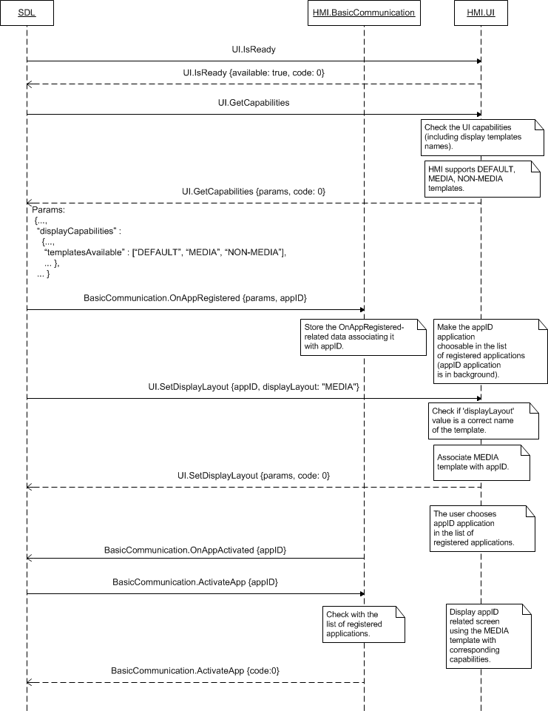

#### 7.31.4.2 SetDisplayLayout (INVALID_DATA) with preceding UI.GetCapabilities

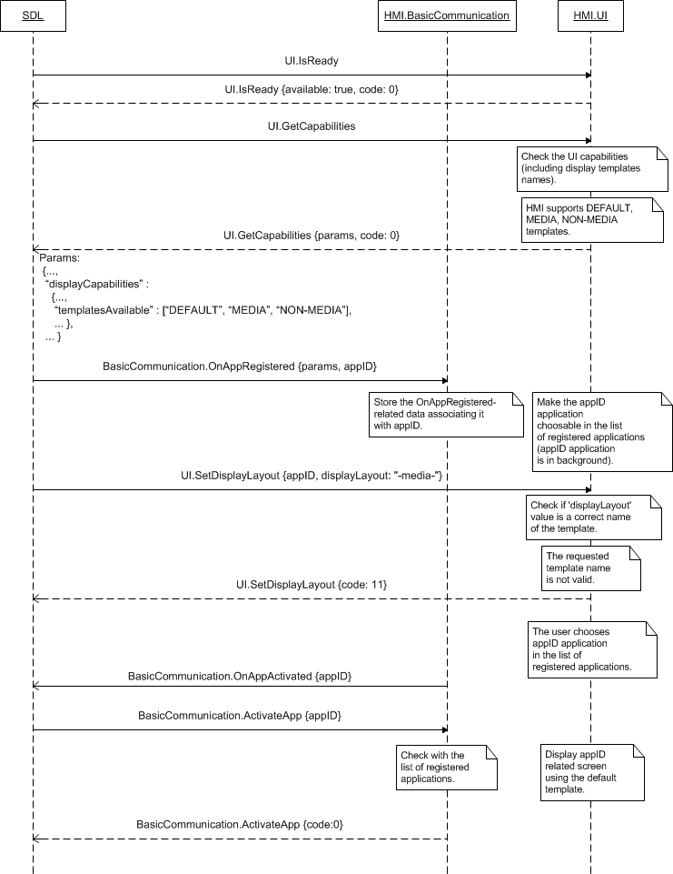

### 7.31.5 JSON Messages Examples

#### 7.31.5.1 Request

|  |
| --- |
| {  "id" : 47,  "jsonrpc" : "2.0",  "method" : "UI.SetDisplayLayout",  “params” :  {  “displayLayout” : “NON-MEDIA”,  “appID” : 65638  }  } |

#### 7.31.5.2 Response

|  |
| --- |
| {  "id" : 47,  "jsonrpc" : "2.0",  "result" :  {  "displayCapabilities" :  {  "displayType" : GEN2_8_DMA,  "textFields" : [mainField1, mainField2, alertText1, alertText2, alertText3, scrollableMessageBody, initialInteractionText, navigationText1, navigationText2, audioPassThruDisplayText1, audioPassThruDisplayText2, notificationText]  “imageFields” :  [  {  "name" : "softButtonImage",  "imageTypeSupported" : ["GRAPHIC_BMP", "GRAPHIC_JPEG", "GRAPHIC_PNG"],  "imageResolution" :  {  "resolutionWidth" : 32,  "resolutionHeight" : 32  }  },  {  "name" : "vrHelpItem",  "imageTypeSupported" : ["GRAPHIC_BMP", "GRAPHIC_JPEG", "GRAPHIC_PNG"],  "imageResolution" :  {  "resolutionWidth" : 32,  "resolutionHeight" : 32  }  },  {  "name" : "appIcon",  "imageTypeSupported" : ["GRAPHIC_BMP", "GRAPHIC_JPEG", "GRAPHIC_PNG"],  "imageResolution" :  {  "resolutionWidth" : 64,  "resolutionHeight" : 64  }  },  ],  "mediaClockFormats" : [CLOCK1, CLOCKTEXT4],  "imageCapabilities" : [DYNAMIC],  "graphicSupported" : true,  “templatesAvailable” : [“DEFAULT”, “MEDIA”, “NON-MEDIA”],  “screenParams” :  {  "resolution" :  {  "resolutionWidth" : 800,  "resolutionHeight" : 480  },  "touchEventAvailable" :  {  "pressAvailable" : true,  "multiTouchAvailable" : true,  “doublePressAvailable" : false  }  },  "numCustomPresetsAvailable" : 8  },  “buttonCapabilities” :  [  {  "name" : OK,  "shortPressAvailable" : true,  "longPressAvailable" : true,  "upDownAvailable" : true  },  {  "name" : SEEKLEFT,  "shortPressAvailable" : true,  "longPressAvailable" : true,  "upDownAvailable" : true  },  {  "name" : SEEKRIGHT,  "shortPressAvailable" : true,  "longPressAvailable" : true,  "upDownAvailable" : true  },  {  "name" : TUNEUP,  "shortPressAvailable" : true,  "longPressAvailable" : true,  "upDownAvailable" : true  },  {  "name" : TUNEDOWN,  "shortPressAvailable" : true,  "longPressAvailable" : true,  "upDownAvailable" : true  },  ],  “softButtonCapabilities” :  [  {  “shortPressAvailable” : true,  “longPressAvailable” : true,  “upDownAvailable” : true,  “imageSupported” : true  }  ],  “presetBankCapabilities” :  {  “onScreenPresetsAvailable” : true  },  "code" : 0,  "method" : "UI.SetDisplayLayout"  }  } |

#### 7.31.5.3 Error message

|  |
| --- |
| {  "id" : 47,  "jsonrpc" : "2.0",  "error" :  {  "code" : 6,  "message" : "Ignored as the requested template is already associated with the named appID",  "data" :  {  "method" : "UI.SetDisplayLayout"  }  }  } |

### 7.31.6 D-Bus Messages Examples

#### 7.31.6.1 Request

|  |
| --- |
| method call //message type (request)  sender=:1.186 //unique for-the-lifetime-of-the-bus name automatically assigned to SDL  -> dest=com.ford.sdl.hmi //the name (requested by and assigned to HMI) to receive a message  serial=89 //serial number of the message  path=/; //the path to the object instance  interface=com.ford.sdl.hmi.UI;  member=SetDisplayLayout  string "NON-MEDIA" //displayLayout  int32 65638 //appID |

#### 7.31.6.2 Response

|  |
| --- |
|  |

#### 7.31.6.3 Failure

|  |
| --- |
| method return  sender=:1.187  -> dest=:1.186  reply_serial=89  int32 6 //code (IGNORED)  string "Ignored as the requested template is already associated with the named appID" //message |

# 8 Buttons Component Description

## 8.1 GetCapabilities

### 8.1.1 Description

|  |  |
| --- | --- |
| **Type:** | Function |
| **Sender:** | SDL |
| **Purpose:** | Get the capabilities of hardware buttons. |

SDL can store the HMI capabilities in smartDeviceLink.ini file saved in SDL directory. Nevertheless, on its startup after getting OnReady notification from HMI, SDL sends the RPC for obtaining the buttons capabilities.

### 8.1.2 Request

#### 8.1.2.1 Behavior

***HMI must:***

1. Check the capabilities of supported hardware buttons and provide the following information about each of them:

* Name (from the ButtonName enumeration).

***Note:***

*CUSTOM_BUTTON name and the corresponding capabilities must be provided for the case when HMI has the ability to draw custom buttons onscreen.*

* Whether the short/long presses (see Chapter 1 “Abbreviations and Definitions”) are supported and distinguished by HMI. (If supported, HMI must notify SDL with OnButtonPress of SHORT/LONG on every button press).
* Whether tracking the events of button being depressed and released are supported. (If supported, HMI must notify SDL with OnButtonEvent of DOWN/UP on every button depress/release).

***Note:***

*For the mobile application better performance on HMI, HMI is recommended to provide the ability of reporting on depress/release events and at least ‘short’ press mode for its supported hardware and custom onscreen buttons.*

2. Chack whether the ability to duplicate the hardware preset buttons with onscreen buttons is supported.

3. Respond correspondingly to results of this check.

### 8.1.3 Response

***Note:***

*There is a difference in message type for WebSocket and D-Bus connection (see the table below).*

|  |  |  |  |  |  |
| --- | --- | --- | --- | --- | --- |
| **Result** | **Description** | **Message type** | | **Message Params** | **Notes** |
| **WebSocket** | **D-Bus** |
| Success | SUCCESS:  HMI provides the buttons capabilities. | JSON response | Method return | capabilities,  presetBankCapabilities,  code: 0 |  |
| Failure | INVALID_DATA:  The data sent is invalid (invalid JSON syntax or parameters out of bounds or of wrong type) | JSON error message | Method return | code: 11 | Applicable for this RPC result codes.  Please see Result Enumeration for all SDL-supported codes. |
| DATA_NOT_AVAILABLE:  The information about buttons capabilities cannot be provided. | Code: 9 |
| GENERIC_ERROR:  The unknown issue occurred or other codes are not applicable. | code: 22 |

#### 8.1.3.1 Parameters

| **Param name** | **Type** | **Mandatory** | **Additional** | **Description** |
| --- | --- | --- | --- | --- |
| capabilities | Common.ButtonCapabilities | true | array = true  minsize = 1  maxsize = 100 | Each element of the array defines the button name and whether shor/long presses and down/up events are supported.  See ButtonCapabilities |
| presetBankCapabilities | Common.PresetBankCapabilities | false | – | Should be returned if the platform supports duplicating the hardware presets with onscreen buttons.  See PresetBankCapabilities |

#### 8.1.3.2 ButtonCapabilities

| **Param Name** | **Type** | **Mandatory** | **Description** |
| --- | --- | --- | --- |
| name | Common.ButtonName | true | The name of supported/existing hardware button.  See ButtonName |
| shortPressAvailable | Boolean | true | Must be ‘true’ if the button supports short press mode.  If ‘true’ HMI must notify SDL with OnButtonPress (SHORT) every time this button is pressed short.  See ButtonPressMode |
| longPressAvailable | Boolean | true | Must be ‘true’ if the button supports long press mode.  If ‘true’ HMI must notify SDL with OnButtonPress (LONG) every time this button is pressed long.  See ButtonPressMode |
| upDownAvailable | Boolean | true | Must be ‘true’ if tracking the events of button being depressed/released is supported.  If ‘true’ HMI must notify SDL with OnButtonEvent of DOWN/UP on every button depress/release.  See ButtonEventMode |

#### 8.1.3.3 ButtonName

| **Element name** | **Value** | **Short Description** |
| --- | --- | --- |
| OK | 0 | Represents the button usually labeled "OK". A typical use of this button is for the User to press it to make a selection. |
| SEEKLEFT | 1 | Represents the seek-left button. A typical use of this button is for the user to scroll to the left through menu choices, one menu item per press. |
| SEEKRIGHT | 2 | Represents the seek-right button. A typical use of this button is for the user to scroll to the right through menu choices one menu item per press. |
| TUNEUP | 3 | Represents a turn of the tuner knob in the clockwise direction one tick. |
| TUNEDOWN | 4 | Represents a turn of the tuner knob in the counter-clockwise direction one tick. |
| PRESET_0 | 5 | Represents the preset 0 button. |
| PRESET_1 | 6 | Represents the preset 1 button. |
| PRESET_2 | 7 | Represents the preset 2 button. |
| PRESET_3 | 8 | Represents the preset 3 button. |
| PRESET_4 | 9 | Represents the preset 4 button. |
| PRESET_5 | 10 | Represents the preset 5 button. |
| PRESET_6 | 11 | Represents the preset 6 button. |
| PRESET_7 | 12 | Represents the preset 7 button. |
| PRESET_8 | 13 | Represents the preset 8 button. |
| PRESET_9 | 14 | Represents the preset 9 button. |
| CUSTOM_BUTTON | 15 | Represents any of onscreen buttons requested by SDL. |
| SEARCH | 16 | Represents the ‘Search’ button on the touchscreen keyboard. |

#### 8.1.3.4 PresetBankCapabilities

|  |  |  |  |
| --- | --- | --- | --- |
| **Param Name** | **Type** | **Mandatory** | **Description** |
| onScreenPresetsAvailable | Boolean | true | Must be ‘true’ if HMI supports duplicating the hardware custom presets with onscreen buttons. |

### 8.1.4 Sequence Diagrams

#### 8.1.4.1 GetCapabilities on system startup

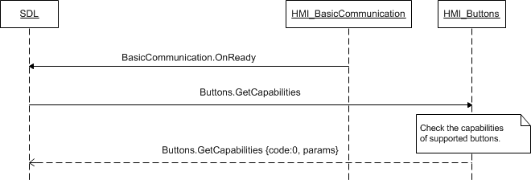

### 8.1.5 JSON Messages Examples

#### 8.1.5.1 Request

|  |
| --- |
| {  "id" : 20,  "jsonrpc" : "2.0",  "method" : "Buttons.GetCapabilities"  } |

#### 8.1.5.2 Response

|  |
| --- |
| {  "id" : 20,  "jsonrpc" : "2.0",  "result" :  {  "capabilities" :  [  {  "name" : OK,  "shortPressAvailable" : true,  "longPressAvailable" : true,  "upDownAvailable" : true  },  {  "name" : SEEKLEFT,  "shortPressAvailable" : true,  "longPressAvailable" : true,  "upDownAvailable" : true  },  {  "name" : SEEKRIGHT,  "shortPressAvailable" : true,  "longPressAvailable" : true,  "upDownAvailable" : true  },  {  "name" : TUNEUP,  "shortPressAvailable" : true,  "longPressAvailable" : true,  "upDownAvailable" : true  },  {  "name" : TUNEDOWN,  "shortPressAvailable" : true,  "longPressAvailable" : true,  "upDownAvailable" : true  },  ],  “presetBankCapabilities” :  [  “onScreenPresetsAvailable” : true  ],  "code" : 0,  "method" : "Buttons.GetCapabilities"  }  } |

#### 8.1.5.3 Error message

|  |
| --- |
| {  "id" : 20,  "jsonrpc" : "2.0",  "error" :  {  "code" : 9,  "message" : "The requested data is not available",  "data" :  {  "method" : "Buttons.GetCapabilities"  }  }  } |

### 8.1.6 D-Bus Messages Examples

#### 8.1.6.1 Request

|  |
| --- |
|  |

#### 8.1.6.2 Response

|  |
| --- |
|  |

#### 8.1.6.3 Failure

|  |
| --- |
|  |

## 8.2 OnButtonEvent

### 8.2.1 Description

|  |  |
| --- | --- |
| **Type:** | Notification |
| **Sender:** | HMI |
| **Purpose:** | Inform about the event of depress/relese has occurred for the button. |

Once HMI confirmed it supports reporting on events of button press/release for the named buttons (via response to Buttons.GetCapabilities), SDL expects to be notified about such events via OnButtonEvent.

***HMI must:***

Send the following information upon every event of press or release occurred for each of supported buttons:

* The name of the button (from ButtonName enumeration) the event has occurred for.
* The event occurred:
* BUTTONDOWN – when the User has pressed the button
* BUTTONUP – when the User has released the button.
* The ID of the custom button: for the case of CUSTOM_BUTTON name only.
* The appID in case the ButtonName is CUSTOM_BUTTON (if not sent, SDL will ignore the notification and will not transfer it to mobile app).

***Note:***

*The value of custom buttom ID is provided by SDL within softButton structure (softButtonID parameter) via one of the following RPCs: UI.Alert, UI.ScrollableMessage, UI.Show.*

***Note:*** SDL ignores all invalid notifications which come from HMI (invalid JSON, invalid data types/bounds etc)

#### 8.2.1.1 Parameters

| **Param name** | **Type** | **Mandatory** | **Additional** | **Description** |
| --- | --- | --- | --- | --- |
| name | Common.ButtonName | true | – | The name of the button involved into event.  See ButtonName. |
| mode | Common.ButtonEventMode | true | – | Indicates whether this is an UP or DOWN event  See ButtonEventMode. |
| customButtonID | Integer | false | minvalue = 0  maxvalue = 65536 | This ID must be provided in case the event has occured for the CUSTOM_BUTTON only.  The value is previously provided by SDL within softButton structure via one of the following RPCs: UI.Alert, UI.ScrollableMessage, UI.Show. |
| appID | Integer | false | - | In case the ButtonName is CUSTOM_BUTTON, HMI must include appID parameters to OnButtonPress notification sent to SDL.  Otherwise, if appID is not sent together with CUSTOM_BUTTON, this notification will be ignored by SDL. |

#### 8.1.3.3 ButtonName

| **Element name** | **Value** | **Short Description** |
| --- | --- | --- |
| OK | 0 | Represents the button usually labeled "OK". A typical use of this button is for the User to press it to make a selection. |
| SEEKLEFT | 1 | Represents the seek-left button. A typical use of this button is for the user to scroll to the left through menu choices, one menu item per press. |
| SEEKRIGHT | 2 | Represents the seek-right button. A typical use of this button is for the user to scroll to the right through menu choices one menu item per press. |
| TUNEUP | 3 | Represents a turn of the tuner knob in the clockwise direction one tick. |
| TUNEDOWN | 4 | Represents a turn of the tuner knob in the counter-clockwise direction one tick. |
| PRESET_0 | 5 | Represents the preset 0 button. |
| PRESET_1 | 6 | Represents the preset 1 button. |
| PRESET_2 | 7 | Represents the preset 2 button. |
| PRESET_3 | 8 | Represents the preset 3 button. |
| PRESET_4 | 9 | Represents the preset 4 button. |
| PRESET_5 | 10 | Represents the preset 5 button. |
| PRESET_6 | 11 | Represents the preset 6 button. |
| PRESET_7 | 12 | Represents the preset 7 button. |
| PRESET_8 | 13 | Represents the preset 8 button. |
| PRESET_9 | 14 | Represents the preset 9 button. |
| CUSTOM_BUTTON | 15 | Represents any of onscreen buttons requested by SDL. |
| SEARCH | 16 | Represents the ‘Search’ button on the touchscreen keyboard. |

#### 8.2.1.2 ButtonEventMode

| **Element name** | **Value** | **Short Description** |
| --- | --- | --- |
| BUTTONDOWN | 0 | The button has been pressed |
| BUTTONUP | 1 | The button has been released |

### 8.2.2 Sequence Diagrams

#### 8.2.2.1 OnButtonEvent for CUSTOM_BUTTON being pressed and released

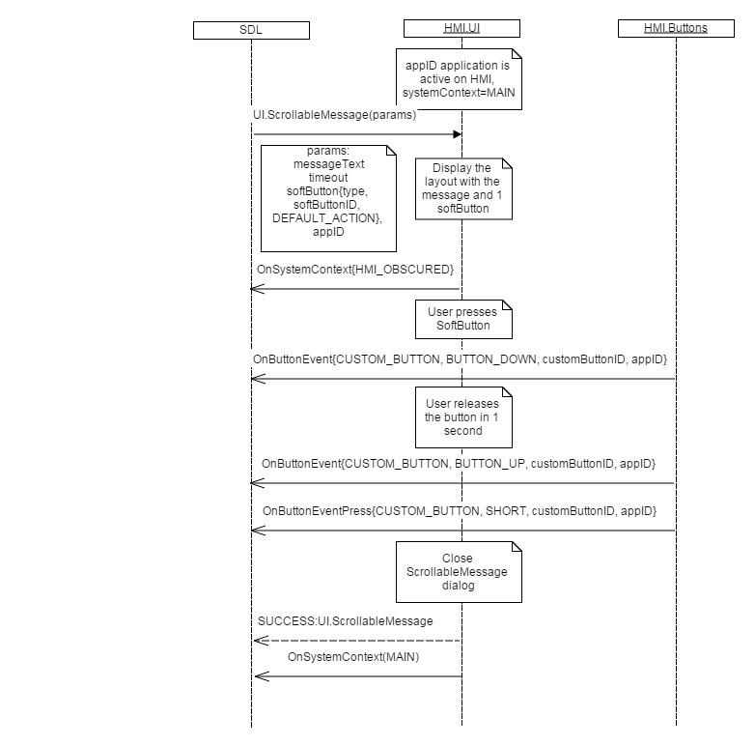

#### 8.2.2.1 OnButtonEvent for hardware button being pressed and released

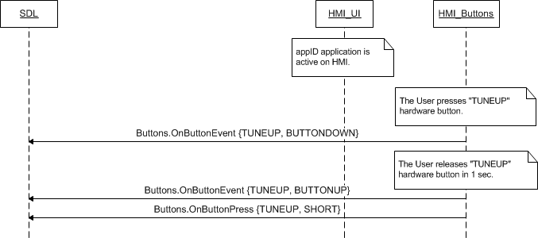

### 8.2.3 JSON Messages Examples

|  |
| --- |
| {  "jsonrpc" : "2.0",  "method" : "Buttons.OnButtonEvent",  "params" :  {  "name" : OK,  “mode” : BUTTONDOWN,  }  } |

### 8.2.4 D-Bus Messages Examples

|  |
| --- |
|  |

## 8.3 OnButtonPress

### 8.3.1 Description

|  |  |
| --- | --- |
| **Type:** | Notification |
| **Sender:** | HMI |
| **Purpose:** | Inform about the press mode detected for the button. |

Once HMI confirmed it supports short and/or long press modes for the named buttons (via response to Buttons.GetCapabilities), SDL expects to be notified with the information of the press mode occurred via OnButtonPress.

***HMI must:***

Send the following information upon every long or short press detected for each of supported buttons:

* The name of the button (from ButtonName enumeration) being pressed.
* The press mode detected:
* SHORT – when the button is pressed and is being held during less than HMI-defined time threshold (e.g. during less than 2 sec.) and then released
* LONG – when the button is pressed and is being held during more than HMI-defined time threshold (e.g. during more than 2 sec.) and then released
* The ID of the custom button: for the case of CUSTOM_BUTTON name only.
* The appID in case the ButtonName is CUSTOM_BUTTON (if not sent, SDL will ignore the notification and will NOT transfer it to mobile app).

***Note:***

*The value of custom buttom ID is provided by SDL within softButton structure (softButtonID parameter) via one of the following RPCs: UI.Alert, UI.ScrollableMessage, UI.Show.*

***Note:*** SDL ignores all invalid notifications which come from HMI (invalid JSON, invalid data types/bounds etc)

***Important note:***

*It is expected that the sequence of OnButtonEvent and OnButtonPress notifications will depend on the button press mode detected:*

1. *The button is pressed SHORT (is held during less than HMI-defined time threshold):*

* *OnButtonEvent (BUTTONDOWN)*
* *OnButtonEvent (BUTTONUP)*
* *OnButtonPress (SHORT)*

1. *The button is pressed LONG (is held during more than HMI-defined time threshold):*

* *OnButtonEvent (BUTTONDOWN)*
* *OnButtonPress (LONG)*
* *OnButtonEvent (BUTTONUP)*

***Note:***

*In case the button supports SHORT press mode only, HMI must send OnButtonPress (SHORT) independently of the time this button is being held for.*

#### 8.3.1.1 Parameters

| **Param name** | **Type** | **Mandatory** | **Additional** | **Description** |
| --- | --- | --- | --- | --- |
| name | Common.ButtonName | true | – | The name of the button the press mode is detected for.  See ButtonName. |
| mode | Common.ButtonPressMode | true | – | Indicates whether this is a LONG or SHORT button press mode  See ButtonPressMode. |
| customButtonID | Integer | false | minvalue = 0  maxvalue = 65536 | This ID must be provided in case the event has occured for the CUSTOM_BUTTON only. |
| appID | Integer | false | - | In case the ButtonName is CUSTOM_BUTTON, HMI must include appID parameters to OnButtonPress notification sent to SDL.  Otherwise, if appID is not sent together with CUSTOM_BUTTON, this notification will be ignored by SDL. |

#### 8.1.3.3 ButtonName

| **Element name** | **Value** | **Short Description** |
| --- | --- | --- |
| OK | 0 | Represents the button usually labeled "OK". A typical use of this button is for the User to press it to make a selection. |
| SEEKLEFT | 1 | Represents the seek-left button. A typical use of this button is for the user to scroll to the left through menu choices, one menu item per press. |
| SEEKRIGHT | 2 | Represents the seek-right button. A typical use of this button is for the user to scroll to the right through menu choices one menu item per press. |
| TUNEUP | 3 | Represents a turn of the tuner knob in the clockwise direction one tick. |
| TUNEDOWN | 4 | Represents a turn of the tuner knob in the counter-clockwise direction one tick. |
| PRESET_0 | 5 | Represents the preset 0 button. |
| PRESET_1 | 6 | Represents the preset 1 button. |
| PRESET_2 | 7 | Represents the preset 2 button. |
| PRESET_3 | 8 | Represents the preset 3 button. |
| PRESET_4 | 9 | Represents the preset 4 button. |
| PRESET_5 | 10 | Represents the preset 5 button. |
| PRESET_6 | 11 | Represents the preset 6 button. |
| PRESET_7 | 12 | Represents the preset 7 button. |
| PRESET_8 | 13 | Represents the preset 8 button. |
| PRESET_9 | 14 | Represents the preset 9 button. |
| CUSTOM_BUTTON | 15 | Represents any of onscreen buttons requested by SDL. |
| SEARCH | 16 | Represents the ‘Search’ button on the touchscreen keyboard. |

#### 8.3.1.2 ButtonPressMode

|  |  |  |
| --- | --- | --- |
| **Element name** | **Value** | **Short Description** |
| SHORT | 0 | Short-time button press: the button is being held during less than HMI-defined time threshold (e.g. during less than 2 sec.) and then released |
| LONG | 1 | Long-time button press: the button is being held during more than HMI-defined time threshold (e.g. during more than 2 sec.) and then released |

### 8.3.2 Sequence Diagrams

#### 8.3.2.1 OnButtonPress (SHORT) for CUSTOM_BUTTON



#### 8.3.2.2 OnButtonPress (LONG) for hardware button

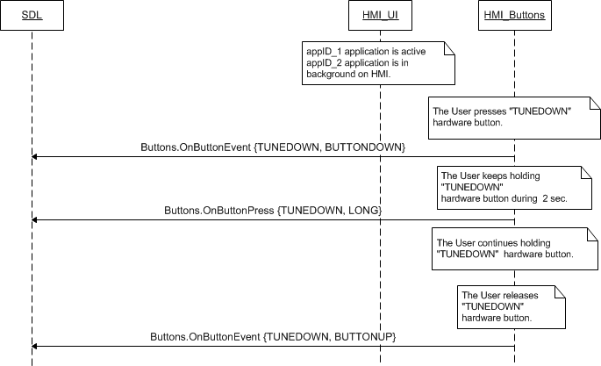

#### 8.3.2.2 OnButtonPress for hardware button that supports SHORT press mode only

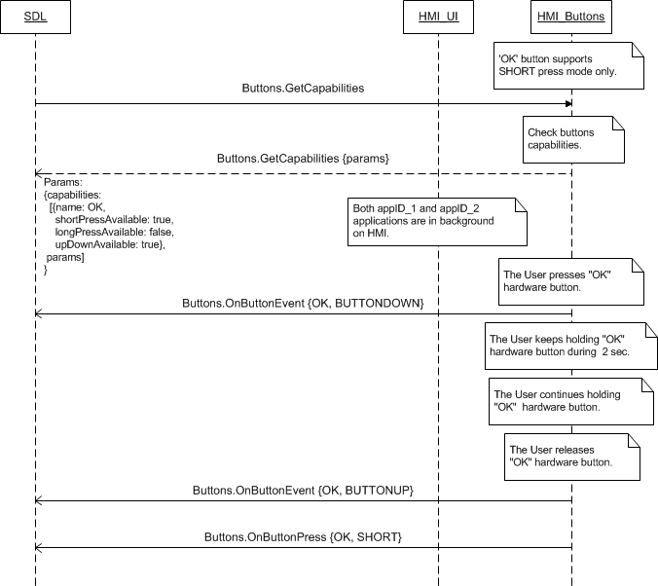

### 8.3.3 JSON Messages Examples

|  |
| --- |
| {  "jsonrpc" : "2.0",  "method" : "Buttons.OnButtonPress",  "params" :  {  "name" : CUSTOM_BUTTON,  “mode” : SHORT,  “customButtonID” : 564  }  } |

### 8.3.4 D-Bus Messages Examples

|  |
| --- |
|  |

## 8.4 OnButtonSubscription

### 8.4.1 Description

|  |  |
| --- | --- |
| **Type:** | Notification |
| **Sender:** | SDL->HMI |
| **Purpose:** | To notify about button subscription state is changed for the named application |

**Note:** SDL subscribes each app to CUSTOM_BUTTON by default after each app registration.

***HMI must:***

a) HMI is expected to display on the screen layout only the duplicates of the HW buttons that the app is subscribed to.  
b) In case SDL sends OnAppUnregistered to HMI (after the app has unregistered or as a result of disconnect), HMI must clean all the subscriptions related to this app.

#### 8.4.1.1 Parameters

| **Param name** | **Type** | **Mandatory** | **Additional** | **Description** |
| --- | --- | --- | --- | --- |
| name | Common.ButtonName | true | – | The name of the button the press mode is detected for.  See ButtonName. |
| isSubscribed | Boolean | true |  | Defines whether the named button has status of 'subscribed' or 'unsubscribed': If "true" - the named button is subscribed. If "false" - the named button is unsubscribed. |
| appID | Integer | true | - | The ID of application that relates to this button-subscription status change |

#### 8.4.1.2 ButtonName

| **Element name** | **Value** | **Short Description** |
| --- | --- | --- |
| OK | 0 | Represents the button usually labeled "OK". A typical use of this button is for the User to press it to make a selection. |
| SEEKLEFT | 1 | Represents the seek-left button. A typical use of this button is for the user to scroll to the left through menu choices, one menu item per press. |
| SEEKRIGHT | 2 | Represents the seek-right button. A typical use of this button is for the user to scroll to the right through menu choices one menu item per press. |
| TUNEUP | 3 | Represents a turn of the tuner knob in the clockwise direction one tick. |
| TUNEDOWN | 4 | Represents a turn of the tuner knob in the counter-clockwise direction one tick. |
| PRESET_0 | 5 | Represents the preset 0 button. |
| PRESET_1 | 6 | Represents the preset 1 button. |
| PRESET_2 | 7 | Represents the preset 2 button. |
| PRESET_3 | 8 | Represents the preset 3 button. |
| PRESET_4 | 9 | Represents the preset 4 button. |
| PRESET_5 | 10 | Represents the preset 5 button. |
| PRESET_6 | 11 | Represents the preset 6 button. |
| PRESET_7 | 12 | Represents the preset 7 button. |
| PRESET_8 | 13 | Represents the preset 8 button. |
| PRESET_9 | 14 | Represents the preset 9 button. |
| CUSTOM_BUTTON | 15 | Represents any of onscreen buttons requested by SDL. |
| SEARCH | 16 | Represents the ‘Search’ button on the touchscreen keyboard. |

### 8.4.2 Sequence Diagrams

#### 8.4.2.1 OnButtonSubscription

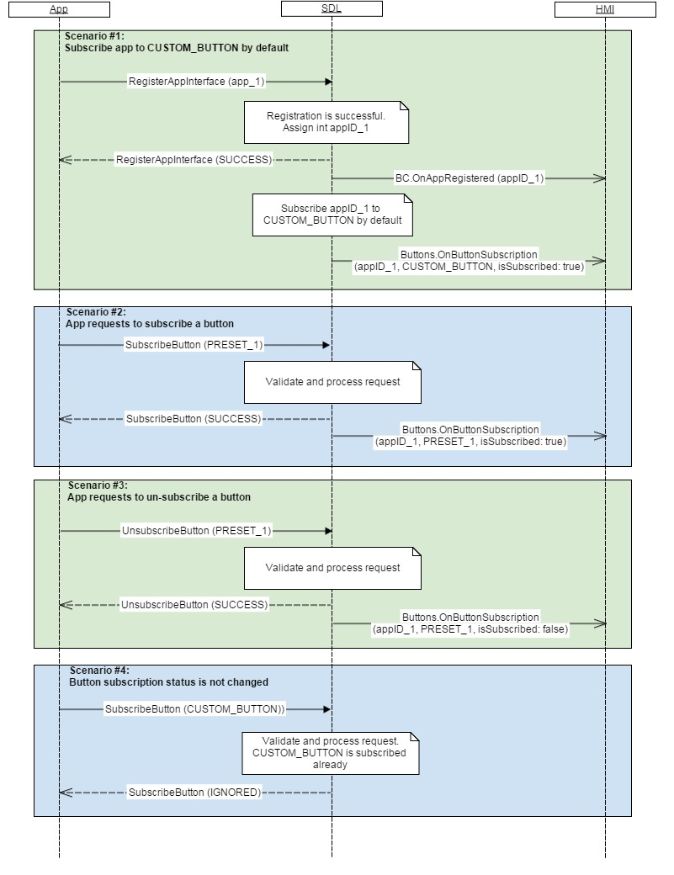

### 8.4.3 JSON Messages Examples

|  |
| --- |
| {  "jsonrpc" : "2.0",  "method" : "Buttons.OnButtonSubscription",  "params" :  {  "name" : SEEKLEFT,  “isSubscribed” : true,  “appID” : 564  }  } |

### 8.4.4 D-Bus Messages Examples

|  |
| --- |
|  |

# 9 VR Component Description

## 9.1 IsReady

### 9.1.1 Description

|  |  |
| --- | --- |
| **Type:** | Function |
| **Sender:** | SDL |
| **Purpose:** | Know if UI module is ready. |

The request comes after HMI`s readiness is confirmed via OnReady notification. SDL requires the information about whether the voice recognition module is physically present on HU and if so whether it is working.

***Note:***

*If VR module is responded to be unavailable or IsReady request is not responded at all, SDL will not further send any requests related to it.*

### 9.1.2 Request

#### 7.1.2.1 Behavior

***HMI must:***

- Check whether VR module is present and ready

- Respond correspondingly to results of this check.

### 9.1.3 Response

***Note:***

*There is a difference in message type for WebSocket and D-Bus connection (see the table below).*

|  |  |  |  |  |  |
| --- | --- | --- | --- | --- | --- |
| **Result** | **Description** | **Message type** | | **Message Params** | **Notes** |
| **WebSocket** | **D-Bus** |
| Success | SUCCESS:  HMI provides the information about VR module availability. | JSON response | Method return | available,  code: 0 |  |
| Failure | INVALID_DATA:  The data sent is invalid (invalid JSON syntax) | JSON error message | Method return | code: 11 | Applicable for this RPC result codes.  Please see Result Enumeration for all SDL-supported codes. |
| DATA_NOT_AVAILABLE:  The information about VR module availability cannot be provided. | Code: 9 |
| GENERIC_ERROR:  The unknown issue occurred or other codes are not applicable. | code: 22 |

#### 9.1.3.1 Parameters

|  |  |  |  |
| --- | --- | --- | --- |
| **Param Name** | **Type** | **Mandatory** | **Description** |
| availabe | Boolean | true | Must be  - ‘true’ if UI is present and ready  - ‘false’ if not. |

### 9.1.4 Sequence Diagrams

#### 9.1.4.1 VR.IsReady

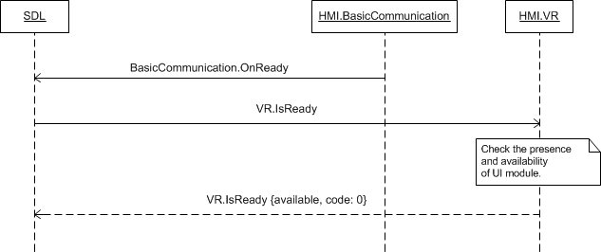

### 9.1.5 JSON Messages Examples

#### 9.1.5.1 Request

|  |
| --- |
| {  "id" : 45,  "jsonrpc" : "2.0",  "method" : "VR.IsReady"  } |

#### 9.1.5.2 Response

|  |
| --- |
| {  "id" : 45,  "jsonrpc" : "2.0",  "result" :  {  "availabe" : true,  "code" : 0,  "method" : "VR.IsReady"  }  } |

#### 9.1.5.3 Error message

|  |
| --- |
| {  "id" : 45,  "jsonrpc" : "2.0",  "error" :  {  "code" : 11,  "message" : "Invalid data",  "data" :  {  "method" : "VR.IsReady"  }  }  } |

### 9.1.6 D-Bus Messages Examples

#### 9.1.6.1 Request

|  |
| --- |
|  |

#### 9.1.6.2 Response

|  |
| --- |
|  |

#### 9.1.6.3 Failure

|  |
| --- |
|  |

## 9.2 GetCapabilities

### 9.2.1 Description

|  |  |
| --- | --- |
| **Type:** | Function |
| **Sender:** | SDL |
| **Purpose:** | Get capabilities of VR. |

SDL can store the HMI capabilities in smartDeviceLink.ini file saved in SDL directory. Nevertheless, on its startup after getting OnReady notification and response to VR.IsReady from HMI, SDL sends this RPC for obtaining the capabilities of VR.

### 9.2.2 Request

#### 9.2.2.1 Behavior

***HMI must:***

1. Check the VR capabilities.

2. Respond correspondingly to results of this check.

***Note:***

*Currently only TEXT is SDL-supported capability of VR.*

### 9.2.3 Response

***Note:***

*There is a difference in message type for WebSocket and D-Bus connection (see the table below).*

|  |  |  |  |  |  |
| --- | --- | --- | --- | --- | --- |
| **Result** | **Description** | **Message type** | | **Message Params** | **Notes** |
| **WebSocket** | **D-Bus** |
| Success | SUCCESS:  HMI provides the VR capabilities. | JSON response | Method return | vrCapabilities,  code: 0 |  |
| Failure | INVALID_DATA:  The data sent is invalid (invalid JSON syntax) | JSON error message | Method return | code: 11 | Applicable for this RPC result codes.  Please see Result Enumeration for all SDL-supported codes. |
| DATA_NOT_AVAILABLE:  The information about VR capabilities cannot be provided. | Code: 9 |
| GENERIC_ERROR:  The unknown issue occurred or other codes are not applicable. | code: 22 |

#### 9.2.3.1 Parameters

| **Param name** | **Type** | **Mandatory** | **Additional** | **Description** |
| --- | --- | --- | --- | --- |
| vrCapabilities | Common.VrCapabilities | false | Array = true  minsize = 1  maxsize = 100 | Types of input recognized by VR module. |

#### 9.2.3.2 VrCapabilities

| **Element name** | **Short Description** |
| --- | --- |
| TEXT | Text is supported |

### 9.2.4 Sequence Diagrams

#### 9.2.4.1 VR.GetCapabilities

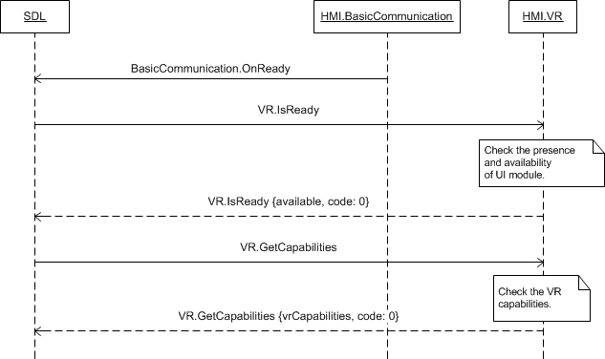

### 9.2.5 JSON Messages Examples

#### 9.2.5.1 Request

|  |
| --- |
| {  "id" : 9,  "jsonrpc" : "2.0",  "method" : "VR.GetCapabilities"  } |

#### 9.2.5.2 Response

|  |
| --- |
| {  "id" : 9,  "jsonrpc" : "2.0",  "result" :  {  "vrCapabilities" : [TEXT],  "code" : 0,  "method" : "VR.GetCapabilities"  }  } |

#### 9.2.5.3 Error message

|  |
| --- |
| {  "id" : 9,  "jsonrpc" : "2.0",  "error" :  {  "code" : 11,  "message" : "The data sent is invalid",  "data" :  {  "method" : "VR.GetCapabilities"  }  }  } |

### 9.2.6 D-Bus Messages Examples

#### 9.2.6.1 Request

|  |
| --- |
|  |

#### 9.2.6.2 Response

|  |
| --- |
|  |

#### 9.2.6.3 Failure

|  |
| --- |
|  |

## 9.3 GetSupportedLanguages

### 9.3.1 Description

|  |  |
| --- | --- |
| **Type:** | Function |
| **Sender:** | SDL |
| **Purpose:** | Get the list of languages supported for VR |

Once VR module is confirmed to be ready (via response to IsReady RPC) SDL starts discovering its capabilities via GetCapabilities and GetSupportedLanguages RPCs.

Response to VR.GetSupportedLanguages is assumed to bring the information about what languages are supported for voice recognition by VR module. Having obtained this information SDL will monitor the language parameter within RPCs from mobile application(s) and reject the requests containing language not supported by HMI.

***Note:***

*The list of languages recognized by SDL is provided in the section 9.3.3.2 Language Enumeration.*

### 9.3.2 Request

#### 7.1.2.1 Behavior

***HMI must:***

- Check the VR supported languages

- Respond correspondingly to results of this check.

### 9.3.3 Response

***Note:***

*There is a difference in message type for WebSocket and D-Bus connection (see the table below).*

|  |  |  |  |  |  |
| --- | --- | --- | --- | --- | --- |
| **Result** | **Description** | **Message type** | | **Message Params** | **Notes** |
| **WebSocket** | **D-Bus** |
| Success | SUCCESS:  HMI provides the VR supported languages. | JSON response | Method return | language,  code: 0 |  |
| Failure | INVALID_DATA:  The data sent is invalid (invalid JSON syntax) | JSON error message | Method return | code: 11 | Applicable for this RPC result codes.  Please see Result Enumeration for all SDL-supported codes. |
| DATA_NOT_AVAILABLE:  The information about VR supported languages cannot be provided. | Code: 9 |
| GENERIC_ERROR:  The unknown issue occurred or other codes are not applicable. | code: 22 |

#### 9.3.3.1 Parameters

| **Param name** | **Type** | **Mandatory** | **Additional** | **Description** |
| --- | --- | --- | --- | --- |
| languages | Common.Language | true | Array = true  minsize = 1  maxsize = 100 | List of languages supported in VR.  See Language. |

#### 9.3.3.2 Language Enumeration

| **Element name** | **Short Description** |
| --- | --- |
| AR-SA | Arabic – Saudi Arabia |
| CS-CZ | Czech – Czech Republic |
| DA-DK | Danish – Denmark |
| DE-DE | German – Germany |
| EN-AU | English – Australia |
| EN-GB | English – GB |
| EN-US | English – US |
| ES-ES | Spanish – Spain |
| ES-MX | Spanish – Mexico |
| FR-CA | French – Canada |
| FR-FR | French – France |
| IT-IT | Italian – Italy |
| JA-JP | Japanese – Japan |
| KO-KR | Korean – South Korea |
| NL-NL | Dutch (Standard) – Netherlands |
| NO-NO | Norwegian - Norway |
| PL-PL | Polish – Poland |
| PT-PT | Portuguese – Portugal |
| PT-BR | Portuguese – Brazil |
| RU-RU | Russian - Russia |
| SV-SE | Swedish – Sweden |
| TR-TR | Turkish – Turkey |
| ZH-CN | Mandarin – China |
| ZH-TW | Mandarin – Taiwan |

### 9.3.4 Sequence Diagrams

#### 9.3.4.1 VR.GetSupportedLanguages

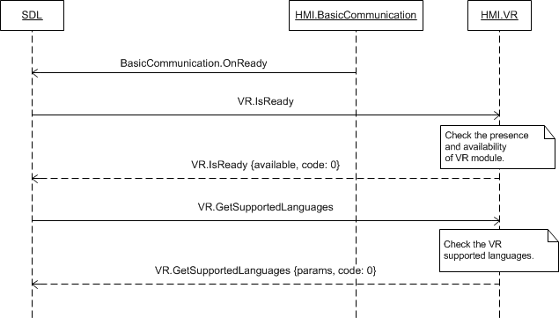

### 9.3.5 JSON Messages Examples

#### 9.3.5.1 Request

|  |
| --- |
| {  "id" : 18,  "jsonrpc" : "2.0",  "method" : "VR.GetSupportedLanguages"  } |

#### 9.3.5.2 Response

|  |
| --- |
| {  "id" : 18,  "jsonrpc" : "2.0",  "result" :  {  "languages" : [AR-SA, DE-DE, EN-GB, EN-US, ES-ES, FR-FR, IT-IT],  "code" : 0,  "method" : "VR.GetSupportedLanguages"  }  } |

#### 9.3.5.3 Error message

|  |
| --- |
| {  "id" : 18,  "jsonrpc" : "2.0",  "error" :  {  "code" : 11,  "message" : "The data sent is invalid",  "data" :  {  "method" : "VR.GetSupportedLanguages"  }  }  } |

### 9.3.6 D-Bus Messages Examples

#### 9.3.6.1 Request

|  |
| --- |
|  |

#### 9.3.6.2 Response

|  |
| --- |
|  |

#### 9.3.6.3 Failure

|  |
| --- |
|  |

## 9.4 AddCommand

### 9.4.1 Description

|  |  |
| --- | --- |
| **Type:** | Function |
| **Sender:** | SDL |
| **Purpose:** | Add a command for voice recognition. |

SDL requests to add a command for voice recognition.

### 9.4.2 Request

#### 9.4.2.1 Behavior

***HMI must:***

1. Store the provided values of cmdID and corresponding vrCommands.

2. Keep these values stored until VR.DeleteCommand or BasicCommunication.OnAppUnregistered RPC comes from SDL.

3. Add the vrCommands to voice recognition system and make them accessible in the following layers:

* If appID parameter is present in request: HMI must use the vrCommands in the layer of the appID application (i.e. when it is active on HMI).
* If appID parameter is not present in request: HMI must use the vrCommands in all layers.

1. Manage grammarID as an identifier for compiled VR grammar for a command/ set of commands (a command and its synonyms or a choiceSet). So in the VR engine's database, there may be multiple cmdID entries under each unique grammarID.

***Important note:***

*HMI must return grammarID and cmdId via VR.OnCommand when the corresponding synonym is recognized.*

*In case the app sends AddCommand with the both UI and VR portionsand adding one of the portions ended with erroneous response or no resonse at all, SDL must send DeleteCommand for a successfully added portion(VR or UI) in the following cases (see diagrams for more detailes* *9.4.4.2-9.4.2.5**) :*

1. *In case SDL sends both UI.AddCommand and VR.AddCommand with one and the same cmdID to HMI AND* ***UI.AddCommand gets successful response*** *from HMI in return AND VR.AddCommand gets any *erroneous response*/no response from HMI - SDL must send* ***UI.DeleteCommand*** *for the successfully added cmdID to HMI.*
2. *In case SDL sends both UI.AddCommand and VR.AddCommand with one and the same cmdID to HMI AND* ***VR.AddCommand gets successful response*** *from HMI in return AND UI.AddCommand gets *erroneous response except of WARNINGS and UNSUPPORTED_RESOURCE*/ no response from HMI - SDL must send* ***VR.DeleteCommand*** *for the successfully added cmdID to HMI*

***VR.AddCommnand in case of CreateInteractionChoiceSet:***

VR.AddCommands for every ChoiceSet is sent by SDL after the app requests CreateInteractionChoiceSet. The subsequent VR.AddCommands are issued for every choice of the ChoiceSet and once a response (positive or negative) is returned by the HMI / Voice Engine, then the app is informed by SDL if the Choice Set is ready (i.e. grammar is built on the platform and can be referenced in an interaction).

#### 9.4.2.2 Parameters

| **Param name** | **Type** | **Mandatory** | **Additional** | **Description** |
| --- | --- | --- | --- | --- |
| cmdId | Integer | true | minvalue = 0 | Unique ID that identifies the command.  Must be returned in the OnCommand notification to identify the command selected by the User. |
| vrCommands | String | true | minsize = 1  maxsize = 100  maxlength = 99  array = true | An array of strings to be used as VR synonyms for this command.  Defines one or more VR phrases the recognition of any of which must trigger the OnCommand notification with the above cmdID. |
| type | Common.VRCommandType | true | - | Type of added command. See VRCommandType. |
| grammarID | Integer | true | minvalue = 0  maxvalue = 2000000000 | ID of the specific grammar, whether top-level or choice set. grammarID is a unique value within each application  For all choices within a choice set grammarID is the same |
| appID | Integer | false | – | ID of the application related to this RPC. |

#### 9.4.2.3 VRCommandType

This type defines whether the command relates to common (top-level) list of the application commands or it’s a part of the ChoiceSet which will be available to the user during PerformInteraction

| **Element name** | **Vlaue** | **Short Description** |
| --- | --- | --- |
| Choice | 0 | The VR command must be used in VR.PerformInteraction that arrived with the corresponding grammarID and must NOT be accessible until then. |
| Command | 1 | The VR command must be accessible for the User upon VR activation while the application of the corresponding appID is active on HMI. |

### 9.4.3 Response

***Note:***

*There is a difference in message type for WebSocket and D-Bus connection (see the table below).*

|  |  |  |  |  |  |
| --- | --- | --- | --- | --- | --- |
| **Result** | **Description** | **Message type** | | **Message Params** | **Notes** |
| **WebSocket** | **D-Bus** |
| Success | SUCCESS:  The command with requested parameters has been added for voice recognition for the named application. | JSON response | Method return | code: 0 |  |
| Failure | INVALID_DATA:  The data sent is invalid (invalid JSON syntax, out of bound values) | JSON error message | Method return | code: 11 | INVALID_ID check is performed on SDL side. In case HMI performs the check on it’s side too, the appropriate code must be return. |
| INVALID_ID  appID, cmdID, grammarID is invalid (e.g. doesn’t exist or already exist) | code:13 |
| GENERIC_ERROR  1) The unknown issue occurred or other codes are not applicable.  2) In case HMI does not respond SDL's request during SDL default timeout (10 sec), SDL will return the result code to the corresponding mobile app's request. | code: 22 |

### 9.4.4 Sequence Diagrams

#### 9.4.4.1 VR.AddCommand

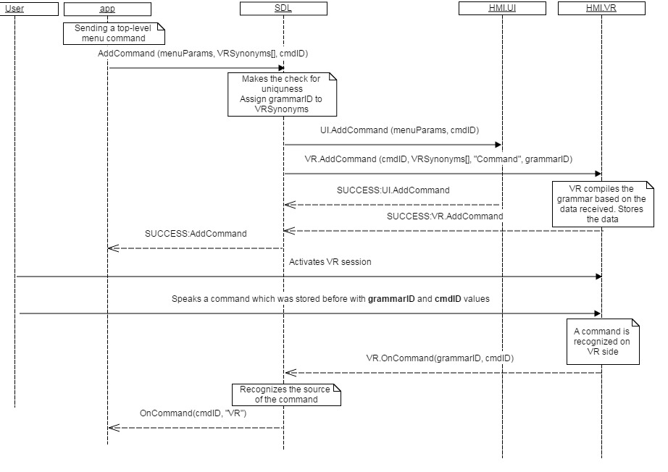

#### 9.4.4.2 UI.AddCommand returnes SUCCESS, VR portion failed



#### 9.4.4.3 UI.AddCommand returnes SUCCESS, VR portion no response



#### 9.4.4.4 UI.AddCommand fails, VR portion SUCCESS



#### 9.4.4.5 UI.AddCommand no response, VR portion SUCCESS



### 9.4.5 JSON Messages Examples

#### 9.4.5.1 Request

|  |
| --- |
| {  "id" : 119,  "jsonrpc" : "2.0",  "method" : "VR. AddCommand",  “params” :  {  “cmdID” : 4365,  “vrCommands” :  [  “Leave”,  “Exit”,  “Quit”  ],  “grammarID”:123,  “appID” : 64467  }  } |
|  |

#### 9.4.5.2 Response

|  |
| --- |
| {  "id" : 119,  "jsonrpc" : "2.0",  "result" :  {  "code" : 0,  "method" : “VR.AddCommand"  }  } |

#### 9.4.5.3 Error message

|  |
| --- |
| {  "id" : 119,  "jsonrpc" : "2.0",  "error" :  {  "code" : 13,  "message" : "Provided appID is not valid",  "data" :  {  "method" : "VR.AddCommand"  }  }  } |

### 9.4.6 D-Bus Messages Examples

#### 9.4.6.1 Request

|  |
| --- |
|  |

#### 9.4.6.2 Response

|  |
| --- |
|  |

#### 9.4.6.3 Failure

|  |
| --- |
|  |

## 9.5 DeleteCommand

### 9.5.1 Description

|  |  |
| --- | --- |
| **Type:** | Function |
| **Sender:** | SDL |
| **Purpose:** | Delete a command from VR. |

SDL requests to delete the command from in-application menu or sub menu of the named application previously added via UI.AddCommand.

The request may arrive in both cases of activated and deactivated application on HMI.

### 9.5.2 Request

#### 9.5.2.1 Behavior

***HMI must:***

1. Update the named application stored data correspondingly to the RPC arrived.

2. Delete the command identified with cmdID and grammarID.

3. Display updates:

* Right away if the named application is active and the corresponding menu/sub menu is open on UI.
* After the corresponding menu/sub menu is opened on UI upon User`s request:
* If the RPC arrived when the named application was active and had another menu or persistent display visible on UI
* If the RPC arrived when the named application was not active on HMI.

5. Provide the response corresponding to the result of RPC execution.

***Note:***

*The applicable to this RPC result codes are provided in section 7.9.3 Response.*

***Note:***

*- The value of cmdID is previously sent via UI.AddCommand.*

*- The value of appID is previously sent via UpdateAppList or OnAppRegistered.*

#### 9.5.2.2 Parameters

| **Param Name** | **Type** | **Mandatory** | **Additional** | **Description** |
| --- | --- | --- | --- | --- |
| cmdId | Integer | true | - | ID that identifies the command to be deleted (sent by AddCommand). |
| type | Common.VRCommandType | true | - | Type of added command. See VRCommandType. |
| grammarID | Integer | true | minvalue = 0  maxvalue = 2000000000 | ID of the specific grammar, whether top-level or choice set. |
| appID | Integer | true | - | ID of application that concerns this RPC. |

### 9.5.3 Response

***Note:***

*There is a difference in message type for WebSocket and D-Bus connection (see the table below).*

|  |  |  |  |  |  |
| --- | --- | --- | --- | --- | --- |
| **Result** | **Description** | **Message type** | | **Message Params** | **Notes** |
| **WebSocket** | **D-Bus** |
| Success | SUCCESS:  The named command has been deleted from VR for the named application. | JSON response | Method return | code: 0 |  |
| Failure | INVALID_DATA:  The data sent is invalid (invalid JSON syntax, out of bounds parameters) | JSON error message | Method return | code: 11 | Applicable for this RPC result codes.  Please see Result Enumeration for all SDL-supported codes. |
| INVALID_ID  cmdId, grammarID or appID is not valid (e.g. doesn’t exist) | code:13 |
| GENERIC_ERROR  1) The unknown issue occurred or other codes are not applicable.  2) In case HMI does not respond SDL's request during SDL default timeout (10 sec), SDL will return the result code to the corresponding mobile app's request. | code: 22 |

### 9.5.4 Sequence Diagrams

#### 9.1.4.1 VR.DeleteCommand @TODO update with grammarID

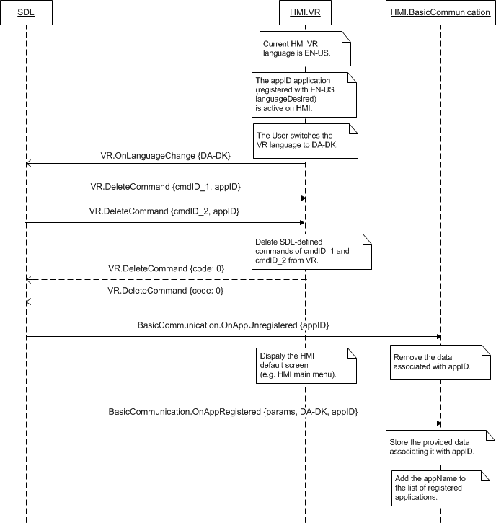

### 9.5.5 JSON Messages Examples

#### 9.5.5.1 Request

|  |
| --- |
| {  "id" : 147,  "jsonrpc" : "2.0",  "method" : "VR. DeleteCommand",  “params” :  {  “cmdID” : 4365,  “type”:”Command”,  “grammarID”:13,  “appID” : 8764  }  } |

#### 9.5.5.2 Response

|  |
| --- |
| {  "id" : 147,  "jsonrpc" : "2.0",  "result" :  {  "code" : 0,  "method" : "VR. DeleteCommand"  }  } |

#### 9.5.5.3 Error message

|  |
| --- |
| {  "id" : 147,  "jsonrpc" : "2.0",  "error" :  {  "code" : 13,  "message" : "One of the provided IDs is not valid",  "data" :  {  "method" : "VR. DeleteCommand"  }  }  } |

### 9.5.6 D-Bus Messages Examples

#### 9.5.6.1 Request

|  |
| --- |
|  |

#### 9.5.6.2 Response

|  |
| --- |
|  |

#### 9.5.6.3 Failure

|  |
| --- |
|  |

## 9.6 ChangeRegistration

### 9.6.1 Description

|  |  |
| --- | --- |
| **Type:** | Function |
| **Sender:** | SDL |
| **Purpose:** | Change the application language for voice recognition on HMI. |

SDL requests to set a display language for the named application on HMI.

The request may arrive for the application whatever being active or in background on HMI.

***Note:***

*SDL will send the language value expected to be supported by HMI via VR.GetCapabilities or properties file.*

### 9.6.2 Request

#### 9.6.2.1 Behavior

***HMI must:***

1. Store the provided information associating it with application`s appID.

2. Respond to the request.

#### 9.6.2.2 Parameters

| **Param Name** | **Type** | **Mandatory** | **Additional** | **Description** |
| --- | --- | --- | --- | --- |
| language | Common.Language | true |  | The language requested to be switched to.  See Language. |
| vrSynonyms | String | false | array=true  maxlength=40  minsize=1  maxsize=100 | Request new VR synonyms registration  Defines an additional voice recognition command.  Must not interfere with any name of previously registered applications(SDL makes check). |
| appID | Integer | true |  | ID of the application that relates to this RPC. |

#### 9.6.2.2 Language

| **Element Name** | **Value** | **Description** |
| --- | --- | --- |
| EN-US | 0 | English – US |
| ES-MX | 1 | Spanish – Mexico |
| FR-CA | 2 | French – Canada |
| DE-DE | 3 | German – Germany |
| ES-ES | 4 | Spanish – Spain |
| EN-GB | 5 | English – GB |
| RU-RU | 6 | Russian - Russia |
| TR-TR | 7 | Turkish – Turkey |
| PL-PL | 8 | Polish – Poland |
| FR-FR | 9 | French – France |
| IT-IT | 10 | Italian – Italy |
| SV-SE | 11 | Swedish – Sweden |
| PT-PT | 12 | Portuguese – Portugal |
| NL-NL | 13 | Dutch (Standard) – Netherlands |
| EN-AU | 14 | English – Australia |
| ZH-CN | 15 | Mandarin – China |
| ZH-TW | 16 | Mandarin – Taiwan |
| JA-JP | 17 | Japanese – Japan |
| AR-SA | 18 | Arabic – Saudi Arabia |
| KO-KR | 19 | Korean – South Korea |
| PT-BR | 20 | Portuguese - Brazil |
| CS-CZ | 21 | Czech – Czech Republic |
| DA-DK | 22 | Danish – Denmark |
| NO-NO | 23 | Norwegian - Norway |

### 9.6.3 Response

***Note:***

*There is a difference in message type for WebSocket and D-Bus connection (see the table below).*

|  |  |  |  |  |  |
| --- | --- | --- | --- | --- | --- |
| **Result** | **Description** | **Message type** | | **Message Params** | **Notes** |
| **WebSocket** | **D-Bus** |
| Success | SUCCESS:  The requested language has been set for voice recognition for the named application. | JSON response | Method return | code: 0 |  |
| Failure | INVALID_DATA:  The data sent is invalid (invalid JSON syntax, parameters are out of bounds or of wrong type) | JSON error message | Method return | code: 11 | Applicable for this RPC result codes.  Please see Result Enumeration for all SDL-supported codes. |
| WRONG_LANGUAGE  Language is not supported by VR | code: 16 |
| INVALID_ID  appID is invalid (e.g. doesn’t exist) | code: 13 |
| GENERIC_ERROR  1) The unknown issue occurred or other codes are not applicable.  2) In case HMI does not respond SDL's request during SDL default timeout (10 sec), SDL will return the result code to the corresponding mobile app's request. | code: 22 |

### 9.6.4 Sequence Diagrams

#### 9.6.4.1 VR.ChangeRegistration

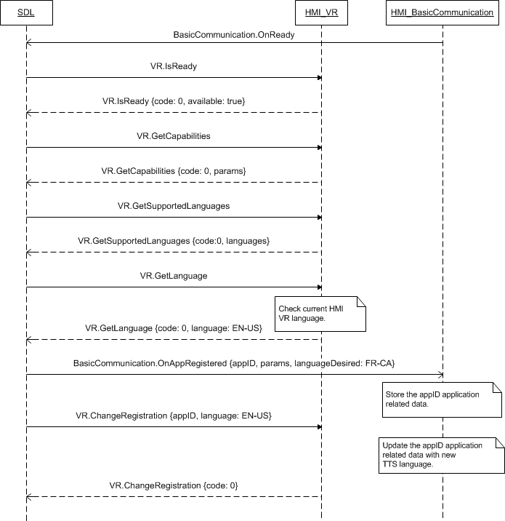

### 9.6.5 JSON Messages Examples

#### 9.6.5.1 Request

|  |
| --- |
| {  "id" : 206,  "jsonrpc" : "2.0",  "method" : "VR.ChangeRegistration",  “params” :  {  “language” : DE-DE,  “appID” : 13264  }  } |

#### 9.6.5.2 Response

|  |
| --- |
| {  "id" : 206,  "jsonrpc" : "2.0",  "result" :  {  "code" : 0,  "method" : "VR.ChangeRegistration"  }  } |

#### 9.6.5.3 Error message

|  |
| --- |
| {  "id" : 206,  "jsonrpc" : "2.0",  "error" :  {  "code" : 22,  "message" : "The unknown error occurred",  "data" :  {  "method" : "VR.ChangeRegistration"  }  }  } |

### 9.6.6 D-Bus Messages Examples

#### 9.6.6.1 Request

|  |
| --- |
|  |

#### 9.6.6.2 Response

|  |
| --- |
|  |

#### 9.6.6.3 Failure

|  |
| --- |
|  |

## 9.7 GetLanguage

### 9.7.1 Description

|  |  |
| --- | --- |
| **Type:** | Function |
| **Sender:** | SDL |
| **Purpose:** | Get the current language of VR |

SDL inquires the current HMI VR language.

This RPC is sent by SDL after VR readiness is confirmed by VR.IsReady. If later the User changes the HMI language of VR, HMI must inform SDL about this event via VR.OnLanguageChange notification.

### 9.7.2 Request

#### 9.7.2.1 Behavior

***HMI must:***

1. Check the HMI VR language currently in effect.

2. Respond providing SDL with the results of this check.

### 9.7.3 Response

***Note:***

*There is a difference in message type for WebSocket and D-Bus connection (see the table below).*

|  |  |  |  |  |  |
| --- | --- | --- | --- | --- | --- |
| **Result** | **Description** | **Message type** | | **Message Params** | **Notes** |
| **WebSocket** | **D-Bus** |
| Success | SUCCESS:  HMI provides the language currently active for VR. | JSON response | Method return | language,  code: 0 |  |
| Failure | INVALID_DATA:  The data sent is invalid (invalid JSON syntax, parameters are out of bounds or of wrong type) | JSON error message | Method return | code: 11 | Applicable for this RPC result codes.  Please see Result Enumeration for all SDL-supported codes. |
| GENERIC_ERROR:  The unknown issue occurred or other codes are not applicable. | code: 22 |

#### 9.7.3.1 Parameters

|  |  |  |  |
| --- | --- | --- | --- |
| **Param Name** | **Type** | **Mandatory** | **Description** |
| language | Common.Language | true | The language requested to be switched to.  See Language. |

#### 9.7.3.2 Language

| **Element Name** | **Value** | **Description** |
| --- | --- | --- |
| EN-US | 0 | English – US |
| ES-MX | 1 | Spanish – Mexico |
| FR-CA | 2 | French – Canada |
| DE-DE | 3 | German – Germany |
| ES-ES | 4 | Spanish – Spain |
| EN-GB | 5 | English – GB |
| RU-RU | 6 | Russian - Russia |
| TR-TR | 7 | Turkish – Turkey |
| PL-PL | 8 | Polish – Poland |
| FR-FR | 9 | French – France |
| IT-IT | 10 | Italian – Italy |
| SV-SE | 11 | Swedish – Sweden |
| PT-PT | 12 | Portuguese – Portugal |
| NL-NL | 13 | Dutch (Standard) – Netherlands |
| EN-AU | 14 | English – Australia |
| ZH-CN | 15 | Mandarin – China |
| ZH-TW | 16 | Mandarin – Taiwan |
| JA-JP | 17 | Japanese – Japan |
| AR-SA | 18 | Arabic – Saudi Arabia |
| KO-KR | 19 | Korean – South Korea |
| PT-BR | 20 | Portuguese - Brazil |
| CS-CZ | 21 | Czech – Czech Republic |
| DA-DK | 22 | Danish – Denmark |
| NO-NO | 23 | Norwegian - Norway |

### 9.7.4 Sequence Diagrams

#### 9.7.4.1 VR.GetLanguage

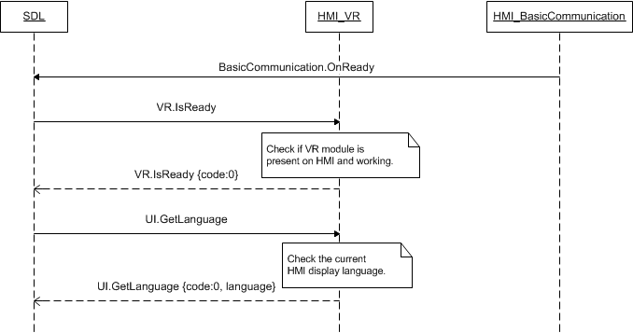

### 9.7.5 JSON Messages Examples

#### 9.7.5.1 Request

|  |
| --- |
| {  "id" : 110,  "jsonrpc" : "2.0",  "method" : "VR.GetLanguage",  } |

#### 9.7.5.2 Response

|  |
| --- |
| {  "id" : 110,  "jsonrpc" : "2.0",  "result" :  {  "language" : DE-DE,  "code" : 0,  "method" : "VR.GetLanguage"  }  } |

#### 9.7.5.3 Error message

|  |
| --- |
| {  "id" : 110,  "jsonrpc" : "2.0",  "error" :  {  "code" : 22,  "message" : "During the API call the unknown error has occured",  "data" :  {  "method" : "VR.GetLanguage"  }  }  } |

### 9.7.6 D-Bus Messages Examples

#### 9.7.6.1 Request

|  |
| --- |
|  |

#### 9.7.6.2 Response

|  |
| --- |
|  |

#### 9.7.6.3 Failure

|  |
| --- |
|  |

## 9.8 Started

### 9.8.1 Description

|  |  |
| --- | --- |
| **Type:** | Notification |
| **Sender:** | HMI |
| **Purpose:** | Inform about start of VR session |

Once VR is activated, HMI should attenuate the audio or make it not audible (depending on its capabilities). SDL needs to be notified about the event in order to provide a mobile application with the accurate information about audio streaming state on HMI.

***Note:*** SDL ignores all invalid notifications which come from HMI (invalid JSON, invalid data types/bounds etc)

***HMI must:***

Send VR.Started notification when VR system is activated by:

* PTT button press
* UI.PerformInteraction RPC from SDL

### 9.8.2 Sequence Diagrams

#### 9.8.2.1 VR.Started on PTT button press

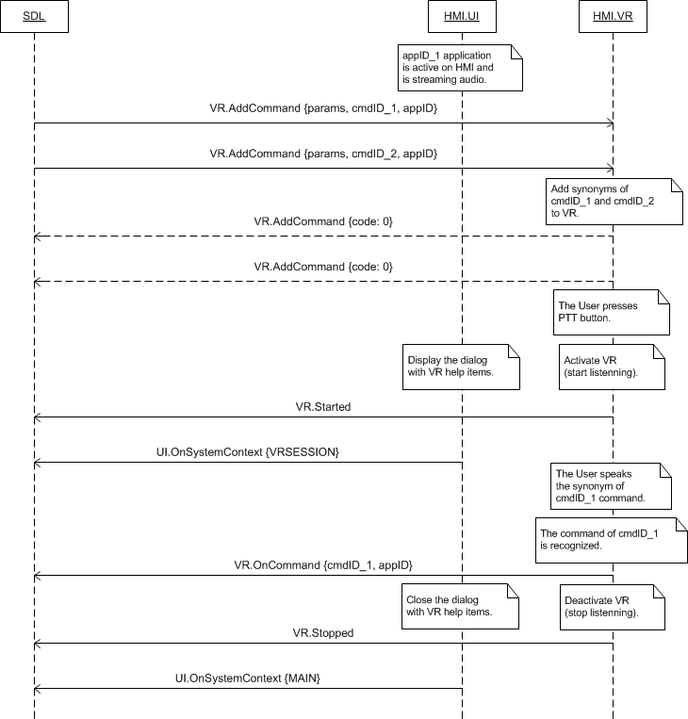

### 9.8.3 JSON Messages Examples

|  |
| --- |
| {  "jsonrpc" : "2.0",  "method" : "VR.Started",  } |

### 9.8.4 D-Bus Messages Examples

|  |
| --- |
| signal  sender=:1.209  -> dest=(null destination)  serial=94  path=/;  interface=com.ford.sdl.hmi.VR;  member=Started |

## 9.9 Stopped

### 9.9.1 Description

|  |  |
| --- | --- |
| **Type:** | Notification |
| **Sender:** | HMI |
| **Purpose:** | Inform about stop of VR session |

After VR interaction with the User has completed, HMI should return the audio to be audible for the User. SDL requires to be notified about the event so that to inform the mobile application about the actual audio streaming state on HMI.

***Note:*** SDL ignores all invalid notifications which come from HMI (invalid JSON, invalid data types/bounds etc)

***HMI must:***

Send VR.Stopped notification when voice recognition is ended by:

* Successfully recognized command
* User cancelling the interaction
* Event of a higher priority

### 9.9.2 Sequence Diagrams

#### 9.8.2.1 VR.Stopped on VR session ending



### 9.9.3 JSON Messages Examples

|  |
| --- |
| {  "jsonrpc" : "2.0",  "method" : "VR.Stopped",  } |

### 9.9.4 D-Bus Messages Examples

|  |
| --- |
| signal  sender=:1.209  -> dest=(null destination)  serial=98  path=/;  interface=com.ford.sdl.hmi.VR;  member=Stopped |

## 9.10 OnCommand

### 9.10.1 Description

|  |  |
| --- | --- |
| **Type:** | Notification |
| **Sender:** | HMI |
| **Purpose:** | Inform the command is recognized by VR |

OnCommand is used for informing about the user's choice of the application added command.

***Note:*** SDL ignores all invalid notifications which come from HMI (invalid JSON, invalid data types/bounds etc)

**HMI must:**

- send a notification to SDL with all mandatory data as a result of recognition a VR command the user spoke

***Note:*** *grammarID is a unique identifier for compiled VR grammar for a command or a set of commands (e.g. a command and its synonyms). So in the VR engine's database, there may be multiple cmdID entries under each unique grammarID. grammarID is assigned on SDL’s side at the time of sending* *VR.AddCommand* *request to HMI.*

#### 9.10.1.1 Parameters

|  |  |  |  |  |
| --- | --- | --- | --- | --- |
| **Param Name** | **Type** | **Mandatory** | **Additional** | **Description** |
| cmdID | Integer | true |  | The ID of the command selected by the User. |
| grammarID | Integer | true | minvalue=0 maxvalue=2000000000 | ID of the specific grammar that the command relates to. Previously provided by SDL via corresponding VR.AddCommand request. |
| appID | Integer | false |  | ID of the application that relates to this RPC. |

### 9.10.2 Sequence Diagrams

#### 9.10.2.1 VR.OnCommand



### 9.10.3 JSON Messages Examples

|  |
| --- |
| {  "jsonrpc" : "2.0",  "method" : "VR.OnCommand",  "params" :  {  "cmdID" : 4365,  "grammarID" : 11,  "appID" : 12564  }  } |

### 9.10.4 D-Bus Messages Examples

|  |
| --- |
|  |

## 9.11 OnLanguageChange

### 9.11.1 Description

|  |  |
| --- | --- |
| **Type:** | Notification |
| **Sender:** | HMI |
| **Purpose:** | Inform about language of VR is changed. |

SDL needs to be in the know when the User changes the language of voice recognition: Upon the receipt of OnLanguageChange notification SDL will unregister the applications of different language to provide them with possibility to re-register with the correct (new HMI) VR language.

***HMI must:***

Send the VR.OnLanguageChange notification when the User switches VR to another language and provide this new value via language parameter.

***Note:*** SDL ignores all invalid notifications which come from HMI (invalid JSON, invalid data types/bounds etc)

#### 9.11.1.1 Parameters

|  |  |  |  |
| --- | --- | --- | --- |
| **Param Name** | **Type** | **Mandatory** | **Description** |
| language | Common.Language | true | Language VR has been switched to.  See Language |

#### 9.11.1.2 Language

| **Element Name** | **Value** | **Description** |
| --- | --- | --- |
| EN-US | 0 | English – US |
| ES-MX | 1 | Spanish – Mexico |
| FR-CA | 2 | French – Canada |
| DE-DE | 3 | German – Germany |
| ES-ES | 4 | Spanish – Spain |
| EN-GB | 5 | English – GB |
| RU-RU | 6 | Russian - Russia |
| TR-TR | 7 | Turkish – Turkey |
| PL-PL | 8 | Polish – Poland |
| FR-FR | 9 | French – France |
| IT-IT | 10 | Italian – Italy |
| SV-SE | 11 | Swedish – Sweden |
| PT-PT | 12 | Portuguese – Portugal |
| NL-NL | 13 | Dutch (Standard) – Netherlands |
| EN-AU | 14 | English – Australia |
| ZH-CN | 15 | Mandarin – China |
| ZH-TW | 16 | Mandarin – Taiwan |
| JA-JP | 17 | Japanese – Japan |
| AR-SA | 18 | Arabic – Saudi Arabia |
| KO-KR | 19 | Korean – South Korea |
| PT-BR | 20 | Portuguese - Brazil |
| CS-CZ | 21 | Czech – Czech Republic |
| DA-DK | 22 | Danish – Denmark |
| NO-NO | 23 | Norwegian - Norway |

### 9.11.2 Sequence Diagrams

#### 9.11.2.1 VR.OnLanguageChange



### 9.11.3 JSON Messages Examples

|  |
| --- |
| {  "jsonrpc" : "2.0",  "method" : "VR.OnLanguageChange",  "params" :  {  "language" : IT-IT  }  } |

### 9.11.4 D-Bus Messages Examples

|  |
| --- |
| signal  sender=:1.226  -> dest=(null destination)  serial=250  path=/;  interface=com.ford.sdl.hmi.VR;  member=OnLanguageChange  int32 22 |

## 9.12 VR.PerformInteraction

### 9.12.1 Description

|  |  |
| --- | --- |
| **Type:** | Function |
| **Sender:** | SDL |
| **Purpose:** | Perform a VR interaction with the User. |

SDL uses PerformInteraction for requesting an interaction with the User, for example:

- To confirm a command

- To make a choice between several suggested ones.

The request concerns the application currently active on HMI.

***Notes about PerformInteraction***

1. *SDL may intend to perform one of three modes of interaction:*
   1. *‘Manual only’ – when the User is expected to make a choice manually only (display, buttons, soft buttons are involved).*
   2. *‘VR only’ – when the User is expected to make a choice by voice only (voice recognition module is involved).*
   3. *‘Both’ – when the User is expected to make a choice whichever by voice or manually (display, buttons, soft buttons, VR module are involved).*
2. *SDL sends both VR.PerformInteraction and UI.PerformInteraction for each of above types of interaction. HMI`s expected behavior differs depending on interaction mode (see section 7.12.2.1 Behavior).*
3. *SDL provides HMI with the set(s) of choices to be presented to the User. See the below Notes of CreateInteractionChoiceSet.*

***Notes about CreateInteractionChoiceSet:***

1. *Mobile application in advance creates a set (or several sets) of choices on SDL to be further used in PerformIntercation.*
2. *SDL in advance provides HMI with VR synonyms of created choices via VR.AddCommand (see section 9.4 for details). They are then referenced in VR.PerformaInteraction (see section 9.12).*
3. *SDL sends UI choices (those to be displayed) within UI.PerformIntercation directly.*

### 9.12.2 Request

#### 9.12.2.1 Behavior

***HMI must:***

1. Distinguish the interaction mode by the following charachteristics:

| **Mode** | **SDL sends both RPCs with the following parameters:** | **Note** |
| --- | --- | --- |
| VR_ONLY | VR.PerformInteraction {**grammarID**, params} | grammarID is present |
| UI.PerformInteraction {params} | No choiceSet |
| MANUAL_ONLY | VR.PerformInteraction {params} | No grammarID |
| UI.PerformInteraction {**choiceSet**, params} | choiceSet is present |
| BOTH | VR.PerformInteraction {**grammarID**, params} | grammarID is present |
| UI.PerformInteraction {**choiceSet**, params} | choiceSet is present |

**I. ‘VR only’ interaction mode:**

***HMI must:***

1. Store the provided text values of initial, help and timeout prompts (see below for how to use) as well as the value of timeout.
2. Start VR session using VR commands of the corresponding grammarID with HMI-defined timeout.
3. Speak the initialPrompt right after request is received (sending notifications of TTS.Started and TTS.Stopped before and after speaking the prompt correspondingly).
4. Start counting down the value provided within timeout parameter.
5. Speak the timeoutPrompt (sending notifications of TTS.Started and TTS.Stopped before and after speaking the prompt correspondingly) when timeout value runs out.
6. Respond the request with one of applicable result codes upon:

* HMI-defined-VR-session timeout (ABORTED result)
* User`s choice (SUCCESS result) providing the choiceID (that is equal to the cmdID of corresponding VR.AddCommand)

1. Forget the prompts data after the interaction completes.

**II. ‘Manual only’ interaction mode:**

1. Store the provided text values of initial, help and timeout prompts (see below for how to use) as well as the value of timeout.
2. Respond the request with SUCCESS result codes (for all of applicable result codes please see section 10.9.3 Response).
3. Speak the initialPrompt right after request is received (sending notifications of TTS.Started and TTS.Stopped before and after speaking the prompt correspondingly).
4. Start counting down the value provided within timeout parameter.
5. Speak the timeoutPrompt (sending notifications of TTS.Started and TTS.Stopped before and after speaking the prompt correspondingly) when timeout value runs out.
6. Forget the prompts data upon the corresponding UI.PerformIntercation is completed by user`s UI choice or aborted by the user or some event.

**III. ‘Both’ interaction mode:**

1. Store the provided text values of initial, help and timeout prompts (see below for how to use) as well as the value of timeout.
2. Start VR session using VR commands of the corresponding grammarID with HMI-defined timeout.
3. Speak the initialPrompt right after request is received (sending notifications of TTS.Started and TTS.Stopped before and after speaking the prompt correspondingly).
4. Start counting down the value provided within timeout parameter.
5. Speak the timeoutPrompt (sending notifications of TTS.Started and TTS.Stopped before and after speaking the prompt correspondingly) when timeout value runs out.
6. Respond the request with one of applicable result codes upon:

* HMI-defined-VR-session timeout (ABORTED result) AND proceed with **step 7.**
* User`s choice (SUCCESS result) providing the choiceID (that is equal to the cmdID of corresponding VR.AddCommand)

1. Repeat step 4. -5. for corresponding UI.PerformInteraction and forget the promts values when UI.PerformInteraction completes.

#### 9.12.2.2 Parameters

| **Param name** | **Type** | **Mandatory** | **Additional** | **Description** |
| --- | --- | --- | --- | --- |
| helpPrompt | Common.TTSChunk | false | Array = true  minsize = 1  maxsize = 100 | This is the array of strings to be spoken when the HMI-defined ‘Help’ VR command is recognized during PerformInteraction (see TTSChunk). |
| initialPrompt | Common.TTSChunk | true | Array = true  minsize = 1  maxsize = 100 | The initial prompt that must be spoken to the User right after request comes to HMI (see TTSChunk). |
| timeoutPrompt | Common.TTSChunk | false | Array = true  minsize = 1  maxsize = 100 | Must be spoken upon timeout defined within request (see TTSChunk). |
| timeout | Integer | true | ­- | Timeout. When ran out timeoutPrompt must be spoken. |
| grammarID | Integer | false | Array = true  minsize = 1  maxsize = 100  minvalue = 0  maxvalue = 2000000000 | ID of VR choice set: contails a set of commands previously added via VR.AddCommand that have one and the same grammrID. |

### 9.12.3 Response

***Note:***

*There is a difference in message type for WebSocket and D-Bus connection (see the table below).*

|  |  |  |  |  |  |
| --- | --- | --- | --- | --- | --- |
| **Result** | **Description** | **Message type** | | **Message Params** | **Notes** |
| **WebSocket** | **D-Bus** |
| Success | SUCCESS  The cases described in 7.12.2:  ‘I.2’, ‘II.3’, ‘III.3’, ‘III.4.3’. | JSON response | Regular response | choiceID,  code: 0 | See section 9.12.4 Parameters. |
| Failure | ABORTED  The interaction is aborted by the User or system event of higher priority. | JSON error message | Regular response | code: 5 | Applicable for this RPC result codes.  Please see Result Enumeration for all SDL-supported codes. |
| TIMED_OUT  The User has not made a choice during HMI-defined timeout. | code: 10 |
| INVALID_ID  Wrong appID or grammarID received | code: 13 |
| GENERIC_ERROR  1) The unknown issue occurred or other codes are not applicable.  @TODO to clarify  2) In case HMI does not respond SDL's request after the 2nd timeout ended, SDL will return the result code to the corresponding mobile app's request. | code: 22 |

#### 9.12.4 Parameters

| **Param Name** | **Type** | **Mandatory** | **Additional** | **Description** |
| --- | --- | --- | --- | --- |
| choiceID | Integer | false | Minvalue = 0  Maxvalue =  2000000000 | ID that represents the choice made by the User (one among those provided within the request). |

### 9.12.4 Sequence Diagrams

#### 9.12.4.1 VR.PerfromInteraction in ‘VR only’ mode successfully completed



#### 9.12.4.2 VR.PerfromInteraction in ‘Manual only’ mode successfully completed



#### 9.12.4.3 VR.PerfromInteraction in ‘Both’ mode timed out



### 9.12.5 JSON Messages Examples

#### 9.12.5.1 Request

|  |
| --- |
| {  "id" : 79,  "jsonrpc" : "2.0",  "method" : "VR.PerformInteraction",  “params” :  {  “initialPrompt” :  [  “text” : “Please make your choice by voice”,  ],  “helpPrompt” :  [  “text” : “Yes”,  “text” : “No”,  “text” : “Skip”  ],  “timeoutPrompt” :  [  “text” : “The time is about to run out”  ],  “timeout” : 10000,  “grammarID” : 245  }  } |

#### 9.12.5.2 Response

|  |
| --- |
| {  "id" : 79,  "jsonrpc" : "2.0",  "result" :  {  “choiceID” : 2416  "code" : 0,  "method" : "VR.PerformInteraction"  }  } |

#### 7.12.5.3 Error message

|  |
| --- |
| {  "id" : 79,  "jsonrpc" : "2.0",  "error" :  {  "code" : 10,  "message" : "Interaction reached the maximum timeout and closed",  "data" :  {  "method" : "VR.PerformInteraction"  }  }  } |

### 7.12.6 D-Bus Messages Examples

#### 7.12.6.1 Request

|  |
| --- |
|  |

#### 7.12.6.2 Response

|  |
| --- |
|  |

#### 7.12.6.3 Failure

|  |
| --- |
|  |

# 10 TTS Component Description

## 10.1 IsReady

### 10.1.1 Description

|  |  |
| --- | --- |
| **Type:** | Function |
| **Sender:** | SDL |
| **Purpose:** | Know if TTS module is ready. |

The request comes after HMI`s readiness is confirmed via OnReady notification. SDL requires the information about whether the TTS module is physically present on HU and if so whether it is working.

***Note:***

*If TTS module is responded to be unavailable, SDL will not further send the requests related to it.*

### 10.1.2 Request

#### 10.1.2.1 Behavior

***HMI must:***

- Check whether TTS module is present and ready

- Respond correspondingly to results of this check.

### 10.1.3 Response

***Note:***

*There is a difference in message type for WebSocket and D-Bus connection (see the table below).*

|  |  |  |  |  |  |
| --- | --- | --- | --- | --- | --- |
| **Result** | **Description** | **Message type** | | **Message Params** | **Notes** |
| **WebSocket** | **D-Bus** |
| Success | SUCCESS:  HMI provides the information about TTS availability. | JSON response | Method return | available,  code: 0 |  |
| Failure | INVALID_DATA:  The data sent is invalid (invalid JSON syntax) | JSON error message | Method return | code: 11 | Applicable for this RPC result codes.  Please see Result Enumeration for all SDL-supported codes. |
| DATA_NOT_AVAILABLE:  The information about TTS availability cannot be provided. | Code: 9 |
| GENERIC_ERROR:  The unknown issue occurred or other codes are not applicable. | code: 22 |

#### 10.1.3.1 Parameters

|  |  |  |  |
| --- | --- | --- | --- |
| **Param Name** | **Type** | **Mandatory** | **Description** |
| availabe | Boolean | true | Must be  - ‘true’ if UI is present and ready  - ‘false’ if not. |

### 10.1.4 Sequence Diagrams

#### 10.1.4.1 TTS.IsReady and preceding OnReady

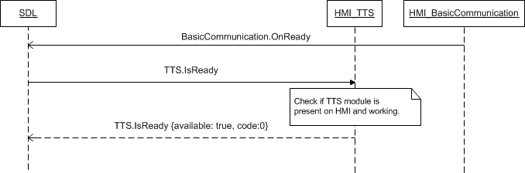

### 10.1.5 JSON Messages Examples

#### 10.1.5.1 Request

|  |
| --- |
| {  "id" : 45,  "jsonrpc" : "2.0",  "method" : "TTS.IsReady"  } |

#### 10.1.5.2 Response

|  |
| --- |
| {  "id" : 45,  "jsonrpc" : "2.0",  "result" :  {  "availabe" : true,  "code" : 0,  "method" : "TTS.IsReady"  }  } |

#### 10.1.5.3 Error message

|  |
| --- |
| {  "id" : 45,  "jsonrpc" : "2.0",  "error" :  {  "code" : 11,  "message" : "Invalid data",  "data" :  {  "method" : "TTS.IsReady"  }  }  } |

### 10.1.6 D-Bus Messages Examples

#### 10.1.6.1 Request

|  |
| --- |
|  |

#### 10.1.6.2 Response

|  |
| --- |
|  |

#### 10.1.6.3 Failure

|  |
| --- |
|  |

## 10.2 GetCapabilities

### 10.2.1 Description

|  |  |
| --- | --- |
| **Type:** | Function |
| **Sender:** | SDL |
| **Purpose:** | Get TTS capabilities |

SDL can store the HMI capabilities in smartDeviceLink.ini file saved in SDL directory. Nevertheless, on its startup after getting OnReady notification and response to TTS.IsReady from HMI, SDL sends this RPC for obtaining the capabilities of TTS.

### 10.2.2 Request

#### 7.1.2.1 Behavior

***HMI must:***

1. Check the TTS capabilities.

2. Respond correspondingly to results of this check.

### 10.2.3 Response

***Note:***

*There is a difference in message type for WebSocket and D-Bus connection (see the table below).*

|  |  |  |  |  |  |
| --- | --- | --- | --- | --- | --- |
| **Result** | **Description** | **Message type** | | **Message Params** | **Notes** |
| **WebSocket** | **D-Bus** |
| Success | SUCCESS:  HMI provides the TTS capabilities. | JSON response | Method return | capabilities,  prerecordedSpeechCapabilities,  code: 0 |  |
| Failure | INVALID_DATA:  The data sent is invalid (invalid JSON syntax) | JSON error message | Method return | code: 11 | Applicable for this RPC result codes.  Please see Result Enumeration for all SDL-supported codes. |
| DATA_NOT_AVAILABLE:  The TTS capabiliries cannot be provided. | Code: 9 |
| GENERIC_ERROR:  The unknown issue occurred or other codes are not applicable. | code: 22 |

#### 10.2.3.1 Parameters

| **Param name** | **Type** | **Mandatory** | **Additional** | **Description** |
| --- | --- | --- | --- | --- |
| capabilities | Common.SpeechCapabilities | true | array = true  minsize = 1  maxsize = 5 | Contains information about the TTS capabilities. |
| prerecordedSpeechCapabilities | Common.PrerecordedSpeech | true | array = true  minsize = 1  maxsize = 5 | Contains a list of prerecorded speech items present on the platform. |

#### 10.2.3.2 SpeechCapabilities

| **Element name** | **Value** | **Short Description** |
| --- | --- | --- |
| TEXT | 0 | HMI has the capability to speak the provided text. |
| SAPI_PHONEMES | 1 | Speech API phonemes: used for cresting pronunciations for words that are not currently in the lexicon. |
| LHPLUS_PHONEMES | 2 | LH Plus API phonemes: used for cresting pronunciations for words that are not currently in the lexicon. |
| PRE_RECORDED | 3 | HMI has the capability to speek the pre-recorded phrases. |
| SILENCE | 4 | HMI has the capability to play silence over TTS during the default HMI-defined period of time. |

#### 10.2.3.3 PrerecordedSpeech

| **Element name** | **Value** | **Short Description** |
| --- | --- | --- |
| HELP_JINGLE | 0 |  |
| INITIAL_JINGLE | 1 |  |
| LISTEN_JINGLE | 2 |  |
| POSITIVE_JINGLE | 3 |  |
| NEGATIVE_JINGLE | 4 |  |

### 10.2.4 Sequence Diagrams

#### 10.1.4.1 TTS.GetCapabilities

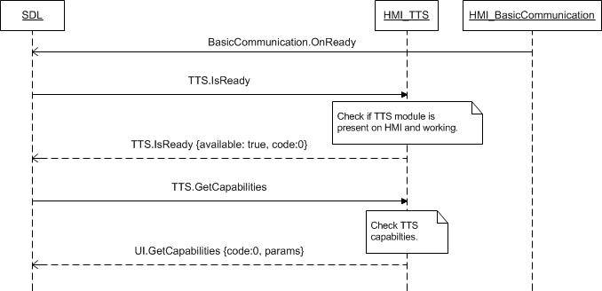

### 10.2.5 JSON Messages Examples

#### 10.2.5.1 Request

|  |
| --- |
| {  "id" : 13,  "jsonrpc" : "2.0",  "method" : "TTS.GetCapabilities"  } |

#### 10.2.5.2 Response

|  |
| --- |
| {  "id" : 13,  "jsonrpc" : "2.0",  "result" :  {  "capabilities" : [TEXT],  “prerecordedSpeechCapabilities” : [HELP_JINGLE, INITIAL_JINGLE, LISTEN_JINGLE, POSITIVE_JINGLE, NEGATIVE_JINGLE],  "code" : 0,  "method" : "TTS.GetCapabilities"  }  } |

#### 10.2.5.3 Error message

|  |
| --- |
| {  "id" : 28,  "jsonrpc" : "2.0",  "error" :  {  "code" : 11,  "message" : "The data sent is invalid",  "data" :  {  "method" : "TTS.GetCapabilities"  }  }  } |

### 10.2.6 D-Bus Messages Examples

#### 10.2.6.1 Request

|  |
| --- |
|  |

#### 10.2.6.2 Response

|  |
| --- |
|  |

#### 10.2.6.3 Failure

|  |
| --- |
|  |

## 10.3 GetSupportedLanguages

### 10.3.1 Description

|  |  |
| --- | --- |
| **Type:** | Function |
| **Sender:** | SDL |
| **Purpose:** | Get languages supported by TTS |

Once TTS module is confirmed to be ready (via response to IsReady RPC) SDL starts discovering its capabilities via GetCapabilities and GetSupportedLanguages RPCs.

Response to TTS.GetSupportedLanguages is assumed to bring the information about what languages are supported for voice recognition by VR module. Having obtained this information SDL will monitor the language parameter within RPCs from mobile application(s) and reject the requests containing language not supported by HMI.

***Note:***

*The list of languages recognized by SDL is provided in the section 10.3.3.2 Language Enumeration.*

### 10.3.2 Request

#### 7.1.2.1 Behavior

***HMI must:***

- Check the TTS supported languages

- Respond correspondingly to results of this check.

### 10.3.3 Response

***Note:***

*There is a difference in message type for WebSocket and D-Bus connection (see the table below).*

|  |  |  |  |  |  |
| --- | --- | --- | --- | --- | --- |
| **Result** | **Description** | **Message type** | | **Message Params** | **Notes** |
| **WebSocket** | **D-Bus** |
| Success | SUCCESS:  HMI provides the TTS supported languages. | JSON response | Method return | languages,  code: 0 |  |
| Failure | INVALID_DATA:  The data sent is invalid (invalid JSON syntax) | JSON error message | Method return | code: 11 | Applicable for this RPC result codes.  Please see Result Enumeration for all SDL-supported codes. |
| DATA_NOT_AVAILABLE:  The TTS supported languages cannot be provided. | Code: 9 |
| GENERIC_ERROR:  The unknown issue occurred or other codes are not applicable. | code: 22 |

#### 10.3.3.1 Parameters

| **Param name** | **Type** | **Mandatory** | **Additional** | **Description** |
| --- | --- | --- | --- | --- |
| languages | Common.Language | true | Array = true  minsize = 1  maxsize = 100 | List of languages supported in TTS.  See Language. |

#### 10.3.3.2 Language

| **Element Name** | **Value** | **Description** |
| --- | --- | --- |
| EN-US | 0 | English – US |
| ES-MX | 1 | Spanish – Mexico |
| FR-CA | 2 | French – Canada |
| DE-DE | 3 | German – Germany |
| ES-ES | 4 | Spanish – Spain |
| EN-GB | 5 | English – GB |
| RU-RU | 6 | Russian - Russia |
| TR-TR | 7 | Turkish – Turkey |
| PL-PL | 8 | Polish – Poland |
| FR-FR | 9 | French – France |
| IT-IT | 10 | Italian – Italy |
| SV-SE | 11 | Swedish – Sweden |
| PT-PT | 12 | Portuguese – Portugal |
| NL-NL | 13 | Dutch (Standard) – Netherlands |
| EN-AU | 14 | English – Australia |
| ZH-CN | 15 | Mandarin – China |
| ZH-TW | 16 | Mandarin – Taiwan |
| JA-JP | 17 | Japanese – Japan |
| AR-SA | 18 | Arabic – Saudi Arabia |
| KO-KR | 19 | Korean – South Korea |
| PT-BR | 20 | Portuguese - Brazil |
| CS-CZ | 21 | Czech – Czech Republic |
| DA-DK | 22 | Danish – Denmark |
| NO-NO | 23 | Norwegian - Norway |

### 10.3.4 Sequence Diagrams

#### 10.3.4.1 TTS.GetSupportedLanguages

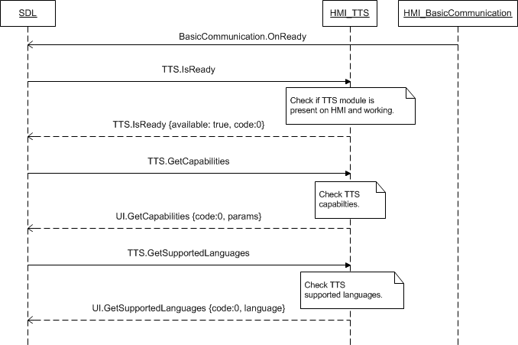

### 10.3.5 JSON Messages Examples

#### 10.3.5.1 Request

|  |
| --- |
| {  "id" : 19,  "jsonrpc" : "2.0",  "method" : "TTS.GetSupportedLanguages"  } |

#### 10.3.5.2 Response

|  |
| --- |
| {  "id" : 19,  "jsonrpc" : "2.0",  "result" :  {  "languages" : [AR-SA, DE-DE, EN-GB, EN-US, ES-ES, FR-FR, IT-IT],  "code" : 0,  "method" : "TTS.GetSupportedLanguages"  }  } |

#### 10.3.5.3 Error message

|  |
| --- |
| {  "id" : 19,  "jsonrpc" : "2.0",  "error" :  {  "code" : 11,  "message" : "The data sent is invalid",  "data" :  {  "method" : "TTS.GetSupportedLanguages"  }  }  } |

### 10.3.6 D-Bus Messages Examples

#### 10.3.6.1 Request

|  |
| --- |
|  |

#### 10.3.6.2 Response

|  |
| --- |
|  |

#### 10.3.6.3 Failure

|  |
| --- |
|  |

## 10.4 Speak

### 10.4.1 Description

|  |  |
| --- | --- |
| **Type:** | Function |
| **Sender:** | SDL |
| **Purpose:** | Prompt TTS to speak the requested text |

SDL provides the text information for HMI to speak it to the User via TTS engine.

### 10.4.2 Request

#### 10.4.2.1 Behavior

***HMI must:***

1. Notify SDL via TTS.Started about speaking is started
2. Depending on HMI capabilities, attenuate or make the audio (if streamed by the application or HMI itself) not audible.
3. Distinguish the type of request (please see section 10.4.2.5 MethodName):
   1. ALERT-type requests have the highest priority: HMI must speek the requested text by all means and rignt away
   2. SPEAK type requests have the normal priority: HMI must speak the requested text, still the delays are acceptable.
   3. AUDIO_PASS_THRU has normal priority type on HMI. HMI must speak the requested text, still the delays are acceptable (see 7.20.4.1 PerformAudioPassThru diagram for more details).
   4. ALERT_MANEUVER has normal priority type on HMI. HMI must speak the requested text, still the delays are acceptable (see 12.2.4 AlertManeuver diagram for more details).
   5. If type is omitted within request, HMI must speak the requested text; still the negative response is acceptable.
4. Speak the text requested within TTSChunk parameter. The text value is specified together with ‘type’ parameter that defines how exactly this text must be used by HMI:

* TEXT – the text is provided and must be pronounced by HMI (letter-to-sound).
* SAPI_PHONEMES / LHPLUS_PHONEMES – the phonemes are provided and must be pronounced by HMI.
* PRE_RECORDED – the provided text must be pronounced by pre-recorded phrases.
* SILENCE – HMI must play silence over TTS during the default HMI-defined period of time.

1. Respond the request with successful result code (the cases of non-successful results are described in section 10.4.3 Response).
2. Notify SDL via TTS.Stopped about speaking is finished.

#### 10.4.2.2 Parameters

| **Param name** | **Type** | **Mandatory** | **Additional** | **Description** |
| --- | --- | --- | --- | --- |
| ttsChunks | Common.TTSChunk | true | Array = true  minsize = 1  maxsize = 100 | List of strings to be spoken.  See TTSChunks |
| speakType | Common. MethodName | false | - | Defines the type of TTS.Speak request |
| appID | Integer | false | ­- | ID of the application that requested this RPC. |

#### 10.4.2.3 TTSChunk

|  |  |  |  |  |
| --- | --- | --- | --- | --- |
| **Param name** | **Type** | **Mandatory** | **Additional** | **Description** |
| text | String | true | Maxlength = 500 | The text or phonemes to speak |
| type | Common.SpeechCapabilities | true | - | Describes, whether it is text or a specific phoneme set. See SpeechCapabilities. |

#### 10.4.2.4 SpeechCapabilities

| **Element name** | **Value** | **Short Description** |
| --- | --- | --- |
| TEXT | 0 | Text is provided to HMI to be spoken. |
| SAPI_PHONEMES | 1 | Speech API phonemes are provided and must be used by HMI for pronouncing. |
| LHPLUS_PHONEMES | 2 | LH Plus phonemes are provided and must be used by HMI for pronouncing. |
| PRE_RECORDED | 3 | The text is provided and must be spoken as a pre-recorded phrase by HMI. |
| SILENCE | 4 | HMI must play silence over TTS during the default HMI-defined period of time. |

#### 10.4.2.5 MethodName

| **Element name** | **Value** | **Short Description** |
| --- | --- | --- |
| ALERT | 0 | TTS.Speak has the alert type (that is, either accompanies UI.Alert RPC or is requested independently from UI as an alert TTS prompting to the User) |
| SPEAK | 1 | TTS.Speak has the ‘regular’ speak type (that is, a friendly reminding or notification or informing, etc., by TTS to the User). |
| AUDIO_PASS_THRU | 2 | TTS.Speak has this type when it prompts to the User as a part of PerformAudioPassThru. See 7.20.4.1 PerformAudioPassThru diagram for more details |
| ALERT_MANEUVER | 3 | Defines the type of the mobile API request (AlertMeneuver mobile API) which initiates the request on HMI e.g. (TTS.Speak, BC.PlayTone) |

### 10.4.3 Response

***Note:***

*There is a difference in message type for WebSocket and D-Bus connection (see the table below).*

|  |  |  |  |  |  |
| --- | --- | --- | --- | --- | --- |
| **Result** | **Description** | **Message type** | | **Message Params** | **Notes** |
| **WebSocket** | **D-Bus** |
| Success | SUCCESS:  HMI speaks the requested text and responds when finished. | JSON response | Method return | code: 0 |  |
| Failure | INVALID_DATA:  The data sent is invalid (invalid JSON syntax, parameters are out of bounds or of wrong type) | JSON error message | Method return | code: 11 | Applicable for this RPC result codes.  Please see Result Enumeration for all SDL-supported codes. |
| INVALID_ID  Wrong appID is sent | code:13 |
| ABORTED:  RPC is interrupted by:  1) StopSpeaking RPC  2) VR session started  3) Another RPC of higher priority | Code: 5 |
| GENERIC_ERROR:  The unknown issue occurred or other codes are not applicable. | code: 22 |

### 10.4.4 Sequence Diagrams

#### 10.4.4.1 Speak

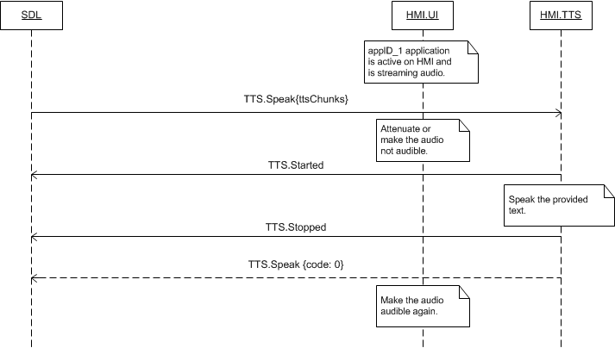

### 10.4.5 JSON Messages Examples

#### 10.4.5.1 Request

|  |
| --- |
| {  "id" : 144,  "jsonrpc" : "2.0",  "method" : "TTS.Speak",  “params” :  {  “ttsChunks” :  [  “text” : “Please say a command”  ]  }  } |

#### 10.4.5.2 Response

|  |
| --- |
| {  "id" : 144,  "jsonrpc" : "2.0",  "result" :  {  "code" : 0,  "method" : "TTS.Speak"  }  } |

#### 10.4.5.3 Error message

|  |
| --- |
| {  "id" : 144,  "jsonrpc" : "2.0",  "error" :  {  "code" : 5,  "message" : "The command was aborted",  "data" :  {  "method" : "TTS.Speak"  }  }  } |

### 10.4.6 D-Bus Messages Examples

#### 10.4.6.1 Request

|  |
| --- |
|  |

#### 10.4.6.2 Response

|  |
| --- |
|  |

#### 10.4.6.3 Failure

|  |
| --- |
|  |

## 10.5 StopSpeaking

### 10.5.1 Description

|  |  |
| --- | --- |
| **Type:** | Function |
| **Sender:** | SDL |
| **Purpose:** | Interrupt the Speak RPC. |

SDL sends StopSpeaking RPC to abort TTS playing initiated by TTS.Speak. This RPC is not intended to interrupt HMI-initiated TTS speaking.

### 10.5.2 Request

#### 10.5.2.1 Behavior

***HMI must:***

1. Stop speaking the text requested via TTS.Speak.

2. Respond to TTS.StopSpeaking

3. Respond with ABORTED result code for TTS.Speak.

4. Notify SDL about TTS has finished speaking via TTS.Stopped.

### 10.5.3 Response

***Note:***

*There is a difference in message type for WebSocket and D-Bus connection (see the table below).*

|  |  |  |  |  |  |
| --- | --- | --- | --- | --- | --- |
| **Result** | **Description** | **Message type** | | **Message Params** | **Notes** |
| **WebSocket** | **D-Bus** |
| Success | SUCCESS:  The Speak RPC is interrupted. | JSON response | Method return | code: 0 |  |
| Failure | INVALID_DATA:  The data sent is invalid (invalid JSON syntax) | JSON error message | Method return | code: 11 | Applicable for this RPC result codes.  Please see Result Enumeration for all SDL-supported codes. |
| GENERIC_ERROR:  The unknown issue occurred or other codes are not applicable. | code: 22 |

### 10.5.4 Sequence Diagrams

#### 10.5.4.1 StopSpeaking

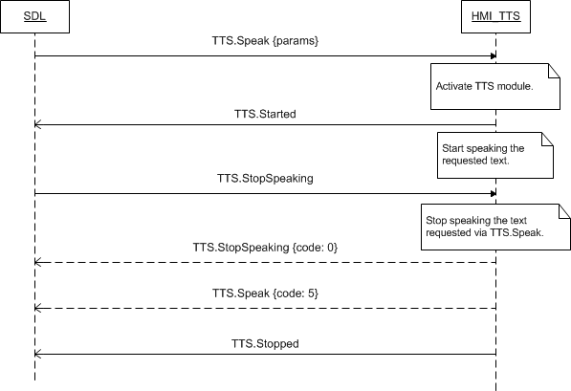

### 10.5.5 JSON Messages Examples

#### 10.5.5.1 Request

|  |
| --- |
| {  "id" : 148,  "jsonrpc" : "2.0",  "method" : "TTS.StopSpeaking"  } |

#### 10.5.5.2 Response

|  |
| --- |
| {  "id" : 148,  "jsonrpc" : "2.0",  "result" :  {  "code" : 0,  "method" : "TTS.StopSpeaking"  }  } |

#### 10.5.5.3 Error message

|  |
| --- |
| {  "id" : 148,  "jsonrpc" : "2.0",  "error" :  {  "code" : 11,  "message" : "Invalid data: invalid JSON syntax",  "data" :  {  "method" : "TTS.StopSpeaking"  }  }  } |

### 10.5.6 D-Bus Messages Examples

#### 10.5.6.1 Request

|  |
| --- |
|  |

#### 10.5.6.2 Response

|  |
| --- |
|  |

#### 10.5.6.3 Failure

|  |
| --- |
|  |

## 10.6 ChangeRegistration

### 10.6.1 Description

|  |  |
| --- | --- |
| **Type:** | Function |
| **Sender:** | SDL |
| **Purpose:** | Change the application language for TTS |

When the application registers and its languageDesired value is different from the current HMI TTS language, this application is provided with the possibility to change the language and re-register just this value. TTS.ChangeRegistration RPC is used for such purpose of re-registering the application with HMI current TTS language.

### 10.6.2 Request

#### 10.6.2.1 Behavior

***HMI must:***

1. Update the appID application related data previously provided via OnAppRegistered with the new application language desired for TTS.

2. Respond the request.

***Note:***

*There may be cases when the application requests to re-register it with the language different from current HMI TTS language (e.g. TTS.ChangeRegistreation (ES-ES) while the current language is EN-US):*

* *HMI must: confirm it accepts such registration (respond with SUCCESS result code)*
* *HMI is expected to:*
* *Recognize the text provided in the registered language for speaking further.*
* *Use the rules and pronounciation of the current HMI TTS language (and all the consequences of using TTS engine in the wrong language (e.g. in ES-ES while the current is EN-US) are on the application).*

#### 10.6.2.2 Parameters

| **Param Name** | **Type** | **Mandatory** | **Additional** | **Description** |
| --- | --- | --- | --- | --- |
| language | Common.Language | true |  | The language requested to be switched to.  See Language. |
| ttsName | Common.TTSChunk | false | array=true  minsize=1  maxsize=100 | Request new VR synonyms registration  Defines an additional voice recognition command.  Must not interfere with any name of previously registered applications(SDL makes check). |
| appID | Integer | true |  | ID of the application that relates to this RPC. |

#### 10.6.2.3 Language

| **Element Name** | **Value** | **Description** |
| --- | --- | --- |
| EN-US | 0 | English – US |
| ES-MX | 1 | Spanish – Mexico |
| FR-CA | 2 | French – Canada |
| DE-DE | 3 | German – Germany |
| ES-ES | 4 | Spanish – Spain |
| EN-GB | 5 | English – GB |
| RU-RU | 6 | Russian - Russia |
| TR-TR | 7 | Turkish – Turkey |
| PL-PL | 8 | Polish – Poland |
| FR-FR | 9 | French – France |
| IT-IT | 10 | Italian – Italy |
| SV-SE | 11 | Swedish – Sweden |
| PT-PT | 12 | Portuguese – Portugal |
| NL-NL | 13 | Dutch (Standard) – Netherlands |
| EN-AU | 14 | English – Australia |
| ZH-CN | 15 | Mandarin – China |
| ZH-TW | 16 | Mandarin – Taiwan |
| JA-JP | 17 | Japanese – Japan |
| AR-SA | 18 | Arabic – Saudi Arabia |
| KO-KR | 19 | Korean – South Korea |
| PT-BR | 20 | Portuguese - Brazil |
| CS-CZ | 21 | Czech – Czech Republic |
| DA-DK | 22 | Danish – Denmark |
| NO-NO | 23 | Norwegian - Norway |

### 10.6.3 Response

***Note:***

*There is a difference in message type for WebSocket and D-Bus connection (see the table below).*

|  |  |  |  |  |  |
| --- | --- | --- | --- | --- | --- |
| **Result** | **Description** | **Message type** | | **Message Params** | **Notes** |
| **WebSocket** | **D-Bus** |
| Success | SUCCESS:  The requested language has been set for TTS for the named application. | JSON response | Method return | code: 0 |  |
| Failure | INVALID_DATA:  The data sent is invalid (invalid JSON syntax, parameters are out of bounds or of wrong type) | JSON error message | Method return | code: 11 | Applicable for this RPC result codes.  Please see Result Enumeration for all SDL-supported codes. |
| INVALID_ID  Wrong appID is sent | code:13 |
| WRONG_LANGUAGE  The language is not supported by TTS | code: 16 |
| GENERIC_ERROR:  The unknown issue occurred or other codes are not applicable. | code: 22 |

### 10.6.4 Sequence Diagrams

#### 10.6.4.1 TTS.ChangeRegistration after OnAppRegistered

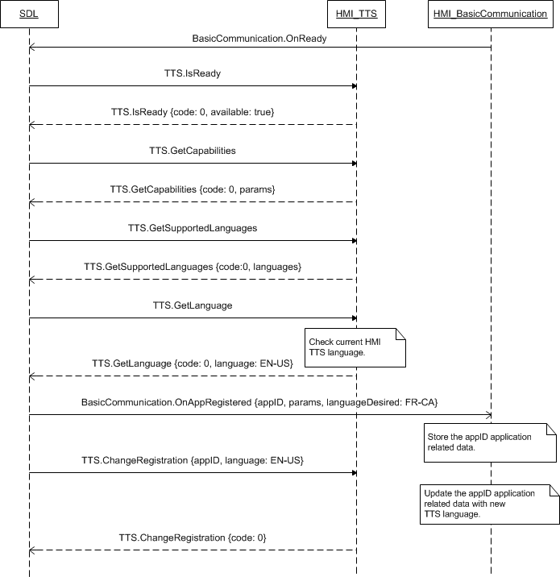

### 10.6.5 JSON Messages Examples

#### 10.6.5.1 Request

|  |
| --- |
| {  "id" : 206,  "jsonrpc" : "2.0",  "method" : "TTS.ChangeRegistration",  “params” :  {  “language” : DE-DE,  “appID” : 65539  }  } |

#### 10.6.5.2 Response

|  |
| --- |
| {  "id" : 206,  "jsonrpc" : "2.0",  "result" :  {  "code" : 0,  "method" : "TTS.ChangeRegistration"  }  } |

#### 10.6.5.3 Error message

|  |
| --- |
| {  "id" : 206,  "jsonrpc" : "2.0",  "error" :  {  "code" : 22,  "message" : "Unknown error occurred",  "data" :  {  "method" : "TTS.ChangeRegistration"  }  }  } |

### 10.6.6 D-Bus Messages Examples

#### 10.6.6.1 Request

|  |
| --- |
|  |

#### 10.6.6.2 Response

|  |
| --- |
|  |

#### 10.6.6.3 Failure

|  |
| --- |
|  |

## 10.7 GetLanguage

### 10.7.1 Description

|  |  |
| --- | --- |
| **Type:** | Function |
| **Sender:** | SDL |
| **Purpose:** | Get the current TTS language |

SDL inquires the current HMI TTS language.

This RPC is sent by SDL after TTS readiness is confirmed by TTS.IsReady. If later the User changes the HMI language of TTS, HMI must inform SDL about this event via TTS.OnLanguageChange notification.

### 10.7.2 Request

#### 10.7.2.1 Behavior

***HMI must:***

1. Check the HMI TTS language currently in effect.

2. Respond providing SDL with the results of this check.

### 10.7.3 Response

***Note:***

*There is a difference in message type for WebSocket and D-Bus connection (see the table below).*

|  |  |  |  |  |  |
| --- | --- | --- | --- | --- | --- |
| **Result** | **Description** | **Message type** | | **Message Params** | **Notes** |
| **WebSocket** | **D-Bus** |
| Success | SUCCESS:  HMI provides the language currently active for TTS. | JSON response | Method return | language,  code: 0 |  |
| Failure | INVALID_DATA:  The data sent is invalid (invalid JSON syntax, parameters are out of bounds or of wrong type) | JSON error message | Method return | code: 11 | Applicable for this RPC result codes.  Please see Result Enumeration for all SDL-supported codes. |
| GENERIC_ERROR:  The unknown issue occurred or other codes are not applicable. | code: 22 |

#### 10.7.3.1 Parameters

|  |  |  |  |
| --- | --- | --- | --- |
| **Param Name** | **Type** | **Mandatory** | **Description** |
| language | Common.Language | true | The current TTS language.  See Language. |

#### 10.6.2.3 Language

| **Element Name** | **Value** | **Description** |
| --- | --- | --- |
| EN-US | 0 | English – US |
| ES-MX | 1 | Spanish – Mexico |
| FR-CA | 2 | French – Canada |
| DE-DE | 3 | German – Germany |
| ES-ES | 4 | Spanish – Spain |
| EN-GB | 5 | English – GB |
| RU-RU | 6 | Russian - Russia |
| TR-TR | 7 | Turkish – Turkey |
| PL-PL | 8 | Polish – Poland |
| FR-FR | 9 | French – France |
| IT-IT | 10 | Italian – Italy |
| SV-SE | 11 | Swedish – Sweden |
| PT-PT | 12 | Portuguese – Portugal |
| NL-NL | 13 | Dutch (Standard) – Netherlands |
| EN-AU | 14 | English – Australia |
| ZH-CN | 15 | Mandarin – China |
| ZH-TW | 16 | Mandarin – Taiwan |
| JA-JP | 17 | Japanese – Japan |
| AR-SA | 18 | Arabic – Saudi Arabia |
| KO-KR | 19 | Korean – South Korea |
| PT-BR | 20 | Portuguese - Brazil |
| CS-CZ | 21 | Czech – Czech Republic |
| DA-DK | 22 | Danish – Denmark |
| NO-NO | 23 | Norwegian - Norway |

### 10.7.4 Sequence Diagrams

#### 10.7.4.1 TTS.GetLanguage

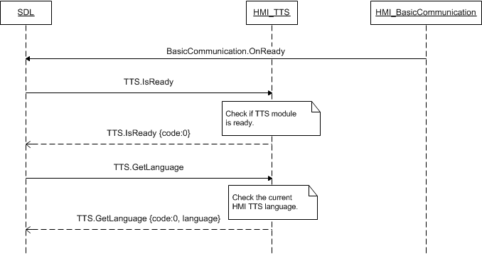

### 10.7.5 JSON Messages Examples

#### 10.7.5.1 Request

|  |
| --- |
| {  "id" : 110,  "jsonrpc" : "2.0",  "method" : "TTS.GetLanguage",  } |

#### 10.7.5.2 Response

|  |
| --- |
| {  "id" : 110,  "jsonrpc" : "2.0",  "result" :  {  "language" : DE-DE,  "code" : 0,  "method" : "TTS.GetLanguage"  }  } |

#### 10.7.5.3 Error message

|  |
| --- |
| {  "id" : 110,  "jsonrpc" : "2.0",  "error" :  {  "code" : 22,  "message" : "During the API call the unknown error has occured",  "data" :  {  "method" : "TTS.GetLanguage"  }  }  } |

### 10.7.6 D-Bus Messages Examples

#### 10.7.6.1 Request

|  |
| --- |
|  |

#### 10.7.6.2 Response

|  |
| --- |
|  |

#### 10.7.6.3 Failure

|  |
| --- |
|  |

## 10.8 SetGlobalProperties

### 10.8.1 Description

|  |  |
| --- | --- |
| **Type:** | Function |
| **Sender:** | SDL |
| **Purpose:** | Set the properties for TTS |

SDL requests to set the values for the prompts to be spoken by TTS in the definite moments during the User`s interaction with the application over head unit.

### 10.8.2 Request

#### 10.8.2.1 Behavior

***HMI must:***

1. Store the provided values associating them with the provided appID.

2. Speak the provided text during the following events related to the appID application:

* helpPrompt – when the HMI-defined ‘Help’ command is recognized by VR.
* timeoutPrompt – when the HMI-defined timeout for VR session is about going to end. After speaking this prompt HMI must provide some additional time for the user to be able to give a command by VR. After this additional amount of time is out, VR session must be closed.

3. Respond with SUCCESSFUL result code after the requested values have been stored. All of applicable result codes please see in the section 10.8.3 Response.

#### 10.8.2.2 Parameters

| **Param name** | **Type** | **Mandatory** | **Additional** | **Description** |
| --- | --- | --- | --- | --- |
| helpPrompt | Common.TTSChunk | false | Array = true  minsize = 0  maxsize = 100 | This is the array of strings to be spoken when the HMI-defined ‘Help’ VR command is recognized (see TTSChunk).  @TODO – define an empty array behavior, there’s difference with mobile API. To clarify with FORD |
| timeoutPrompt | Common.TTSChunk | false | Array = true  minsize = 1  maxsize = 100 | This is the array of strings to be spoken when the HMI-defined timeout for VR session is about going to end (see TTSChunk).  After speaking this prompt HMI must provide some additional time for the user to be able to give a command by VR. After this additional amount of time is out, VR session must be closed. |
| appID | Integer | true | ­- | ID of the application that requested this RPC. |

### 10.8.3 Response

***Note:***

*There is a difference in message type for WebSocket and D-Bus connection (see the table below).*

|  |  |  |  |  |  |
| --- | --- | --- | --- | --- | --- |
| **Result** | **Description** | **Message type** | | **Message Params** | **Notes** |
| **WebSocket** | **D-Bus** |
| Success | SUCCESS:  The requested properties are set for TTS for the named application. | JSON response | Method return | code: 0 |  |
| Failure | UNSUPPORTED_RESOURSE  The request comes for TTS which is not there on HU or doesn’t support the type of phoneme provided. | JSON error message | Method return | code: 2 | Applicable for this RPC result codes.  Please see Result Enumeration for all SDL-supported codes. |
| INVALID_ID  Wrong appID sent | code: 13 |
| INVALID_DATA:  The data sent is invalid (invalid JSON syntax, parameters are out of bounds or of wrong type) | code: 11 |
| GENERIC_ERROR  1) The unknown issue occurred or other codes are not applicable.  2) In case HMI does not respond SDL's request during SDL default timeout (10 sec), SDL will return the result code to the corresponding mobile app's request. | code: 22 |

### 10.8.4 Sequence Diagrams

#### 10.8.4.1 TTS.SetGlobalProperties and corresponding HMI processing

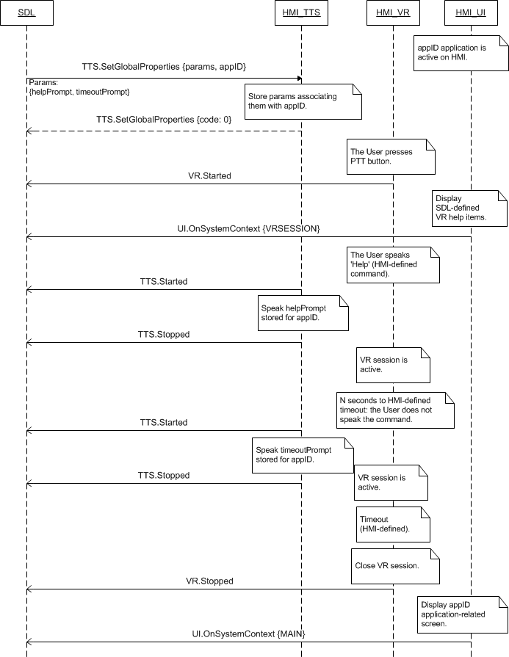

*Note:*

*SDL-defined VR help items are provided by SDL via UI.SetGlobalProperties RPC.*

### 10.8.5 JSON Messages Examples

#### 10.8.5.1 Request

|  |
| --- |
| {  "id" : 37,  "jsonrpc" : "2.0",  "method" : "TTS.SetGlobalProperties",  “params” :  {  “helpPrompt” :  [  “text” : “Yes”,  “text” : “No”,  “text” : “Skip”  ],  “timeoutPrompt” :  [  “text” : “Please make a choice”,  “text” : “The time is about to expire”  ],  “appID” : 65542  }  } |

#### 10.8.5.2 Response

|  |
| --- |
| {  "id" : 37,  "jsonrpc" : "2.0",  "result" :  {  "code" : 0,  "method" : "TTS.SetGlobalProperties"  }  } |

#### 10.8.5.3 Error message

|  |
| --- |
| {  "id" : 37,  "jsonrpc" : "2.0",  "error" :  {  "code" : 2,  "message" : "TTS is not supported",  "data" :  {  "method" : "TTS.SetGlobalProperties"  }  }  } |

### 10.8.6 D-Bus Messages Examples

#### 10.8.6.1 Request

|  |
| --- |
|  |

#### 10.8.6.2 Response

|  |
| --- |
|  |

#### 10.8.6.3 Failure

|  |
| --- |
|  |

## 10.10 OnLanguageChange

### 10.10.1 Description

|  |  |
| --- | --- |
| **Type:** | Notification |
| **Sender:** | HMI |
| **Purpose:** | Inform about TTS language change |

SDL needs to be in the know when the User changes the language of TTS: Upon the receipt of OnLanguageChange notification SDL will unregister the applications of different language to provide them with possibility to re-register with the correct (new HMI) TTS language.

***HMI must:***

Send the TTS.OnLanguageChange notification when the User switches TTS to another language and provide this new value via language parameter.

***Note:*** SDL ignores all invalid notifications which come from HMI (invalid JSON, invalid data types/bounds etc)

#### 10.10.1.1 Parameters

|  |  |  |  |
| --- | --- | --- | --- |
| **Param Name** | **Type** | **Mandatory** | **Description** |
| language | Common.Language | true | Language TTS has been switched to.  See Language |

#### 10.10.1.2 Language

| **Element Name** | **Value** | **Description** |
| --- | --- | --- |
| EN-US | 0 | English – US |
| ES-MX | 1 | Spanish – Mexico |
| FR-CA | 2 | French – Canada |
| DE-DE | 3 | German – Germany |
| ES-ES | 4 | Spanish – Spain |
| EN-GB | 5 | English – GB |
| RU-RU | 6 | Russian - Russia |
| TR-TR | 7 | Turkish – Turkey |
| PL-PL | 8 | Polish – Poland |
| FR-FR | 9 | French – France |
| IT-IT | 10 | Italian – Italy |
| SV-SE | 11 | Swedish – Sweden |
| PT-PT | 12 | Portuguese – Portugal |
| NL-NL | 13 | Dutch (Standard) – Netherlands |
| EN-AU | 14 | English – Australia |
| ZH-CN | 15 | Mandarin – China |
| ZH-TW | 16 | Mandarin – Taiwan |
| JA-JP | 17 | Japanese – Japan |
| AR-SA | 18 | Arabic – Saudi Arabia |
| KO-KR | 19 | Korean – South Korea |
| PT-BR | 20 | Portuguese - Brazil |
| CS-CZ | 21 | Czech – Czech Republic |
| DA-DK | 22 | Danish – Denmark |
| NO-NO | 23 | Norwegian - Norway |

### 10.10.2 Sequence Diagrams

#### 10.10.2.1 TTS.OnLanguageChange

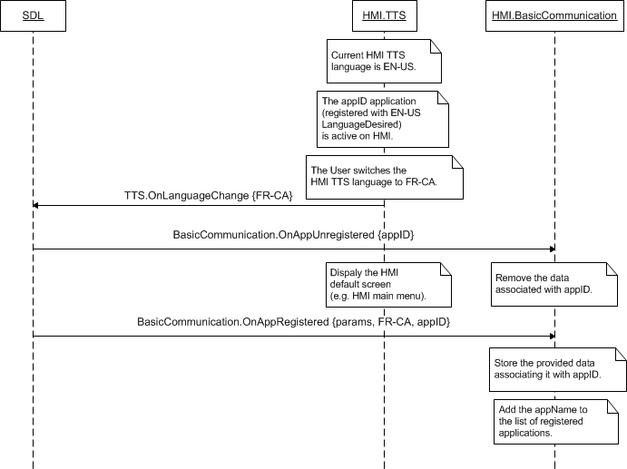

### 10.10.3 JSON Messages Examples

|  |
| --- |
| {  "jsonrpc" : "2.0",  "method" : "TTS.OnLanguageChange",  "params" :  {  "language" : IT-IT  }  } |

### 10.10.4 D-Bus Messages Examples

|  |
| --- |
|  |

## 10.11 Started

### 10.11.1 Description

|  |  |
| --- | --- |
| **Type:** | Notification |
| **Sender:** | HMI |
| **Purpose:** | Inform about TTS started |

Once TTS starts speaking, HMI should attenuate the audio or make it not audible (depending on its capabilities). SDL needs to be notified about the event in order to provide a mobile application with the accurate information about audio streaming state on HMI.

***HMI must:***

Send TTS.Started notification when TTS has started speaking either upon SDL`s request (e.g. TTS.Speak) or upon HMI-defined prompting.

***Note:*** SDL ignores all invalid notifications which come from HMI (invalid JSON, invalid data types/bounds etc)

### 10.11.2 Request

#### 10.11.2.1 Parameters

### 10.11.3 Response

***Note:***

*There is a difference in message type for WebSocket and D-Bus connection (see the table below).*

|  |  |  |  |  |  |
| --- | --- | --- | --- | --- | --- |
| **Result** | **Description** | **Message type** | | **Message Params** | **Notes** |
| **WebSocket** | **D-Bus** |
| Success | SUCCESS:  The requested properties are set for TTS for the named application. | JSON response | Method return | code: 0 |  |
| Failure | GENERIC_ERROR:  The unknown issue occurred or other codes are not applicable. | JSON error message | Method return | code: 22 |  |

### 10.11.3 Sequence Diagrams

#### 10.11.3.1 TTS.Started upon TTS.Speak request from SDL



#### 10.11.3.2 TTS.Started during PerfromInteraction

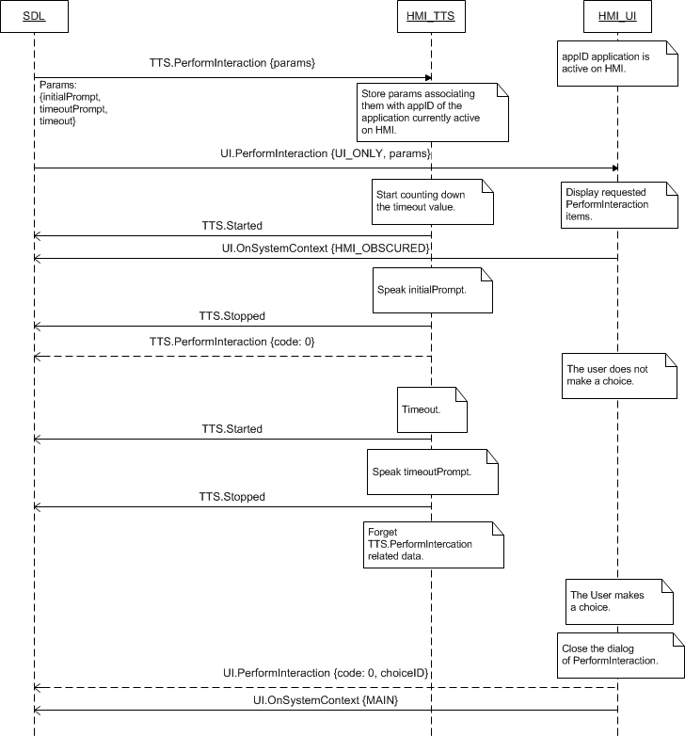

### 10.11.4 JSON Messages Examples

#### 10.11.4.1 Request

|  |
| --- |
| {  "jsonrpc" : "2.0",  "method" : "TTS.Started",  } |

#### 10.11.4.2 Response

|  |
| --- |
| {  "id" : 37,  "jsonrpc" : "2.0",  "result" :  {  "code" : 0,  "method" : "TTS.Started"  }  } |

#### 10.11.4.3 Error message

|  |
| --- |
| {  "id" : 37,  "jsonrpc" : "2.0",  "error" :  {  "code" : 22,  "message" : "Something went wrong",  "data" :  {  "method" : "TTS.Started"  }  }  } |

### 10.10.4 D-Bus Messages Examples

|  |
| --- |
|  |

## 10.12 Stopped

### 10.12.1 Description

|  |  |
| --- | --- |
| **Type:** | Notification |
| **Sender:** | HMI |
| **Purpose:** | Inform about TTS has stopped speaking |

When TTS module has finished speaking (started whatever by SDL via e.g. TTS.Speak or by HMI itself), HMI must notify SDL about the event via TTS.Stopped.

***HMI must:***

Send TTS.Stopped notification when TTS has stopped speaking

* By having finished speaking the designated text
* Having been aborted by
* SDL (e.g. TTS.StopSpeaking)
* User (e.g. PTT button press)
* Event of higher priority (e.g. system or SDL-defined alert message)

***Note:*** SDL ignores all invalid notifications which come from HMI (invalid JSON, invalid data types/bounds etc)

### 10.12.2 Request

#### 10.12.2.1 Parameters

### 10.12.3 Response

***Note:***

*There is a difference in message type for WebSocket and D-Bus connection (see the table below).*

|  |  |  |  |  |  |
| --- | --- | --- | --- | --- | --- |
| **Result** | **Description** | **Message type** | | **Message Params** | **Notes** |
| **WebSocket** | **D-Bus** |
| Success | SUCCESS:  The requested properties are set for TTS for the named application. | JSON response | Method return | code: 0 |  |
| Failure | GENERIC_ERROR:  The unknown issue occurred or other codes are not applicable. | JSON error message | Method return | code: 22 |  |

### 10.12.4 Sequence Diagrams

#### 10.12.4.1 TTS.Stopped after TTS.StopSpeaking from SDL



### 10.12.5 JSON Messages Examples

#### 10.12.5.1 Request

|  |
| --- |
| {  "jsonrpc" : "2.0",  "method" : " TTS.Stopped ",  } |

#### 10.12.5.2 Response

|  |
| --- |
| {  "id" : 37,  "jsonrpc" : "2.0",  "result" :  {  "code" : 0,  "method" : "TTS.Stopped"  }  } |

#### 10.12.5.3 Error message

|  |
| --- |
| {  "id" : 37,  "jsonrpc" : "2.0",  "error" :  {  "code" : 22,  "message" : "Something went wrong",  "data" :  {  "method" : "TTS.Stopped"  }  }  } |

### 10.12.6 D-Bus Messages Examples

|  |
| --- |
|  |

## 10.13 OnResetTimeout

### 10.13.1 Description

|  |  |
| --- | --- |
| **Type:** | Notification |
| **Sender:** | HMI |
| **Purpose:** | Inform about timeout reset on TTS for defined running RPC |

SDL’s default timeout for any response from HMI is 10 seconds. So it needs to know if some TTS RPC is still running on HMI to predict senging wrong response by timeout. OnResetTimeout notifies SDL to reset the timeout for some TTS RPC running on HMI (e.g.Speak).

***HMI must:***

Send the OnResetTimeout notification in the following cases:

* In case HMI speak event is going longer than 10 seconds

***Note:*** SDL ignores all invalid notifications which come from HMI (invalid JSON, invalid data types/bounds etc)

#### 10.13.1.1 Parameters

|  |  |  |  |
| --- | --- | --- | --- |
| **Param Name** | **Type** | **Mandatory** | **Description** |
| appID | Integer | true | Id of application that invoked notifcation. |
| methodName | String | true | Method name which is still active on TTS and requires timeout reset on SDL |

### 10.13.2 Sequence Diagrams

#### 10.13.2.1 OnResetTimeout for TTS.Speak SUCCESS

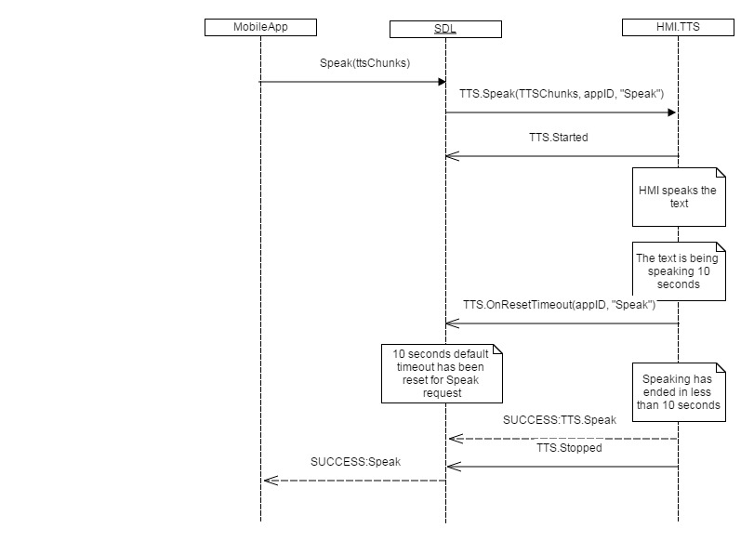

#### 10.13.2.2 OnResetTimeout for TTS.Speak GENERIC ERROR

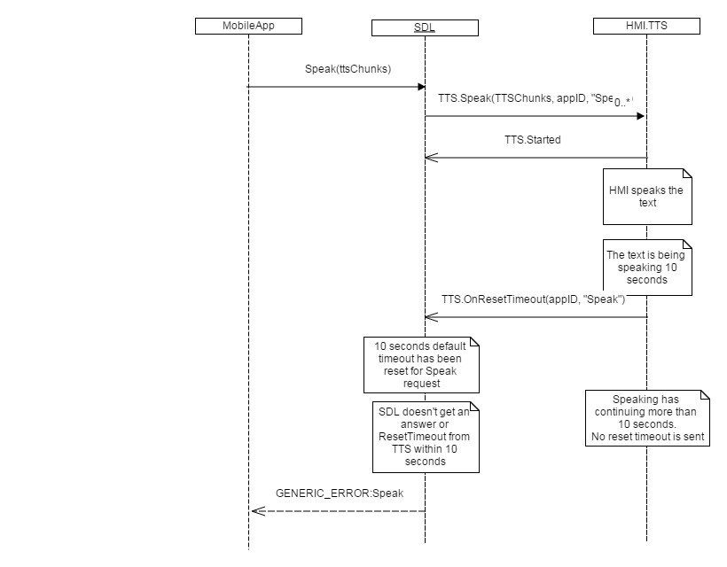

### 10.13.3 JSON Messages Examples

|  |
| --- |
| {  "jsonrpc" : "2.0",  "method" : "TTS.OnResetTimeout",  “params” :  {  “appID” : 123,  “methodName” : “Speak”    }  } |

### 10.13.4 D-Bus Messages Examples

|  |
| --- |
|  |

# 11 VehicleInfo Component Description

## 11.1 IsReady

### 11.1.1 Description

|  |  |
| --- | --- |
| **Type:** | Function |
| **Sender:** | SDL |
| **Purpose:** | Know if component is ready. |

The request comes after HMI`s readiness is confirmed via OnReady notification. SDL requires the information about whether the vehicle information can be collected and provided by HMI.

***Note:***

*If VehicleInfo component is responded to be unavailable, SDL will not further send the requests related to it.*

### 11.1.2 Request

#### 11.1.2.1 Behavior

***HMI must:***

- Check whether VehicleInfo component is present and ready

- Respond correspondingly to results of this check.

### 11.1.3 Response

***Note:***

*There is a difference in message type for WebSocket and D-Bus connection (see the table below).*

|  |  |  |  |  |  |
| --- | --- | --- | --- | --- | --- |
| **Result** | **Description** | **Message type** | | **Message Params** | **Notes** |
| **WebSocket** | **D-Bus** |
| Success | SUCCESS:  HMI provides the information about VehicleInfo availability. | JSON response | Method return | available,  code: 0 |  |
| Failure | INVALID_DATA:  The data sent is invalid (invalid JSON syntax) | JSON error message | Method return | code: 11 | Applicable for this RPC result codes.  Please see Result Enumeration for all SDL-supported codes. |
| DATA_NOT_AVAILABLE:  The information about VehicleInfo availability cannot be provided. | Code: 9 |
| GENERIC_ERROR:  The unknown issue occurred or other codes are not applicable. | code: 22 |

#### 11.1.3.1 Parameters

|  |  |  |  |
| --- | --- | --- | --- |
| **Param Name** | **Type** | **Mandatory** | **Description** |
| availabe | Boolean | true | Must be  - ‘true’ if UI is present and ready  - ‘false’ if not. |

### 11.1.4 Sequence Diagrams

#### 11.1.4.1 VehicleInfo.IsReady and preceding OnReady

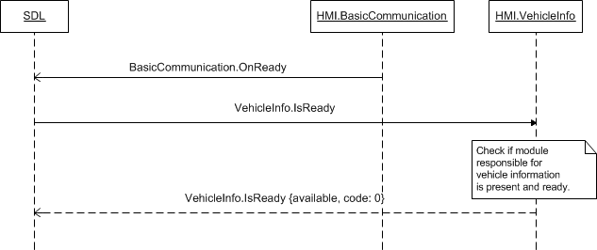

### 11.1.5 JSON Messages Examples

#### 11.1.5.1 Request

|  |
| --- |
| {  "id" : 17,  "jsonrpc" : "2.0",  "method" : "VehicleInfo.IsReady"  } |

#### 11.1.5.2 Response

|  |
| --- |
| {  "id" : 17,  "jsonrpc" : "2.0",  "result" :  {  "availabe" : true,  "code" : 0,  "method" : "VehicleInfo.IsReady"  }  } |

#### 11.1.5.3 Error message

|  |
| --- |
| {  "id" : 17,  "jsonrpc" : "2.0",  "error" :  {  "code" : 9,  "message" : "Data not available",  "data" :  {  "method" : "VehicleInfo.IsReady"  }  }  } |

### 11.1.6 D-Bus Messages Examples

#### 11.1.6.1 Request

|  |
| --- |
|  |

#### 11.1.6.2 Response

|  |
| --- |
|  |

#### 11.1.6.3 Failure

|  |
| --- |
|  |

## 11.2 GetVehicleType

### 11.2.1 Description

|  |  |
| --- | --- |
| **Type:** | Function |
| **Sender:** | SDL |
| **Purpose:** | Get the information about vehicle. |

SDL can store the information about the type of the host vehicle in smartDeviceLink.ini file stored in SDL directory. Still in current implementation, SDL will request the information via VehicleInfo.GetVehicleType after getting OnReady notification and response to VehicleInfo.IsReady from HMI.

### 11.2.2 Request

#### 11.2.2.1 Behavior

***HMI must:***

1. Check for the information requested (make, model, trim and model year).
2. Provide this information in response message (see section 11.2.3).

### 11.2.3 Response

***Note:***

*There is a difference in message type for WebSocket and D-Bus connection (see the table below).*

|  |  |  |  |  |  |
| --- | --- | --- | --- | --- | --- |
| **Result** | **Description** | **Message type** | | **Message Params** | **Notes** |
| **WebSocket** | **D-Bus** |
| Success | SUCCESS:  HMI provides the information about vehicle. | JSON response | Method return | vehicleType,  code: 0 |  |
| Failure | INVALID_DATA:  The data sent is invalid (invalid JSON syntax) | JSON error message | Method return | code: 11 | Applicable for this RPC result codes.  Please see Result Enumeration for all SDL-supported codes. |
| DATA_NOT_AVAILABLE:  The information about vahicle cannot be provided. | Code: 9 |
| GENERIC_ERROR:  The unknown issue occurred or other codes are not applicable. | code: 22 |

#### 11.2.3.1 Parameters

|  |  |  |  |
| --- | --- | --- | --- |
| **Param Name** | **Type** | **Mandatory** | **Description** |
| vehicleType | Common.VehicleType | true | See VehicleType |

#### 11.2.3.2 VehicleType

| **Param Name** | **Type** | **Mandatory** | **Additional** | **Description** |
| --- | --- | --- | --- | --- |
| make | String | false | maxlength = 500 | Make of the vehicle (e.g. Ford) |
| model | String | false | maxlength = 500 | Model of the vehicle (e.g. Fiesta) |
| modelYear | String | false | maxlength = 500 | Model Year of the vehicle (e.g. 2013) |
| trim | String | false | maxlength = 500 | Trim of the vehicle (e.g. SE) |

### 11.2.4 Sequence Diagrams

#### 11.2.4.1 GetVehicleType

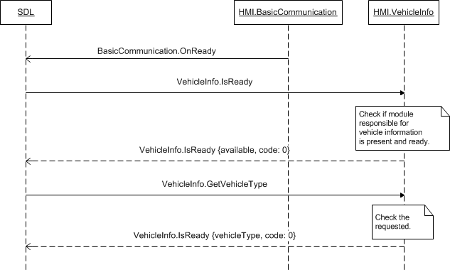

### 11.2.5 JSON Messages Examples

#### 11.2.5.1 Request

|  |
| --- |
| {  "id" : 21,  "jsonrpc" : "2.0",  "method" : "VehicleInfo.GetVehicleType"  } |

#### 11.2.5.2 Response

|  |
| --- |
| {  "id" : 21,  "jsonrpc" : "2.0",  "result" :  {  "vehicleType" :  [  “make” : “Ford”,  “model” : “Fusion”,  “modelYear” : “2013”,  “trim” : “SE”  ]  "code" : 0,  "method" : "VehicleInfo.GetVehicleType"  }  } |

#### 11.2.5.3 Error message

|  |
| --- |
| {  "id" : 21,  "jsonrpc" : "2.0",  "error" :  {  "code" : 9,  "message" : "The requested data is not available",  "data" :  {  "method" : "VehicleInfo.GetVehicleType"  }  }  } |

### 11.2.6 D-Bus Messages Examples

#### 11.2.6.1 Request

|  |
| --- |
|  |

#### 11.2.6.2 Response

|  |
| --- |
|  |

#### 11.2.6.3 Failure

|  |
| --- |
|  |

## 11.3 ReadDID

### 11.3.1 Description

|  |  |
| --- | --- |
| **Type:** | Function |
| **Sender:** | SDL |
| **Purpose:** | Receive the known DIDs. |

SDL requests to provide the known DIDs, i.e. Data Identifiers: addressed memory locations of the Electronic Control Unit (ECU).

### 11.3.2 Request

#### 11.3.2.1 Behavior

***HMI must:***

1. Check data in the requested locations (from didLocation parameter, which may be the array of addresses) on the named ECU (ecuName parameter).
2. Respond with one of the appropriate result codes (see section 11.3.3 Response for applicable result codes). And in case of SUCCESS return the array of didResult, each element of which refers the data from one of the requested locations:

* Data itself (data parameter in DIDResult structure), which is the hex byte string of however many bytes stored at named location. May be missing in case of any kind of error occurred (see section 11.3.3.3 VehicleDataResultCode).
* Address where it is taken from (didLocation parameter). Must be equal to the value from request.
* Individual result code (resultCode parameter), which defines the status of the data being provided.

#### 11.3.2.1 Parameters

| **Param Name** | **Type** | **Mandatory** | **Additional** | **Description** |
| --- | --- | --- | --- | --- |
| ecuName | Integer | true | Minvalue = 0  Maxvalue = 65535 | Name of ECU. |
| didLocation | Integer | true | Array = true  Minsize = 1  Maxsize = 1000  Minvalue = 0  Maxvalue = 65535 | The array of addresses of DID location on ECU. |
| appID | Integer | true | – | ID of the application that requested this RPC. |

### 11.3.3 Response

***Note:***

*There is a difference in message type for WebSocket and D-Bus connection (see the table below).*

|  |  |  |  |  |  |
| --- | --- | --- | --- | --- | --- |
| **Result** | **Description** | **Message type** | | **Message Params** | **Notes** |
| **WebSocket** | **D-Bus** |
| Success | SUCCESS:  HMI provides requested DIDs. | JSON response | Method return | didResult,  code: 0 |  |
| Failure | UNSUPPORTED_RESOURSE:  The named ECU does not exist. | JSON error message | Method return | code: 2 | Applicable for this RPC result codes.  Please see Result Enumeration for all SDL-supported codes. |
| TOO_MANY_PENDING_REQUESTS  Diagnostic module is overflow or busy | code: 18 |
| REJECTED:  1. The named ECU exists, but all of requested DIDs data is unavailable.  2. The HU System is busy with a higher priority event and rejects this RPC. | code: 4 |
| INVALID_DATA:  The data sent is invalid (invalid JSON syntax, parameters out of bounds or of wrong type) | code: 11 |
| DATA_NOT_AVAILABLE  Some of the data requested is not available (but not all) | code:9 |
| INVALID_ID  Wrong appID sent | code:13 |
| GENERIC_ERROR  1) The unknown issue occurred or other codes are not applicable.  2) In case HMI does not respond SDL's request during SDL default timeout (10 sec), SDL will return the result code to the corresponding mobile app's request | code: 22 |
| TRUNCATED_DATA:  One or more individual resultCodes (see DIDResult struct) conatins TRUNCATED_DATA. | didResult,  Code: 24 |

#### 11.3.3.1 Parameters

| **Param Name** | **Type** | **Mandatory** | **Additional** | **Description** |
| --- | --- | --- | --- | --- |
| didResult | Common.DIDResult | false | Array = true  Minsize = 0  Maxsize = 1000 | Array of requested DID results (with data if available).  See DIDResult |

#### 11.3.3.2 DIDResult

| **Param Name** | **Type** | **Mandatory** | **Additional** | **Description** |
| --- | --- | --- | --- | --- |
| resultCode | Common.VehicleDataResultCode | true | – | Individual DID result code.  See VehicleDataResultCode. |
| didLocation | Integer | true | minvalue = 0  maxvalue = 65535 | The address of DID location from the corresponding request. |
| data | String | false | maxlength = 5000 | The DID data which is the hex byte string of however many bytes are stored at that location |

#### 11.3.3.3 VehicleDataResultCode

| **Element name** | **Value** | **Short Description** |
| --- | --- | --- |
| SUCCESS | 0 | The requested data is accessible. |
| TRUNCATED_DATA | 1 | The data is truncated: not all of the requested information is available. |
| DISALLOWED | 2 | Not applicable |
| USER_DISALLOWED | 3 | The request is included in a functional group explicitly blocked by the User. |
| INVALID_ID | 4 | One of the provided IDs is not valid. |
| VEHICLE_DATA_NOT_AVAILABLE | 5 | The requested data is not available. |
| DATA_ALREADY_SUBSCRIBED | 6 | Not applicable |
| DATA_NOT_SUBSCRIBED | 7 | Not applicable |
| IGNORED | 8 | Not applicable |

### 11.3.4 Sequence Diagrams

#### 11.3.4.1 ReadDID general processing

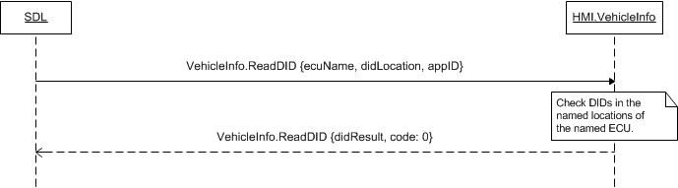

#### 11.3.4.2 ReeadDID with expanded didResult in response

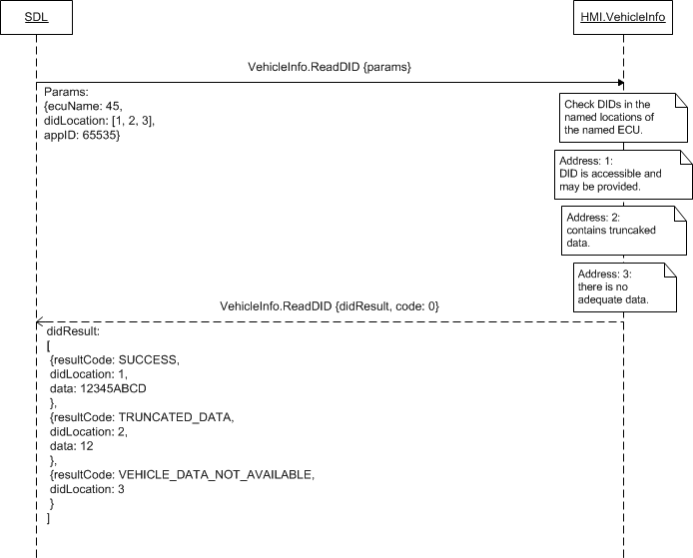

### 11.3.5 JSON Messages Examples

#### 11.3.5.1 Request

|  |
| --- |
| {  "id" : 158,  "jsonrpc" : "2.0",  "method" : "VehicleInfo.ReadDID",  “params” :  {  “ecuName” : 1287,  “didLocation” : [35, 48, 182],  “appID” : 93  }  } |

#### 11.3.5.2 Response

|  |
| --- |
| {  "id" : 158,  "jsonrpc" : "2.0",  "result" :  {  "didResult" :  [  {  “resultCode” : SUCCESS,  “didLocation” : 35,  “data” : “38AF”  },  {  “resultCode” : TRUNCATED_DATA,  “didLocation” : 48,  “data” : “35”  },  {  “resultCode” : INVALID_ID,  “didLocation” : 182  }  ],  "code" : 0,  "method" : "VehicleInfo.ReadDID"  }  } |

#### 11.3.5.3 Error message

|  |
| --- |
| {  "id" : 158,  "jsonrpc" : "2.0",  "error" :  {  "code" : 2,  "message" : "The requested ECU does not exist",  "data" :  {  "method" : "VehicleInfo.ReadDID"  }  }  } |

### 11.3.6 D-Bus Messages Examples

#### 11.3.6.1 Request

|  |
| --- |
|  |

#### 11.3.6.2 Response

|  |
| --- |
|  |

#### 11.3.6.3 Failure

|  |
| --- |
|  |

## 11.4 GetDTCs

### 11.4.1 Description

|  |  |
| --- | --- |
| **Type:** | Function |
| **Sender:** | SDL |
| **Purpose:** | Receive the known DTCs. |

SDL requests to provide the known Diagnostic Trouble Codes (DTCs) of the Electronic Control Unit (ECU).

### 11.4.2 Request

#### 11.4.2.1 Behavior

***HMI must:***

1. Check the requested DTCs using provided information of ecuName and dtcMask.
2. Respond with one of the appropriate result codes (see section 11.3.3 Response for applicable result codes). And in case of SUCCESS return the following:

* 2 byte ECU Header (ecuHeader parameter) that must contain the information whether the below list of DTCs is truncated or not.
* Array of all reported DTCs on module (dtc parameter), each of the elements is expected to consist of 4 bytes: 3 bytes of data and 1 byte of status.

#### 11.4.2.1 Parameters

| **Param Name** | **Type** | **Mandatory** | **Additional** | **Description** |
| --- | --- | --- | --- | --- |
| ecuName | Integer | true | minvalue = 0  maxvalue = 65535 | Name of ECU. |
| dtcMask | Integer | false | minvalue = 0  maxvalue = 255 | DTC Mask Byte to be sent in diagnostic request to module |
| appID | Integer | true | – | ID of the application that requested this RPC. |

### 11.4.3 Response

***Note:***

*There is a difference in message type for WebSocket and D-Bus connection (see the table below).*

|  |  |  |  |  |  |
| --- | --- | --- | --- | --- | --- |
| **Result** | **Description** | **Message type** | | **Message Params** | **Notes** |
| **WebSocket** | **D-Bus** |
| Success | SUCCESS:  HMI provides requested DTCs. | JSON response | Method return | ecuHeader,  dtc,  code: 0 |  |
| Failure | TOO_MANY_PENDING_REQUESTS  Diagnostic module is overflow or busy | JSON error message | Method return | code: 18 |  |
| UNSUPPORTED_RESOURCE:  The named ECU does not exist. | code: 2 | Applicable for this RPC result codes.  Please see Result Enumeration for all SDL-supported codes. |
| REJECTED:  1. The named ECU exists, but all of requested DIDs data is unavailable.  2. The HU System is busy with a higher priority event and rejects this RPC. | code: 4 |
| DATA_NOT_AVAILABLE  Some of the data requested is not available (but not all) | code:9 |
| INVALID_ID  Wrong appID sent | code: 13 |
| GENERIC_ERROR  1) The unknown issue occurred or other codes are not applicable.  2) In case HMI does not respond SDL's request during SDL default timeout (10 sec), SDL will return the result code to the corresponding mobile app's request | code: 22 |
| TRUNCATED_DATA:  One or more DTCs in the array is truncated . | ecuHeader,  dtc,  Code: 24 |

#### 11.4.3.1 Parameters

| **Param Name** | **Type** | **Mandatory** | **Additional** | **Description** |
| --- | --- | --- | --- | --- |
| ecuHeader | Integer | true | minvalue = 0  maxvalue = 65535 | 2 byte ECU Header for DTC response. Contains the information whether the below list of DTCs is truncated. |
| dtc | String | false | Array = true  Minsize = 1  Maxsize = 15  Maxlength = 10 | Array of all reported DTCs on module. Each DTC is represented with 4 bytes:  - 3 bytes for data  - 1 byte for status |

### 11.4.4 Sequence Diagrams

#### 11.4.4.1 GetDTCs

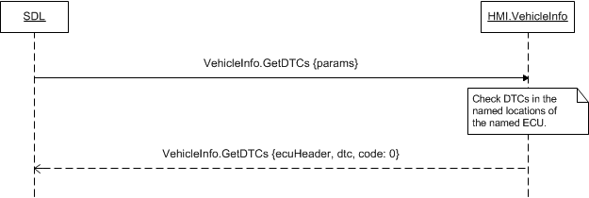

### 11.4.5 JSON Messages Examples

#### 11.4.5.1 Request

|  |
| --- |
| {  "id" : 139,  "jsonrpc" : "2.0",  "method" : "VehicleInfo.GetDTCs",  “params” :  {  “ecuName” : 56  “dtcMask” : 84,  “appID” : 65645  }  } |

#### 11.4.5.2 Response

|  |
| --- |
| {  "id" : 139,  "jsonrpc" : "2.0",  "result" :  {  "ecuHeader" : 6534,  "dtc" : [“84752093”, “28237”, “748398”],  "code" : 0,  "method" : "VehicleInfo.GetDTCs"  }  } |

#### 11.4.5.3 Error message

|  |
| --- |
| {  "id" : 139,  "jsonrpc" : "2.0",  "error" :  {  "code" : 9,  "message" : "Data not available",  "data" :  {  "method" : "VehicleInfo.GetDTCs"  }  }  } |

### 11.4.6 D-Bus Messages Examples

#### 11.4.6.1 Request

|  |
| --- |
|  |

#### 11.4.6.2 Response

|  |
| --- |
|  |

#### 11.4.6.3 Failure

|  |
| --- |
|  |

## 11.5 DiagnosticMessage

### 11.5.1 Description

|  |  |
| --- | --- |
| **Type:** | Function |
| **Sender:** | SDL |
| **Purpose:** | Vehicle diagnostic |

Non periodic vehicle diagnostic request.

### 11.5.2 Request

#### 11.5.2.1 Behavior

***HMI must:***

1. Check the requested data using provided information of targetID (name of ECU), messageLength and messageData.
2. Respond with one of the appropriate result codes (see section 11.3.3 Response for applicable result codes). And in case of SUCCESS return messageDataResult which is an array of bytes comprising CAN message result.

#### 11.5.2.1 Parameters

| **Param Name** | **Type** | **Mandatory** | **Additional** | **Description** |
| --- | --- | --- | --- | --- |
| targetID | Integer | true | Minvalue = 0  Maxvalue = 65535 | Name of target ECU. |
| messageLength | Integer | true | Minvalue = 0  Maxvalue = 65535 | Length of message (in bytes). |
| messageData | Integer | true | Array = true  Minsize = 1  Maxsize = 65535  Minvalue = 0  Maxvalue = 255 | Array of bytes comprising CAN message. |
| appID | Integer | true | - | ID of application that requested this RPC. |

### 11.5.3 Response

***Note:***

*There is a difference in message type for WebSocket and D-Bus connection (see the table below).*

|  |  |  |  |  |  |
| --- | --- | --- | --- | --- | --- |
| **Result** | **Description** | **Message type** | | **Message Params** | **Notes** |
| **WebSocket** | **D-Bus** |
| Success | SUCCESS:  HMI provides requested DTCs. | JSON response | Method return | messageDataResult,  code: 0 |  |
| Failure | UNSUPPORTED_RESOURCE:  The named ECU does not exist. | JSON error message | Method return | code: 2 | Applicable for this RPC result codes.  Please see Result Enumeration for all SDL-supported codes. |
| TOO_MANY_PENDING_REQUESTS  Diagnostic module is overflow or busy | code: 18 |
| REJECTED:  The HU System is busy with a higher priority event and rejects this RPC. | Code: 4 |
| DATA_NOT_AVAILABLE  The data requested is not available | code:9 |
| INVALID_ID  Wrong appID sent | code:13 |
| GENERIC_ERROR  1) The unknown issue occurred or other codes are not applicable.  2) In case HMI does not respond SDL's request during SDL default timeout (10 sec), SDL will return the result code to the corresponding mobile app's request | code: 22 |
|  | TRUNCATED_DATA:  One or more messages in the array is truncated |  |  | messageDataResult,  code: 24 |  |

#### 11.5.3.1 Parameters

| **Param Name** | **Type** | **Mandatory** | **Additional** | **Description** |
| --- | --- | --- | --- | --- |
| messageDataResult | Integer | true | Array = true  Minsize = 1  Maxsize = 65535  Minvalue = 0  Maxvalue = 255 | Array of bytes comprising CAN message result. |

### 11.5.4 Sequence Diagrams

#### 11.5.4.1 DiagnosticMessage

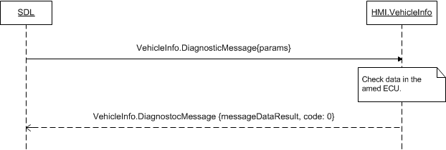

### 11.5.5 JSON Messages Examples

#### 11.5.5.1 Request

|  |
| --- |
| {  "id" : 139,  "jsonrpc" : "2.0",  "method" : "VehicleInfo.DiagnostocMessage",  “params” :  {  “targetID” : 5456  “messageLength” : 1084,  “messageData” : [1,2,3,4,5,6,7,8,9]  }  } |

#### 11.5.5.2 Response

|  |
| --- |
| {  "id" : 139,  "jsonrpc" : "2.0",  "result" :  {  "messageDataResult" : [1,2,3,4,5,6],  "code" : 0,  "method" : "VehicleInfo.GetDTCs"  }  } |

#### 11.5.5.3 Error message

|  |
| --- |
| {  "id" : 139,  "jsonrpc" : "2.0",  "error" :  {  "code" : 9,  "message" : "Data not available",  "data" :  {  "method" : "VehicleInfo.GetDTCs"  }  }  } |

### 11.5.6 D-Bus Messages Examples

#### 11.5.6.1 Request

|  |
| --- |
|  |

#### 11.5.6.2 Response

|  |
| --- |
|  |

#### 11.5.6.3 Failure

|  |
| --- |
|  |

## 11.6 SubscribeVehicleData

### 11.6.1 Description

|  |  |
| --- | --- |
| **Type:** | Function |
| **Sender:** | SDL |
| **Purpose:** | Subscribe for definite vehicle data types updates |

SDL provides the data types for which periodic updates an application of requested appID would like to subscribe. In case of no errors, SDL expects to receive the information via OnVehicleData from HMI whenever the subscribed data type gets updates.

The request may come for the application being whatever active or in background on HMI.

### 11.6.2 Request

#### 11.6.2.1 Behavior

***HMI must:***

1. Check whether the periodic updates can be provided for requested data type. The data type is defined with Boolean parameters of gps, speed, rpm and other that are provided in *section 11.6.2.2*:

* Parameters of true value have to be subscribed
* One or several or all of the parameters from section 11.6.2.2 may be included into request..

***Note:***

*Within a request SDL will provide at least one ‘ture’-value parameter of data type to be subscribed.*

2. Remember the requested data type in the list of members that get OnVehicleData update notifications.

3. Respond with one of appropriate result codes (see section *11.6.3 Response*). And in case of SUCCESS return the parameter(s) of the name(s) equal to those requested for subscription. The returned parameters must contain

* Data type (see *section 11.6.3.3*) correspondent to the name of related parameter (for example,

*gps* : {VEHICLEDATA_*GPS*, SUCCESS}, *speed* : {VEHICLEDATA_*SPEED*, SUCCESS}).

* And individual VehicleDataResult code from *section 11.6.3.4*. The codes different from SUCCESS will inform SDL about the status of the named data type and whether the updates would be provided.

4. Provide OnVehicleData notifications whenever the successfully subscribed vehicle data type chnges until SDL unsubscribes from updates via UnsubscribeVehicleData (see section 11.7).

***HMI is recommended to:***

Display the HMI-defined popup requesting the User for allowance to provide periodic updates of the named data type(s) for the named application.

#### 11.6.2.2 Parameters

| **Param Name** | **Type** | **Mandatory** | **Description** |
| --- | --- | --- | --- |
| gps | Boolean | false | Subscribe for GPS data updates.  Information related to GPS data: number of satellites, compass direction, longitude, latitude, etc. See GPSData |
| speed | Boolean | false | Subscribe for vehicle speed updates to be provided in kilometers per hour. |
| rpm | Boolean | false | Subscribe for the number of engine revolutions per minute updates. |
| fuelLevel | Boolean | false | Subscribe for the fuel level in the tank updates (percentage). |
| fuelLevel_State | Boolean | false | Subscribe for the fuel level state updates: normal, low, etc. See ComponentVolumeStatus. |
| instantFuelConsumption | Boolean | false | Subscribe for the instantaneous fuel consumption updates to be provided in microliters. |
| externalTemperature | Boolean | false | Subscribe for the external temperature to be provided in degrees Celsius. |
| prndl | Boolean | false | Subscribe for gear stick position updates: first, second, etc. See PRNDL. |
| tirePressure | Boolean | false | Subscribe for tire pressure status updates:  - The warning status (on, off, etc.)  - The status of the tire pressure itself: normal, low, etc.  See TireStatus. |
| odometer | Boolean | false | Subscribe for the information from odometer to be provided in km. |
| beltStatus | Boolean | false | Subscribe for the information of the seat belts status updates: deployed, buckled. See BeltStatus. |
| bodyInformation | Boolean | false | Subscribe for updates of body information including power modes: park brake status, ignition and ignition stable status. See BodyInformation. |
| deviceStatus | Boolean | false | Subscribe for updates of device status including signal and battery strength. See DeviceStatus. |
| driverBraking | Boolean | false | Subscribe for the information of the brake pedal status updates: on, off, etc. See VehicleDataEventStatus. |
| wiperStatus | Boolean | false | Subscribe for updates of the wipers status: when they are manually on, manually off, stalled, etc. See WiperStatus. |
| headLampStatus | Boolean | false | Subscribe for the updates of the head lamps status: when they are on, off, etc. See HeadLampStatus. |
| engineTorque | Boolean | false | Subscribe for the updates of the torque value for engine (in Nm) on non-diesel variants |
| accPedalPosition | Boolean | false | Subscribe for the information of accelerator pedal position (percentage depressed). |
| steeringWheelAngle | Boolean | false | Subscribe for the information of current angle of the steering wheel (in degrees) |
| appID | Integer | true | Id of application that concerns this RPC. |

#### FORD specific data (extension of 11.6.2.2 table)

| **Param Name** | **Type** | **Mandatory** | **Description** |
| --- | --- | --- | --- |
| eCallInfo | Boolean | false | Subscribe for Emergency Call notification and confirmation data. See ECallInfo. |
| airbagStatus | Boolean | false | Subscribe for the information on status of air bags updates. See AirbagStatus. |
| emergencyEvent | Boolean | false | Subscribe for the information related to an emergency event (if it occurred). See EmergencyEvent. |
| clusterModes | Boolean | false | Subscribe for the status modes of cluster updates. See ClusterModeStatus. |
| myKey | Boolean | false | Subscribe for the information related to MyKey feature. See MyKey. |

### 11.6.3 Response

***Note:***

*There is a difference in message type for WebSocket and D-Bus connection (see the table below).*

|  |  |  |  |  |  |
| --- | --- | --- | --- | --- | --- |
| **Result** | **Description** | **Message type** | | **Message Params** | **Notes** |
| **WebSocket** | **D-Bus** |
| Success | SUCCESS:  HMI processes the request successfully and returns the information about the data type(s) and the corresponding individual subscription result code (see p.3 of section 11.6.2.1) | JSON response | Method return | Parameters of the names equal to requested ones,  code: 0 | See *11.6.3.1 Parameters*. |
| Failure | IGNORED:  Subscribtion is requested for the single data which is already subscribed @TODO – to clarify with SDL team | JSON error message | Method return | Parameters of the names equal to requested ones  code: 6 | Applicable for this RPC result codes.  Please see Result Enumeration for all SDL-supported codes. |
| INVALID_ID  Wrong appID | code:13 |
| GENERIC_ERROR  1) The unknown issue occurred or other codes are not applicable.  2) In case HMI does not respond SDL's request during SDL default timeout (10 sec), SDL will return the result code to the corresponding mobile app's request | code: 22 |

#### 11.6.3.1 Parameters

| **Param Name** | **Type** | **Mandatory** | **Description** |
| --- | --- | --- | --- |
| gps | Common.VehicleDataResult | false | GPS data subscription status.  See *section 11.6.3.2 VehicleDataResult* (VEHICLEDATA_GPS must be used). |
| speed | Common.VehicleDataResult | false | Vehicle speed subscription status.  See *section 11.6.3.2 VehicleDataResult* (VEHICLEDATA_SPEED must be used). |
| rpm | Common.VehicleDataResult | false | The engine number of revolutions per minute data subscription status.  See *section 11.6.3.2 VehicleDataResult* (VEHICLEDATA_RPM must be used). |
| fuelLevel | Common.VehicleDataResult | false | The fuel level data subscription status.  See *section 11.6.3.2 VehicleDataResult* (VEHICLEDATA_FUELLEVEL must be used). |
| fuelLevel_State | Common.VehicleDataResult | false | The fuel level state data subscription status.  See *section 11.6.3.2 VehicleDataResult* (VEHICLEDATA_FUELLEVEL_STATE must be used). |
| instantFuelConsumption | Common.VehicleDataResult | false | The instantaneous fuel consumption data subscription status.  See *section 11.6.3.2 VehicleDataResult* (VEHICLEDATA_FUELCONSUMPTION must be used). |
| externalTemperature | Common.VehicleDataResult | false | The external temperature data subscription status.  See *section 11.6.3.2 VehicleDataResult* (VEHICLEDATA_EXTERNTEMP must be used). |
| prndl | Common.VehicleDataResult | false | The gear stick position data subscription status.  See *section 11.6.3.2 VehicleDataResult* (VEHICLEDATA_PRNDL must be used). |
| tirePressure | Common.VehicleDataResult | false | The tire pressure data subscription status.  See *section 11.6.3.2 VehicleDataResult* (VEHICLEDATA_TIREPRESSURE must be used). |
| odometer | Common.VehicleDataResult | false | Odometer data subscription status.  See *section 11.6.3.2 VehicleDataResult* (VEHICLEDATA_ODOMETER must be used). |
| beltStatus | Common.VehicleDataResult | false | The seat belts status data subscription status.  See *section 11.6.3.2 VehicleDataResult* (VEHICLEDATA_BELTSTATUS must be used). |
| bodyInformation | Common.VehicleDataResult | false | The body information data subscription status.  See *section 11.6.3.2 VehicleDataResult* (VEHICLEDATA_BODYINFO must be used). |
| deviceStatus | Common.VehicleDataResult | false | The device status data subscription status.  See *section 11.6.3.2 VehicleDataResult* (VEHICLEDATA_DEVICESTATUS must be used). |
| driverBraking | Common.VehicleDataResult | false | The brake pedal status data subscription status.  See *section 11.6.3.2 VehicleDataResult* (VEHICLEDATA_BRAKING must be used). |
| wiperStatus | Common.VehicleDataResult | false | The wipers status data subscription status.  See *section 11.6.3.2 VehicleDataResult* (VEHICLEDATA_WIPERSTATUS must be used). |
| headLampStatus | Common.VehicleDataResult | false | The head lamps status data subscription status.  See *section 11.6.3.2 VehicleDataResult* (VEHICLEDATA_HEADLAMPSTATUS must be used). |
| engineTorque | Common.VehicleDataResult | false | Torque value for engine data subscription status.  See *section 11.6.3.2 VehicleDataResult* (VEHICLEDATA_ENGINETORQUE must be used). |
| accPedalPosition | Common.VehicleDataResult | false | Accelerator pedal position data subscription status.  See *section 11.6.3.2 VehicleDataResult* (VEHICLEDATA_ACCPEDAL must be used). |
| steeringWheelAngle | Common.VehicleDataResult | false | Current angle of the steering wheel data subscription status.  See *section 11.6.3.2 VehicleDataResult* (VEHICLEDATA_STEERINGWHEEL must be used). |

#### FORD specific data (extension of 11.6.3.1 table)

| **Param Name** | **Type** | **Mandatory** | **Description** |
| --- | --- | --- | --- |
| eCallInfo | Common.VehicleDataResult | false | Emergency Call data subscription status.  See *section 11.6.3.2 VehicleDataResult* (VEHICLEDATA_ECALLINFO must be used). |
| airbagStatus | Common.VehicleDataResult | false | The air bags status data subscription status.  See *section 11.6.3.2 VehicleDataResult* (VEHICLEDATA_AIRBAGSTATUS must be used). |
| emergencyEvent | Common.VehicleDataResult | false | The emergency event data subscription status.  See *section 11.6.3.2 VehicleDataResult* (VEHICLEDATA_EMERGENCYEVENT must be used). |
| clusterModes | Common.VehicleDataResult | false | Cluster modes status data subscription status.  See *section 11.6.3.2 VehicleDataResult* (VEHICLEDATA_CLUSTERMODESTATUS must be used). |
| myKey | Common.VehicleDataResult | false | MyKey data subscription status.  See *section 11.6.3.2 VehicleDataResult* (VEHICLEDATA_MYKEY must be used). |

#### 11.6.3.2 VehicleDataResult

| **Param Name** | **Type** | **Mandatory** | **Description** |
| --- | --- | --- | --- |
| dataType | Common.VehicleDataType | true | The data type being subscribed. Must correspond to the name of related parameter from section 11.6.3.1. |
| resultCode | Common.VehicleDataResultCode | true | Result code that defines the subscription status for the named data type. |

#### 11.6.3.3 VehicleDataType Enumeration

| **Element name** | **Value** | **Short Description** |
| --- | --- | --- |
| VEHICLEDATA_GPS | 0 | Parameter that must contain this value: gps |
| VEHICLEDATA_SPEED | 1 | Parameter that must contain this value: speed |
| VEHICLEDATA_RPM | 2 | Parameter that must contain this value: rpm |
| VEHICLEDATA_FUELLEVEL | 3 | Parameter that must contain this value: fuelLevel |
| VEHICLEDATA_FUELLEVEL_STATE | 4 | Parameter that must contain this value: fuelLevel_State |
| VEHICLEDATA_FUELCONSUMPTION | 5 | Parameter that must contain this value: instantFuelConsumption |
| VEHICLEDATA_EXTERNTEMP | 6 | Parameter that must contain this value: externalTemperature |
| VEHICLEDATA_VIN | 7 | Not used for subscription |
| VEHICLEDATA_PRNDL | 8 | Parameter that must contain this value: prndl |
| VEHICLEDATA_TIREPRESSURE | 9 | Parameter that must contain this value: tirePressure |
| VEHICLEDATA_ODOMETER | 10 | Parameter that must contain this value: odometer |
| VEHICLEDATA_BELTSTATUS | 11 | Parameter that must contain this value: beltStatus |
| VEHICLEDATA_BODYINFO | 12 | Parameter that must contain this value: bodyInformation |
| VEHICLEDATA_DEVICESTATUS | 13 | Parameter that must contain this value: deviceStatus |
| VEHICLEDATA_ECALLINFO | 14 | Parameter that must contain this value: eCallInfo |
| VEHICLEDATA_AIRBAGSTATUS | 15 | Parameter that must contain this value: airbagStatus |
| VEHICLEDATA_EMERGENCYEVENT | 16 | Parameter that must contain this value: emergencyEvent |
| VEHICLEDATA_CLUSTERMODESTATUS | 17 | Parameter that must contain this value: clusterModes |
| VEHICLEDATA_MYKEY | 18 | Parameter that must contain this value: myKey |
| VEHICLEDATA_BRAKING | 19 | Parameter that must contain this value: driverBraking |
| VEHICLEDATA_WIPERSTATUS | 20 | Parameter that must contain this value: wiperStatus |
| VEHICLEDATA_HEADLAMPSTATUS | 21 | Parameter that must contain this value: headLampStatus |
| VEHICLEDATA_BATTVOLTAGE | 22 | Not used for subscription |
| VEHICLEDATA_ENGINETORQUE | 23 | Parameter that must contain this value: engineTorque |
| VEHICLEDATA_ACCPEDAL | 24 | Parameter that must contain this value: accPedalPosition |
| VEHICLEDATA_STEERINGWHEEL | 25 | Parameter that must contain this value: steeringWheelAngle |

#### 11.6.3.4 VehicleDataResultCode Enumeration

| **Element name** | **Value** | **Short Description** |
| --- | --- | --- |
| SUCCESS | 0 | The named data type is successfully subscribed. Whenever it receives the updates, HMI will notify SDL about the event via OnVehicleData. |
| TRUNCATED_DATA | 1 | Not applicable. |
| DISALLOWED | 2 | Not applicable. |
| USER_DISALLOWED | 3 | Providing periodic updates for the named data type is disallowed by the User. |
| INVALID_ID | 4 | Not applicable. |
| VEHICLE_DATA_NOT_AVAILABLE | 5 | The named data type is not supported (or reported, published) by HMI. |
| DATA_ALREADY_SUBSCRIBED | 6 | The named data type is already marked by HMI to receive periodic update notifications. |
| DATA_NOT_SUBSCRIBED | 7 | Not applicable. |
| IGNORED | 8 | Not applicable. |

### 11.6.4 Sequence Diagrams

#### 11.6.4.1 SubscribeVehicleData

### 11.6.5 JSON Messages Examples

#### 11.6.5.1 Request

|  |
| --- |
| {  "id" : 139,  "jsonrpc" : "2.0",  "method" : "VehicleInfo.SubscribeVehicleData",  “params” :  {  “gps” : true,  “speed” : true,  “fuelLevel_State” : true,  “externalTemperature” : true,  “prndl” : true,  “tirePressure” : true,  “odometer” : true,  “beltStatus” : true,  “bodyInformation” : true,  “deviceStatus” : true,  “wiperStatus” : true,  “headLampStatus” : true,  “accPedalPosition” : true,  }  } |

#### 11.6.5.2 Response

|  |
| --- |
| {  "id" : 139,  "jsonrpc" : "2.0",  "result" :  {  “gps” :  {  dataType : VEHICLEDATA_GPS,  resultCode : SUCCESS  },  “speed” :  {  dataType : VEHICLEDATA_SPEED,  resultCode : DATA_ALREADY_SUBSCRIBED  },  “fuelLevel_State” :  {  dataType : VEHICLEDATA_FUELLEVEL,  resultCode : SUCCESS  },  “externalTemperature” :  {  dataType : VEHICLEDATA_EXTERNTEMP,  resultCode : VEHICLE_DATA_NOT_AVAILABLE  },  “prndl” :  {  dataType : VEHICLEDATA_PRNDL,  resultCode : VEHICLE_DATA_NOT_AVAILABLE  },  “tirePressure” :  {  dataType : VEHICLEDATA_TIREPRESSURE,  resultCode : SUCCESS  },  “odometer” :  {  dataType : VEHICLEDATA_odometer,  resultCode : SUCCESS  },    “beltStatus” :  {  dataType : VEHICLEDATA_BELTSTATUS,  resultCode : SUCCESS  },  “bodyInformation” :  {  dataType : VEHICLEDATA_BODYINFO,  resultCode : SUCCESS  },  “deviceStatus” :  {  dataType : VEHICLEDATA_DEVICESTATUS,  resultCode : DATA_ALREADY_SUBSCRIBED  },  “wiperStatus” :  {  dataType : VEHICLEDATA_WIPERSTATUS,  resultCode : SUCCESS  },  “headLampStatus” :  {  dataType : HEADLAMPSTATUS,  resultCode : SUCCESS  },  “accPedalPosition” :  {  dataType : VEHICLEDATA_ACCPEDAL,  resultCode : VEHICLE_DATA_NOT_AVAILABLE  },  "code" : 0,  "method" : "VehicleInfo.SubscribeVehicleData"  }  } |

#### 11.6.5.3 Error message

|  |
| --- |
| {  "id" : 139,  "jsonrpc" : "2.0",  "error" :  {  "code" : 6,  "message" : "All of requested data types is subscribed already",  "data" :  {  "method" : "VehicleInfo.SubscribeVehicleData"  }  }  } |

### 11.6.6 D-Bus Messages Examples

#### 11.6.6.1 Request

|  |
| --- |
|  |

#### 11.6.6.2 Response

|  |
| --- |
|  |

#### 11.6.6.3 Failure

|  |
| --- |
|  |

## 11.7 UnSubscribeVehicleData

### 11.7.1 Description

|  |  |
| --- | --- |
| **Type:** | Function |
| **Sender:** | SDL |
| **Purpose:** | Unsubscribe from definite vehicle data type(s) updates |

Initially SDL requests HMI via SubscribeVehicleData to provide periodic updates for the named data types. Once HMI responds successfully (see section 11.6 SubscribeVehicleData), it shall inform SDL upon every update of the named data type via OnVehicleData notification.

Via UnsubscribeVehicleData SDL requests HMI to stop sending updates for the named data type(s) previously subscribed.

The request may come for the application being whatever active or in background on HMI.

### 11.7.2 Request

#### 11.7.2.1 Behavior

***HMI must:***

1. Check whether the named data type may be successfully unsubscribed. The data type is defined with Boolean parameters of gps, speed, rpm and other that are provided in *section 11.7.2.2*:

* Parameters of true value have to be unsubscribed
* One or several or all of the parameters from section 11.7.2.2 may be included into request.
* One or several or all of the parameters previously subscribed may be included into request.

***Note:***

*Within a request SDL will provide at least one ‘true’-value parameter of data type to be unsubscribed.*

2. Delete the requested data type from the list of members that get OnVehicleData update notifications.

3. Respond with one of appropriate result codes (see section *11.7.3 Response*). And in case of SUCCESS return the parameter(s) of the name(s) equal to those requested for subscription. The returned parameters must contain

* Data type (see *section 11.7.3.3*) correspondent to the name of related parameter (for example,

*gps* : {VEHICLEDATA_*GPS*, SUCCESS}, *speed* : {VEHICLEDATA_*SPEED*, SUCCESS}).

* And individual VehicleDataResult code from *section 11.7.3.4*. The codes different from SUCCESS will inform SDL about the status of the named data type and whether it is unsubscribed indeed.

4. Stop providing OnVehicleData notifications upon any changes of successfully unsubscribed vehicle data type.

#### 11.7.2.2 Parameters

| **Param Name** | **Type** | **Mandatory** | **Description** |
| --- | --- | --- | --- |
| gps | Boolean | false | Unsubscribe from GPS data updates.  Information related to GPS data: number of satellites, compass direction, longitude, latitude, etc. See GPSData |
| speed | Boolean | false | Unsubscribe from vehicle speed updates that are provided in kilometers per hour. |
| rpm | Boolean | false | Unsubscribe from the number of engine revolutions per minute updates. |
| fuelLevel | Boolean | false | Unsubscribe from the fuel level in the tank updates (percentage). |
| fuelLevel_State | Boolean | false | Unsubscribe from the fuel level state updates: normal, low, etc. See ComponentVolumeStatus. |
| instantFuelConsumption | Boolean | false | Unsubscribe from the instantaneous fuel consumption updates to be provided in microliters. |
| externalTemperature | Boolean | false | Unsubscribe from the external temperature that is provided in degrees Celsius. |
| prndl | Boolean | false | Unsubscribe from gear stick position updates: first, second, etc. See PRNDL. |
| tirePressure | Boolean | false | Unsubscribe from tire pressure status updates:  - The warning status (on, off, etc.)  - The status of the tire pressure itself: normal, low, etc.  See TireStatus. |
| odometer | Boolean | false | Unsubscribe from the information from odometer that is provided in km. |
| beltStatus | Boolean | false | Unsubscribe from the information of the seat belts status updates: deployed, buckled. See BeltStatus. |
| bodyInformation | Boolean | false | Unsubscribe from updates of body information including power modes: park brake status, ignition and ignition stable status. See BodyInformation. |
| deviceStatus | Boolean | false | Unsubscribe from updates of device status including signal and battery strength. See DeviceStatus. |
| driverBraking | Boolean | false | Unsubscribe from the information of the brake pedal status updates: on, off, etc. See VehicleDataEventStatus. |
| wiperStatus | Boolean | false | Unsubscribe from updates of the wipers status: when they are manually on, manually off, stalled, etc. See WiperStatus. |
| headLampStatus | Boolean | false | Unsubscribe from the updates of the head lamps status: when they are on, off, etc. See HeadLampStatus. |
| engineTorque | Boolean | false | Unsubscribe from the updates of the torque value for engine (in Nm) on non-diesel variants |
| accPedalPosition | Boolean | false | Unsubscribe from the information of accelerator pedal position (percentage depressed). |
| steeringWheelAngle | Boolean | false | Unsubscribe from the information of current angle of the steering wheel (in degrees) |
| appID | Integer | true | Id of application that requested this RPC. |

### 11.7.3 Response

***Note:***

*There is a difference in message type for WebSocket and D-Bus connection (see the table below).*

|  |  |  |  |  |  |
| --- | --- | --- | --- | --- | --- |
| **Result** | **Description** | **Message type** | | **Message Params** | **Notes** |
| **WebSocket** | **D-Bus** |
| Success | SUCCESS:  HMI processes the request successfully and returns the information about the data type(s) and the corresponding individual unsubscription result code (see p.3 of section 11.7.2.1) | JSON response | Method return | Parameters of the names equal to requested ones,  code: 0 | See 11.7.3.1 Parameters. |
| Failure | IGNORED:  Unsubscribe is requested for the single data not yet subscribed |  |  | Parameters of the names equal to requested ones,  Code:6 | Applicable for this RPC result codes.  Please see Result Enumeration for all SDL-supported codes. |
| DATA_NOT_AVAILABLE:  All of requested data types did not and will not receive update notifications since they are not supported (or reported, published) by HMI. | JSON error message | Method return | code: 9 |
| INVALID_ID  Wrong appID | code:13 |
| GENERIC_ERROR  1) The unknown issue occurred or other codes are not applicable.  2) In case HMI does not respond SDL's request during SDL default timeout (10 sec), SDL will return the result code to the corresponding mobile app's request | code: 22 |

#### 11.7.3.1 Parameters

| **Param Name** | **Type** | **Mandatory** | **Description** |
| --- | --- | --- | --- |
| gps | Common.VehicleDataResult | false | GPS data unsubscription status.  See *section 11.7.3.2 VehicleDataResult* (VEHICLEDATA_GPS must be used). |
| speed | Common.VehicleDataResult | false | Vehicle speed unsubscription status.  See *section 11.7.3.2 VehicleDataResult* (VEHICLEDATA_SPEED must be used). |
| rpm | Common.VehicleDataResult | false | The engine number of revolutions per minute data unsubscription status.  See *section 11.7.3.2 VehicleDataResult* (VEHICLEDATA_RPM must be used). |
| fuelLevel | Common.VehicleDataResult | false | The fuel level data unsubscription status.  See *section 11.7.3.2 VehicleDataResult* (VEHICLEDATA_FUELLEVEL must be used). |
| fuelLevel_State | Common.VehicleDataResult | false | The fuel level state data unsubscription status.  See *section 11.7.3.2 VehicleDataResult* (VEHICLEDATA_FUELLEVEL_STATE must be used). |
| instantFuelConsumption | Common.VehicleDataResult | false | The instantaneous fuel consumption data unsubscription status.  See *section 11.7.3.2 VehicleDataResult* (VEHICLEDATA_FUELCONSUMPTION must be used). |
| externalTemperature | Common.VehicleDataResult | false | The external temperature data unsubscription status.  See *section 11.7.3.2 VehicleDataResult* (VEHICLEDATA_EXTERNTEMP must be used). |
| prndl | Common.VehicleDataResult | false | The gear stick position data unsubscription status.  See *section 11.7.3.2 VehicleDataResult* (VEHICLEDATA_PRNDL must be used). |
| tirePressure | Common.VehicleDataResult | false | The tire pressure data unsubscription status.  See *section 11.7.3.2 VehicleDataResult* (VEHICLEDATA_TIREPRESSURE must be used). |
| odometer | Common.VehicleDataResult | false | Odometer data unsubscription status.  See *section 11.7.3.2 VehicleDataResult* (VEHICLEDATA_ODOMETER must be used). |
| beltStatus | Common.VehicleDataResult | false | The seat belts status data unsubscription status.  See *section 11.7.3.2 VehicleDataResult* (VEHICLEDATA_BELTSTATUS must be used). |
| bodyInformation | Common.VehicleDataResult | false | The body information data unsubscription status.  See *section 11.7.3.2 VehicleDataResult* (VEHICLEDATA_BODYINFO must be used). |
| deviceStatus | Common.VehicleDataResult | false | The device status data unsubscription status.  See *section 11.7.3.2 VehicleDataResult* (VEHICLEDATA_DEVICESTATUS must be used). |
| driverBraking | Common.VehicleDataResult | false | The brake pedal status data unsubscription status.  See *section 11.7.3.2 VehicleDataResult* (VEHICLEDATA_BRAKING must be used). |
| wiperStatus | Common.VehicleDataResult | false | The wipers status data unsubscription status.  See *section 11.7.3.2 VehicleDataResult* (VEHICLEDATA_WIPERSTATUS must be used). |
| headLampStatus | Common.VehicleDataResult | false | The head lamps status data unsubscription status.  See *section 11.7.3.2 VehicleDataResult* (VEHICLEDATA_HEADLAMPSTATUS must be used). |
| engineTorque | Common.VehicleDataResult | false | Torque value for engine data unsubscription status.  See *section 11.7.3.2 VehicleDataResult* (VEHICLEDATA_ENGINETORQUE must be used). |
| accPedalPosition | Common.VehicleDataResult | false | Accelerator pedal position data sunubscription status.  See *section 11.7.3.2 VehicleDataResult* (VEHICLEDATA_ACCPEDAL must be used). |
| steeringWheelAngle | Common.VehicleDataResult | false | Current angle of the steering wheel data unsubscription status.  See *section 11.7.3.2 VehicleDataResult* (VEHICLEDATA_STEERINGWHEEL must be used). |

#### 11.7.3.2 VehicleDataResult

| **Param Name** | **Type** | **Mandatory** | **Description** |
| --- | --- | --- | --- |
| dataType | Common.VehicleDataType | true | The data type being unsubscribed. Must correspond to the name of related parameter from section 11.7.3.1. |
| resultCode | Common.VehicleDataResultCode | true | Result code that defines the unsubscription status for the named data type. |

#### 11.7.3. VehicleDataType Enumeration

| **Element name** | **Value** | **Short Description** |
| --- | --- | --- |
| VEHICLEDATA_GPS | 0 | Parameter that must contain this value: gps |
| VEHICLEDATA_SPEED | 1 | Parameter that must contain this value: speed |
| VEHICLEDATA_RPM | 2 | Parameter that must contain this value: rpm |
| VEHICLEDATA_FUELLEVEL | 3 | Parameter that must contain this value: fuelLevel |
| VEHICLEDATA_FUELLEVEL_STATE | 4 | Parameter that must contain this value: fuelLevel_State |
| VEHICLEDATA_FUELCONSUMPTION | 5 | Parameter that must contain this value: instantFuelConsumption |
| VEHICLEDATA_EXTERNTEMP | 6 | Parameter that must contain this value: externalTemperature |
| VEHICLEDATA_VIN | 7 | Not used for unsubscription |
| VEHICLEDATA_PRNDL | 8 | Parameter that must contain this value: prndl |
| VEHICLEDATA_TIREPRESSURE | 9 | Parameter that must contain this value: tirePressure |
| VEHICLEDATA_ODOMETER | 10 | Parameter that must contain this value: odometer |
| VEHICLEDATA_BELTSTATUS | 11 | Parameter that must contain this value: beltStatus |
| VEHICLEDATA_BODYINFO | 12 | Parameter that must contain this value: bodyInformation |
| VEHICLEDATA_DEVICESTATUS | 13 | Parameter that must contain this value: deviceStatus |
| VEHICLEDATA_ECALLINFO | 14 | Parameter that must contain this value: eCallInfo |
| VEHICLEDATA_AIRBAGSTATUS | 15 | Parameter that must contain this value: airbagStatus |
| VEHICLEDATA_EMERGENCYEVENT | 16 | Parameter that must contain this value: emergencyEvent |
| VEHICLEDATA_CLUSTERMODESTATUS | 17 | Parameter that must contain this value: clusterModes |
| VEHICLEDATA_MYKEY | 18 | Parameter that must contain this value: myKey |
| VEHICLEDATA_BRAKING | 19 | Parameter that must contain this value: driverBraking |
| VEHICLEDATA_WIPERSTATUS | 20 | Parameter that must contain this value: wiperStatus |
| VEHICLEDATA_HEADLAMPSTATUS | 21 | Parameter that must contain this value: headLampStatus |
| VEHICLEDATA_BATTVOLTAGE | 22 | Not used for unsubscription |
| VEHICLEDATA_ENGINETORQUE | 23 | Parameter that must contain this value: engineTorque |
| VEHICLEDATA_ACCPEDAL | 24 | Parameter that must contain this value: accPedalPosition |
| VEHICLEDATA_STEERINGWHEEL | 25 | Parameter that must contain this value: steeringWheelAngle |

#### 11.7.3. VehicleDataResultCode Enumeration

| **Element name** | **Value** | **Short Description** |
| --- | --- | --- |
| SUCCESS | 0 | The named data type is successfully unsubscribed. HMI shall NOT notify SDL about any changes of this data type further more. |
| TRUNCATED_DATA | 1 | Not applicable. |
| DISALLOWED | 2 | Not applicable. |
| USER_DISALLOWED | 3 | Not applicable. |
| INVALID_ID | 4 | Not applicable. |
| VEHICLE_DATA_NOT_AVAILABLE | 5 | The named data type did not and will not receive update notifications since it is not supported (or reported, published) by HMI. |
| DATA_ALREADY_SUBSCRIBED | 6 | Not applicable |
| DATA_NOT_SUBSCRIBED | 7 | The named data type cannot be unsubscribed because it has not been subscribed yet. |
| IGNORED | 8 | Not applicable. |

### 11.7.4 Sequence Diagrams

#### 11.7.4.1 UnSubscribeVehicleData

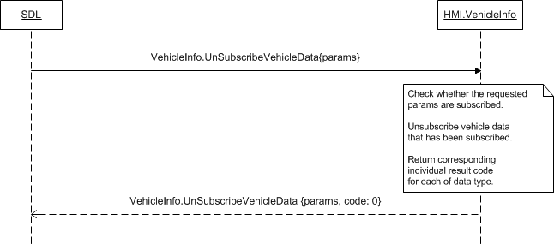

### 11.7.5 JSON Messages Examples

#### 11.7.5.1 Request

|  |
| --- |
| {  "id" : 139,  "jsonrpc" : "2.0",  "method" : "VehicleInfo.UnsubscribeVehicleData",  “params” :  {  “gps” : true,  “speed” : true,  “fuelLevel_State” : true,  “externalTemperature” : true,  “prndl” : true,  “tirePressure” : true,  “odometer” : true,  “beltStatus” : true,  “bodyInformation” : true,  “deviceStatus” : true,  “wiperStatus” : true,  “headLampStatus” : true,  “accPedalPosition” : true,  “myKey” : true  }  } |

#### 11.7.5.2 Response

|  |
| --- |
| "id" : 139,  "jsonrpc" : "2.0",  "result" :  {  “gps” :  {  dataType : VEHICLEDATA_GPS,  resultCode : SUCCESS  },  “speed” :  {  dataType : VEHICLEDATA_SPEED,  resultCode : DATA_NOT_SUBSCRIBED  },  “fuelLevel_State” :  {  dataType : VEHICLEDATA_FUELLEVEL,  resultCode : SUCCESS  },  “externalTemperature” :  {  dataType : VEHICLEDATA_EXTERNTEMP,  resultCode : DATA_NOT_SUBSCRIBED  },  “prndl” :  {  dataType : VEHICLEDATA_PRNDL,  resultCode : DATA_NOT_SUBSCRIBED  },  “tirePressure” :  {  dataType : VEHICLEDATA_TIREPRESSURE,  resultCode : SUCCESS  },  “odometer” :  {  dataType : VEHICLEDATA_odometer,  resultCode : SUCCESS  },    “beltStatus” :  {  dataType : VEHICLEDATA_BELTSTATUS,  resultCode : SUCCESS  },  “bodyInformation” :  {  dataType : VEHICLEDATA_BODYINFO,  resultCode : SUCCESS  },  “deviceStatus” :  {  dataType : VEHICLEDATA_DEVICESTATUS,  resultCode : DATA_NOT_SUBSCRIBED  },  “wiperStatus” :  {  dataType : VEHICLEDATA_WIPERSTATUS,  resultCode : SUCCESS  },  “headLampStatus” :  {  dataType : HEADLAMPSTATUS,  resultCode : SUCCESS  },  “accPedalPosition” :  {  dataType : VEHICLEDATA_ACCPEDAL,  resultCode : DATA_NOT_SUBSCRIBED  },  "code" : 0,  "method" : "VehicleInfo.UnsubscribeVehicleData"  }  } |

#### 11.7.5.3 Error message

|  |
| --- |
| {  "id" : 139,  "jsonrpc" : "2.0",  "error" :  {  "code" : 22,  "message" : "An unknown error occurred",  "data" :  {  "method" : "VehicleInfo.UnsubscribeVehicleData"  }  }  } |

### 11.7.6 D-Bus Messages Examples

#### 11.7.6.1 Request

|  |
| --- |
|  |

#### 11.7.6.2 Response

|  |
| --- |
|  |

#### 11.7.6.3 Failure

|  |
| --- |
|  |

## 11.8 GetVehicleData

### 11.8.1 Description

|  |  |
| --- | --- |
| **Type:** | Function |
| **Sender:** | SDL |
| **Purpose:** | Receive current values of vehicle data |

SDL sends GetVehicleData (in contrast to SubscribeVehicleData) for getting the current value(s) of the named data type(s).

### 11.8.2 Request

#### 11.8.2.1 Behavior

***HMI must:***

1. Check whether the current values of requested data type can be provided. The data type is defined with Boolean parameters of gps, speed, rpm and other that are provided in *section 11.8.2.2*:

* true value parameters are those which require information in response.
* One or several or all of the parameters from section 11.8.2.2 may be included into request.

***Note:***

*Within a request SDL will provide at least one ‘ture’-value parameter of data type the current values of which must be provided.*

2. Respond with one of appropriate result codes (see section *11.8.3 Response*).

2.1. HMI must return the parameter(s) of the name(s) equal to those requested, only together with result codes of:

* SUCCESS: when HMI can provide the current values of all requested data types.
* SUCCESS when HMI can provide just one or several values of the total requested (that is, less than requested). The example cases: when sensor is broken or HMI does not support or publish some data type.

See the table below for clarification.

| **Request** | **Response** | | |
| --- | --- | --- | --- |
| code: **SUCCESS** | code: **SUCCESS** | code: **SUCCESS** |
| data available: **all** | data available: **some** | data available: **none** |
| data_type_1  data_type_2  data_type_3  data_type_4  data_type_5 | data_type_1  data_type_2  data_type_3  data_type_4  data_type_5 | data_type_1  data_type_3  data_type_4 |  |

2.2. Every of parameters returned must contain the appropriate values as described in section 11.8.3.1.

#### 11.8.2.2 Parameters

| **Param Name** | **Type** | **Mandatory** | **Description** |
| --- | --- | --- | --- |
| gps | Boolean | false | Get GPS data current values.  Information related to GPS data: number of satellites, compass direction, longitude, latitude, etc. See GPSData |
| speed | Boolean | false | Get vehicle speed current value to be provided in kilometers per hour. |
| rpm | Boolean | false | Get the number of engine revolutions per minute current value. |
| fuelLevel | Boolean | false | Get the fuel level in the tank current value (percentage). |
| fuelLevel_State | Boolean | false | Get the fuel level state current value: normal, low, etc. See ComponentVolumeStatus. |
| instantFuelConsumption | Boolean | false | Get the instantaneous fuel consumption current value to be provided in microliters. |
| externalTemperature | Boolean | false | Get the external temperature current value to be provided in degrees Celsius. |
| vin | Boolean | false | Vehicle identification number. |
| prndl | Boolean | false | Get the gear stick position current value: first, second, etc. See PRNDL. |
| tirePressure | Boolean | false | Get tire pressure status current values:  - The warning status (on, off, etc.)  - The status of the tire pressure itself: normal, low, etc.  See TireStatus. |
| odometer | Boolean | false | Get the current information from odometer to be provided in km. |
| beltStatus | Boolean | false | Get the current information of the seat belts status: deployed, buckled. See BeltStatus. |
| bodyInformation | Boolean | false | Get the current values of body information including power modes: park brake status, ignition and ignition stable status. See BodyInformation. |
| deviceStatus | Boolean | false | Get the current values of device status including signal and battery strength. See DeviceStatus. |
| driverBraking | Boolean | false | Get the current information of the brake pedal status updates: on, off, etc. See VehicleDataEventStatus. |
| wiperStatus | Boolean | false | Get the current information of the wipers status: whether they are manually on, manually off, stalled, etc. See WiperStatus. |
| headLampStatus | Boolean | false | Get the current information of the head lamps status: when they are on, off, etc. See HeadLampStatus. |
| engineTorque | Boolean | false | Get the current information of the torque value for engine (in Nm) on non-diesel variants |
| accPedalPosition | Boolean | false | Get the current information of accelerator pedal position (percentage depressed). |
| steeringWheelAngle | Boolean | false | Get the current information of current angle of the steering wheel (in degrees) |
| eCallInfo | Boolean | false | Get the current information about whether the ‘eCall’ Event is currently active. |
| airbagStatus | Boolean | false | Get the current information of air-bags current status. |
| emergencyEvent | Boolean | false | Get the current information about whether the ‘emergency’ event is currently active. |
| clusterModeStatus | Boolean | false | Get the current information about the status modes of the cluster |
| myKey | Boolean | false | Get the current information about ‘MyKey’ feature. |
| appID | Integer | true | Id of application that requested this RPC. |

### 11.8.3 Response

***Note:***

*There is a difference in message type for WebSocket and D-Bus connection (see the table below).*

|  |  |  |  |  |  |
| --- | --- | --- | --- | --- | --- |
| **Result** | **Description** | **Message type** | | **Message Params** | **Notes** |
| **WebSocket** | **D-Bus** |
| Success | SUCCESS:  HMI provides values of all requested vehicle data. | JSON response | Method return | Parameters of the names equal to requested ones,  code: 0 | See 11.8.3.1 Parameters.  See 11.8.2.1. Behavior. |
| Failure | DATA_NOT_AVAILABLE:  1. HMI can provide just one or several values of the total requested (that is, less than requested). | JSON error message | Method return | Parameters of the names equal to requested ones,  code: 9 |
| DATA_NOT_AVAILABLE:  2. HMI can provide none of the requested data types. | code: 9 | Applicable for this RPC result codes.  Please see Result Enumeration for all SDL-supported codes. |
| INVALID_ID  appID is invalid | code: 13 |
| GENERIC_ERROR:  The unknown issue occurred or other codes are not applicable. | code: 22 |

#### 11.8.3.1 Parameters

| **Param Name** | **Type** | **Mandatory** | **Additional** | **Description** |
| --- | --- | --- | --- | --- |
| gps | Common.GPSData | false | – | The current values of GPS data: number of satellites, compass direction, longitude, latitude, etc. See section 11.8.3.2 GPSData |
| speed | Float | false | minvalue = 0  maxvalue = 700 | The current value of vehicle speed in kilometers per hour. |
| rpm | Integer | false | minvalue = 0  maxvalue = 20000 | The current number of revolutions per minute of the engine. |
| fuelLevel | Float | false | minvalue = -6  maxvalue = 106 | The current value of fuel level in the tank (percentage). |
| fuelLevel_State | Common.ComponentVolumeStatus | false | – | The current value of fuel level state: normal, low, etc. See ComponentVolumeStatus |
| instantFuelConsumption | Float | false | minvalue = 0  maxvalue = 25575 | The current value of instantaneous fuel consumption in microliters. |
| externalTemperature | Float | false | minvalue = -40  maxvalue = 100 | The current external temperature in degrees Celsius. |
| vin | String | false | maxlength = 17 | Vehicle identification number. |
| prndl | Common.PRNDL | false | – | The current position of gear stick: first, second, etc.  See PRNDL. |
| tirePressure | Common.TireStatus | false | – | The current information of:  - The warning status (on, off, etc.)  - The status of the tire pressure itself: normal, low, etc.  See TireStatus. |
| odometer | Integer | false | minvalue = 0  maxvalue = 17000000 | Current value of odometer in km. |
| beltStatus | Common.BeltStatus | false | – | The current status of the seat belts: deployed, buckled.  See BeltStatus |
| bodyInformation | Common.BodyInformation | false | – | The cuurent body information: park brake status, ignition and ignition stable status.  See BodyInformation |
| deviceStatus | Common.DeviceStatus | false | – | The current information of device status including signal and battery strength.  See DeviceStatus. |
| driverBraking | Common.VehicleDataEventStatus | false | – | The current status of the brake pedal: on, off, etc.  See VehicleDataEventStatus |
| wiperStatus | Common.WiperStatus | false | – | The current status of the wipers: whether they are manually on, manually off, stalled, etc.  See WiperStatus |
| headLampStatus | Common.HeadLampStatus | false | – | The current status of the head lamps: whether they are on, off, etc.  See HeadLampStatus |
| engineTorque | Float | false | minvalue =  -1000  maxvalue = 2000 | The current torque value for engine (in Nm) for non-diesel models. |
| accPedalPosition | Float | false | minvalue = 0  maxvalue = 100 | The current value of accelerator pedal position (percentage depressed). |
| steeringWheelAngle | Float | false | minvalue =  -2000  maxvalue = 2000 | Current angle of the steering wheel (in degrees). |
| eCallInfo | Common.ECallInfo | false | - |  |
| airbagStatus | Common.AirbagStatus | false | - |  |
| emergencyEvent | Common.EmergencyEvent | false | - |  |
| clusterModeStatus | Common.ClusterModeStatus | false | - |  |
| myKey | Common.MyKey | false | - |  |

#### 11.8.3.2 GPSData

| **Param Name** | **Type** | **Mandatory** | **Maxvalue** | **Description** |
| --- | --- | --- | --- | --- |
| longitudeDegrees | Float | false | minvalue = -180  maxvalue = 180 | Position longitude in degrees. |
| latitudeDegrees | Float | false | minvalue = -90  maxvalue = 90 | Position latitude in degrees. |
| utcYear | Integer | false | minvalue = 2010  maxvalue = 2100 | The current UTC year. |
| utcMonth | Integer | false | minvalue = 1  maxvalue = 12 | The current UTC month. |
| utcDay | Integer | false | minvalue = 1  maxvalue = 31 | The current UTC day. |
| utcHours | Integer | false | minvalue = 0  maxvalue = 23 | The current UTC hour. |
| utcMinutes | Integer | false | minvalue = 0  maxvalue = 59 | The current UTC minute. |
| utcSeconds | Integer | false | minvalue = 0  maxvalue = 59 | The current UTC second. |
| compassDirection | Common.CompassDirection | false | – | The compass direction: north, east, etc. See section 11.8.3.3 CompassDirection |
| pdop | Float | false | minvalue = 0  maxvalue = 10 | Positional Dilution Of Precision. |
| hdop | Float | false | minvalue = 0  maxvalue = 10 | Horizontal Dilution Of Precision. |
| vdop | Float | false | minvalue = 0  maxvalue = 10 | Vertical Dilution Of Precision. |
| actual | Boolean | false | – | The information about actuality of GPS data:  ‘true’, if actual  ‘false’, if inferred |
| satellites | Integer | false | minvalue = 0  maxvalue = 31 | Number of satellites in view. |
| dimension | Common.Dimension | false | – | The supported GPS dimension: 2D, 3D. See section 11.8.3.4 Dimension |
| altitude | Float | false | minvalue = -10000  maxvalue = 10000 | Altitude in meters. |
| heading | Float | false | minvalue = 0  maxvalue = 359.99 | ‘0’ is considered as heading North.  SDL expects to receive data with resolution of 0.01. |
| speed | Float | false | minvalue = 0  maxvalue = 500 | The speed in KPH. |

#### 11.8.3.3 CompassDirection

| **Element name** | **Value** | **Short Description** |
| --- | --- | --- |
| NORTH | 0 | Represents the North compass direction |
| NORTHWEST | 1 | Represents the North-West compass direction |
| WEST | 2 | Represents the West compass direction |
| SOUTHWEST | 3 | Represents the South-West compass direction |
| SOUTH | 4 | Represents the South compass direction |
| SOUTHEAST | 5 | Represents the South-East compass direction |
| EAST | 6 | Represents the East compass direction |
| NORTHEAST | 7 | Represents the North-East compass direction |

#### 11.8.3.4 Dimension

| **Element name** | **Value** | **Short Description** |
| --- | --- | --- |
| NO_FIX | 0 | No GPS at all |
| 2D | 1 | Longitude and latitude |
| 3D | 2 | Longitude and latitude and altitude |

#### 11.8.3.5 ComponentVolumeStatus

| **Element name** | **Value** | **Short Description** |
| --- | --- | --- |
| UNKNOWN | 0 | The data is unknown. |
| NORMAL | 1 | The volume is normal. |
| LOW | 2 | The volume is low. |
| FAULT | 3 | The module/sensor is currently faulted. |
| ALERT | 4 | The component`s volume is in critical level. |
| NOT_SUPPORTED | 5 | The data is not supported. |

#### 11.8.3.6 PRNDL

| **Element name** | **Value** | | **Short Description** |
| --- | --- | --- | --- |
| PARK | 0 | | Parking |
| REVERSE | 1 | | Reverse gear |
| NEUTRAL | 2 | | No gear |
| DRIVE | 3 | | Drive Sport mode |
| SPORT | 4 | | Sport mode |
| LOWGEAR | | 5 | 1st gear hold |
| FIRST | | 6 | 1st gear |
| SECOND | | 7 | 2nd gear |
| THIRD | | 8 | 3d gear |
| FOURTH | | 9 | 4th gear |
| FIFTH | | 10 | 5th gear |
| SIXTH | | 11 | 6th gear |
| SEVENTH | | 12 | 7th gear |
| EIGHTH | | 13 | 8th gear |
| FAULT | | 14 | The module/sensor is currently faulted. |

#### 11.8.3.7 TireStatus

| **Param Name** | **Type** | **Mandatory** | **Description** |
| --- | --- | --- | --- |
| pressureTelltale | Common.WarningLightStatus | false | Status of the Tire Pressure Telltale.  See WarningLightStatus. |
| leftFront | Common.SingleTireStatus | false | The status of the left front tire. |
| rightFront | Common.SingleTireStatus | false | The status of the right front tire. |
| leftRear | Common.SingleTireStatus | false | The status of the left rear tire. |
| rightRear | Common.SingleTireStatus | false | The status of the right rear tire. |
| innerLeftRear | Common.SingleTireStatus | false | The status of the inner left rear. |
| innerRightRear | Common.SingleTireStatus | false | The status of the inner right rear. |

#### 11.8.3.8 WarningLightStatus

|  |  |  |
| --- | --- | --- |
| **Element name** | **Value** | **Short Description** |
| OFF | 0 | The warning light is off |
| ON | 1 | The warning light is on |
| FLASH | 2 | The warning light is flashing |
| NOT_USED | 3 | There is no warning light for the event on HU. |

#### 11.8.3.9 SingleTireStatus

| **Param Name** | **Type** | **Mandatory** | **Description** |
| --- | --- | --- | --- |
| status | Common.ComponentVolumeStatus | true | See section 11.8.3.5 ComponentVolumeStatus |

#### 11.8.3.10 BeltStatus

| **Param Name** | **Type** | **Mandatory** | **Description** |
| --- | --- | --- | --- |
| driverBeltDeployed | Common.VehicleDataEventStatus | false | The driver seat belt is deployed. |
| passengerBeltDeployed | Common.VehicleDataEventStatus | false | The passenger seat belt is deployed. |
| passengerBuckleBelted | Common.VehicleDataEventStatus | false | The passenger seat belt is buckled. |
| driverBuckleBelted | Common.VehicleDataEventStatus | false | The driver seat belt is buckled. |
| leftRow2BuckleBelted | Common.VehicleDataEventStatus | false | The left seat belt of the 2nd row is buckled. |
| passengerChildDetected | Common.VehicleDataEventStatus | false | The child passenger is detected. |
| rightRow2BuckleBelted | Common.VehicleDataEventStatus | false | The right seat belt of the 2nd row is buckled. |
| middleRow2BuckleBelted | Common.VehicleDataEventStatus | false | The middle seat belt of the 2nd row is buckled. |
| middleRow3BuckleBelted | Common.VehicleDataEventStatus | false | The middle seat belt of the 3rd row is buckled. |
| leftRow3BuckleBelted | Common.VehicleDataEventStatus | false | The left seat belt of the 3rd row is buckled. |
| rightRow3BuckleBelted | Common.VehicleDataEventStatus | false | The right seat belt of the 3rd row is buckled. |
| leftRearInflatableBelted | Common.VehicleDataEventStatus | false | The left rear inflatable is belted. |
| rightRearInflatableBelted | Common.VehicleDataEventStatus | false | The right rear inflatable is belted. |
| middleRow1BeltDeployed | Common.VehicleDataEventStatus | false | The seat belt of the middle row is deployed. |
| middleRow1BuckleBelted | Common.VehicleDataEventStatus | false | The seat belt of the middle row is buckled. |

### 11.8.4 Sequence Diagrams

#### 11.8.4.1 GetVehicleData

### 11.8.5 JSON Messages Examples

#### 11.8.5.1 Request

|  |
| --- |
| {  "id" : 139,  "jsonrpc" : "2.0",  "method" : "VehicleInfo.GetVehicleData",  “params” :  {  “gps” : true,  “speed” : true,  “fuelLevel_State” : true,  “externalTemperature” : true,  “prndl” : true,  “tirePressure” : true,  “odometer” : true,  “beltStatus” : true,  “bodyInformation” : true,  “deviceStatus” : true,  “wiperStatus” : true,  “headLampStatus” : true,  “accPedalPosition” : true,  “myKey” : true  }  } |

#### 11.8.5.2 Response

|  |
| --- |
| {  "id" : 139,  "jsonrpc" : "2.0",  "result" :  {  “gps” :  [  “longitudeDegrees” : 46.4774700,  “latitudeDegrees” : 30.7326200,  “utcYear” : 2013,  “utcMonth” : 12,  “utcDay” : 31,  “utcHours” : 23,  “utcMinutes” : 50,  “utcSeconds” : 5,  “compassDirection” : NORTH,  “pdop” : 0.15,  “hdop” : 1.01,  “vdop” : 1.56,  “actual” : true,  “satellites” : 8,  “dimension” : 3D,  “altitude” : 47,  “heading” : 0,  “speed” : 90  ],  “speed” : 90,  “fuelLevel_State” : LOW,  “externalTemperature” : -5,  “prndl” : FOURTH,  “tirePressure” :  [  “pressureTelltale” : ON,  “leftFront” : NORMAL,  “rightFront” : NORMAL,  “leftRear” : LOW,  “rightRear” : UNKNOWN  ],  “odometer” : 1065,  “beltStatus” :  [  “driverBeltDeployed” : YES,  “passengerBeltDeployed” : YES,  ],  “bodyInformation” :  [  “parkBrakeActive” : false,  “ignitionStableStatus” : IGNITION_SWITCH_STABLE,  “ignitionStatus” : RUN  ],  “deviceStatus” :  [  “voiceRecOn” : false,  “btIconOn” : false,  “callActive” : false,  “phoneRoaming” : false,  “textMsgAvailable” : true,  “battLevelStatus” : THREE_LEVEL_BARS,  “stereoAudioOutputMuted” : true,  “monoAudioOutputMuted” : false,  “signalLevelStatus” : NOT_PROVIDED,  “primaryAudioSource” : MOBILE_APP,  “eCallEventActive” : false  ],  “wiperStatus” : OFF,  “headLampStatus” :  [  “lowBeamsOn” : true,  “highBeamsOn” : false  ],  “accPedalPosition” : 80,  “myKey” :  [  “e911Override” : OFF  ],  "code" : 0,  "method" : "VehicleInfo.GetVehicleData"  }  } |

#### 11.8.5.3 Error message

|  |
| --- |
| {  "id" : 139,  "jsonrpc" : "2.0",  "error" :  {  "code" : 9,  "message" : "The requested data is not available",  "data" :  {  "method" : "VehicleInfo.GetVehicleData"  }  }  } |

### 11.8.6 D-Bus Messages Examples

#### 11.8.6.1 Request

|  |
| --- |
|  |

#### 11.8.6.2 Response

|  |
| --- |
|  |

#### 11.8.6.3 Failure

|  |
| --- |
|  |

## 11.9 OnVehicleData

### 11.9.1 Description

|  |  |
| --- | --- |
| **Type:** | Notification |
| **Sender:** | HMI |
| **Purpose:** | Inform about changes of vehicle data. |

Initially SDL sends SubscribeVehicleData for getting the periodic updates from HMI whenever each of subscribed data types changes. OnVehicleData is expected to bring such updated values to SDL

***Note:*** SDL ignores all invalid notifications which come from HMI (invalid JSON, invalid data types/bounds etc)

#### 11.9.1.1 Parameters

| **Param Name** | **Type** | **Mandatory** | **Additional** | **Description** |
| --- | --- | --- | --- | --- |
| gps | Common.GPSData | false | – | Information related to GPS data: number of satellites, compass direction, longitude, latitude, etc. For more details please see GPSData |
| speed | Float | false | minvalue = 0  maxvalue = 700 | The vehicle speed in kilometers per hour. |
| rpm | Integer | false | minvalue = 0  maxvalue = 20000 | The number of revolutions per minute of the engine. |
| fuelLevel | Float | false | minvalue = -6  maxvalue = 106 | The fuel level in the tank (percentage). |
| fuelLevel_State | Common.ComponentVolumeStatus | false | – | The fuel level state should be returned: normal, low, etc. For more details please see ComponentVolumeStatus |
| instantFuelConsumption | Float | false | minvalue = 0  maxvalue = 25575 | The instantaneous fuel consumption in microliters. |
| externalTemperature | Float | false | minvalue = -40  maxvalue = 100 | The external temperature in degrees Celsius. |
| vin | String | false | maxlength = 17 | Vehicle identification number. |
| prndl | Common.PRNDL | false | – | The position of change-speed lever: first, second, etc.  For more details please see PRNDL. |
| tirePressure | Common.TireStatus | false | – | The following information should be returned:  - The warning status (on, off, etc.)  - The status of the tire pressure itself: normal, low, etc.  For more details please see TireStatus. |
| odometer | Integer | false | minvalue = 0  maxvalue = 17000000 | Odometer in km |
| beltStatus | Common.BeltStatus | false | – | The status of the seat belts: deployed, buckled.  For more details please see BeltStatus |
| bodyInformation | Common.BodyInformation | false | – | The body information should be provided: park brake status, ignition and ignition stable status.  For more details please see BodyInformation |
| deviceStatus | Common.DeviceStatus | false | – | The information on device status should be provided including signal and battery strength.  For more details please see DeviceStatus. |
| driverBraking | Common.VehicleDataEventStatus | false | – | The status of the brake pedal should be provided: on, off, etc.  For more details please see  VehicleDataEventStatus |
| wiperStatus | Common.WiperStatus | false | – | The status of the wipers should be provided: if they are manually on, manually off, stalled, etc.  For more details please see WiperStatus |
| headLampStatus | Common.HeadLampStatus | false | – | Status of the head lamps should be provided: if they are on, off, etc.  For more details please see  HeadLampStatus |
| engineTorque | Float | false | minvalue =  -1000  maxvalue = 2000 | Torque value for engine (in Nm) for non-diesel models. |
| accPedalPosition | Float | false | minvalue = 0  maxvalue = 100 | Accelerator pedal position (percentage depressed). |
| steeringWheelAngle | Float | false | minvalue =  -2000  maxvalue = 2000 | Current angle of the steering wheel (in degrees). |
| myKey | Common.MyKey | false | – | Information related to the MyKey feature.  For more details please see MyKey |

### 11.9.2 Sequence Diagrams

#### 11.9.2.1 OnVehicleData

### 11.9.3 JSON Messages Examples

|  |
| --- |
| {  "jsonrpc" : "2.0",  "method" : "VehicleInfo.OnVehicleData",  "params" :  {  “speed” : 60,  “externalTemperature” : -7,  “prndl” : THIRD,  “odometer” : 1066,  “wiperStatus” : MAN_INT_ON,  “accPedalPosition” : 70  }  } |

### 11.9.4 D-Bus Messages Examples

|  |
| --- |
|  |

# 12 Navigation Component Description

## 12.1 IsReady

### 12.1.1 Description

|  |  |
| --- | --- |
| **Type:** | Function |
| **Sender:** | SDL |
| **Purpose:** | Know if component is ready. |

The request comes after HMI`s readiness is confirmed via OnReady notification. SDL requires the information about whether the navigation information could be processed or provided by HMI.

***Note:***

*If Navigation component is responded to be unavailable, SDL will not further send the requests related to it.*

### 12.1.2 Request

#### 12.1.2.1 Behavior

***HMI must:***

- Check whether Navigation component is present and ready

- Respond correspondingly to results of this check.

### 12.1.3 Response

***Note:***

*There is a difference in message type for WebSocket and D-Bus connection (see the table below).*

|  |  |  |  |  |  |
| --- | --- | --- | --- | --- | --- |
| **Result** | **Description** | **Message type** | | **Message Params** | **Notes** |
| **WebSocket** | **D-Bus** |
| Success | SUCCESS:  HMI provides the information about Navigation component availability. | JSON response | Method return | available,  code: 0 |  |
| Failure | DATA_NOT_AVAILABLE:  The information about Navigation availability cannot be provided. | JSON error message | Method return | Code: 9 | Applicable for this RPC result codes.  Please see Result Enumeration for all SDL-supported codes. |
| GENERIC_ERROR:  The unknown issue occurred or other codes are not applicable. | code: 22 |

#### 12.1.3.1 Parameters

|  |  |  |  |
| --- | --- | --- | --- |
| **Param Name** | **Type** | **Mandatory** | **Description** |
| availabe | Boolean | true | Must be  - ‘true’ if Navigation component is present and ready  - ‘false’ if not. |

### 12.1.4 Sequence Diagrams

#### 12.1.4.1 Navigation.IsReady and preceding OnReady

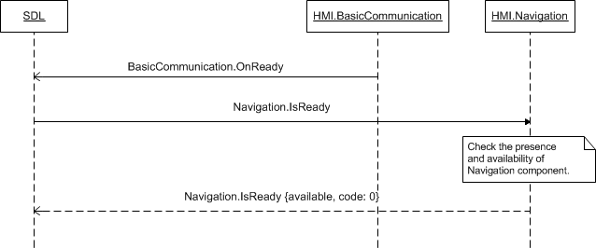

### 12.1.5 JSON Messages Examples

#### 12.1.5.1 Request

|  |
| --- |
| {  "id" : 27,  "jsonrpc" : "2.0",  "method" : "Navigation.IsReady"  } |

#### 12.1.5.2 Response

|  |
| --- |
| {  "id" : 27,  "jsonrpc" : "2.0",  "result" :  {  "availabe" : true,  "code" : 0,  "method" : "Navigation.IsReady"  }  } |

#### 12.1.5.3 Error message

|  |
| --- |
| {  "id" : 27,  "jsonrpc" : "2.0",  "error" :  {  "code" : 22,  "message" : "The unknown error has occurred",  "data" :  {  "method" : "Navigation.IsReady"  }  }  } |

### 12.1.6 D-Bus Messages Examples

#### 12.1.6.1 Request

|  |
| --- |
|  |

#### 12.1.6.2 Response

|  |
| --- |
|  |

#### 12.1.6.3 Failure

|  |
| --- |
|  |

## 12.2 AlertManeuver

### 12.2.1 Description

|  |  |
| --- | --- |
| **Type:** | Function |
| **Sender:** | SDL |
| **Purpose:** | Annaunce the navigation maneuver |

SDL sends AlertManeuver together with TTS.Speak RPC. The purpose is to notify the embedded navigation system about the next navigation maneuver.

### 12.2.2 Request

#### 12.2.2.1 Behavior

***HMI must:***

1. To notify the user by TTS.Speak RPC which comes together with Navi.AlertManeuver.

2. Display the dialog of Navi.AlertManeuver with HMI-defined alert icon and one of the following:

* Up to three soft buttons once defined within request with softButtons parameter
* HMI-defined ‘Close’ soft button once the empty request has arrived (that is, without softButtons parameter).
* HMI must process SystemContext behavior for AlertManeuver in the same way as for Alert
* **SystemContext rules:**

Scenario1:

**Precondition**:

app1 is in FULL, app2 is in BACKGROUND, app2 is allowed to send AlertManeuver from BACKGROUND

app1 SystemContext=MAIN, app2 SystemContext=MAIN

**Action:**

App2 ->AlertManeuver

**Expected:**

AlertManeuver pop-up is shown on HMI

HMI->SDL.OnSystemContex(ALERT, app2)

HMI->SDL.OnSystemContex(OBSCURED, app1)

**Action:**

Alert is closed

**Expected:**

AlertManeuver pop-up is shown on HMI

HMI->SDL.OnSystemContex(MAIN, app2)

HMI->SDL.OnSystemContex(MAIN, app1)

**AppID rules for AlertManeuver when it causes SystemContext updates:**

1. AppID should not be sent for MENU and HMI_OBCSURED system contexts. Only the apps in FULL may get these updates.  
2 .In case OnSystemContext of MENU and HMI_OBCSURED are sent with appID by HMI, appID is ignored and anyway the notification is transfered to the app in FULL HMI Level  
3. OnSystemContext appID parameter should be mandatory for MAIN and ALERT values. In case there's no such application with appID recieved, the notifications will be ignored by SDL

#### 12.1.2.1 Parameters

| **Param Name** | **Type** | **Mandatory** | **Additional** | **Description** |
| --- | --- | --- | --- | --- |
| softButtons | Common.SoftButton | false | Array = true  minsize = 0  maxsize = 3 | Up to three soft buttons defined.  If omitted, only the system defined "Close" soft button should be displayed (if applicable). |
| appID | Integer | true |  | ID of the application which requested this RPC |

### 12.2.3 Response

***Note:***

*There is a difference in message type for WebSocket and D-Bus connection (see the table below).*

|  |  |  |  |  |  |
| --- | --- | --- | --- | --- | --- |
| **Result** | **Description** | **Message type** | | **Message Params** | **Notes** |
| **WebSocket** | **D-Bus** |
| Success | SUCCESS:  HMI displayed the requested dialog of navigation maneuver. | JSON response | Method return | code: 0 | Applicable for this RPC result codes.  Please see Result Enumeration for all SDL-supported codes. |
| Failure | INVALID_DATA:  The data sent is invalid (invalid JSON syntax or out of bound parameters) | JSON error message | Method return | code: 11 | The check for invalid data is actually performed by SDL. Optionally, HMI may also perform the check, In this casу the code must be returned |
| ABORTED:  The dialog is aborted with the higher priority RPC. | Code: 5 | Applicable for this RPC result codes.  Please see Result Enumeration for all SDL-supported codes. |
| INVALID_ID  appID is invalid | code:13 | The check for invalid appID is actually performed by SDL. Optionally, HMI may also perform the check, In this casу the code must be returned |
| UNSUPPORTED_RESOURCE  When icon is sent by SDL but HMI doesn’t support the type of images sent by SDL (STATIC/DYNAMIC). | code:2 | Applicable for this RPC result codes.  Please see Result Enumeration for all SDL-supported codes. |
| GENERIC_ERROR  1) The unknown issue occurred or other codes are not applicable.  2) In case HMI does not respond SDL's request during request or/SDL default timeout, SDL will return the result code to the corresponding mobile app's request | code: 22 |

### 12.2.4 Sequence Diagrams

#### 12.2.4.1 AlertManeuver Default success path

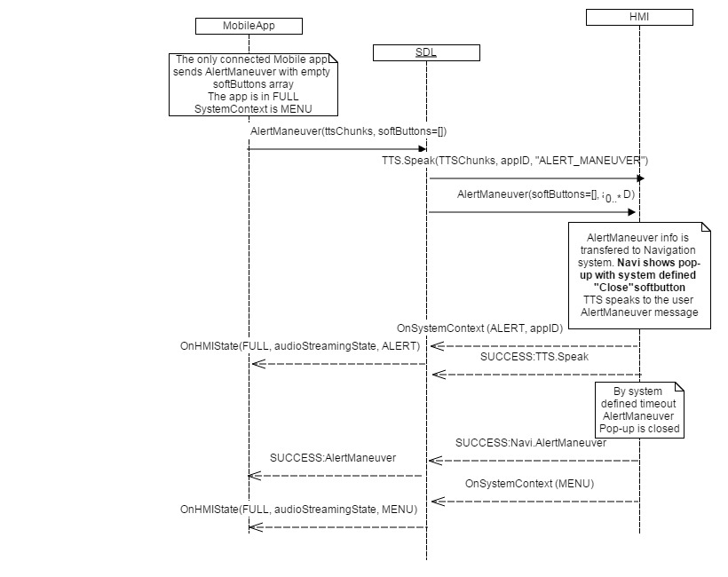

#### 12.2.4.2 AlertManeuver from BACKGROUND success path

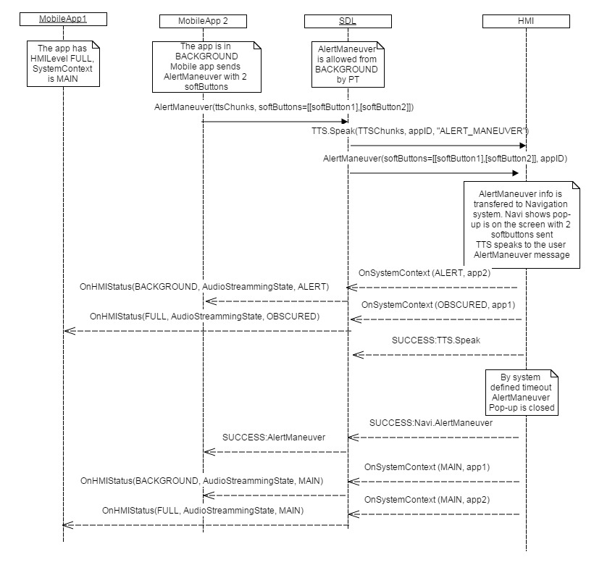

#### 12.2.4.3 AlertManeuver ABORTED

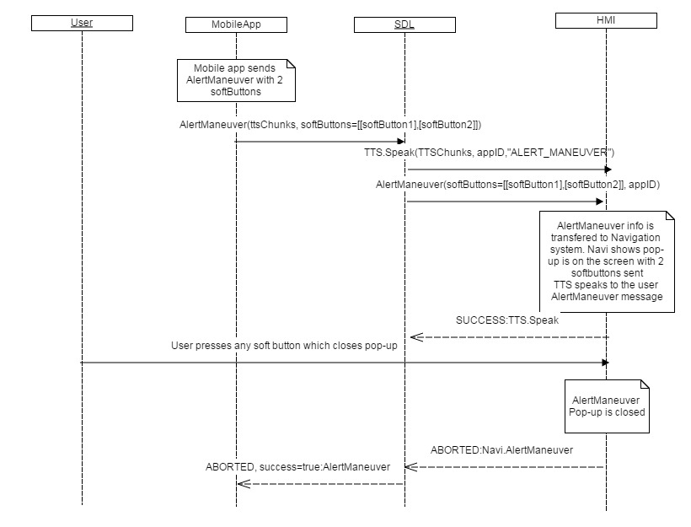

#### 12.2.4.4 AlertManeuver REJECTED

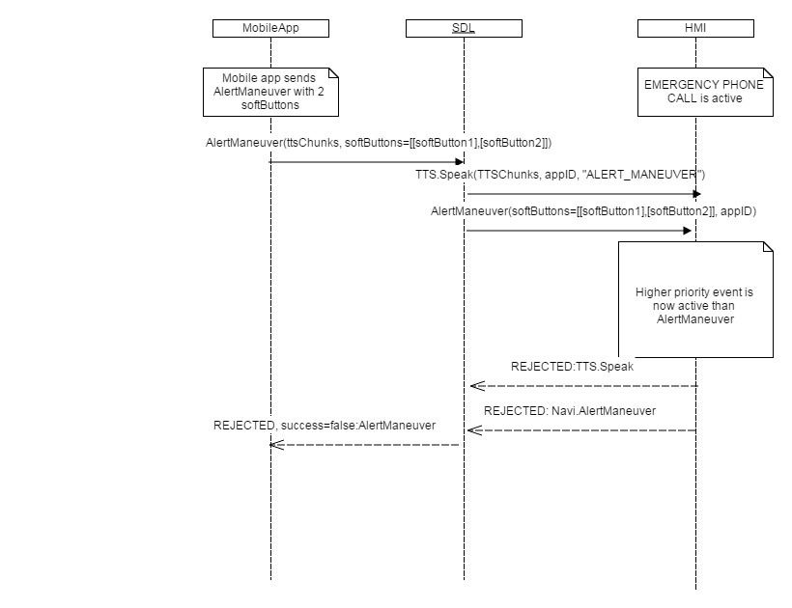

### 12.2.5 JSON Messages Examples

#### 12.2.5.1 Request Navi.AlertManeuver

|  |
| --- |
| {  "id" : 143,  "jsonrpc" : "2.0",  "method" : "Navigation.AlertManeuver",  “params” :  {  “softButtons” :  [  {  “type” : TEXT,  “text” : “Leave onscreen”,  “softButtonID” : 45,  “systemAction” : KEEP_CONTEXT  },  {  “type” : TEXT,  “text” : “Close”,  “softButtonID” : 46,  “systemAction” : STEAL_FOCUS  },  ],  “appID” : 96} |

#### 12.2.5.2 Response Navi.AlertManeuver

|  |
| --- |
| {  "id" : 143,  "jsonrpc" : "2.0",  "result" :  {  "code" : 0,  "method" : "Navigation.AlertManeuver"  }  } |

#### 12.2.5.3 Request TTS.Speak for AlertManeuver

|  |
| --- |
| {  "id" : 144,  "jsonrpc" : "2.0",  "method" : "TTS.Speak",  “params” :  {  “ttsChunks” :  [  “text” : “Attention! Turn Left”  ],  “appID”:96  }  } |
|  |

#### 12.2.5.4 Response TTS.Speak for AlertManeuver

|  |
| --- |
| {  "id" : 144,  "jsonrpc" : "2.0",  "result" :  {  "code" : 0,  "method" : "TTS.Speak"  }  } |

#### 12.2.5.5 Error message

|  |
| --- |
| {  "id" : 143,  "jsonrpc" : "2.0",  "error" :  {  "code" : 13,  "message" : " A command cannot be executed because there is NO specified with appID application registered ",  "data" :  {  "method" : "Navigation.AlertManeuver"  }  }  } |

### 12.2.6 D-Bus Messages Examples

#### 12.2.6.1 Request

|  |
| --- |
|  |

#### 12.2.6.2 Response

|  |
| --- |
|  |

#### 12.2.6.3 Failure

|  |
| --- |
|  |

## 12.3 ShowConstantTBT

### 12.3.1 Description

|  |  |
| --- | --- |
| **Type:** | Function |
| **Sender:** | SDL |
| **Purpose:** | Update navigation information of the embedded navigation system |

SDL request to display navigation information sent from the mobile application to the embedded navigation system. This information may reproduce the data about the current navigation state (e.g. destination place, icon of the destination place, total distance, distance to maneuver, scale, softbuttons to operate the information on the screen and other).

### 12.3.2 Request

#### 12.3.2.1 Behavior

***HMI must:***

#### 12.3.2.1 Parameters

| **Param Name** | **Type** | **Mandatory** | **Additional** | **Description** |
| --- | --- | --- | --- | --- |
| navigationTexts | Common.TextFieldStruct | true | Array = true  minsize = 0  maxsize = 5 | The text to be displayed in up to four fields on Navigation display:  - navigationText1  - navigationText2  - ETA  - totalDistance  For more details please see TextFieldStruct, section 14.2.11 |
| turnIcon | Common.Image | false | – | The icon to be displayed.  For more details please see Image, section 14.2.14. |
| nextTurnIcon | Common.Image | false | - |  |
| distanceToManeuver | Float | true | minvalue = 0  maxvalue = 1000000000 | The distance from the previous maneuver till the next one.  HMI may use these data for calculating the progress bar. |
| distanceToManeuverScale | Float | true | minvalue = 0  maxvalue = 1000000000 | Fraction of distance from the AlertManeuver triggering till the next maneuver.  HMI may use these data for calculating the progress bar. |
| maneuverComplete | Boolean | false | – | If ‘true’, the maneuver has been completed and the AlertManeuver overlay must be cleared.  If omitted the value must be assumed as ‘false’. |
| softButtons | Common.SoftButton | false | Array = true  minsize = 0  maxsize = 3 | SDL may request to draw up to three soft buttons for Navigation.  If the empty array is sent or the parameter is omitted, the currently displayed soft button values must remain unchanged.  For more details please see SoftButton, section 14.2.13 |
| appID | Integer | true | – | ID of the application that concerns this RPC. |

### 12.3.3 Response

***Note:***

*There is a difference in message type for WebSocket and D-Bus connection (see the table below).*

|  |  |  |  |  |  |
| --- | --- | --- | --- | --- | --- |
| **Result** | **Description** | **Message type** | | **Message Params** | **Notes** |
| **WebSocket** | **D-Bus** |
| Success | SUCCESS:  HMI executed the request successfully. | JSON response | Method return | code: 0 |  |
| Failure | INVALID_DATA:  The data sent is invalid (invalid JSON syntax, parameters out of bounds or of wrong type) | JSON error message | Method return | code: 11 | The check for invalid data is actually performed by SDL. Optionally, HMI may also perform the check, In this casу the code must be returned |
| INVALID_ID  appID is invalid (e.g. the app with current id doesn’t exist) | code:13 | The check for appID is actually performed by SDL. Optionally, HMI may also perform the check, In this casу the code must be returned |
| UNSUPPORTED_RESOURCE  When icon is sent by SDL but HMI doesn’t support the type of images sent by SDL (STATIC/DYNAMIC). | code:2 |  |
| REJECTED:  HMI is expected to return ABORTED result code in case HMI is currently busy with a higher-priority event. | Code:45 |  |
| GENERIC_ERROR  1) The unknown issue occurred or other codes are not applicable.  2) In case HMI does not respond SDL's request during SDL default timeout (10 sec), SDL will return the result code to the corresponding mobile app's request | code: 22 |  |

### 12.3.4 Sequence Diagrams

#### 12.3.4.1 ShowConstantTBT

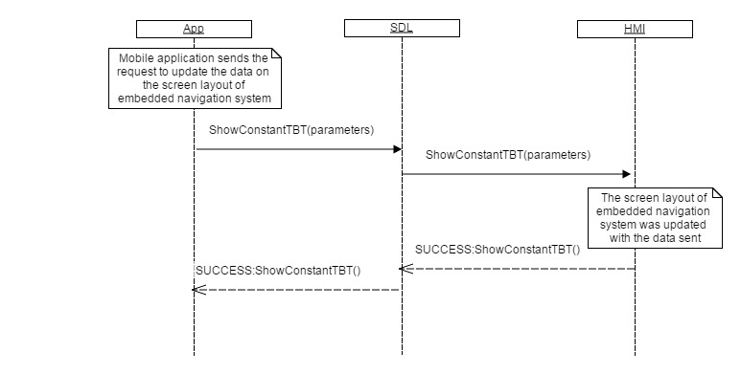

### 12.3.5 JSON Messages Examples

#### 12.3.5.1 Request

|  |
| --- |
| {  "id" : 543,  "jsonrpc" : "2.0",  "method" : "Navigation.ShowConstantTBT",  “params” :  {  “navigationTexts” :  [  {  “fieldName” : navigationText1,  “fieldText” : “Destination point: Berlin”  },  {  “fieldName” : ETA,  “fieldText” : “15:45”  },  {  “fieldName” : totalDistance,  “fieldText” : “658”  }  ],  “turnIcon” :  [  “value” : “tmp/SDL/app/Navi/icon_3245.jpeg”,  “imageType” : DYNAMIC  ],  “distanceToManeuver” : 168,  “distanceToManeuverScale” : 265,  “softButtons” :  [  “type” : TEXT,  “text” : “Close”,  “softButtonID” : 76,  “systemAction” : DEFAULT_ACTION  ],  “appID” : 26743  }  } |

#### 12.3.5.2 Response

|  |
| --- |
| {  "id" : 543,  "jsonrpc" : "2.0",  "result" :  {  "code" : 0,  "method" : "Navigation.ShowConstantTBT"  }  } |

#### 12.3.5.3 Error message

|  |
| --- |
| {  "id" : 543,  "jsonrpc" : "2.0",  "error" :  {  "code" : 5,  "message" : " A command was aborted",  "data" :  {  "method" : "Navigation.ShowConstantTBT"  }  }  } |

### 12.3.6 D-Bus Messages Examples

#### 12.3.6.1 Request

|  |
| --- |
|  |

#### 12.3.6.2 Response

|  |
| --- |
|  |

#### 12.3.6.3 Failure

|  |
| --- |
|  |

## 12.4 UpdateTurnList

### 12.4.1 Description

|  |  |
| --- | --- |
| **Type:** | Function |
| **Sender:** | SDL |
| **Purpose:** | Update turn list |

### 12.4.2 Request

#### 12.4.2.1 Behavior

***HMI must:***

#### 12.4.2.1 Parameters

| **Param Name** | **Type** | **Mandatory** | **Additional** | **Description** |
| --- | --- | --- | --- | --- |
| turnList | Common.Turn | false | Array = true  minsize = 1  maxsize = 100 | The array of objects that consist of:  - text string to be displayed in navigation field  - image for turn prompt.  For more details please see Turn, section |
| softButtons | Common.SoftButton | false | Array = true  minsize = 0  maxsize = 1 | One soft button defined.  For more details regarding the type/highlighted or not/etc. please see SoftButton, section  If omitted on supported displays, app-defined SoftButton will be left blank. |

### 12.4.3 Response

***Note:***

*There is a difference in message type for WebSocket and D-Bus connection (see the table below).*

|  |  |  |  |  |  |
| --- | --- | --- | --- | --- | --- |
| **Result** | **Description** | **Message type** | | **Message Params** | **Notes** |
| **WebSocket** | **D-Bus** |
| Success | SUCCESS:  HMI executed the RPC successfully. | JSON response | Method return | code: 0 |  |
| Failure | INVALID_DATA:  The data sent is invalid (invalid JSON syntax, parameters out of bounds or of wrong type) | JSON error message | Method return | code: 11 | Applicable for this RPC result codes.  Please see Result Enumeration for all SDL-supported codes. |
| INVALID_ID  appID is invalid (e.g. the app with current id doesn’t exist) | code:13 |
| UNSUPPORTED_RESOURCE  When icon is sent by SDL but HMI doesn’t support the type of images sent by SDL (STATIC/DYNAMIC). | code:2 |
| GENERIC_ERROR  1) The unknown issue occurred or other codes are not applicable.  2) In case HMI does not respond SDL's request during SDL default timeout (10 sec), SDL will return the result code to the corresponding mobile app's request | code: 22 |

### 12.4.4 Sequence Diagrams

#### 12.4.4.1 UpdateTurnList

### 12.4.5 JSON Messages Examples

#### 12.4.5.1 Request

|  |
| --- |
| {  "id" : 176,  "jsonrpc" : "2.0",  "method" : "Navigation.UpdateTurnList",  “params” :  {  “turnList” :  [  {  “navigationText” :  [  “fieldName” : navigationText,  “fieldText” : “Turn Right”  ],  “turnIcon” :  [  “value” : “tmp/SDL/app/Navi/icon_turn_right.jpeg”,  “imageType” : DYNAMIC  ]  },  {  “navigationText” :  [  “fieldName” : navigationText,  “fieldText” : “Turn Left”  ],  “turnIcon” :  [  “value” : “tmp/SDL/app/Navi/icon_turn_left.jpeg”,  “imageType” : DYNAMIC ]  ]  },  {  “navigationText” :  [  “fieldName” : navigationText,  “fieldText” : “Go Forward”  ],  “turnIcon” :  [  “value” : “tmp/SDL/app/Navi/icon_go_forward.jpeg”,  “imageType” : DYNAMIC  ]  }  ],  “softButtons” :  [  “type” : BOTH,  “text” : “Return”,  “image” :  [  “value” : “tmp/SDL/app/Navi/icon_583.jpg”,  “imageType” : DYNAMIC  ],  “isHighlighted” : true,  “softButtonID” : 118,  “systemAction” : DEFAULT_ACTION  ]  }  } |

#### 12.4.5.2 Response

|  |
| --- |
| {  "id" : 176,  "jsonrpc" : "2.0",  "result" :  {  "code" : 0,  "method" : "Navigation.UpdateTurnList"  }  } |

#### 12.4.5.3 Error message

|  |
| --- |
| {  "id" : 176,  "jsonrpc" : "2.0",  "error" :  {  "code" : 4,  "message" : " A command was rejected because a higher priority command is requested",  "data" :  {  "method" : "Navigation.UpdateTurnList"  }  }  } |

### 12.4.6 D-Bus Messages Examples

#### 12.4.6.1 Request

|  |
| --- |
|  |

#### 12.4.6.2 Response

|  |
| --- |
|  |

#### 12.4.6.3 Failure

|  |
| --- |
|  |

## 12.5 StartStream

### 12.5.1 Description

|  |  |
| --- | --- |
| **Type:** | Notification |
| **Sender:** | SDL |
| **Purpose:** | To initiate the channel between SDL and HMI to stream video data futher |

When an application opens the 11th service, SDL sends StartStream to HMI. It initiates the channel between SDL and HMI for streaming video raw data which is being sent by navigation application. The request just initiates the connection by URL defined in a requset, but not starts read the data. OnVideoDataStreaming notification is responsible for notifying to start/end read the data from the channel.

**Note**:

* Video streaming is allowed by SDL only for the apps in FULL and LIMITED HMI levels

**HMI must:**

* prepare to read the raw video data from the URL defined in StartStream request

### 12.5.2 Request

#### 12.5.2.1 Parameters

| **Param Name** | **Type** | **Mandatory** | **Additional** | **Description** |
| --- | --- | --- | --- | --- |
| url | String | true | Minlength = 21  maxlength = 500 | URL that HMI will start playing after OnVideoDataStreaming(available:true) |
| appID | Integer | true | - | ID of the application requested this RPC |

### 12.5.3 Response

#### 12.5.3.1 Parameters

***Note:***

*There is a difference in message type for WebSocket and D-Bus connection (see the table below).*

|  |  |  |  |  |  |
| --- | --- | --- | --- | --- | --- |
| **Result** | **Description** | **Message type** | | **Message Params** | **Notes** |
| **WebSocket** | **D-Bus** |
| Success | SUCCESS:  HMI executed the RPC successfully. | JSON response | Method return | code: 0 |  |
| Failure | GENERIC_ERROR:  The unknown issue occurred or other codes are not applicable. |  |  | code: 22 |  |

### 12.5.4 Sequence Diagrams

#### 12.5.4.1 StartStream

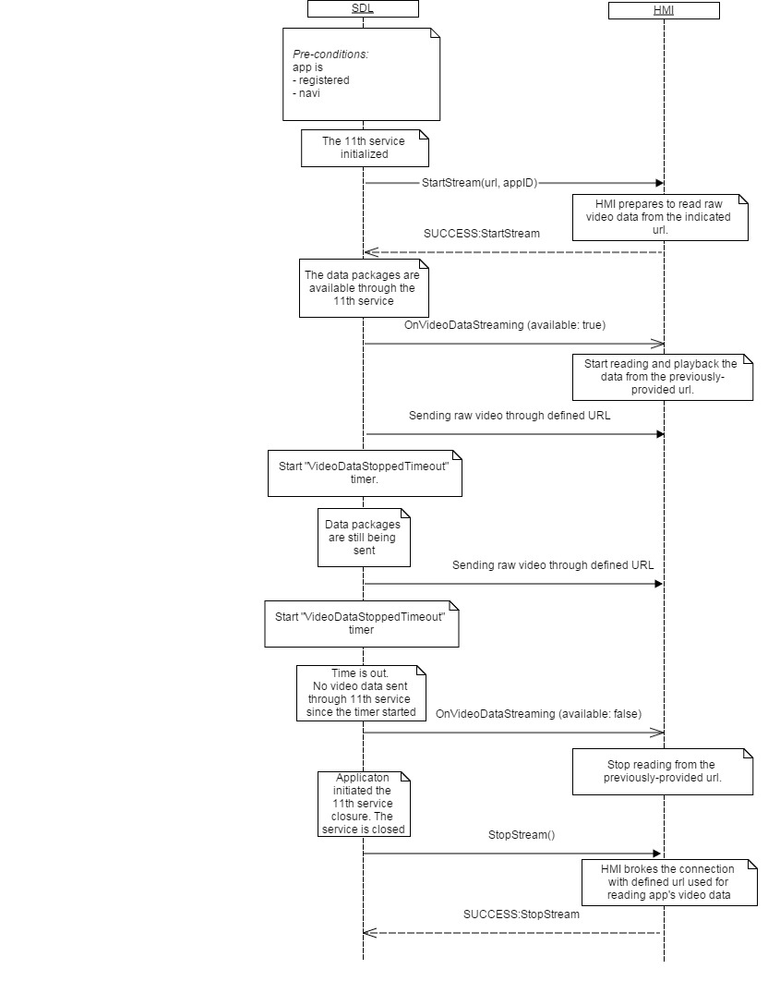

### 12.5.5 JSON Messages Examples

#### 12.5.5.1 Request

|  |
| --- |
| {  "jsonrpc" : "2.0",  "method" : "Navigation.StartStream",  "params" :  {  “url” : SDL/application_directory/video/123.mp4,  “appID” : 65674  }  } |

#### 12.5.5.2 Response

|  |
| --- |
| {  "id" : 176,  "jsonrpc" : "2.0",  "result" :  {  "code" : 0,  "method" : "Navigation.StartStream"  }  } |

#### 12.5.5.3 Error message

|  |
| --- |
| {  "id" : 176,  "jsonrpc" : "2.0",  "error" :  {  "code" : 22,  "message" : "Start stream failed or some other error occured",  "data" :  {  "method" : "Navigation. StartStream"  }  }  } |

### 12.5.4 D-Bus Messages Examples

|  |
| --- |
|  |

## 12.6 StopStream

### 12.6.1 Description

|  |  |
| --- | --- |
| **Type:** | Notification |
| **Sender:** | SDL |
| **Purpose:** | To initiate the video streaming channel closure between SDL and HMI |

When an application closes the 11th service, SDL sends StopStream to HMI. It initiates the channel closure between SDL and HMI which is used for streaming video raw data sent by navigation application. The request just interrupts the connection defined in StartStream request.

**Note**:

* Video streaming is allowed by SDL only in FULL and LIMITED HMI levels

**HMI must:**

* close the channel used for reading the raw video data from the URL defined in StartStream request

### 12.6.2 Request

#### 12.6.2.1 Parameters

| **Param Name** | **Type** | **Mandatory** | **Additional** | **Description** |
| --- | --- | --- | --- | --- |
| appID | Integer | true | - | ID of the app;lication requested this RPC |

### 12.6.3 Response

#### 12.6.3.1 Parameters

***Note:***

*There is a difference in message type for WebSocket and D-Bus connection (see the table below).*

|  |  |  |  |  |  |
| --- | --- | --- | --- | --- | --- |
| **Result** | **Description** | **Message type** | | **Message Params** | **Notes** |
| **WebSocket** | **D-Bus** |
| Success | SUCCESS:  HMI executed the RPC successfully. | JSON response | Method return | code: 0 |  |
| Failure | GENERIC_ERROR:  The unknown issue occurred or other codes are not applicable. |  |  | code: 22 |  |

### 12.6.4 Sequence Diagrams

#### 12.6.2.1 StopStream



### 12.6.5 JSON Messages Examples

#### 12.6.5.1 Request

|  |
| --- |
| {  "jsonrpc" : "2.0",  "method" : "Navigation.StopStream",  "params" :  {  “appID” : 65674  }  } |

#### 12.6.5.2 Response

|  |
| --- |
| {  "id" : 176,  "jsonrpc" : "2.0",  "result" :  {  "code" : 0,  "method" : "Navigation.StopStream"  }  } |

#### 12.6.5.3 Error message

|  |
| --- |
| {  "id" : 176,  "jsonrpc" : "2.0",  "error" :  {  "code" : 22,  "message" : "Stop stream failed or some other error occured",  "data" :  {  "method" : "Navigation.StopStream"  }  }  } |

### 12.6.4 D-Bus Messages Examples

|  |
| --- |
|  |

## 12.7 StartAudioStream

### 12.7.1 Description

|  |  |
| --- | --- |
| **Type:** | Notification |
| **Sender:** | SDL |
| **Purpose:** | To initiate the channel between SDL and HMI to stream audio data futher |

The request initiate the channel between SDL and HMI for streaming audio raw data which is being sent by navigation application. The request just initiates the connection by URL defined in a requset, but not starts read the data. OnAudioDataStreaming notification is responsible for notifying to start/end read the data from the channel.

**Note**:

* audio streaming is allowed by SDL only in FULL and LIMITED HMI levels

**HMI must:**

- create a channel for getting raw audio data streaming via defined URL

### 12.7.2 Request

#### 12.7.1.1 Parameters

| **Param Name** | **Type** | **Mandatory** | **Additional** | **Description** |
| --- | --- | --- | --- | --- |
| url | String | true | Minlength = 21  maxlength = 500 | URL that HMI gets data from . |
| appID | Integer | true | - | ID of the application requested this RPC |

### 12.7.3 Response

#### 12.7.3.1 Parameters

***Note:***

*There is a difference in message type for WebSocket and D-Bus connection (see the table below).*

|  |  |  |  |  |  |
| --- | --- | --- | --- | --- | --- |
| **Result** | **Description** | **Message type** | | **Message Params** | **Notes** |
| **WebSocket** | **D-Bus** |
| Success | SUCCESS:  HMI executed the RPC successfully. | JSON response | Method return | code: 0 |  |
| Failure | GENERIC_ERROR:  The unknown issue occurred or other codes are not applicable. |  |  | code: 22 |  |

### 12.7.4 Sequence Diagrams

#### 12.5.4.1 StartAudioStream/StopAudioStream/OnAudioDataStreaming

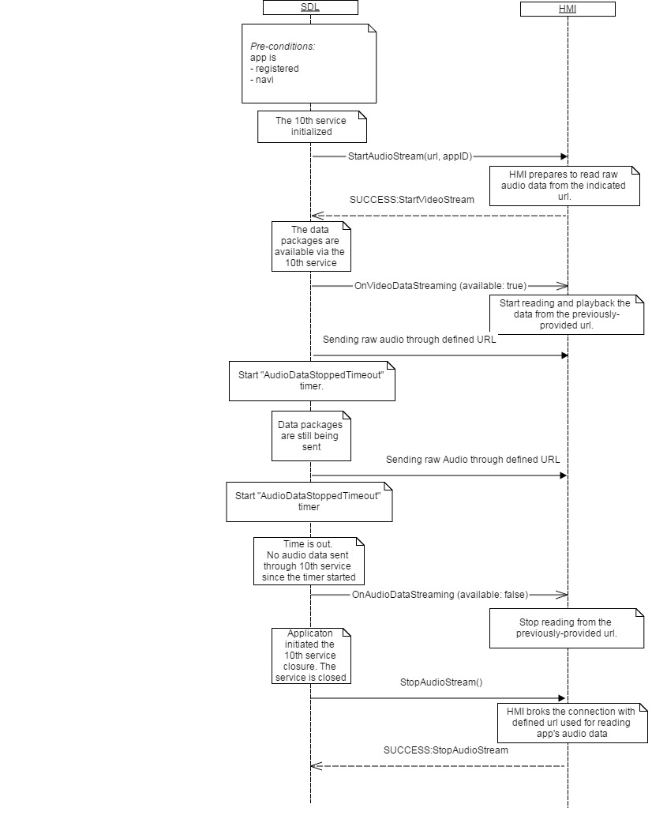

### 12.7.5 JSON Messages Examples

#### 12.7.5.1 Request

|  |
| --- |
| {  "jsonrpc" : "2.0",  "method" : "Navigation.StartAudioStream",  "params" :  {  “url” : SDL/application_directory/audio/123.mp3,  “appID” : 65674  }  } |

#### 12.7.5.2 Response

|  |
| --- |
| {  "id" : 176,  "jsonrpc" : "2.0",  "result" :  {  "code" : 0,  "method" : "Navigation.StartAudioStream"  }  } |

#### 12.7.5.3 Error message

|  |
| --- |
| {  "id" : 176,  "jsonrpc" : "2.0",  "error" :  {  "code" : 22,  "message" : "Start stream failed or some other error occured",  "data" :  {  "method" : "Navigation.StartAudioStream"  }  }  } |

### 12.7.4 D-Bus Messages Examples

|  |
| --- |
|  |

## 12.8 StopAudioStream

### 12.8.1 Description

|  |  |
| --- | --- |
| **Type:** | Notification |
| **Sender:** | SDL |
| **Purpose:** | To initiate the audio streaming channel closure between SDL and HMI. |

When an application closes the 10th service, SDL sends StopAudioStream to HMI. It initiates the channel closure between SDL and HMI which was used for streaming audio raw data sent by navigation application. The request just closes the connection defined in StartAudioStream request.

**Note:**

* Audio streaming is allowed by SDL only in FULL and LIMITED HMI levels

**HMI must:**

* close the channel used for reading the raw audio data through the URL defined in StartAudioStream request

### 12.8.2 Request

#### 12.8.2.1 Parameters

| **Param Name** | **Type** | **Mandatory** | **Additional** | **Description** |
| --- | --- | --- | --- | --- |
| appID | Integer | true | - | ID of the application requested this RPC |

### 12.8.3 Response

#### 12.8.3.1 Parameters

***Note:***

*There is a difference in message type for WebSocket and D-Bus connection (see the table below).*

|  |  |  |  |  |  |
| --- | --- | --- | --- | --- | --- |
| **Result** | **Description** | **Message type** | | **Message Params** | **Notes** |
| **WebSocket** | **D-Bus** |
| Success | SUCCESS:  HMI executed the RPC successfully. | JSON response | Method return | code: 0 |  |
| Failure | GENERIC_ERROR:  The unknown issue occurred or other codes are not applicable. |  |  | code: 22 |  |

### 12.8.4 Sequence Diagrams

#### 12.8.4.1 StopAudioStream



### 12.8.5 JSON Messages Examples

#### 12.8.5.1 Request

|  |
| --- |
| {  "jsonrpc" : "2.0",  "method" : "Navigation.StopAudioStream",  "params" :  {  “appID” : 65674  }  } |

#### 12.8.5.2 Response

|  |
| --- |
| {  "id" : 176,  "jsonrpc" : "2.0",  "result" :  {  "code" : 0,  "method" : "Navigation.StopAudioStream"  }  } |

#### 12.8.5.3 Error message

|  |
| --- |
| {  "id" : 176,  "jsonrpc" : "2.0",  "error" :  {  "code" : 22,  "message" : "Stop stream failed or some other error occured",  "data" :  {  "method" : "Navigation.StopAudioStream"  }  }  } |

### 12.8.4 D-Bus Messages Examples

|  |
| --- |
|  |

## 12.9 OnTBTClientState

### 12.9.1 Description

|  |  |
| --- | --- |
| **Type:** | Notification |
| **Sender:** | HMI |
| **Purpose:** | Provide the information about TBT Client state |

***HMI must:***

1. HMI must provide SDL with notifications specific to the current Turn-By-Turn client status on the module

OnTBTClientState informs SDL about some event or state happened on HMI Turn-By-Turn client. Futher, SDL transfers this data to the application which uses this information for the navigation actual data support. Application may provide some information back to HMI as a result of OnTBTClientState receival.

***Note:*** SDL ignores all I nvalid notifications which come from HMI (invalid JSON, invalid data types/bounds etc)

#### 12.9.1.1 Parameters

| **Param Name** | **Type** | **Mandatory** | **Description** |
| --- | --- | --- | --- |
| state | Common.TBTState | true | Current State of TBT client.  For more details please see TBTState |

#### 12.9.1.2 TBTState

| **Element name** | **Short Description** |
| --- | --- |
| ROUTE_UPDATE_REQUEST | HMI requested for the route update. |
| ROUTE_ACCEPTED | Confirmation about accepting the route. |
| ROUTE_REFUSED | The current route has been refused. |
| ROUTE_CANCELLED | Cancelling the route. |
| ETA_REQUEST | HMI requested to estimate the time of arrival |
| NEXT_TURN_REQUEST | Navigation requested the information about the the next turn. |
| ROUTE_STATUS_REQUEST | Navigation requested the information about the route status |
| ROUTE_SUMMARY_REQUEST | Navigation requested the information about the route summary |
| TRIP_STATUS_REQUEST | Navigation requested the information about the about trip status. |
| ROUTE_UPDATE_REQUEST_TIMEOUT | Navigation requested the rout update request by timeout |

### 12.9.2 Sequence Diagrams

#### 12.9.2.1 OnTBTClientState ROUTE_UPDATE_REQUEST

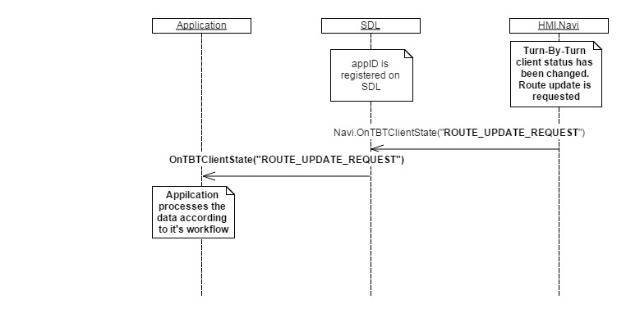

### 12.9.3 JSON Messages Examples

|  |
| --- |
| {  "jsonrpc" : "2.0",  "method" : "Navigation.OnTBTClientState",  "params" :  {  “state” : “NEXT_TURN_REQUEST”  }  } |

### 12.9.4 D-Bus Messages Examples

|  |
| --- |
|  |

## 12.10 SendLocation

### 12.10.1 Description

|  |  |
| --- | --- |
| **Type:** | Function |
| **Sender:** | SDL |
| **Purpose:** | To allow app to send a destination to the embedded nav system. |

### 12.10.2 Request

#### 12.10.2.1 Behavior

***HMI must:***

* 1. Receive the data from SDL and transfer it to navigation embedded module. Navigation embedded HU system should update the location data on the embedded navi screen. Initially, this data is transferred from mobile application to notify the embedded navi system about the location coordinates where the user navigates to.
  2. Send a SUCCESS response to SDL in case the destination data has been obtained by HMI

#### 12.10.2.2 Parameters

|  |  |  |  |  |
| --- | --- | --- | --- | --- |
| **Param Name** | **Type** | **Mandatory** | **Additional** | **Description** |
| longitudeDegrees | Float | true | Minvalue = -180  Maxvalue = 180 |  |
| latitudeDegrees | Float | true | Minvalue = -90  Maxvalue = 90 |  |
| locationName | String | false | Maxlength = 500 |  |
| addressLines | String | false | Maxlength = 500  minsize= 0  maxsize= 4  array= true |  |
| phoneNumber | String | false | Maxlength = 500 |  |
| locationImage | Common.Image | false |  |  |

### 12.10.3 Response

***Note:***

*There is a difference in message type for WebSocket and D-Bus connection (see the table below).*

|  |  |  |  |  |  |
| --- | --- | --- | --- | --- | --- |
| **Result** | **Description** | **Message type** | | **Message Params** | **Notes** |
| **WebSocket** | **D-Bus** |
| Success | SUCCESS: | JSON response | Method return | code: 0 |  |
|  | UNSUPPORTED_RESOURCE  1) When icon is sent by SDL but HMI doesn’t support the type of images sent by SDL (STATIC/DYNAMIC).  2) In case UI is not supported (UI.IsReady returned false) | JSON response | Method return | code:2 |  |
| WARNINGS  1) In case the requested image to display is corrupted or does not exist by the defined path  2) Some of the parameters sent by SDL aren’t supported as text fields on HMI. Supported values should be displayed/processed as expected | code:21 | HMI displays all other requested info except of missed images and returns WARNINGS code with problem description  **Note:** from SDL’s point of view the request is executed successfully, so mobile app will get WARNINGS response, but value success=true |
| INVALID_DATA:  The data sent is invalid (invalid JSON syntax or parameters out of bounds or of wrong type) | code: 11 |  |
| REJECTED  HMI rejects RPCs in terms of HMI-matrix (higher priority event is now active) | code: 4 |  |
| GENERIC_ERROR  1) The unknown issue occurred or other codes are not applicable.  2) In case HMI does not respond SDL's request during SDL default timeout (10 sec), SDL will return the result code to the corresponding mobile app's request | code: 22 |  |

### 12.10.4 Sequence Diagrams

#### 12.10.4.1 SendLocation Success scenario

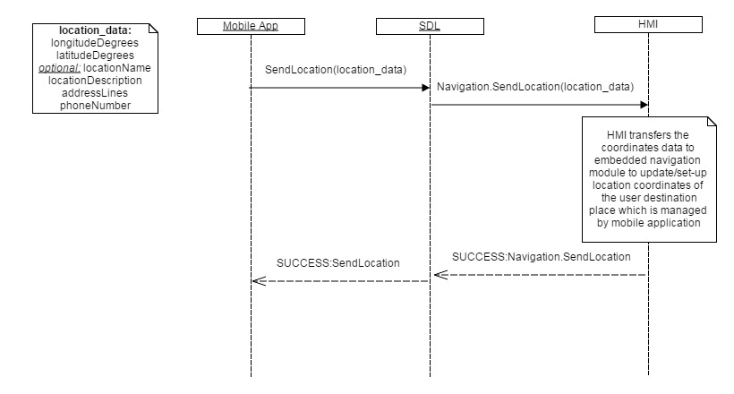

#### 12.10.4.2 SendLocation Failure scenario WARNINGS

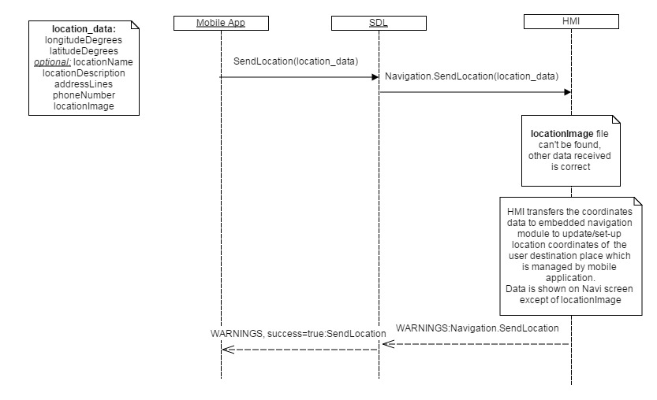

#### 12.10.4.3 SendLocation Failure scenario REJECTED

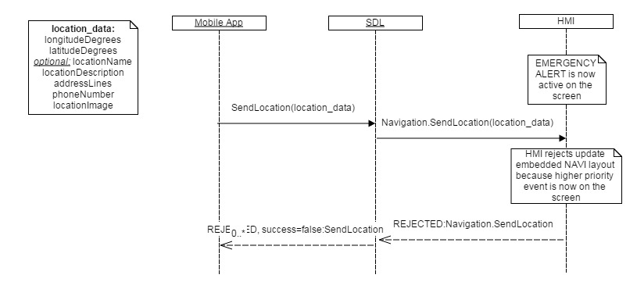

### 12.10.5 JSON Messages Examples

#### 12.10.5.1 Request

|  |
| --- |
| {  "id" : 138,  "jsonrpc" : "2.0",  "method" : "Navigation.SendLocation",  “params” :  {  “longitudeDegrees” : 139.34,  “latitudeDegrees” : 35.36,  “locationName” : “Ford Repair”,  “locationImage” :  {  “value” : “tmp/SDL/app/Navi/12345.jpg”,  “imageType” : DYNAMIC  }  }  } |

#### 12.10.5.2 Response

|  |
| --- |
| {  "id" : 138,  "jsonrpc" : "2.0",  "result" :  {  "code" : 0,  "method" : "Navigation.SendLocation"  }  } |

#### 12.10.5.3 Error message

|  |
| --- |
| {  "id" : 138,  "jsonrpc" : "2.0",  "error" :  {  "code" : 22,  "message" : " The unknown issue occurred ",  "data" :  {  "method" : "Navigation.SendLocation"  }  }  } |

### 12.10.6 D-Bus Messages Examples

#### 12.10.6.1 Request

#### 12.10.6.2 Response

#### 12.10.6.3 Failure

## 12.11 OnAudioDataStreaming

### 12.11.1 Description

|  |  |
| --- | --- |
| **Type:** | Notification |
| **Sender:** | SDL->HMI |
| **Purpose:** | To notify about raw audio data sending over the URL provided via StartAudioStream SDL's request. |

**Note:**

* Audio streaming is allowed by SDL only in FULL and LIMITED HMI levels

**HMI must:**

- get the audio through the URL

- playback the received audio data via audio system

#### 12.11.1.1 Parameters

| **Param Name** | **Type** | **Mandatory** | **Description** |
| --- | --- | --- | --- |
| available | Boolean | true | If "true" - audio data started. If "false" - audio data stopped. |

### 12.11.2 Sequence Diagrams

#### 12.11.2.1 OnAudioDataStreaming SDL<->HMI



#### 12.11.2.1 OnAudioDataStreaming full diagram App<->HMI

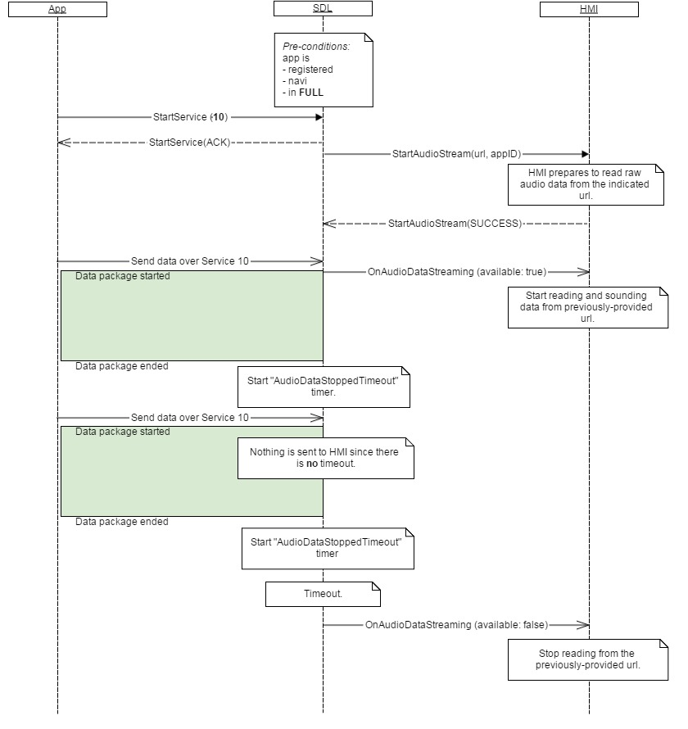

### 12.11.3 JSON Messages Examples

|  |
| --- |
| {  "jsonrpc" : "2.0",  "method" : "Navigation.OnAudioDataStreaming",  "params" :  {  “available” : true  }  } |

### 12.11.4 D-Bus Messages Examples

|  |
| --- |
|  |

## 12.12 OnVideoDataStreaming

### 12.12.1 Description

|  |  |
| --- | --- |
| **Type:** | Notification |
| **Sender:** | SDL->HMI |
| **Purpose:** | To notify about raw video data sending over the URL provided via StartStream SDL's request. |

**Note:**

* Video streaming is allowed by SDL only in FULL and LIMITED HMI levels

**HMI must:**

- get the audio through the URL defined in StartStream

- playback the received video data

#### 12.12.1.1 Parameters

| **Param Name** | **Type** | **Mandatory** | **Description** |
| --- | --- | --- | --- |
| available | Boolean | true | If "true" - video data is started to be sending. If "false" - video data sending has been stopped. |

### 12.12.2 Sequence Diagrams

#### 12.12.2.1 OnVideoDataStreaming



### 12.12.3 JSON Messages Examples

|  |
| --- |
| {  "jsonrpc" : "2.0",  "method" : "Navigation.OnVideoDataStreaming",  "params" :  {  “available” : true  }  } |

### 12.12.4 D-Bus Messages Examples

|  |
| --- |
|  |

# 13 SDL Component Description

**Notes about ‘SDL’ component:**

A. ‘SDL’ names a component that is a part of SDL. HMI has the ability to request and recive definite information from SDL using ‘SDL’ interface, in contrast to communicating using other interfaces of HMI_API.

B. HMI-SDL communication with ‘SDL’ component over WebSocket (WS):

B.1. Both parties should use the WS registered with the name of ‘BasicCommunication’ (see section 2.1 Connection Opening of chapter 2 WebSocketTransport). Separate WS connection should not be opened for communication with ‘SDL’ component.

B.2. Both parties should send JSON messages with the field of:

"method" : "SDL.*<RPC_name>*" (for example, “SDL.ActivateApp”)

when communicating using ‘SDL’ ‘interface.

## 13.1 SDL.ActivateApp (Ford-specific)

### 13.1.1 Description

|  |  |
| --- | --- |
| **Type:** | Function |
| **Sender:** | HMI |
| **Purpose:** | Inform about User has activated the application and get the permissions for it. |

SDL needs SDL.ActivateApp request to:

1. Know that the named application has been chosen by the User.

2. Provide HMI with the policies-related data for the named application that SDL sends within response to SDL.ActivateApp.

### 13.1.2 Request

#### 13.1.2.1 Behavior

***HMI must:***

1. Send SDL.ActivateApp to SDL when the User requests to activate the application either form UI or by VR. Include the appID of the application being activated to the request is a must.

***Note:***

*The information about the application (name, ID, etc.) is provided by SDL via either BasicCommunication.UpdateAppList or BasicCommunication.OnAppRegistered RPCs.*

2. Wait for the response from SDL before activating the named application.

3. Read the information from SDL`s response and behave in one of the following ways depending on parameters provided.

* 1. **DO NOT activate the application** in one of the following cases:
     1. isSDLAllowed: false -

a) Do not activate the application

b) Request the appropriate user-friendly message from SDL (via SDL.GetUserFriendlyMessage {messageCodes: "DataConsent"})

c) Display the message providing the User with the possibility to accept or decline the prompt (for example, “Yes” / “No” buttons)

d) After User`s making choice, send SDL.OnAllowSDLFunctionality to SDL notifying whether the User accepted the prompt or not (“allowed:true” or “allowed:false” correspondingly)

e) Wait for BasicCommunication.ActivateApp from SDL in both cases of User`s accepting or declining the prompt:

e-1) BasicCommunication.ActivateApp{appID} will come for the purpose to activate the app to FULL after the User has accepted the prompt.

e-2) otherwise, BasicCommunication.ActivateApp{appID, level: NONE} will come for the purpose to clearly restrict HMI from activating the app in case the User has declined the prompt.

***Note****:*

*Related diagrams: see sections #12.1.4.1 and #12.1.4.2*

* + 1. isAppRevoked: true –

a) Do not activate the application

b) Request the appropriate user-friendly message from SDL (via SDL.GetUserFriendlyMessage {messageCodes: "AppUnauthorized"})

c) Unregister the corresponding application upon BasicCommunication.OnAppUnregistered{appID} (*Information: while the appID has NULL permissions in PT, SDL will reject such app`s registration afterwards*)

***Note****:*

*Related diagram: see section #12.1.4.5.*

* 1. **Activate the application** in one of the following cases:
     1. isSDLAllowed: true and isPermissionsConsentNeeded: true

a) Activate the application

b) Request the appropriate user-friendly message from SDL (via SDL.GetUserFriendlyMessage {messageCodes: "AppPermissions" })

c) Request the list of permissions that require User`s consent from SDL (via SDL.GetListOfPermissions)

d) Display the message providing the User with the possibility to allow-disallow each of permission items (for example, using checkboxes)

e) After the User has finished choosing, notify SDL via SDL.OnAppPermissionConsent.

***Note****:*

*Related diagram: see section #12.1.4.3*

* + 1. isSDLAllowed: true and isAppPermissionsRevoked: true

a) Activate the application

b) Request the appropriate user-friendly message from SDL (via SDL.GetUserFriendlyMessage {messageCodes: “AppPermissionsRevoked" })

c) Display the message to the User.

***Note****:*

*Related diagram: see section #12.1.4.4*

##### 13.1.2.1.1 App Launching and Querying (Open-source and Ford-specific)

Applications may support the feauture of applications launiching and querying. This option is available only to the applications which supports SDL 4.0 protocol.

This feature means that currently registered single SDL 4.0-enabled application may provide HMI with the list of applications available for running on HMI from the named device. HMI is informed via UpdateAppList request from SDL about the list of applications. The listed applications may be the not-yet-registered-with-SDL applications, still the User has the possibility to choose any of them and have it launched on the mobile device, registered with SDL, and activated then on vehicle HMI.In case the User-requested application fails to be launched on mobile device and-or to be registered, SDL will notify HMI with the appropriate resultCode (for more details see 13.1.4.6 diagram SDL.ActivateApp in AppLaunching and Querying sequence).

***HMI must:***

1. Update applications list with appropriate applications data obtained via UpdateAppList
2. To grey out the application names (that is, make them impossible for activation) that come with "greyOut:true” parameter in UpdateAppList.   
   ***Note:*** applications that come with "greyOut:false” parameter in UpdateAppList must be available for activation
3. To send SDL.ActivateApp to SDL in case the User chooses an app name from HMI (either by button press or by voice."
4. Use progress bar during application registering to hide application registering process from the user and notify him about the app launching is in progress
5. Notify user with appropriate pop-up message when available-for-launching application selected in the list can’t be launched (APPLICATION_NOT_REGISTERED got from SDL as a response of SDL.ActivateApp)

#### 13.1.2.2 Parameters

| **Param Name** | **Type** | **Mandatory** | **Additional** | **Description** |
| --- | --- | --- | --- | --- |
| appID | Integer | true | - | ID of the application that the User has chosen. |

### 13.1.3 Response

***Note:***

*There is a difference in message type for WebSocket and D-Bus connection (see the table below).*

|  |  |  |  |  |  |
| --- | --- | --- | --- | --- | --- |
| **Result** | **Description** | **Message type** | | **Message Params** | **Notes** |
| **WebSocket** | **D-Bus** |
| Success | SUCCESS:  SDL has processed the request and provides the app`s policies status information. | JSON response | Method return | code: 0,  params | ‘params’ are described in section 12.1.3.1 Parameters. |
| Failure | INVALID_ID  appID is invalid (e.g. the app with current id doesn’t exist) | JSON error message |  | code:13 |  |
| GENERIC_ERROR:  The unknown issue occurred or other codes are not applicable. | Method return | code: 22 |  |

#### 13.1.3.1 Parameters

| **Param Name** | **Type** | **Mandatory** | **Additional** | **Description** |
| --- | --- | --- | --- | --- |
| isSDLAllowed | Boolean | true | - | SDL returns:  - ‘**true**’, in case the User has allowed using the device for PolicyTable Exchange.  - ‘**false**’, in case the User has not yet been asked for or in case the User has disallowed using the device for PolicyTable Exchange. |
| device | Common.DeviceInfo | false | - | If isSDLAllowed is false, consent for sending PT through specified device is required. |
| isPermissionsConsentNeeded | Boolean | true | - | SDL returns:  - ‘**true**’, in case the policies assigned to the named app require the User`s consent before taking into effect..  - ‘**false**’, in case there are no policy groups that require User`s consent. |
| isAppPermissionsRevoked | Boolean | true | - | SDL returns:  - ‘**true**’, in case the latest PT Update removed one or more permission groups from the named app`s policies.  - ‘**false**’, in case there are no permission groups removed from the named app`s policies. |
| appRevokedPermissions | Common.PermissionItem | false | array = true,  minsize = 1,  maxsize = 100 | If app permissions were reduced (isAppPermissionsRevoked == true), then this array specifies list of removed permissions. |
| isAppRevoked | Boolean | true | - | SDL returns:  - ‘**true**’, in case the latest PT Update specified the named app to have NULL permissions (meaning the app became anauthorized).  - ‘**false**’, in case the named app has different from NULL permissions. |
| priority | Common.AppPriority | false | - | Send to HMI so that it can coordinate order of requests/notifications correspondingly. |

#### 13.1.3.2 AppPriority

| **Element name** | **Value** | **Short Description** |
| --- | --- | --- |
| EMERGENCY | 0 |  |
| NAVIGATION | 1 |  |
| VOICE_COMMUNICATION | 2 |  |
| COMMUNICATION | 3 |  |
| NORMAL | 4 |  |
| NONE | 5 |  |

### 13.1.4 Sequence Diagrams

#### 13.1.4.1 SDL.ActivateApp for the application registered from the non-consented device, which gets User`s consent afterwards

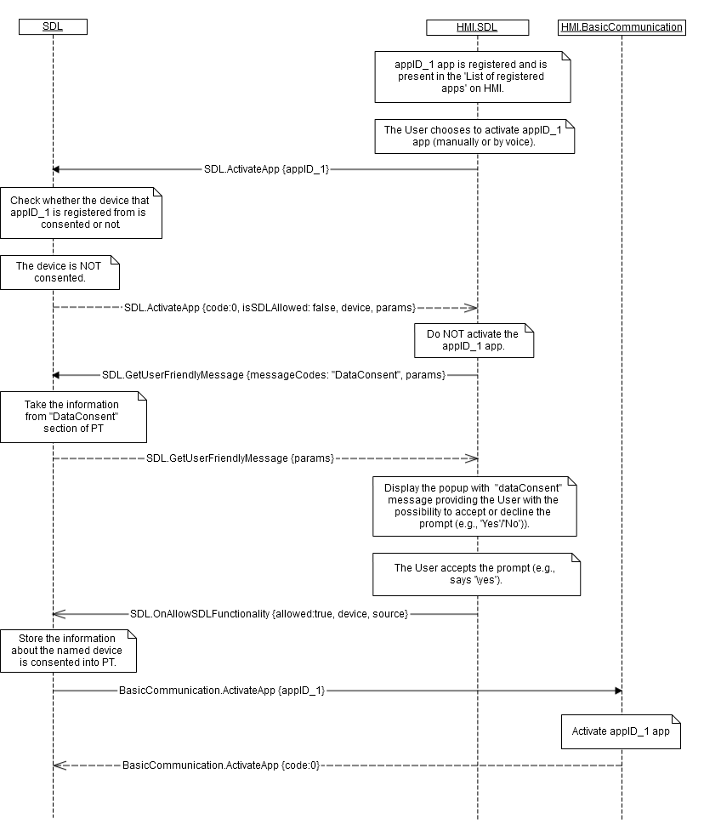

#### 13.1.4.2 SDL.ActivateApp for the application registered from the non-consented device, which does NOT get User`s consent afterwards



#### 13.1.4.3 SDL.ActivateApp for the application registered from the consented device and this application requires User`s consent for special permissions

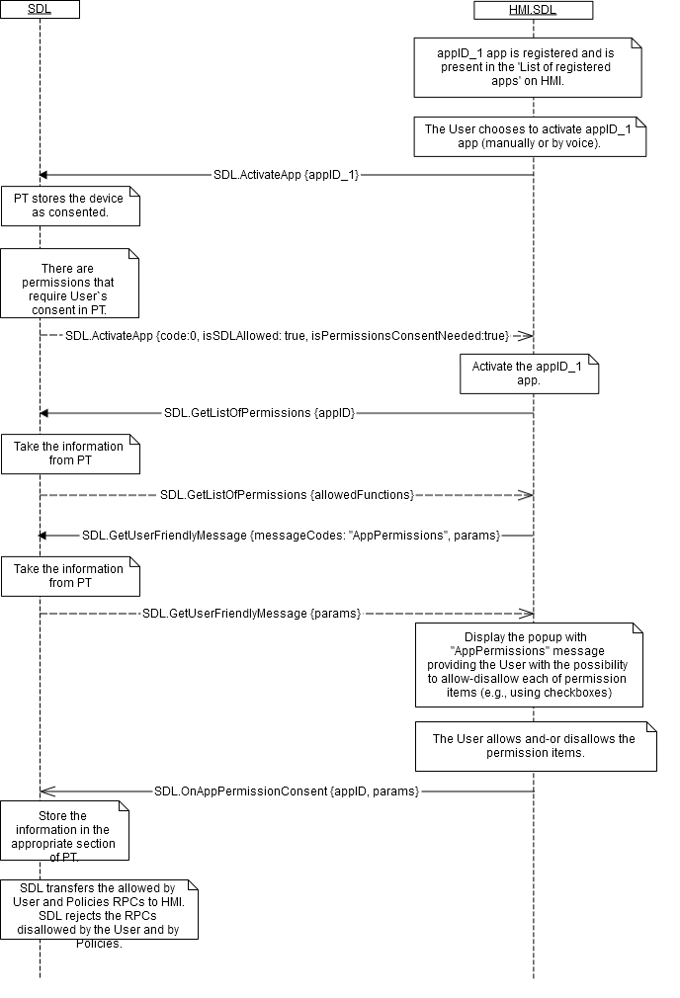

#### 13.1.4.4 SDL.ActivateApp for the application registered from the consented device and this application was reduced in permissions by the latest PT Update.

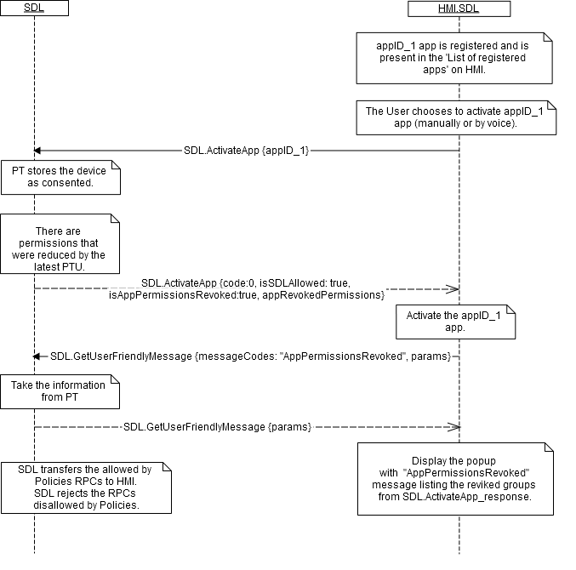

#### 13.1.4.5 SDL.ActivateApp for the application registered from the consented device and this application was unauthorized by the latest PT Update.

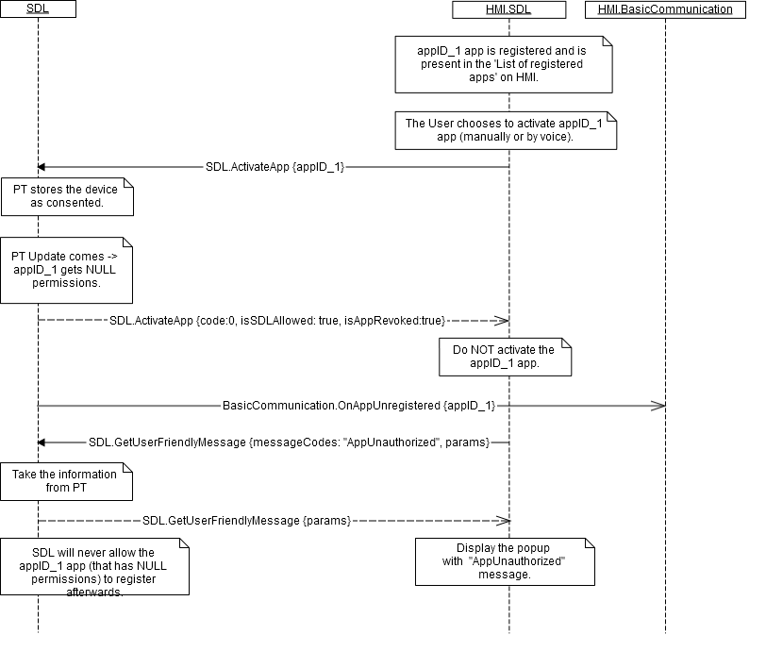

#### 13.1.4.6 SDL.ActivateApp in App Launching and Querying sequence (Open-source and Ford-specific)

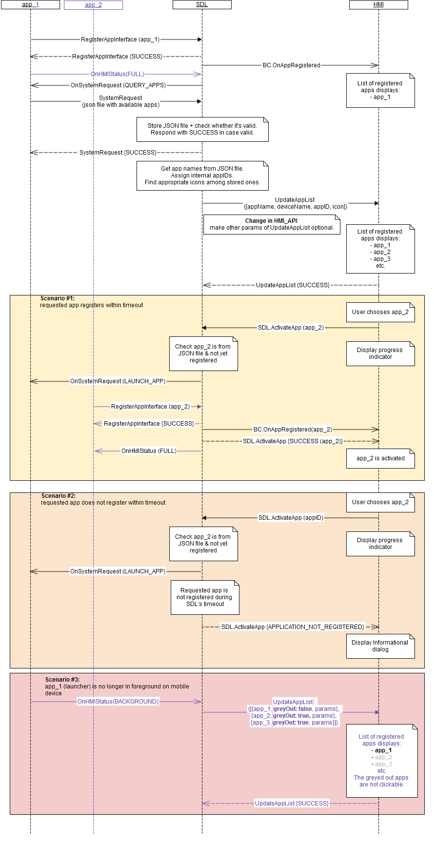

### 13.1.5 JSON Messages Examples

#### 13.1.5.1 Request

|  |
| --- |
| {  "id" : 27,  "jsonrpc" : "2.0",  "method" : "SDL.ActivateApp"  “params” :  {  “appID” : 12345  }  } |

#### 13.1.5.2 Response

|  |
| --- |
| {  "id" : 27,  "jsonrpc" : "2.0",  "result" :  {  "isSDLAllowed" : true,  "isPermissionsConsentNeeded" : false,  "isAppPermissionsRevoked" : false,  "isAppRevoked" : false,  "code" : 0,  "method" : "SDL.ActivateApp"  }  } |

#### 13.1.5.3 Error message

|  |
| --- |
| {  "id" : 27,  "jsonrpc" : "2.0",  "error" :  {  "code" : 22,  "message" : "The unknown error has occurred",  "data" :  {  "method" : "SDL.ActivateApp"  }  }  } |

### 13.1.6 D-Bus Messages Examples

#### 13.1.6.1 Request

|  |
| --- |
|  |

#### 13.1.6.2 Response

|  |
| --- |
|  |

#### 13.1.6.3 Failure

|  |
| --- |
|  |

## 13.2 GetListOfPermissions

### 13.2.1 Description

|  |  |
| --- | --- |
| **Type:** | Function |
| **Sender:** | HMI |
| **Purpose:** | Get the list of permissions either for the named application or for all applications. |

The function returns the permission groups names the status of which (that is ‘allowed’ or ‘disallowed’) may be changed by the User.

### 13.2.2 Request

#### 13.2.2.1 Behavior

***HMI must:***

1. Initiate sending GetListOfPermissions **with “appID”** parameter in the following cases:
   1. After receiving SDL.ActivateApp{isPermissionsConsentNeeded: true} from SDL.

***Note:***

*appID is known from the corresponding SDL.ActivateApp request.*

* 1. After receiving SDL.OnAppPermissionChanged{appID, appPermissionsConsentNeeded: true} from SDL.
  2. After the User presses the button to change the permissions for the application.

1. Initiate sending GetListOfPermissions **without “appID”** parameter in the following cases:

2.1) After the User presses the button to change the permissions of all currently registered applications.

***Impotant:*** When GetListOfPermissions is requested **without “appID”** parameter, the response of PermissionItem array contains the PermissionGroups (“name” parameters) for all the applications as a whole and “allowed” parameter is common for each group (e.g. if at least one of the applications has disallowed parameter for some group, “allowed” value returned for this group in the context of all application must be **false**). For more details see the diagram 13.2.4.2 GetListOfPermissions without appID

1. Store the pair of values id<->name of PermissionItem structure which were obtained via GetListOfPermissions response. These pairs will be used for future notifications via OnAppPermissionConsent in case user’s choice for the application to allow some functionality has been updated (fore more details see [13.8.2.2 OnAppPermissionConsent (id<->name dependency)](#_13.8.2.2_OnAppPermissionConsent_(id)

***Note:***

*The information about the application (name, ID, etc.) is provided by SDL via either BasicCommunication.UpdateAppList or BasicCommunication.OnAppRegistered RPCs.*

#### 13.1.2.1 Parameters

| **Param Name** | **Type** | **Mandatory** | **Additional** | **Description** |
| --- | --- | --- | --- | --- |
| appID | integer | false | - | ID of the application the list of permissions is required for. If the parameter is omitted, the permissions list will be returned for all currently registred applications on HMI |

### 13.2.3 Response

***Note:***

*There is a difference in message type for WebSocket and D-Bus connection (see the table below).*

|  |  |  |  |  |  |
| --- | --- | --- | --- | --- | --- |
| **Result** | **Description** | **Message type** | | **Message Params** | **Notes** |
| **WebSocket** | **D-Bus** |
| Success | SUCCESS: | JSON response | Method return | allowedFunctions,  code: 0 |  |
| Failure | INVALID_ID  appID is invalid (e.g. the app with current id doesn’t exist) |  |  | code:13 |  |
| INVALID_DATA  The data sent is invalid (invalid JSON syntax, parameters out of bounds or of wrong type) | JSON error message | Method return | code: 11 | Applicable for this RPC result codes.  Please see Result Enumeration for all SDL-supported codes. |
| GENERIC_ERROR:  The unknown issue occurred or other codes are not applicable. | code: 22 |

#### 13.2.3.1 Parameters

| **Param Name** | **Type** | **Mandatory** | **Additional** | **Description** |
| --- | --- | --- | --- | --- |
| allowedFunctions | Common.PermissionItem | true | array="true" minsize="0" maxsize="100" | If no permissions were specified for application the array will come empty. |

#### 13.2.3.2 PermissionItem

| **Param Name** | **Type** | **Mandatory** | **Description** |
| --- | --- | --- | --- |
| name | String | true |  |
| id | Integer | true |  |
| allowed | Boolean | false | Specifies whether functionality was allowed/disallowed. If ommited - no information about User Consent is yet found for app. |

### 13.2.4 Sequence Diagrams

#### 13.2.4.1 GetListOfPermissions

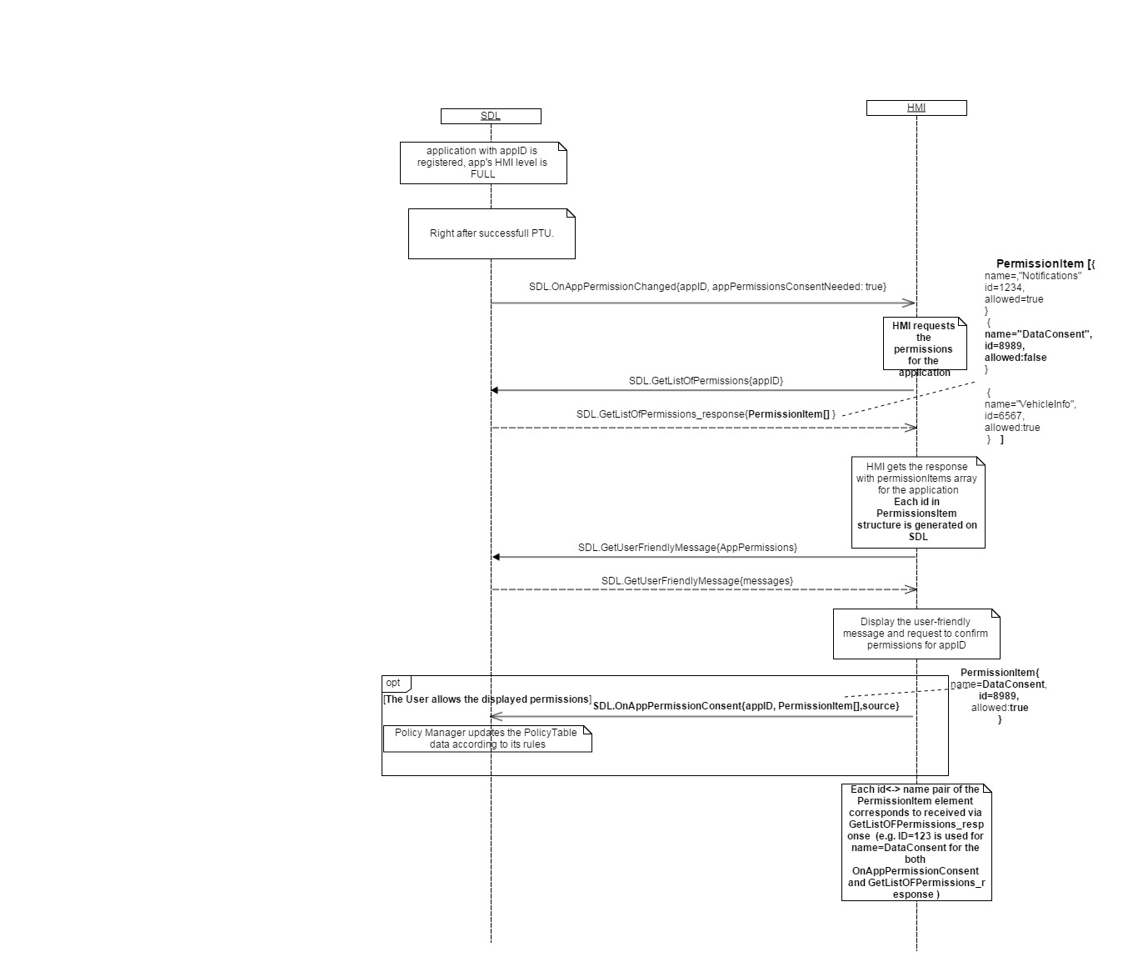

#### 13.2.4.2 GetListOfPermissions without appID

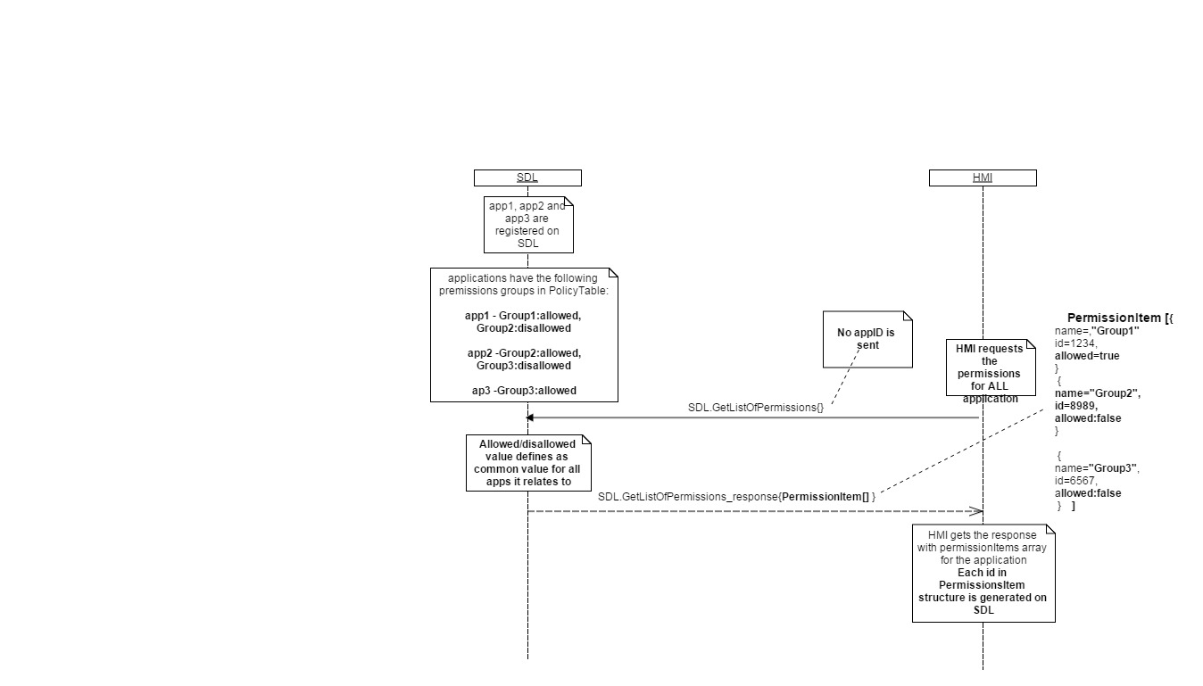

### 13.2.5 JSON Messages Examples

#### 13.2.5.1 Request

|  |
| --- |
| {  "id" : 143,  "jsonrpc" : "2.0",  "method" : "SDL.GetListOfPermissions",  “params” :  {  “appID” : 65596  }  } |

#### 13.2.5.2 Response

|  |
| --- |
| {  "id" : 143,  "jsonrpc" : "2.0",  "result" :  {  “allowedFunctions” :    [  {  “name” : “Location-1”,  “id”:1234,  “allowed”:true  },    {  “name” : “Notifications”,  “id”:76876,  “allowed”:false  },  ]    "code" : 0,  "method" : "SDL.GetListOfPermissions"  }  } |

#### 13.2.5.3 Error message

|  |
| --- |
| {  "id" : 143,  "jsonrpc" : "2.0",  "error" :  {  "code" : 15,  "message" : " A command cannot be executed because there is NO specified with appID application registered ",  "data" :  {  "method" : "SDL.GetListOfPermissions"  }  }  } |

### 13.2.6 D-Bus Messages Examples

#### 13.2.6.1 Request

|  |
| --- |
|  |

#### 13.2.6.2 Response

|  |
| --- |
|  |

#### 13.2.6.3 Failure

|  |
| --- |
|  |

## 13.3 UpdateSDL

### 13.3.1 Description

|  |  |
| --- | --- |
| **Type:** | Function |
| **Sender:** | HMI |
| **Purpose:** | Update the Policy Table request |

### 13.3.2 Request

#### 13.3.2.1 Behavior

The request notifies PolicyManager about Policy Table Update is requested by User on HMI.

***HMI must:***

1. send UpdateSDL request to SDL in case the user requests Policy Table update on HMI
2. After UpdateSDL response follow the process of Policy Update according to “result” received

***Information:***According to result sent to HMI in UpdateSDL response, SDL will follow Policy Update process:

1. UP_TO_DATE – Policy Table is now up to date, but anyway SDL starts a new policy update cycle because of user request (e.i. UpdateSDL) (see 13.3.4.1 UpdateSDL UP_TO_DATE diagram)
2. UPDATING – Policy Update process is now in already progress, anyway when currently active update process will be finished, SDL must start PT Update from the beginning (see 13.3.4.2 UpdateSDL UPDATING diagram)
3. UPDATE_NEEDED – Polciy Table is not up to date, update process must be started by SDL(see 13.3.4.3 UpdateSDL UPDATE_NEEDED diagram)

### 12.3.3 Response

***Note:***

*There is a difference in message type for WebSocket and D-Bus connection (see the table below).*

|  |  |  |  |  |  |
| --- | --- | --- | --- | --- | --- |
| **Result** | **Description** | **Message type** | | **Message Params** | **Notes** |
| **WebSocket** | **D-Bus** |
| Success | SUCCESS: | JSON response | Method return | code: 0 |  |
| Failure | INVALID_DATA:  Wrong json format | JSON error message | Method return | code: 11 | Applicable for this RPC result codes.  Please see Result Enumeration for all SDL-supported codes. |
| GENERIC_ERROR:  The unknown issue occurred or other codes are not applicable. | code: 22 |

#### 13.3.3.1 Parameters

| **Param Name** | **Type** | **Mandatory** | **Additional** | **Description** |
| --- | --- | --- | --- | --- |
| result | Common.UpdateResult | true | - | result: no update needed, update was successful/unsuccessful etc |

#### 13.3.3.2 UpdateResult

| **Element** | **Description** |
| --- | --- |
| UP_TO_DATE | PolicyTable has actual state and doesn’t require update |
| UPDATING | The process of POlicyTableUpdate is in Progress |
| UPDATE_NEEDED | PolicyTable requires to be updated |

### 13.3.4 Sequence Diagrams

#### 13.3.4.1 UpdateSDL UP_TO_DATE

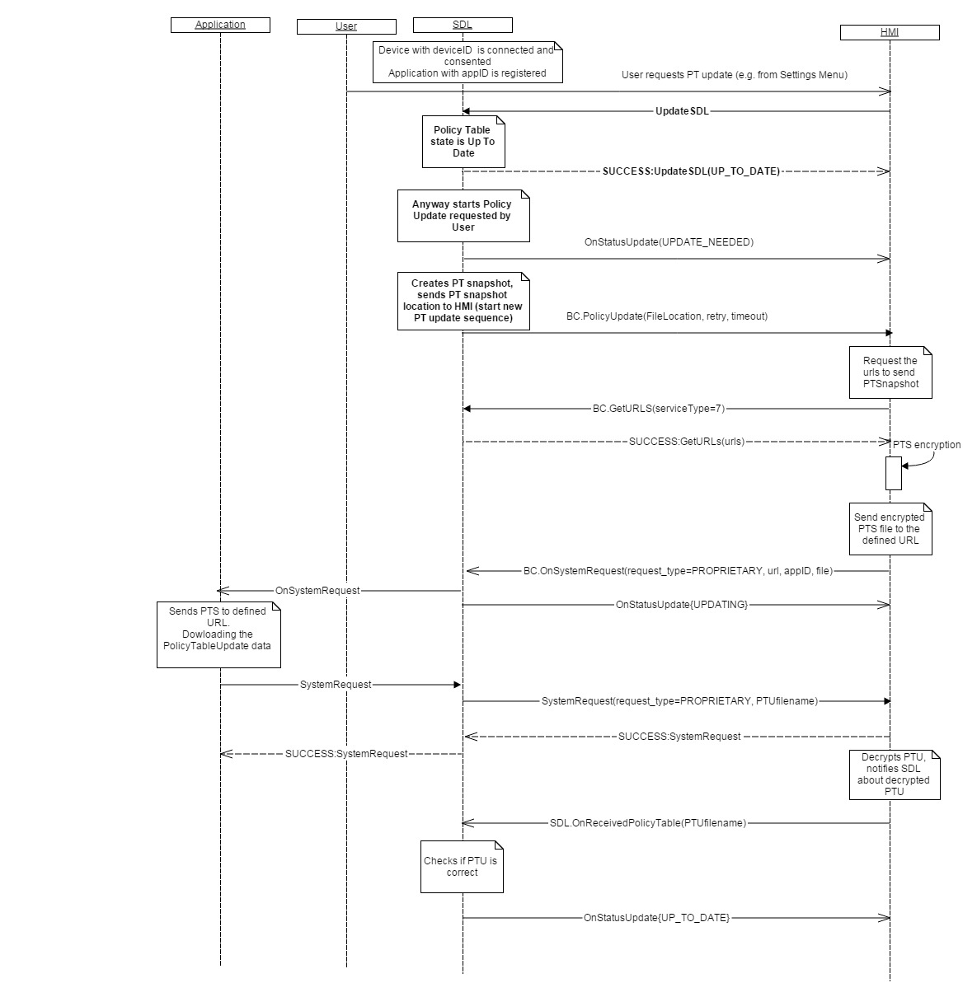

#### 13.3.4.2 UpdateSDL UPDATING

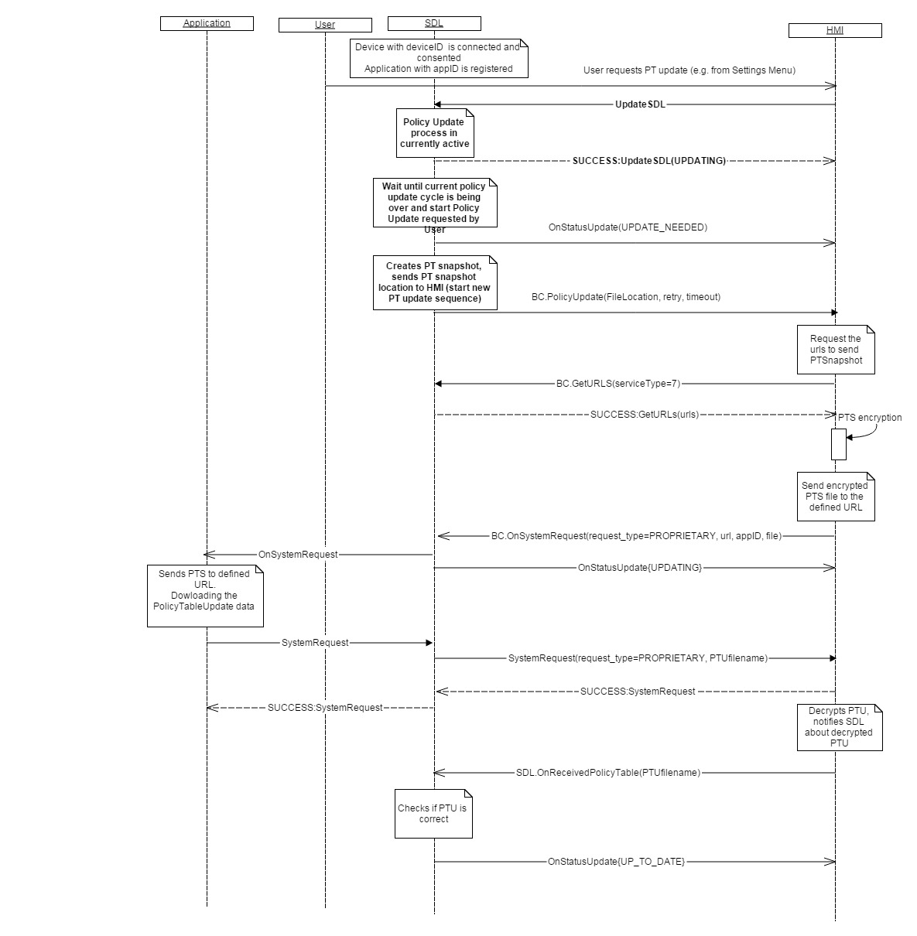

#### 13.3.4.3 UpdateSDL UPDATE_NEEDED

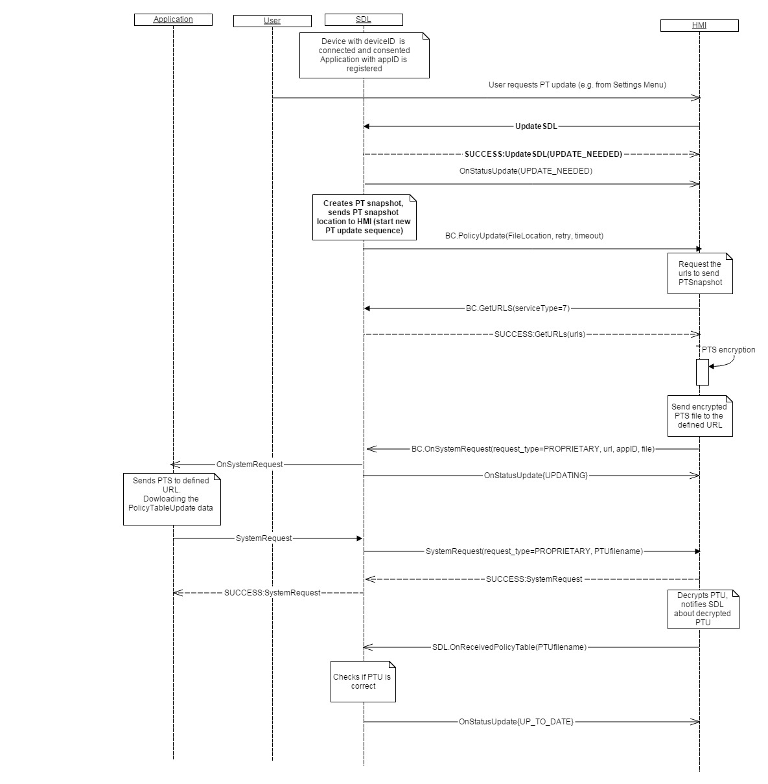

### 13.3.5 JSON Messages Examples

#### 13.3.5.1 Request

|  |
| --- |
| {  "id" : 543,  "jsonrpc" : "2.0",  "method" : "SDL.UpdateSDL"  } |

#### 13.3.5.2 Response

|  |
| --- |
| {  "id" : 543,  "jsonrpc" : "2.0",  "result" :  {  “result” : “UPDATING”  "code" : 0,  "method" : "SDL.UpdateSDL"  }  } |

#### 13.3.5.3 Error message

|  |
| --- |
| {  "id" : 543,  "jsonrpc" : "2.0",  "error" :  {  "code" : 22,  "message" : "The unknown error has occurred",  "data" :  {  "method" : "SDL.UpdateSDL"  }  }  } |

### 13.3.6 D-Bus Messages Examples

#### 13.3.6.1 Request

|  |
| --- |
|  |

#### 13.3.6.2 Response

|  |
| --- |
|  |

#### 13.3.6.3 Failure

|  |
| --- |
|  |

## 13.4 GetStatusUpdate

### 13.4.1 Description

|  |  |
| --- | --- |
| **Type:** | Function |
| **Sender:** | HMI |
| **Purpose:** | Get information about current status of PT update process. |

### 13.4.2 Request

#### 13.4.2.1 Behavior

If HMI needs to get the current status of SDL, it may send GetStatusUpdate request to SDL.  
The request GetStatusUpdate duplicates the functionality of the notification OnStatusUpdate. In case the policy update status is being changed.(e.g. an update is finished successfully or retry strategy failed),SDL must send notification OnStatusUpdate to HMI with the corresponding UpdateStatus code, whereas GetStatusUpdate allowes to request the status of policy table at any time, not on update only.

***HMI must:***

* Send a request to HMI if it needs to get a current policy update status according to its workflows

### 13.4.3 Response

***Note:***

*There is a difference in message type for WebSocket and D-Bus connection (see the table below).*

|  |  |  |  |  |  |
| --- | --- | --- | --- | --- | --- |
| **Result** | **Description** | **Message type** | | **Message Params** | **Notes** |
| **WebSocket** | **D-Bus** |
| Success | SUCCESS: | JSON response | Method return | code: 0 |  |
| Failure | INVALID_DATA:  Wrong JSON | JSON error message | Method return | code: 11 | Applicable for this RPC result codes.  Please see Result Enumeration for all SDL-supported codes. |
| GENERIC_ERROR:  The unknown issue occurred or other codes are not applicable. | code: 22 |

#### 13.4.3.1 Parameters

| **Param Name** | **Type** | **Mandatory** | **Additional** | **Description** |
| --- | --- | --- | --- | --- |
| status | Common.UpdateResult | true | - | See 13.4.3.2 UpdateResult |

#### 13.4.3.2 UpdateResult

| **Element** | **Description** |
| --- | --- |
| UP_TO_DATE | PolicyTable is up to date and doesn’t require an update |
| UPDATING | The process of Policy Table Update is in Progress |
| UPDATE_NEEDED | Policy Table requires to be updated |

### 13.4.4 Sequence Diagrams

#### 13.4.4.1 GetStatusUpdate

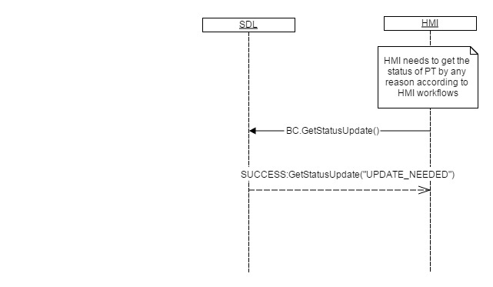

### 13.4.5 JSON Messages Examples

#### 13.4.5.1 Request

|  |
| --- |
| {  "id" : 176,  "jsonrpc" : "2.0",  "method" : "SDL.GetStatusUpdate",  } |

#### 13.4.5.2 Response

|  |
| --- |
| {  "id" : 176,  "jsonrpc" : "2.0",  "result" :  {  “status” : “UPDATE_NEEDED”  "code" : 0,  "method" : "SDL.GetStatusUpdate"  }  } |

#### 13.4.5.3 Error message

|  |
| --- |
| {  "id" : 176,  "jsonrpc" : "2.0",  "error" :  {  "code" :22,  "message" : "Some error occured",  "data" :  {  "method" : "SDL.GetStatusUpdate"  }  }  } |

### 13.4.6 D-Bus Messages Examples

#### 13.4.6.1 Request

|  |
| --- |
|  |

#### 13.4.6.2 Response

|  |
| --- |
|  |

#### 13.4.6.3 Failure

|  |
| --- |
|  |

## 13.5 GetURLS

### 13.5.1 Description

|  |  |
| --- | --- |
| **Type:** | Function |
| **Sender:** | HMI |
| **Purpose:** | Get list of URL for specified service type and optionally policy's application id. |

SDL responds with the url(s) and optionally corresponding appID(s) from policies database based on service number provided by HMI in GetURLs request.

### 13.5.2 Request

#### 13.5.2.1 Behavior

***HMI must:***

- specify the service number which requires the list of URLs (defines if IVSU (7) or Policy (4) workflow requests the data)

- on a response from SDL, use the urls and appIDs according to IVSU or Policies WorkFlow.

**Information(IVSU workflow):**

On receival GetURLs response**,** SYNCP Manager on HMI will send the file to the cloud via BasicCommunication.OnSystemRequest(request_type=PROPRIETARY, url, appID, file)

 - url is from BC.GetURLs

 - appID is from BC.SystemRequest received previously

 - file is the InterrogatorLog

For more details see 13.5.4.2 GetURLS for IVSU

***Information (Policies workflow):***

* 1. SYNCP Manager reads file from SDL.PolicyUpdate and encrypts and encodes the data into a file. The format of the file will be JSON.
  2. SYNCP requests the list of URLs via BC.GetURLS (7)
  3. On receival of BC.GetURLS reponse, SYNCP manager must send the file to the cloud via BasicCommunication.OnSystemRequest(request_type=PROPRIETARY, url, appID, file).

 - “url” and “appID” are an element of ServiceInfo array got from SDL.GetURLs;

 - “file” is Policy Table Snapshot encrypted

For more details see 13.5.4.1 GetURLS for Policies

#### 13.5.2.1 Parameters

| **Param Name** | **Type** | **Mandatory** | **Additional** | **Description** |
| --- | --- | --- | --- | --- |
| service | Integer | true | minvalue="0" maxvalue="100" | Service type the list of urls is required for. |

### 13.5.3 Response

***Note:***

*There is a difference in message type for WebSocket and D-Bus connection (see the table below).*

|  |  |  |  |  |  |
| --- | --- | --- | --- | --- | --- |
| **Result** | **Description** | **Message type** | | **Message Params** | **Notes** |
| **WebSocket** | **D-Bus** |
| Success | SUCCESS: | JSON response | Method return | code: 0 |  |
| Failure | INVALID_DATA:  Data is out of bounds or wrong JSON | JSON error message | Method return | code: 11 | Applicable for this RPC result codes.  Please see Result Enumeration for all SDL-supported codes. |
| GENERIC_ERROR:  Some fail occurred or other codes are not applicable. | code: 22 |

#### 13.5.3.1 Parameters

| **Param Name** | **Type** | **Mandatory** | **Additional** | **Description** |
| --- | --- | --- | --- | --- |
| urls | Common.ServiceInfo | false | array="true" minsize="1" maxsize="100" |  |

#### 13.5.3.2 ServiceInfo

| **Param Name** | **Type** | **Mandatory** | **Description** |
| --- | --- | --- | --- |
| url | String | true | Get URL based on service type. |
| appID | Integer | false | Internal ID of the application that corresponds to the policyAppID |

### 13.5.4 Sequence Diagrams

#### 13.5.4.1 GetURLS for Policies

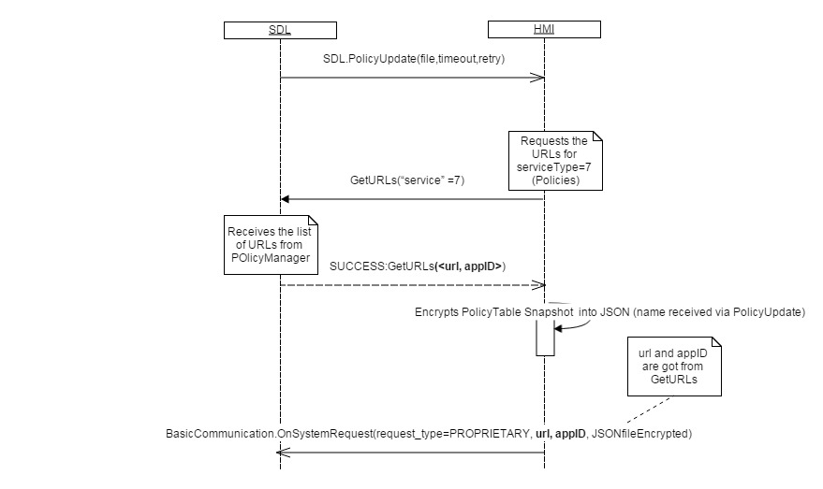

#### 13.5.4.2 GetURLS for IVSU

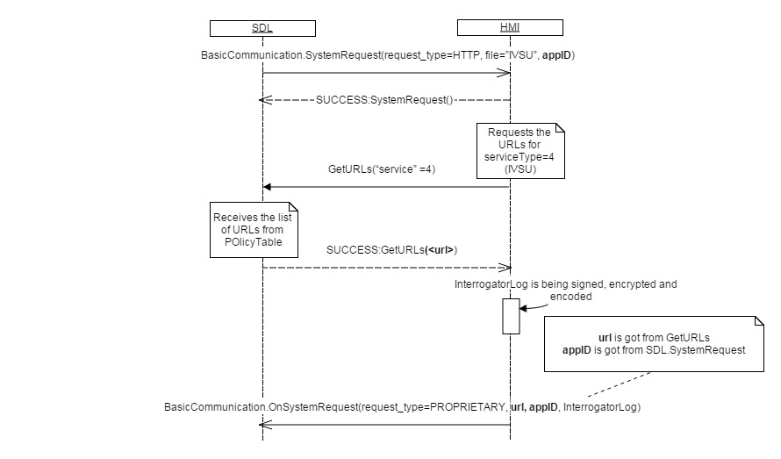

### 13.5.5 JSON Messages Examples

#### 13.5.5.1 Request

|  |
| --- |
| {  "id" : 176,  "jsonrpc" : "2.0",  "method" : "SDL.GetURLS",  “params” :  {  “service” :7  }  } |

#### 13.5.5.2 Response

|  |
| --- |
| {  "id" : 176,  "jsonrpc" : "2.0",  "result" :  {  “urls” :  [{  "url" : "http://policies.telematics.ford.com/api/policies"  }  ]  "code" : 0,  "method" : "SDL.GetURLS"  }  } |

#### 13.5.5.3 Error message

|  |
| --- |
| {  "id" : 176,  "jsonrpc" : "2.0",  "error" :  {  "code" :22,  "message" : "Some fail occurred",  "data" :  {  "method" : "SDL.GetURLS"  }  }  } |

### 13.4.6 D-Bus Messages Examples

#### 13.4.6.1 Request

|  |
| --- |
|  |

#### 13.4.6.2 Response

|  |
| --- |
|  |

#### 13.4.6.3 Failure

|  |
| --- |
|  |

## 13.6 GetUserFriendlyMessage

### 13.6.1 Description

|  |  |
| --- | --- |
| **Type:** | Function |
| **Sender:** | HMI |
| **Purpose:** | Get the user-friendly message(s) reserved in Policy Table |

### 13.6.2 Request

#### 13.6.2.1 Behavior

***HMI must:***

* Request message text to notify user via UI or/and TTS message about some event is happening. Message text may also be requested for some specific dialogs on HMI which require user’s answers.
* Notify user according to HMI flow via UI pop-ups or/and TTS messages, the text for them obtained in GetUserFriendlyMessage response in correspondence to messageCodes requested

#### 13.6.2.2 Parameters

| **Param Name** | **Type** | **Mandatory** | **Additional** | **Description** |
| --- | --- | --- | --- | --- |
| messageCodes | String | true | array="true" minsize="1" maxsize="100" maxlength="500" | Id of message to be received according to Policy Table i.e. StatusNeeded, Notifications, DrivingCharacteristics etc. |
| language | Common.Language | false | - | Optional parameter if HMI wants message in some other language then its current one already known to SDL. |

#### 13.6.2.3 MessageCodes

Message codes specify appropriate user messages which notifies the user about some events/conditions on HMI. Messages and message codes are coming from Policy Table and must be used on HMI in different information pop-ups according to HMI use-cases scenarios.

***Important:*** “MessageText” column specifies the messages just for an information purposes. The MessageText received from SDL may differ from listed in the table.

| **MessageCode** | **MessageText** |
| --- | --- |

|  |  |
| --- | --- |
| AppPermissions | %appName% is requesting the use of the following vehicle information and permissions %functionalGroupLabels%. Grant requested permission(s)? |
| AppPermissionsHelp | "%appName% is requesting the following vehicle information and permissions: %functionalGroupLabels%. You can change these permissions and hear detailed descriptions in the mobile apps settings menu. Please press yes to grant permissions or no to deny. |
| AppPermissionsRevoked | App authorizations have changed. %appName% can no longer access %functionalGroupLabels%. Please you have the most recent app version installed on your mobile device. |

|  |  |
| --- | --- |
| AppUnauthorized | This version of %appName% is not authorized and will not work with Applink. Please update to the latest version of %appName%. |
| AppUnsupported | Your version of %appName% is not supported by SYNC. |
| DataConsent | Would you like to enable Mobile Apps on SYNC?\n\nTo use Mobile Apps with SYNC, SYNC will communicate with Ford at least once per month using your mobile device’s data plan. Standard rates may apply. SYNC will send your VIN and SYNC module number to Ford U.S.\n\nUpdates are about the size of an email, and the occurrence of updates depends on your vehicle usage and when a new app is found on your device. To turn on or off, visit the SYNC Settings menu. See your Owner Guide for more information. |
| DataConsentHelp | Updates are about the size of an email, and the occurrence of updates depends on your vehicle usage and when a new app is found on your device. See your Owner Guide for more information. |
| DisableApps | Disabling automatic updates will also disable sync mobile apps. You will not be able to use any mobile apps with SYNC. Please press yes to confirm or no to cancel. |
| DrivingCharacteristics | An app can access the following driving characteristics: Fuel Consumption, MyKey, Seat Belt Status. |
| Location | An app can access vehicle GPS and speed. |
| Notifications | An app can send notifications when running in the background. |
| SettingDisableUpdates | Disable Updates |
| SettingEnableUpdates | Enable Apps |
| SettingUpdateAuto | Select `Update now` to receive app authorization information for your SYNC-enabled mobile apps. This may enable additional functionality depending on the app and your settings. If your phone has a working data connection, an update should complete in less than 1 minute. |
| StatusNeeded | Update Needed |
| StatusPending | Updating... |
| StatusUpToDate | Up-To-Date |
| VehicleInfo | An app can access the following vehicle information: Fuel Level, Fuel Economy, Engine RPMs, Odometer, VIN, External Temperature, Gear Position, Tire Pressure. |

### 13.6.3 Response

***Note:***

*There is a difference in message type for WebSocket and D-Bus connection (see the table below).*

|  |  |  |  |  |  |
| --- | --- | --- | --- | --- | --- |
| **Result** | **Description** | **Message type** | | **Message Params** | **Notes** |
| **WebSocket** | **D-Bus** |
| Success | SUCCESS: | JSON response | Method return | code: 0 |  |
| Failure | INVALID_DATA:  Data is out of bounds or wrong JSON | JSON error message | Method return | code: 11 | Applicable for this RPC result codes.  Please see Result Enumeration for all SDL-supported codes. |
| GENERIC_ERROR:  Some fail occurred or other codes are not applicable. | code: 22 |

#### 13.6.3.1 Parameters

| **Param Name** | **Type** | **Mandatory** | **Additional** | **Description** |
| --- | --- | --- | --- | --- |
| messages | Common.UserFriendlyMessage | false | array="true" minsize="1" maxsize="100" | If no message was found in PT for specified message code and for HMI current or specified language, this parameter will be omitted. |

#### 13.6.3.2 UserFriendlyMessage

| **Param Name** | **Type** | **Mandatory** | **Description** |
| --- | --- | --- | --- |
| messageCode | String | true | Id of message to be received according to Policy Table i.e. StatusNeeded, Notifications, DrivingCharacteristics etc. See 13.6.2.3 MessageCodesfor more details |
| ttsString | String | false |  |
| label | String | false |  |
| line1 | String | false |  |
| line2 | String | false |  |
| textBody | String | false |  |

### 13.6.4 Sequence Diagrams

#### 13.6.4.1 GetUserFriendlyMessage for DeviceConsent



### 13.6.5 JSON Messages Examples

#### 13.6.5.1 Request

|  |
| --- |
| {  "id" : 176,  "jsonrpc" : "2.0",  "method" : "SDL.GetUserFriendlyMessage",  “params” :  {  "messageCodes": "AppPermissions", “language” : “EN-GB”  }  } |

#### 13.6.5.2 Response

|  |
| --- |
| {  "id" : 176,  "jsonrpc" : "2.0",  "result" :  {  "messages": {  “messageCode”: "AppPermissions",  “ttsString”: "%appName% is requesting the use of the following ....",  line1: "Grant Requested", line2: "Permission(s)?"  } "code" : 0,  "method" : "SDL.GetUserFriendlyMessage"  }  } |
|  |

#### 13.6.5.3 Error message

|  |
| --- |
| {  "id" : 176,  "jsonrpc" : "2.0",  "error" :  {  "code" :22,  "message" : "Some error occured ",  "data" :  {  "SDL.GetUserFriendlyMessage"  }  }  } |

### 13.6.6 D-Bus Messages Examples

#### 13.6.6.1 Request

|  |
| --- |
|  |

#### 13.6.6.2 Response

|  |
| --- |
|  |

#### 13.6.6.3 Failure

|  |
| --- |
|  |

## 13.7 OnAllowSDLFunctionality

### 13.7.1 Description

|  |  |
| --- | --- |
| **Type:** | Notification |
| **Sender:** | HMI |
| **Purpose:** | Inform about allowing SDL functionality |

Notifies about user/HMI allowing SDL functionality or disallowing access to all mobile apps on the specified device.

***HMI must:***

* Send OnAllowSDLFuntionality notification to SDL as a result of user’s choice about device data consent via pop-up dialog or user’s settings change in Settings Menu (if applicable)

***Impotant:*** In case HMI sends OnAllowSDLFunctionality without “device” parameter, the data access allowance/disallowance will be applied to all the devices connected at the current moment to HU,

***Note:*** SDL ignores all invalid notifications which come from HMI (invalid JSON, invalid data types/bounds etc)

#### 13.7.1.1 Parameters

| **Param Name** | **Type** | **Mandatory** | **Additional** | **Description** |
| --- | --- | --- | --- | --- |
| device | Common.DeviceInfo | false | - | If no device is specified permission counts for SDL functionality in general. |
| allowed | Boolean | true | - | Must be true if allowed |
| source | Common.ConsentSource | true | - |  |

#### 13.7.1.2 DeviceInfo

| **Param Name** | **Type** | **Mandatory** | **Additional** | **Description** |
| --- | --- | --- | --- | --- |
| name | String | true |  | The name of the device connected |
| id | Integer | true |  | The ID of the device connected. It remains unique during the ignition cycle. |
| transportType | Common.TransportType | false |  | Not applicable for OnAllowSDLFunctionality notification |
| isSDLAllowed | Boolean | false |  | Not applicable for OnAllowSDLFunctionality notification |

#### 13.7.1.3 ConsentSource

| **Element name** | **Value** | **Short Description** |
| --- | --- | --- |
| GUI | 0 |  |
| VUI | 1 | Voice recognition user interface |

#### 13.7.1.4 TransportType Enumeration

| **Element name** | **Value** | **Short Description** |
| --- | --- | --- |
| BLUETOOTH | 0 |  |
| USB | 1 |  |
| WIFI | 2 |  |

### 13.7.2 Sequence Diagrams

#### 13.7.2.1 OnAllowSDLFunctionality



### 13.7.3 JSON Messages Examples

|  |
| --- |
| {  "jsonrpc" : "2.0",  "method" : "SDL.OnAllowSDLFunctionality",  "params" :  {  "deviceInfo":  {  "name" : “Mary`s Phone”,  "id" : 8  }  “allowed” : true,  “source” :”GUI”  }  } |

### 13.7.4 D-Bus Messages Examples

|  |
| --- |
|  |

## 13.8 OnAppPermissionConsent

### 13.8.1 Description

|  |  |
| --- | --- |
| **Type:** | Notification |
| **Sender:** | HMI |
| **Purpose:** | Inform about the User permission changes for some functionality for the named application. |

Initiated by HMI for specifying the allowance for the application to perform some functionality.The notification informs Policy Manager about some changes in application permissions, that effect application behavior on HMI.

***HMI must:***  
 1) send OnAppPermissionConsent when User answers to prompt about app's permisstions consent (see diagram 13.8.2.1 OnAppPermissionConsent )  
 2) send OnAppPermissionConsent when User enters settings menu and allows/disallows app's permissions

3) use the pair of values id<->name in PermissionItem structure which were obtained via GetListOfPermissions response (fore more details see [13.8.2.2 OnAppPermissionConsent (id<->name dependency)](#_13.8.2.2_OnAppPermissionConsent_(id)

***SDL information:***

PoliciesManager applies the changes to all applications in case OnAppPermissionConsent is received without "<appID>" parameter.

PoliciesManager applies the changes received via OnAppPermissionConsent according to its internal rules (update appropriate application permissions sections in the policies database etc).

***Note:*** SDL ignores all invalid notifications which come from HMI (invalid JSON, invalid data types/bounds etc)

#### 13.8.1.1 Parameters

| **Param Name** | **Type** | **Mandatory** | **Additional** | **Description** |
| --- | --- | --- | --- | --- |
| appID | Integer | false | - | ID of the application the RPC is applied to |
| consentedFunctions | Common.PermissionItem | true | array="true" minsize="1" maxsize="100" |  |
| source | Common.ConsentSource | true | - |  |

#### 13.8.1.2 PermissionItem

| **Param Name** | **Type** | **Mandatory** | **Description** |
| --- | --- | --- | --- |
| name | String | true |  |
| id | Integer | true |  |
| allowed | Boolean | false | Specifies whether functionality was allowed/disallowed. If ommited - no information about User Consent is yet found for app. |

#### 13.8.1.3 ConsentSource

| **Element name** | **Value** | **Short Description** |
| --- | --- | --- |
| GUI | 0 |  |
| VUI | 1 | Voice recognition user interface |

### 13.8.2 Sequence Diagrams

#### 13.8.2.1 OnAppPermissionConsent (User answers to prompt about app's permisstions consent)

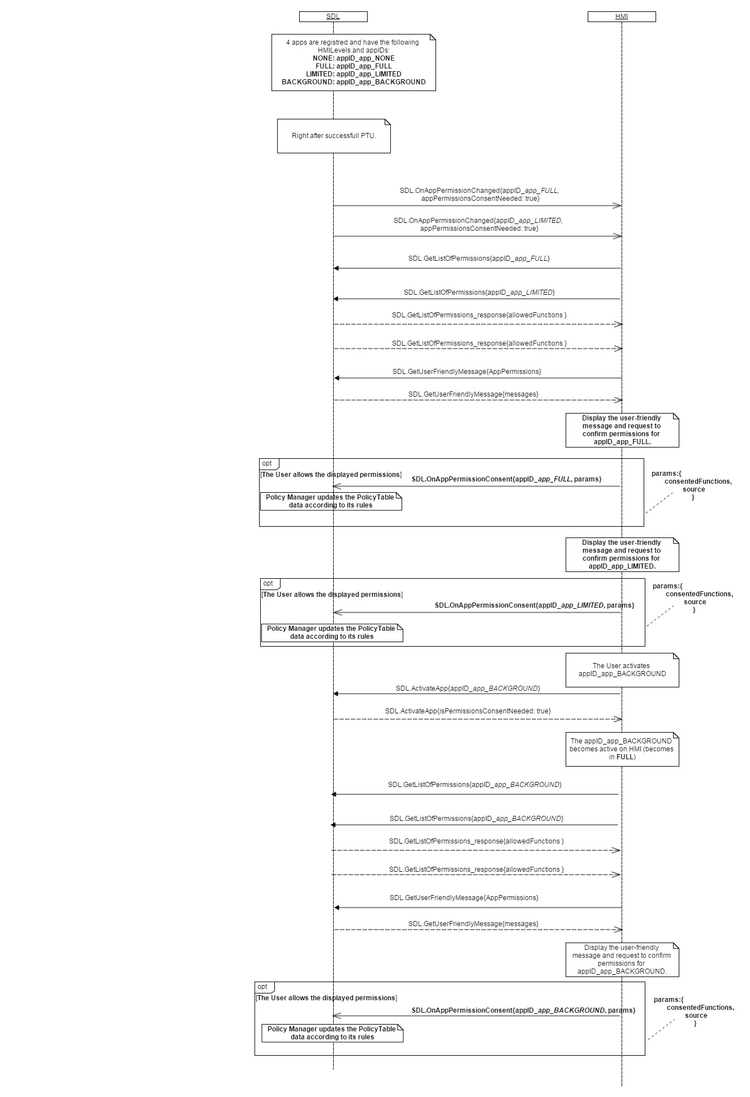

#### 13.8.2.2 OnAppPermissionConsent (id<->name dependency)

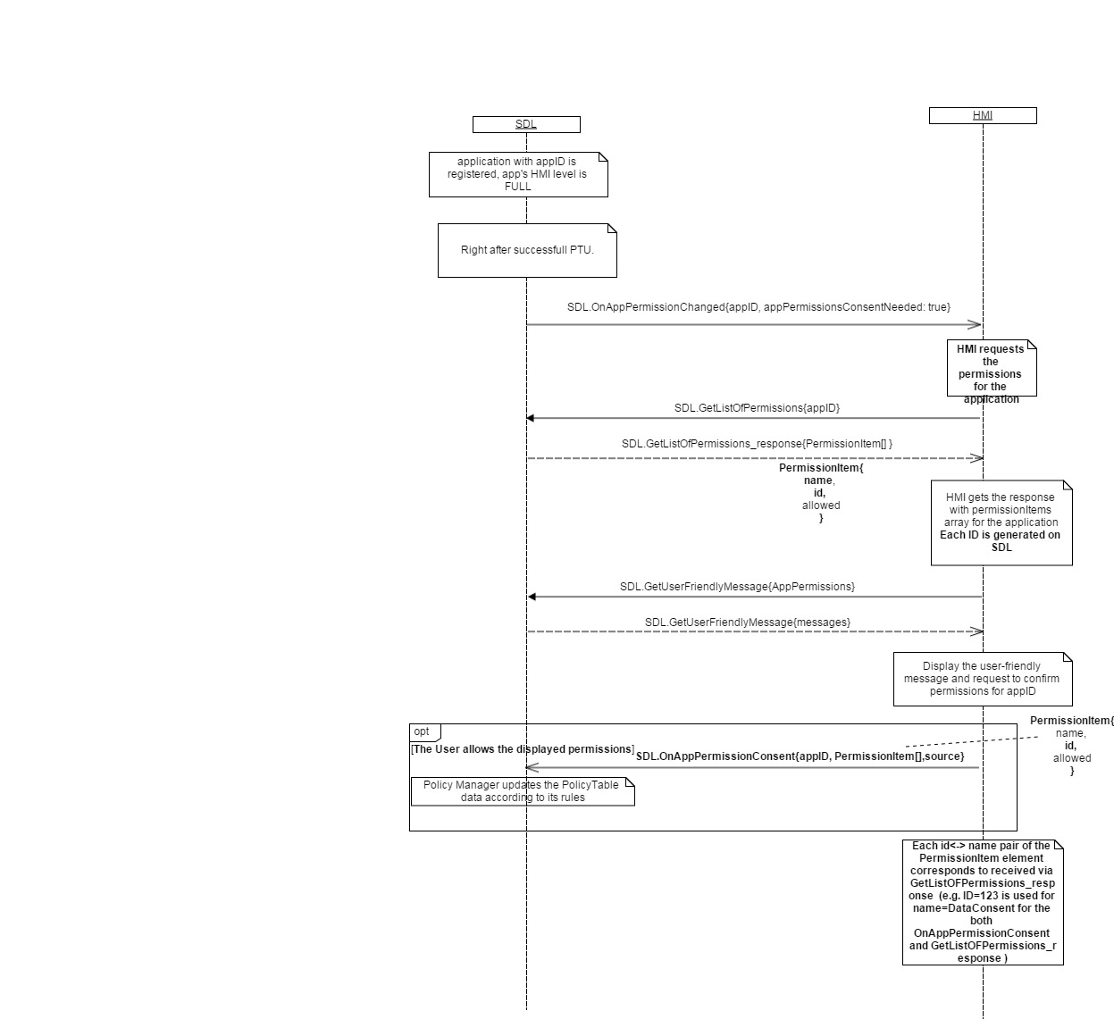

### 13.8.3 JSON Messages Examples

|  |
| --- |
| {  "jsonrpc" : "2.0",  "method" : "SDL.OnAppPermissionConsent",  "params" :  {  "appID":13759,  "consentedFunctions":[  {"allowed":false,  "id":4734356,  "name":"DrivingCharacteristics"  }],  "source":"GUI"  }} |

### 13.8.4 D-Bus Messages Examples

|  |
| --- |
|  |

## 13.9 OnAppPermissionChanged

### 13.9.1 Description

|  |  |
| --- | --- |
| **Type:** | Notification |
| **Sender:** | SDL |
| **Purpose:** | Inform about the permissions changes for the application |

Notification from SDL to HMI. Occurs when app permissions were changed. If no permission specified means that app was dissallowed and has to be unregitstered.

**Note:** SDL sends the list of RequestTypes allowed by Policies via OnAppPermissionChanged API. In case HMI will use some not allowed by PolicyTable, SDL will **ignore** all notofications from HMI which contain prohibited RequestTypes values (e.g. sent via OnSystemRequest).

#### 13.9.1.1 Parameters

| **Param Name** | **Type** | **Mandatory** | **Additional** | **Description** |
| --- | --- | --- | --- | --- |
| appID | Integer | true |  |  |
| isAppPermissionsRevoked | Boolean | false |  |  |
| appRevokedPermissions | Common.PermissionItem | false | array="true" minsize="1" maxsize="100" | If app permissions were reduced (isAppPermissionsRevoked == true), then this array specifies list of removed permissions |
| appRevoked | Boolean | false |  | If present then specified application was prohibited to used with Sync. |
| appPermissionsConsentNeeded | Boolean | false |  | If present specifies that permissions were added to application that require User Consent, then HMI can send GetListOfPermissions request to obtain list of permissions. |
| appUnauthorized | Boolean | false |  | When present and set to true (should be if present) then this means that application was not authorized (nickname check failed.) |
| priority | Common.AppPriority | false |  | Send to HMI so that it can coordinate order of requests/notifications correspondingly. |
| requestType | Common.RequestType | false | minsize="0" maxsize="100" array="true" | The list of SystemRequest's RequestTypes allowed by policies for the named application (the app's SystemRequest sent with RequestType out of this list will get 'disallowed' response from SDL).  If SDL sends an empty array - any RequestType is allowed for this app.  If SDL omits this parameter - nothing is changed for RequestType in the policies |

#### 13.9.1.3 AppPriority

| **Element name** | **Value** | **Short Description** |
| --- | --- | --- |
| EMERGENCY | 0 |  |
| NAVIGATION | 1 |  |
| VOICE_COMMUNICATION | 2 |  |
| COMMUNICATION | 3 |  |
| NORMAL | 4 |  |
| NONE | 5 |  |

#### 13.9.1.3 RequestType Enumeration

| **Element name** | **Value** | **Short Description** |
| --- | --- | --- |
| HTTP | 0 |  |
| FILE_RESUME | 1 |  |
| AUTH_REQUEST | 2 |  |
| AUTH_CHALLENGE | 3 |  |
| AUTH_ACK | 4 |  |
| PROPRIETARY | 5 |  |
| QUERY_APPS | 6 |  |
| LAUNCH_APP | 7 |  |
| LOCK_SCREEN_ICON_URL | 8 |  |
| TRAFFIC_MESSAGE_CHANNEL | 9 |  |
| DRIVER_PROFILE | 10 |  |
| VOICE_SEARCH | 11 |  |
| NAVIGATION | 12 |  |
| PHONE | 13 |  |
| CLIMATE | 14 |  |
| SETTINGS | 15 |  |
| VEHICLE_DIAGNOSTICS | 16 |  |
| EMERGENCY | 17 |  |
| MEDIA | 18 |  |
| FOTA | 19 |  |

### 13.9.2 Sequence Diagrams

#### 13.9.2.1 OnAppPermissionChanged with appPermissionsConsentNeeded:true

Pre-conditions to the sequence:  
a) SDL and HMI are started  
b) Device is connected to the System (SDL/HU) and is consented by the User.  
c) Four apps are registered with SDL and HMI ('name_HMILevel'): app_FULL, app_LIMITED, app_BACKGROUND, app_NONE.

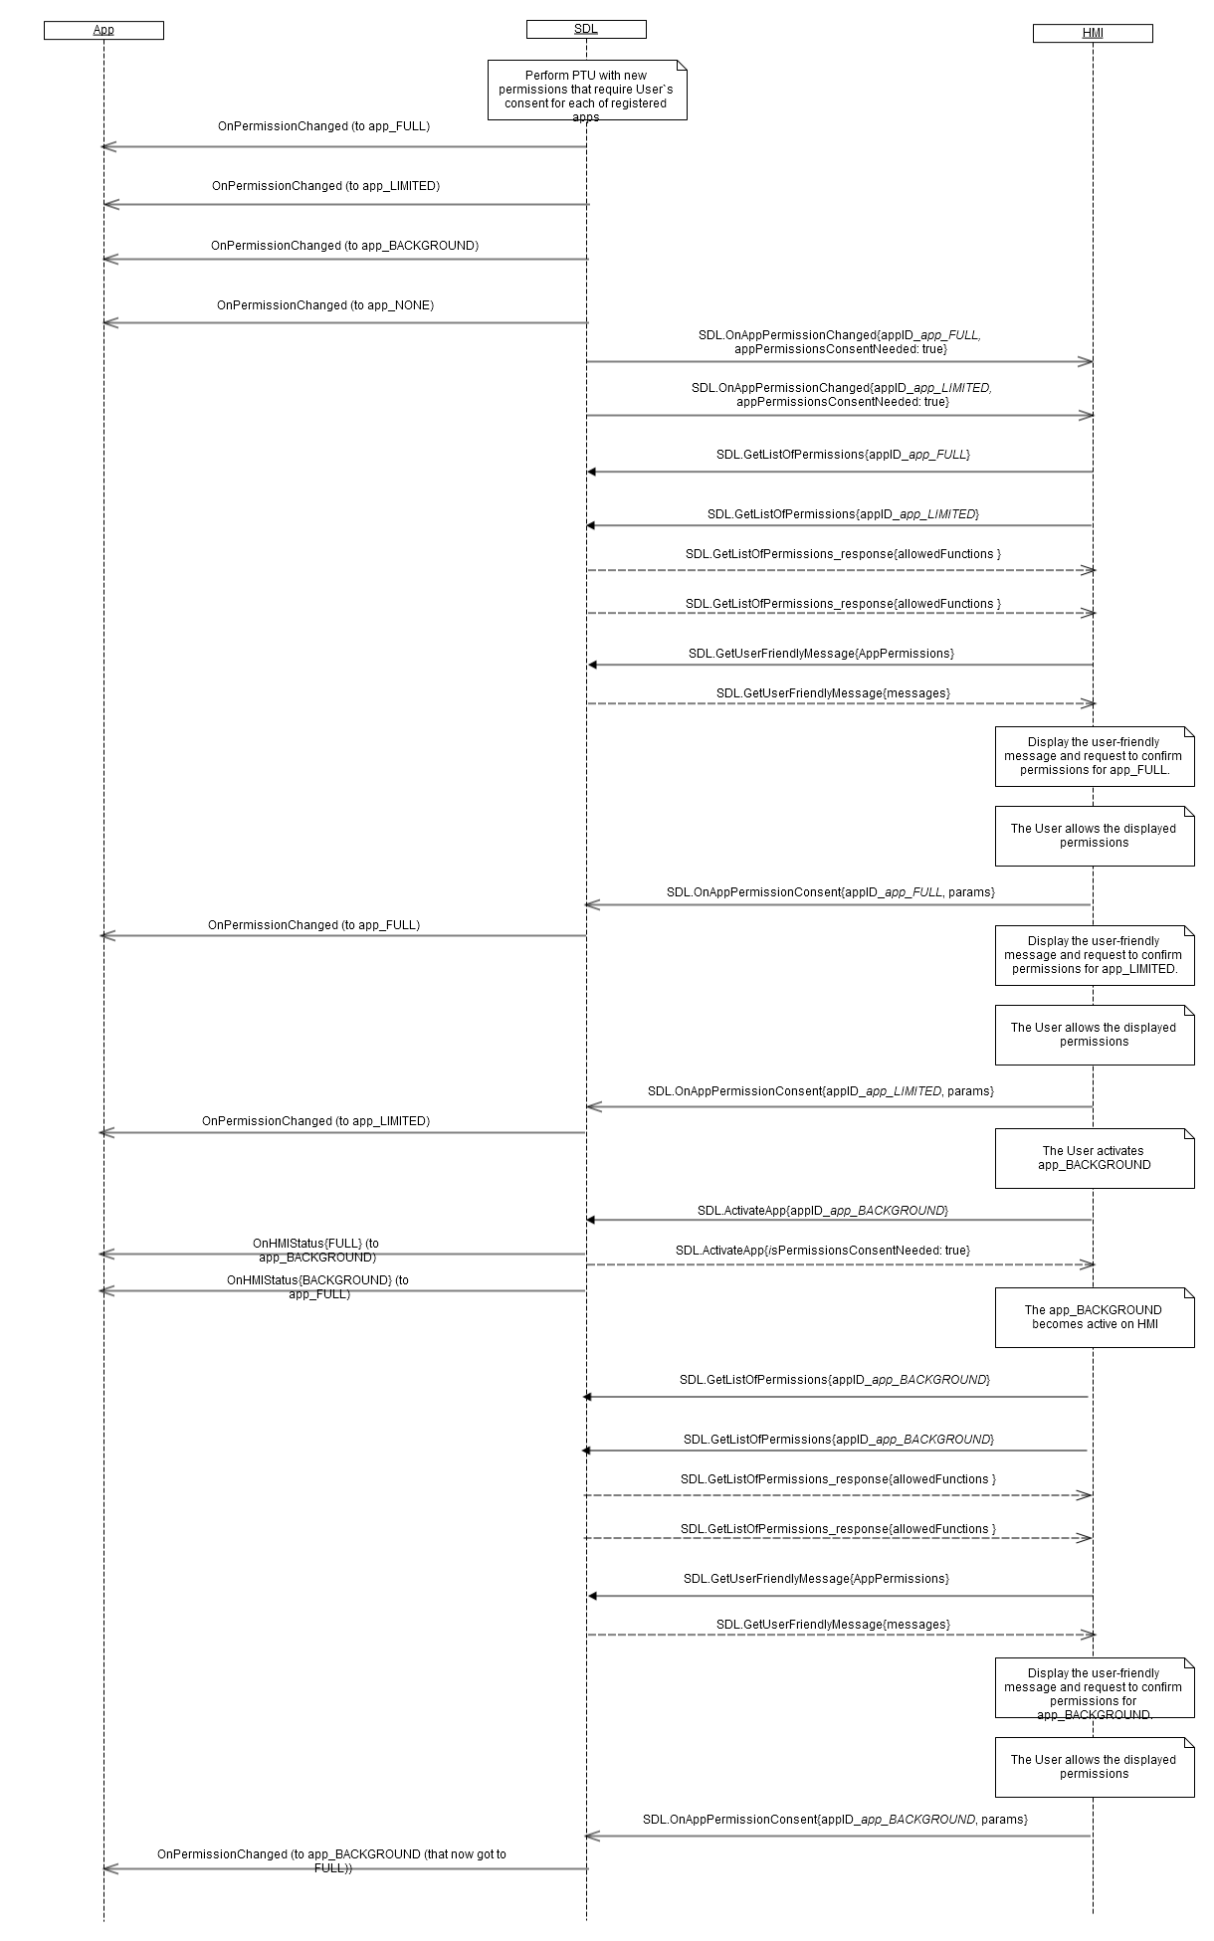

### 13.9.3 JSON Messages Examples

|  |
| --- |
| {  "jsonrpc" : "2.0",  "method" : "SDL.OnAppPermissionChanged",  "params" :  {  “appID” : 65674,  }  } |

### 13.9.4 D-Bus Messages Examples

|  |
| --- |
|  |

## 13.10 OnSDLConsentNeeded

### 13.10.1 Description

|  |  |
| --- | --- |
| **Type:** | Notification |
| **Sender:** | SDL |
| **Purpose:** | Send from SDL to HMI to notify that data consent is needed for device |

The notification is applicable only for the case when the device is not consented by the user and the user requests Policy Table update from HMI. For more details see the diagram 13.10.2.1 OnSDLConsentNeeded

1. HMI must: Initiate the sequence of device data consent on getting OnSDLConsentNeeded
2. Upon getting OnSDLConsentNeeded, request SDL.GetUserFriendlyMessages from SDL
3. Display the 'device consent' dialog after getting SDL.GetUserFriendlyMessages_response from SDL
4. Send OnAllowSDLFunctionality (true or false) after and depending on User's choice on HMI

For more details see the diagram 13.10.2.1 OnSDLConsentNeeded

***Note:*** If the user doesn’t give a consent on device data, policy table update will not be performed.

#### 13.10.1.1 Parameters

| **Param Name** | **Type** | **Mandatory** | **Additional** | **Description** |
| --- | --- | --- | --- | --- |
| device | Common.DeviceInfo | true | - | Device that needs to receive the User`s consent from HMI side. |

#### 13.10.1.2 DeviceInfo

| **Param Name** | **Type** | **Mandatory** | **Additional** | **Description** |
| --- | --- | --- | --- | --- |
| name | String | true |  | The name of the device connected |
| id | Integer | true |  | The ID of the device connected. It remains unique during the ignition cycle. |
| transportType | Common.TransportType | false |  | Not applicable for OnSDLConsentNeeded notification |
| isSDLAllowed | Boolean | false |  | Not applicable for OnSDLConsentNeeded notification |

#### 13.10.1.3 TransportType Enumeration

| **Element name** | **Value** | **Short Description** |
| --- | --- | --- |
| BLUETOOTH | 0 |  |
| USB | 1 |  |
| WIFI | 2 |  |

### 13.10.2 Sequence Diagrams

#### 13.10.2.1 OnSDLConsentNeeded

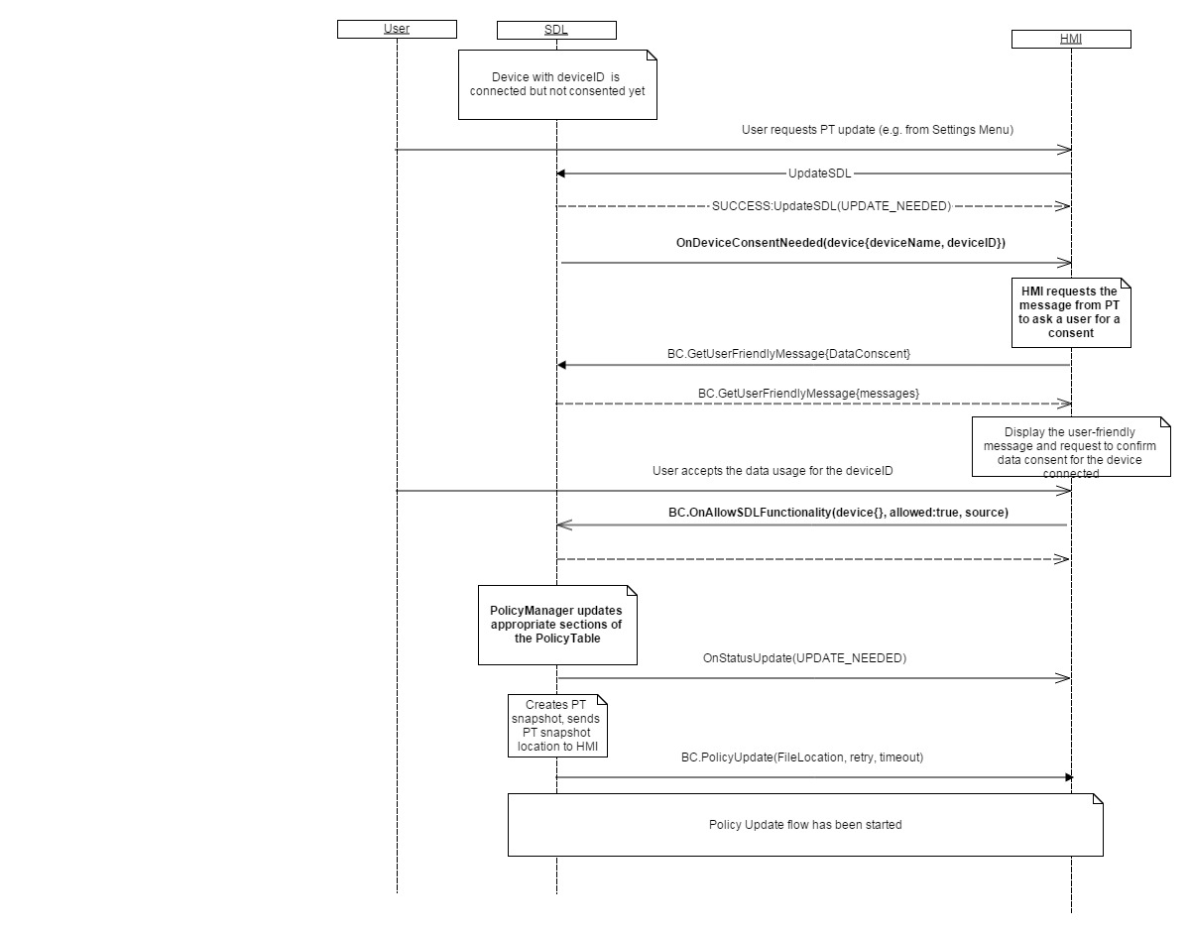

### 13.10.3 JSON Messages Examples

|  |
| --- |
| {  "jsonrpc" : "2.0",  "method" : "SDL.OnSDLConsentNeeded",  "params" :  {  "deviceInfo" :  {  "name" : “Mary`s Phone”,  "id" : 8  }  }  } |

### 13.10.4 D-Bus Messages Examples

|  |
| --- |
|  |

## 13.11 OnStatusUpdate

### 13.11.1 Description

|  |  |
| --- | --- |
| **Type:** | Notification |
| **Sender:** | SDL |
| **Purpose:** | Inform about the status of Policy Table update |

PoliciesManager must notify HMI about Policy Table status update via SDL.OnStatusUpdate notification right after one of the statuses of UPDATING, UPDATE_NEEDED and UP_TO_DATE is changed from one to another.

**Note:** When Policy Table update is triggered manually from HMI, HMI sends SDL.UpdateSDL request to SDL. In this case OnStatusUpdate **must NOT** be obtained on HMI’s side, because the current status is provided to HMI via SDL.UpdateSDL response with status “UPDATE_NEEDED”.

#### 13.11.1.1 Parameters

| **Param Name** | **Type** | **Mandatory** | **Description** |
| --- | --- | --- | --- |
| status | Common.UpdateResult | true | Notification from SDL to HMI when current status of T exchange changed (i.e. requires an update, update in progress, up to date etc) |

#### 13.11.1.2 UpdateResult

| **Element** | **Description** |
| --- | --- |
| UP_TO_DATE | Status is got right after applying the Updated PT delivered |
| UPDATING | Status got when PTSnapshot has just sent out to mobile app via OnSystemRequest RPC |
| UPDATE_NEEDED | PT requires an update. All the cases when PT requires an update are managed by SDL and Policy Manager (except of user manual update trigger) |

### 13.11.2 Sequence Diagrams

#### 13.11.2.1 OnStatusUpdate

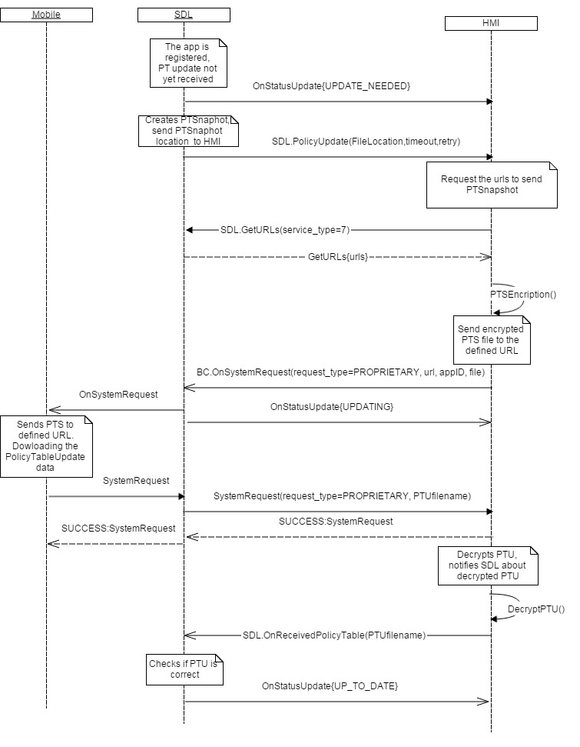

### 13.11.3 JSON Messages Examples

|  |
| --- |
| {  "jsonrpc" : "2.0",  "method" : "SDL.OnStatusUpdate",  "params" :  {  “status” : “UPDATE_NEEDED”  }  } |

### 13.11.4 D-Bus Messages Examples

|  |
| --- |
|  |

## 13.12 OnSystemError

### 13.12.1 Description

|  |  |
| --- | --- |
| **Type:** | Notification |
| **Sender:** | HMI |
| **Purpose:** | Informs SDL about the error occurred on HMI |

The notification is used to notify SDL’s Policy Manager component about the errors occurred on HMI. Policy Manager uses this data for errors statistic gathering.

***Note:*** SDL ignores all invalid notifications which come from HMI (invalid JSON, invalid data types/bounds etc)

***HMI must:***

- notify SDL when the system is being rebooted

- notify SDL in case it experiences the lack of memory

#### 13.12.1.1 Parameters

| **Param Name** | **Type** | **Mandatory** | **Description** |
| --- | --- | --- | --- |
| error | Common.SystemError | true | Defines the error occured |

#### 13.12.1.2 SystemError

| **Element** | **Description** |
| --- | --- |
| SYNC_REBOOTED | HMI is being rebooted |
| SYNC_OUT_OF_MEMMORY | HMI experiences a lack of memory |

### 13.12.2 Sequence Diagrams

#### 13.12.2.1 OnSystemError

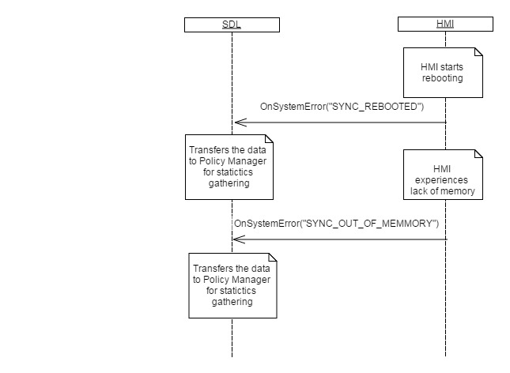

### 13.12.3 JSON Messages Examples

|  |
| --- |
| {  "jsonrpc" : "2.0",  "method" : "SDL.OnSystemError",  "params" :  {  “error” : “SYNC_REBOOTED”  }  } |

### 13.12.4 D-Bus Messages Examples

|  |
| --- |
|  |

## 13.13 AddStatisticsInfo

### 13.13.1 Description

|  |  |
| --- | --- |
| **Type:** | Notification |
| **Sender:** | HMI |
| **Purpose:** | Provide statistics data to be recorded in Policy Table. |

The notification informs SDL that one of events defined in Common.StatisticsType enumeration occurred on HMI. The statistics about the events is gathered by PolicyManager and written to policies database.

***HMI must:***

- notify SDL in case it experiences iAAP buffer overflaw

***Note:*** SDL ignores all invalid notifications which come from HMI (invalid JSON, invalid data types/bounds etc)

#### 13.13.1.1 Parameters

| **Param Name** | **Type** | **Mandatory** | **Description** |
| --- | --- | --- | --- |
| statisticType | Common.StatisticsType | true | Sent by system to record statiscs and error counts. Increment statistics specified for statisticType |

### 13.13.2 Sequence Diagrams

#### 13.13.2.1 AddStatisticsInfo

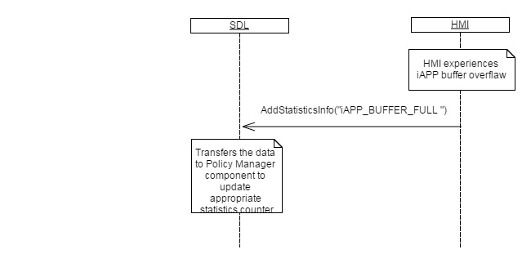

### 13.13.3 JSON Messages Examples

|  |
| --- |
| {  "jsonrpc" : "2.0",  "method" : "SDL.AddStatisticsInfo",  "params" :  {  “statisticType” : iAPP_BUFFER_FULL  }  } |

### 13.13.4 D-Bus Messages Examples

|  |
| --- |
|  |

## 13.14 OnDeviceStateChanged

### 13.14.1 Description

|  |  |
| --- | --- |
| **Type:** | Notification |
| **Sender:** | HMI |
| **Purpose:** | Inform about BLUETOOTH device state changed |

SDL's PoliciesManager needs this notification for updating the data in policies database. Information about unpaired device will cause SDL's PoliciesManager to remove all data related to it from the database..

***HMI must:***

* Notify SDL when the state of bluetooth paired device has been changed

***Note:*** SDL ignores all invalid notifications which come from HMI (invalid JSON, invalid data types/bounds etc)

#### 13.14.1.1 Parameters

| **Param Name** | **Type** | **Mandatory** | **Additional** | **Description** |
| --- | --- | --- | --- | --- |
| deviceState | Common.DeviceState | true |  |  |
| deviceInternalId | String | true | minlength="0" maxlength="500" |  |
| deviceId | Common.DeviceInfo | false |  |  |

#### 13.14.1.2 DeviceState

| **Element name** | **Value** | **Short Description** |
| --- | --- | --- |
| UNKNOWN | 0 |  |
| UNPAIRED | 1 |  |

#### 13.14.1.2 DeviceInfo

| **Param Name** | **Type** | **Mandatory** | **Additional** | **Description** |
| --- | --- | --- | --- | --- |
| name | String | true |  | The name of the device connected |
| id | Integer | true |  | The ID of the device connected. It remains unique during the ignition cycle. |
| transportType | Common.TransportType | false |  | The only transport type applicable for OnDeviceStateChanged is “BLUETOOTH” |
| isSDLAllowed | Boolean | false |  | No applicable for OnDeviceStateChanged |

#### 13.4.1.3 TransportType Enumeration

| **Element name** | **Value** | **Short Description** |
| --- | --- | --- |
| BLUETOOTH | 0 | The only value applicable for OnDeviceStateChanged |
| USB | 1 | Not applicable |
| WIFI | 2 | Not applicable |

### 13.14.2 Sequence Diagrams

#### 13.14.2.1 OnDeviceStateChanged

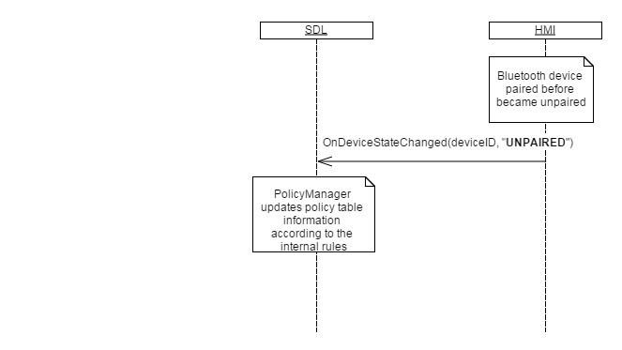

### 13.14.3 JSON Messages Examples

|  |
| --- |
| {  "jsonrpc" : "2.0",  "method" : "SDL.OnDeviceStateChanged",  "params" :  {  "deviceInternalId":"0017CAF56A51",  "deviceState":"UNPAIRED" }  } |

### 13.14.4 D-Bus Messages Examples

|  |
| --- |
|  |

## 13.15 OnReceivedPolicyUpdate (Ford-specific)

### 13.15.1 Description

|  |  |
| --- | --- |
| **Type:** | Notification |
| **Sender:** | HMI |
| **Purpose:** | Inform that PolicyTable Update is decrypted and can be applied by SDL’s PoliciesManager |

HU System`s component (SyncP Manager) decrypts the encrypted file of PolicyTableUpdate(PTU) received via SystemRequest. OnReceivedPolicyUpdate notifies PoliciesManager about successful decryption and readiness to implement this PTU.

***HMI must:***

* Decrypt the PTU file received via SystemRequest
* Notify SDL on successful decryption and provide the path to decrypted PTU file

***Note:*** SDL ignores all invalid notifications which come from HMI (invalid JSON, invalid data types/bounds etc)

#### 13.15.1.1 Parameters

| **Param Name** | **Type** | **Mandatory** | **Additional** | **Description** |
| --- | --- | --- | --- | --- |
| policyfile | String | true | minlength= 1  maxlength= 255 | Location of decrypted policy table JSON file on HU |

### 13.15.2 Sequence Diagrams

#### 13.15.2.1 OnReceivedPolicyUpdate

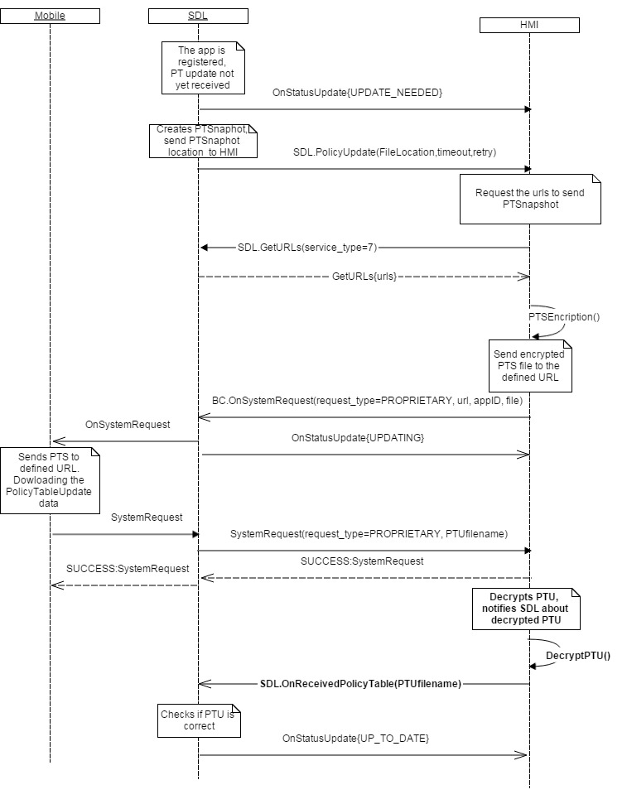

### 13.15.3 JSON Messages Examples

|  |
| --- |
| {  "jsonrpc" : "2.0",  "method" : "SDL.OnReceivedPolicyUpdate",  "params" :  {  “policyfile” : “example/path/to/the-file.json”  }  } |

### 13.15.4 D-Bus Messages Examples

|  |
| --- |
|  |

## 13.16 OnPolicyUpdate (Ford-specific)

### 13.16.1 Description

|  |  |
| --- | --- |
| **Type:** | Notification |
| **Sender:** | HMI |
| **Purpose:** | Notifies SDL to supply a new "PolicyUpdate" request with more recent snapshot data |

HMI sends SDL.OnPolicyUpdate in case the new PT Snapshot is required from PoliciesManager (as a result of retry sequence end). For more details see the diagram 13.16.2.1 OnPolicyUpdate

HMI must:

***Note:*** SDL ignores all invalid notifications which come from HMI (invalid JSON, invalid data types/bounds etc)

### 13.16.2 Sequence Diagrams

#### 13.16.2.1 OnPolicyUpdate

### 13.16.3 JSON Messages Examples

|  |
| --- |
| {  "jsonrpc" : "2.0",  "method" : "SDL.OnPolicyUpdate",  } |

### 13.16.4 D-Bus Messages Examples

|  |
| --- |
|  |

# 14 Common Component Description

## 14.1 Enumerations

### 14.1.1 Result

The enumeration defines the possible result codes for all operations provided by API between SDL and HMI.

Success is the only result code that notifies that no errors, nonstandard situations or lack of resources/privileges were encountered.

| **Element Name** | **Value** | **Description** |
| --- | --- | --- |
| SUCCESS | 0 | The request is executed successfully. |
| UNSUPPORTED_REQUEST | 1 | The request is not supported. |
| UNSUPPORTED_RESOURCE | 2 | The requested resource is not supported under the current system.  E.g.: notifications from the button are requested but physically this button is not present on HU. |
| DISALLOWED | 3 | API call is not allowed by HMI. |
| REJECTED | 4 | The requested command is rejected.  E.g.:  - Because the mobile app is in background and cannot perform any commands from HMI.  - Or an HU command (e.g. Speak) is rejected because a higher priority HU command (e.g. Alert) is playing. |
| ABORTED | 5 | A requested command was aborted.  E.g.:  - Due to user interaction (e.g. user pressed the button).  - Or an HMI command (e.g. Speak) is aborted because a higher priority HMI command (e.g. Alert) was requested. |
| IGNORED | 6 | A command was ignored, because the intended result is already in effect.  E.g.:  - SetMediaClockTimer was used to pause the media clock although the clock is paused already. |
| RETRY | 7 | The user interrupted the RPC and indicated to start over.  E.g. : PerformAudioPassThru . |
| IN_USE | 8 | The data may not be changed, because it is currently in use.  E.g.: when trying to delete a command set that is currently involved in an interaction. |
| DATA_NOT_AVAILABLE | 9 | The requested data is not available. |
| TIMED_OUT | 10 | Overlay reached the maximum timeout and closed. |
| INVALID_DATA | 11 | The data sent is invalid.  E.g.:   * Invalid Json syntax * Parameters out of bounds (number or enum range) * Mandatory parameters not provided * Parameter provided with wrong type * Invalid characters * Empty string |
| CHAR_LIMIT_EXCEEDED | 12 | The string data is too long. |
| INVALID_ID | 13 | One of the provided IDs is not valid. |
| DUPLICATE_NAME | 14 | There was a conflict with an already registered name. |
| APPLICATION_NOT_REGISTERED | 15 | A command cannot be executed because there is no registered application specified with AppID. |
| WRONG_LANGUAGE | 16 | The requested language is currently not supported. |
| OUT_OF_MEMORY | 17 | The system could not process the request because the necessary memory RAM couldn't be allocated |
| TOO_MANY_PENDING_REQUESTS | 18 | There are too many requests pending (means, that the response cannot be delivered yet) |
| NO_APPS_REGISTERED | 19 | The request cannot be executed because no application interface has been registered. |
| NO_DEVICES_CONNECTED | 20 | No device has been connected. |
| WARNINGS | 21 | The RPC is executed successfully but one or more items have a warning or failure (e.g. Speak). |
| GENERIC_ERROR | 22 | During the API call an unknown or unspecified within the current Result Enumeration error has occurred. |
| USER_DISALLOWED | 23 | RPC is included in a functional group explicitly blocked by the user. |
| TRUNCATED_DATA | 24 | The request (e.g. ReadDID) executed successfully but the data exceeded the platform maximum threshold and thus, only part of the data is available. |

***Related items:***

Table of Contents.

### 14.1.2 AppHMIType

The enumeration that lists possible types of the application.

| **Element name** | **Short Description** |
| --- | --- |
| DEFAULT | The application of default type. |
| COMMUNICATION | The application for communication |
| MEDIA | The media application |
| MESSAGING | The application of messaging type |
| NAVIGATION | The application of navigation type |
| INFORMATION | The application of information type |
| SOCIAL | The application of social type |
| BACKGROUND_PROCESS | The application does not require displaying the information |
| TESTING | The application of testing type |
| SYSTEM | The application of system type |

***Related items:***

HMIApplication – section 5.2.1

Table of Contents.

### 14.1.3 DeactivateReason

This enumeration specifies the non-application functionality the User may switch to.

| **Element name** | **Short Description** |
| --- | --- |
| AUDIO | The User has navigated to audio (radio, etc.) |
| PHONECALL | The User has navigated to make a call. |
| NAVIGATIONMAP | The User has navigated to navigation screen. |
| PHONEMENU | The User has navigated to phone menu. |
| SYNCSETTINGS | The User has navigated to HU settings menu. |
| GENERAL | Other screens navigation apart from other mobile app. |

***Related items:***

OnAppDeactivated – section 6.2.3

Table of Contents.

### 14.1.4 ApplicationsCloseReason

This enumeration describes the possible reasons for exiting from all of registered applications.

| **Element name** | **Short Description** |
| --- | --- |
| IGNITION_OFF | When the ignition is off. |
| MASTER_RESET | When the master reset takes place. |
| FACTORY_DEFAULTS | When the factory default settings are chosen. |

***Related items:***

OnExitAllApplications – section 6.2.11

Table of Contents.

### 14.1.5 ClockUpdateMode

The enumeration describes how HMI must update the media clock timer. The details are in the table below.

| **Element name** | **Short Description** |
| --- | --- |
| COUNTUP | HMI must start the media clock timer counting upwards, as in time elapsed, in increments of 1 second. |
| COUNTDOWN | HMI must start the media clock timer counting downwards, as in time remaining, in decrements of 1 second. |
| PAUSE | HMI must pause the media clock timer. |
| RESUME | HMI must resume the media clock timer The timer must resume counting in whatever mode was in effect before pausing (i.e. COUNTUP or COUNTDOWN). |
| CLEAR | HMI must clear the media clock timer (previously set through setMediaClockTimer). |

**Related Items:**

setMediaClockTimer – section 7.1.11

Table of Contents.

### 14.1.6 SystemContext

Enumeration that describes possible contexts the application might be in on HU.

| **Element name** | **Short Description** |
| --- | --- |
| MAIN | If there is currently no user interaction (user-initiated or app-initiated) with the head-unit, the application must be notified the the SystemContext is MAIN. |
| VRSESSION | Must be sent if there is a current user interaction that is VR-oriented (VR becomes active as a result of PTT or PerformInteraction). |
| MENU | Must be sent if HMI is currently displaying an in-application menu onscreen. |
| HMI_OBSCURED | Must be sent if HU is currently obscuring the application display either with a system or with another application overlay (except of Alert element). |
| ALERT | Must be sent if the Alert message is currently displayed onscreen. |

***Related items:***

OnSystemContext – section 7.2.2

Table of Contents.

### 14.1.7 DisplayType

HMI must send the information about the supported displays within DisplayCapabilities structure of the GetCapabilities RPC. The display types are described in the enumeration below.

| **Element name** | **Short Description** |
| --- | --- |
| CID | Center Information Display.  This display type provides a 2-line x 20 character "dot matrix" display. |
| TYPE2 | TYPE II display. 1 line older radio head unit. |
| TYPE5 | TYPE V display  Old radio head unit. |
| NGN | Next Generation Navigation display. |
| GEN2_8_DMA | GEN-2, 8 inch display. |
| GEN2_6_DMA | GEN-2, 6 inch display. |
| MFD3 | 3 inch GEN1.1 display |
| MFD4 | 4 inch GEN1.1 display |
| MFD5 | 5 inch GEN1.1 display |
| GEN3_8-INCH | GEN-3, 8 inch display. |

***Related items:***

DisplayCapabilities – section 5.2.7

GetCapabilities – section 7.1.2

Table of Contents.

### 14.1.8 MediaClockFormat

The enumeration describes the format of media clock value supported by HMI.

Media clock is used by media aplications for indicating the total/remaining duration of a song/album.

Upon GetCapabilities request from SDL HMI must provide the information on supported media clock format sent within DisplayCapabilities structure. Further SDL will use the accurate values of the corresponding format for setting the time of media clock on UI.

| **Element name** | **Short Description** |
| --- | --- |
| CLOCK1 | minutesFieldWidth = 2; minutesFieldMax = 19;  secondsFieldWidth = 2; secondsFieldMax = 99;  maxHours = 19;  maxMinutes = 59;  maxSeconds = 59;  Is used for Type II, NGN and CID head units. |
| CLOCK2 | minutesFieldWidth = 3; minutesFieldMax = 199;  secondsFieldWidth = 2; secondsFieldMax = 99;  maxHours = 59;  maxMinutes = 59;  maxSeconds = 59;  Is used for Type V head units. |
| CLOCK3 | minutesFieldWidth = 2; minutesFieldMax = 59;  secondsFieldWidth = 2; secondsFieldMax = 59;  maxHours = 9;  maxMinutes = 59;  maxSeconds = 59;  Is used for GEN1.1 (i.e. MFD3/4/5) head units. |
| CLOCKTEXT1 | 5 characters possible  Format: 1|sp c :|sp c c  1|sp : digit "1" or space  c : character out of following character set: sp|0-9|[letters  :|sp : colon or space  Is used for Type II head unit |
| CLOCKTEXT2 | 5 chars possible  Format: 1|sp c :|sp c c  1|sp : digit "1" or space  c : character out of following character set: sp|0-9|[letters  :|sp : colon or space  Is used for CID and NGN head unit. |
| CLOCKTEXT3 | 6 chars possible  Format: 1|sp c c  :|sp c c 1|sp : digit "1" or space  c : character out of following character set: sp|0-9|[letters  :|sp : colon or space  Is used for Type V head unit. |
| CLOCKTEXT4 | 6 chars possible  Format: c :|sp c  c : c c :|sp : colon or space c : character out of following character set: sp|0-9|[letters].  Is used for GEN1.1 (i.e. MFD3/4/5) head units. |

***Related items:***

DisplayCapabilities – section 5.2.7

TextFieldName – section 14.1.15

Table of Contents.

### 14.1.9 HmiZoneCapabilities

Upon GetCapabilities request, HMI must provide the information about the zone it is available from:

| **Element name** | **Short Description** |
| --- | --- |
| FRONT | Indicates HMI available for front seat passengers. |
| BACK | Indicates HMI available for rear seat passengers. |

***Related items:***

GetCapabilities – for UI, section 7.1.2

Table of Contents.

### 14.1.10 SpeechCapabilities

Upon TTS. GetCapabilities request, HMI must provide the information about the zone it is available from:

| **Element name** | **Short Description** |
| --- | --- |
| TEXT |  |
| SAPI_PHONEMES |  |
| LHPLUS_PHONEMES |  |
| PRE_RECORDED |  |
| SILENCE |  |

***Related items:***

GetCapabilities – for TTS, section

Table of Contents.

### 14.1.11 VrCapabilities

Upon TTS. GetCapabilities request, HMI must provide the information about the zone it is available from:

| **Element name** | **Short Description** |
| --- | --- |
| TEXT |  |

***Related items:***

GetCapabilities – for VR, section

Table of Contents.

### 14.1.12 DriverDistractionState

HMI must provide the information about either the driver distraction rules are in effect or not. This enumeration describes the possible states of driver distraction.

| **Element name** | **Short Description** |
| --- | --- |
| DD_ON | Driver Distraction rules are in effect. |
| DD_OFF | Driver Distraction rules are not in effect. |

***Related items:***

OnDriverDistraction – section 7.2.4

Table of Contents.

### 14.1.11 SoftButtonType

The enumeration defines the types of the soft buttons to be displayed on UI component:

1. The text is displayed on the soft button
2. The image is displayed on the soft button
3. Both image and text are displayed on the soft button.

| **Element name** | **Short Description** |
| --- | --- |
| TEXT | Text displayed |
| IMAGE | Image displayed |
| BOTH | Both text and image displayed |

***Related items:***

SoftButton – section 5.2.10

Table of Contents.

### 14.1.12 SystemAction

The HMI may provide three possible ways of reacting on soft button click (the exact behavior may vary and be platform-dependent):

1. Default action (DEFAULT_ACTION). For example, if the soft button is preset for cleaning the overlay, the click on it should close the pop-up or clean the overlay.
2. Returning application to the full mode (STEAL_FOCUS). The soft button with presets for this action should close the pop-up window and return the application which caused that pop-up to the full mode.
3. Making the pop-up or event remain active (KEEP_CONTEXT). The pop-up or event should be left on the screen after clicking the soft button with presets for this action, renewing the timeout for this event.

The responsibility of behavior on System Action implementation is on HMI.

If HMI does not support some System Action it has to respond correspondingly.

The following enumeration defines the system actions for the soft button click:

| **Element name** | **Short Description** |
| --- | --- |
| DEFAULT_ACTION | Default action should occur. Standard behavior (e.g. SoftButton clears overlay) |
| STEAL_FOCUS | - The pop-up/dialog should be closed  - The app, having been obscured with that pop-up/dialog, should be returned into the full mode. |
| KEEP_CONTEXT | - The pop-up/dialog should be left on the screen  - The timeout for this pop-up/dialog should be renewed |

***Related items:***

SoftButton – section 5.2.10

Table of Contents.

### 14.1.13 TextAlignment

This enumeration lists the variants of text alignment.

| **Element name** | **Short Description** |
| --- | --- |
| LEFT_ALIGNED | Text is aligned left. |
| RIGHT_ALIGNED | Text is aligned right. |
| CENTERED | Text is centered. |

***Related items:***

Show – section 7.1.5

Table of Contents.

### 14.1.14 Language

The enumeration defines the possible languages that the HU components might support and the SDL might request:

| **Element name** | **Short Description** |
| --- | --- |
| AR-SA | Arabic – Saudi Arabia |
| CS-CZ | Czech – Czech Republic |
| DA-DK | Danish – Denmark |
| DE-DE | German – Germany |
| EN-AU | English – Australia |
| EN-GB | English – GB |
| EN-US | English – US |
| ES-ES | Spanish – Spain |
| ES-MX | Spanish – Mexico |
| FR-CA | French – Canada |
| FR-FR | French – France |
| IT-IT | Italian – Italy |
| JA-JP | Japanese – Japan |
| KO-KR | Korean – South Korea |
| NL-NL | Dutch (Standard) – Netherlands |
| NO-NO | Norwegian - Norway |
| PL-PL | Polish – Poland |
| PT-PT | Portuguese – Portugal |
| PT-BR | Portuguese – Brazil |
| RU-RU | Russian - Russia |
| SV-SE | Swedish – Sweden |
| TR-TR | Turkish – Turkey |
| ZH-CN | Mandarin – China |
| ZH-TW | Mandarin – Taiwan |

***Related items:***

HMIApplication – section 5.2.1

GetSupportedLanguages – for UI, section 7.1.3

– for VR, section 9.1.2

– for TTS, section 10.1.2

ChangeRegistration – for UI, section 7.1.15

– for VR, section 9.1.5

– for TTS, section 10.1.5

GetLanguage – for UI, section 7.1.16

– for VR, section 9.1.6

– for TTS, section 10.1.5

OnLanguageChange – for UI, section 7.2.3

– for VR, section 9.2.4

– for TTS, section 10.2.1

Table of Contents.

### 14.1.15 TextFieldName

The enumeration describes the possible fields for the text information to be displayed.

Upon SDL`s request HMI must provide the list of supported fields.

Further SDL will request displaying the text information in these fields within different requests to HMI.

The table below contains the information about:

* The name of the field
* Conditions of displaying the text
* The name of the method concerned

| **Element name** | **Short Description** |
| --- | --- |
| mainField1 | The text that must be displayed in a single or upper display line.  If this value is not set, the text of mainField1 must stay unchanged.  If this text is empty "", the field must be cleared.  Applies to Show, section 7.1.5. |
| mainField2 | The text that must be displayed on the second display line.  If this text is not set, the text of mainField2 must stay unchanged.  If this text is empty "", the field must be cleared.  Applies to Show, section 7.1.5. |
| mainField3 | The text that must be displayed on the second "page" first display line.  If this text is not set, the text of mainField3 must stay unchanged.  If this text is empty "", the field must be cleared.  Applies to Show, section 7.1.5. |
| mainField4 | The text that must be displayed on the second "page" second display line.  If this text is not set, the text of mainField4 must stay unchanged.  If this text is empty "", the field must be cleared.  Applies to Show, section 7.1.5. |
| statusBar | The text is placed in the status bar area.  ***Note:*** *This relates to navigation displays*  If this parameter is omitted, the status bar text must remain unchanged.  If this parameter is an empty string, the field must be cleared.  If provided and the display has no status bar, this parameter must be ignored.  Applies to Show, section 7.1.5. |
| mediaClock | Text value for MediaClock field. Shall arrive in the form as described in the MediaClockFormat enumeration  If this text is set, any automatic media clock updates previously set with SetMediaClockTimer must be stopped.  Applies to Show, section 7.1.5. |
| mediaTrack | The text that should be displayed in the track field. This field should be valid only for media applications on.  If this text is not set, the text of mediaTrack must stay unchanged.  If this text is empty "", the field must be cleared.  Applies to Show, section 7.1.5. |
| alertText1 | The text that must be displayed in the top field of the display during the Alert.  Applies to Alert, section 7.1.4. |
| alertText2 | The text that must be displayed in the bottom field of the display during the Alert.  Applies to Alert, section 7.1.4. |
| alertText3 | The optional third line of the alert text field.  Applies to Alert, section 7.1.4. |
| scrollableMessageBody | The long form body of text that can include newlines and tabs.  Applies to ScrollableMessage, section 7.1.17. |
| initialInteractionText | Must be displayed when the interaction begins. The text must be displayed on the first line of a multiline display, and must be centered.  Applies to PerformInteraction, section 7.1.10. |
| navigationText1 | The text that must be displayed on the first line of navigation text.  Applies to ShowConstantTBT, section 12.1.3. |
| navigationText2 | The text that must be displayed on the second line of navigation text.  Applies to ShowConstantTBT, section 12.1.3. |
| ETA | Estimated Time of Arrival for navigation.  Applies to ShowConstantTBT, section 12.1.3. |
| totalDistance | Total distance to destination for navigation.  Applies to ShowConstantTBT, section 12.1.3. |
| navigationText | Navigation text for UpdateTurnList.  Applies to Turn, section 5.2.25. |
| audioPassThruDisplayText1 | The first line of text that must be displayed during audio capture.  Applies to PerformAudioPassThru, section 7.1.20. |
| audioPassThruDisplayText2 | The second line of text that must be displayed during audio capture.  Applies to PerformAudioPassThru, section 7.1.20. |
| sliderHeader | The text that must be displayed on the header of slider.  Applies to Slider, section 7.1.18. |
| sliderFooter | The text that must be displayed on the footer of slider.  Applies to Slider, section 7.1.18. |
| notificationText | The text that must be displayed to notify the User on some event.  Applies to ShowNotification, section 7.2.6. |
| locationName | Optional name / title of intended location for SendLocation, section 12.8 |
| locationDescription | Optional description of intended location / establishment (if applicable) for SendLocation, section 12.10 |
| addressLines | Optional location address (if applicable) for SendLocation, section 12.10 |
| phoneNumber | Optional hone number of intended location / establishment (if applicable) for SendLocation, section 12.10 |
| menuName | Primary text for Choice |
| secondaryText | Secondary text for Choice |
| tertiaryText | Tertiary text for Choice |
| timeToDestination |  |
| turnText |  |

***Related Items:***

MediaClockFormat – section 5.1.8

DisplayCapabilities – section 5.2.7

TextFieldStruct – section 5.2.8

Turn – section 5.2.25

Alert – section 7.1.4

Show – section 7.1.5

PerformInteraction – section 7.1.10

Slider – section 7.1.16

ScrollableMessage – section 7.1.17

PerformAudioPassThru – section 7.1.18

ShowNotification – section 7.2.5

ShowConstantTBT – section 12.1.3

SendLocation – section 12.8

Table of Contents.

### 14.1.17 ImageFieldName

This enumeration contains the information about the type of the image.

| **Element name** | **Short Description** |
| --- | --- |
| softButtonImage | The image field for SoftButton |
| choiceImage | The first image field for Choice |
| choiceSecondaryImage | The secondary image field for Choice |
| vrHelpItem | The image field for vrHelpItem |
| turnIcon | The image field for Turn |
| menuIcon | The image field for the menu icon in SetGlobalProperties |
| cmdIcon | The image field for AddCommand |
| graphic | The image field for Show |
| showConstantTBTIcon | The primary image field for ShowConstantTBT |
| showConstantTBTNextTurnIcon | The secondary image field for ShowConstantTBT |
| nextTurnIcon |  |

***Related items:***

DisplayCapabilities – section 5.2.7

Image – section 5.2.11

Table of Contents.

### 14.1.18 ImageType

This enumeration contains the information about the type of the image.

| **Element name** | **Short Description** |
| --- | --- |
| STATIC | Static image. The image that is sent as the binary or hex code within the request. |
| DYNAMIC | Dynamic image. The image that is stored on HMI and just a link to it is further used within requests. |

***Related items:***

DisplayCapabilities – section 5.2.7

Image – section 5.2.11

Table of Contents.

### 14.1.17 ButtonName

The following enumeration defines the hard (physical) and soft (touchscreen) buttons that may be available from HMI.

| **Element name** | **Short Description** |
| --- | --- |
| OK | Represents the button usually labeled "OK". A typical use of this button is for the User to press it to make a selection. |
| SEEKLEFT | Represents the seek-left button. A typical use of this button is for the user to scroll to the left through menu choices, one menu item per press. |
| SEEKRIGHT | Represents the seek-right button. A typical use of this button is for the user to scroll to the right through menu choices one menu item per press. |
| TUNEUP | Represents a turn of the tuner knob in the clockwise direction one tick. |
| TUNEDOWN | Represents a turn of the tuner knob in the counter-clockwise direction one tick. |
| PRESET_0 | Represents the preset 0 button. |
| PRESET_1 | Represents the preset 1 button. |
| PRESET_2 | Represents the preset 2 button. |
| PRESET_3 | Represents the preset 3 button. |
| PRESET_4 | Represents the preset 4 button. |
| PRESET_5 | Represents the preset 5 button. |
| PRESET_6 | Represents the preset 6 button. |
| PRESET_7 | Represents the preset 7 button. |
| PRESET_8 | Represents the preset 8 button. |
| PRESET_9 | Represents the preset 9 button. |
| CUSTOM_BUTTON | Represents any of touchscreen buttons provided by Mobile Application |
| SEARCH | Represents the ‘Search’ button. |

***Related items:***

ButtonCapabilities – section 5.2.11

PresetBankCapabilities – section 5.2.13

GetCapabilities – for Buttons, section 8.1.1

OnButtonEvent – section 8.2.1

OnButtonPress – section 8.2.2

Table of Contents.

### 14.1.18 ButtonEventMode

The following events must be supported by HMI for the hardware/soft buttons and must be reported within UI.GetCapabilities or Buttons.GetCapabilities RPCs:

1. The User has pressed the button (BUTTONDOWN event).
2. The User has released the button (BUTTONUP event).

HMI must provide the OnButtonEvent notification whenever the button is pressed/released.

This enumeration defines UP/DOWN events for the button.

| **Element name** | **Short Description** |
| --- | --- |
| BUTTONDOWN | The button has been pressed |
| BUTTONUP | The button has been released |

***Related Items:***

SoftButtonCapabilities – section 5.2.9

ButtonCapabilities –section 5.2.12

OnButtonEvent –section 8.2.1

Table of Contents.

### 14.1.19 ButtonPressMode

The following press modes might be supported by HMI`s hardware/soft buttons and if supported must be reported within UI.GetCapabilities or Buttons.GetCapabilities RPCs.

1. ***Short*** – occurs when a button is pressed, then released within two (varies depending on HMI) seconds. The event is considered to occur immediately after the button is released.
2. ***Long*** – occurs when a button is pressed and held for two seconds or more. The event is considered to occur immediately after the two (varies depending on HU) seconds threshold has been crossed, before the button is released

HMI must provide the onButtonPress notification whenever the Long/Short press occurs.

The following enumeration defines SHORT/LONG modes for the hardware/soft button:

|  |  |
| --- | --- |
| **Element name** | **Short Description** |
| SHORT | Short-time button press |
| LONG | Long-time button press |

***Related Items:***

SoftButtonCapabilities – section 5.2.9

ButtonCapabilities – section 5.2.12

OnButtonPress – section 8.2.2

Table of Contents.

### 14.1.20 LayoutMode

For touchscreen interactions, the mode of how the choices are presented.:

|  |  |
| --- | --- |
| **Element name** | **Short Description** |
| ICON_ONLY | This mode causes the interaction to display the previous set of choices as icons |
| ICON_WITH_SEARCH | This mode causes the interaction to display the previous set of choices as icons along with a search field in the HMI. |
| LIST_ONLY | This mode causes the interaction to display the previous set of choices as a list |
| LIST_WITH_SEARCH | This mode causes the interaction to display the previous set of choices as a list along with a search field in the HMI. |
| KEYBOARD | This mode causes the interaction to immediately display a keyboard entry through the HMI. |

***Related Items:***

SoftButtonCapabilities – section 5.2.9

ButtonCapabilities – section 5.2.12

OnButtonPress – section 8.2.2

Table of Contents.

### 14.1.21 TouchEvent

For touchscreen interactions, the mode of how the choices are presented:

|  |  |
| --- | --- |
| **Element name** | **Short Description** |
| TOUCHSTART |  |
| TOUCHMOVE |  |
| TOUCHEND |  |
| DOUBLETOUCH |  |

***Related Items:***

SoftButtonCapabilities – section 5.2.9

ButtonCapabilities – section 5.2.12

OnButtonPress – section 8.2.2

Table of Contents.

### 14.1.22 SamplingRate

Describes different sampling options for PerformAudioPassThru

|  |  |
| --- | --- |
| **Element name** | **Short Description** |
| 8KHZ |  |
| 16KHZ |  |
| 22KHZ |  |
| 44KHZ |  |

***Related Items:***

SoftButtonCapabilities – section 5.2.9

ButtonCapabilities – section 5.2.12

OnButtonPress – section 8.2.2

Table of Contents.

### 14.1.23 BitsPerSample

Describes different quality options for PerformAudioPassThru.

|  |  |
| --- | --- |
| **Element name** | **Short Description** |
| 8_BIT |  |
| 16_BIT |  |

***Related Items:***

SoftButtonCapabilities – section 5.2.9

ButtonCapabilities – section 5.2.12

OnButtonPress – section 8.2.2

Table of Contents.

### 14.1.24 AudioType

Describes different audio type options for PerformAudioPassThru

|  |  |
| --- | --- |
| **Element name** | **Short Description** |
| PCM |  |

***Related Items:***

SoftButtonCapabilities – section 5.2.9

ButtonCapabilities – section 5.2.12

OnButtonPress – section 8.2.2

Table of Contents.

### 14.1.25 KeyboardLayout

Enumeration listing possible keyboard layouts

|  |  |
| --- | --- |
| **Element name** | **Short Description** |
| QWERTY |  |
| QWERTZ |  |
| AZERTY |  |

***Related Items:***

SoftButtonCapabilities – section 5.2.9

ButtonCapabilities – section 5.2.12

OnButtonPress – section 8.2.2

Table of Contents.

### 14.1.26 KeyboardEvent

Enumeration listing possible keyboard events.

|  |  |
| --- | --- |
| **Element name** | **Short Description** |
| KEYPRESS |  |
| ENTRY_SUBMITTED |  |
| ENTRY_VOICE | Indicates that a voice button was pressed for a request to search via voice. |
| ENTRY_CANCELLED |  |
| ENTRY_ABORTED |  |

**Note:** ENTRY_VOICE is**not**related to UI.PerformInteraction(KEYBOARD).

v iagram details see ta values rogressand application registrs SDL 4.0e user. and querying. all end.

***Related Items:***

SoftButtonCapabilities – section 5.2.9

ButtonCapabilities – section 5.2.12

OnButtonPress – section 8.2.2

OnKeyboardInput – section 7.26

Table of Contents.

### 14.1.27 KeypressMode

Enumeration listing possible keyboard events.

|  |  |
| --- | --- |
| **Element name** | **Short Description** |
| SINGLE_KEYPRESS | Each keypress is individually sent as the user presses the keyboard keys. |
| QUEUE_KEYPRESSES | The keypresses are queued and a string is eventually sent once the user chooses to submit their entry. |
| RESEND_CURRENT_ENTRY | The keypresses are queue and a string is sent each time the user presses a keyboard key; the string contains the entire current entry. |

***Related Items:***

SoftButtonCapabilities – section 5.2.9

ButtonCapabilities – section 5.2.12

OnButtonPress – section 8.2.2

Table of Contents.

### 14.1.28 AmbientLightStatus

Reflects the status of the ambient light sensor.

|  |  |
| --- | --- |
| **Element name** | **Short Description** |
| NIGHT |  |
| TWILIGHT_1 |  |
| TWILIGHT_2 |  |
| TWILIGHT_3 |  |
| TWILIGHT_4 |  |
| DAY |  |
| UNKNOWN |  |
| INVALID |  |

***Related Items:***

SoftButtonCapabilities – section 5.2.9

ButtonCapabilities – section 5.2.12

OnButtonPress – section 8.2.2

Table of Contents.

### 14.1.29 ECallConfirmationStatus

Reflects the status of the eCall Notification.

|  |  |
| --- | --- |
| **Element name** | **Short Description** |
| NORMAL |  |
| CALL_IN_PROGRESS |  |
| CALL_CANCELLED |  |
| CALL_COMPLETED |  |
| CALL_UNSUCCESSFUL |  |
| ECALL_CONFIGURED_OFF |  |
| CALL_COMPLETE_DTMF_TIMEOUT |  |

***Related Items:***

SoftButtonCapabilities – section 5.2.9

ButtonCapabilities – section 5.2.12

OnButtonPress – section 8.2.2

Table of Contents.

### 14.1.30 VehicleDataNotificationStatus

Reflects the status of a vehicle data notification.

|  |  |
| --- | --- |
| **Element name** | **Short Description** |
| NOT_SUPPORTED |  |
| NORMAL |  |
| ACTIVE |  |
| NOT_USED |  |

***Related Items:***

SoftButtonCapabilities – section 5.2.9

ButtonCapabilities – section 5.2.12

OnButtonPress – section 8.2.2

Table of Contents.

### 14.1.31 EmergencyEventType

Reflects the emergency event status of the vehicle.

|  |  |
| --- | --- |
| **Element name** | **Short Description** |
| NO_EVENT |  |
| FRONTAL |  |
| SIDE |  |
| REAR |  |
| ROLLOVER |  |
| NOT_SUPPORTED |  |
| FAULT |  |

***Related Items:***

SoftButtonCapabilities – section 5.2.9

ButtonCapabilities – section 5.2.12

OnButtonPress – section 8.2.2

Table of Contents.

### 14.1.32 FuelCutoffStatus

Reflects the status of the RCM fuel cutoff.

|  |  |
| --- | --- |
| **Element name** | **Short Description** |
| TERMINATE_FUEL |  |
| NORMAL_OPERATION |  |
| FAULT |  |

***Related Items:***

SoftButtonCapabilities – section 5.2.9

ButtonCapabilities – section 5.2.12

OnButtonPress – section 8.2.2

Table of Contents.

### 14.1.33 PowerModeQualificationStatus

Reflects the status of the current power mode qualification.

|  |  |
| --- | --- |
| **Element name** | **Short Description** |
| POWER_MODE_UNDEFINED |  |
| POWER_MODE_EVALUATION_IN_PROGRESS |  |
| NOT_DEFINED |  |
| POWER_MODE_OK |  |

***Related Items:***

SoftButtonCapabilities – section 5.2.9

ButtonCapabilities – section 5.2.12

OnButtonPress – section 8.2.2

Table of Contents.

### 14.1.34 CarModeStatus

Reflects the status of the current car mode.

|  |  |
| --- | --- |
| **Element name** | **Short Description** |
| NORMAL |  |
| FACTORY |  |
| TRANSPORT |  |
| CRASH |  |

***Related Items:***

SoftButtonCapabilities – section 5.2.9

ButtonCapabilities – section 5.2.12

OnButtonPress – section 8.2.2

Table of Contents.

### 14.1.35 PowerModeStatus

Reflects the status of the current power mode.

|  |  |
| --- | --- |
| **Element name** | **Short Description** |
| KEY_OUT |  |
| KEY_RECENTLY_OUT |  |
| KEY_APPROVED_0 |  |
| POST_ACCESORY_0 |  |
| ACCESORY_1 |  |
| POST_IGNITION_1 |  |
| IGNITION_ON_2 |  |
| RUNNING_2 |  |
| CRANK_3 |  |

***Related Items:***

SoftButtonCapabilities – section 5.2.9

ButtonCapabilities – section 5.2.12

OnButtonPress – section 8.2.2

Table of Contents.

### 14.1.36 ComponentVolumeStatus

The enumeration provides the cases for the component volume status (e.g., fuel level, tire pressure).

| **Element name** | **Short Description** |
| --- | --- |
| UNKNOWN | The data is unknown. |
| NORMAL | The volume is normal. |
| LOW | The volume is low. |
| FAULT | The module/sensor is currently faulted. |
| ALERT | The component`s volume is in critical level. |
| NOT_SUPPORTED | The data is not supported. |

***Related items:***

SingleTireStatus – section 5.2.19

GetVehicleData – section 11.1.5

OnVehicleData – section 11.2.1

Table of Contents.

### 14.1.37 PRNDL

The following enumeration describes the possible positions of vehicle`s change-speed lever.

| **Element name** | **Short Description** |
| --- | --- |
| PARK | Parking |
| REVERSE | Reverse gear |
| NEUTRAL | No gear |
| DRIVE | Drive Sport mode |
| SPORT | Sport mode |
| LOWGEAR | 1st gear hold |
| FIRST | The change-speed lever is in the first position |
| SECOND | The change-speed lever is in the second position |
| THIRD | The change-speed lever is in the third position |
| FOURTH | The change-speed lever is in the fifth position |
| FIFTH | The change-speed lever is in the sixth position |
| SIXTH | The change-speed lever is in the seventh position |
| SEVENTH |  |
| EIGHTH |  |
| FAULT |  |

***Related items:***

GetVehicleData – section 11.1.5

OnVehicleData – section 11.2.1

Table of Contents.

### 14.1.38 WarningLightStatus

The enumeration reflects the status of a cluster instrument warning light.

|  |  |
| --- | --- |
| **Element name** | **Short Description** |
| OFF | The warning light is off |
| ON | The warning light is on |
| FLASH | The warning light is flashing |
| NOT_USED |  |

***Related items:***

TireStatus – section 5.2.18

Table of Contents.

### 14.1.39 VehicleDataEventStatus

The following enumeration reflects the status of a vehicle data event (e.g. a seat belt event status).

| **Element name** | **Short Description** |
| --- | --- |
| NO_EVENT | The system does not have the adequate information to send valid ‘YES’ or ‘NO’ states. |
| NO | The requested event is in ‘NO’ state. |
| YES | The requested event is in ‘YES’ state. |
| NOT_SUPPORTED | The requested data is not supported |
| FAULT | The module/sensor is currently faulted. |

***Related items:***

BeltStatus – section 5.2.20

GetVehicleData – section 11.1.5

OnVehicleData – section 11.2.1

Table of Contents.

### 14.1.40 IgnitionStableStatus

This enumeration describes the states of the ignition switch.

| **Element name** | **Short Description** |
| --- | --- |
| IGNITION_SWITCH_NOT_STABLE | Ignition switch is not stable. |
| IGNITION_SWITCH_STABLE | Ignition switch is stable. |
| MISSING_FROM_TRANSMITTER | Either the data is not accessible or the sensor is broken. |

***Related items:***

BodyInformation – section 5.2.21

Table of Contents.

### 14.1.41 IgnitionStatus

This enumeration reflects the status of ignition.

| **Element name** | **Short Description** |
| --- | --- |
| UNKNOWN | The information is not acceptable. The sensor cannot provide accurate data at this time. |
| OFF | The ignition is off. |
| ACCESSORY | The accessories are active (power windows, audio, display, etc.). |
| RUN | Ignition is active. |
| START | Starter is switched. |
| INVALID | The data is provided, but there is some sort of fault or problem. |

***Related items:***

BodyInformation – section 5.2.21

Table of Contents.

### 14.1.42 DeviceLevelStatus

The enumeration describes the possible status of the battery if reported.

| **Element name** | **Short Description** |
| --- | --- |
| ZERO_LEVEL_BARS | The battery is low |
| ONE_LEVEL_BARS | The battery is in the first level bar. |
| TWO_LEVEL_BARS | The battery is in the second level bar |
| THREE_LEVEL_BARS | The battery is in the fourth level bar |
| FOUR_LEVEL_BARS | The battery is in the fifth level bar |
| NOT_PROVIDED | The data is not provided |

***Related items:***

DeviceStatus – section 5.2.22

Table of Contents.

### 14.1.43 PrimaryAudioSource

Reflects the current primary audio source (if selected).

| **Element name** | **Short Description** |
| --- | --- |
| NO_SOURCE_SELECTED | No source for playing audio is selected. |
| USB | The audio is played from USB. |
| USB2 | The audio is played from USB2 |
| BLUETOOTH_STEREO_BTST | The audio in stereo format is played from Bluetooth. |
| LINE_IN | The audio is played from the line input. |
| IPOD | The audio is played from the IPod. |
| MOBILE_APP | The audio is played from the mobile application. |

***Related items:***

DeviceStatus – section 5.2.22

Table of Contents.

### 14.1.44 VehicleDataStatus

The following enumeration reflects the status of a binary vehicle data item.

| **Element name** | **Short Description** |
| --- | --- |
| NO_DATA_EXISTS | The information is not acceptable. The sensor cannot provide accurate data at this time. |
| OFF | The vehicle item is in ‘Off’ state |
| ON | The vehicle item is in ‘On’ state |

***Related items:***

MyKey – section 5.2.24

Table of Contents.

### 14.1.45 WiperStatus

This enumeration reflects the status of the wipers.

| **Element name** | **Short Description** |
| --- | --- |
| OFF | The wipers are off. |
| AUTO_OFF | The wipers are automatically off after detecting the wipers do not need to be engaged (rain stopped, etc.). |
| OFF_MOVING | Means that though set to off, somehow the wipers have been engaged (physically moved enough to engage a wiping motion). |
| MAN_INT_OFF | The wipers are manually off after having been working. |
| MAN_INT_ON | The wipers are manually on. |
| MAN_LOW | The wipers are manually set to low speed. |
| MAN_HIGH | The wipers are manually set to high speed. |
| MAN_FLICK | The wipers are manually set for doing a flick. |
| WASH | The wipers are set to use the water from vehicle washer bottle for cleaning the windscreen. |
| AUTO_LOW | The wipers are automatically set to low speed. |
| AUTO_HIGH | The wipers are automatically set to high speed. |
| COURTESYWIPE | This is for when a user has just initiated a WASH and several seconds later a secondary wipe is automatically initiated to clear remaining fluid. |
| AUTO_ADJUST | This is set as the user moves between possible automatic wiper speeds. |
| STALLED | The wiper is stalled to its place. There may be an obstruction. |
| NO_DATA_EXISTS | The sensor / module cannot provide any information for wiper. |

***Related items:***

GetVehicleData – section 11.1.5

OnVehicleData – section 11.2.1

Table of Contents.

### 14.1.46 CompassDirection

The potential compass directions that IVI component may provide are listed below.

| **Element name** | **Short Description** |
| --- | --- |
| NORTH | Represents the North compass direction |
| NORTHWEST | Represents the North-West compass direction |
| WEST | Represents the West compass direction |
| SOUTHWEST | Represents the South-West compass direction |
| SOUTH | Represents the South compass direction |
| SOUTHEAST | Represents the South-East compass direction |
| EAST | Represents the East compass direction |
| NORTHEAST | Represents the North-East compass direction |

***Related items:***

GPSData – section 5.2.17

Table of Contents.

### 14.1.47 Dimension

The enumeration defines the supported dimensions of GPS.

| **Element name** | **Short Description** |
| --- | --- |
| NO_FIX | No GPS at all |
| 2D | Longitude and latitude |
| 3D | Longitude and latitude and altitude |

***Related items:***

GPSData – section 5.2.17

Table of Contents.

### 14.1.48 VehicleDataResultCode

Enumeration that describes possible result codes of a vehicle data entry request.

| **Element name** | **Short Description** |
| --- | --- |
| SUCCESS | The requested data is accessible. |
| TRUNCATED_DATA | The data is truncated: not all of the requested information is available. |
| DISALLOWED | The request is not authorized in local policies. |
| USER_DISALLOWED | The request is included in a functional group explicitly blocked by the User. |
| INVALID_ID | One of the provided IDs is not valid. |
| VEHICLE_DATA_NOT_AVAILABLE | The requested data is not available. |
| DATA_ALREADY_SUBSCRIBED | The requested data has been subscribed already. |
| DATA_NOT_SUBSCRIBED | The data is not subscribed. |
| IGNORED | The request is ignored because the intended result is already in effect. |

***Related items:***

DIDResult – section 5.2.16

ReadDID – section 11.1.3

Table of Contents.

### 14.1.49 TBTState

The enumeration describes the possible needs of HMI turn-by-turn.

| **Element name** | **Short Description** |
| --- | --- |
| ROUTE_UPDATE_REQUEST | Request from HMI for updating the route. |
| ROUTE_ACCEPTED | Confirmation from HMI about accepting the route. |
| ROUTE_REFUSED | Information from HMI about the route refusal. |
| ROUTE_CANCELLED | Information from HMI about cancelling the route. |
| ETA_REQUEST | Request from HMI for Estimated time of arrival. |
| NEXT_TURN_REQUEST | Request from HMI for the information of the next turn. |
| ROUTE_STATUS_REQUEST | Request from HMI for the route status. |
| ROUTE_SUMMARY_REQUEST | Request from HMI for the route summary. |
| TRIP_STATUS_REQUEST | Request from HMI for the information about trip status. |
| ROUTE_UPDATE_REQUEST_TIMEOUT | Request from HMI for the timeout for waiting for the route updating. |

***Related items:***

OnTBTClientState – section 12.2.1

Table of Contents.

### 14.1.50 MethodName

| **Element name** | **Value** | **Short Description** |
| --- | --- | --- |
| ALERT | 0 | Defines the type of the mobile API request (Alert mobile API) which initiates some request on HMI e.g. (TTS.Speak, BC.PlayTone) |
| SPEAK | 1 | Defines the type of the mobile API request (Speak mobile request) which initiates some request on HMI (TTS.Speak, BC.PlayTone) as a part of itself |
| AUDIO_PASS_THROUGH | 2 | Defines the type of the mobile API request (PerformAudioPassThru mobile API) which initiates the request e.g. (TTS.Speak, BC.PlayTone) as a part of itself |
| ALERT_MANEUVER | 3 | Defines the type of the mobile API request (AlertMeneuver mobile API) which initiates the request on HMI e.g. (TTS.Speak, BC.PlayTone) |

***Related items:***

PlayTone – section 6.18

Speak - section

Table of Contents.

### 14.1.51 EmergencyState

Enumeration that describes possible states of "911 Assist" mode.

| **Element name** | **Short Description** |
| --- | --- |
| EMERGENCY_ON | Emergency mode is ON on HU |
| EMERGENCY_OFF | Emergency mode is OFF on HU |

***Related items:***

Table of Contents.

### 14.1.52 TransportType

| **Element name** | **Value** | **Short Description** |
| --- | --- | --- |
| BLUETOOTH | 0 |  |
| USB | 1 |  |
| WIFI | 2 |  |

***Related items:***

**OnAppRegistered –** section 6.14

**UpdateAppList –** section 6.27

## 14.2 Structures

### 14.2.1 HMIApplication

The structure defines the information about the application: its name, ID, the device concerned and etc. described in the table below.

| **Param Name** | **Type** | **Mandatory** | **Additional** | **Description** |
| --- | --- | --- | --- | --- |
| appName | String | true | Maxlength = 100 | The mobile application name. |
| ngnMediaScreenAppName | String | false | Maxlength = 100 | Provides an abbreviated version of the application name (may be displayed on the NGN media screen).  If not provided, the appName should be used instead (and may be truncated if too long) |
| icon | String | false | – | Path to the application icon stored on HU. |
| deviceName | String | true | – | The name of the device where the identified application is running on. |
| appID | Integer | true | – | The application ID that remains unique during the ignition cycle.  This ID will be sent by SDL further and must be provided by HMI within all the RPCs related to this application. |
| hmiDisplayLanguageDesired | Common.Language | false | – | The language that the application intends to use.  See Language. |
| isMediaApplication | Boolean | false | – | Indicates whether the application is a media or a non-media one.  Only media applications are allowed by SDL to stream audio to HU that is audible outside of the BT media source. |
| appType | Common.AppHMIType | false | array = true Minsize = 1 maxsize = 100 | The HMI may use this information for determining what functionality should be available for the application (e.g. navigation type of application will require displaying the information and not playing the audio).  See AppHMIType. |
| requestType | Common.RequestType | false | minsize=0maxsize=  100  array=  true | The list of SystemRequest's RequestTypes allowed by policies for the named application  (the app's SystemRequest sent with RequestType out of this list will get 'disallowed' response from SDL).  If SDL sends an empty array – an any RequestType is allowed for this app.  If SDL omits this parameter - none RequestType is allowed for this app  (either this is a pre-registered app or such is dictated by policies). |

***Related items:***

UpdateAppList – section 6.1.2

AllowApp – section 6.1.6

OnAppRegistered – section 6.2.8

Language – section 5.1.14

AppHMIType – section 5.1.2

Table of Contents.

### 14.2.2 DeviceInfo

The structure is used for providing the information about the device connected to SDL:

| **Param Name** | **Type** | **Mandatory** | **Description** |
| --- | --- | --- | --- |
| name | String | true | The name of the device. |
| id | Integer | true | The ID of the device. It remains unique during the ignition cycle. |
| transportType | Common.TransportType | false | The transport type the named-app's-device is connected over to HU (BlueTooth, USB or WiFi). Always returned by SDL in OnAppRegistered and UpdateAppList RPCs. |
| isSDLAllowed | Boolean | false | Sent by SDL in UpdateDeviceList. ’true’ – if device is allowed for PolicyTable Exchange; ‘false’ – if device is NOT allowed for PolicyTable Exchange |

***Related items:***

UpdateDeviceList – section 6.1

OnAppRegistered – section 6.14

AllowDeviceToConnect – section 6.1.4

OnDeviceChosen – section 6.2.3

OnFindApplications – section 6.2.4

Table of Contents.

### 14.2.3 MenuParams

The structure is used for setting the position of the command/sub-menu and the name of the sub-menu to be added within the requests of AddCommand and AddSubMenu.

|  |  |  |  |  |
| --- | --- | --- | --- | --- |
| **Param Name** | **Type** | **Mandatory** | **Additional** | **Description** |
| parentID | Integer | false | minvalue = 0  maxvalue = 2000000000 | - This value will NOT be provided for AddSubMenu request.  - Unique ID of the sub menu, the command must be added to.  - If not provided, the command must be added to the top-level application menu. |
| position | Integer | false | minvalue = 0  maxvalue = 1000 | This value is the position within the elements of top-level application menu where the command/sub-menu must be added to:  - If 0, the item must be inserted to the first position.  - If 1, the item must be inserted to the second position.  - Etc.  If the value is greater than or equal to the number of elements of the top-level application menu, the sub menu or a command must be appended to the end of the list.  If omitted the entry must be added to the end of the list. |
| menuName | String | true | maxlength = 500 | The text that must be shown as a name of a command/sub -menu. |

***Related items:***

AddCommand – for UI, section 7.1.6

AddSubMenu – for UI, section 7.1.8

Table of Contents.

### 14.2.4 Choice

A choice is an option given to the user which can be selected either by menu or through voice recognition system during an application initiated interaction. For example, the application may request for the user`s choice among several suggested ones: ‘Yes’, ‘No’, ‘Skip’.

The given structure defines the UI representation of the choice.

The choices for VR interaction are added by the AddCommand (section 9.1.3), where cmdID param is provided for the choice identifier.

| **Param Name** | **Type** | **Mandatory** | **Additional** | **Description** |
| --- | --- | --- | --- | --- |
| choiceID | Integer | true | minvalue = 0  maxvalue = 65535 | The unique within the concerned application identifier for this choice |
| menuName | String | false | Maxlength = 500 | The text to be displayed in the onscreen menu indicating the name of the choice (e.g. ‘Yes’). |
| image | Common.Image | false | – | Image that must appear in the menu, representing this choice.  See Image |
| secondaryText | String | false | Maxlength = 500 | Optional secondary text to display; e.g. address of POI in a search result entr |
| tertiaryText | String | false | Maxlength = 500 | Optional tertiary text to display; e.g. distance to POI for a search result entry |
| secondaryImage | Common.Image | false | - | Optional secondary image struct for choice |

***Related items:***

PerformInteraction – section 7.1.10

AddCommand – section 9.1.3

Image – section 5.2.11

Table of Contents.

### 14.2.5 TimeFormat

The structure describes the format of time value to be set upon request from SDL with SetMediaClockTimer.

| **Param Name** | **Type** | **Mandatory** | **Additional** | **Description** |
| --- | --- | --- | --- | --- |
| hours | Integer | true | minvalue = 0  maxvalue = 59 | The hour of the media clock. Some display types only support a max of 19 hours. If out of range, the request must be rejected. |
| minutes | Integer | true | minvalue = 0  maxvalue = 59 | The minute. |
| seconds | Integer | true | minvalue = 0  maxvalue = 59 | The second. |

***Related items:***

SetMediaClockTimer – section 7.1.11

Table of Contents.

### 14.2.6 VrHelpItem

The structure provides the information about VR Help Menu item that must be displayed on UI representing the command of VR to the User.

| **Param Name** | **Type** | **Mandatory** | **Additional** | **Description** |
| --- | --- | --- | --- | --- |
| text | String | True | maxlength = 500 | The text that must be displayed as a name for VR Help item. |
| image | Common.Image | False | – | Image that must be displayed by HU to represent the VR Help item.  See Image |
| position | Integer | false | minvalue = 1  maxvalue = 100 | This value is the position within the elements of VR Help menu where the item must be added to: |

***Related items:***

Image – section 5.2.11

ShowVrHelp – section 7.1.12

PerformInteraction – section 7.1.10

Image – section 5.2.11

Table of Contents.

### 14.2.7 DisplayCapabilities

The structure contains the information about the display capabilities.

| **Param Name** | **Type** | **Mandatory** | **Additional** | **Description** |
| --- | --- | --- | --- | --- |
| displayType | Common.DisplayType | true | - | The type of the display that is installed on HU.  See DisplayType. |
| textFields | Common.TextFieldName | true | Array = true  minsize = 0  maxsize = 100 | A set of all fields that support displaying text data.  If there are no textfields supported HMI must send the empty array.  See TextFieldName. |
| mediaClockFormats | Common.MediaClockFormat | true | Array = true  minsize = 1  maxsize = 100 | A set of all supported formats of the media clock.  See MediaClockFormat. |
| imageCapabilities | Common.ImageType | false | Array = true  minsize = 0  maxsize = 2 | The array of supported image types (static and/or dynamic).  The empty array should be returned if the platform does not support displaying images.  See ImageType. |
| graphicSupported | Boolean | true | - | The display's persistent screen supports referencing a static or dynamic image. |

***Related items:***

DisplayType – section 5.1.7

MediaClockFormat – section 5.1.8

TextFieldName – section 5.1.15

ImageType – section 5.1.16

GetCapabilities – for UI, section 7.1.2

Table of Contents.

### 14.2.7 TouchEventCapabilities

The structure contains the information about the display capabilities.

| **Param Name** | **Type** | **Mandatory** | **Description** |
| --- | --- | --- | --- |
| pressAvailable | Boolean | true |  |
| multiTouchAvailable | Boolean | true |  |
| oublePressAvailable | Boolean | true |  |

***Related items:***

DisplayType – section 5.1.7

MediaClockFormat – section 5.1.8

TextFieldName – section 5.1.15

ImageType – section 5.1.16

GetCapabilities – for UI, section 7.1.2

Table of Contents.

### 14.2.8 ImageResolution

The structure contains the information about the display capabilities.

| **Param Name** | **Type** | **Mandatory** | **Additional** | **Description** |
| --- | --- | --- | --- | --- |
| resolutionWidth | Integer | true | minvalue = 1  maxvalue = 10000 | The image resolution width. |
| resolutionHeight | Integer | true | minvalue = 1  maxvalue = 10000 | The image resolution height. |

***Related items:***

DisplayType – section 5.1.7

MediaClockFormat – section 5.1.8

TextFieldName – section 5.1.15

ImageType – section 5.1.16

GetCapabilities – for UI, section 7.1.2

Table of Contents.

### 14.2.9 ScreenParams

The structure contains the information about the display capabilities.

| **Param Name** | **Type** | **Mandatory** | **Description** |
| --- | --- | --- | --- |
| resolution | Common.ImageResolution | true | The resolution of the prescribed screen area. |
| touchEventAvailable | Common.TouchEventCapabilities | true | Types of screen touch events available in screen area. |

***Related items:***

DisplayType – section 5.1.7

MediaClockFormat – section 5.1.8

TextFieldName – section 5.1.15

ImageType – section 5.1.16

GetCapabilities – for UI, section 7.1.2

Table of Contents.

### 14.2.10 ImageField

The structure contains the information about the display capabilities.

| **Param Name** | **Type** | **Mandatory** | **Additional** | **Description** |
| --- | --- | --- | --- | --- |
| name | Common.ImageFieldName | true | - | The name that identifies the field. See ImageFieldName. |
| imageTypeSupported | Common.FileType | false | Array = true  minsize = 1  maxsize = 100 | The image types that are supported in this field. See FileType. |
| imageResolution | Common.ImageResolution | false | - | The image resolution of this field |

***Related items:***

DisplayType – section 5.1.7

MediaClockFormat – section 5.1.8

TextFieldName – section 5.1.15

ImageType – section 5.1.16

GetCapabilities – for UI, section 7.1.2

Table of Contents.

### 14.2.11 TextFieldStruct

The structure is used in requests for HMI for displaying the text message in the appropriate text area of the display.

| **Param Name** | **Type** | **Mandatory** | **Additional** | **Description** |
| --- | --- | --- | --- | --- |
| fieldName | Common.TextFieldName | true | – | The name of the field where the text must be displayed in. |
| fieldText | String | true | Maxlength = 500 | The text to be displayed. |

***Related items:***

TextFieldName – section 5.1.14

Turn – section 5.2.25

Alert – section 7.1.4

ShowNotification – section 7.2.5

Show – section 7.1.5

PerformInteraction – section 7.1.10

ScrollableMessage – section 7.1.17

PerformAudioPassThru – section 7.1.18

ShowConstantTBT – section 12.1.3

Table of Contents.

### 14.2.12 SoftButtonCapabilities

The structure contains the information about the soft buttons capabilities:

| **Param Name** | **Type** | **Mandatory** | **Description** |
| --- | --- | --- | --- |
| shortPressAvailable | Boolean | true | Must be  - ‘true’ if soft buttons support a short press  - ‘false’ if not.  See ButtonPressMode for more information. |
| longPressAvailable | Boolean | true | Must be  - ‘true’ if soft buttons support a LONG press  - ‘false’ if not.  See ButtonPressMode for more information. |
| upDownAvailable | Boolean | true | Must be  - ‘true’ if soft buttons support "button down" and "button up".  - ‘false’ if not.  See ButtonEventMode for more information. |
| imageSupported | Boolean | true | Must be  - ‘true’ if soft buttons support referencing image  - ‘false’ if not. |

***Related items:***

ButtonEventMode – section 5.1.18

ButtonPressMode – section 5.1.19

GetCapabilities – for UI, section 7.1.2

onButtonEvent – section 8.2.1

onButtonPress – section 8.2.2

Table of Contents.

### 14.2.13 SoftButton

The structure describes all the values sent to HMI for displaying a soft button on UI.

| **Param Name** | **Type** | **Mandatory** | **Additional** | **Description** |
| --- | --- | --- | --- | --- |
| type | Common.SoftButtonType | true | – | Defines the type of the soft button: whether it must be displayed with a text, image or both text and image.  See SoftButtonType. |
| text | String | false | maxlength = 500 | If the value is present, UI must display the text on the corresponding soft button.  This value is provided if the soft button type is defined as TEXT. |
| image | Common.Image | false | – | If the value is present, UI must display the image on the corresponding soft button.  This parameter is provided if the soft button type is defined as IMAGE.  See Image. |
| isHighlighted | Boolean | false | – | If ‘true’, the soft button must be highlighted.  If ‘false’, must be not.  If omitted, the button must NOT be highlighted. |
| softButtonID | Integer | true | minvalue = 0  maxvalue = 65535 | The unique ID provided for identifying the soft button within the application.  This value must be returned via OnButtonPress / OnButtonEvent as a customButtonId parameter. |
| systemAction | Common.SystemAction | false | – | Parameter that indicates whether clicking the SoftButton must call a specific system action. See SystemAction.  If omitted the default system action should occur. |

***Related items:***

SoftButtonType – section 5.1.11

SystemAction – section 5.1.12

Image – section 5.2.11

Alert – section 7.1.4

Show – section 7.1.5

ScrollableMessage – section 7.1.17

onButtonPress – section 8.2.2

onButtonEvent – section 8.2.1

AlertManeuver – section 12.1.2

ShowConstantTBT – section 12.1.3

UpdateTurnList – section 12.1.4

Table of Contents.

### 14.2.14 Image

The structure describes the type of and the path to the image to be displayed on UI upon corresponding request of SDL.

|  |  |  |  |  |
| --- | --- | --- | --- | --- |
| **Param Name** | **Type** | **Mandatory** | **Additional** | **Description** |
| value | String | true | maxlength = 65535 | - The path to the dynamic image stored on HU  - Or the static binary image itself |
| imageType | Common.ImageType | true | - | Describes, whether it is a static or dynamic image. |

***Related items:***

ImageType – section 5.1.15

Choice – section 5.2.4

VrHelpItem – section 5.2.6

SoftButton – section 5.2.10

Turn – section 5.2.25

Show –section 7.1.5

AddCommand – section 7.1.6

SetAppIcon – section 7.1.15

ShowNotification – section 7.2.5

ShowConstantTBT – section 12.1.3

Table of Contents.

### 14.2.15 ButtonCapabilities

The structure describes the hardware buttons capabilities.

Upon the request HMI must provide the list of the following information:

* The names of all existing/supported hardware buttons as described in the section 5.1.2.
* The availability of LONG/SHORT press for each existing/supported hardware button correspondingly (as described in the section 5.1.4).
* The availability of UP/DOWN events for each existing/supported hardware button correspondingly (as described in the section 5.1.3).

| **Param Name** | **Type** | **Mandatory** | **Description** |
| --- | --- | --- | --- |
| name | Common.ButtonName | true | The name of supported/existing hardware buttons.  See ButtonName |
| shortPressAvailable | Boolean | true | Must be ‘true’ if the button supports SHORT press mode.  See ButtonPressMode |
| longPressAvailable | Boolean | true | The button supports LONG press mode.  See ButtonPressMode |
| upDownAvailable | Boolean | true | The button supports "button down" and "button up".  See ButtonEventMode |

***Related items:***

ButtonName – section 5.1.16

ButtonEventMode – section 5.1.17

ButtonPressMode – section 5.1.18

GetCapabilities – for Buttons, section 8.1.1

Table of Contents.

### 14.2.16 PresetBankCapabilities

Some HMI displays can duplicate hardware buttons with on-screen buttons. Such on-screen buttons have the same capabilities and functionality (e.g. play, pause, etc.) as hardware buttons (e.g. ‘short press’, ‘long press’).

HMI must provide the information about the availability of on-screen presets for supported hardware buttons.

|  |  |  |  |
| --- | --- | --- | --- |
| **Param Name** | **Type** | **Mandatory** | **Description** |
| onScreenPresetsAvailable | Boolean | true | Must be ‘true’ if on-screen custom presets are available for the hardware button of the provided ButtonName. |

***Related items:***

ButtonName – section 5.1.16

GetCapabilities – for Buttons, section 8.1.1

Table of Contents.

### 14.2.17 AudioPassThruCapabilities

Describes different audio type configurations for PerformAudioPassThru.

e.g. 8kHz,8-bit,PCM

|  |  |  |  |
| --- | --- | --- | --- |
| **Param Name** | **Type** | **Mandatory** | **Description** |
| samplingRate | Common.SamplingRate | true |  |
| bitsPerSample | Common.BitsPerSample | true |  |
| audioType | Common.AudioType | true |  |

***Related items:***

ButtonName – section 5.1.16

GetCapabilities – for Buttons, section 8.1.1

Table of Contents.

### 14.2.18 TouchLists

Describes different audio type configurations for PerformAudioPassThru.

e.g. 8kHz,8-bit,PCM

|  |  |  |  |  |
| --- | --- | --- | --- | --- |
| **Param Name** | **Type** | **Mandatory** | **Additional** | **Description** |
| touches | Integer | true | Array = true  minvalue = 0  maxvalue = 9  minsize = 1  maxsize = 10 | List of fingers currently on screen |
| changedTouches | Integer | true | Array = true  minvalue = 0  maxvalue = 9  minsize = 1  maxsize = 10 | List of fingers involved in the current event. For example, in a touchend event, this will be the finger that was removed |

***Related items:***

ButtonName – section 5.1.16

GetCapabilities – for Buttons, section 8.1.1

Table of Contents.

### 14.2.19 Coordinate

Describes different audio type configurations for PerformAudioPassThru.

e.g. 8kHz,8-bit,PCM

|  |  |  |  |
| --- | --- | --- | --- |
| **Param Name** | **Type** | **Mandatory** | **Description** |
| xCoord | Integer | true |  |
| yCoord | Integer | true |  |

***Related items:***

ButtonName – section 5.1.16

GetCapabilities – for Buttons, section 8.1.1

Table of Contents.

### 14.2.20 TouchArea

Describes different audio type configurations for PerformAudioPassThru.

e.g. 8kHz,8-bit,PCM

|  |  |  |  |  |
| --- | --- | --- | --- | --- |
| **Param Name** | **Type** | **Mandatory** | **Additional** | **Description** |
| rotationAngle | Float | false | minvalue = 0  maxvalue = 360 |  |
| radiusCoord | Common.Coordinate | true | - |  |

***Related items:***

ButtonName – section 5.1.16

GetCapabilities – for Buttons, section 8.1.1

Table of Contents.

### 14.2.21 TouchEventInfo

Describes different audio type configurations for PerformAudioPassThru.

e.g. 8kHz,8-bit,PCM

|  |  |  |  |  |
| --- | --- | --- | --- | --- |
| **Param Name** | **Type** | **Mandatory** | **Additional** | **Description** |
| id | Integer | false | minvalue = 0  maxvalue = 9 | Finger / stylus ID |
| point | Common.Coordinate | true |  | XY coordinate of where on screen the event happened |
| area | Common.TouchArea | false |  | Describe the ellipse approximating touch input shape |

***Related items:***

ButtonName – section 5.1.16

GetCapabilities – for Buttons, section 8.1.1

Table of Contents.

### 14.2.22 KeyboardProperties

Configuration of on-screen keyboard (if available).

|  |  |  |  |  |
| --- | --- | --- | --- | --- |
| **Param Name** | **Type** | **Mandatory** | **Additional** | **Description** |
| language | Common.Language | false |  | The keyboard language. |
| keyboardLayout | Common.KeyboardLayout | false |  | Desired keyboard layout. |
| sendDynamicEntry | Boolean | false |  | In this mode, all keypresses will be sent as they occur.  If disabled, entire string of text will be returned only once submitted by user.  If omitted, this value will be set to FALSE. |
| limitedCharacterList | String | false | Array = true  maxlength = 1  minsize = 1  maxsize = 100 | Array of keyboard characters to enable.  All omitted characters will be greyed out (disabled) on the keyboard.  If omitted, the entire keyboard will be enabled. |
| autoCompleteText | String | false | maxlength = 1000 | Allows an app to prepopulate the text field with a suggested or completed entry as the user types |

***Related items:***

ButtonName – section 5.1.16

GetCapabilities – for Buttons, section 8.1.1

Table of Contents.

### 14.2.23 TTSChunk

The following structure defines a TTS chunk that consists of the text/phonemes to be spoken by the TTS module of HU:

|  |  |  |  |  |
| --- | --- | --- | --- | --- |
| **Param Name** | **Type** | **Mandatory** | **Maxlength** | **Description** |
| text | String | true | 500 | The text or phonemes to speak |
| type | Common.SpeechCapabilities | true | - | Describes, whether it is text or a specific phoneme set. See SpeechCapabilities. |

***Related items:***

Speak – section 10.1.3

SetGlobalProperties – for TTS, section 10.1.7

Table of Contents.

### 14.2.23 VehicleType

The following structure describes the information about vehicle type: its manufacturer, model, model year and trim.

| **Param Name** | **Type** | **Mandatory** | **Additional** | **Description** |
| --- | --- | --- | --- | --- |
| make | String | false | maxlength = 500 | Make of the vehicle (e.g. Ford) |
| model | String | false | maxlength = 500 | Model of the vehicle (e.g. Fiesta) |
| modelYear | String | false | maxlength = 500 | Model Year of the vehicle (e.g. 2013) |
| trim | String | false | maxlength = 500 | Trim of the vehicle (e.g. SE) |

***Related items:***

GetVehicleType – section 11.1.2

Table of Contents.

### 14.2.24 DIDResult

The structure describes the information returned for the ReadDID request.

| **Param Name** | **Type** | **Mandatory** | **Additional** | **Description** |
| --- | --- | --- | --- | --- |
| resultCode | Common.VehicleDataResultCode | true | – | Individual DID result code (see VehicleDataResultCode). |
| didLocation | Integer | true | minvalue = 0  maxvalue = 65535 | The address of DID location from the ReadDID request. |
| data | String | false | maxlength = 5000 | The DID data which is the hex byte string of however many bytes are stored at that location |

***Related items:***

VehicleDataResultCode – section 5.1.31

ReadDID – section 11.1.3

Table of Contents.

### 14.2.25 GPSData

The following structure describes the GPS data, which IVI module is expected to return for the request of SDL.

| **Param Name** | **Type** | **Mandatory** | **Maxvalue** | **Description** |
| --- | --- | --- | --- | --- |
| longitudeDegrees | Float | true | minvalue = -180  maxvalue = 180 | Position longitude in degrees |
| latitudeDegrees | Float | true | minvalue = -90  maxvalue = 90 | Position latitude in degrees |
| utcYear | Integer | false | minvalue = 2010  maxvalue = 2100 | The current UTC year. |
| utcMonth | Integer | false | minvalue = 1  maxvalue = 12 | The current UTC month. |
| utcDay | Integer | false | minvalue = 1  maxvalue = 31 | The current UTC day |
| utcHours | Integer | false | minvalue = 0  maxvalue = 23 | The current UTC hour. |
| utcMinutes | Integer | false | minvalue = 0  maxvalue = 59 | The current UTC minute |
| utcSeconds | Integer | false | minvalue = 0  maxvalue = 59 | The current UTC second |
| compassDirection | Common.CompassDirection | false | – | The information about compass direction (see section 5.1.25). |
| pdop | Float | false | minvalue = 0  maxvalue = 10 | Positional Dilution Of Precision |
| hdop | Float | false | minvalue = 0  maxvalue = 10 | Horizontal Dilution Of Precision |
| vdop | Float | false | minvalue = 0  maxvalue = 10 | Vertical Dilution Of Precision |
| actual | Boolean | false | – | The information about actuality of GPS data should be returned:   * ‘true’, if actual * ‘false’, if inferred |
| satellites | Integer | false | minvalue = 0  maxvalue = 31 | Number of satellites in view |
| dimension | Common.Dimension | false | – | The supported GPS dimension (see section 12.2.26) |
| altitude | Float | false | minvalue = -10000  maxvalue = 10000 | Altitude in meters |
| heading | Float | false | minvalue = 0  maxvalue = 359.99 | ‘0’ is considered as heading North.  Resolution accepted by SDL is 0.01. |
| speed | Float | false | minvalue = 0  maxvalue = 500 | The speed in KPH |

***Related items:***

CompassDirection – section 5.1.29

Dimension – section 5.1.30

GetVehicleData – section 11.1.5

OnVehicleData – section 11.2.1

Table of Contents.

### 14.2.26 TireStatus

The following structure describes the status and pressure of vehicle tires.

| **Param Name** | **Type** | **Mandatory** | **Description** |
| --- | --- | --- | --- |
| pressureTelltale | Common.WarningLightStatus | false | Status of the Tire Pressure Telltale.  See WarningLightStatus. |
| leftFront | Common.SingleTireStatus | false | The status of the left front tire. |
| rightFront | Common.SingleTireStatus | false | The status of the right front tire. |
| leftRear | Common.SingleTireStatus | false | The status of the left rear tire. |
| rightRear | Common.SingleTireStatus | false | The status of the right rear tire. |
| innerLeftRear | Common.SingleTireStatus | false | The status of the inner left rear. |
| innerRightRear | Common.SingleTireStatus | false | The status of the inner right rear. |

***Related items:***

WarningLightStatus – section 5.1.21

SingleTireStatus – section 5.2.19

GetVehicleData – section 11.1.5

OnVehicleData – section 11.2.1

Table of Contents.

### 14.2.27 SingleTireStatus

The structure provides the status of component volume.

| **Param Name** | **Type** | **Mandatory** | **Description** |
| --- | --- | --- | --- |
| status | Common.ComponentVolumeStatus | true | See ComponentVolumeStatus |

***Related items:***

ComponentVolumeStatus – section 5.1.19

Table of Contents.

### 14.2.28 BeltStatus

The structure references the signals from the sensors that detect whether the seat belt is deployed or buckled.

| **Param Name** | **Type** | **Mandatory** | **Description** |
| --- | --- | --- | --- |
| driverBeltDeployed | Common.VehicleDataEventStatus | false | The driver seat belt is deployed. |
| passengerBeltDeployed | Common.VehicleDataEventStatus | false | The passenger seat belt is deployed. |
| passengerBuckleBelted | Common.VehicleDataEventStatus | false | The passenger seat belt is buckled. |
| driverBuckleBelted | Common.VehicleDataEventStatus | false | The driver seat belt is buckled. |
| leftRow2BuckleBelted | Common.VehicleDataEventStatus | false | The left seat belt of the 2nd row is buckled. |
| passengerChildDetected | Common.VehicleDataEventStatus | false | The child passenger is detected. |
| rightRow2BuckleBelted | Common.VehicleDataEventStatus | false | The right seat belt of the 2nd row is buckled. |
| middleRow2BuckleBelted | Common.VehicleDataEventStatus | false | The middle seat belt of the 2nd row is buckled. |
| middleRow3BuckleBelted | Common.VehicleDataEventStatus | false | The middle seat belt of the 3rd row is buckled. |
| leftRow3BuckleBelted | Common.VehicleDataEventStatus | false | The left seat belt of the 3rd row is buckled. |
| rightRow3BuckleBelted | Common.VehicleDataEventStatus | false | The right seat belt of the 3rd row is buckled. |
| leftRearInflatableBelted | Common.VehicleDataEventStatus | false | The left rear inflatable is belted. |
| rightRearInflatableBelted | Common.VehicleDataEventStatus | false | The right rear inflatable is belted. |
| middleRow1BeltDeployed | Common.VehicleDataEventStatus | false | The seat belt of the middle row is deployed. |
| middleRow1BuckleBelted | Common.VehicleDataEventStatus | false | The seat belt of the middle row is buckled. |

***Related items:***

VehicleDataEventStatus – section 5.1.22

GetVehicleData – section 11.1.5

OnVehicleData – section 11.2.1

Table of Contents.

### 14.2.29 BodyInformation

The structure defines the information about the park brake and ignition.

| **Param Name** | **Type** | **Mandatory** | **Description** |
| --- | --- | --- | --- |
| parkBrakeActive | Boolean | true | The information about the park brake:  - ‘true’, if active  - ‘false’ if not. |
| ignitionStableStatus | Common.IgnitionStableStatus | true | The information about stability of the ignition switch.  See IgnitionStableStatus. |
| ignitionStatus | Common.IgnitionStatus | true | The information about ignition status.  See IgnitionStatus. |
| driverDoorAjar | Boolean | false |  |
| passengerDoorAjar | Boolean | false |  |
| rearLeftDoorAjar | Boolean | false |  |
| rearRightDoorAjar | Boolean | false |  |

***Related items:***

IgnitionStableStatus – section 5.1.23

IgnitionStatus – section 5.1.24

GetVehicleData – section 11.1.5

OnVehicleData – section 11.2.1

Table of Contents.

### 14.2.30 DeviceStatus

The structure reflects the information about the Head Unit status.

| **Param Name** | **Type** | **Mandatory** | **Description** |
| --- | --- | --- | --- |
| voiceRecOn | Boolean | false | Must be ‘true’ if the voice recording is on. |
| btIconOn | Boolean | false | Must be ‘true’ if Bluetooth icon is displayed. |
| callActive | Boolean | false | Must be ‘true’ if there is an active call. |
| phoneRoaming | Boolean | false | Must be ‘true’ if there is a phone roaming. |
| textMsgAvailable | Boolean | false | Must be ‘true’ if the text message is available. |
| battLevelStatus | Common.DeviceLevelStatus | false | Device battery level status.  See DeviceLevelStatus. |
| stereoAudioOutputMuted | Boolean | false | Must be ‘true’ if stereo audio output is muted. |
| monoAudioOutputMuted | Boolean | false | Must be ‘true’ if mono audio output is muted. |
| signalLevelStatus | Common.DeviceLevelStatus | false | Device signal level status.  See DeviceLevelStatus. |
| primaryAudioSource | Common.PrimaryAudioSource | false | Primary audio source.  See PrimaryAudioSource. |
| eCallEventActive | Boolean | false | Must be ‘true’ if emergency call event is active. |

***Related items:***

DeviceLevelStatus – section 5.1.25

PrimaryAudioSource – section 5.1.26

GetVehicleData – section 11.1.5

OnVehicleData – section 11.2.1

Table of Contents.

### 14.2.31 HeadLampStatus

The structure describes the status of the headlights.

| **Param Name** | **Type** | **Mandatory** | **Description** |
| --- | --- | --- | --- |
| lowBeamsOn | Boolean | true | Status of the low beam lamps. |
| highBeamsOn | Boolean | true | Status of the high beam lamps. |
| ambientLightSensorStatus | Common.AmbientLightStatus | true | Status of the ambient light sensor. |

***Related items:***

GetVehicleData – section 11.1.5

OnVehicleData – section 11.2.1

Table of Contents.

### 14.2.32 MyKey

The following structure defines whether E911 override (see section 2 for definition) is on.

| **Param Name** | **Type** | **Mandatory** | **Description** |
| --- | --- | --- | --- |
| e911Override | Common.VehicleDataStatus | true | Indicates whether e911 override is on.  See VehicleDataStatus. |

***Related items:***

GetVehicleData – section 11.1.5

OnVehicleData – section 11.2.1

VehicleDataStatus – section 5.1.27

Table of Contents.

### 14.2.33 Turn

The structure represents the information for TBT navigation.

| **Param Name** | **Type** | **Mandatory** | **Description** |
| --- | --- | --- | --- |
| navigationText | Common.TextFieldStruct | false | Contains the information text and the field for the text to be displayed in.  Uses navigationText from TextFieldName |
| turnIcon | Common.Image | false | The image that represents the information about the turn.  See Image |

***Related items:***

UpdateTurnList – section 12.1.4

TextFieldStruct – section 5.2.8

TextFieldName – section 5.1.14

Image – section 5.2.11

Table of Contents.

### 14.2.34 ECallInfo

The structure represents the information for TBT navigation.

| **Param Name** | **Type** | **Mandatory** | **Description** |
| --- | --- | --- | --- |
| eCallNotificationStatus | Common.VehicleDataNotificationStatus |  | References signal "eCallNotification_4A". See VehicleDataNotificationStatus. |
| auxECallNotificationStatus | Common.VehicleDataNotificationStatus |  | References signal "eCallNotification". See VehicleDataNotificationStatus. |
| eCallConfirmationStatus | Common.ECallConfirmationStatus |  | eferences signal "eCallConfirmation". See ECallConfirmationStatus. |

***Related items:***

UpdateTurnList – section 12.1.4

TextFieldStruct – section 5.2.8

TextFieldName – section 5.1.14

Image – section 5.2.11

Table of Contents.

### 14.2.35 AirbagStatus

The structure represents the information for TBT navigation.

| **Param Name** | **Type** | **Mandatory** | **Description** |
| --- | --- | --- | --- |
| driverAirbagDeployed | Common.VehicleDataEventStatus |  | References signal "VedsDrvBag_D_Ltchd". See VehicleDataEventStatus. |
| driverSideAirbagDeployed | Common.VehicleDataEventStatus |  | References signal "VedsDrvSideBag_D_Ltchd". See VehicleDataEventStatus. |
| driverCurtainAirbagDeployed | Common.VehicleDataEventStatus |  | References signal "VedsDrvCrtnBag_D_Ltchd". See VehicleDataEventStatus. |
| passengerAirbagDeployed | Common.VehicleDataEventStatus |  | References signal "VedsPasBag_D_Ltchd". See VehicleDataEventStatus |
| passengerCurtainAirbagDeployed | Common.VehicleDataEventStatus |  | References signal "VedsPasCrtnBag_D_Ltchd". See VehicleDataEventStatus. |
| driverKneeAirbagDeployed | Common.VehicleDataEventStatus |  | References signal "VedsKneeDrvBag_D_Ltchd". See VehicleDataEventStatus. |
| passengerSideAirbagDeployed | Common.VehicleDataEventStatus |  | References signal "VedsPasSideBag_D_Ltchd". See VehicleDataEventStatus. |
| passengerKneeAirbagDeployed | Common.VehicleDataEventStatus |  | References signal "VedsKneePasBag_D_Ltchd". See VehicleDataEventStatus. |

***Related items:***

UpdateTurnList – section 12.1.4

TextFieldStruct – section 5.2.8

TextFieldName – section 5.1.14

Image – section 5.2.11

Table of Contents.

### 14.2.36 EmergencyEvent

The structure represents the information for TBT navigation.

| **Param Name** | **Type** | **Mandatory** | **Description** |
| --- | --- | --- | --- |
| emergencyEventType | Common.EmergencyEventType |  | References signal "VedsEvntType_D_Ltchd". See EmergencyEventType. |
| fuelCutoffStatus | Common.FuelCutoffStatus |  | References signal "RCM_FuelCutoff". See FuelCutoffStatus. |
| rolloverEvent | Common.VehicleDataEventStatus |  | References signal "VedsEvntRoll_D_Ltchd". See VehicleDataEventStatus. |
| maximumChangeVelocity | Common.VehicleDataEventStatus |  | References signal "VedsMaxDeltaV_D_Ltchd". See VehicleDataEventStatus. |
| multipleEvents | Common.VehicleDataEventStatus |  | References signal "VedsMultiEvnt_D_Ltchd". See VehicleDataEventStatus. |

***Related items:***

UpdateTurnList – section 12.1.4

TextFieldStruct – section 5.2.8

TextFieldName – section 5.1.14

Image – section 5.2.11

Table of Contents.

### 14.2.37 ClusterModeStatus

The structure represents the information for TBT navigation.

| **Param Name** | **Type** | **Mandatory** | **Description** |
| --- | --- | --- | --- |
| powerModeActive | Boolean |  |  |
| powerModeQualificationStatus | Common.PowerModeQualificationStatus |  |  |
| carModeStatus | Common.CarModeStatus |  |  |
| powerModeStatus | Common.PowerModeStatus |  |  |

***Related items:***

UpdateTurnList – section 12.1.4

TextFieldStruct – section 5.2.8

TextFieldName – section 5.1.14

Image – section 5.2.11

Table of Contents.

### 14.2.38 HMICapabilities

| **Param Name** | **Type** | **Mandatory** | **Additional** | **Description** |
| --- | --- | --- | --- | --- |
| navigation | boolean | false |  | Availability of build in Navigation. True: available, False: not available |
| phoneCall | boolean | false |  | Availability of build in phone. True: available, False: not available |

***Related items:***

UI.GetCapabilities – section 7.2

Table of Contents.

### 14.2.38 ServiceInfo

| **Param Name** | **Type** | **Mandatory** | **Description** |
| --- | --- | --- | --- |
| url | String | true | Get URL based on service type. |
| appID | Integer | false | Internal ID of the application that corresponds to the policyAppID |

***Related items:***

BC.GetURLs – section 13.5

***Related items:***

GetURLS – section 13.5

Table of Contents.

# 15 Other

## 15.1 Heartbeat (synchronization) between SDL and Applink (Ford-specific)

### 15.1.1 Description

To synchronize SDL and Applink processes, heartbeat via Mqueue is implemented.

Applink initiates SDL-process and waits for a heartbeat from SDL for every 3 seconds (this parameter is configurable via SDL’s ini file). In case SDL doesn’t send heartbeat within two timeframes defined in ini file, Applink terminates SDL process and then restarts again (see the diagram 15.1.2).

***Important:***

* On the event of LowVoltage (via Mqueue) SDL will not send HeartBeat, so Applink mustn’t restart SDL during this state in case no other reasons are valid

### 15.1.2 Sequence Diagrams

#### 15.1.2.1 SDL<->Applink heartbeat

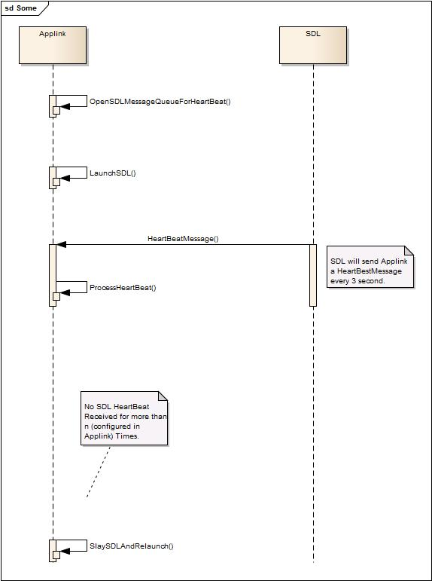

## 15.2 Low Voltage (Ford-specific)

### 15.2.1 Description

'LowVoltage' event occurs on HMI when battery voltage hits below 7v (EShutdown state). When the voltage stays below 7v more than **10s**, VMCU powers off the CCPU.

During 'LowVoltage' all the operations of emmc are blocked. When EShutdown happened, HMI system keeps running as normal, EMMC will be suspend from PowerManager, any operation to read/write eMMC will cause process into block state until low voltage recovered.

**HMI must:**

* Send "SDL_LOW_VOLTAGE" message via mqueue to SDL when 'LowVoltage' event occurs
* Send WAKE_UP via mqueue to SDL when the voltage recovers
* Send SHUT_DOWN via mqueue to SDL in case LOW_VOLTAGE event continuing more than 10 seconds

**Notes regarding SDL:**

1. During 'LowVoltage' all of transports must be unavailable for SDL. No disconnect notification comes to HMI, it just freezez it’s process and initiates the closure of all connections/sessions.
2. In case LOW voltage event continuing more than 10 seconds, SDL is expected to get shutdown notification from power manager, but anyway it will wait and not terminate itself 10 seconds after.
3. In case SDL is ‘killed’ during low_voltage, SDL will not be able to perform the accurate resumption upon the next ign_on (as data-persistence procedure was not triggered).
4. When connections will be reinitiated after WAKE_UP, resumption process will be started on SDL.

### 15.2.2 Sequence diagrams

#### 15.2.2.1 LowVoltage and WakeUp

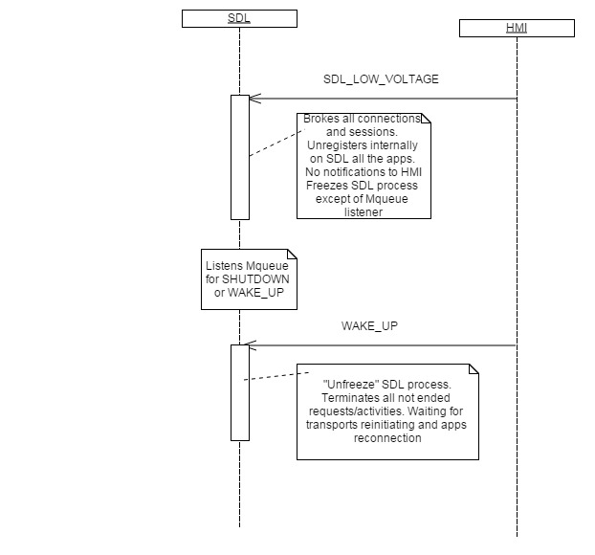

#### 15.2.2.2 LowVoltage and ShutDown

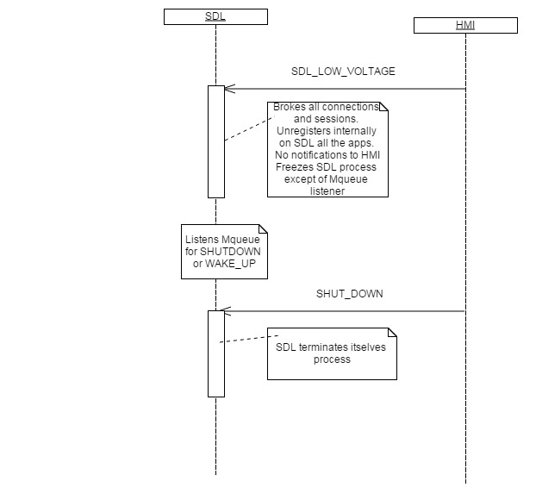

## 15.3 SDL’s configuration file structure (ini-file)

### 15.3.1 Description

To configure some specific SDL rules or to define the filepathes and other other SDL settings, *smartDeviceLink.ini* file is used. The file is divided into a sections, each section relates to the configuration of some functional area. Some of the settings have no reference to HMI behavior, anyway they are described for information purposes to understand particular properties. See 15.3.2 Structure for getting detailed information about each group.

### 15.3.2 Structure

#### 15.3.2.1 HMI

| **Parameter** | **Description** |
| --- | --- |
| LaunchHMI | Defines if SDL will start HMI process or will be running without HMI initiation(for open-source project) |
| ServerAddress | Address to connect HMI (web-socket only) |
| ServerPort | ServerPort (web-socket only) |
| VideoStreamingPort | Port number for streaming video (in case of socket type) |
| AudioStreamingPort | Port number for streaming audio (in case of socket type) |

#### 15.3.2.2 MAIN

| **Parameter** | **Description** |
| --- | --- |
| LogsEnabled | SDL logging output enabled/disabled on system |
| AppConfigFolder | The path to application configuration folder where hmi_capabilities,smartDeviceLink.ini, log4cxx.properties and policy table files (preload, snapshot) are stored |
| AppStorageFolder | The root folder for storing all applications folder |
| ThreadStackSize | ThreadStackSize used only if its realy needed, other way stack size will be PTHREAD_STACK_MIN, which for  Ubuntu:  THREAD_STACK_MIN = 16384  QNX:  PTHREAD_STACK_MIN = 256 |
| MixingAudioSupported | Defines if HMI support attenuated mode (able to mix audio sources) |
| HMICapabilities | The file of default HMICapabilities. In case HMI doesn’t send some capabilities to SDL, the values from the file are used by SDL |
| MaxCmdID | Maximum cmdId of VR command which may be registered on SDL (to clarify) |
| HMIHeartBeatTimeout | HMI's heartbeat timeout. The value specifies seconds to send heartbeat to HMI from SDL |
| DefaultTimeout | The timeout the response must be senf to mobile |
| AppDirectoryQuota | Definines folder size limitation for any application on SDL |
| AppHMILevelNoneTimeScaleMaxRequests | Number of the requests allowed for the application in NONE HMI Level. If exceeded, the application will be unregistered |
| AppHMILevelNoneRequestsTimeScale | Requests frequency allowed for the application in NONE HMI Level. If exceeded, the application will be unregistered |
| AppTimeScaleMaxRequests | Number of the requests allowed for the application in any HMI Level except of NONE. If exceeded, the application will be unregistered |
| AppRequestsTimeScale | Requests frequency allowed for the application in any HMI Level except of NONE. If exceeded, the application will be unregistered |
| PendingRequestsAmount | Number of the SDL pending requests allowed for an application. If exceeded, the application will be unregistered |
| HeartBeatTimeout | Heart beat timeout used for protocol v3. Timeout must be specified in milliseconds. If timeout is 0 heart beat between Mobile device and SDL will be disabled. SDL sends heartbeat and waiting for a response within HeartBeatTimeout timeframes, otherwise it consider connection to be broken. |
| SupportedDiagModes | The list of diagnostic modes supported on HMI |
| SystemFilesPath | The path to the system file directory for interoperation between SDL and System (e.g. IVSU files and others) |
| UseLastState | To restore the last transport state |
| TimeTestingPort | Port to obtain the performance information about messages processing on different component levels |
| ReadDIDRequest | Limitation for a number of ReadDID requests (the 1st value) per seconds (the 2nd value) |
| GetVehicleDataRequest | Limitation for a number of GetVehicleData requests (the 1st value) per seconds (the 2nd value) |
| TargetBootCountFile | Counter for the target boots |
| TargetTmpDir | The path to the system temporary files |

#### 15.3.2.3 LOGGING

| **Parameter** | **Description** |
| --- | --- |
| LoggerConfigFile | Config file of Logging library |
| RemoteLoggingFlagFile | Defines if remote logging is enabled (enabled in case the logging flag file is found by full path  RemoteLoggingFlagFilePath /RemoteLoggingFlagFile) |
| RemoteLoggingFlagFilePath | The path to the remote logging file flag |
| TargetLogFileHomeDir | Directory for storing target log files |
| TargetLogFileNamePattern | Defines the name pattern for a target log file |
| LogFileMaxSize | The limit size of the log file – 0K (unlimited), otherwise – limit defined |

#### 15.3.2.4 MEDIA MANAGER

| **Parameter** | **Description** |
| --- | --- |
| StartStreamRetry | Where the 1st one of the values is a number of retries and the 2nd number is a timeout in seconds for request frequency |
| EnableRedecoding | If decoding on HMI is required?APTHR |
| VideoStreamConsumer | Pipe/file or socket type of data streaming |
| AudioStreamConsumer | Pipe/file or socket type of data streaming |
| NamedVideoPipePath | Named pipe path will be constructed using AppStorageFolder + NamedVideoPipePath |
| NamedAudioPipePath | Named pipe path will be constructed using AppStorageFolder + NamedAudioPipePath |
| VideoStreamFile | File path will be constructed using AppStorageFolder + VideoStreamFile |
| AudioStreamFile | File path will be constructed using AppStorageFolder + name |
| RecordingFileSource | Recording file source (used for audio pass thru emulation only), not applicable for SYNC HU system |
| StopStreamingTimeout | The timeout in milliseconds for mobile to stop streaming or end up session |
| RecordingFileName | The filename of the file for audio pass thru data recording |
| MQAudioPath | The name of MQ which is used by system HMI to send AudioPassThru data |
| AudioDataStoppedTimeout | Defines time in milliseconds for SDL to wait for the next package of raw data over audio service. |
| VideoDataStoppedTimeout | Defines time in milliseconds for SDL to wait for the next package of raw data over video service. |

#### 15.3.2.5 GLOBAL PROPERTIES

| **Parameter** | **Description** |
| --- | --- |
| TTSDelimiter | Defines the delimiter, which will be appended to each TTS chunck, e.g. helpPrompt/timeoutPrompt |
| HelpPromt | Default prompt items, separated by comma. The value is set up in case ResetGlobalProperties request from the application or SDL (in case of TTSGlobalPropertiesTimeout) |
| TimeOutPromt | Default prompt to be spoken by VR-engine timeout (when system expects some action by user and the time for this action is going to be out) |
| HelpTitle | Text to be set-up for default value of the title of help list |
| TTSGlobalPropertiesTimeout | In case mobile app didn't send global properties request, then default global properties will be sent defined timeout in seconds  Max value TTSGlobalPropertiesTimeout 64K |

#### 15.3.2.6 FILESYSTEM RESTRICTIONS

| **Parameter** | **Description** |
| --- | --- |
| PutFileRequest | Max allowed number of PutFile requests for one application in NONE. The application will be unregistered in case the number of requests exceeded the limitation |
| DeleteFileRequest | Max allowed number of DeleteFile requests for one application in NONE. The application will be unregistered in case the number of requests exceeded the limitation |
| ListFilesRequest | Max allowed number of ListFiles requests for one application in NONE. The application will be unregistered in case the number of requests exceeded the limitation |

#### 15.3.2.6 VR COMMANDS

| **Parameter** | **Description** |
| --- | --- |
| HelpCommand | Default command which initiates VR Help of the application |

#### 15.3.2.7 AppInfo

| **Parameter** | **Description** |
| --- | --- |
| AppInfoStorage | The path for applications information storage (for resumption purposes) |

#### 15.3.2.7 Policy

| **Parameter** | **Description** |
| --- | --- |
| EnablePolicy | Turn on/off policies |
| PreloadedPT | The filename of the preloaded policy table |
| PathToSnapshot | The filename of the policy table snapshot |
| AttemptsToOpenPolicyDB | Number of attempts to open policy DB |
| OpenAttemptTimeoutMs | Timeout between attempts during opening DB in milliseconds |

#### 15.3.2.7 TransportManager

| **Parameter** | **Description** |
| --- | --- |
| TCPAdapterPort | Listening port form incoming mobile connection |
| MMEDatabase |  |
| EventMQ |  |
| AckMQ |  |

#### 15.3.2.7 IAP

| **Parameter** | **Description** |
| --- | --- |
| DefaultHubProtocolIndex |  |
| LegacyProtocol |  |
| HubProtocol |  |
| PoolProtocol |  |
| IAPSystemConfig |  |
| IAP2SystemConfig |  |
| IAP2HubConnectAttempts |  |
| ConnectionWaitTimeout |  |
| ArmEventTimeout |  |

#### 15.3.2.7 ProtocolHandler

| **Parameter** | **Description** |
| --- | --- |
| MaximumPayloadSize | Packet with a payload bigger than # MaximumPayloadSize will be marked as a malformed  Default value: 1488 = 1500 - 12 (TCP MTU - header size) |
| FrequencyCount | Application shall send not more than #FrequencyCount messages per #FrequencyTime mSecs  Frequency check could be disabled by setting #FrequencyTime or #FrequencyCount to “0” |
| FrequencyTime | The limitation in ms for sending number of the requests not more than #FrequencyCount |
| MalformedMessageFiltering | Enable filtering transport data stream;  On #MalformedMessageFiltering disabling, SDL will close the connection with the first  malformed message detection |
| MalformedFrequencyCount | Boundary value of malformed message detection for connection closure  Can be disabled by setting #MalformedFrequencyTime or #MalformedFrequencyCount to “0” |
| MalformedFrequencyTime | Boundary value of malformed message detection for connection closure. In case the frequency of mailformed requests will be more than per #MalformedFrequencyTime, SDL will close the connection |

#### 15.3.2.7 ApplicationManager

| **Parameter** | **Description** |
| --- | --- |
| ApplicationListUpdateTimeout | Application list update timeout ms |
| ThreadPoolSize | Max allowed threads for handling mobile requests. Currently max allowed is 2 |
| HashStringSize | The max size of hash which is used by OnHashUpdated() |

#### 15.3.2.7 SDL4

| **Parameter** | **Description** |
| --- | --- |
| EnableProtocol4 | Enables SDL 4.0 support |
| AppIconsFolder | Path where apps icons must be stored |
| AppIconsFolderMaxSize | Max size of the folder in bytes |
| AppIconsAmountToRemove | Amount of oldest icons to remove in case of max folder size was reached |

#### 15.3.2.7 Resumption

| **Parameter** | **Description** |
| --- | --- |
| ApplicationResumingTimeout | # Timeout in milliseconds for resumption Application HMILevel and resolving conflicts in case if multiple applications initiate resumption |
| AppSavePersistentDataTimeout | Timeout in milliseconds for pereodical saving resumption persisten data |
| ResumptionDelayBeforeIgn | Timeout in seconds to store hmi_level for media app before ign_off |
| ResumptionDelayAfterIgn | Timeout in seconds to restore hmi_level for media app after sdl run |
| UseDBForResumption | Resumption ctrl uses JSON if UseDBForResumption=false for store data otherwise uses DB |
| AttemptsToOpenResumptionDB | Number of attempts to open resumption DB |
| OpenAttemptTimeoutMsResumptionDB | Timeout between attempts during opening DB in milliseconds |

# References

1. JSON-RPC 2.0 Specification: <http://www.jsonrpc.org/specification>

# Change History

|  |  |  |  |  |
| --- | --- | --- | --- | --- |
| **Version** | **Date** | **Status** | **Change description** | **Author/Editor** |
| V.1.0 | 05/23/2013 | Initial Version | Template creation; Chapters 4, 8, 10,11 creation | A.Britanova |
| V.1.1 | 06/12/2013 | Draft | Chapters 6, 12 creation | A.Britanova |
| V.1.2 | 06/25/2013 | Draft | Chapters 5, 7 creation | A.Britanova |
| V.1.3 | 07/04/2013 | Draft | Chapters ‘Contents’, ‘Introduction’, ‘Overview’ creation. Descriptions updating. | A.Britanova |
| V.2.0 | 07/25/2013 | Draft | Ready for customer review | A.Britanova |
| V.2.1 | 08/20/2013 | Draft | Possible layout pictures are added. | A.Britanova |
| V.2.2 | 10/25/13 | Draft | Diagrams are added. | A.Britanova |
| V.2.3 | 11/08/13 | Draft | D-Bus overview added | Y.Kazakov |
| V.2.4 | 12/02/13 | Draft | Template is changed. | A.Britanova |
| V.2.5.1 | 12/10/13 | Draft | ‘WebSocket Transport’ is added | A.Britanova |
| V.2.5.2 | 12/23/13 | Draft | Sections 6.1 – 6.19 are updated: expanded description, requirements to HMI, sequence diagrams. | A.Britanova |
| V.2.5.3 | 02/07/14 | Draft | Sections 7.1 – 7.5 and 7.8 – 7.26 are updated: expanded description, requirements to HMI, sequence diagrams, pictures of pissible layout. | A.Britanova |
| V.2.5.4 | 02/13/14 | Draft | - Sections #7.6 ‘ShowKeyboard” and #7.7 “ShowCustomForm” are deleted as not actual. The numbering of further sections is shifted.  - Interfaces are updated in correspondence to HMI_API that implements protocol 3.0 revision L.  - Sections #7.27 - #7.31; #8.1 - #8.3; #9.1. – #9.3 are updated: expanded description, requirements to HMI, sequence diagrams. | A.Britanova |
|  |  |  |  |  |
| V.2.5.10 | 05/16/14 | Draft | - Add ‘Chapter 13 SDL Component Description’  - Update section 10.4 Speak (add sec.10.4.2.1 p.3, sec.10.2.3.3)  - Add sections  6.25 OnUpdateDeviceList,  6.26. OnResumeAudioSource  6.27 UpdateAppList |  |
| V.2.5.11. | 08/26/14 | Draft | - Add ‘level’ param to “6.2.2.2 Parameters” section  - Add diagram to “6.2.4.1 BasicCommunication.ActivateApp after successsful resumption.”  - Add diagram to “6.2.4.2 BasicCommunication.ActivateApp after UNsuccesssful resumption.”  - Add diagram to “6.2.4.3 BasicCommunication.ActivateApp after unexpected disconnect”  - Add diagram to “6.2.4.4 BasicCommunication.ActivateApp after the User accepted the data consent prompt”  - Add diagram to “6.2.4.5 BasicCommunication.ActivateApp after the User declined the data consent prompt”  - Add description to “6.15.1 Description” of “6.15 OnAppUnregistered”  - Add “unexpectedDisconnect” param to “6.15.1.1 Parameter” of “6.15 OnAppUnregistered”  - Update description of “7.18.2.1 Behavior” in “7.18 Slider” section.  - Update description of “7.18.3 Response” in “7.18 Slider” section.  - Update the diagram “7.18.4.1 Slider with static footer displayed then closed by the timeout”  - Add the diagram “7.18.4.2 Slider with static footer displayed then closed by ‘OK’ button press”  - Add description to “13.1.2.1 Behavior” of “13.1 SDL.ActivateApp” section  - Add description to “13.1.3 Response”  - Add description to “13.1.3.1 Parameters”  - Add diagram “13.1.4.1 SDL.ActivateApp for the application registered from the non-consented device, which gets User`s consent afterwards”  - Add diagram “13.1.4.2 SDL.ActivateApp for the application registered from the non-consented device, which does NOT get User`s consent afterwards”  - Add diagram “13.1.4.3 SDL.ActivateApp for the application registered from the consented device and this application requires User`s consent for special permissions”  - Add diagram “13.1.4.4 SDL.ActivateApp for the application registered from the consented device and this application was reduced in permissions by the latest PT Update.”  - Add diagram “13.1.4.5 SDL.ActivateApp for the application registered from the consented device and this application was unauthorized by the latest PT Update.”  - Update “13.1.5 JSON Messages Examples” |  |
| V.2.5.12. | 09/29/14 | Draft | - Add “6.2.2.4 HMILevel” enum description  - Add description to “6.5.2.1 Behavior” of “6.5 SystemRequest”  - Add “SUSPEND” value to “6.17.1.2 ApplicationsCloseReason Enumeration”  - Add new section “6.28 OnSDLPersistenceComplete” with all relevant sub-sections.  - Add “locationImage” to “7.2.3.6 ImageFieldName Enumeration”  - Add “alertType” param to “7.4.2.2 Parameters” of “7.4 Alert”  - Add “7.4.2.4 AlertType Enumeration”  - Change “customPresets -> Maxsize = 10” in ”7.5.2.2 Parameters” of “7.5 Show”  - Add new params to “7.15.2.2 Parameters” of “7.15 ChangeRegistration”  - Add description to “8.2.1 Description” of “8.2 OnButtonEvent”  - Add "appID” param to “8.2.1.1 Parameters” of “8.2 OnButtonEvent” section  - Add description to “8.3.1 Description” of “8.3 OnButtonPress”  - Add "appID” param to “8.3.1.1 Parameters” of “8.3 OnButtonPress” section  - Add new params to “9.6.2.2 Parameters” of “9.6 ChangeRegistration”  - - Add new params to “10.6.2.2 Parameters” of “10.6 ChangeRegistration”  - Add “appID” to “11.5.2.1 Parameters” of “11.5 DiagnosticMessage”  - Add new section “12.8 SendLocation” with all relevant sub-sections  - Add description to “13.2.1 Description” of “13.2 GetListOfPermissions”  - Add description to “13.2.2.1 Behavior”  - Add diagram “13.6.4.1 GetUserFriendlyMessage”  - Add diagram to “13.7.2.1 OnAllowSDLFunctionality”  - Add diagram, to “13.9.2.1 OnAppPermissionChanged with appPermissionsConsentNeeded:true”  - Add new section “13.15 OnReceivedPolicyUpdate”  - Add new section “13.16 OnPolicyUpdate” |  |
| V. RB_B3.16_0.1 | Mar/19/2015 | Draft | 1) Section #11.3.3 Response:  - add ‘REJECTED’ result  - add ‘Truncated_data” result  - remove “User_disallowed” result  2) Section #11.4.3 Response:  - add ‘REJECTED’ result  - add ‘Truncated_data” result  - remove “User_disallowed” result  - remove ‘Data_not_available” result  3) Section #11.5.3 Response:  - add ‘REJECTED’ result  - add ‘Truncated_data” result  - remove ‘Data_not_available” result | A.Britanova |
| V. RB_B3.16_CW13 | Mar/25/2015 | Draft | 1) Section #13.1.15  - add locationName  -add locationDescription  -add addressLines  -add phoneNumber  2)Section #7.28, #7.29, #7.30, #7.31 renumeration  3)Section #10.8.2.2  helpPrompt parameter value change: minsize="1" to minsize="0" 4) Section #13.9.1.1 OnAppPermissionChanged Parameters - add RequestType  5) Section #14.1.1  - add TRUNCATED_DATA  6) Section 14.1.15  -add locationName  -add locationDescription  -add addressLines  -add phoneNumber  7) Section #14.1.51 “EmergencyState” added  8) Section #14.1.50 “MethodName” added  9) Section #6.5.2.2  - added new values for enum  10) Section #6.19.1.2  -added new values for enum  11) Chapter numeration for #13.1 and subsections has been changed to #14.1  12) Section #6.18.1.1 PlayTone Parameters added  13) Section #10.4  - SpeakType changed to MethodName in all subsections  - add AUDIO_PASS_THRU value to MethodName enum  -changed numeration of the subsections to correct one  14) Section #10.4.2.1  -add description of AUDIO_PASS_THRU type 15) Added #13.5.3.2 ServiceInfo 16) Section #6.14.1.2 HMIApplication Structure  - hmiDisplayLanguageDesired mandatory="false"  - isMediaApplication mandatory="false"  - add RequestType  17) Section #6.27.2.3 HMIApplication Structure  - hmiDisplayLanguageDesired mandatory="false"  - isMediaApplication mandatory="false"  - add RequestType  18) Section #14.2.1HMIApplication  - hmiDisplayLanguageDesired mandatory="false"  - isMediaApplication mandatory="false"  - add RequestType  19) Section #6.29  - add function OnPhoneCall  20) Section #6.29  - add function OnEmergencyEvent  21) Section #6.27.2.2 UpdateAppList Parameters  - parameter "applications" minsize “1” to “0” change  22) Section #6.31  - add function OnAwakeSLD  23) Section #6.32  - add function DialNumber  24) Section #6.19.1.1 OnSystemRequest Parameters  - policyAppID added  25) Section #9.10.1.1 OnCommand Parameters  - grammarID added  - appID mandatory "true" to "false" | E.Saenko |
| V. RB_B3.16_CW14 |  |  | 1) Section #6.1.3 Response UpdateDeviceList  - INVALID_DATA code added  - OUT_OF_MEMORY code added (under clarification)  2) Section # 6.2.3 Response ActivateApp  - INVALID_DATA code added  - INVALID_ID code added  - OUT_OF_MEMORY code added (under clarification)  3) Section #6.4.3.1 AllowDeviceToConnect  - Added codes: REJECTED, IGNORED, TIMED_OUT, INVALID_DATA  OUT_OF_MEMORY code added (under clarification)  4) Section #6.5.2.2 SystemRequest parameters  update appID to mandatory "true"  5) Section #6.5.2.3 Added RequestType values of SystemRequest  -VEHICLE_DIAGNOSTICS  - EMERGENCY  - MEDIA  - FOTA  6) Section #6.5.3 Response SystemRequest  Added codes: INVALID_DATA, INVALID_ID  OUT_OF_MEMORY, FILE_NOT_FOUND codes added (under clarification)  7) Section #6.6.2.2 PolicyUpdate parameters  -update description for "file" parameter  8) Section #6.6.3.1 PolicyUpdate response codes  Added codes: INVALID_DATA, TIMED_OUT, GENERIC_ERROR  OUT_OF_MEMORY, FILE_NOT_FOUND codes added (under clarification)  9) Section #6.6.5 PolicyUpdate JSON Messages Examples  - fix examples (were applicable for AllowApp)  10) Section #6.6.5 GetSystemInfo response codes  - added DATA_NOT_AVAILABLE, TIMED_OUT, GENERIC_ERROR  OUT_OF_MEMORY codes added (under clarification)  11) Section #6.7.5.2 Response GetSystemInfo JSON Messages Examples  -added missed mandatory parameters  Section #6.7.5.3 Error message GetSystemInfo examples  -fix of error message, the previous one wasn't applicable for the request  12) Section #6.15.3 OnAppUnregistered JSON sample  -added missed “unexpectedDisconnect” parameter in a sample  13) Section #6.18.5  -numeration fix  14) Section #6.18.5.2 PlayTone Response section added  15) Section #6.18.5.3 PlayTone JSON Messages Examples  -fixed wrong sample of Playtone request  -added response and notification examples  16) Section # 6.29.1 Description OnPhoneCall  - updated the purpose section  17) Section #6.30.1 Description OnEmergencyEvent  -When section removed  -Purpose update  -HMI must update  18) Section #6.31 OnAwakeSDL  -numeration fix  19) Section #6.32.2.2 DialNumber Parameters  -minlength changed to maxlength  -"number" description update  20) Section #6.32.3 DialNumber Response added  21) Section #7.1.3 isReady Response  -added code names to the description  22) Section #7.1.5.3 isReady JSON Error message  -update message and the code  23) Section #7.2.3 GetCapabilities Response  -added code names to the description  24) Section #7.3.3 GetSupportedLanguages Response  -added code names to the description  25) Section #7.4.3 Alert Response  -added codes UNSUPPORTED_RESOURCE, INVALID_DATA, INVALID_ID  -to clarify OUT_OF_MEMORY  26) Section #7.5.3 Show Response  -added codes UNSUPPORTED_RESOURCE, REEJCTED, INVALID_DATA, INVALID_ID  -to clarify OUT_OF_MEMORY  27) Section #7.5.6  -update numeration to the correct one  28) Section #7.5.6.3 Show JSON Error message example  -update message and result code to correct one  29) Section #7.5.3 AddCommand Response  -added codes UNSUPPORTED_RESOURCE, REJECTED, INVALID_DATA, INVALID_ID  -to clarify OUT_OF_MEMORY  30) Section #7.8.6.3 AddCommand Error message JSON example  -update message and result code to correct one  31) Section #7.9.3 DeleteCommand Response  -added codes INVALID_DATA, INVALID_ID  -to clarify OUT_OF_MEMORY  31) Section #7.10.3 AddSubMenu Response  -added codes DUPLICATE_NAME  -named all the codes  -update the description of INVALID_ID  -to clarify OUT_OF_MEMORY  32) Section #7.11.3 DeleteSubMenu Response  -named all the codes  -update the description of INVALID_ID  -to clarify OUT_OF_MEMORY  33) Section #7.11.4.2 Removed the diagram for DeleteSubMenu as not actual  34) Section #7.11.5 DeleteSubMenu JSON Messages Examples  -fixed all method names  35) Section #7.12.3 UI.PerformInteraction Response  -added codes INVALID_DATA, INVALID_ID  -to clarify OUT_OF_MEMORY  36) Section #7.13 SetMediaClockTimer  -update description  37) Section #7.13.3 SetMediaClockTimer Response  -added codes INVALID_ID  -to clarify OUT_OF_MEMORY  38) Section #7.14.3 SetGlobalProperties Response  -added codes INVALID_ID  -to clarify OUT_OF_MEMORY  39) Section #7.15.3 UI.ChangeRegistration Response  -added codes INVALID_ID, WRONG_LANGUAGE  -to clarify OUT_OF_MEMORY  40) Section #7.16.3 GetLanguage Response  -to clarify OUT_OF_MEMORY  41) Section #7.15.3 UI.SetAppIcon Response  -added codes INVALID_ID, UNSUPPORTED_RESOURCE  -to clarify OUT_OF_MEMORY, FILE_NOT_FOUND  42) Section #7.18.3 UI.Slider Response  -added codes INVALID_ID  -to clarify OUT_OF_MEMORY  43) Section #7.19.3 ScrollableMessage Response  -added codes INVALID_ID, CHAR_LIMIT_EXCEEDED  -to clarify OUT_OF_MEMORY  44) Section #7.19.3 UI.PerformAudioPassThru Response  -added codes INVALID_ID  -to clarify OUT_OF_MEMORY  45) Section #7.22.3 UI.ClosePopUp Response  - added codes REJECTED  - update INVALID_DATA description  46) Section #7.31.3 UI.SetDisplayLayout Response  - added codes INVALID_DATA  - update UNSUPPORTED_RESOURCE description  47) Section #9.4.3 VR.AddCommand Response  - added codes INVALID_ID  - update INVALID_DATA description  48) Section #9.4.5.1 VR.AddCommand Request example  -update with grammarID parameter  49) Section #9.5.3 VR.DeleteCommand Response  - added codes INVALID_ID  - update INVALID_DATA description  50) Section #9.5.5.1 VR.DeleteCommand Request example  -update with "grammarID" and "type" parameter  51) Section #9.6.1 ChangeRegistration Description  -note updated  52) Section #9.6.3 VR.DeleteCommand Response  - added codes INVALID_ID, WRONG_LANGUAGE  53) Section #9.12.3 VR.PerformInteraction Response  - added codes INVALID_ID  54) Section #10.4.3 Speak Response  - added codes INVALID_ID  55) Section #10.6.3 Speak Response  - added codes INVALID_ID, WRONG_LANGUAGE  56) Section #10.8.3 SetGlobalProperties Response  - added codes INVALID_ID  - update UNSUPPORTED_RESOURCE description  57) Section #10.11  -numeration updated  -response codes information added  58) Section #10.11.4 JSON Messages Examples  -added message examples  59) Section #10.12  -numeration updated  -response codes information added  60) Section #10.12.5 JSON Messages Examples  -added message examples  61) Section #11.3.3 ReadDID Response  - added codes INVALID_ID, DATA_NOT_AVAILABLE  62) Section #11.3.3.3 VehicleDataResultCode  -marked not applicable result codes  63) Section #11.4.3 GetDTC Response  - added codes INVALID_ID, DATA_NOT_AVAILABLE  64) Section #11.5.3 DiagnisticMessage Response  - added codes INVALID_ID, DATA_NOT_AVAILABLE  - update REJECTED description  65) Section #11.6.3 SubscribeVehicleData Response  - added codes INVALID_ID  - update IGNORED description  66) Section #11.7.3 UnsubscribeVehicleData Response  - added codes INVALID_ID, IGNORED  67) Section #11.7.3. VehicleDataResultCode Enumeration  - DATA_ALREADY_SUBSCRIBED not applicable  68) Section #11.8.3 GetVehicleData Response  - added codes INVALID_ID | E.Saenko |
| V. RB_B3.16_CW15 |  |  | 1) Section #11.8.3 GetVehicleData Response  - added codes INVALID_ID  2) Section #7.4.3 Alert Response  -add clarification for OUT_OF_MEMORY code  3) Section #7.27 OnTouchEvent  - add description  4) Section #7.27.2 OnTouchEvent Sequence Diagrams  - added diagrams  5)Section #7.27.3 OnTouchEvent JSON Messages Examples  - added example  6) Section #8.4 OnButtonSubscription added  7) Section #12.2.2.1 AlertManeuver Behavior update  8) Section #12.2.3 AlertManeuver Response  - INVALID_ID, UNSUPPORTED_RESOURCE codes added  - notes added clarifications  9) Section #12.2.4 AlertManeuver Sequence Diagrams added  10) Section #12.2.5.3, 12.2.5.4 Request/Response TTS.Speak for AlertManeuver added  11) Section #12.3.1 ShowConstantTBT Description update  12) Section #12.3.3 ShowConstantTBT Response  - INVALID_ID, UNSUPPORTED_RESOURCE, REJECTED codes added  - ABORTED removed  - added clarifications in the notes  13) Section #12.3.4.1 ShowConstantTBT diagram added  14) Section #12.4.3 UpdateTurnList Response  - INVALID_ID, UNSUPPORTED_RESOURCE codes added  15) Section #12.5.3 StartStream Response added  16) Section #12.5.5.2 StartStream Response example added  Section #12.5.5.3 StartStream Error message example added  17) Section #12.6.3 StopStream Response added  18) Section #12.6.5.2 StopStream Response example added  19) Section #12.6.5.3 StopStream Error message example added  20) Section #12.7.3 StartAudioStream Response added  21) Section #12.7.5.2 StartAudioStream Response example added  22) Section #12.7.5.3 StartAudioStream Error message example added  23) Section #12.8.3 StopAudioStream Response added  Section #12.8.5.2 StopAudioStream Response example added  24) Section #12.8.5.3 StopAudioStream Error message example added  25) Section #12.10 numeration changed  26) Section #12.10 SendLocation update description  27) Section #12.10.3 SendLocation Response  - WARNINGS,REJECTED, UNSUPPORTED_RESOURCE codes added  28) Section #12.10.4 SendLocation diagrams added  29) Section #12.10.5.3 SendLocation Error message fix  30) Section #13.1.3 SDL.ActivateApp Response  - added codes INVALID_ID  - update description of GENERIC_ERROR  31) Section #13.2.3 GetListOfPermissions Response  - added codes INVALID_ID  - update description of GENERIC_ERROR, INVALID_DATA  32) Section #13.3.3 UpdateSDL Response  - update description of GENERIC_ERROR, INVALID_DATA  33) Section #13.4.3 GetStatusUpdate Response  - update description of GENERIC_ERROR, INVALID_DATA  34) Section #13.4.3.2 UpdateResult added  35) Section #13.4.5 JSON Messages Examples  -added missed parameters  36) Section #13.4.3 GetURLs Response  - update description of GENERIC_ERROR, INVALID_DATA  37) Section #13.5.5.3 Error message  -added missed parameters  38) Section #13.6.3 GetUserFriendlyMessage Response  - added codes INVALID_DATA, GENERIC_ERROR  39) Section #13.6.5.3 Error message  -added missed parameters  40) Section #6.32.2.1 DialNumber behaviour  -updated the behavior description  41) Section #6.32.3 DialNumber Response  - added REJECTED, UNSUPPORTED_REQUEST  42) Section #6.32.4 DialNumber Sequence Diagrams  - added diagrams | E. Saenko |
| V. RB_B3.16_CW16 |  |  | 1) Section #6.18.2.1 MethodName for Alert  -update description, elements  -added "HMI must" section  2) Section #6.18.4.1 PlayTone with Alert request  - diagram update  3) Section #6.18.4.1 PlayTone with Alert request  - diagram update  4) Section #7.4.1 Alert Description update  5) Section #7.4.2.1 Alert Behavior update  6) Section #7.4.4 Alert Sequence Diagrams updated  7) Section #7.5  - subitems numeration fixed  8) Section #7.6 AddCommand  - numeration fixed  9) Section #7.6.2 AddCommand Request  - Impotant note update  10) Section #7.6.4.6 -7.6.4.9  -added diagrams  11) Section #7.20.4.1 PerformAudioPassTru  -diagram update  12) Section #8.4.1.1 OnButtonSubscription  - appID mandatory="true" fix  13) Section #9.4.2.1 AddCommand Behavior update  14) Section #9.4.2.2 AddCommand Parameters  -grammarID update information  15) Section #9.4.2.3 VRCommandType  -update information  16) Section #9.4.3 AddCommand Response  -added notes  17) Section #9.4.4 AddCommand diagrams update  18) Section #9.5.2.1 DeleteCommand behavior  - added grammarID information  19) Section #9.10.1 OnCommand Description  -update with grammarID information  20) Section #9.10.2 OnCommand Sequence Diagrams update  21) Section #10.4 Speak  - update with PerformAudioPassThru information  22) Section #12.5 StartStream  -update description  - added sequence diagrams  23) Section #12.6 StopStream  -update description  - added sequence diagrams  24) Section #12.7 StartAudioStream  -update description  - added sequence diagrams  25) Section #12.8 StopAudioStream  -update description  - added sequence diagrams  26) Section #12.11 OnAudioDataStreaming  -numeration fixed  -update description  - added sequence diagrams  27) Section #12.11 OnVideoDataStreaming  -numeration fixed  -update description  - added sequence diagrams  28) Section #14.1.50 MethodName  -description update | E.Saenko |
| CW17 |  |  | 1) Section #6.2.3 ActivateApp  -GENERIC_ERROR description update  2) Section #6.5 SystemRequest  - description update  - result codes description update  - diagram added  3) Section #6.8 OnReady  - added note to description  4) Section #6.9 OnStartDeviceDiscovery  - added note to description  5) Section #6.10 OnDeviceChosen  - added note to description  6) Section #6.11 OnFindApplications  - added note to description  7) Section #6.12 OnAppActivated  - added note to description  8) Section #6.13 OnAppDeactivated  - added note to description  9) Section #6.14 OnAppRegistered  - added note to description  10) Section #6.14.1.5. RequestType added  11) Section #6.16 OnExitApplication  - added note to description  12) Section #6.17 OnExitApplications  - added note to description  13) Section #6.18.2.2 MethodName  - added ALERT_MANEUVER  14) Section #6.19 OnSystemRequest  - update description  - added diagram  15) Section #6.22 OnSystemInfoChanged  - added note to description  16) Section #6.23 OnIgnitionCycleOver  - added note to description  17) Section #6.25 UpdateDeviceList  - added note to description  18) Section #6.29 OnPhoneCall  - update description  - added diagram  - json message example update  19) Section #6.30 OnEmergencyEvent  - added note to description  20) Section #6.31 OnAwakeSDL  - added note to description  21) Section #6.32 DialNumber  - update description  - added response codes TIMED_OUT, ABORTED, update description for others  - added diagrams  - update JSON error message example  22) Section #7.4 Alert  - update description  - update diagrams  - update GENERIC_ERROR description  23) Section #7.6 UI.AddCommand  - update description  - update diagrams  - update GENERIC_ERROR description  24) Section #7.9 UI.DeleteCommand  - update GENERIC_ERROR description  25) Section #7.10 UI.AddSubMenu  - update GENERIC_ERROR description  26) Section #7.11 UI.DeleteSubMenu  - update GENERIC_ERROR description  27) Section #7.12 UI.PerformInteraction  - update GENERIC_ERROR description  28) Section #7.13 UI.SetMediaClockTimer  - update GENERIC_ERROR description  29) Section #7.13 UI.SetMediaClockTimer  - update GENERIC_ERROR description  30) Section #7.14 SetGlobalProperties  - update GENERIC_ERROR description  31) Section #7.15 ChangeRegistration  - update GENERIC_ERROR description  32) Section #7.17 SetAppIcon  - update GENERIC_ERROR description  33) Section #7.18 Slider  - update GENERIC_ERROR description  34) Section #7.19 ScrollableMessage  - update GENERIC_ERROR description  35) Section #7.20 PerforAudioPassThru  - update GENERIC_ERROR description  - update diagram  36) Section #7.21 EndAudioPassThru  - update GENERIC_ERROR description  37) Section #7.23 OnCommand  - added note to description  38) Section #7.24 OnSystemContext  - update description  39) Section #7.25 OnLanguageChange  - added note to description  40) Section #7.26 OnKeyboardInput  - added note to description  41) Section #7.27 OnTouchEvent  - added note to description  42) Section #7.28 OnResetTimeout  - added note to description  43) Section #7.29 OnDriverDistraction  - added note to description  44) Section #7.30 OnRecordStart  - added description  - added diagrams  45) Section #7.31 SetDisplayLayout  - update GENERIC_ERROR description  46) Section #8.2 OnButtonEvent  - added note to description  - update diagram with params  47) Section #8.2 OnButtonPress  - added note to description  - update diagram with params  48) Section #9.4 VR.AddCommand  - update description  -update grammarID description in parameters seсtion  - update GENERIC_ERROR description  49) Section #9.5 VR.DeleteCommand  - update GENERIC_ERROR description  50) Section #9.4 VR.ChangeRegistration  - update GENERIC_ERROR description  51) Section #9.8 VR.Started  - added note to description  52) Section #9.9 VR.Stopped  - added note to description  53) Section #9.10 VR.OnCommand  - description update  54) Section #9.11 VR.OnLanguageChange  - added note to description  55) Section #9.12 VR.PerformInteraction  - update GENERIC_ERROR description  56) Section #10.4 TTS.Speak  - fix AUDIO_PASS_THRU spelling  - added ALERT_MANEUVER value  - update GENERIC_ERROR description  57) Section #10.10 TTS.OnLanguageChange  - added note to description  58) Section #10.11 TTS.Started  - added note to description  59) Section #10.12 TTS.Stopped  - added note to description  60) Section #10.13 OnResetTimeout added  61) Section #11.3 ReadDID  - update GENERIC_ERROR description  62) Section #11.4 GetDTC  - update GENERIC_ERROR description  63) Section #11.5 DiagnosticMessage  - update GENERIC_ERROR description  64) Section #11.6 SubscribeVehicleData  - update GENERIC_ERROR description  65) Section #11.7 UnsubscribeVehicleData  - update GENERIC_ERROR description  66) Section #11.9 OnVehicleData  - added note to description  67) Section #12.2 AlertManeuver  - added appID parameter  - update GENERIC_ERROR description  - diagrams update  68) Section #12.3 ShowConstantTBT  - update GENERIC_ERROR description  69) Section #12.4 UpdateTurnList  - update GENERIC_ERROR description  70) Section #12.5 StartStream  - fix of the service number in description  71) Section #12.9 OnTBTClientState  - added note to description  72) Section #12.10 SendLocation  - update GENERIC_ERROR description  73) Section #12.11 OnAudioDataStreaming  - added diagram  74) Section #13.7 OnAllowSDLFunctionality  - added note to description  75) Section #13.8 OnPermissionConcent  - added note to description  76) Section #13.9 OnAppPermissionChanged  - update description  - added RequestType enum  77) Section #13.11 OnStatusUpdate  - update description  - update parameter description  - added UpdateResult enum  - added diagram  - update JSON example  78) Section #13.12 OnSystemError  - complete section update  79) Section #13.15 OnReceivedPolicyUpdate  - added note to description  80) Section #13.16 OnPolicyUpdate  - added note to description  81) Section #14.1.50 MethodName  - added ALERT_MANEUVER | E.Saenko |
| CW18 |  |  | 1) Section #6.1.2.3 DeviceInfo Structure  - update with transportType, isSDLAllowed  2) Section #6.1.2.4 TransportType Enumeration  - added  3) Section #6.4.2.3 DeviceInfo Structure  - update with transportType, isSDLAllowed  4) Section #6.4.2.4 TransportType Enumeration  - added  5) Section #6.10.1.2 DeviceInfo Structure  - update with transportType, isSDLAllowed  6) Section #6.10.1.4 TransportType Enumeration  - added  7) Section #6.11.1.2 DeviceInfo Structure  - update with transportType, isSDLAllowed  8) Section #6.11.1.3 TransportType Enumeration added  9) Section #6.14 OnAppRegistered  - description updated  - json message example updated  10) Section #6.14.1.2 HMIApplication Structure  - deviceName removed  - deviceInfo added  - policyAppID added  11) Section #6.14.1.6 DeviceInfo Structure added  12) Section #6.14.1.7 TransportType Enumeration added  13) Section #6.21 OnFileRemoved  - description updated  - parameters description updated  - sequence diagram added  - json message example updated  14) Section #6.23 OnIgnitionCycleOver  - description updated  - sequence diagram added  - json message example updated  15) Section #6.24 OnSDLClose  - description updated  - sequence diagrams added  16) Section #6.26 OnResumeAudioSource  - description updated  - sequence diagrams added  - json message example updated  17) Section #6.28 OnSDLPersistenceComplete  - description updated  - sequence diagram added  18) Section #6.30 OnEmergencyEvent  - description updated  - sequence diagrams added  - json message example updated  19) Section #6.31 OnAwakeSDL  - description updated  - sequence diagrams added  20) Section #7.13.2.1 SetMediaClockTimer Behavior  - added updates for PAUSE mode  21) Section #7.30.2.2 OnRecordStart diagram added  22) Section #13.10.1.2 DeviceInfo added  23) Section #13.10.1.3 TransportType Enumeration added  24) Section #13.14.1.2 DeviceInfo added  25) Section #14.1.52 TransportType Enumeration added  26) Section #14.2.2 DeviceInfo  - transportType added  - isSDLAllowed added  27) Section #15.1 Heartbeat (synchronization) between SDL and Applink (Ford-specific) added  28) Section #15.2 Low Voltage (Ford-specific) added | E,Saenko |
| CW19 | 2015/11/05 | Draft | 1) Section #6.14 OnAppRegistered  - description update  - parameters description update  - diagrams update  - JSON Messages examples update  2) Section #6.19 OnSystemRequest  - fix links  3) Section #6.26 OnResumeAudioSource  - update description  - add diagrams 6.26.2.3, 6.26.2.3  4) Section #7.2 GetCapabilities  - description update  - add hmiCapabilities parameter  - add section 7.2.13.9 hmiCapabilities  - json message (added hmiCapabilities structure)  5) Section #7.26 OnKeyboardInput  - ENTRY_VOICE description added  6) Section #7.26.1.2 KeyboardEvent  - - ENTRY_VOICE added  7) Section #7.26.2.5 OnKeyboardInput for ENTRY_VOICE diagram added  8) Section #7.27 OnTouchEvent  - HMI must update  - update diagrams with MOVE TouchType  9) Section #13.1.2.1.1 App Launching and Querying (Open-source and Ford-specific) added  10) Section #13.1.4.6 SDL.ActivateApp in App Launching and Querying sequence (Open-source and Ford-specific) added  11) Section #14.1.26 KeyboardEvent  - ENTRY_VOICE added  12) Section #14.2.38 HMICapabilities added  13) Section #6,2 ActivateApp  - add resume AudioSource info to description 14) Section #13.13 AddStatisticsInfo -update desctiption  - added diagram | E.Saenko |
| CW20 | 2015/05/15 | Draft | 1) Section #6.2 ActivateApp  - updated description with OnResumeAudioSource information  2) Section #6.6 PolicyUpdate  - description and behaviour update  - changed the diagram  - fixed json examples  3) Section #6.7 GetSystemInfo  - description and behaviour update  - add diagram  4) Section #6.26 OnResumeAudioSource  - added note about 3 seconds resume timeout  5) Section #6.26.2 OnResumeAudioSource diagrams  - 6.26.2.1 and 6.26.2.2 updated  6) Section #13.5 GetURLs  - description and behaviour update  - added the diagrams  - fixed json examples  7) Section #13.7 OnAllowSDLFunctionality  -added "impotant" note  -added DeviceInfo and ConsentSource updated  8) Section #13.8 OnAppPermissionConsent  - description and behaviour update  - fixed parameters, added structures description  - added the diagram  - fixed json examples  9) Section #13.10 OnSDLConsentNeeded  - description and behaviour update  - update parameters  - added the diagram  - fixed json examples  10) Section #13.14 OnDeviceStateChanged  - description and behaviour update  - DeviceInfo and TransportType updated  - added the diagram  - fixed json examples  11) Section #13.15 OnReceivedPolicyUpdate  - description and behaviour update  - added the diagram  12) Section #13.16 OnPolicyUpdate  - description update  13)Section #6.22 OnSystemInfoChanged  - description update  - added Language structure  - added diagram  - update json example | E.Saenko |
| CW21 | 2015/05/22 | Draft | 1) Section #6.16 OnExitApplication  - description update  - renamed ApplicationExitReason to ApplicationExitReason  - added new enum value UNAUTHORIZED_TRANSPORT_REGISTRATION  - update json example  2) Section #7.2.3.1 GetCapabilities parameters response  - SoftButtonCapabilities fixed to array  3) Section #12.9 OnTBTClientState  - description update  - added diagram  - update json example  - TBTState added  4) Section #13.2 GetListOfPermissions  - Impotant paragraph added  - added the 3rd item of HMI must  - parameters description updated  - added UpdateResult enum  - added diagrams  - fix json example  5) Section #13.3 UpdateSDL  - description update  - update behavior  - added PermissionItem structure  - added diagrams  - fix json example  6) Section #13.4 GetStatusUpdate  - update behavior  - added UpdateResult enum  - added diagram  - small fix json example  7) Section #13.6 GetUserFriendlyMessage  - update behavior  - added 13.6.2.3 MessageCodes  - added 13.6.3.2 UserFriendlyMessage  - fix json example  8) Section #13.7 OnAllowSDLFunctionality  - description update  - added 13.7.1.4 TransportType Enumeration  - fix json example  9) Section #13.7 OnAppPermissionConsent  - description update  - added diagrams | E.Saenko |
| CW21 | 2015/05/29 | Draft | 1) Section #4 Build and Run SDL and Set Up the Environment update  2) Section #6.5 SystemRequest  -IVSU and Policies workflows added  3) Section #6.5.2.2 SystemRequest Parameters  -policyAppID removed  4) Section #6.5.2.2 SystemRequest sequence diagrams  -IVSU and Policies workflows added  5) Section #6.19 OnSystemRequest  -IVSU and Policies workflows added  6) Section #6.19.1.1 OnSystemRequest Parameters  -policyAppID removed  7) Section #6.19.2 OnSystemRequest sequence diagrams  -IVSU and Policies workflows added  8) Section #11.3 ReadDID  - TOO_MANY_PENDING_REQUESTS response code added  9) Section #11.4 GetDTC  - TOO_MANY_PENDING_REQUESTS response code added  10) Section #11.5 DiagnosticMessage  - TOO_MANY_PENDING_REQUESTS response code added  11) Section #13.5.3.2 ServiceInfo  -policyAppID removed  12) Section #14.2.38 ServiceInfo added  13) Section #15.1 SDL’s configuration file structure (ini-file) added | E.Saenko |